|  |  |  |
| --- | --- | --- |
|  |  | RFID attendance  With gsm notification |

Date

# Basic

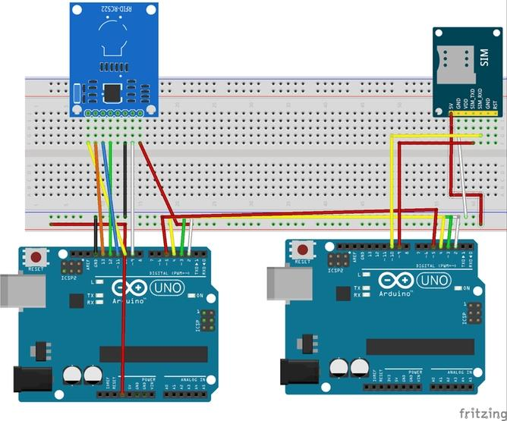The project Arduino and RFID Based Attendance System With GSM  is a simple and is used at any place where attendance is taken for maintaining register.

In this project we used

1. Ardunio uno

2. RFID-MRC522

3. SIM900A/Sim800c GSM Module

4. Breadboard

5. Connecting Ware

We Divided this project into Two part-

1 . RFID to ardunio part

The software of Arduino and RFID Based Attendance System is written in arduino programming language and comde. Before using code, you must first add RFID tag code and its corresponding name (name of person to whom that RFID card is assigned).

RFID to ardunio Connection  RFID Code-

#include <SPI.h>

#include <MFRC522.h>

int count = 0;

#define SS_PIN 10

#define RST_PIN 9

#define sw3 2 //define green LED pin

#define sw4 3 //define red LED

#define BUZZER A4//buzzer pin

#define sw1 4

#define sw2 5

MFRC522 mfrc522(SS_PIN, RST_PIN); // Create MFRC522 instance.

void setup()

{

  Serial.begin(9600); // Initiate a serial communication

  SPI.begin(); // Initiate SPI bus

  mfrc522.PCD_Init(); // Initiate MFRC522

  pinMode(sw3, OUTPUT);

  pinMode(sw4, OUTPUT);

  pinMode(sw1, OUTPUT);

  pinMode(sw2, OUTPUT);

  pinMode(BUZZER, OUTPUT);

  noTone(BUZZER);

  digitalWrite(sw3, HIGH);

  digitalWrite(sw4, HIGH);

  digitalWrite(sw1, HIGH);

  digitalWrite(sw2, HIGH);

  Serial.println("Put your card to the reader...");

  Serial.println();

}

void loop()

{

  // Look for new cards

  if ( ! mfrc522.PICC_IsNewCardPresent())

  {

    return;

  }

  // Select one of the cards

  if ( ! mfrc522.PICC_ReadCardSerial())

  {

    return;

  }

  //Show UID on serial monitor

  Serial.print("UID tag :");

  String content= "";

  byte letter;

  for (byte i = 0; i < mfrc522.uid.size; i++)

  {

     Serial.print(mfrc522.uid.uidByte[i] < 0x10 ? " 0" : " ");

     Serial.print(mfrc522.uid.uidByte[i], HEX);

     content.concat(String(mfrc522.uid.uidByte[i] < 0x10 ? " 0" : " "));

     content.concat(String(mfrc522.uid.uidByte[i], HEX));

  }

  Serial.println();

  Serial.print("Message : ");

  content.toUpperCase();

  if (content.substring(1) == "50 64 D8 A4")

  {

    Serial.println("Authorized access");

    Serial.println();

    delay(500);

    //digitalWrite(sw3, HIGH);

    tone(BUZZER, 500);

    delay(300);

    noTone(BUZZER);

    digitalWrite(sw3, LOW);

    delay(300);

 digitalWrite(sw3, HIGH);

    delay(400);

  }

   if (content.substring(1) == "57 E0 5C 74")

  {

    Serial.println("Authorized access");

    Serial.println();

    delay(500);

    //digitalWrite(sw4, HIGH);

    tone(BUZZER, 500);

    delay(300);

    noTone(BUZZER);

    digitalWrite(sw4, LOW);

    delay(300);

 digitalWrite(sw4, HIGH);

  }

if (content.substring(1) == "E0 F1 77 A4")

  {

    Serial.println("Authorized access");

    Serial.println();

    delay(500);

   // digitalWrite(sw1, HIGH);

    tone(BUZZER, 500);

    delay(300);

    noTone(BUZZER);

    digitalWrite(sw1, LOW);

    delay(300);

 digitalWrite(sw1, HIGH);

  }

 if (content.substring(1) == "82 4C 3F 65")

  {

    Serial.println("Authorized access");

    Serial.println();

    delay(500);

  // digitalWrite(sw2, HIGH);

    tone(BUZZER, 500);

    delay(300);

    noTone(BUZZER);

    digitalWrite(sw2, LOW);

    delay(300);

 digitalWrite(sw2, HIGH);

  }

}

2.RFID to ardunio to Ardunio to GSM part

Now you have to need  connecting two ardunio and GSM Module Flowing Image



GSM code and upload  your ardunio Board –

#include <SoftwareSerial.h>

SoftwareSerial GPRS(8,9);

boolean state, lastState;

boolean state1, lastState1;

boolean state2, lastState2;

boolean state3, lastState3;

void setup()

{

  pinMode(2, INPUT_PULLUP);

      pinMode(3, INPUT_PULLUP);

          pinMode(4, INPUT_PULLUP);

            pinMode(5, INPUT_PULLUP);

  state = digitalRead(2);

  lastState = state;

       state1 = digitalRead(3);

  lastState1 = state1;

              state2 = digitalRead(4);

  lastState2 = state2;

            state3 = digitalRead(5);

  lastState3 = state3;

  GPRS.begin(9600);

  Serial.begin(9600);

  GPRS.println("AT+CMGF=1");

  delay(1000);

}

void loop()

{

  while(GPRS.available()) {

    Serial.write(GPRS.read());

  }

  lastState = state;

     state = digitalRead(2);

        lastState1 = state1;

                state1 = digitalRead(3);

                 lastState2 = state2;

                       state2 = digitalRead(4);

                        lastState3 = state3;

                            state3 = digitalRead(5);

  if ( state != lastState ) {

    sendSMS();

  }

       if ( state1 != lastState1 ) {

    sendSMS1();

  }

            if ( state2 != lastState2 ) {

              sendSMS2();

            }

            if ( state3 != lastState3 ) {

              sendSMS3();

            }

  delay(500);

}

void sendSMS() {

 //GPRS.println("AT+CMGF=1"); //Sets the GSM Module in Text Mode

  // delay(1000); // Delay of 1000 milli seconds or 1 second

  GPRS.println("AT+CMGS=\"+8801723673803\"\r"); // Replace x with mobile number

  delay(500);

  GPRS.println(" This is SAKIB");// The SMS text you want to send

  delay(100);

   GPRS.println((char)26);// ASCII code of CTRL+Z

  delay(500);

  //GPRS.write( 0x1a ); // ctrl+Z character

  //delay(500);

}

void sendSMS1() {

 //GPRS.println("AT+CMGF=1"); //Sets the GSM Module in Text Mode

 // delay(1000); // Delay of 1000 milli seconds or 1 second

  GPRS.println("AT+CMGS=\"+8801723673803\"\r"); // Replace x with mobile number

  delay(1000);

  GPRS.println(" This is MOSTAKIN");// The SMS text you want to send

  delay(100);

   GPRS.println((char)26);// ASCII code of CTRL+Z

  delay(100);

  //GPRS.write( 0x1a ); // ctrl+Z character

  //delay(500);

}

void sendSMS2() {

 //GPRS.println("AT+CMGF=1"); //Sets the GSM Module in Text Mode

 // delay(1000); // Delay of 1000 milli seconds or 1 second

  GPRS.println("AT+CMGS=\"+8801723673803\"\r"); // Replace x with mobile number

  delay(1000);

  GPRS.println(" This is SUKUMAR");// The SMS text you want to send

  delay(100);

   GPRS.println((char)26);// ASCII code of CTRL+Z

  delay(100);

  //GPRS.write( 0x1a ); // ctrl+Z character

 // delay(500);

}

void sendSMS3() {

 //GPRS.println("AT+CMGF=1"); //Sets the GSM Module in Text Mode

 // delay(1000); // Delay of 1000 milli seconds or 1 second

  GPRS.println("AT+CMGS=\"+8801723673803\"\r"); // Replace x with mobile number

  delay(1000);

  GPRS.println(" This is Hasssan");// The SMS text you want to send

  delay(100);

   GPRS.println((char)26);// ASCII code of CTRL+Z

  delay(100);

  //GPRS.write( 0x1a ); // ctrl+Z character

  //delay(500);



