**TEST DATA SET**

Let us suppose have three products, that are, an Oreo biscuit, box of apple and a packet of washing powder which is chosen by a customer form shopping mall. The price of respective commodities is

₹ 40, ₹160,₹100 respectively. Now when the customer heads to the mall entrance the RFID reader module at the EXIT gate will scan and read the **ID’s** of these three products as follow:

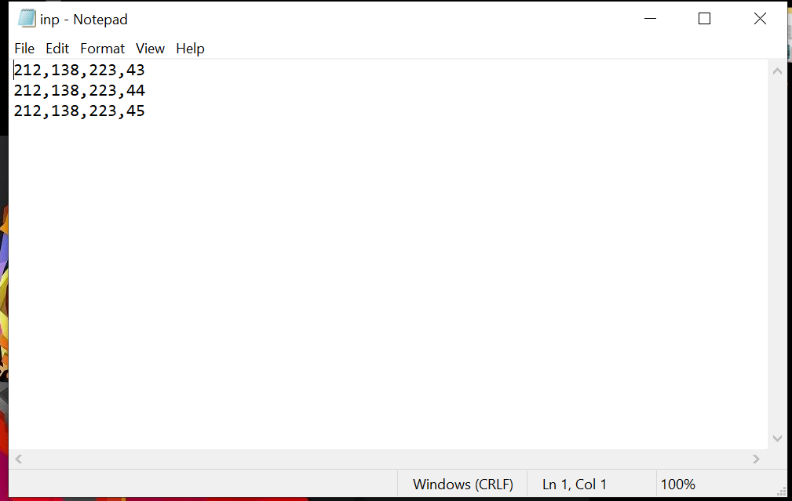

As per the configuration the **data (price and tagID)** of each commodity will be stored in a **local cloud** and each time the data will be compared using TagID as **primary field** then the total sum will be displayed on the LCD. then the user can pay and move out easily.

Here for the proof of the concept we have taken three commodities, their quantity and total of ₹200 displayed on the serial monitor of Arduino 1.8.8.

We can extend this functionality by creating a system as a local cloud and creating a database for the items present in that particular shopping mall. After finding the related to the database the TOTAL will be displayed in the 16x2 LCD of the circuit

**TEST RESULTS**

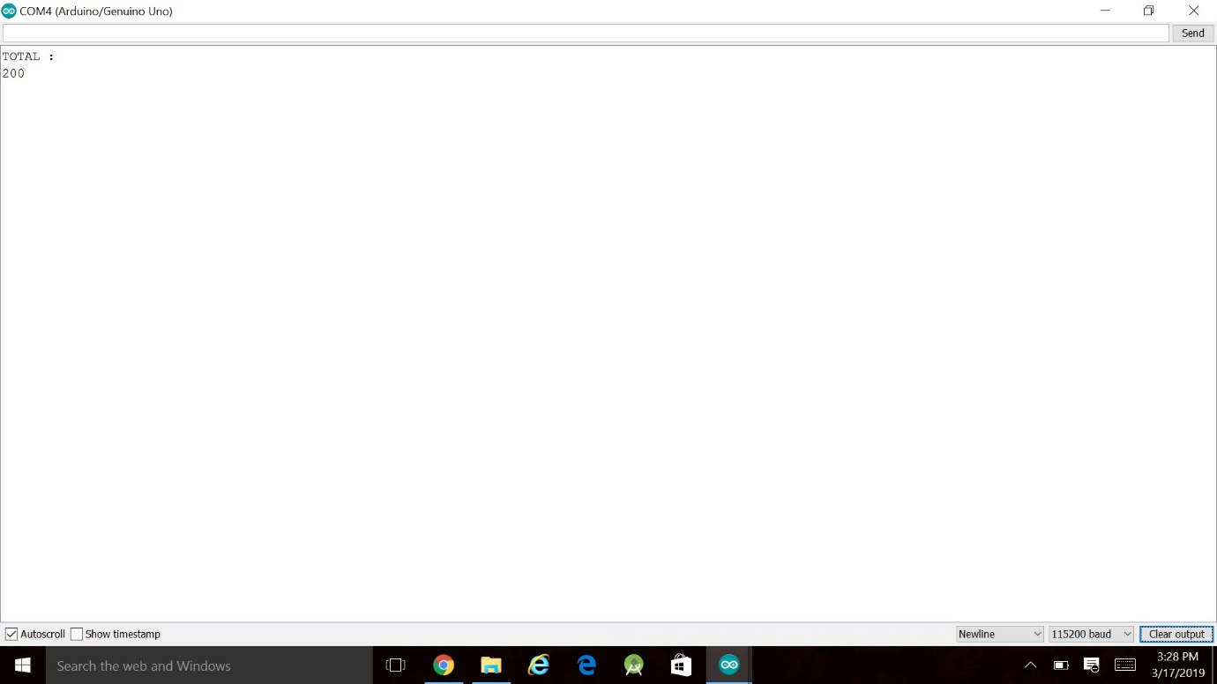

***Optional***

Further this same circuit can also be implemented by using proteus. The **Proteus Design Suite** is a proprietary software tool suite used primarily for electronic design automation. We can virtually create the design and simulate the system with the use of **Virtual Serial Ports** **Emulator.** VirtualSerial Ports is a Windows user-mode application, which allows you to create software **virtual serial ports** and emulate physical **serial ports** behaviour.

The hex file generated after the compilation of the Arduino code is used on proteus for virtual simulation.