

CRYPTONEX

**USER MANUAL**

# **Acknowledgement**

We would like to mention that our project would not have reached its maximum potential without our supervisor Mr. Shoaib Raza who has been a source of constant support nudging us to improve our work. Moreover, guiding us and correcting our path whenever we deviated from the goal encouraged us to work hard.

Thank you to the FAST NUCES University for assisting us in the evaluation of the project and for producing this report.

**Table of Contents**

**1.** **Acknowledgement** 2

**2.** **About Cryptonex:** 4

**3.** **Logging In** 4

**Login PC/Laptop** 4

**Login Mobile Phones** 5

**4.** **Register** 6

**Register Pc/Laptop** 6

**5.** **API key and Secret Key (Registration)** 7

**How to Get Your Binance API Keys and Link Them (Steps):** 7

**Step 1: Generate Your Keys** 7

**Step 2: Confirm Your Request** 9

**Step 3: Link Your Keys to Cryptonex App** 10

**6.** **Register Mobile** 11

**7.** **Main Dashboard** 12

**8.** **Recent Coins** 13

**9.** **Analytics** 14

**10.** **Crypto News** 15

**11.** **Coin Info** 16

**12.** **Kid Mode** 17

**13.** **About Coin** 18

**14.** **Troubleshoot and support** 19

# **About Cryptonex:**

# Cryptonex is a platform for naïve users to trade cryptocurrency without any risk of losing their valuable earning. It enables users to do emotionless trading. Cryptonex uses Binance API to fetch real-time data and automatically perform 24/7 trades for users by using technical indicators (RSI). This allows the user to enter the market at a lower price and exit at a higher price and uses strategies to maximize profit generation. We aim to generate at least 1% to 2% profit which will be accumulated using multiple trades towards the end of the day. We have developed a fully automated trading bot for buying and selling cryptocurrency (SHIB-USDT coin) which can be easily used by a naive user to generate profit. Moreover, this project can be further extended to incorporate other different currencies such as Ethereum, Bitcoin, and many more. With further development, the CRYPTONEX trading bot can be extended to be used for MAC OS and Apple devices. Conclusively, our trading bot can also be developed for Binance Future Trading.

# **Logging In**

# There are two ways to log-in/access Cryptonex. Either on your pc or laptop through your browser or on your smartphone (Android) through the Cryptonex app.

# **Login PC/Laptop**

# If you already have an account then login

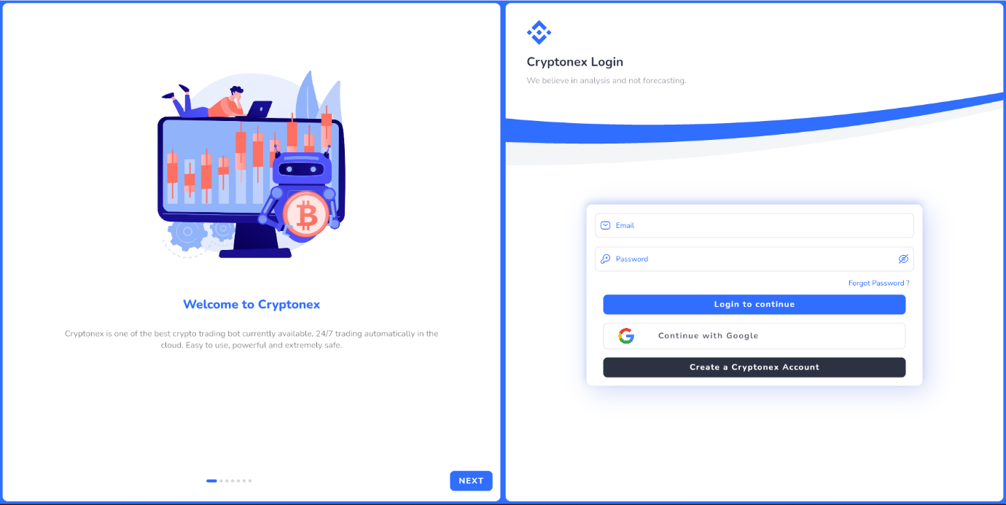

You are now sent to the CRYPTONEX login screen. Here you should

* + Enter your CRYPTONEX username, or ( **@gmail.com**)
  + Enter your password

# **Login Mobile Phones**

# Enter Email id and password on login screen

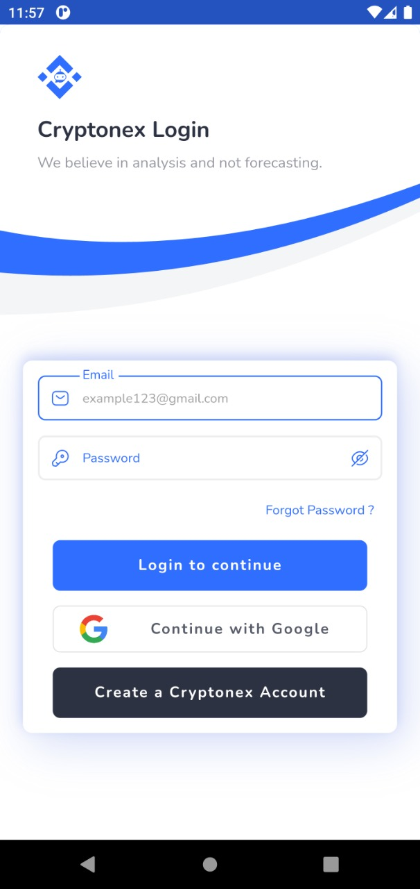

# **Register**

# **Register Pc/Laptop**

# If you don’t have an account then register to cryptonex application.

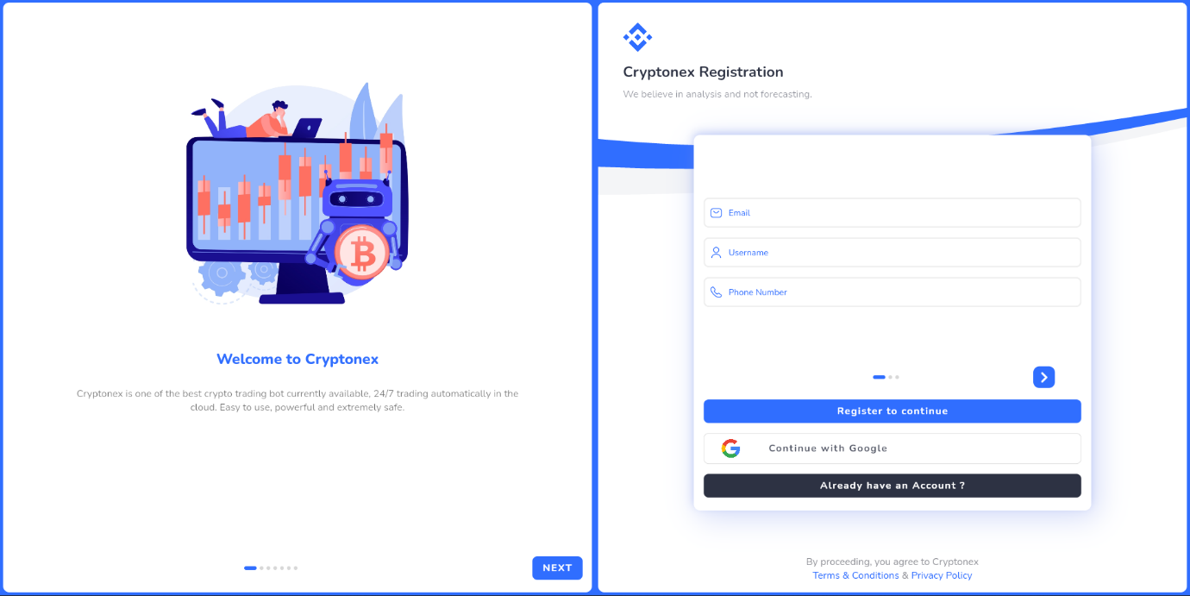

# **Binance Account is must to use Cryptonex app as Cryptonex uses Binance Exchange to trade.** For your API KEY and Secret KEY follow step 4 to get them and paste in the API key and secret Key fields below.

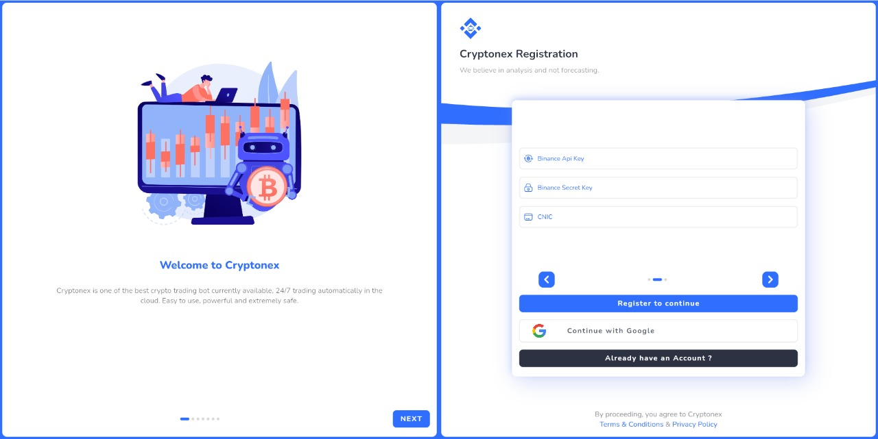

Secret KEY

API KEY

# **API key and Secret Key (Registration)**

## Why Do I Need to Link My Keys?

## There are several benefits to connecting your Binance account(s) with an app like Cryptonex. You will be able to automate your trading process cryptonex trading bot with auto buy and sell feature which enables you to make 1% - 2% profit on each trade. Your portfolio will start to automatically update after every trade or investment you make. You’ll also be able to access the analytics report, check your highest gainers & losers, digest news about your favourite cryptocurrencies, set exchange specific alerts, and more, all in one single app. Cryptonex creates a seamless tracking experience that we are positive you’ll love.

## **How to Get Your Binance API Keys and Link Them (Steps):**

### **Step 1: Generate Your Keys**

* 1. Sign into your [Binance](https://www.binance.com) account and click on “Account”

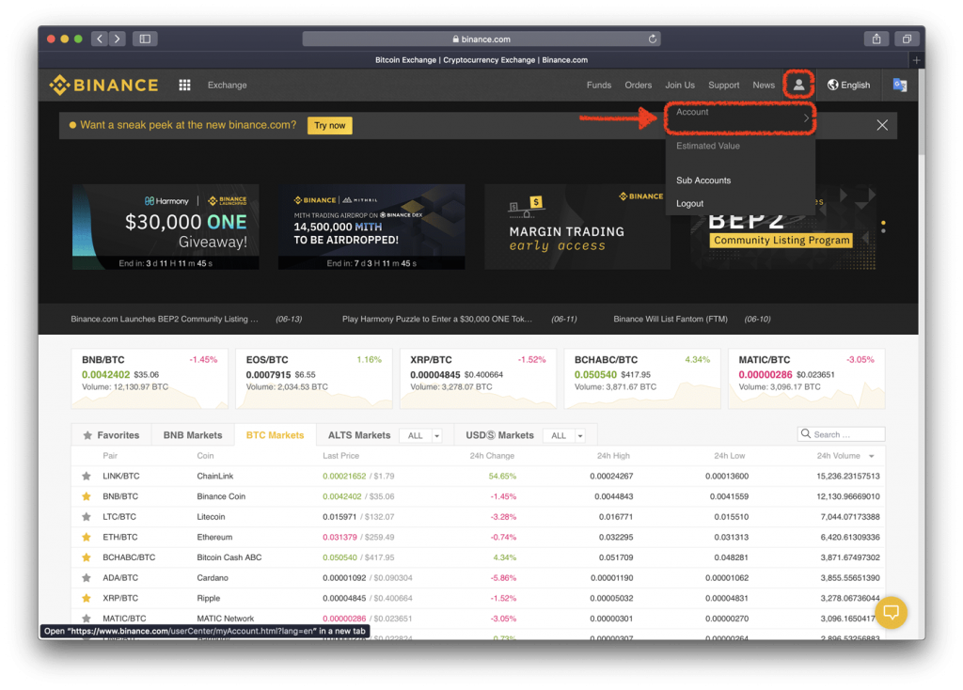

* 1. Click on “API Settings”

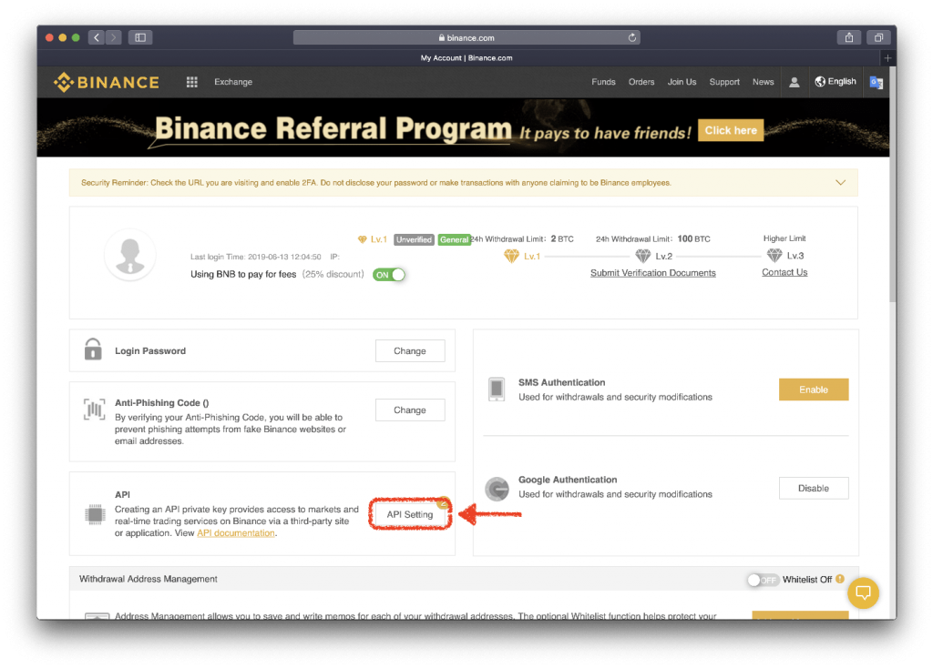

* 1. Type a name for your Key. In this example, we are linking it to the Crypto Pro App so the name “Crypto Pro” is appropriate. Then click on Generate Key. 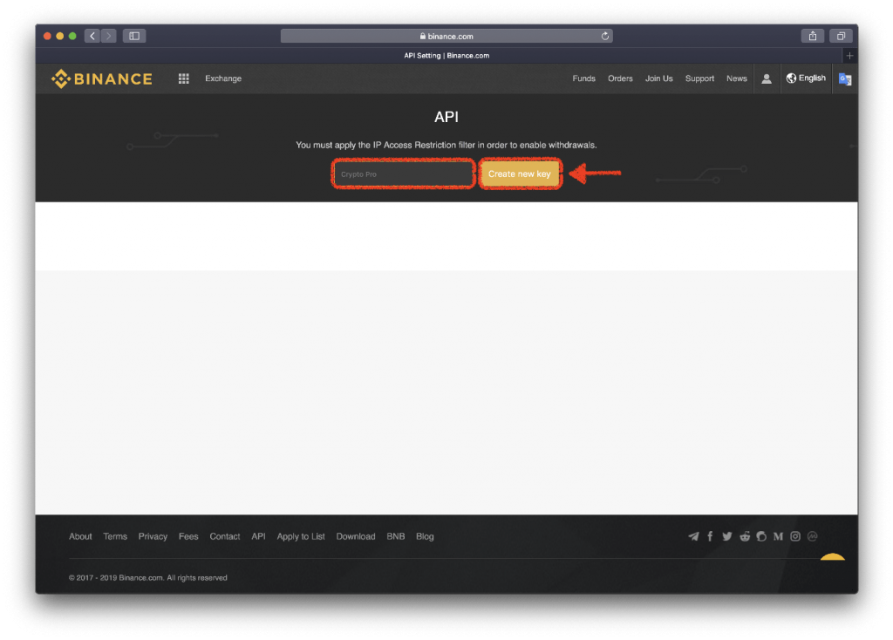

### **Step 2: Confirm Your Request**

2.1 You should now see a message letting you know that a confirmation email has been sent out.

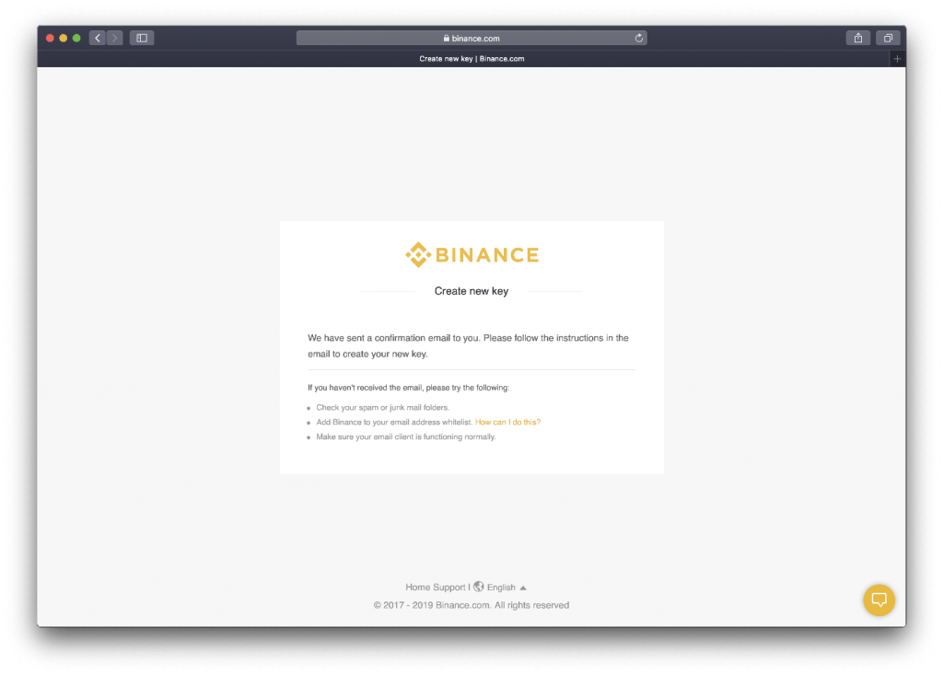

2.2 Check your email address. Binance sends a confirmation email for security purposes. It will be titled: “[Binance] Create New API Key”. Open it and click on “Confirm Key”. keep in mind that you have 30 minutes to confirm before the link expires. This is a security measure set by Binance.

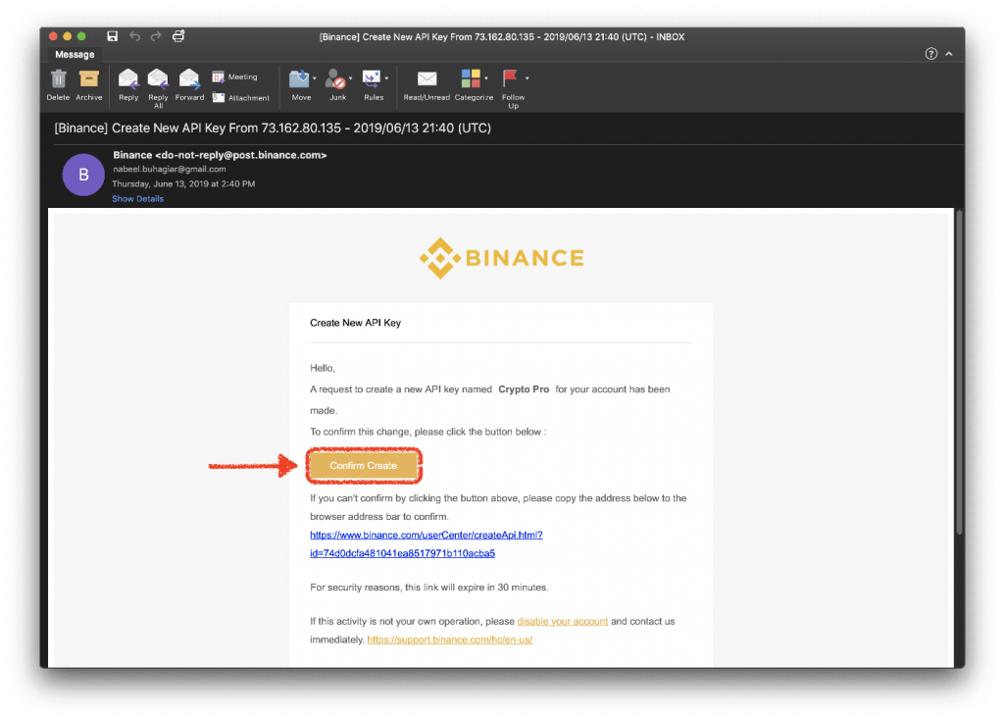

2.3 The link will take you back to Binance and you will be able to see both the API Key and the Secret Key you just generated.

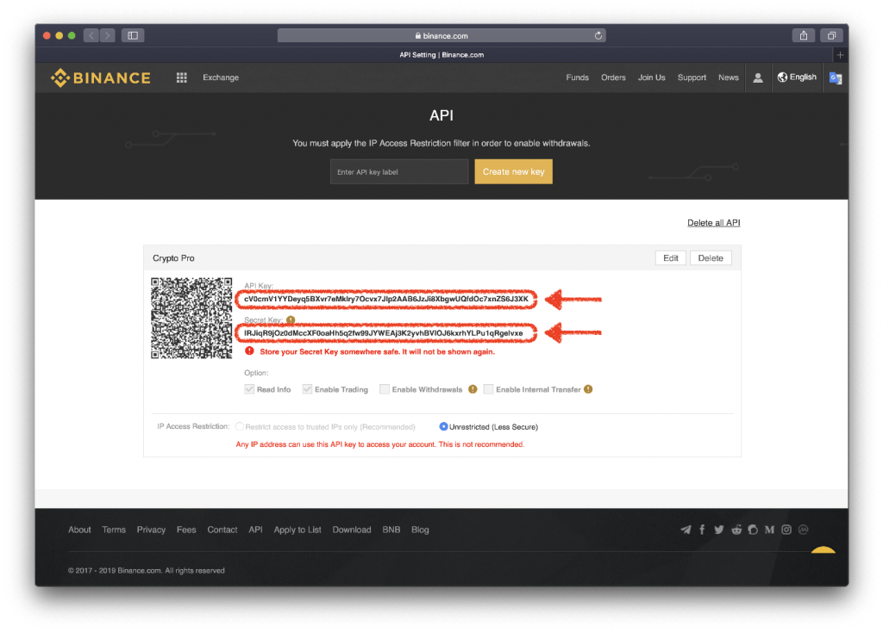

### **Step 3: Link Your Keys to Cryptonex App**

3.1 Head over to the Cryptonex App and tap on the “Registration” tab  
3.2 Slide forward in registration form and find “Binance API key & Secret Key field ”  
3.3 Paste both the API Key and Secret Key in the “API Key” and “Secret Key” fields.

## **Success!**

If you have successfully completed these steps, the working status will be set to “Active”. and you’ll be able to check your Binance portfolio from within the app.

# **Register Mobile**

# For registration through mobile phone enter the following details and then enter the API key and secret key in the respective fields carefully.

# 

# **Main Dashboard**

# Here user can see his main dashboard. User will also see

### Bot statistics

### Total profit

### Current Coin selected

### Good decision

### Bad decision

### Last transaction

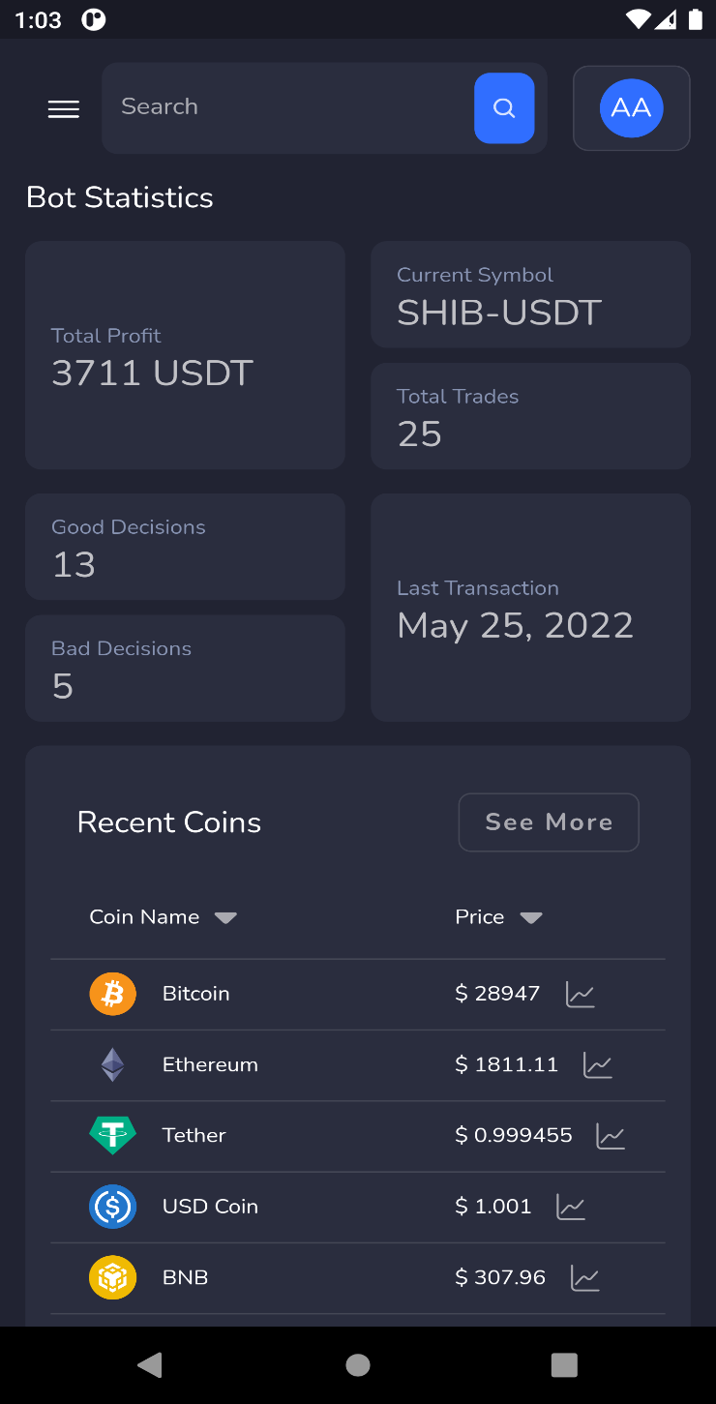

# **Recent Coins**

# Here user can see his recent coins and their analytics.

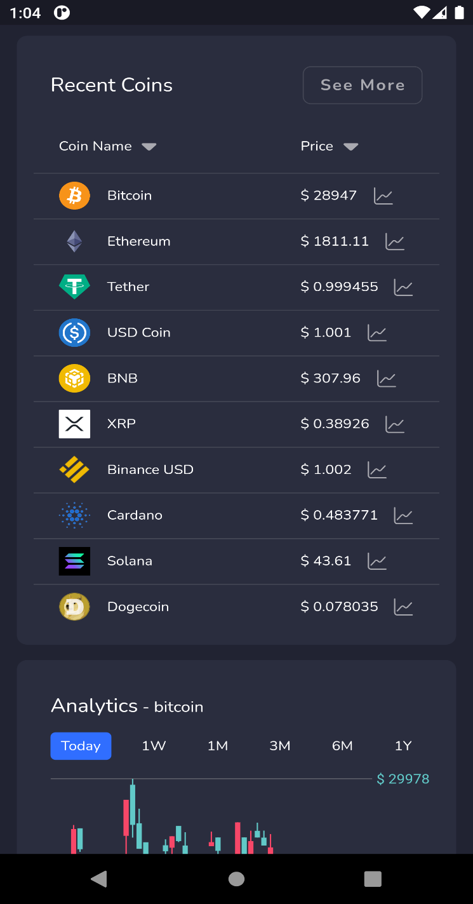

# **Analytics**

# User can see the candle stick graph for the analytics of the selected coin.

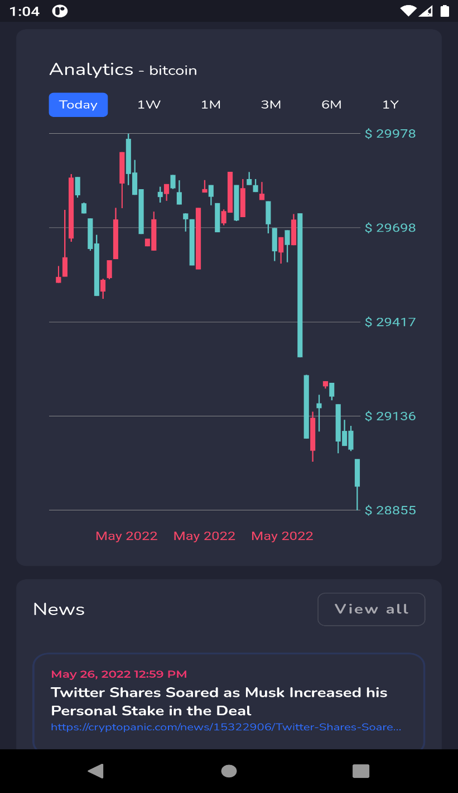

# **Crypto News**

# Here user can see news related to crypto currency and make decisions to invest or not.

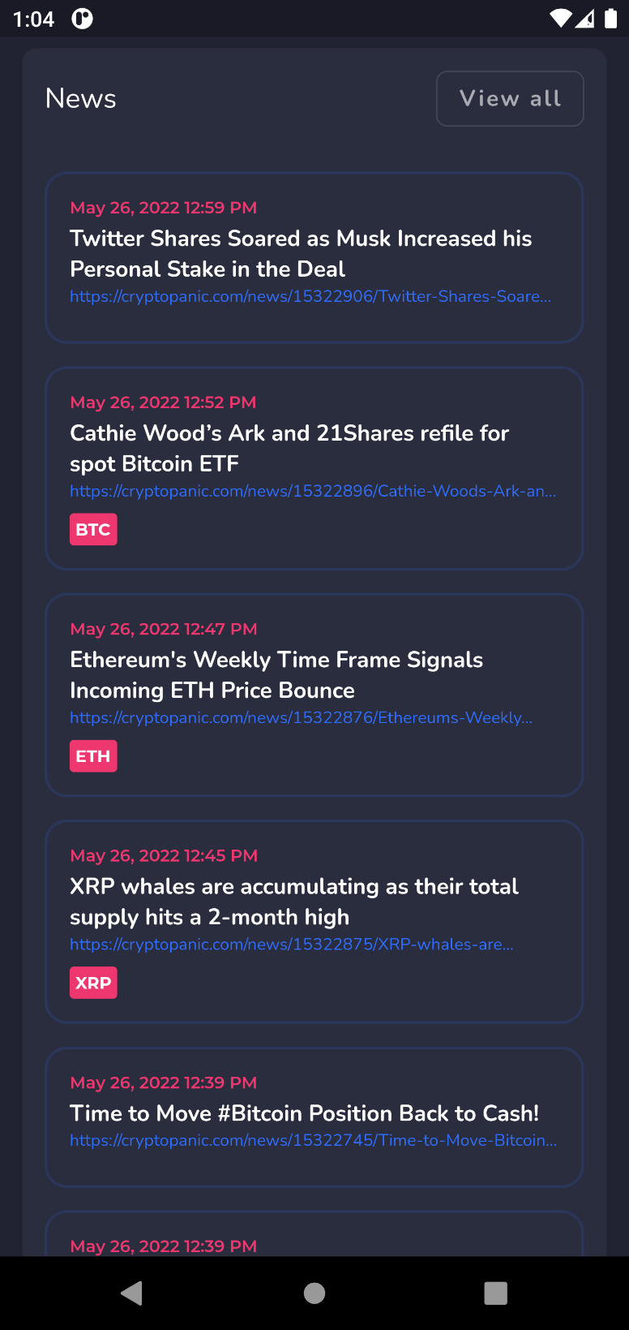

# **Coin Info**

# Here user can see all the coin information and increase and decrease in their prices in the form of portages in the last 24 hours.

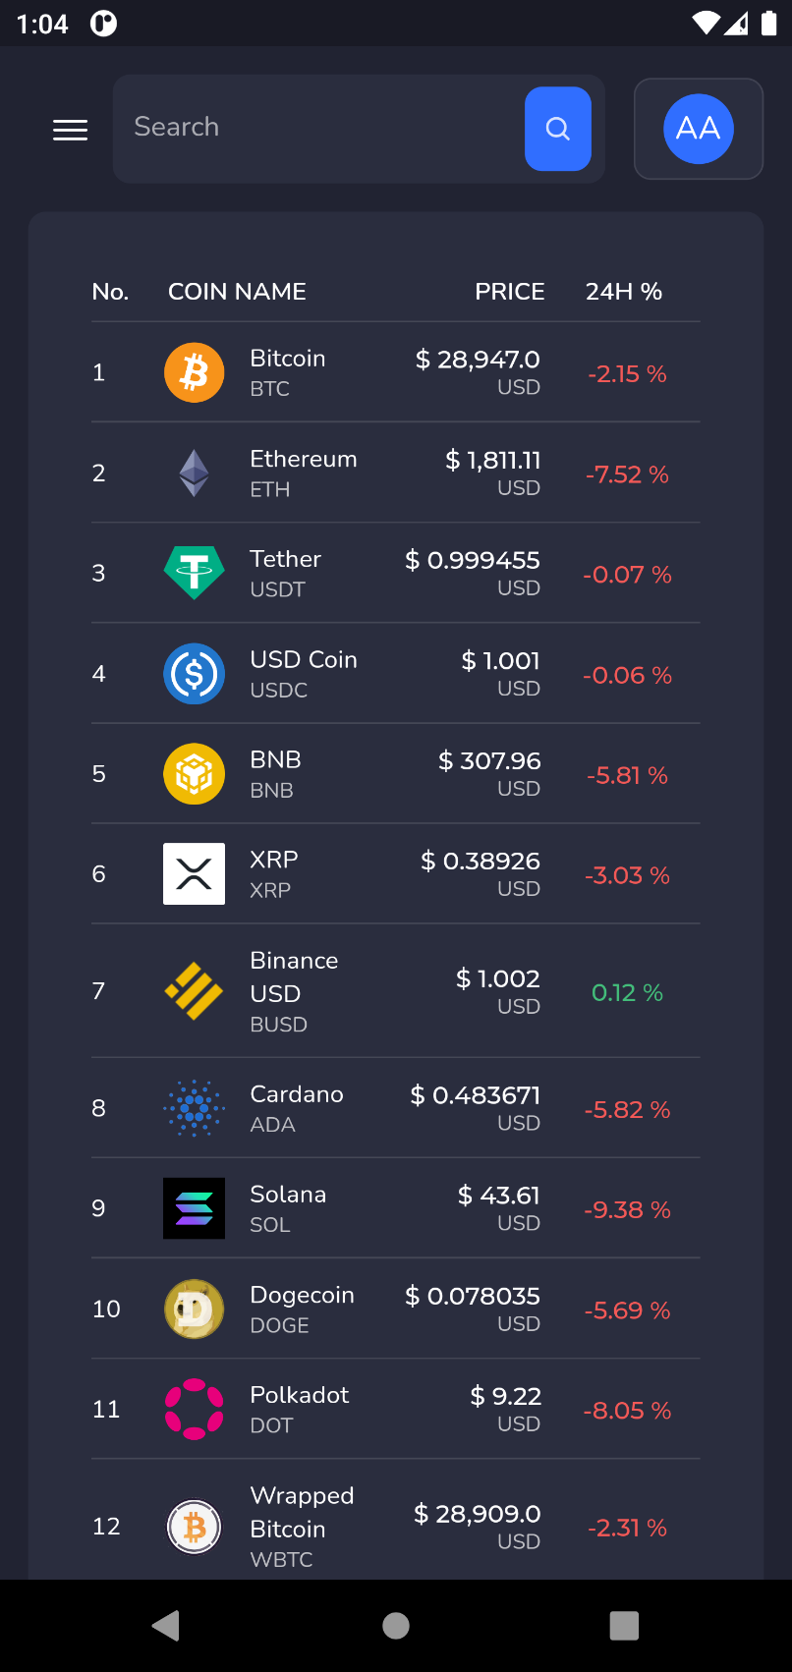

# **Kid Mode**

# Here user can the in the kid mode the normal analytics graph which is easy for analysis and take decision to invest.

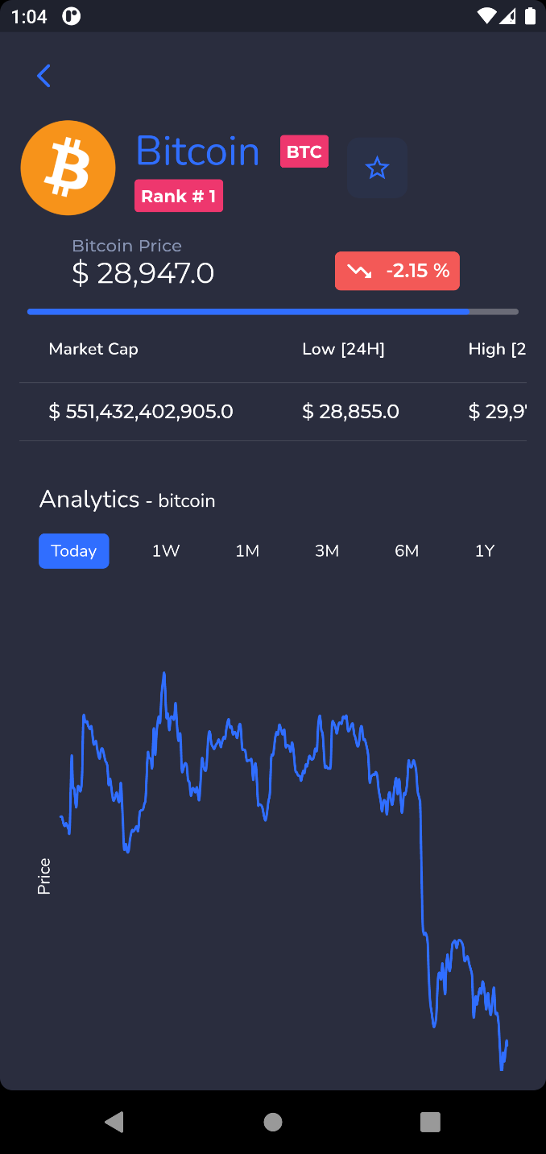

# **About Coin**

Here the user will get the information about the coin with its statistics which would make easy for the user to take decision to trade.

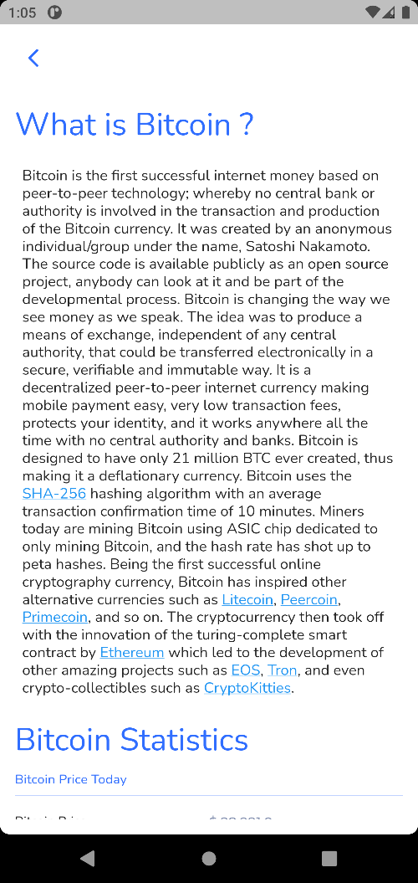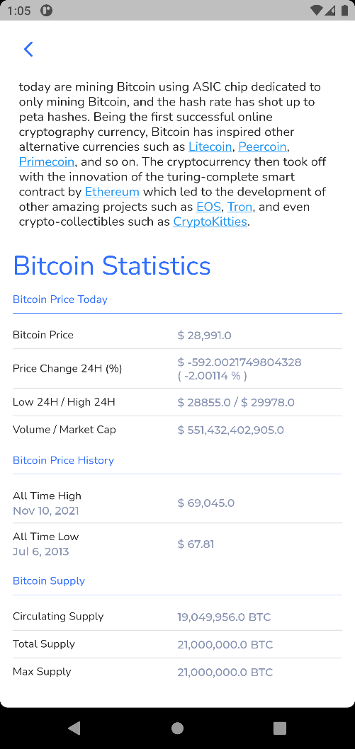-

# **Troubleshoot and support**

For any further questions or issues, you can contact the CRYPTONEX official coordinator Sharjeel Ghauri,

[**sharjeelghauri.99@gmail.com**](mailto:sharjeelghauri.99@gmail.com)

The official CRYPTONEX support page can be found here:

**https://www.facebook.com/Cryptonex-103007955773796**