Tutorial 1: Problems based on Graphs and Trees.
- Use paths either to show that these graphs are not isomorphic or to find an isomorphism between them
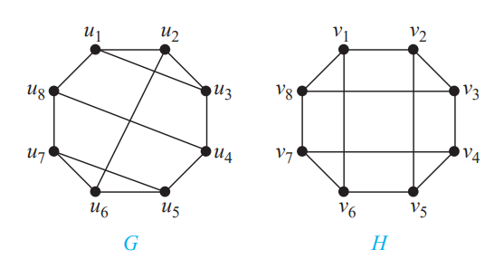
- How many vertices does a regular graph of degree four with 10 edges have?
- Let Kn denote the complete graph on n vertices, with n≥3, and let u, v, w be three distinct vertices of Kn. Determine the number of distinct paths from u to v that do not contain the vertex w.
- Determine whether the picture shown can be drawn with a pencil in a continuous motion without lifting the pencil or retracing part of the picture.

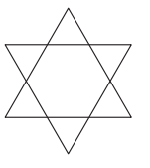 | 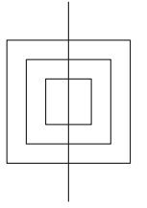

- A chain letter starts when a person sends a letter to five others. Each person who receives the letter either sends it to five other people who have never received it or does not send it to anyone. Suppose that 10,000 people send out the letter before the chain ends and that no one receives more than one letter. How many people receive the letter, and how many do not send it out?
- Find the least number of comparisons needed to sort five elements and devise an algorithm that sorts these elements using this number of comparisons.
- Construct a binary tree using following traversals.
Inorder: [40, 20, 50, 10, 60, 30]
Preorder: [10, 20, 40, 50, 30, 60]
- Define:
- Complete Graph
- Connected graph
- Bipartitie graph
- Regular graph

