Django – Environment Setup and Creating a Project
Django is a high-level, open-source web framework written in Python that helps developers build secure, scalable, and maintainable web applications quickly.
It follows the MTV architecture:
- Model → Database structure
- Template → Frontend (HTML/CSS)
- View → Business logic (acts like controller)
Django follows the philosophy: “Don’t Repeat Yourself (DRY)”
1. Prerequisites (System Requirements)
Before installing Django, ensure the following are properly configured:
1.1 Operating System
- Windows 10/11
- macOS
- Linux (Ubuntu recommended)
1.2 Python Installation
Django requires Python 3.10+ (3.11 or 3.12 preferred for stability).
Verify Python Installation
python --version
or
python3 --version
If not installed:
- Download from https://python.org
- Ensure “Add Python to PATH” is checked (Windows).

2. Virtual Environment Setup (Critical for Professional Development)
Never install Django globally in production-level development. Use isolated environments.

2.1 Create Project Directory
mkdir myproject
cd myproject

2.2 Create Virtual Environment
python -m venv venv
This creates:
myproject/
│
└── venv/

2.3 Activate Virtual Environment
Windows
venv\Scripts\activate
macOS/Linux
source venv/bin/activate
If successful, terminal changes to:
(venv) C:\myproject>

2.4 Upgrade pip
pip install --upgrade pip

3. Installing Django
Inside the activated virtual environment:
pip install django
Verify installation:
django-admin --version

4. Creating a Django Project

4.1 Create Project
django-admin startproject core .
⚠ The dot (.) means create project inside current directory.

4.2 Project Structure Explanation
After creation:
myproject/
│
├── manage.py
├── core/
│ ├── __init__.py
│ ├── asgi.py
│ ├── settings.py
│ ├── urls.py
│ └── wsgi.py
└── venv/

5. Deep Breakdown of Each File

5.1 manage.py
Entry point for:
- Running server
- Migrations
- App creation
- Database operations
Example usage:
python manage.py runserver

5.2 settings.py
This is the configuration engine.
Major sections:
INSTALLED_APPS
Registers apps used in the project.
MIDDLEWARE
Handles request-response processing pipeline.
DATABASES
Default database configuration (SQLite by default).
TEMPLATES
Template engine configuration.
STATIC_URL
Static file serving configuration.

5.3 urls.py
Main URL router.
Example default:
from django.contrib import admin
from django.urls import path

urlpatterns = [
path('admin/', admin.site.urls),
]

5.4 wsgi.py & asgi.py
Used for deployment:
- WSGI → Traditional web servers (Gunicorn)
- ASGI → Async servers (Uvicorn, Daphne)

6. Running the Development Server
python manage.py runserver
Output:
Starting development server at http://127.0.0.1:8000/
Open in browser:
http://127.0.0.1:8000/
You will see Django welcome page.

7. Creating a Django App
A project can contain multiple apps.

7.1 Create App
python manage.py startapp users
Structure:
users/
├── migrations/
├── __init__.py
├── admin.py
├── apps.py
├── models.py
├── tests.py
└── views.py

7.2 Register App
Add to settings.py:
INSTALLED_APPS = [
...
'users',
]

8. Database Configuration
Default database:
DATABASES = {
'default': {
'ENGINE': 'django.db.backends.sqlite3',
'NAME': BASE_DIR / 'db.sqlite3',
}
}

8.1 Apply Initial Migrations
python manage.py migrate
This creates system tables:
- auth
- admin
- sessions
- contenttypes

9. Creating Superuser
python manage.py createsuperuser
Provide:
- Username
- Email
- Password
Access admin panel:
http://127.0.0.1:8000/admin/

10. Django Project Workflow Architecture
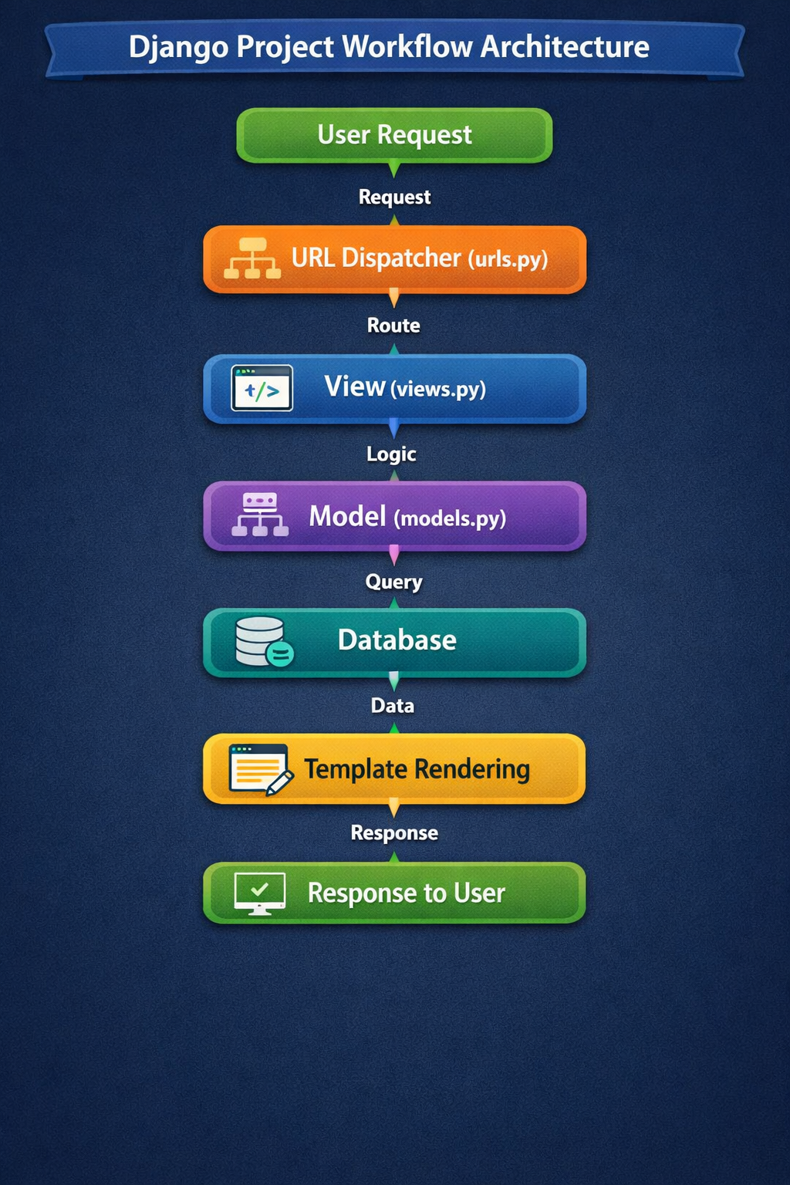

11. Recommended Production-Ready Project Structure
For scalable architecture:
project/
│
├── core/ # Main config
├── apps/
│ ├── users/
│ ├── dashboard/
│ └── api/
│
├── static/
├── templates/
├── media/
├── .env
├── requirements.txt
└── manage.py

12. Environment Variables Setup (Professional Setup)
Install dotenv:
pip install python-dotenv
Create .env file:
SECRET_KEY=your-secret-key
DEBUG=True
DATABASE_URL=postgres://...
In settings.py:
import os
from dotenv import load_dotenv

load_dotenv()

SECRET_KEY = os.getenv("SECRET_KEY")

13. Freeze Dependencies
pip freeze > requirements.txt

14. Typical Development Workflow
- Create virtual environment
- Install Django
- Create project
- Create apps
- Define models
- Run migrations
- Create views
- Map URLs
- Create templates
- Test locally
- Push to Git
- Deploy

15. Common Errors & Debugging
Error: django-admin not recognized
→ Python not added to PATH
Error: No module named django
→ Virtual environment not activated
Error: Port already in use
python manage.py runserver 8001

16. Best Practices for Clean Setup
- Always use virtual environments
- Use separate apps for modularity
- Keep business logic out of views
- Use class-based views when appropriate
- Keep settings separated for dev & prod
- Never commit .env file

17. Version Control Setup
git init
Create .gitignore:
venv/
__pycache__/
db.sqlite3
.env

18. Summary Workflow
Install Python
→ Create Virtual Environment
→ Install Django
→ Start Project
→ Create App
→ Configure Settings
→ Run Migrations
→ Create Superuser
→ Start Development

