

“PROJECT: [J.A.R.V.I.S. A STEP TOWARDS AUTOMATION”](http://en.wikipedia.org/wiki/Colpitts_oscillator)



# By

# Ankit Kumar Srivastava CSE-1809710016

A Project submitted to the Computer Science Department

In partial fulfillment of the requirements for the degree of B.Tech (COMPUTER SCIENCE ENGINEERING)

Faculty of Engineering Galgotias College of Engineering and Technology

Greater Noida

# ABSTRACT

This is the report of my fourth semester final project of the Python lab .This report will give the reader an overview about the steps which are involved in the making of my automation project JARVIS with the help of Python modules. The project is about the making of automated chatbot which will perform the task given by the voice command. In modeling the project, various python modules are used for web scrapping voice command to text conversion etc. Firstly, the program starts with salutation to the user asking his name. Then it will implement a few of the asked stuffs from the user in the form of sound. Using a mic would be an appropriate mode of addressing Jarvis and a quite environment would suite it for a sweet communication. For making the web scrapping stuff out of the web pages, BeautifulSoup, webbrowser, and Selenium module of python has been used. Pyttsx3 module for speech-rendering and recognition is used.

The very special feature of my project is corona virus notification system which I have made by scrapping off the page of info of Ministry of health and family welfare (government of India).

**Table of Contents**

Chapter 1…………………………………...

INTRODUCTION

Jarvis

Overview

* 1. Purpose of the project
  2. Applications of the Project
  3. Summary :

Chapter 2

LITERATURE REVIEW

* 1. Related Technologies 
     1. Special modules available
  2. Related Projects

Developer side view

* 1. Related Studies
  2. Summary:

Chapter 3

TOOLS AND TECHNIQUES

* 1. Software used with technical specifications 
     + IDLE(the editor for python) and its versatile use…………………..
     + pip and its command line specialty ..
     + Modules the tools that inspire……………………………………....
     + Pyttsx3……………….. ..
     1. BeautifulSoup
     2. Selenium
     3. Web browser module

Fun with automation : …………………….............................................

* 1. Summary:

Chapter 4

METHODOLOGIES

* 1. Design of the Algorithms
  2. Analysis procedures
  3. Implementation procedure 
     1. Details about hardware
     2. Details about software/ algorithms
  4. Verification of functionalities
  5. Details about simulation :
  6. Summary:

Chapter 5

RESULTS AND ANALYSIS

* 1. Presentation of the findings 
     1. Software results
  2. Discussion of the findings 
     1. Comparison with initial GOAL
  3. Recommendations

Summary:

Chapter 6

CONCLUSION

REFERENCES

Chapter 1

## INTRODUCTION

## 

## Jarvis the automation Chatbot:

Jarvis is a discrete Chatbot that completes the command specified by the user as per the coded information. Combination of web-scrapping modules help it to obtain information from the internet easily and pyttsx3 module helps to convey the information through Microsoft assistant voices. You may talk to it. My Jarvis is a female Chatbot which replies to all kinds of queries asked like time, news, weather-report, etc. During the pandemic period the very feature which makes it really special is its corona virus alert about a few states. Just say ‘coronavirus’ on the console screen to get the relevant info about the states. At the end with zero feeling of love at all Jarvis is really good at implement the tasks without any payback.

## Overview:

Jarvis takes a voice input, processes it, and produces the desired output as per the source code. This project gives the exact feeling of using iron man’s helping command chatbot. It does makes the work as simple as possible.

# User Interface of Jarvis:

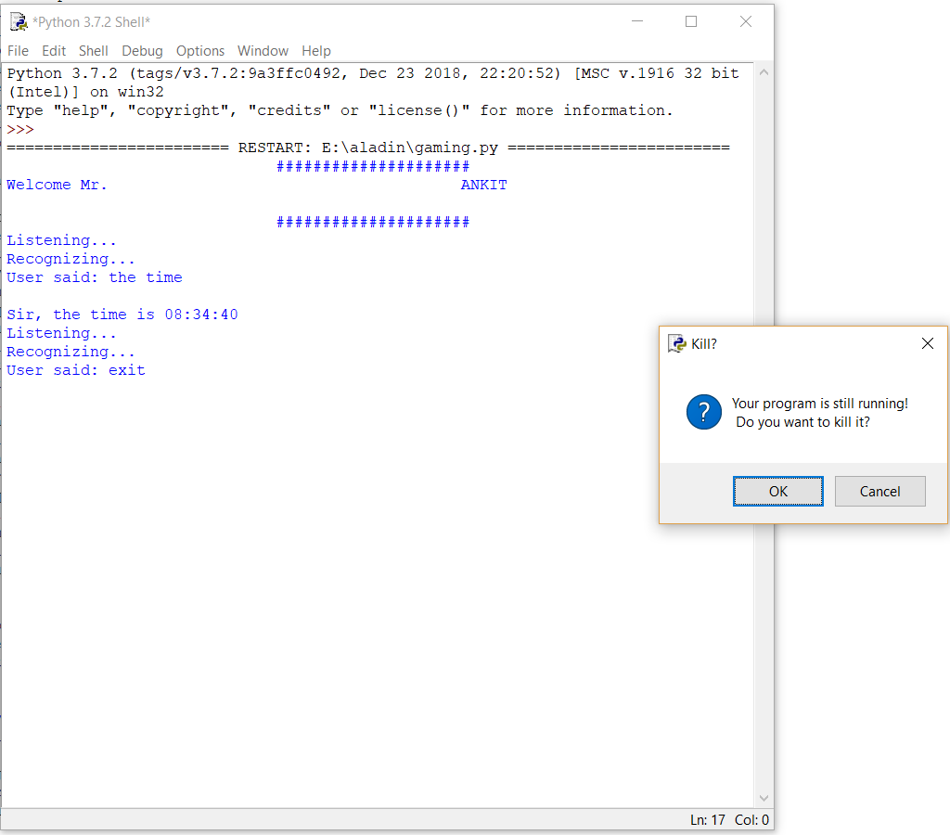

## Purpose of the project:

The purpose of the project is to check that how automation can really work out as a helping hand in the field of technology. Its purpose is just to study flow of control of various modules of python work and to integrate them to produce useful results.

## Applications of the Project:

Leaving all the fun stuff apart the very useful feature of the project is the corona virus detection notification system which keeps us update throughout the pandemic season.

## Summary:

In this chapter I explained about the project and the modules which were used in the making of project and the applications of this project and the theory of project and little introduction about the attractive user interface that was used in this project. Also explained about the special feature of the project . As the Jarvis is basically a chatbot it takes voice input from the master and responds as per the query. A microphone would be better for the same.

# Chapter 2 LITERATURE REVIEW

## Related Technologies.

* + 1. **Artificial intelligence:**

Artificial intelligence is the most growing field in the current era. It is the intelligence demonstrated the machines which they gain through experience. The neural networks specially help them to develop this intelligence. Python now a days provides a nice platform to communicate with the machines and make them to perform the required task. Its inbuilt as well as third party modules are very helpful in making useful projects at the industry level. I have demonstrated a small gist of the power of Python programming language through this project which made me to understand its third party modules nicely.

## Related Projects:

**Gmail & SMTP:**

I made a project recently which just sends a mail to the required recipient using python. It involved Simple Mail Transfer Protocol controlled by requests sent by python’s request module. The security of Gmail system is really tough to crack but in order to send the email through request module of python we have to lower the security level of the sender but not the recipient.

It is in one of those functionalities which I have added in my Jarvis program.

**Pyttsx3 and pandemic season:**

The hard days of pandemic season led me to think of this stuff. I thought of making a corona virus alert notification system which would inform us the ongoing status of a few of the states. For that I researched a bit on YouTube and googled a few stuffs. I came to know about the pyautogui module which would automate this for me and hence I made my way to the program.

## Related Studies:

There are different books and different websites to get maximum application of this project and got number of application. Specifically I pursued the Automate the boring stuff with Python textbook and its lectures on Udemy to get more information about various modules. The YouTube channel code with harry also helped me a lot to make it upto the point.

## Summary:

In this chapter the relative study about the project and relative structure of Jarvis was explained. Main modules discovered by me for my project has been discussed a bit and the idea of the project has been highlighted. It would surely give a gist of what is happening in the project.

# Chapter 3

**TOOLS AND TECHNIQUES**

## Software used with technical specifications:

* + - **Python(IDLE for programming stuff)**
    - **Various helping, API, speech-recognition and web-scrapping modules**
    - **Other third-party modules**
    1. **Python(IDLE):**

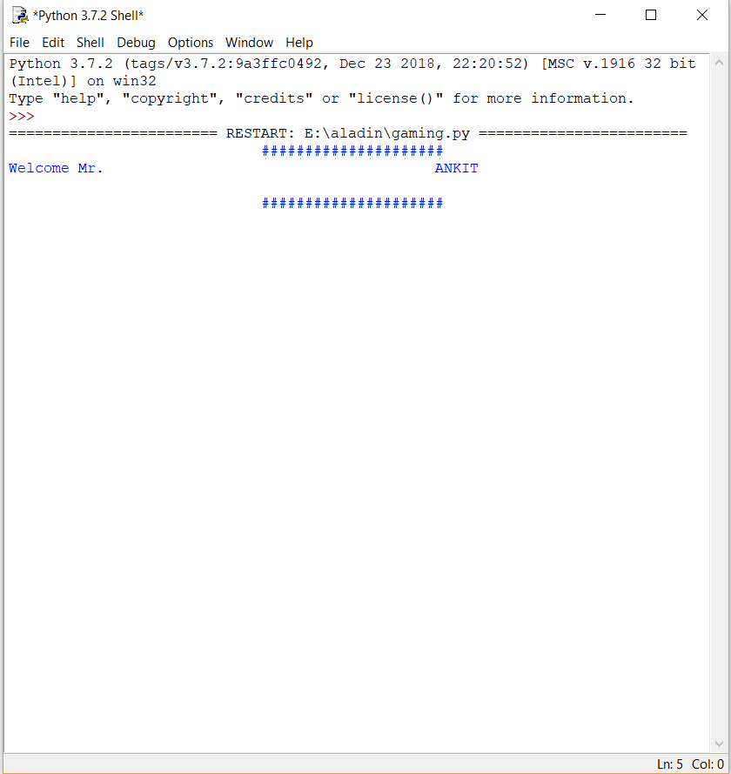

IDLE is Python’s Integrated Development and Learning Environment.

IDLE has the following features:

* coded in 100% pure Python, using the tkinter GUI toolkit
* cross-platform: works mostly the same on Windows, Unix, and macOS
* Python shell window (interactive interpreter) with colorizing of code input, output, and error messages
* multi-window text editor with multiple undo, Python colorizing, smart indent, call tips, auto completion, and other features
* search within any window, replace within editor windows, and search through multiple files (grep)
* debugger with persistent breakpoints, stepping, and viewing of global and local namespaces
* configuration, browsers, and other dialogs

## Various python modules involved:

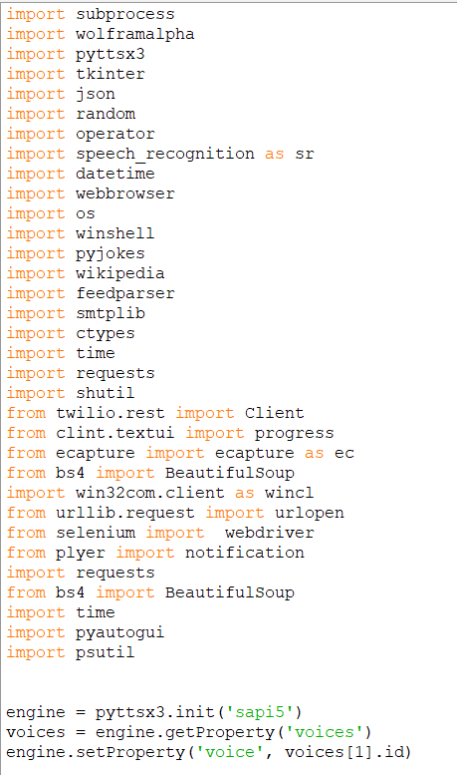

* + 1. **Main Modules involved:**

Python is a suitable language for script writers and developers. The script for Voice Assistant using Python can be written using various modules of python for automating user’s need. The query for the assistant can be manipulated as per the user’s need.

Speech recognition is the process of converting audio into text. This is commonly used in voice assistants like Alexa, Siri, etc. Python provides an API called speech_Recognition to allow us to convert audio into text for further processing. In this article, we will look at converting large or long audio files into text using the speech_Recognition  API  in python.



* **Subprocess:-** This module is used for getting system subprocess details which are used in various commands i.e Shutdown, Sleep, etc. This module comes buit-in with Python.
* **Wolframalpha:-** It is used to compute expert-level answers using Wolfram’s algorithms, knowledgebase and AI technology. To install this module type the below command in the terminal.
* **Pyttsx3:-** This module is used for conversion of text to speech in a program it works offline. To install this module type the below command in the terminal.
* **Tkinter:-** This module is used for building GUI and comes inbuit with Python. This module comes buit-in with Python.
* **Wikipedia:-** As we all know Wikipedia is a great source of knowledge just like GeeksforGeeks we have used Wikipedia module to get information from Wikipedia or to perform Wikipedia search. To install this module type the below command in the terminal.

**Speech Recognition:-** Since I am building an Application of voice assistant, one of the most important things in this is that your assistant recognizes your voice (means what you want to say/ ask). To install this module type the below command in the terminal.

* **Web browser:-** To perform Web Search. This module comes buit-in with Python.
* **ES capture:-** To capture images from your Camera. To install this module type the below command in the terminal.
* **Pyjokes:-** Pyjokes is used for collection Python Jokes over the Internet. To install this module type the below command in the terminal.
* **Datetime:-** Date and Time is used to showing Date and Time. This module comes built-int with Python.
* **Twilio:-** Twilio is used for making call and messages. To install this module type the below command in the terminal.
* **Requests:** Requests is used for making GET and POST requests. To install this module type the below command in the terminal.
* **BeautifulSoup:** Beautiful Soup is a library that makes it easy to scrape information from web pages. To install this module type the below command in the terminal.



**FOR EXAMPLE : -**



# “IF THE MODULE IS PREINSTALLED IT WILL SHOW UP THE REQUIREMENT ALREADY SATISFIED”.

# API’s Used:

An**API**is a set of programming code that enables data transmission between one software product and another. It also contains the terms of this data exchange.

Application programming interfaces consist of two components:

* Technical specification describing the data exchange options between solutions with the specification done in the form of a request for processing and data delivery protocols.
* Software interface written to the specification that represents it.

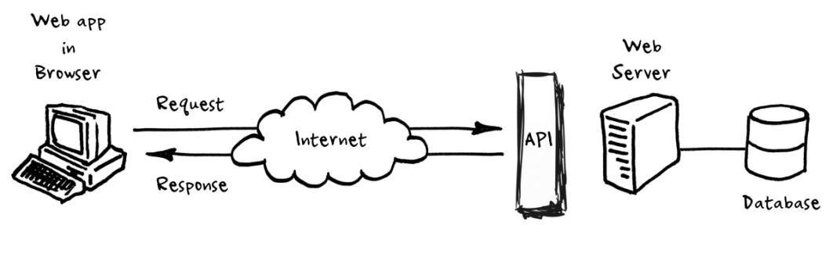

Wolfram API has been used to perform simple calculations as specified by the end user.

The times of India API has been used to extract the latest Indian news using web scrapping modules.

Google maps API has been used in order to locate the specified location.

**NOTE**:-- The user has to register on the required website and has to specify the use of the API being genetrated. A few of the API are free to use but most of them are paid and require subscription.

# pip:

pip is useful software for installing the third party software in your windows PC.pip is de facto standard package-management system used to install and manage software packaes written in Python.[[4]](https://en.wikipedia.org/wiki/Pip_(package_manager)#cite_note-rhos-pip-4) Many packages can be found in the default source for packages and their dependencies Python Package Index (PyPI).

One major advantage of pip is the ease of its command-line interface, which makes installing Python software packages as easy as issuing a command:

pip install some-package-name

Users can also easily remove the package:

pip uninstall some-package-name

# Summary:

The details of tools used in this project are explained in this chapter. The tools are able to make this project perfect and the API’s are also given in this chapter that were used in project. These tools help for efficient output of the program. The IDLE output shell can be used to see the output of the program. The API used really makes the task easy for Jarvis to redirect the end used to its results. The program has not been converted to a .exe file and hence has to be run from the console itself. Extra GUI can be added as per the necessity.

# Chapter 4 METHODOLOGIES

## Design of the investigation/Algorithms/ Software:

Basically the input command is provided in the form of user voice (microphone can be used for better responses). There is the beginning of the program with the JARVIS introducing itself with a proper salutation of morning, afternoon and night. After that flow of control goes along the elif ladder considering the part of code which has been requested by the end user. Some of the important algorithms used in implementation of the important features are:-

1. Use of try and exception handlers for special errors.

2. JSON format web scrapping which involves extraction of received data as per the requirement and display them in a particular manner.

3. Use of special modules to retrieve the required data off the python shell.

Hence I can summarize my project overall a combination of voice recognition + web-scrapping + modules matter to carry out the work and make it look like the work has been automated by the Jarvis.

## Analysis procedures:

Hard and difficult process of the project is analysis of the project after making it a working software. As it is a simple python project with cross platform dependencies it will work on almost every provided operating system and CPU given the platform has the required modules for proper working of the software.

# Implementation procedure and features including mode of operations:

Here goes the implementation part of the program. The following are the main features of the program: -

* 1. Ask Jarvis about itself it would respond to it nicely.
  2. Ask Jarvis about a particular query to extract from Wikipedia and it would do so.
  3. Ask him to tell a joke and it would tell a funny programming joke.
  4. You may ask it to open YouTube, Google, stack overflow as these are the most frequent websites opened by a programmer as per the latest states of the google.
  5. Ask it to play music which is present in the default directory. If the directory has not been set then it would ask you to do so.
  6. You may ask him about the current time.
  7. Ask him to send an email by specifying the receiver as the sender has to be specified in the source code itself. For that it uses SMTP.
  8. You may ask Jarvis to calculate the stuff asked by the end user.
  9. You may make a random search on default web browser by saying search and the thing you want to search.
  10. You may ask Jarvis to tell the latest news which it would tell by using the times of India website API.
  11. You may ask him about the weather condition of a city by entering the name of the city.
  12. You may restart, hibernate, lock, shutdown, empty recycle bin by just saying those commands (power of automation through python).
  13. You may ask it to write a note for you or to take a screenshot as you wish.
  14. Ask funny questions like…will you be my gf…..what is love and it would response accordingly.
  15. At last but not the least during the hard times of corona it would extract the current information about a few states from the website of Ministry of health and family welfare and show them in the form of notifications using the third party plyer module.
  16. The corona virus alert system makes it really nice software for the pandemic which would give you updates of all the corona patients of a few states. The time threshold may be adjusted to get the notifications as per the requirements of the end user.

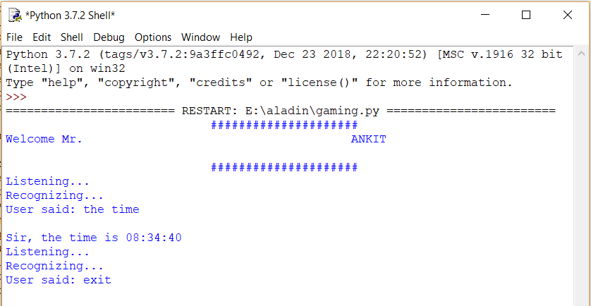

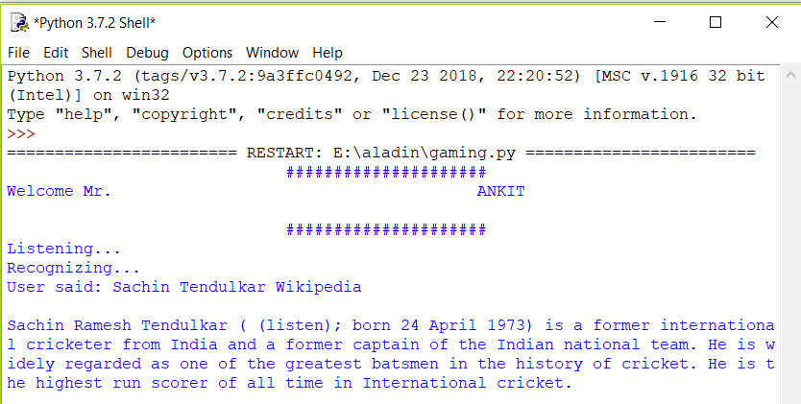

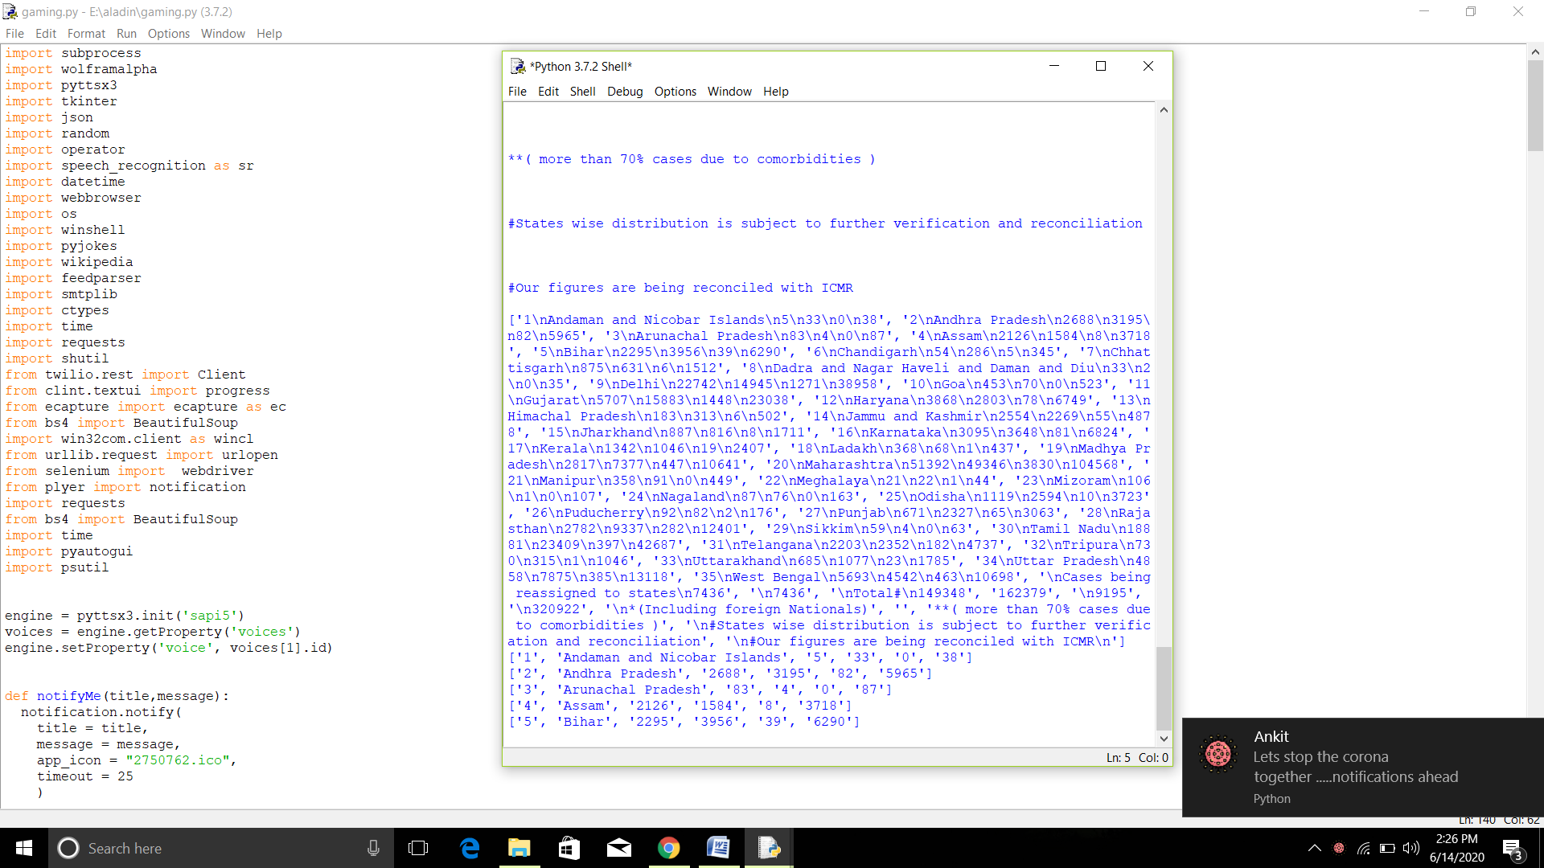

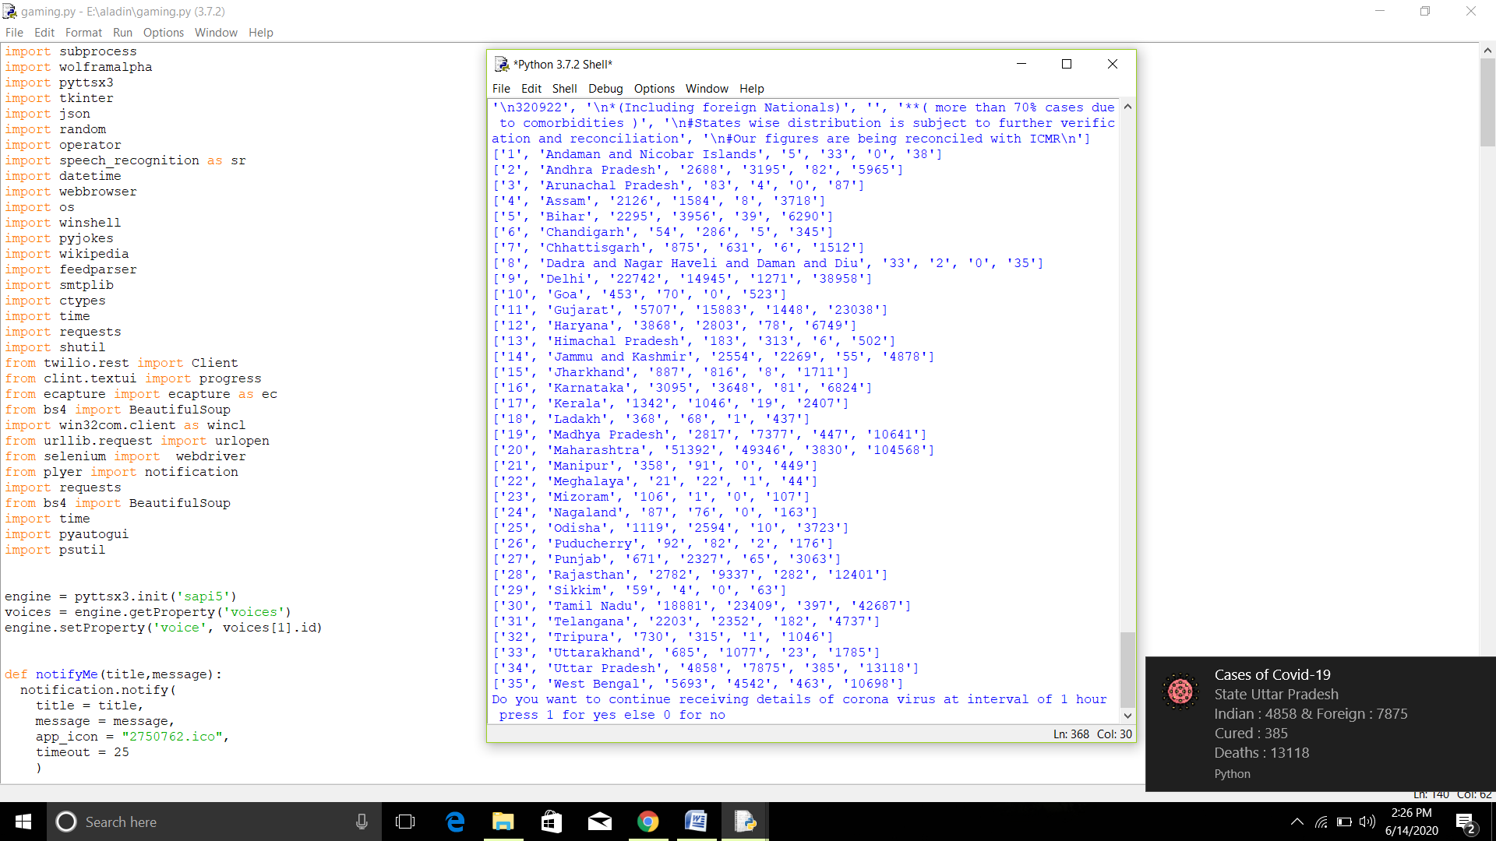

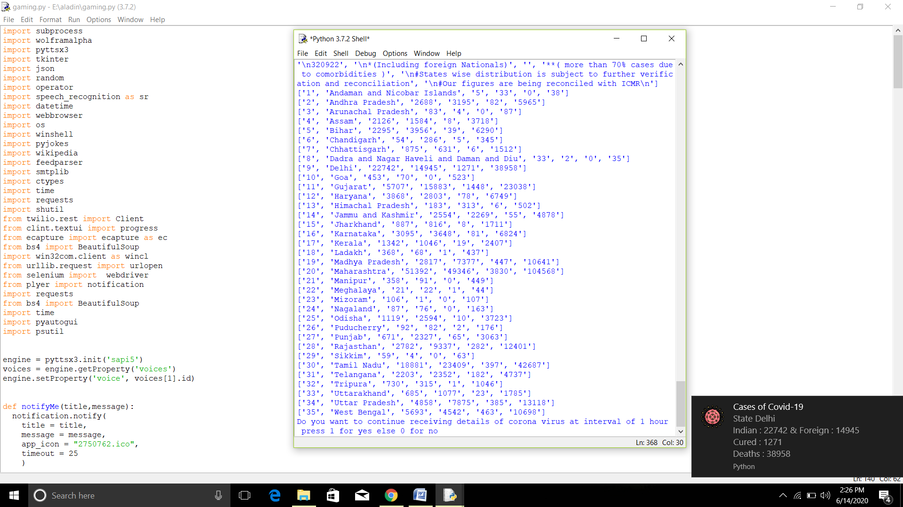

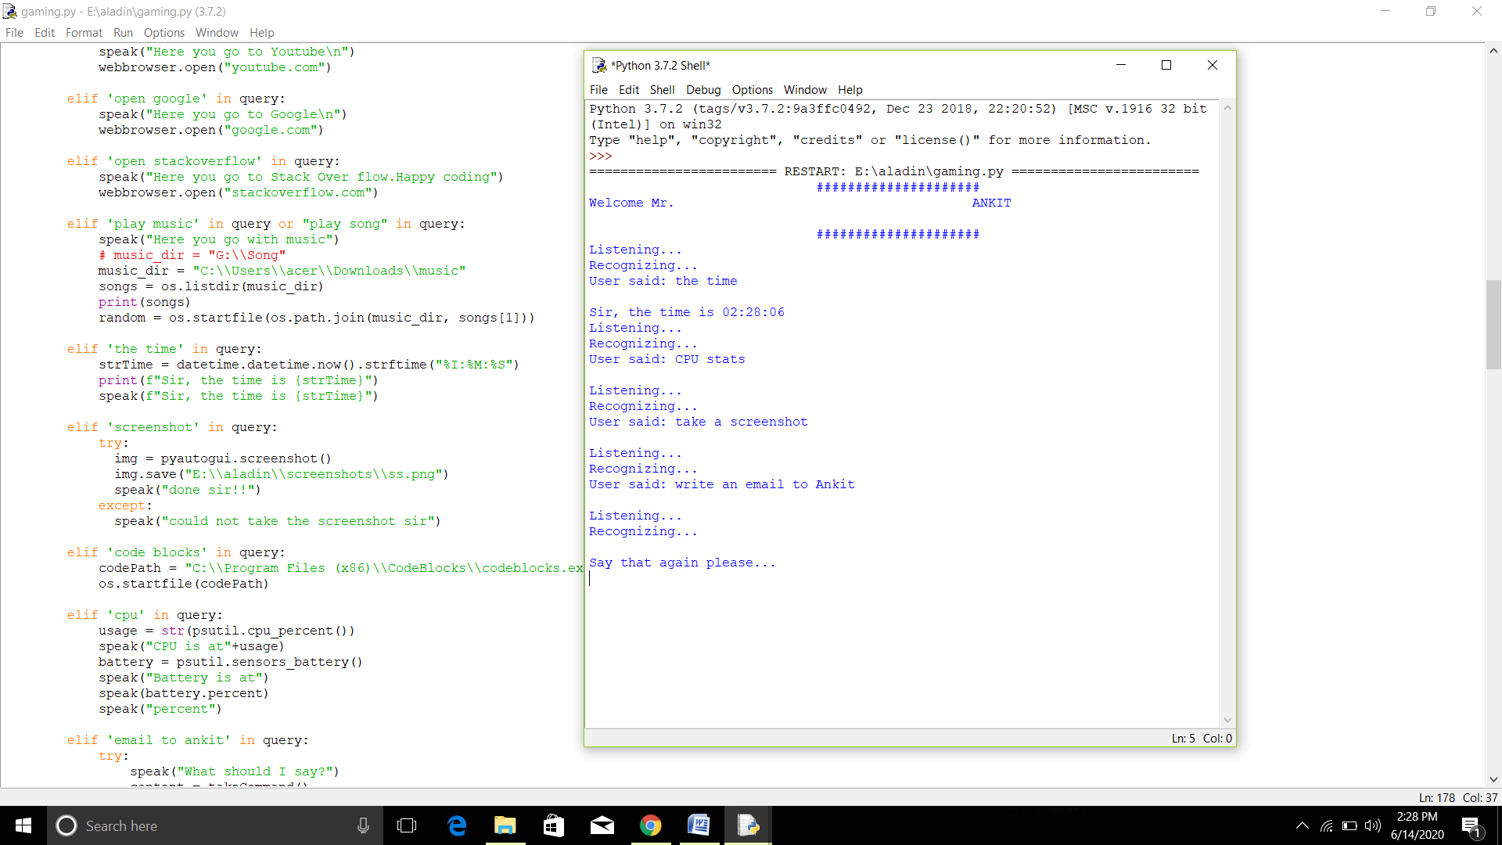

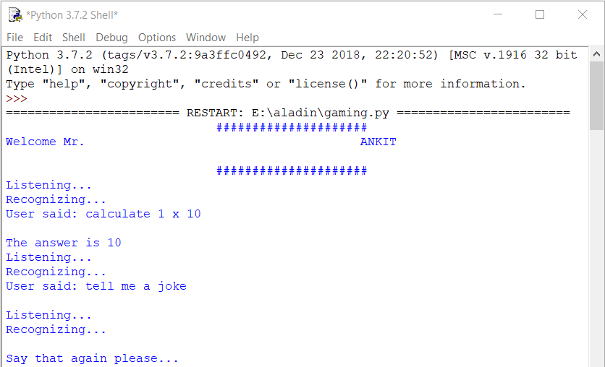

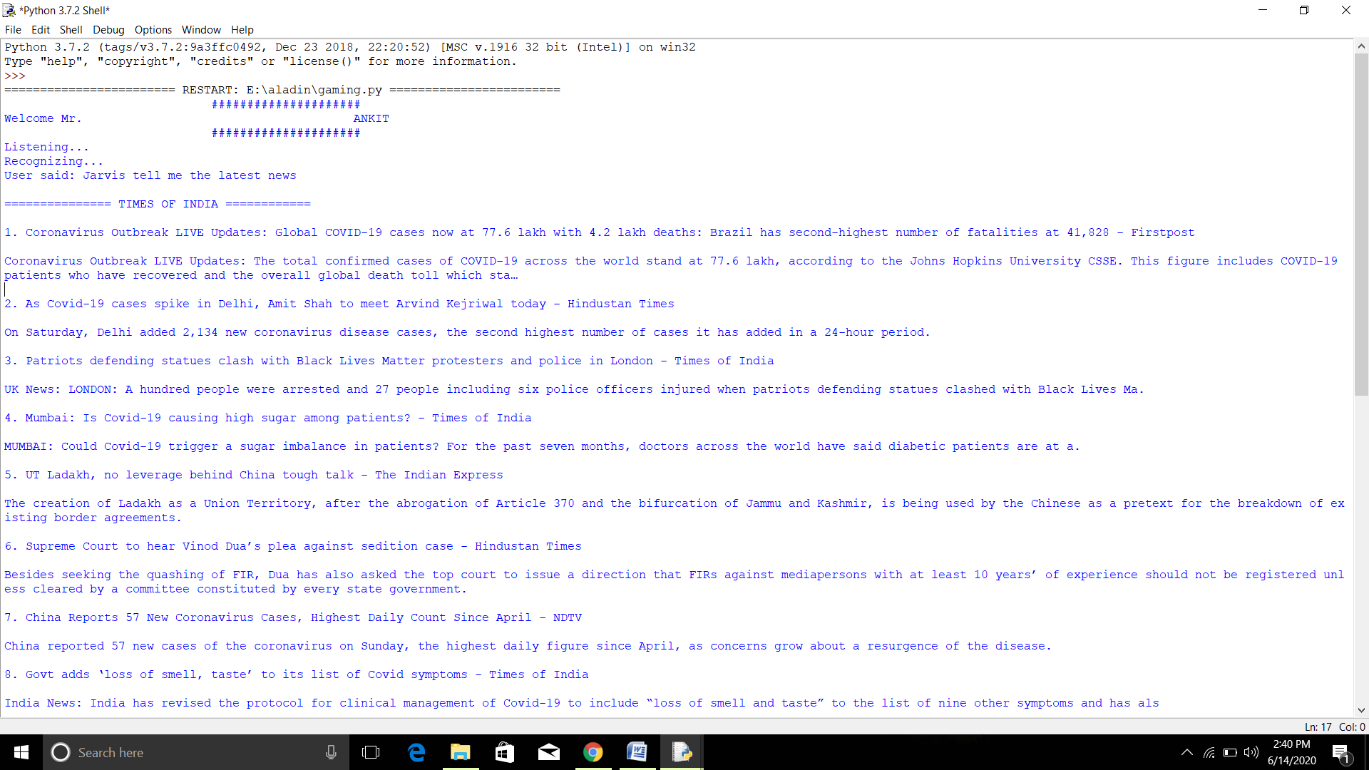

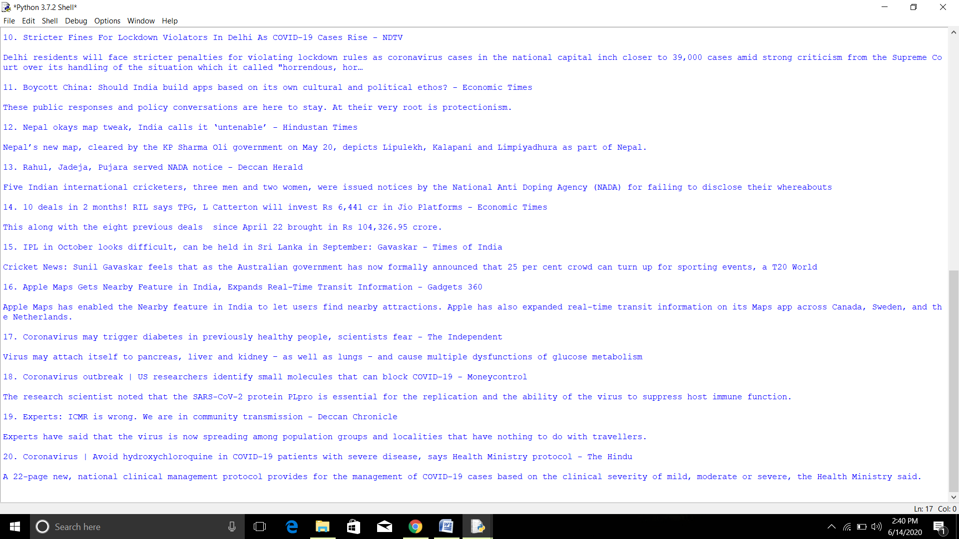

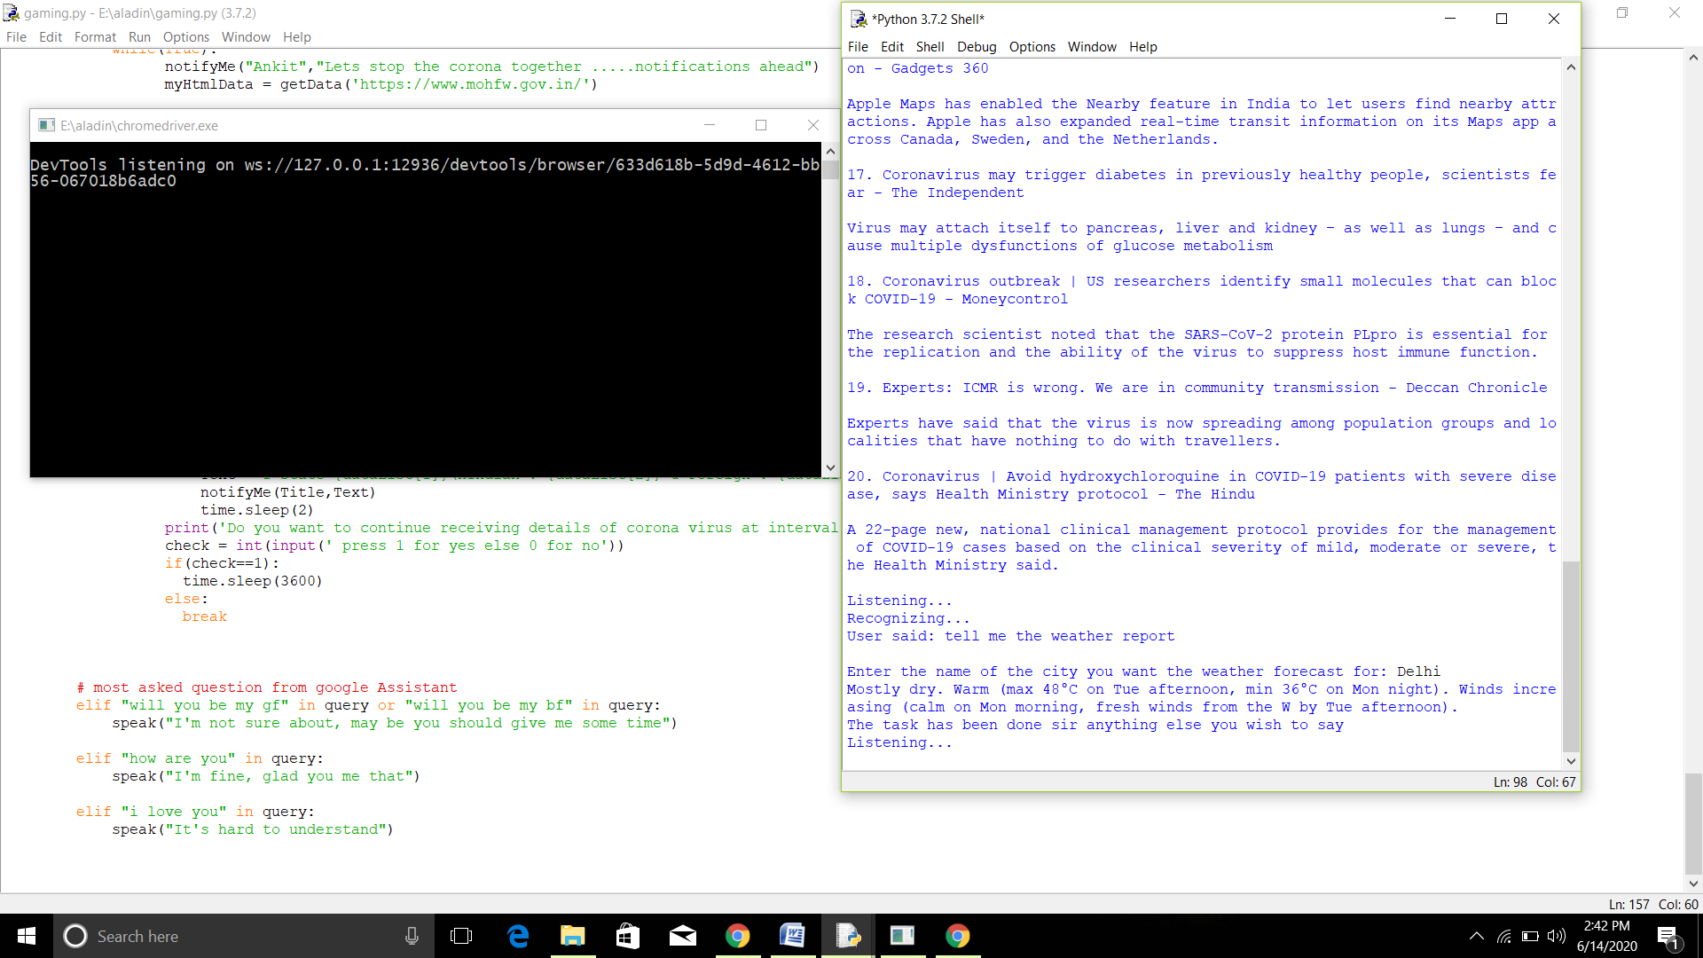

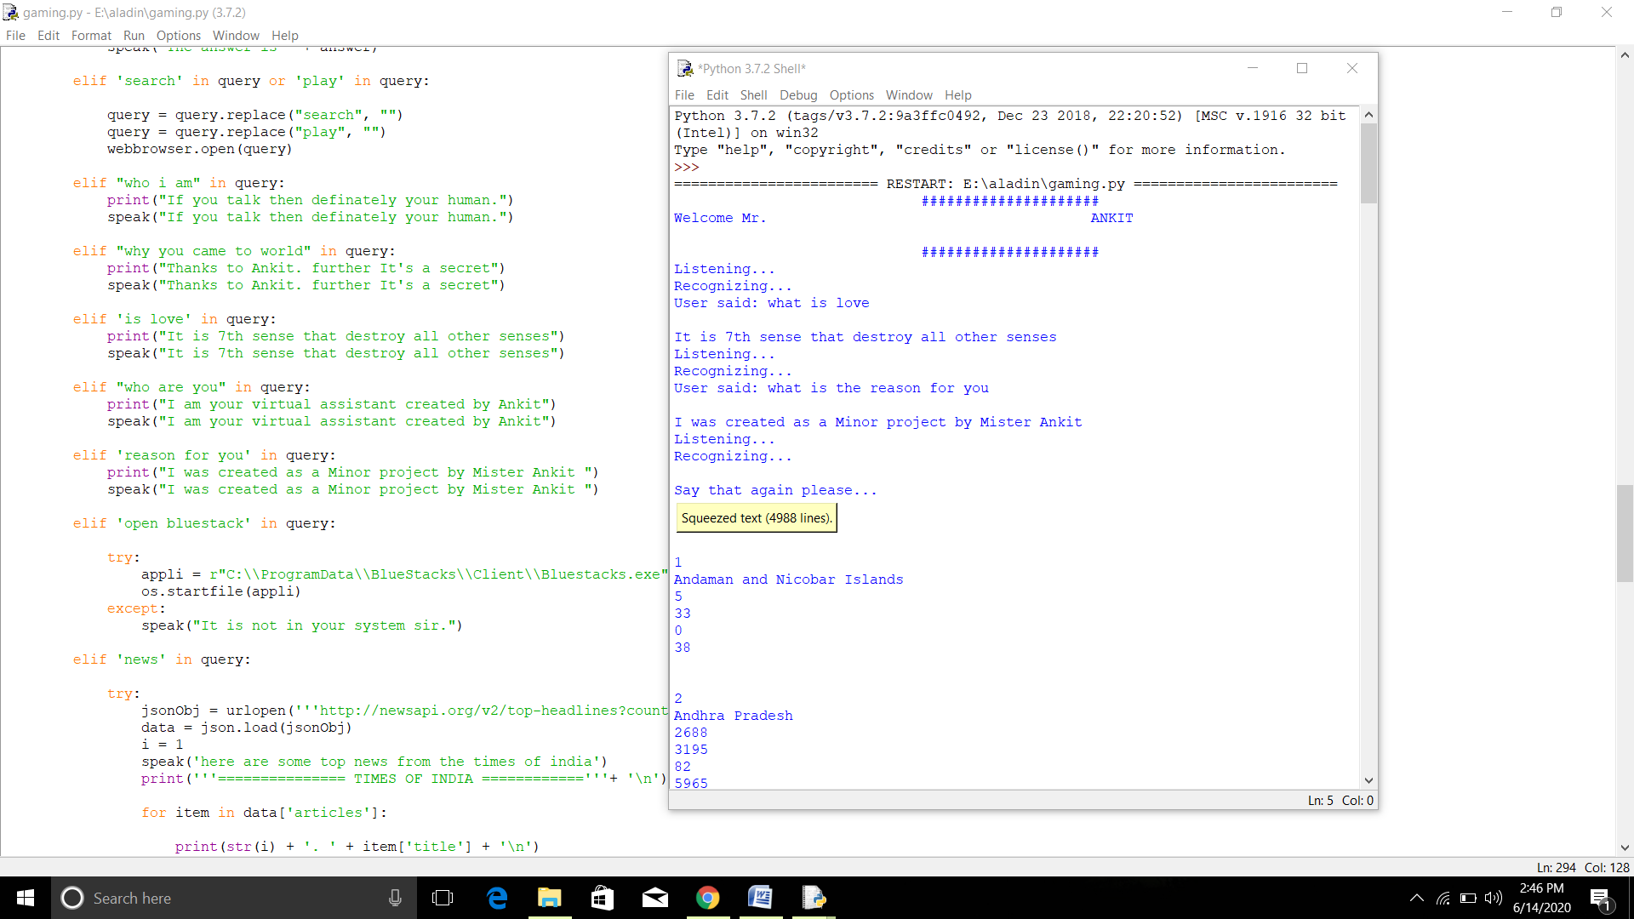

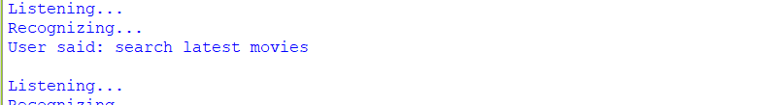



# Details about hardware:

Having a latest system with nice specs would be a good platform for the software but it may run on almost every system independent of the operating systems used. Given that the system should have the required modules for proper working of the software. Jarvis itself specifies its requirements.

# -: USE CASE DIAGRAM :-

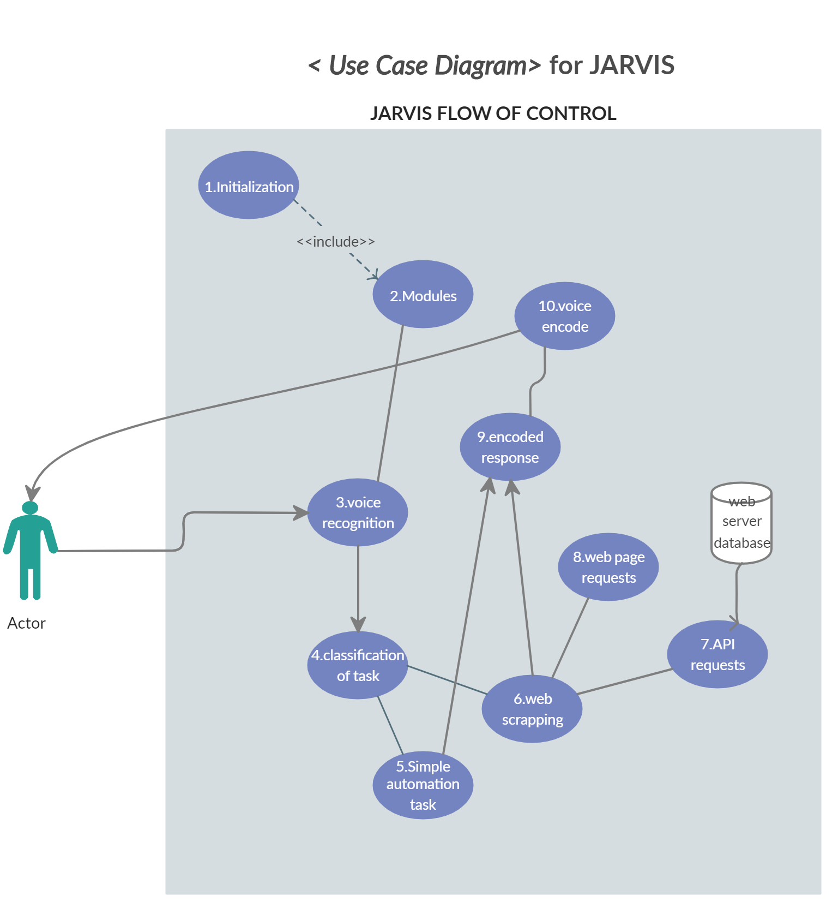

## 

# Summary:

In this chapter methodology of the project was explained. Complete analysis of modules and features of software that were used for this project and output analysis of the project based on the platform dependencies. The expression used for the output frequency across the inductor, which is the main part of the project. This chapter was about the analysis and the implementation of the project from the software to hardware and its complete methodology and its functionalities, verification and simulation and complete investigation.

# Chapter 5 RESULTS AND ANALYSIS

This chapter was explained the following result and the analysis of the circuit.

* Software Results
* JSON format Results.
* modules Results.

## Presentation of the findings:

* + 1. **Hardware results:**
       - For the nice user interface and smooth flow of control there should be a nice internet connection and third party modules installed.
       - Software is platform independent therefore it will run independent of the O.S. used.
    2. **Software results:**

As in the previous chapter explained about the software used in the making of this project there may be small technical glitch while interacting with Jarvis because of speech recognition module, slow internet connection and slow API response.

# Discussion of the findings:

Finding the result obtained from the program by analysis and try to find the error if it’s done.

Jarvis may give a small indication of errors while recognizing the speech but its web scrapping part with BeautifulSoup is the best part whose integration with internet gives a deadly combo.

* + 1. **Comparison with initial GOAL:**

Initially I thought of just making it a simple Chatbot which utilizes web scrapping very efficiently but with the help of Udemy instructor and Harry sir’s YouTube channel I got a lot of knowledge of automating my project and at the end I made far more features which were just a thought to me couple of years ago.

## Recommendations:

* + - * You may add some more features by learning new modules of Python.
      * Do have a look on the source code which would give you an inside depth of how the flow of control goes about.
      * At last but not the least have fun with you Chatbot automation friend Jarvis.

## 5.5 Summary:

This chapter is about the results and analysis of the program as the main overcome of the program and its output on the end user’s screen and also telling about the initial goal, comparison of hardware and software results and limitation and recommendation.

# Chapter 6

**CONCLUSION**

Jarvis is upto the expectation which I thought of ever. The main problem that was faced in this project was about getting the API keys from different websites and then using them in my webbrowser module to extract the useful data. With very hard work and right online mentorship on this project I am able to make it upto the point. Despite not being a member of devops I have done a lot of trials of the project in adding the source code and modifying stuffs to make it work properly. My udemy instructor is awesome who helped me and gave a drift to the project. Main problem is time issue and the time limit of the speech recognition but its threshold may be adjusted as per the require ment. Hence, I would like to conclude it was a good project to maintain the understanding of the python modules and a good read of Automate the boring stuff with python as well. I enjoyed a lot making this project. I hope the end user of the project would also enjoy it. Features of Jarvis are not limited to the ones I have created you may also add a feature to it and enjoy, I have attached my github profile link to make you reach to my source code , Happy coding :).

# REFERENCES

1. <https://www.codewithharry.com/>
2. [www.google.com](http://www.google.com/)
3. <https://www.mohfw.gov.in/#state-data>
4. <https://www.geeksforgeeks.org/python-programming-language/>
5. <https://www.udemy.com/course/learn-to-create-ai-assistant-jarvis-with-python/learn/lecture/19968996#overview>
6. <https://www.udemy.com/course/automate/learn/lecture/3547544?start=0#overview>
7. <https://www.crummy.com/software/BeautifulSoup/bs4/doc/>