
Shri Vile Parle Kelavani Mandal's
INSTITUTE OF TECHNOLOGY
DHULE (M.S.)
DEPARMENT OF COMPUTER ENGINEERING
Subject : Artificial Intelligence Lab |  |  | Remark
Name : Pushpak Sachin Deore |  | Roll No. : 32 | Remark
Class : B.Tech Final Year | Batch : B2 | Division: - | Remark
Expt. No. :01 | Date : 21/08/2025 |  | Signature
Title : Implement The Basic in Prolog. |  |  | Signature

Program 1:-
Code:
likes(ram, mango).
girl(seema).
like(bill, candy).
real(rose).
own(john, gold).
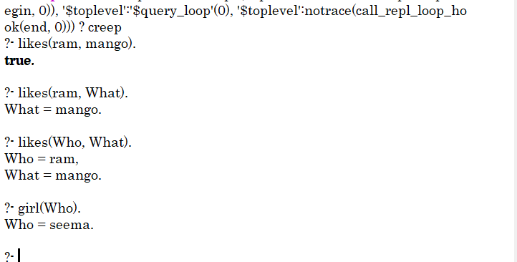
Output:

Program 2:-
Code:
c_to_f(C, F) :- F is (C * 9 / 5) + 32.
freezing(F):-F =< 32 .
Output:
