
Shri Vile Parle Kelavani Mandal's
INSTITUTE OF TECHNOLOGY
DHULE (M.S.)
DEPARMENT OF COMPUTER ENGINEERING
Subject :Artificial Intelligence Lab |  |  | Remark
Name : Pushpak Sachin Deore |  | Roll No. : 32 | Remark
Class : B.tech Final Year | Batch : B2 | Division: - | Remark
Expt. No. : 02 | Date : 28/08/2025 |  | Signature
Title : Implement The N-Queens problem in Prolog. |  |  | Signature

Code:
queens(N, Qs):- range(1, N, Us) , queens(Us , [] , Qs).
queens([] , Qs , Qs).
queens(Us , Ps , Qs ):- select(Q , Us , Us1), \+ attack( Q , Ps),
queens(Us1 , [Q |Ps] ,Qs).
range(J ,J ,[J]).
range(I , J , [I|Ns]):- I < J, I1 is I+1 , range(I1 ,J ,Ns).
attack(Q , Qs ):- attack(Q ,1 , Qs).
attack(X, N ,[Y| _]):- X is Y + N.
attack(X, N ,[Y|_]):- X is Y - N.
attack(X, N ,[_|Ys]):-
N1 is N+1 ,attack(X , N1 , Ys ).
go:- queens(8 , Qs) , write(Qs).

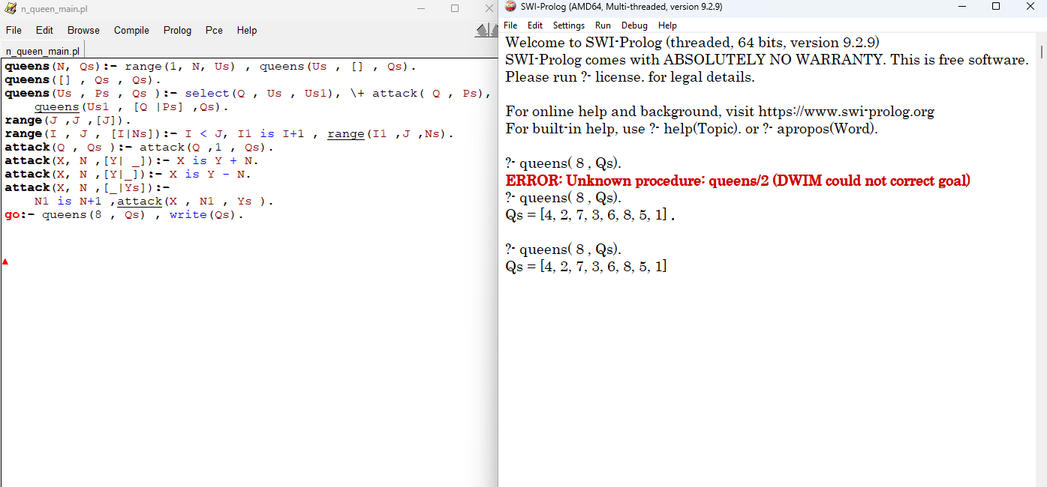
Output:

