《并行计算》上机报告

姓名： | 魏钊 |  | 学号： | PB18111699 | 日期： | 2021/5/25
上机题目： | GPU并行编程实验
实验环境：
CPU：i7-8750H; 内存: 16GB;操作系统WIN10;软件平台:Visual Studio 2017+CUDA11;
一、算法设计与分析：

题目一:
GPU上矩阵乘法：
▪ 每一个线程计算C矩阵中的一个元素。
▪ 每一个线程从全局存储器读入A矩阵的一行和B矩阵的一列。
▪ A矩阵和B矩阵中每个元素都被方位N =BLOCK_SIZE次
题目二：
GPU上矩阵向量乘：
Ax=b
A为矩阵，x,b为列向量，类似矩阵乘法不再赘述。

二、核心代码：

题目一:
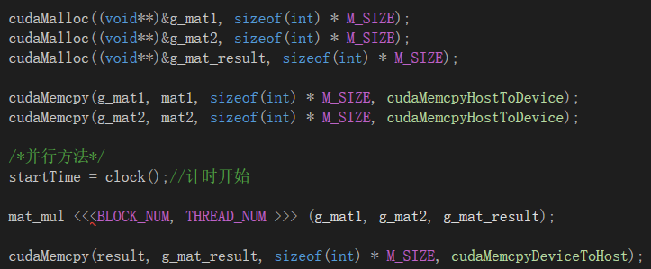
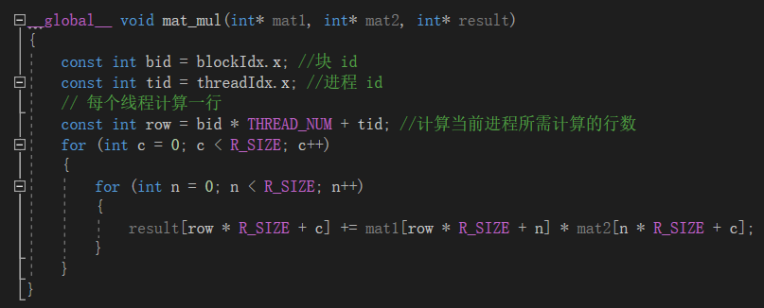

题目二：
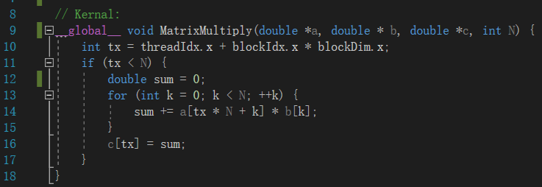
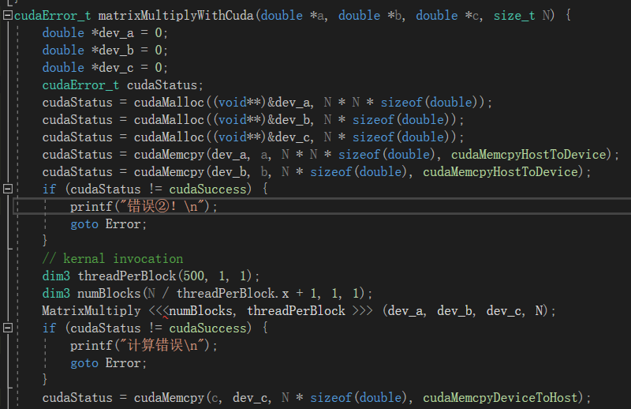

三、结果与分析：
题目一:
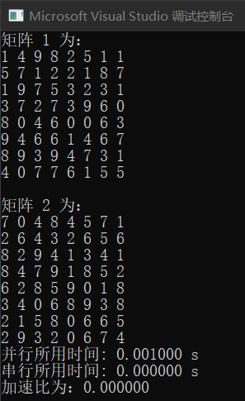
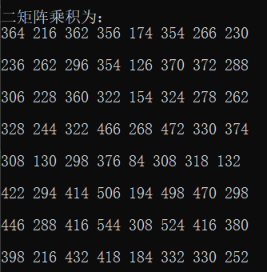

题目二：
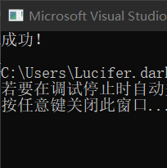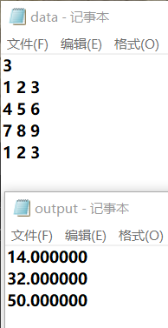
四、备注（* 可选）：
有可能影响结论的因素：
GPU型号不同结果可能略有差异
总结：
GPU在大规模数据并行时有明显的优势
附录（源代码） |  | 算法源代码（C/C++/JAVA描述）  ①矩阵乘法  #include "cuda_runtime.h"  #include "device_launch_parameters.h"  #include <stdio.h>  #include<cuda.h>  #include<string.h>  #include<ctime>  #define BLOCK_NUM 4 // 块数量  #define THREAD_NUM 2 // 每个块中的线程数  #define R_SIZE (BLOCK_NUM * THREAD_NUM) // 矩阵行列数  #define M_SIZE (R_SIZE * R_SIZE) //矩阵规模  __global__ void mat_mul(int* mat1, int* mat2, int* result)  {  const int bid = blockIdx.x; //块 id  const int tid = threadIdx.x; //进程 id  // 每个线程计算一行  const int row = bid * THREAD_NUM + tid; //计算当前进程所需计算的行数  for (int c = 0; c < R_SIZE; c++)  {  for (int n = 0; n < R_SIZE; n++)  {  result[row * R_SIZE + c] += mat1[row * R_SIZE + n] * mat2[n * R_SIZE + c];  }  }  }  int main(int argc, char* argv[])  {  int* mat1, *mat2, *result;  int* g_mat1, *g_mat2, *g_mat_result;  double time_pc, time_normal;  clock_t startTime, endTime;  // 用一位数组表示二维矩阵  mat1 = (int*)malloc(M_SIZE * sizeof(int));  mat2 = (int*)malloc(M_SIZE * sizeof(int));  result = (int*)malloc(M_SIZE * sizeof(int));  // initialize  for (int i = 0; i < M_SIZE; i++)  {  mat1[i] = rand() % 10;  mat2[i] = rand() % 10;  result[i] = 0;  }  printf("矩阵 1 为：\n");  for (int i = 0; i < M_SIZE; i++)  if((i + 1) % R_SIZE == 0)  printf("%d\n", mat1[i]);  else  printf("%d ", mat1[i]);  printf("\n矩阵 2 为：\n");  for (int i = 0; i < M_SIZE; i++)  if ((i + 1) % R_SIZE == 0)  printf("%d\n", mat2[i]);  else  printf("%d ", mat2[i]);  cudaMalloc((void**)&g_mat1, sizeof(int) * M_SIZE);  cudaMalloc((void**)&g_mat2, sizeof(int) * M_SIZE);  cudaMalloc((void**)&g_mat_result, sizeof(int) * M_SIZE);  cudaMemcpy(g_mat1, mat1, sizeof(int) * M_SIZE, cudaMemcpyHostToDevice);  cudaMemcpy(g_mat2, mat2, sizeof(int) * M_SIZE, cudaMemcpyHostToDevice);  /*并行方法*/  startTime = clock();//计时开始  mat_mul <<<BLOCK_NUM, THREAD_NUM >>> (g_mat1, g_mat2, g_mat_result);  cudaMemcpy(result, g_mat_result, sizeof(int) * M_SIZE, cudaMemcpyDeviceToHost);  endTime = clock();//计时结束  time_pc = (double)(endTime - startTime) / CLOCKS_PER_SEC;  printf("并行所用时间: %lf s\n", time_pc);  /*串行方法*/  startTime = clock();//计时开始  for (int r = 0; r < R_SIZE; r++) {  for (int c = 0; c < R_SIZE; c++) {  for (int n = 0; n < R_SIZE; n++) {  result[r * R_SIZE + c] += mat1[r * R_SIZE + n] * mat2[n * R_SIZE + c];  }  }  }  endTime = clock();//计时结束  time_normal = (double)(endTime - startTime) / CLOCKS_PER_SEC;  printf("串行所用时间: %lf s\n", time_normal);  printf("加速比为：%lf\n", time_normal / time_pc);  printf("\n二矩阵乘积为：\n");  for (int i = 0; i < M_SIZE; i++)  if ((i + 1) % R_SIZE == 0)  printf("%d\n\n", result[i]);  else  printf("%d ", result[i]);  }  ②矩阵向量乘  #include "cuda_runtime.h"  #include "device_launch_parameters.h"  #include <iostream>  #include <fstream>  #include <iomanip>  #include <stdio.h>  // Kernal:  __global__ void MatrixMultiply(double *a, double * b, double *c, int N) {  int tx = threadIdx.x + blockIdx.x * blockDim.x;  if (tx < N) {  double sum = 0;  for (int k = 0; k < N; ++k) {  sum += a[tx * N + k] * b[k];  }  c[tx] = sum;  }  }  cudaError_t matrixMultiplyWithCuda(double *a, double *b, double *c, size_t size);  int main()  {  std::ifstream in("data.txt");  int N;  in >> N;//矩阵阶数  if (in.fail()) {  printf("错误①！\n");  }  else {  printf("成功！\n");  }  // host initial  double *a = new double[N * N];  double *b = new double[N];  double *c = new double[N];  // read  for (int i = 0; i < N; ++i)  for (int j = 0; j < N; ++j) in >> a[i * N + j];  for (int i = 0; i < N; ++i) in >> b[i];  cudaError_t cudaStatus = matrixMultiplyWithCuda(a, b, c, N);  std::ofstream out("output.txt");  for (int i = 0; i < N; ++i) {  out << std::setiosflags(std::ios::fixed) << c[i] << " ";  out << std::endl;  }  cudaStatus = cudaThreadExit();  // host free  delete[] a;  delete[] b;  delete[] c;  return 0;  }  cudaError_t matrixMultiplyWithCuda(double *a, double *b, double *c, size_t N) {  double *dev_a = 0;  double *dev_b = 0;  double *dev_c = 0;  cudaError_t cudaStatus;  cudaStatus = cudaMalloc((void**)&dev_a, N * N * sizeof(double));  cudaStatus = cudaMalloc((void**)&dev_b, N * sizeof(double));  cudaStatus = cudaMalloc((void**)&dev_c, N * sizeof(double));  cudaStatus = cudaMemcpy(dev_a, a, N * N * sizeof(double), cudaMemcpyHostToDevice);  cudaStatus = cudaMemcpy(dev_b, b, N * sizeof(double), cudaMemcpyHostToDevice);  if (cudaStatus != cudaSuccess) {  printf("错误②！\n");  goto Error;  }  // kernal invocation  dim3 threadPerBlock(500, 1, 1);  dim3 numBlocks(N / threadPerBlock.x + 1, 1, 1);  MatrixMultiply <<<numBlocks, threadPerBlock >>> (dev_a, dev_b, dev_c, N);  if (cudaStatus != cudaSuccess) {  printf("计算错误\n");  goto Error;  }  cudaStatus = cudaMemcpy(c, dev_c, N * sizeof(double), cudaMemcpyDeviceToHost);  Error:  cudaFree(dev_a);  cudaFree(dev_b);  cudaFree(dev_c);  return cudaStatus;  }

