Demographics vs. Sustainability Attitudes

Age vs. Importance of Sustainability Gender vs. Responsibility Beliefs

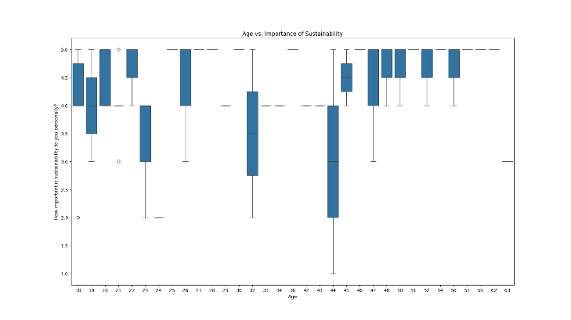 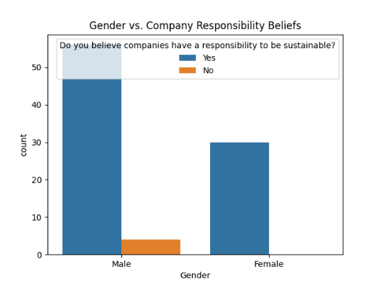

Willingness to Pay and Perceived Value

Income Level vs. Willingness to Pay Extra Awareness vs. Willingness to Pay

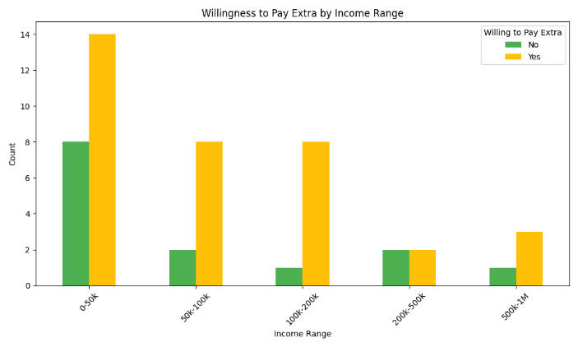 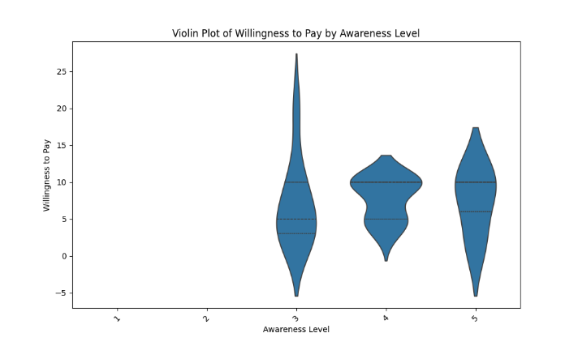

Trust and Responsibility

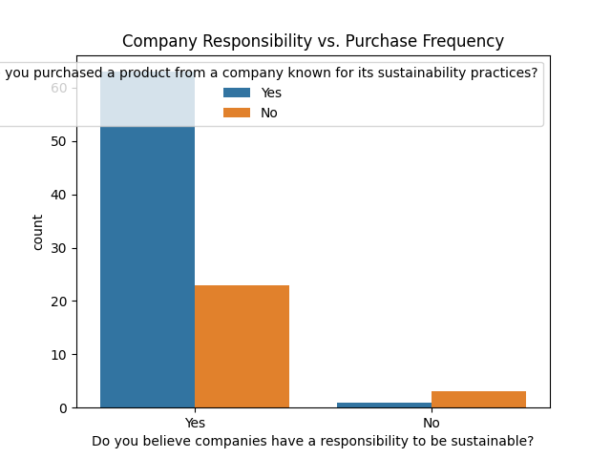

Consumer Habits

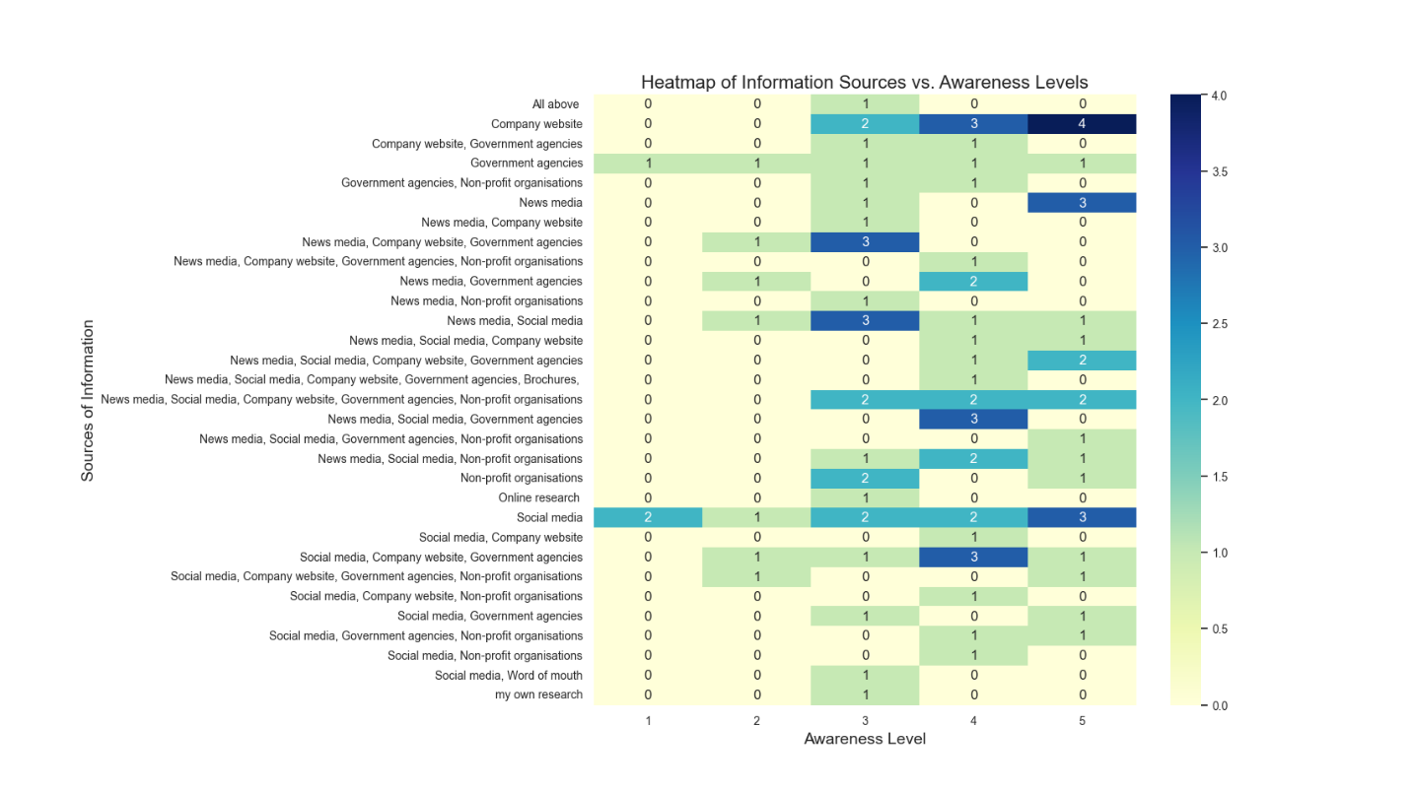

Factors Influencing Purchase Decisions

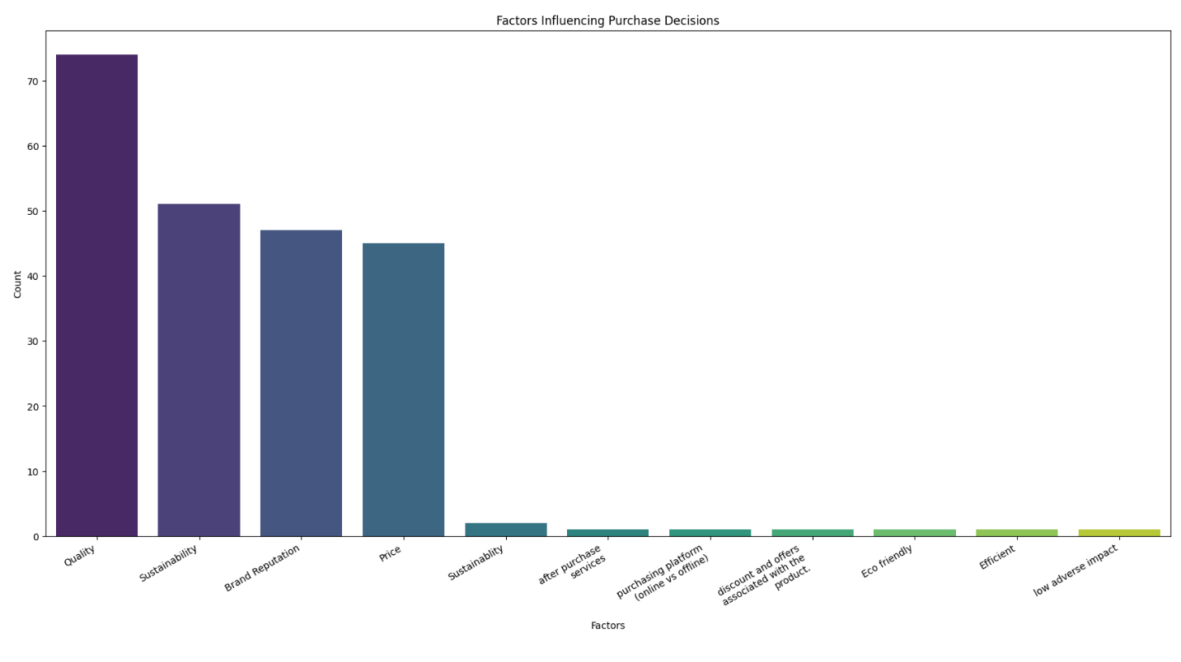

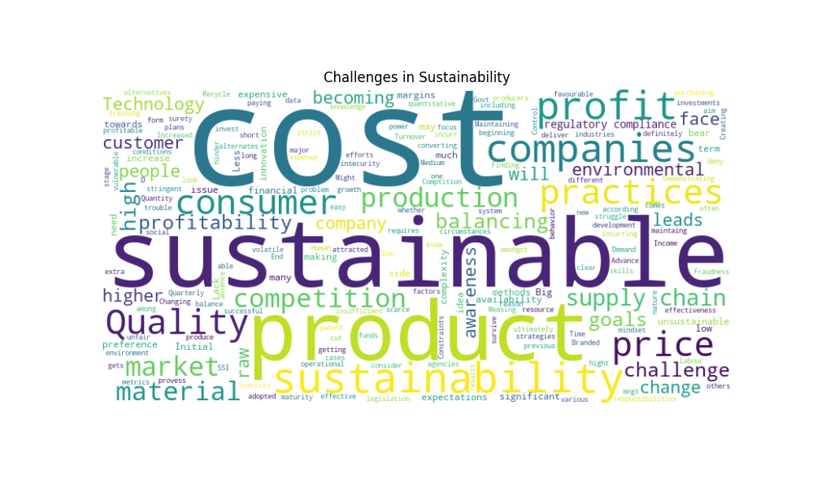Text Analysis on Challenges and Advice

