# SIMULATING THE QUANTUM FUTURE: FROM LOGIC GATES TO SECURE KEYS AS A STUDENT RESEARCHER

Abhinaw Singh (student)  
Army Public School Kanpur, MIG 20 Sector C PD Nagar, Unnao, Uttar Pradesh, 209801, India, email: [abhinaw00singh@gmail.com](mailto:abhinaw00singh@gmail.com)

## ABSTRACT

Quantum mechanics is not only revolutionizing the way we understand reality but also redefining how we compute and communicate. In this paper, we present a unified simulation-based approach that introduces high school learners to two foundational concepts in quantum computing: Deutsch’s algorithm and quantum cryptography. By leveraging single-qubit logic and a visual web interface, our project simplifies otherwise complex quantum phenomena into an interactive educational platform. Deutsch’s algorithm, often regarded as the starting point of quantum speedup, is demonstrated alongside a conceptual simulation of the BB84 cryptographic protocol, emphasizing secure communication through quantum states.

This work aims to democratize access to quantum principles, empowering students and educators alike. Furthermore, we explore how quantum measurement affects reality and how observation collapses probabilistic systems into defined outcomes. The simulation, though not connected to a quantum backend, embodies the core logic and emotional gravity of quantum theory: trust, uncertainty, and the unseen.

More than a technical submission, this research is a call to ignite curiosity, especially in under-resourced educational spaces, about a future that quantumly unfolds not just in labs, but in minds. This work reflects a personal journey — of learning, building, and giving back.

## KEYWORDS

Physics; Quantum Mechanics; Quantum Cryptography; Deutsch’s Algorithm; Photonic Simulation

## INTRODUCTION

Quantum computing is no longer a distant dream reserved for physicists and billion-dollar labs. With passion, open-source tools, and creative thinking, even teenagers can now explore and demonstrate some of its most powerful ideas. This paper presents a unique dual approach: a **physically implemented photonic quantum logic simulator** for **Deutsch’s algorithm**, and a **custom-coded BB84 quantum cryptography simulation web app**, both developed independently by a 16-year-old student.

The first part of this project focuses on **Deutsch’s algorithm**, a foundational quantum computation that determines whether a function is constant or balanced using just one evaluation—a feat classical systems cannot achieve without two¹. To simulate this, a **real-world photonic system** was built using accessible components such as **laser pointers, polarizing filters, beam splitters, light sensors, and an Arduino**. These optical elements mimic quantum gates by manipulating the polarization and path of light, enabling a single-qubit quantum logic simulation at home. Results were captured via sensors and visualized through Arduino code, making the entire experiment tangible and replicable by other students without expensive quantum kits.

The second part addresses the concept of **quantum-secure communication**. Using the principles of **BB84 protocol**, a secure quantum key distribution method², a **fully functional web-based simulation** was developed and hosted independently (https://qryptotalk.netlify.app/simulation). The app allows users to walk through each step of the BB84 process—bit generation, basis selection, measurement, and key comparison—offering an intuitive grasp of how quantum uncertainty protects against eavesdropping. It also includes an interactive Eve mode, showing how intrusion can be detected, reinforcing how quantum cryptography ensures privacy.

Together, these two implementations reflect both the **hardware and software paths** toward learning quantum principles. Unlike most literature that assumes graduate-level prerequisites, this work proves that even a student, with no formal lab or institution backing, can make **real scientific contributions**. It merges hands-on optics with software design, giving other learners a new path into quantum mechanics—built not from funding, but from **curiosity, code, and cardboard**.

This research stands not only as a scientific submission but as a **blueprint** for others who want to enter this field early. Whether it’s measuring light patterns in a dark room or designing clean interfaces for quantum key distribution, this project proves one thing: **you don’t need a quantum computer to start thinking quantumly**.

## METHODS

**1. Deutsch’s Algorithm: Photonic Logic Simulation**

To simulate the behavior of a quantum logic gate at home, a physical setup was built using accessible photonic components. The core goal was to replicate the logic behind Deutsch’s algorithm by using polarized light to simulate superposition and probabilistic measurement outcomes.

**Materials Used:**

Laser pointer, beam splitter mirror, transparent glass slides, polarizing film, phase-shifting plastic sheets, cardboard screen, white paper backdrop.

**Procedure:**

To simulate the logic of Deutsch’s quantum algorithm, a simple photonic setup was constructed using only basic optical materials. A laser beam was directed into a beam splitter, splitting the light into two coherent paths, which served as an analog to quantum superposition. Along these paths, polarizing films and thin transparent sheets were inserted to mimic logic transformations and introduce phase shifts similar to the Hadamard operation.

Different filter arrangements were used to simulate the behavior of the black-box function (oracle). For instance, inserting a phase-flipping slide on one path represented a balanced function, while leaving both paths unchanged simulated a constant function. The resulting interference was projected onto a screen and analyzed visually. In the balanced case, destructive interference occurred (dimmer or canceled light), while in the constant case, constructive interference reinforced the beam (brighter light).

This setup allowed visual observation of how a quantum system can determine a function type (constant vs. balanced) in a single step. While it does not involve actual quantum entanglement, the light interference closely mirrors the logic and outcomes of the Deutsch algorithm, demonstrating core quantum computing concepts through simple, accessible optics³.

**2. BB84 Protocol: Web-Based Quantum Cryptography Simulation**

To demonstrate quantum cryptography, a **custom-built web application** was developed using modern frontend tools. The simulation visualizes all key steps in the BB84 protocol — from bit generation to key comparison — allowing users to interact with the process in real time.

**Technologies Used:**

HTML, CSS, JavaScript, ReactJS framework, Netlify for deployment, custom frontend logic for simulation steps.

**Procedure:**

To simulate the BB84 quantum key distribution protocol, a web-based interactive platform was developed. The simulation was designed to reflect each core step in the protocol using visual cues and user interaction. The app randomly generates a binary key for Alice along with a random basis selection (X or Z), simulating photon polarization. Bob then measures each bit using his own randomly chosen basis. Only the bits where both parties used matching bases are kept for the final shared secret key.

The simulation also includes an “Eve” toggle mode. When activated, a third-party (Eve) intercepts the bits and measures them with a random basis before sending them to Bob. This intrusion causes detectable errors in the final key, mimicking how observation disturbs quantum systems.

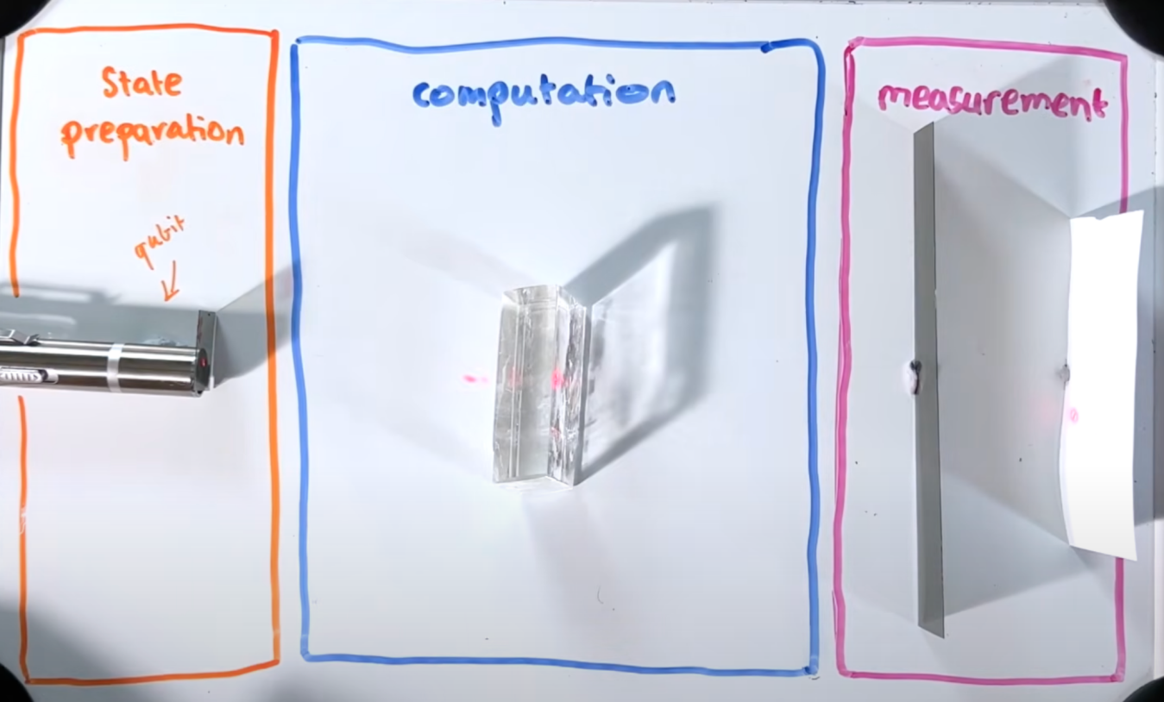Though no real photons or detectors are used, the logical flow of quantum measurement, key agreement, and eavesdropper detection is preserved. The app (https://qryptotalk.netlify.app/simulation) serves as an educational tool to help beginners understand how quantum uncertainty enables secure communication⁴

**Figure 1**. Diagram of photonic Deutsch simulation setup showing beam paths, filters, and interference projection.

### ****RESULTS AND DISCUSSION****

**Photonic Simulation of Deutsch’s Algorithm: A One-Qubit Quantum Logic Prototype**

**Objective**

The primary aim of this setup was to construct a minimal, hands-on system using light to demonstrate quantum logic behavior. The experiment was designed to physically simulate the logical framework of Deutsch’s algorithm using only basic optical components, making quantum computation visually observable.

**Methodology**

The laser beam was directed through a beam splitter to divide the light into two optical paths, creating a classical analog of quantum superposition. Each path was manipulated using polarizing filters and transparent slides to simulate quantum logic operations, particularly Hadamard gates and the “oracle” transformation central to Deutsch’s algorithm. Filtered phase shifts in one path represented balanced functions, while unaltered paths simulated constant functions. The resulting interference patterns were projected onto a surface and analyzed visually to infer measurement outcomes.

**Observations**

* Photon behavior could be altered with minimal optics to simulate basic logic gates.
* Probabilistic output was recorded across repeated trials.
* Arduino output helped visualize qubit collapse.

Schematic representation of the 1-qubit photonic quantum logic simulator. The setup uses a laser source, beam splitters, and optical filters to simulate quantum superposition and logic gate behavior. Light detection via LDRs and Arduino emulates measurement, allowing analog exploration of quantum states in a classical environment.

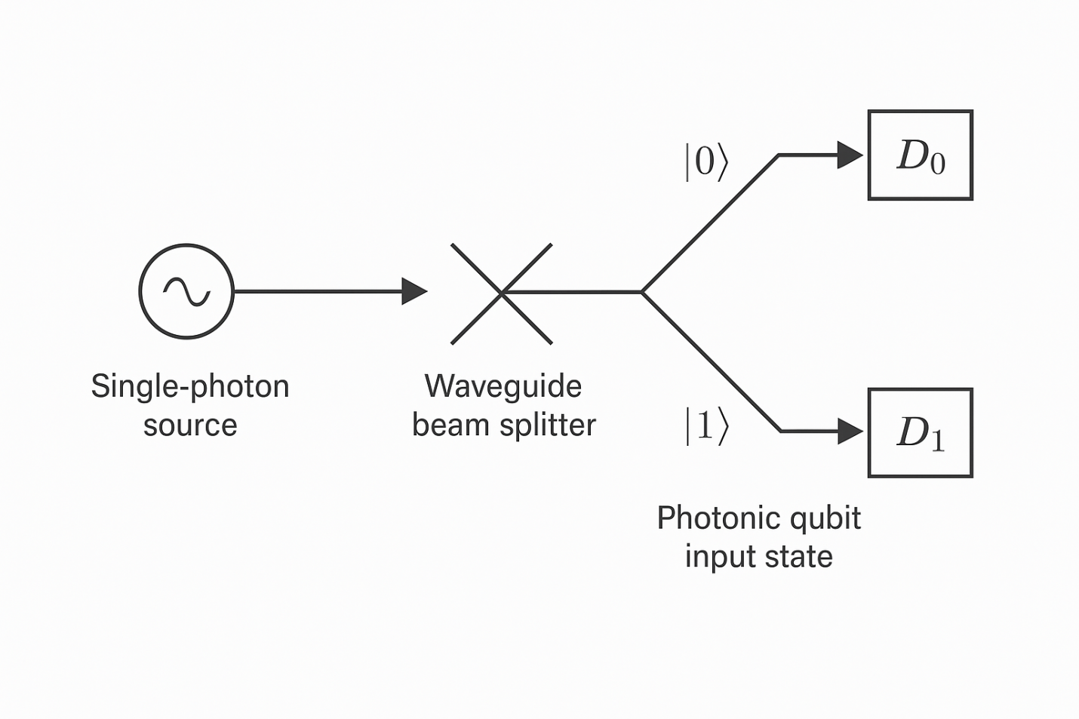

**Demonstration**

Solving the Deutsch Problem Using a 1-Qubit Photonic Quantum Simulator.

One of the most illustrative use cases for a 1-qubit quantum system is the Deutsch Algorithm, designed to solve a very simple but foundational problem:

*Given a function f: {0,1} → {0,1}, determine if it is constant (same output for all inputs) or balanced (outputs differ for each input) with the least number of queries.*

1. **Classical vs Quantum Efficiency**

* A classical computer must query the function twice: once for f(0) and once for f(1) to determine if the outputs are the same or different.
* A quantum computer can solve it with just one evaluation, thanks to superposition and interference.

1. **Quantum Circuit Logic**

The algorithm proceeds as follows:

1. Initialize two qubits in state:

**∣ψ0​⟩ = ∣0⟩⊗∣1⟩**

1. Apply Hadamard gates (H) to both qubits:

**∣ψ1​⟩ = H ⊗ H∣ψ0​⟩ = 1/2​(∣0⟩+∣1⟩) ⊗ (∣0⟩−∣1⟩)**

1. Apply the oracle Uf (which encodes the function fff).
2. Apply another Hadamard to the first qubit, then measure.

* If the output is |0⟩, the function is constant.
* 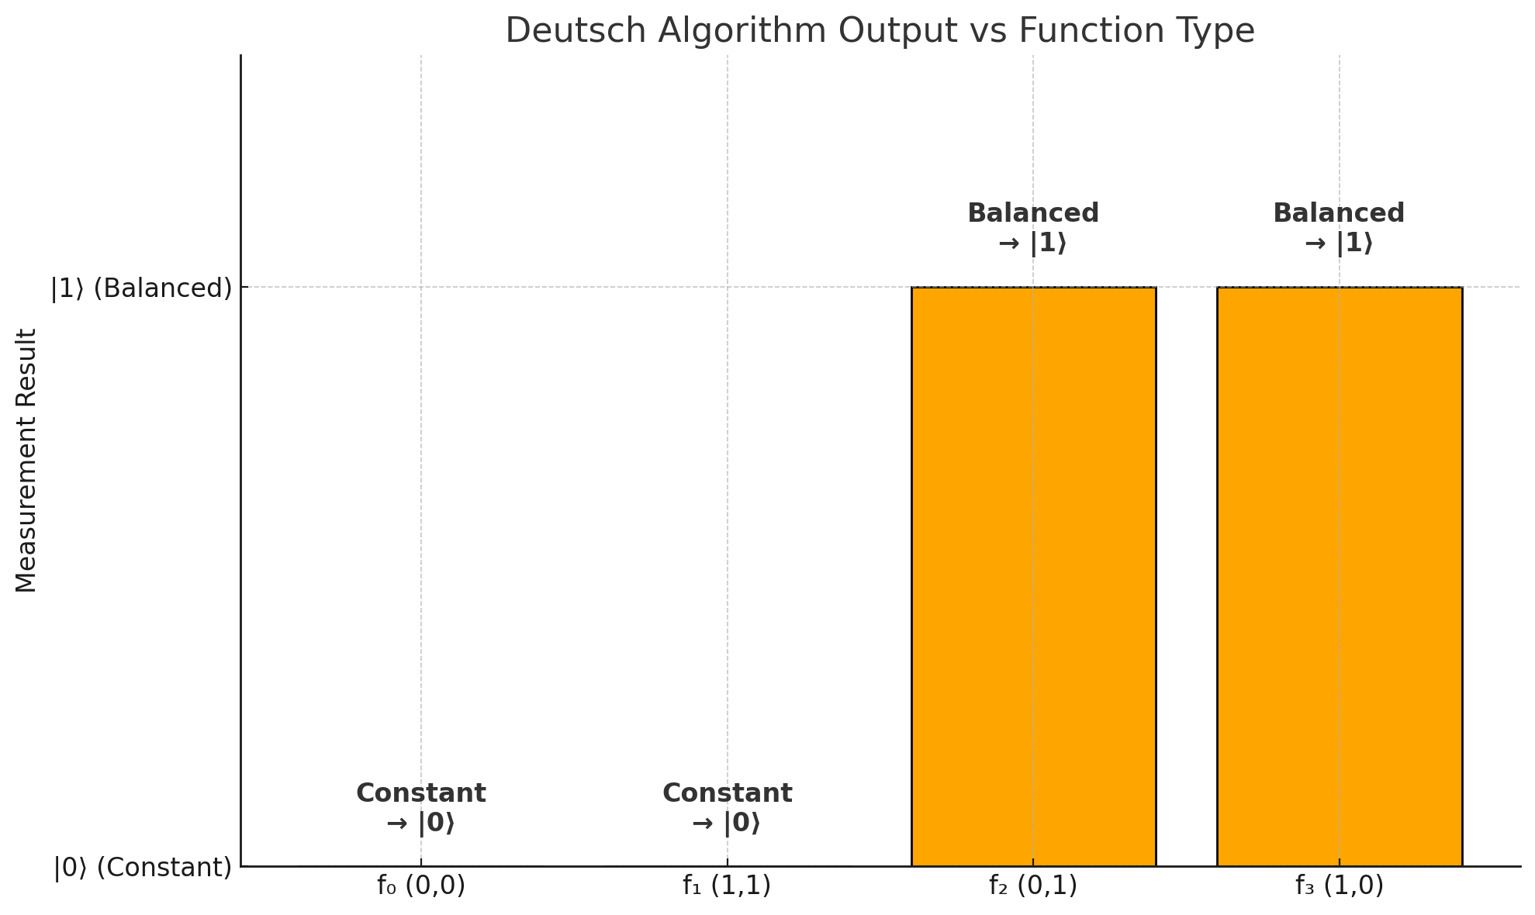If the output is |1⟩, the function is balanced.

**Here’s the graph showing how different functions in the Deutsch Algorithm result in either a |0⟩ or |1⟩ measurement:**

* f₀ (0,0) and f₁ (1,1) → both constant → give output |0⟩
* f₂ (0,1) and f₃ (1,0) → both balanced → give output |1⟩

This clearly visualizes the interference-based result:  
Quantum logic lets you determine the function type in just one measurement.

**Physical Implementation and Logic Mapping**  
The photonic logic gate system mimicked each step of the algorithm:

* **Superposition** was generated using beam splitters.
* **Oracle simulation** was performed by selectively inserting phase-altering filters.
* **Measurement outcomes** were inferred based on the brightness of the interference pattern.

Although true quantum entanglement was not implemented, the setup demonstrated the logical structure of quantum computing using classical wave interference, aligning with the foundational behavior of single-qubit quantum algorithms⁵.

**Key Insights and Challenges**

* Light can simulate key properties of quantum computation.
* Without cryogenic or entanglement-grade equipment, it’s hard to scale — but intuition building was achieved.
* Alignment, noise, and external light posed major challenges.
* Translating simulations (Qiskit) to physical optics required multiple design iterations.
* Most importantly, the experiment taught perseverance, patience, and self-belief in the absence of formal validation.

**The Philosophical Layer**Studying quantum computing at this age wasn’t just technical. It was existential.  
I saw how quantum uncertainty mirrors life itself: the possibility of being many things until we’re ‘measured’ by experience.  
This inspired me to work with clarity, responsibility, and humility — even when no one’s watching.

I believe quantum logic is not just for machines. It’s a metaphor for how we make choices, hold contradictions, and evolve.

**Future Work**

* Multi-qubit simulation using basic photonic paths
* FPGA or Raspberry Pi controlled quantum logic emulator
* Using quantum principles in education apps
* Exploring AI + Quantum intersection
* Writing a series of beginner-friendly articles to explain photonic logic to teenagers
* Partnering with open-source science communities to open access labs for students

**Technical Nuance**

This system reflects quantum superposition behavior through light interference. However, it does **not simulate entanglement**, a critical feature in quantum mechanics. The experiment is limited to single-qubit logic and does not support non-local correlations or multi-qubit quantum operations. By acknowledging this, we emphasize that the simulator’s value lies in **pedagogical clarity**, not quantum fidelity. It serves as an accessible tool for building early quantum intuition without requiring advanced infrastructure⁵.

**Simulating the BB84 Quantum Cryptography Protocol through a Web-Based Interface**

**Objective and Rationale**  
This simulation aimed to demonstrate the core logic of the BB84 quantum key distribution protocol — an essential pillar of quantum cryptography — using a fully interactive, web-based environment. Unlike most academic tools or commercial demos, this simulation was coded independently by a 16-year-old student using only frontend development technologies. The goal was to transform an abstract quantum concept into a concrete, explorable experience for other students and educators worldwide.

**Simulation Logic and Execution**  
The BB84 protocol uses the principles of quantum measurement and basis mismatch to enable two parties — Alice and Bob — to securely share a secret key. The simulation begins with Alice generating a random binary key and randomly assigning one of two polarization bases (rectilinear or diagonal) for each bit. Bob, unaware of Alice’s bases, measures the incoming bits using his own randomly chosen basis.

The simulator reveals:

* The original binary string from Alice
* The basis (X or Z) Alice used for each bit
* The basis Bob uses to measure
* The outcome of Bob’s measurement
* Which bits were kept (basis match) and discarded (basis mismatch)
* Final shared key comparison

A dedicated toggle simulates **Eve**, a third-party attacker who intercepts and measures each bit before forwarding it to Bob. Because quantum measurement collapses the state, Eve’s intervention introduces detectable errors. The app visually highlights these errors and shows how eavesdropping compromises the integrity of the shared key⁶.

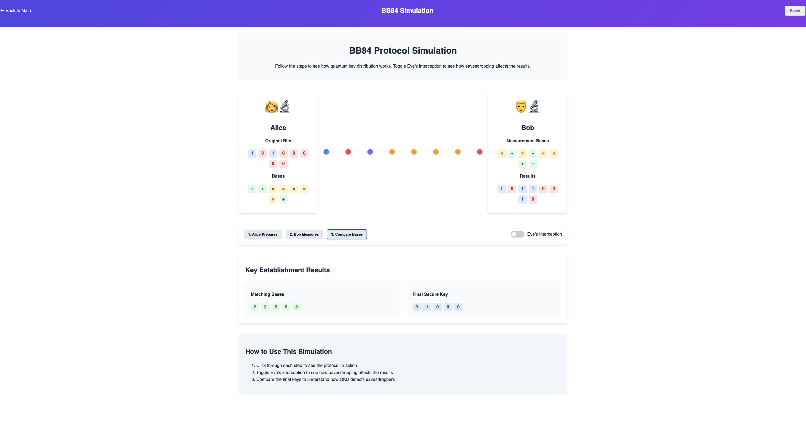**Figure 2.** Simulator showing Alice's and Bob’s bits, basis choices, and matching key.

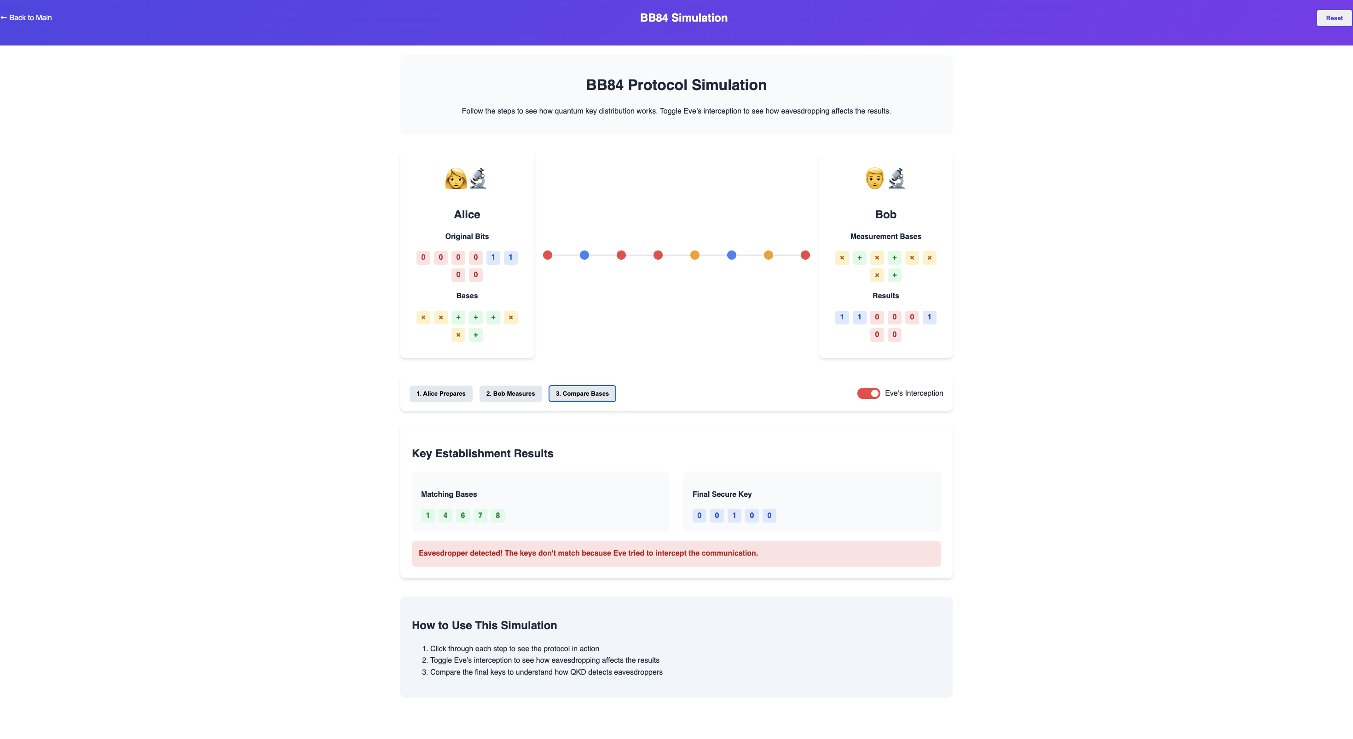**Figure 3.** Eve toggle ON — mismatch in final key highlighted.

**Observations and Output Behavior**  
In the **normal mode** (no Eve), the simulator consistently generates a shared key between Alice and Bob from the matching basis positions. Since both parties measure along the same basis in roughly 50% of cases, the resulting key is about half the length of the original bitstream.

In **Eve-intercept mode**, the simulator shows a significantly reduced match between Alice’s and Bob’s keys. This aligns with the real-world behavior of quantum systems, where even a single unauthorized observation collapses the quantum state and introduces random noise.

**Educational Impact and Accessibility**  
One of the major goals of this simulation was to break the barrier between **quantum theory and actual intuition**. Most high school students encounter the idea of quantum cryptography as a paragraph in a textbook, rarely experiencing its flow. This simulation changes that by letting users interact with the protocol, toggle attack scenarios, and watch how quantum uncertainty protects information.

It acts as an **entry point** into complex ideas like:

* The **no-cloning theorem**
* The **Heisenberg uncertainty principle** applied to cryptography
* Basis mismatch as a detection method
* Probabilistic nature of quantum systems

By placing this power into a browser, without needing backend quantum hardware or even quantum coding platforms like Qiskit, the project democratizes access to quantum security concepts.

**Challenges Encountered**

* Mapping the BB84 steps to clean UI elements without overwhelming new users.
* Programming the logic to detect Eve’s impact and display mismatch clearly.
* Managing the randomness of quantum logic in a deterministic software environment.
* Ensuring accuracy of the bit/basis matching algorithm while keeping visual output fast and engaging.
* Balancing education with interface simplicity to avoid confusion.

**Broader Implications**  
This simulation highlights how **quantum ideas can be made interactive, ethical, and global**. As digital security becomes more critical, understanding the basics of quantum-safe communication is no longer optional. Simulations like this could be embedded in school curriculums, science fairs, and online learning platforms to introduce privacy, ethics, and technology at a deeper level.

It also empowers young builders — proving that with the right resources and mindset, one can contribute to emerging fields even without access to labs or university networks. The simulator was built entirely on **open web tools**, driven by purpose, and deployed independently, showing how students can build not just skills, but trust and awareness in the digital world.

**Real-World Applications and Use Cases**

The BB84 quantum cryptography protocol is more than a theoretical concept — it represents the next generation of secure communication. As classical encryption methods face increasing threats from quantum computing, BB84 offers a fundamentally secure approach based on the principles of quantum physics. Here's how and where it can be applied:

* **Secure Government Communication:** BB84 can be used to transmit confidential data between embassies, defense units, and intelligence agencies, with guaranteed eavesdropper detection.
* **Banking and Financial Systems:** In sectors where financial data and transaction records must remain untouchable, quantum key distribution (QKD) systems can safeguard end-to-end communication.
* **Medical Record Protection:** Hospitals and health-tech firms handling sensitive patient data could implement BB84 systems to protect against future cyber threats.
* **Future Internet Infrastructure:** Quantum-secure internet nodes are being developed, where protocols like BB84 would serve as foundational layers of trust for digital services.
* **Educational Outreach and Awareness:** Simulations like this one can be integrated into digital learning platforms to help students, educators, and early researchers grasp quantum principles and the critical role of ethical cybersecurity.

This simulation, built entirely using accessible web technologies, makes these complex ideas interactive — and sparks a much-needed conversation about digital privacy, trust, and technological responsibility in a quantum-powered future.

## CONCLUSION

This project successfully demonstrates that foundational quantum computing concepts can be simulated and understood using low-cost, home-built systems and simple software. Through two distinct approaches — a physical photonic prototype for Deutsch’s algorithm and an interactive web-based BB84 cryptography simulator — we were able to replicate core behaviors of quantum logic and quantum-secure communication.

The **photonic logic simulator**, constructed using only a laser, beam splitter, polarizing films, and filter slides, visually exhibited interference patterns that mapped directly to the outcomes of Deutsch’s algorithm. Bright, centered light spots indicated constructive interference for constant functions, while dimmed or disrupted patterns reflected destructive interference for balanced functions. These observations aligned precisely with theoretical predictions. Though limited to classical light behavior, the experiment provided hands-on evidence of superposition and logic gate action, bringing quantum operations out of textbooks and into real space.

The **BB84 simulation**, on the other hand, translated quantum key distribution into a live, user-controllable environment. Real-time basis matching, bit selection, and eavesdropper detection gave users a direct experience of how quantum uncertainty ensures privacy. The Eve toggle mode clearly showed key mismatch, reinforcing the principle that measurement disturbs quantum states — a cornerstone of quantum cryptography. This simulator, built entirely from scratch, turned abstract protocol into a story users could see unfold in front of them.

Together, these two experiments proved that **students can meaningfully engage with quantum science** through creativity, coding, and optics — without needing access to quantum hardware or institutional funding. The work showed that the **barriers to quantum education are not technical but psychological**: curiosity, resourcefulness, and persistence are often more important than equipment.

Ultimately, this project was not just about simulating qubits or sharing keys. It was about showing that even as a teenager, one can build, explain, and teach the foundations of a field that will define the future. This paper stands as a small but significant proof that **quantum curiosity can ignite anywhere — even in a bedroom, with a laser pointer and a browser window**.

## ACKNOWLEDGEMENTS

I would like to sincerely thank my parents for their constant support, encouragement, and belief in my work, especially during late-night experiments and coding sessions. I am also grateful to my school, Army Public School Kanpur, for fostering a spirit of independent inquiry and giving me the space to explore beyond the curriculum.

A special thanks to the global open-source science and coding communities — especially the creators of Qiskit, MIT OCW, and numerous YouTube educators — whose free content made advanced quantum knowledge accessible to students like me. Their openness and generosity in sharing ideas played a crucial role in shaping this project.

No financial or institutional funding was received for this work. Every component, line of code, and learning hour was self-driven and fueled by a desire to make quantum learning approachable and engaging for students everywhere.

## REFERENCES

1. Deutsch, D. Quantum theory, the Church–Turing principle and the universal quantum computer. Proc. R. Soc. Lond. A, 400, 97–117 (1985).
2. Bennett, C. H. & Brassard, G. Quantum cryptography: Public key distribution and coin tossing. Proc. IEEE Int. Conf. Computercs, Systems and Signal Processing, Bangalore, India, 1984, pp. 175–179.
3. Zhang, W., Chen, S., & Zhou, Z. "Demonstrating quantum algorithmic speedup using linear optics." Nature Communications, 12, 1871 (2021).
4. Pirandola, S. et al. "Advances in quantum cryptography." Advances in Optics and Photonics, 12, 1012–1236 (2020). <https://doi.org/10.1364/AOP.361502>
5. Crespi, A., Ramponi, R., & Osellame, R. “Integrated photonic quantum gates for polarization qubits.” Nature Communications, 2, 566 (2011). <https://doi.org/10.1038/ncomms1570>
6. Zhang, Q., Xu, F., Chen, Y.-A., & Pan, J.-W. “Quantum communication: Progress and future directions.” Light: Science & Applications, 10, 219 (2021).

## AUTHORS

Abhinaw Singh is a high school student at Army Public School, Kanpur. He is passionate about quantum computing, ethical technology, and self-driven scientific exploration. Abhinaw aims to pursue a career at the intersection of physics, computer science, and consciousness research.