Mapping Monitoring Reporting and Verification procedures and key stakeholders promoting soils

Authors: Camille Imbert¹, Antonio Bispo², Sophia Götzinger³, Peter Hoebe⁴, Amy Nieuwenstein⁴, Taru Sandén³, Sambit Shome¹, Lucile Rabeau⁵, Tiina? and Kilian Walz⁶
Affiliations:
¹Leibniz-Centre for Agricultural Landscape Research (ZALF), Eberswalder Str. 84, D-15384 Müncheberg, Germany
²INRAE Info&Sols, 2163, avenue de la Pomme de Pin, CS 40001 Ardon, 45075 ORLEANS cedex 2, France
³Austrian Agency for Health and Food Safety – AGES, Institute for Sustainable Plant Production, Department for Soil Health and Plant Nutrition, Spargelfeldstraße 191, A-1220 Wien, Austria
⁴Earthwatch Europe, 102-104 St Aldates, Oxford, OX1 1BT, United Kingdom 5 Independent researcher, Paris, France 6 Commonland Foundation, Kraanspoor 26, 1033 SE Amsterdam, Netherlands
Keywords: Literature review, Web scrapping, Artificial Intelligence, Transparency, Soil health, Carbon market, Scientific robustness
Journal: SOIL https://www.soil-journal.net/

Contents
Abstract 3
Context 3
Gap of knowledge 3
Research question 3
Materials and methods 3
Results 4
Discussion 4
Conclusion 4
1. Introduction 4
1.1. Actions to promote soils 4
1.2. Green washing risks 4
1.3. Monitoring Reporting and Verification procedures (MRVs) 5
1.4. Gap of knowledge: no broad classification of MRV procedures including soils 5
1.5. Presentation of the study 5
1.5.1. Objectives of the study 5
1.5.2. Presentation of the methodology 5
1.5.2. Hypothesis 6
1.5.4. Relevance of the study 6
2. Materials and methods 6
2.1. Search methodologies 6
2.1.1. Search string 6
2.1.2. Search methodologies 6
2.2. Data extraction 7
2.2.1. Data collection 7
2.2.1. Inclusion rules 9
2.2.2. Duplicate management 9
2.3. Data analysis 9
2.3.1. Management of missing information 9
2.3.2. Data description 9
2.3.3. Typology of MRV procedures 9
2.3.4. Building the classification tree 10
3. Results 10
3.1. Data collection 10
3.1.1. Database for scientific articles 10
3.1.2. Webscraping 11
3.1.3. Browser based on Artificial Intelligence 11
3.1.4. Total number of MRV procedures and rate of missing information per variable 12
3.2. Data description 12
3.2.1. Geographical location and implementation state 12
3.2.3. Stakeholders 13
3.2.4. Monitoring 16
3.2.5. Reporting 18
3.2.6. Verification 19
3.2.7. Co-occurrence between stakeholders’ and MRVs’ characteristics 20
3.4. Typology of stakeholders and MRV procedures 21
3.5. Decision tool 22
3.5.1. Classification tree 22
3.5.4. Interface 22
4. Discussion 22
4.1. Knowledge state about MRV procedures including soils 22
4.1.1. Gap of knowledge regarding MRV procedures including soils 22
4.1.2. Lack of information translating a lack of transparence 22
4.2. Most frequent characteristics of the stakeholders and the MRV procedures 22
4.3. Pro and cons of the different groups of MRV procedures including soils 23
4.4. How far are we from an MRV procedure aiming soil health preservation? 24
5. Conclusion and perspectives 24
6. References 24
7. Acknowledgments 26
8. Appendices 26
9. Author contribution 27

Abstract

Context
Monitoring, Reporting and Verification (MRV) is an emerging tool in environmental markets and is used within payment schemes and policy instruments to monitor, report and verify environmental outcomes required for compliance.

Gap of knowledge
For soils, this procedure is mainly known for carbon market but barely studied.

Research question
The objective of this study is to fill this gap of knowledge and establish a typology of MRV procedures including soil aspects.

Materials and methods
We combine three methodologies to map them: the classical article review, webscraping and a search with an Artificial Intelligence browser. We also develop a decision tool to help the future user to select the adequat MRV procedure.

Results
We found 96 MRV procedures. Few information was available. Most of the MRV procedures take place at local scale, in agriculture areas, answering voluntary carbon market and so, focusing on soil organic matter and carbon. Regarding the reporting and verification part, the results are mainly gathered in a classical report and result-based verified. We define three groups of MRV procedures. With the decision tool, we advise the user the MRV procedures fitted with his/her context.

Discussion
This study highlights the lack of transparency in MRV procedures, the dominance of carbon farming and the partial inclusion of soils far from assessing soil health.

Conclusion
To add

1. Introduction

1.1. Actions to promote soils
Numerous solutions to preserve or restore soils are applied by stakeholders such as adopting agro-ecological practices, de-sealing or planting trees (Altieri et al., 2015; Bárcena et al., 2014; Vieillard et al., 2024). Another example is regenerative agriculture that is a promising approach to re-establish soils’ natural processes while providing important ecosystem services and encompasses a suite of practices aimed at restoring and enhancing soil health (Khangura et al., 2023; Sher et al., 2024).

1.2. Green washing risks
To create an incentive for land managers to preserve and restore soils, a few instruments are currently available. On a global level, voluntary carbon markets have been evolving as a major instrument allowing to generate and trade certificates as credits that help to finance the adoption of more sustainable agricultural practices (Batjes et al., 2024). A carbon credit is a certificate that represents one ton of CO2-equivalent and is the common trading unit on carbon markets (https://www.offsetguide.org/understanding-carbon-offsets/what-is-a-carbon-offset/). Credits are generated from projects which implement regenerative farming practices, afforestation, reforestation and natural regeneration or peatland restoration and conservation measures.
However, carbon offsetting projects were deemed to under deliver on the expected climate mitigation outcomes leading to the numerous green washing i.e. when actions to preserve environment (as mitigating climate change) do not attain what the stakeholder claims (Trouwloon et al., 2023). These scandals discredit the effectiveness of carbon credits as a means to achieve climate mitigation (Probst et al., 2024; Schreefel et al., 2023; Trencher et al., 2024).
A prominent example is the non-commensurate use of carbon credits to achieve greenhouse gas GHG reductions beyond solely offsetting residual emissions as prescribed in voluntary best-practice guidance (Trouwloon et al., 2023).

1.3. Monitoring Reporting and Verification procedures (MRVs)
To avoid green washing, the effects of the actions that lead to an intended outcome should be monitored in a scientific robust way and the results should be transparently reported and verified. It is the purpose of Monitoring, Reporting and Verification (MRV) procedures. They are frameworks giving indications in the way to assess the impact of an action on an object (ref to add). Regarding soils, the actions are mainly land management as agricultural practices or reforestation and the objects are soil parameters as organic matter content or biodiversity (ref to add). Moreover, MRV centered of other topics such as forest preservation can include the assessment of soil parameters (ref to add).

1.4. Gap of knowledge: no broad classification of MRV procedures including soils
MRV procedures seem to not be known by soil stakeholders except in the sector of carbon markets (Batjes et al. 2024). In particular, MRV procedures are an emerging topic in the scientific community. Only some recent projects as BENCHMARKS or MARVIC include MRV procedures (reference to add). Thus, there is a need to highlight the MRV procedures existing across the world and to establish a classification. (Batjes et al. 2024) suggested one for MRV related to carbon markets but no classification targeted a larger spectrum of purposes exists. Moreover, the stakeholders involved in these ongoing MRV are neither visible.

1.5. Presentation of the study

1.5.1. Objectives of the study
In the present study, we answer to this gap of knowledge by proposing a wider classification of MRV procedures and highlighting the stakeholders they target. Based on this work, we develop a decision tool to help future users to select the right MRV procedure, corresponding to their context. Moreover, we develop a reflection about the development of MRV procedure aiming soil health preservation. Soil health is the capacity of soil to function as a vital living ecosystem that sustains plants, animals, and humans (https://www.nrcs.usda.gov/wps/portal/nrcs/main/soils/health/).

1.5.2. Presentation of the methodology
This study is based on a literature review. As we suspect that few scientific articles would be written on the topic of MRV procedures including soils, we decide to combine three methods: the traditional literature review using a database of scientific articles, web scraping and AI browser. While traditional literature review has been the common method for any academic researcher, web scraping has introduced as a standardized approach for accessing literature in a more systematic manner. Web scraping consists in gathering information from the web page structures, in an automatized way (Sayles, Furey, and Ten Brink 2022). Most recently, Artificial Intelligence has emerged providing a wide array of search capabilities and in particular, browsers trained for the scientists.

1.5.2. Hypothesis
As MRV is a new term for the soil domain, we may struggle finding the information. Moreover, it seems mainly used in the carbon market so we expect that most of the MRV procedures would focus agriculture areas, voluntary carbon market and soil organic matter and carbon. Regarding the reporting and verification part, we think that the classical report will be very frequent and the verification rather action-based because easier to implement. We think that the main characteristics shaping the classification of the MRV procedures would be the monitoring of soil parameters other than soil organic matter and carbon. The reporting and verfication may be homogeneous.

1.5.4. Relevance of the study
This study is relevant for future stakeholders that want to develop or implement MRV procedures including soils. They will be able to select the MRV procedure that fits the most with their needs and their context.

2. Materials and methods

2.1. Search methodologies
We combined three methods to gather documents presenting MRV procedures e.g. scientific articles, websites, reports: a search on a database of scientific articles, webscraping and the use of ArtificiaI Intelligence browsers.

2.1.1. Search string
As MRV procedures on soils seem to be not well studied, we decided to use a very broad search string: Monitor* AND Report* AND Verif* AND MRV AND soil*. We also focused on MRV procedures literally named “MRV”. Indeed, stakeholders can implement MRV procedures without calling them like this. We used the same search string for the three methodologies.

2.1.2. Search methodologies

a. Database of scientific articles
The search was done in Scopus in March 2025 and includes article titles, abstracts and keywords. It resulted in 18 articles (primary studies, reviews and book chapters). We recorded the name of the first author, the title, the publication year, the DOI and the type of document i.e. if it was a primary study, an editorial article or a review.

b. Webscraping
We developed a web scraping script using Python 3.9.7 and Selenium web driver (Appendix X.a., https://www.selenium.dev/documentation/webdriver/). We ran the script to scrap 20 pages on Google SERP. We manually handled reCaptcha images.
As results provided by Google vary according the country location, the date and the IP address, we decided to run the script during Autumn 2025, from different countries and different computers in Europe (Appendix X.b.). We recorded the URL link, webpage title and URL domain.

c. Browser based on Artificial Intelligence
We used the Artificial Intelligence browsers Perplexity (https://www.perplexity.ai/) and Elicit (https://elicit.com/) In December 2025 with as prompt: ” I would like to investigate existing Monitoring, Reporting and Verification Systems for soil parameters. Please find the documents for this contextual focus and give a table that I can copy, listing these documents, with for each of them, a URL link to download them.” We recorded the document title and the URL link.

2.2. Data extraction

2.2.1. Data collection

a. Information regarding the stakeholders
We considered three land uses: agricultural areas, forest and urban areas. Pastures were included in agricultural areas. In case, other land uses were also recorded. Several land uses can be covered by the same MRV procedure.
We also recorded the geographical scale: 1) local scale for MRV developed for a site (e.g. a field, a farm, or a forest), 2) regional scale (e.g. several sites), 2) national scale, 3) continental scale and/or 4) global scale.
The occupation of the stakeholder targeted by the MRV procedure were recorded. We did not record the occupation of the stakeholder proposing the MRV procedure. We categorized the occupations as in the literature : farmers, foresters and forester associations, public administrators, educational and research institutions, NGOs, agroindustry, forestry companies and consultants (Chowdhury et al., 2023; Eggers et al., 2020; Pachón Maldonado et al., 2024; Strauss et al., 2023; Vanino et al., 2023). We also recorded the other occupations.
We also indicated the purpose of the MRV procedure i.e. the reason why it was developed. We suggested three categories : 1) voluntary carbon market i.e. a carbon market in which members are not legally compelled to reduce their emissions but do so voluntarily, 2) compliance carbon markets also known as mandatory markets, governed by national, regional, or provincial law and 3) certification i.e. a procedure to attribute a label (Batjes et al., 2024; Ceschia et al., submitted). Other purposes were also recorded.
We indicated the drivers i.e. the implemented actions that the effect is assessed by the MRV procedure, mainly agricultural and forest management. We also recorded other drivers.
The costs of the MRV procedures were also recorded.

b. Information regarding Monitoring
We listed the soil parameters assessed in the MRV procedure. Our basis list was 1) soil microorganisms, 2) soil fauna, 3) soil pH, 4) Oxygen content, 5) clay mineralogy, 6) soil organic matter and carbon, 7) CEC, 8) soil moisture, 9) soil temperature, 10) particle size distribution and texture, 11) soil porosity, 12) soil diffusivity, 13) aggregate stability, 14) soil compaction and bulk density, 15) nutrient availability, 16) pollutant concentration and 17) soil depth (BENCHMARKS deliverable). When encountered, other soil parameters were also recorded.
We recorded th type of monitoring methodology: 1) information about land management, 2) spatial images, 3) on-site images via a scanner or photos, 4) soil samples and 5) modelling.
We also recorded if the monitoring methodology came from a standard (e.g. ISO) or not.
We also collected information about the sampling design: 1) the plot area and 2) the monitoring frequency i.e. duration between two monitoring sessions (less than every 5 years, between 5 and 10 years, between 10 and 15 years or more than 15 years) (Batjes et al. 2024).

c. Information regarding Reporting
We described the format i.e. if the results were gathered in a document or entered on an online platform (Andries et al. 2021).
We indicated the statistical methodology employed to compute the uncertainty of the results : 1) probabilistic methods corresponding to Markov chain Monte Carlo (MCMC) and Bayesian inference, sensitivity analysis, i.e. the effect of the explanatory variables on the uncertainty of the results and 3) quantile distribution, with the representation and/or consideration of the quantiles in the result interpretation (Ceschia et al., submitted). Other methods were also recorded.
We recorded the methodology used to compute the reference values, to act a real change. We used the categories suggested by (Matson et al. 2024) : 1) fixed value i.e. a static value based on best available research or knowledge, 2) reference value i.e. a static value, calculated as a percentage of what would be found in a reference situation, where soil processes are occurring in a way that is considered to be desirable such as natural areas, 3) distribution i.e. a changeable value, based on the regional state of the soil, 4) relative change i.e. a changeable value, based on the local state of the soil (i.e., target defined as an increase or decrease of a certain percent within a specified number of years for a same place), static only for stated time span, after which the soil is re-measured, and the target will change.

d. Information regarding Verification
We recorded the verification scheme, that could be action based i.e. the verification that the action (or the driver) was implemented, or result based i.e. an effect of this action was clearly measured (Batjes et al. 2024).
The method used for verification was also recorded: 1) use of satellite data, 2) use of a phone application and or 3) site inspection.
We also recorded 1) if the verification was automatized and/or manual, 2) the independance of the auditor (internal or external) and 3) if the data was shared or not.

e. Additional information
We also recorded if the MRV procedure was already implemented or under development. We recorded the country location where the MRV procedure was/ would be implemented.

2.2.1. Inclusion rules
For the three methodologies, the collected documents (article, website, other) should at least give one of the required information related to Monitoring, one for those related to Reporting and one for those related to Verification. For example, if only information about Monitoring was given, such as the assessed soil parameters and no information about Reporting nor Verification, the document was excluded of the analysis.
Moreover, the MRV procedure should include at least one soil parameter. For example, MRV procedures about green house gas emissions in forest, focusing on parameters related to the vegetation, without taking into account a soil parameter, were excluded.

2.2.2. Duplicate management
The same document or the same MRV procedure could be collected several times. For example, several scientific articles could include the same MRV procedure or a website could appear several times. We consider any new mention of an already mentioned MRV procedure as duplicate. Thus, we avoided counting twice the same MRV procedure.

2.3. Data analysis

2.3.1. Management of missing information
Once the data collection was done, we noticed a large part of missing information. As missing information could bias the results, in particular with categorical variables, we decided to keep in the analysis only the variables that presented less than 30% MRV procedures without information.

2.3.2. Data description
We pooled the data collected from the three search methods. We used the software R and the library ggplot2 to build barplots for each variable and build a co-occurrence matrix.

2.3.3. Typology of MRV procedures
We used the software R version 4.3.0 for statistical analysis.
All the MRV procedures pooled, we implemented multiple component analysis (MCA) with the function MCA from the package FactomineR, in order to highlight main groups of MRV procedures.
We implemented HCPC to identify the groups of MRV procedures and the elements characterizing them. We computed a v-test and a p-value. We focused our analysis on the categories presenting 1) v-test>2 and a p-value<0.05. We focus our analysis of the owned categories (i.e. Yes).

2.3.4. Building the classification tree
Then, we built a user-friendly interface with Python. The outputs are the MRV procedures with a card format, fitted to the context of the user. All the codes and datasets needed to run the decision tool are part of the appendices (Appendix X).

3. Results

3.1. Data collection

3.1.1. Database for scientific articles
We collected 31 articles and only 9 fitted the requirements (Figure 1).
Figure 1. PRISMA diagram for article review
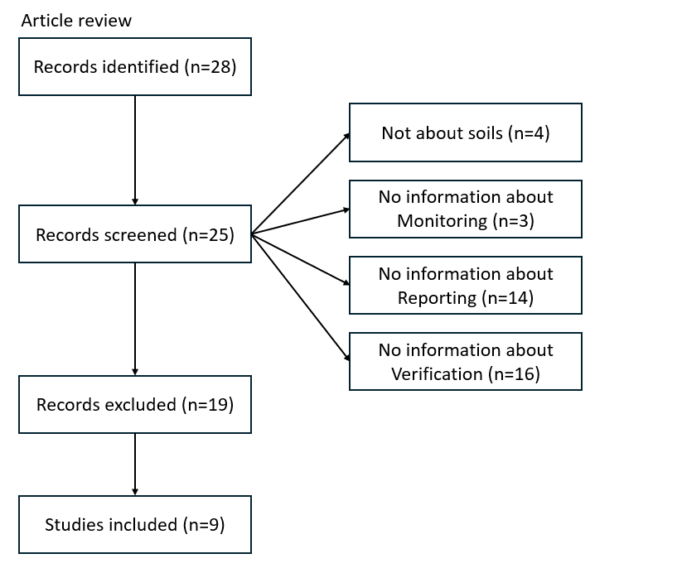

3.1.2. Webscraping
With webscraping, we collected 1180 websites but only 34 fitted the requirements (Figure 2).
Figure 2. PRISMA diagram with webscraping
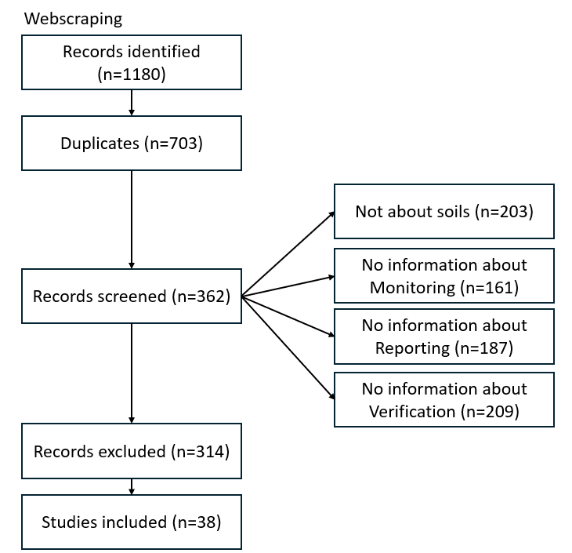

3.1.3. Browser based on Artificial Intelligence
With AI browsers, we obtained 31 websites and only one fitted the requirements (Figure 3).
Figure 3. PRISMA diagram with data from AI browser
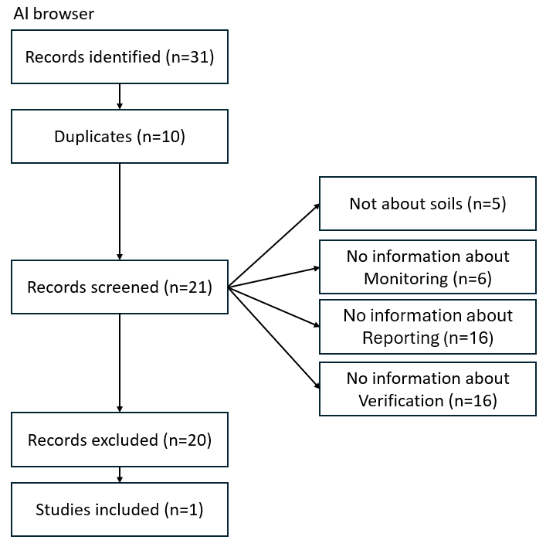

3.1.4. Total number of MRV procedures and rate of missing information per variable
In total, we found 96 MRV procedures. A lot of information was not provided in the documents we collected (Appendix X). As the information was missing for more than 30% of the dataset, we did not include in the analysis 1) regarding the monitoring, the use of the sampling frequency, the standard methodologies, the cost and the plot area, 2) regarding the reporting, the uncertainty measurement and the threshold methodology, 3) considering the verification, the methodology, the automatization, the auditor type and the data sharing.

3.2. Data description

3.2.1. Geographical location and implementation state
MRV procedures mainly took place in America, Oceania and Europe. Only few countries were covered in Africa and Asia (Figure 4).
Figure 4. Map of the number of MRV procedures taking place in each country
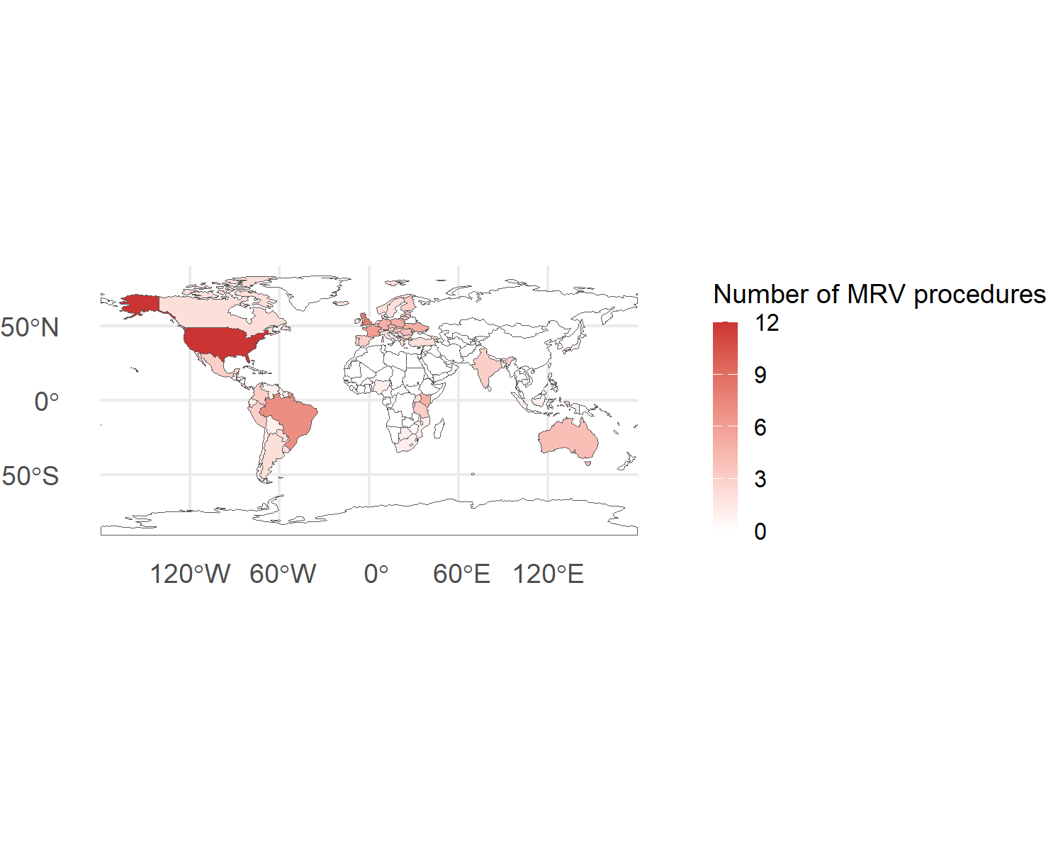
More than 80% of the MRV procedures were already implemented (Appendix X).

3.2.3. Stakeholders
More than 70% of the MRV procedures take place in agricultural areas. The other land uses were forest, peatlands or wetlands and degraded lands (Figure 5).
Figure 5. Number of MRV procedures according to the land use
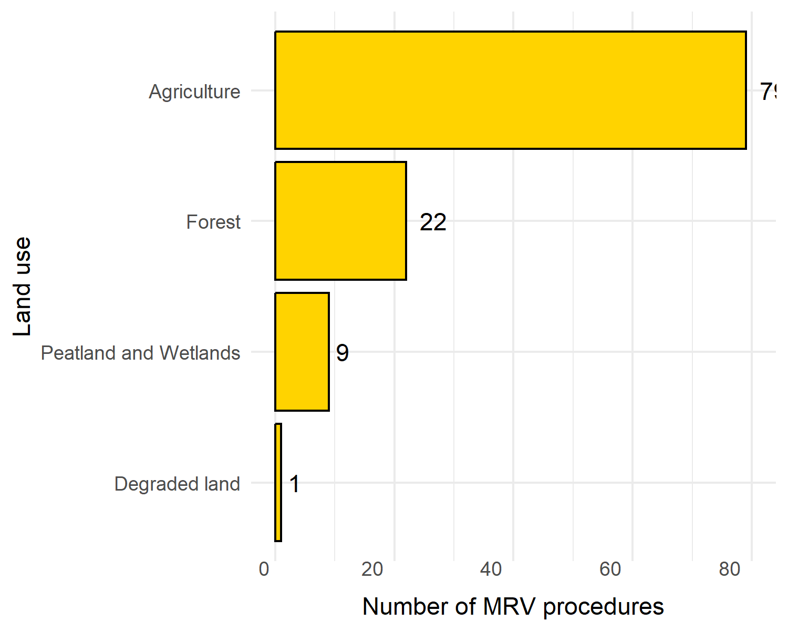
They take place mainly at local scale. More than 40 MRV procedures take place at regional scale and 17 at national scale (Figure 6). Only one MRV procedure was found at Global or continental scale.
Figure 6.Number of MRV procedures according to the geographical scale
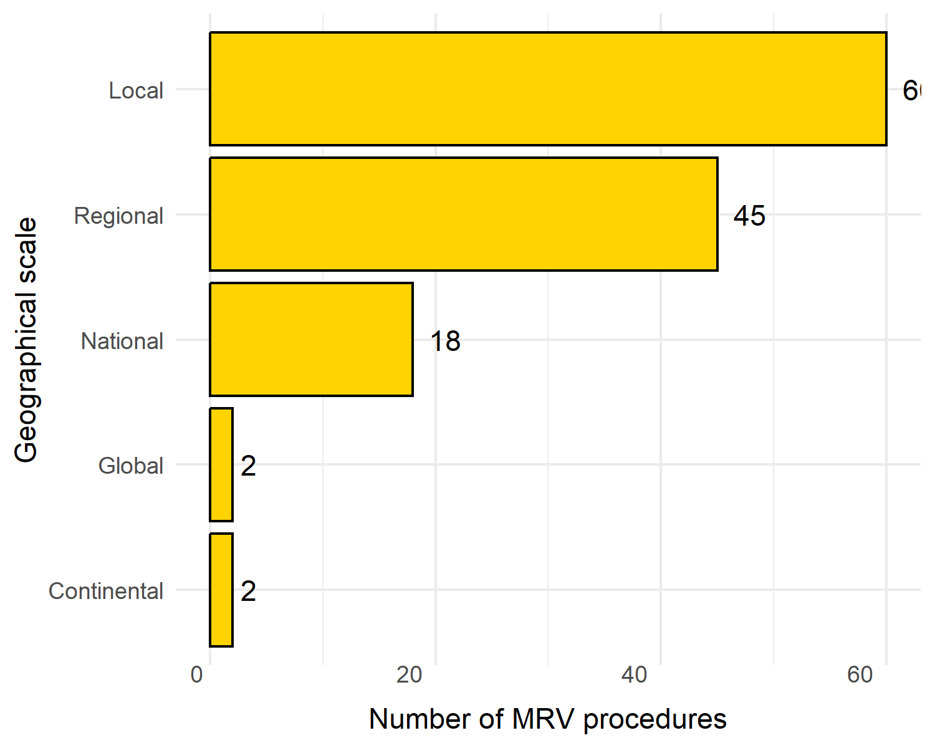
A large diversity of occupations were target by the MRV procedures. The majority involve are farmers and consultants and then, to a lesser extent, public administrators, agroindustry, NGO, academia, foresterforest companies, software developers and other companies (Figure 7).
Figure 7. Number of MRV procedures according the stakeholder occupation
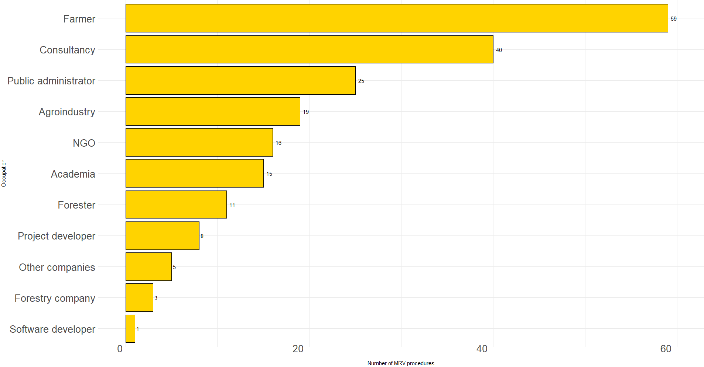

Five purposes were found: voluntary and compliance carbon market, certification, sustainability and certification (Figure 8). The main purpose of the MRV procedure was by far, voluntary carbon market.

Figure 8. Number of MRV procedures according to the purposes

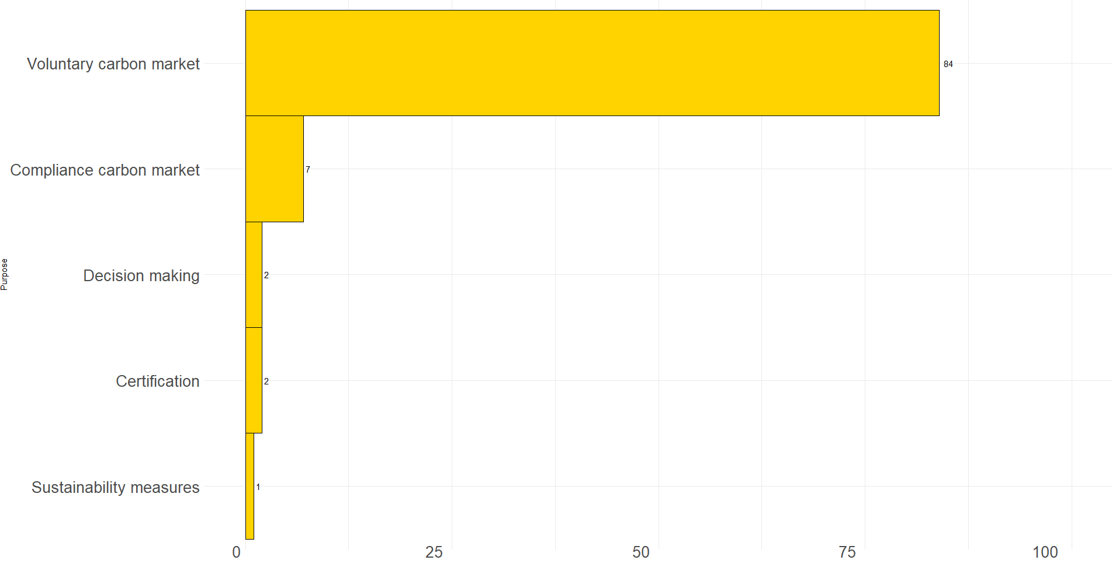

(Figure 9).

Figure 9. Number of MRV procedures according to the drivers
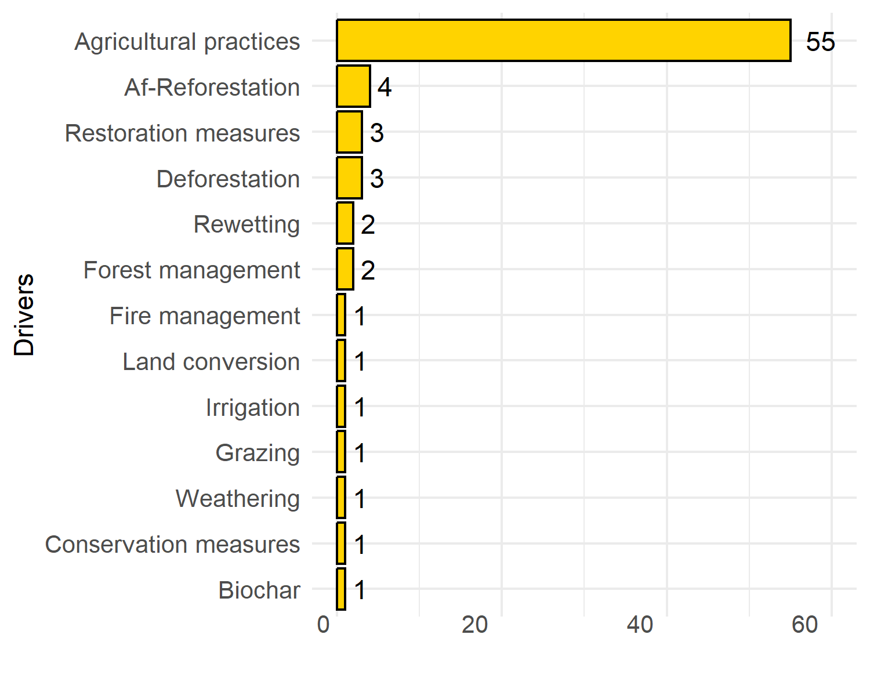

3.2.4. Monitoring
Twenty-two soil parameters are included in the MRV procedures. The most frequent is soil organic matter and carbon (Figure 10).
Figure 10. Number of MRV procedures according to Monitoring characteristics
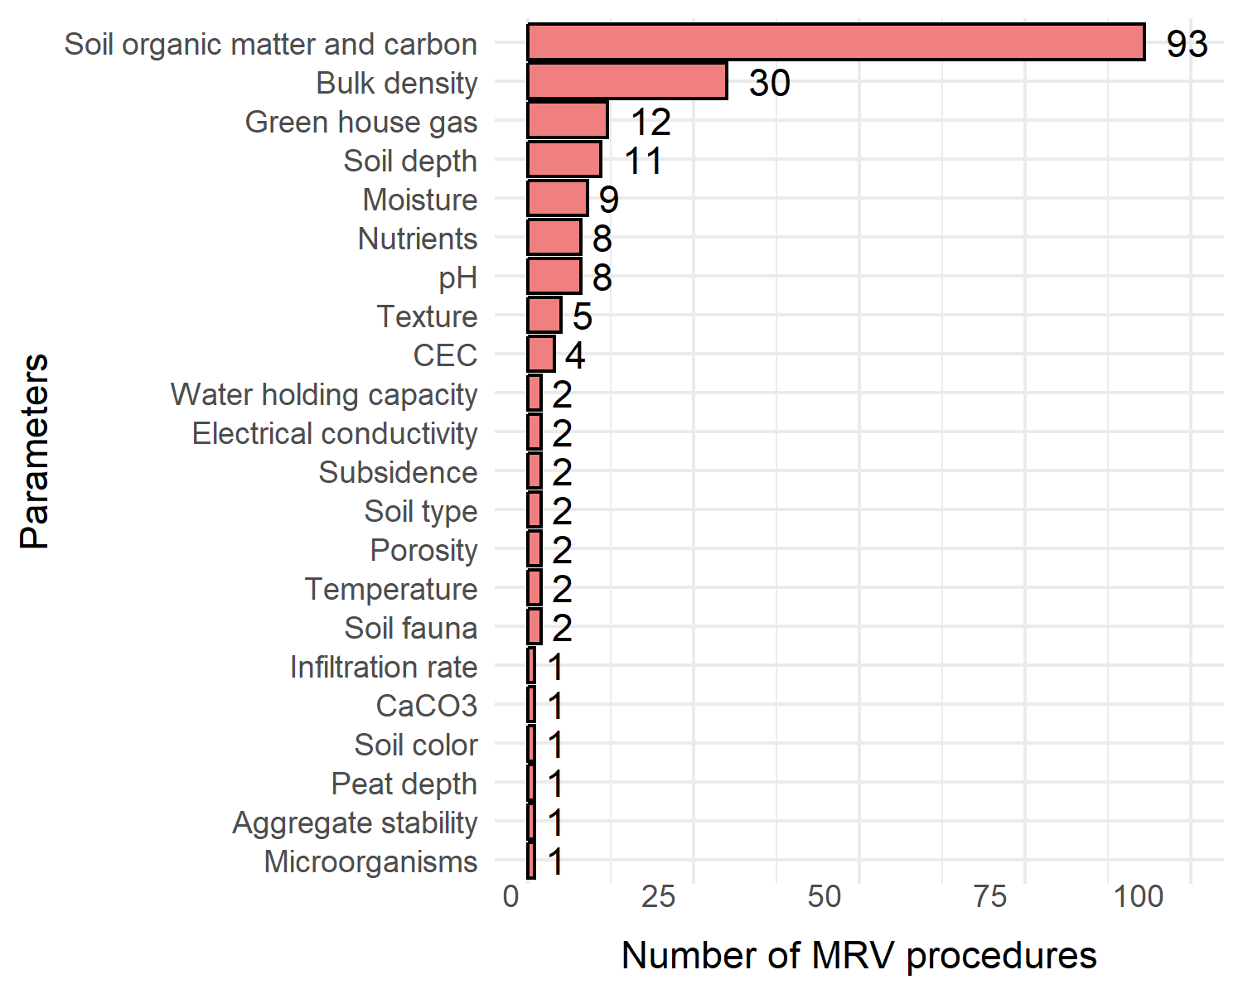
The monitoring methodology the most used is modelling combined with other methodologies or alone, based on literature data. Soil samples, spatial images and management information are also used in more than 50 MRV procedures. We found an MRV procedure based on site images i.e. a soil scanner (Figure 11).

Figure 11. Number of MRV procedures according to the monitoring methodology

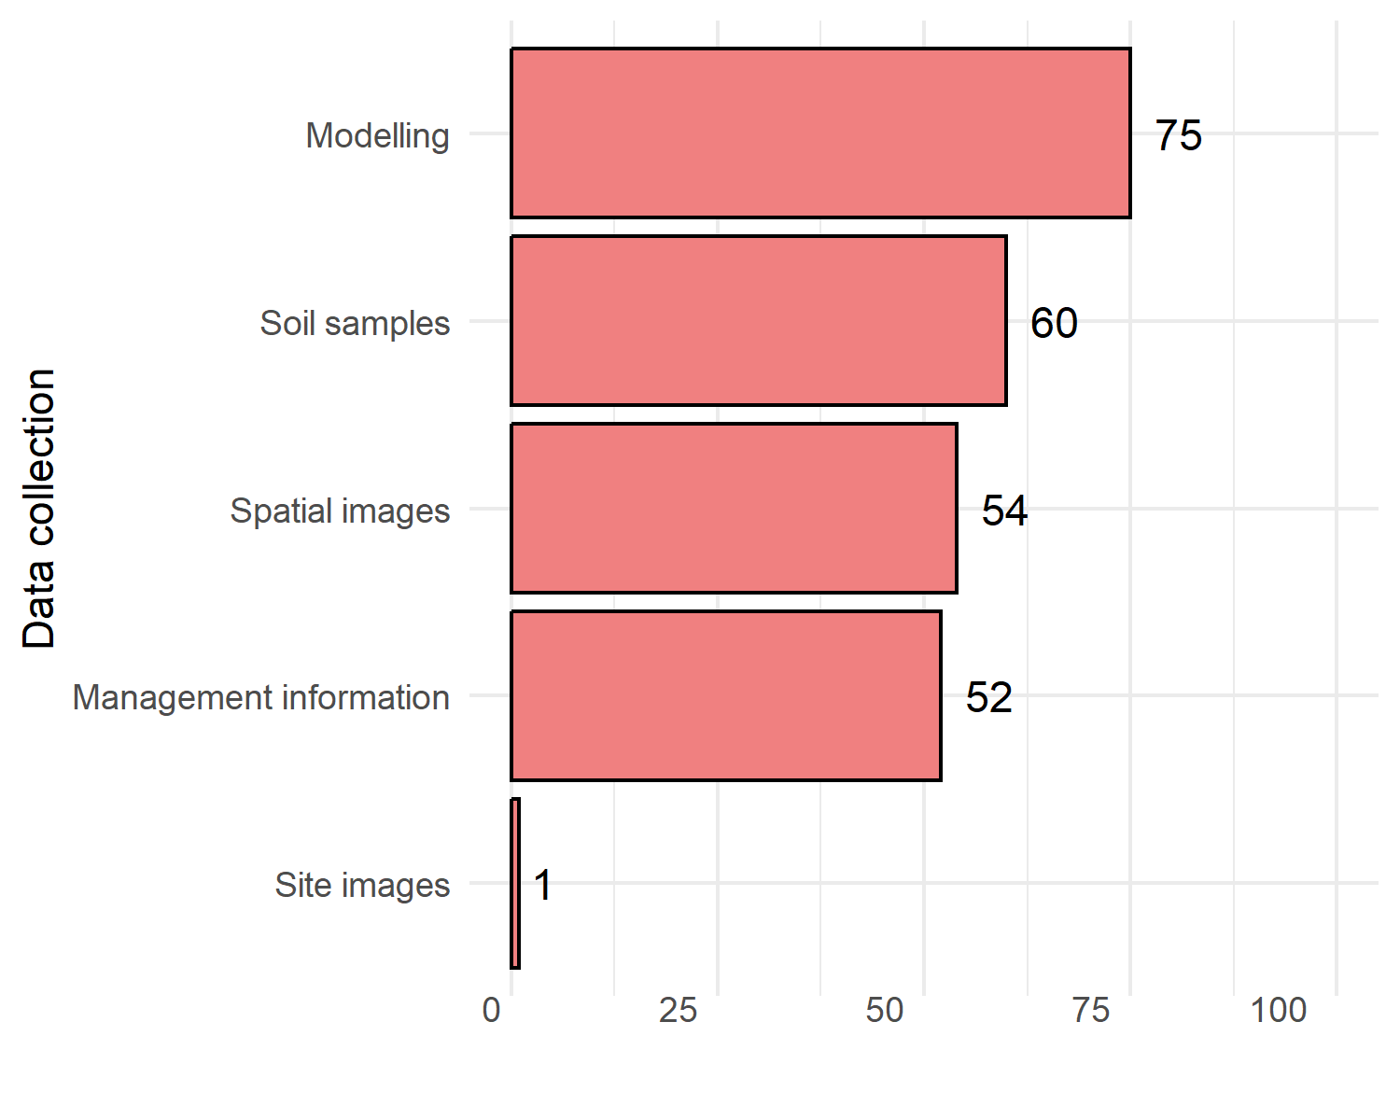

3.2.5. Reporting
The results are for more than 50 MRV procedures gathered in a classical report. An online platform is used for 29 MRV procedures (Figure 12).

Figure 12. Number of MRV procedures according to the reporting format
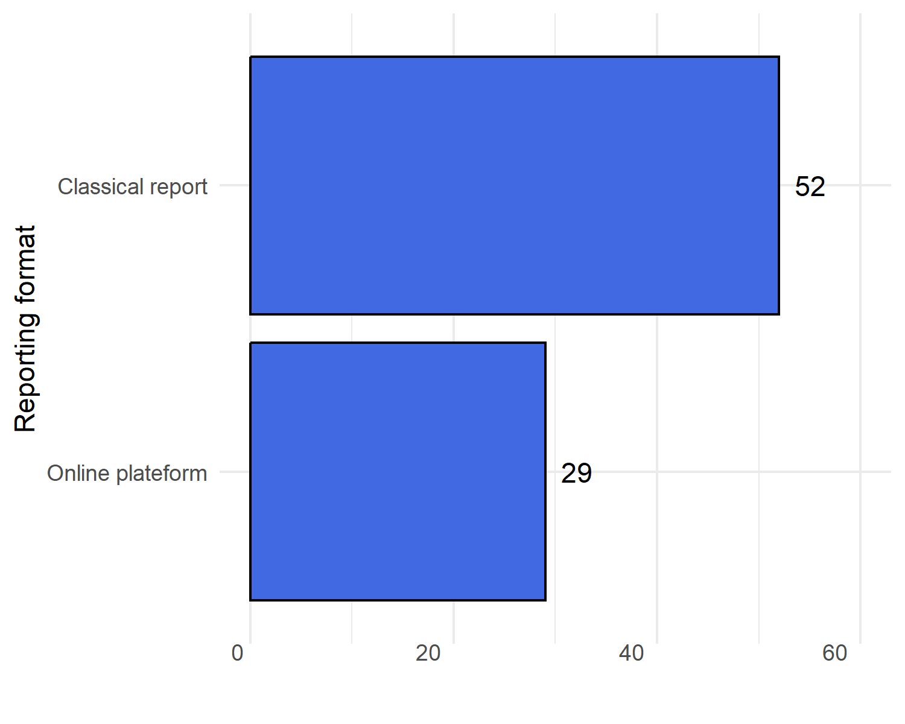

3.2.6. Verification
The verification is result-based for more than 60 MRV pocedures and action-based for 20 (Figure 13).
Figure 13. Number of MRV procedures according to the verification scheme
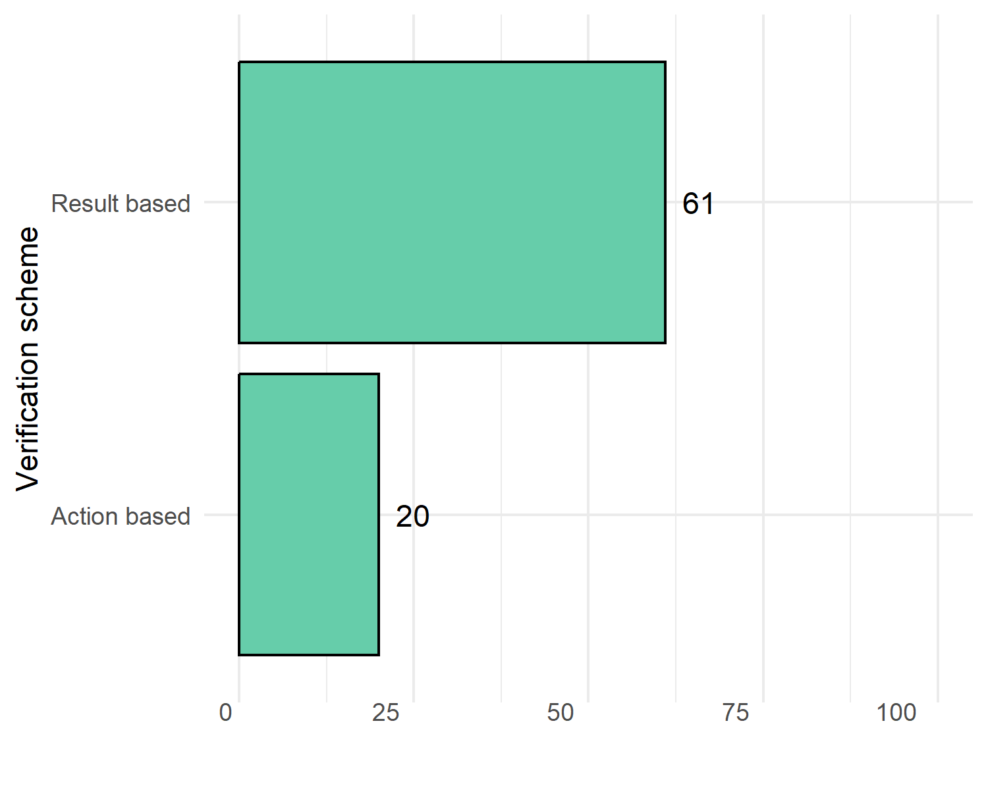

3.2.7. Co-occurrence between stakeholders’ and MRVs’ characteristics
Looking more precisely at the link between the characteristics of the stakeholders and the MRV procedures, we confirmed the previous results (Figure 14).
Focusing on the main co-occurrences (more than 25 MRV procedures), farmers and consultants are mainly involved in MRV procedures monitoring soil organic matter and carbon. For farmers, land management information, spatial images, soil sampling and modelling are very used methodologies. For consultants, it is mainly modelling. For farmers, the output is a classical report and the verification is action-based. For consultants, the result-based verification is also the most common.
The MRV procedures answering to voluntary carbon market mainly include the monitoring of soil organic matter and carbon, using a diversity of methodologies (soil sampling, satellite images, modelling, land management information). A classical report is written and the verification is result-based.
At local as regional scales, the main monitored parameter is soil organic matter and carbon. Soil sampling, satellite images, modelling, land management information were used in more that 25 MRV procedures. At local scale, the classical report and the result-based verification were the most common.
The MRV procedures implemented in agricultural areas were also mainly focused on soil organic matter and carbon, using the four methodologies previusly mentionned, a classical report and a result-based verification.
Regarding the drivers, the number of MRV procedures was very low (i.e. less than 10) per combination so no clear pattern appears.
Figure 14. Co-occurrence between the characteristics of stakeholders and MRV procedures
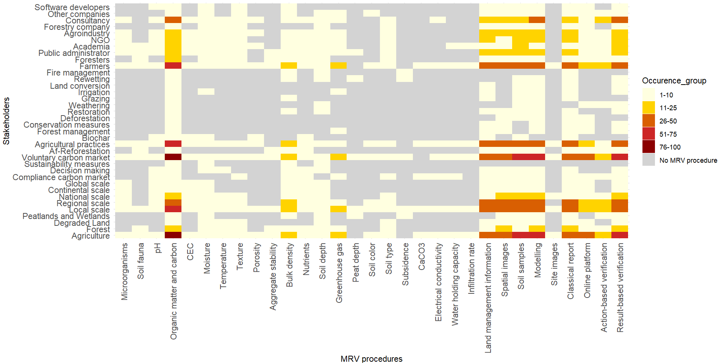

3.4. Typology of stakeholders and MRV procedures
Table to add
We classified the MRV procedures into six groups.
The first group involves stakeholders other than farmers: agroindustry, academia, consultancy, public administrators and NGOs. These MRV procedures take place from local to continental scale. The purpose is to help in decision-making and assess the effect of the changes in agricultural practices. The monitored parameters are nutrients, texture, soil depth, moisture, pH and temperature.
The second group is only defined by the monitored parameters: nutrients, pH, water holding capacity, porosity, CEC, moisture, infiltration ate and CaCO3.
The third group is very specific on the effect of grazing and by the lack of information regarding the implementation scale.
The fourth group involves only farmers and is focused on local scale. The driver is only the change in agricultural practices. The monitoring methodology could be land management information, soil sampling or the use of spatial images. The results are available on an online plateform. The verification is result-based.
The fifth group is focused on peatlands and wetlands. The effect of restoration measures is assessed. Soil depth and subsidence are monitored, and the results are gathered in a classical report.
The sixth group concerned only consultants. The monitoring is based on modelling.

3.5. Decision tool

3.5.1. Classification tree
to add

3.5.4. Interface
to add

4. Discussion

4.1. Knowledge state about MRV procedures including soils

4.1.1. Gap of knowledge regarding MRV procedures including soils
With only nine articles published, Monitoring Reporting and Verification is definitively a science frontier in soil sciences. The articles mentioning MRV usually describe the Monitoring part but do no give any information about Reporting and Verification. The term MRV is wider spread in the private sector. A good indicator of this statement is the higher information we got from webscraping than from scientific literature.

4.1.2. Lack of information translating a lack of transparence
Moreover, lot of information was not provided in the documents we collected that translates from a lack of transparency from the MRV providers. Lack of information about the sampling design could lead to a lack of robustness. Moreover, the uncertainty measurement is rarely described, risking green washing. The cost was almost never mentioned.

4.2. Most frequent characteristics of the stakeholders and the MRV procedures
Our study illustrates the hegemony of carbon market when soils are considered in the market. Thus, soil organic matter and carbon is from far, the most frequent monitored soil parameter. Moreover, agriculture sector was also the most represented. The absence of MRV procedures aiming urban areas is also mentioned. In the European Union, the recent Carbon Removals and Carbon Farming (CRCF) Regulation provides guidance for carbon farming (reference to add: https://eur-lex.europa.eu/legal-content/EN/PIN/?uri=OJ:L_202502358).
Soil sampling, satellite images, land management information and modelling are widely use as monitoring methodologies. Most of the time, soil sampling came as validation of other methodologies. Land management information were used to list the undertook actions such as the change of agricultural practices. However, the verification was clearly more often based on the changes in soil parameters values (called result-based) rather than on the implementation of these new practices (corresponding to action-based verification).
Looking specifically to the use of each MRV component by each type of stakeholders, these results were confirmed. The only difference that was highlighted was that consultants rather use modelling.

4.3. Pro and cons of the different groups of MRV procedures including soils
We established a typology of the MRV procedures by identifying six groups.
Group | Characteristic | Pro | Cons
1 | Target agroindustry, academia, consultancy, public administrators and NGOs)  From local to continental scale.  Focused on help in decision-making and the effect of the changes in agricultural practices.  The monitored parameters are nutrients, texture, soil depth, moisture, pH and temperature. | Very broad regarding stakeholder occupation and covered scale.  Several parameters assessed.
2 | Monitor nutrients, pH, water holding capacity, porosity, CEC, moisture, infiltration rate and CaCO3. | Several soil parameters assessed
3 | Assess the effect of grazing. |  | Very specific
4 | Target only farmers at local scale and the change in agricultural practices.  The monitoring methodologies are land management information, soil sampling or the use of spatial images.  Reporting via an online plateform  Verification result-based.
5 | Target peatlands and wetlands and assess the effect of restoration measures  Monitor soil depth and subsidence  Classical report |  | Very specific
6 | Target consultants.  The monitoring is based on modelling. | Easy to implement | Modelling could be approximative if based on data collected outside of the study area.

4.4. How far are we from an MRV procedure aiming soil health preservation?
Assessing soil health is a challenging ambition raised by the European Union with the Soil monitoring law and the Horizon project BENCHMARKS. In BENCHMARKS, a consortium of scientists are identifying the key soil parameters to assess soil health. The MRV procedures listed are focused mainly on carbon and include sometimes other parameters. Thus, they are far to cover soil health.

5. Conclusion and perspectives
This study answers to this need of knowledge regarding the existing MRV procedures including soils.

6. References

Altieri, M.A., Nicholls, C.I., Henao, A., Lana, M.A., 2015. Agroecology and the design of climate change-resilient farming systems. Agron. Sustain. Dev. 35, 869–890. https://doi.org/10.1007/s13593-015-0285-2
Bárcena, T.G., Kiær, L.P., Vesterdal, L., Stefánsdóttir, H.M., Gundersen, P., Sigurdsson, B.D., 2014. Soil carbon stock change following afforestation in Northern Europe: a meta‐analysis. Global Change Biology 20, 2393–2405. https://doi.org/10.1111/gcb.12576
Batjes, N.H., Ceschia, E., Heuvelink, G.B.M., Demenois, J., Le Maire, G., Cardinael, R., Arias-Navarro, C., Van Egmond, F., 2024. Towards a modular, multi-ecosystem monitoring, reporting and verification (MRV) framework for soil organic carbon stock change assessment. Carbon Management 15, 2410812. https://doi.org/10.1080/17583004.2024.2410812
Ceschia, E., Ihasusta, A., Al Bitar, A., Batjes, N., van Egmond, F., Heuvelink, G., Paul-Victor, C., Nogues, M., Pontes, L., Reynders, S., Wijmer, T., Karunaratne, S., Macdonald, B., Lanckriet, E., Ruau, C., Juber, R., Vira, J., Kulmala, L., submitted. Monitoring, reporting and verification of soil organic carbon stock changes at arable land: Cookbook for assessment in different MRV contexts and proposition of a harmonised approach - ORCASA Deliverable 4.2.
Chowdhury, S., Kain, J.-H., Adelfio, M., Volchko, Y., Norrman, J., 2023. Transforming brownfields into urban greenspaces: A working process for stakeholder analysis. PLoS ONE 18, e0278747. https://doi.org/10.1371/journal.pone.0278747
Eggers, J., Räty, M., Öhman, K., Snäll, T., 2020. How Well Do Stakeholder-Defined Forest Management Scenarios Balance Economic and Ecological Forest Values? Forests 11, 86. https://doi.org/10.3390/f11010086
Khangura, R., Ferris, D., Wagg, C., Bowyer, J., 2023. Regenerative Agriculture—A Literature Review on the Practices and Mechanisms Used to Improve Soil Health. Sustainability 15, 2338. https://doi.org/10.3390/su15032338
Pachón Maldonado, J.C., Leonard, E.C., Field, D.J., McRobert, K., Heath, R., McBratney, A.B., 2024. Quantifying the connectivity dimension of the soil security assessment framework. Soil Security 17, 100175. https://doi.org/10.1016/j.soisec.2024.100175
Probst, B.S., Toetzke, M., Kontoleon, A., Díaz Anadón, L., Minx, J.C., Haya, B.K., Schneider, L., Trotter, P.A., West, T.A.P., Gill-Wiehl, A., Hoffmann, V.H., 2024. Systematic assessment of the achieved emission reductions of carbon crediting projects. Nat Commun 15, 9562. https://doi.org/10.1038/s41467-024-53645-z
Schreefel, L., Creamer, R.E., Van Zanten, H.H.E., De Olde, E.M., Pas Schrijver, A., De Boer, I., Schulte, R.P.O., 2023. How to Monitor the ‘Success’ of (Regenerative) Agriculture: A Perspective (preprint). SSRN. https://doi.org/10.2139/ssrn.4525658
Sher, A., Li, H., Ullah, A., Hamid, Y., Nasir, B., Zhang, J., 2024. Importance of regenerative agriculture: climate, soil health, biodiversity and its socioecological impact. Discov Sustain 5, 462. https://doi.org/10.1007/s43621-024-00662-z
Strauss, V., Paul, C., Dönmez, C., Löbmann, M., Helming, K., 2023. Sustainable soil management measures: a synthesis of stakeholder recommendations. Agronomy for Sustainable Development 43. https://doi.org/10.1007/s13593-022-00864-7
Trencher, G., Nick, S., Carlson, J., Johnson, M., 2024. Demand for low-quality offsets by major companies undermines climate integrity of the voluntary carbon market. Nat Commun 15, 6863. https://doi.org/10.1038/s41467-024-51151-w
Trouwloon, D., Streck, C., Chagas, T., Martinus, G., 2023. Understanding the Use of Carbon Credits by Companies: A Review of the Defining Elements of Corporate Climate Claims. Global Challenges 7, 2200158. https://doi.org/10.1002/gch2.202200158
Vanino, S., Pirelli, T., Di Bene, C., Bøe, F., Castanheira, N., Chenu, C., Cornu, S., Feiza, V., Fornara, D., Heller, O., Kasparinskis, R., Keesstra, S., Lasorella, M.V., Madenoğlu, S., Meurer, K.H.E., O’Sullivan, L., Peter, N., Piccini, C., Siebielec, G., Smreczak, B., Thorsøe, M.H., Farina, R., 2023. Barriers and opportunities of soil knowledge to address soil challenges: Stakeholders’ perspectives across Europe. Journal of Environmental Management 325, 116581. https://doi.org/10.1016/j.jenvman.2022.116581
Vieillard, C., Vidal-Beaudet, L., Dagois, R., Lothode, M., Vadepied, F., Gontier, M., Schwartz, C., Ouvrard, S., 2024. Impacts of soil de-sealing practices on urban land-uses, soil functions and ecosystem services in French cities. Geoderma Regional 38, e00854. https://doi.org/10.1016/j.geodrs.2024.e00854

7. Acknowledgments
To add

8. Appendices

Appendix 1. Missing information for each MRV procedure
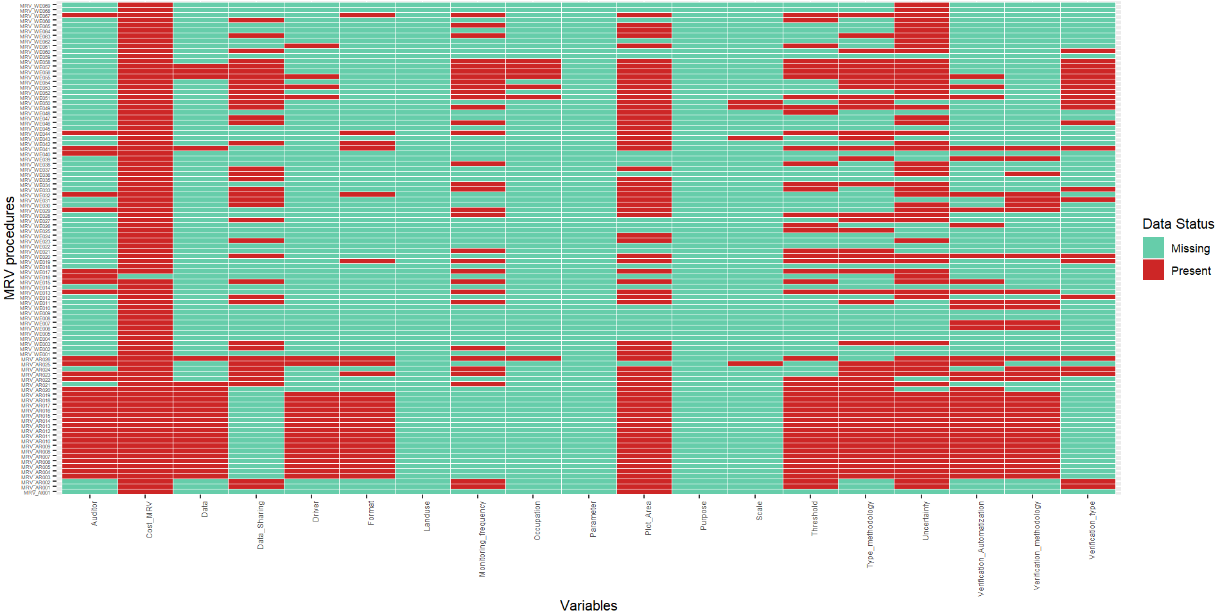
Appendix 2. Percentage of MRV procedures already implemented or under development
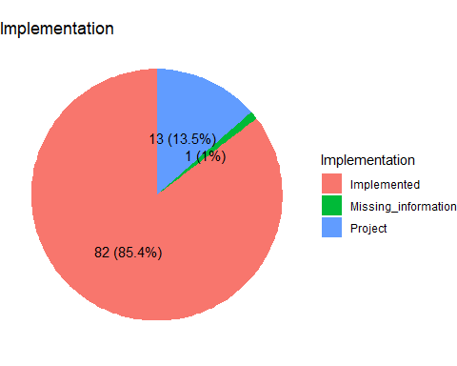

9. Author contribution

