Monitoring, Reporting and Verification procedures for soil health: Current landscape, stakeholder dynamics and future pathways
Authors: Camille Imbert¹, Antonio Bispo², Sophia Götzinger³, Peter Hoebe⁴, Taru Sandén³, Sambit Shome¹, Lucile Rabeau⁵ and Kilian Walz⁶
Affiliations:
¹Leibniz-Centre for Agricultural Landscape Research (ZALF), Eberswalder Str. 84, D-15384 Müncheberg, Germany
²INRAE Info&Sols, 2163, avenue de la Pomme de Pin, CS 40001 Ardon, 45075 Orléans cedex 2, France
³Austrian Agency for Health and Food Safety – AGES, Institute for Sustainable Plant Production, Department for Soil Health and Plant Nutrition, Spargelfeldstraße 191, A-1220 Wien, Austria
⁴Earthwatch Europe, 102-104 St Aldates, Oxford, OX1 1BT, United Kingdom
⁵Independent researcher, Paris, France
⁶ Commonland Foundation,Kraanspoor 26, 1033 SE Amsterdam, Netherlands
Keywords: Monitoring Reporting Verification (MRV), Soil health, Carbon market, Literature review, Web scrapping, Artificial Intelligence browser, Transparency, Monitoring accuracy

Abstract
To counteract green washing, the effects of human activities on soil health should be monitored in an accurate way and results should be transparently reported and verified. It is the purpose of Monitoring, Reporting and Verification (MRV) procedures. They were studied in the context of soil carbon credits but no broader overview, including other aspects of soils, exists. The objective of this study is to fill this gap of knowledge by gathering, describing and classifying the MRV procedures including soil parameters, across the world. As the term MRV seems to be not very used by scientists, we combined three methodologies to collect information about MRV procedures: the classical use of scientific article database, web scraping and Artificial Intelligence browsers. We found 96 MRV procedures and partial information was available. Most of the available MRV procedures were applied on a local scale, in agriculture areas, answering the need of voluntary carbon markets. Results were mainly gathered in a classical report and result-based verified. We classified the MRV procedures into six groups. Our study illustrated the hegemony of carbon market in the MRV context. They were well distinct: the largest group focused on agriculture with farmers and consultants, adopt a large variety of monitoring methodologies, report the results on an online platform and the verification is result-based. The second largest group targeted consultants and is based on modelling. The verification is action-based. The other groups were very small and specific: one was focused on the effect of grazing rate and the other on peatland and wetland restoration. The last group was characterized by the absence of information regarding stakeholder occupation. We also highlighted the lack of transparency from companies offering MRV procedures. In complement, we developed a decision tool to help future users of MRV procedures to navigate in our dataset and select the adequate MRV procedure, adapted to their context. The next step is to understand how to pass from a carbon-focused MRV procedure to a broader one, assessing soil health.

1. Introduction
Numerous solutions to preserve or restore soil health are applied by stakeholders such as adopting agro-ecological practices, de-sealing or planting trees (Altieri et al., 2015; Bárcena et al., 2014; Vieillard et al., 2024). Healthy soils correspond to soils that are in good chemical, biological, and physical conditions, and which can therefore provide ecosystem services vital to human and the environment, such as a safe, nutritious and sufficient food, biomass, clean water, nutrient cycling, carbon storage, and a habitat for biodiversity (Directorate-General for Environment, 2025; Vazquez, et al., 2025). To create an incentive for land managers to preserve and restore soil health, few instruments are currently available. On a global level, voluntary carbon markets have been evolving as one of the major market-based instruments allowing to generate and trade credits as certified units that help to finance the adoption of more sustainable agricultural practices (Batjes et al., 2024; European parliament and the council of the European Union, 2024). A carbon credit is a certificate that represents one ton of CO2-equivalent and is the common trading unit on carbon markets (https://www.offsetguide.org/understanding-carbon-offsets/what-is-a-carbon-offset/). However, in several cases, carbon offsetting projects were deemed to under deliver on the expected climate mitigation outcomes leading to numerous green washing situations i.e. when actions to preserve environment (as mitigating climate change) do not attain what the stakeholder claims (Trouwloon et al., 2023). These scandals discredit the effectiveness of carbon credits as means to achieve climate mitigation (Probst et al., 2024; Schreefel et al., 2023; Trencher et al., 2024). A prominent example is the non-commensurate use of carbon credits to achieve greenhouse gas reductions beyond solely offsetting residual emissions as prescribed in voluntary best-practice guidance (Trouwloon et al., 2023).
To counteract green washing, the effects of the activities that lead to an intended outcome should be monitored in a scientifically robust way and results should be transparently reported and verified. It is the purpose of Monitoring, Reporting and Verification (MRV) procedures (Smith et al., 2020). They are transparent and accurate frameworks giving indications in the way to assess the impact of an action on an object. Regarding soils, the objective of the MRV procedures is to demonstrate the effect of land management (mainly, e.g. moving to agro-ecological practices) or reforestation, on soil parameters (such as organic matter content or biodiversity). Moreover, MRV procedures centred on other topics such as forest preservation include the assessment of soil parameters. The term MRV seems to not be known by soil stakeholders except in the sector of carbon markets (Batjes et al., 2024). In the soil scientific community, this term is promoted by the two recent EU projects BENCHMARKS and MARVIC (https://soilhealthbenchmarks.eu/, https://www.project-marvic.eu/ ). Until now, scientists mainly described carbon-focused MRV procedures and no classification targeting a larger spectrum of purposes exists (Batjes et al. 2024).
Thus, there is a need to go beyond carbon and identify all the MRV procedures including soil parameters. Indeed, MRV procedures could be applied in all the contexts dealing with soils. The main stakeholders are land managers as farmers, foresters or public administration but also scientists, NGOs and companies are concerned because they encourage practices enhancing soil health. Regarding soil monitoring, biological, physical and chemical parameters could be assessed with sampling, remote sensing, on-site images, modelling or several of these methodologies combined (Batjes et al., 2024). Land management information, collected with questionnaires answered by farmers, could also be used as proxy of soil parameters (Batjes et al., 2024). Result uncertainty is computed with probabilistic methods (Markov chain Monte Carlo and Bayesian inference), a sensitivity analysis or basic quantile distribution (with the representation and/or consideration of the quantiles in the result interpretation, Ceschia et al., 2025). Data are compared to reference values to determine if the implemented action is beneficial or not to soils. Matson et al., 2024 describes four methodologies for computing these reference values : 1) fixed value i.e. a static value based on best available research or knowledge, 2) reference value i.e. a static value, calculated as a percentage of what would be found in a reference situation, where soil processes are occurring in a way that is considered to be desirable such as natural areas, 3) data distribution i.e. a changeable value, based on the regional state of the soil, 4) relative change i.e. the target defined as an increase or decrease of a certain percent within a specified number of years for a same place. Results are gathered in a document or entered on an online platform (Andries et al., 2021). The verification could take two forms: result-based i.e. doubling soil measurements with the same or a different methodology than for the monitoring step, or action-based i.e. the implementation of the actions is verified during a site visit, by remote sensing or with a phone application. The auditor could be part of the organization implementing the soil monitoring or independant.
In this study, we review and classify the adoption of MRV procedures for assessing soil health and, in doing so, to determine whether it is used beyond the context of carbon markets. We also identify the involved stakeholders, as well as the associated soil management practices. We also suggest a decision tool to help future users to select the right MRV procedure, corresponding to their context. As we suspected that few scientific articles would be written on the topic of soil MRV procedures, we decided to combine three methods: the traditional literature review using a database of scientific articles and recent ones: web scraping and the AI browsers Perplexity and Elicit. While traditional literature review has been the common method for any academic researcher, web scraping has been introduced for accessing grey literature from websites in a more systematic manner (Sayles et al., 2022). Most recently, Artificial Intelligence has emerged providing a wide array of search capabilities and in particular, browsers as Perplexity and Elicit trained for the scientists. Our findings are very relevant for future stakeholders wishing to develop or implement MRV procedures for soil health that will be able to identify existing approaches or build upon them, with a view to adapting existing practices to their needs and context.

2. Materials and methods

2.1. Data search
As MRV procedures on soils seem to not be well studied, we decided to use a very broad search string: Monitor* AND Report* AND Verif* AND MRV AND soil*. We used it for the three methods we combined to collect scientific articles and websites presenting MRV procedures: a search on the database of scientific articles Scopus, web scraping and the use of Artificial Intelligence browsers Elicit and Perplexity. The search was done in Scopus in March 2025 and includes article titles, abstracts and keywords. It resulted in 18 articles (primary studies, reviews and book chapters). We recorded the name of the first author, the title, the publication year, the DOI and the type of document i.e. if it was a primary study, an editorial article or a review. Then, we developed a web scraping script using Python 3.9.7 and Selenium web driver (Appendix 2, https://www.selenium.dev/documentation/webdriver/). We ran the script to scrap the first 20 pages on Google SERP. We manually handled reCAPTCHA images. As results provided by Google varied according to the country location, the date and the IP address, we decided to run the script during Autumn 2025, from different countries and different computers in Europe (Appendix 3). We recorded the URL link, webpage title and URL domain in a database for further analysis. We used the Artificial Intelligence browsers Perplexity (https://www.perplexity.ai/) and Elicit (https://elicit.com/) in December 2025 with the following prompt: "I would like to investigate existing Monitoring, Reporting and Verification Systems for soil parameters. Please find the documents for this contextual focus and give a table that I can copy, listing these documents, with for each of them, a URL link to download them." We recorded the document title and the URL link in a dataset for further analysis.

2.2. Data extraction

2.2.1. Inclusion rules
To be included in the study, the collected articles and websites should at least indicate one of the required types of information for each step of the MRV procedure i.e. one information regarding monitoring, one for reporting and one for verification. For example, if only information about monitoring was given, such as the assessed soil parameters and no information about reporting nor verification, the document was excluded of the analysis. Moreover, the MRV procedure was required to include at least one soil parameter. For example, MRV procedures about greenhouse gas emissions in forest, focusing on parameters related to the vegetation, without considering a single soil parameter, were excluded.

2.2.2. Duplicate management
The same document or the same MRV procedure could be collected several times. For example, several scientific articles could include the same MRV procedure, or a website could appear several times. We consider any new mention of an already mentioned MRV procedure as duplicate. Thus, we avoided counting twice the same MRV procedure.

2.2.3. Data collection
We considered the land uses and land covers were the MRV procedures are applied, the geographical scale (i.e. local such as a field, a farm or a forest area, regional corresponding to several sites or farms, national, continental and global scale). We categorized occupations of stakeholders implementing the MRV procedures as farmers, foresters and forester associations, public administrators, educational and research institutions, NGOs, agroindustry, forestry companies and consultants and others (Chowdhury et al., 2023; Eggers et al., 2020; Pachón Maldonado et al., 2024; Strauss et al., 2023; Vanino et al., 2023). We indicated the purpose of the MRV procedure i.e. the reason why it was developed : 1) voluntary carbon market i.e. a carbon market in which members are not legally compelled to reduce their emissions but do so voluntarily, 2) compliance carbon markets also known as mandatory markets, governed by national, regional, or provincial law and 3) certification i.e. a procedure to attribute a label (Batjes et al., 2024; Ceschia et al., 2025). We recorded the actions that were implemented.
Monitoring methodologies were divided in : 1) information about land management, 2) spatial images, 3) on-site images with photos, 4) soil samples and 5) modelling (Batjes et al., 2024). When soil samples are used, we collected information about the sampling design: 1) the plot area and 2) the monitoring frequency i.e. duration between two monitoring sessions (less than every 5 years, between 5 and 10 years, between 10 and 15 years or more than 15 years as in Batjes et al. 2024). Soil parameters required in each MRV procedure were listed. We also recorded if sampling and/or analytical methods comply to existing standards (e.g. ISO). We described the format of the report (classical document or online platform, Andries et al., 2021) and the statistical methodology employed to compute the uncertainty of the results: 1) probabilistic methods corresponding to Markov chain Monte Carlo (MCMC) and Bayesian inference, 2) sensitivity analysis, i.e. the effect of the explanatory variables on the uncertainty of the results and 3) quantile distribution, with the representation and/or consideration of the quantiles in the result interpretation (Ceschia et al., 2025). We recorded the methodology used to compute the reference values : 1) fixed value, 2) reference value, 3) data distribution, or 4) relative change (Matson et al. 2024). Regarding verification, five information were listed: the scheme i.e. action-based or result-based (Batjes et al. 2024), the methodology i.e. soil sampling, satellite data, phone application or site inspection, its automatization, auditor independence and data access. Finally, we recorded if the MRV procedure was already implemented or under development and the country where the MRV procedure was/would be implemented.

2.3. Data analysis

2.3.1. Management of missing information
Once the data collection was done, we noticed a large part of missing information. As missing information could bias the results, in particular with categorical variables, we decided to keep in the analysis only variables that presented more than 70% MRV procedures with information.

2.3.2. Data description
We pooled the data collected from the three search methods. We used the software R 4.3.0 and the library ggplot2 to build bar plots for each variable and a co-occurrence matrix between stakeholder' and MRV procedure' s characteristics.

2.3.3. Typology of MRV procedures
We implemented multiple component analysis (MCA, function MCA, package R FactomineR, Lê et al., 2008) and a Hierarchical Clustering on Principle Components (HCPC, function HCPC, package FactoMineR) to identify the groups of MRV procedures and the particular elements characterizing them. We computed a v-test and its p-value (Husson et al., 2017). We focused our analysis on the categories with 1) v-test>2 and 2) a p-value<0.05.

2.3.4. Building the decision tool
We built a user-friendly interface to access our dataset, with Python version to add. The outputs are the MRV procedures with a card format, fitted to the context of the user. All the codes and datasets needed to run the decision tool are part of the appendices (Appendix 8).

3. Results
All sources pooled, nine scientific articles and 32 websites were selected (on 28 articles and 1211 websites collected, Appendix 1). In total, we found 96 MRV procedures. Only little information was provided in the documents we collected (Appendix 5). We did not include in the analysis variables with information missing for more than 30% of the MRV procedures: 1) regarding the monitoring, sampling frequency, standard methodologies, cost and plot area, 2) regarding the reporting, uncertainty measurement and threshold methodology, 3) considering the verification, methodology, automatization, auditor type and data sharing.

MRV procedures mainly took place in America, Oceania and Europe. Only few countries were covered in Africa and Asia (Figure 1).

Figure 1. Map of the number of MRV procedures taking place in each country
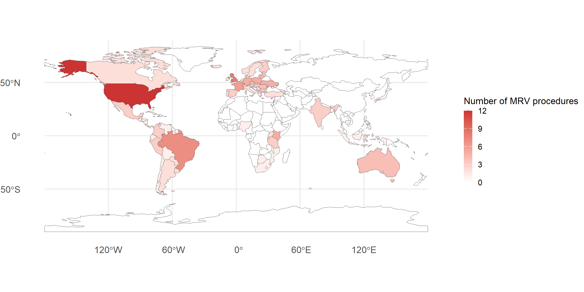
More than 80% of the MRV procedures were already implemented (Appendix 5).

3.1. Data description
Seventy-nine MRV procedures took place in agricultural areas (Fig. 2 a.). The other land uses and land covers were forests (22), peatlands or wetlands (9) and degraded lands (1, Fig. 2 a.). They took place mainly at local scale (62 MRV procedures) and then at regional scale (45) and national scale (18, Figure 6). Only two MRV procedures were applied at continental or at Global scale.
A large diversity of occupations was involved in the MRV procedures. The majority targeted farmers (59 MRV procedures) and then consultants (40). At a lesser extent, MRV procedures also included other occupations as public administrators (25), agroindustry (19), NGO (16), academia (15), project developers (12), foresters (11), forest companies (3), software developers (1) and other companies (5, Fig. 2 d.). Five purposes were found: voluntary and compliance carbon markets, certification and sustainability measures (Fig. 2 c.). The main purpose of the MRV procedure was by far, voluntary carbon market with 84 MRV procedures. The main actions was the change in agricultural practices (59 MRV procedures). They could be specified as mineral weathering, irrigation, grazing practices and biochar spreading. We found other very rare actions (less than five MRV procedures) as: afforestation and reforestation, restoration measures, deforestation, rewetting of peatlands and wetlands, forest management, fire management and land conversion (Fig. 2 e.).

Figure 2. Number of MRV procedures according stakeholders’ characteristics: land uses and land covers (a.), geographical scales (b.), occupation (c.), purpose (d.) and the implemented actions (e.)
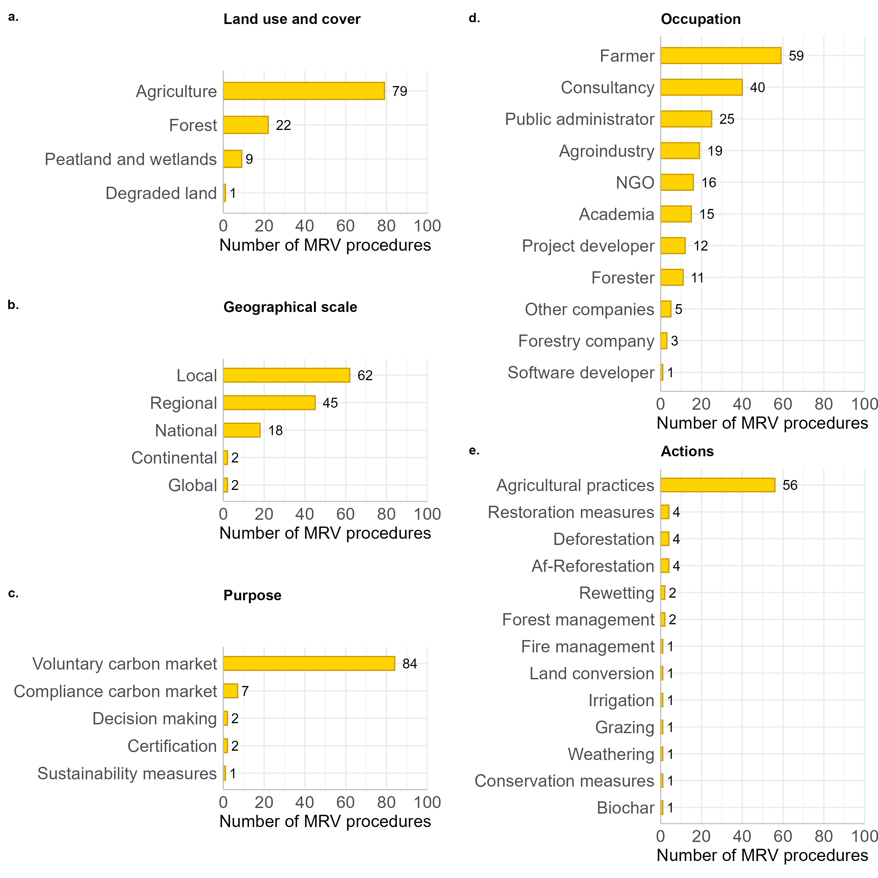
Regarding monitoring, a total of 22 soil parameters were identified in the MRV procedures (Fig. 3 a.). Physical, chemical and biological parameters were assessed. The most frequent was soil organic matter and carbon, monitored in almost all of them (93 MRV procedures, Fig. 3 a.). In average, two parameters were assessed by MRV procedure. The minimum number was one parameter, and the maximum was nine for the procedure MRV WE020 (measurements included pH, soil organic matter, texture, bulk density, nutrient availability, greenhouse gases, soil type, calcium carbonates, electrical conductivity and water holding capacity, Appendix 3). The most used monitoring methodology was modelling with 75 MRV procedures. Soil samples, spatial images and management information are also used in more than 50 MRV procedures. We also found a MRV procedure (MRV WE011) based on site images taken with a smart phone (Appendix 3).

Figure 3. Number of MRV procedures according to the included soil parameters (a.) and the type of data used for monitoring (b.)
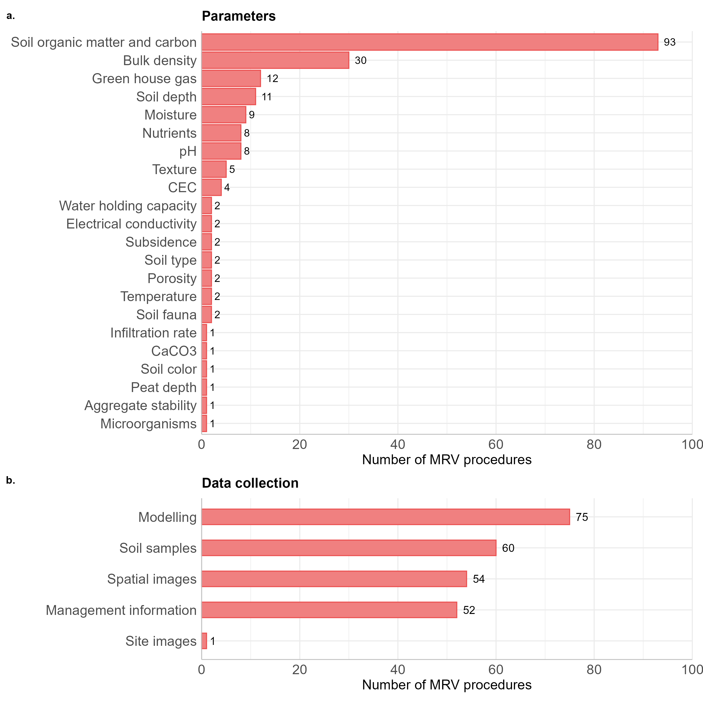
Results were for 52 MRV procedures gathered in a classical report. An online platform was used for 29 MRV of them (Fig. 4 a.). The verification was mainly based on the results (61 MRV procedures) and on the implementation of the actions for 20 MRV procedures (Fig. 4 b.).

Figure 4. Number of MRV procedures according to the reporting format (a.) and the verification scheme (b.)
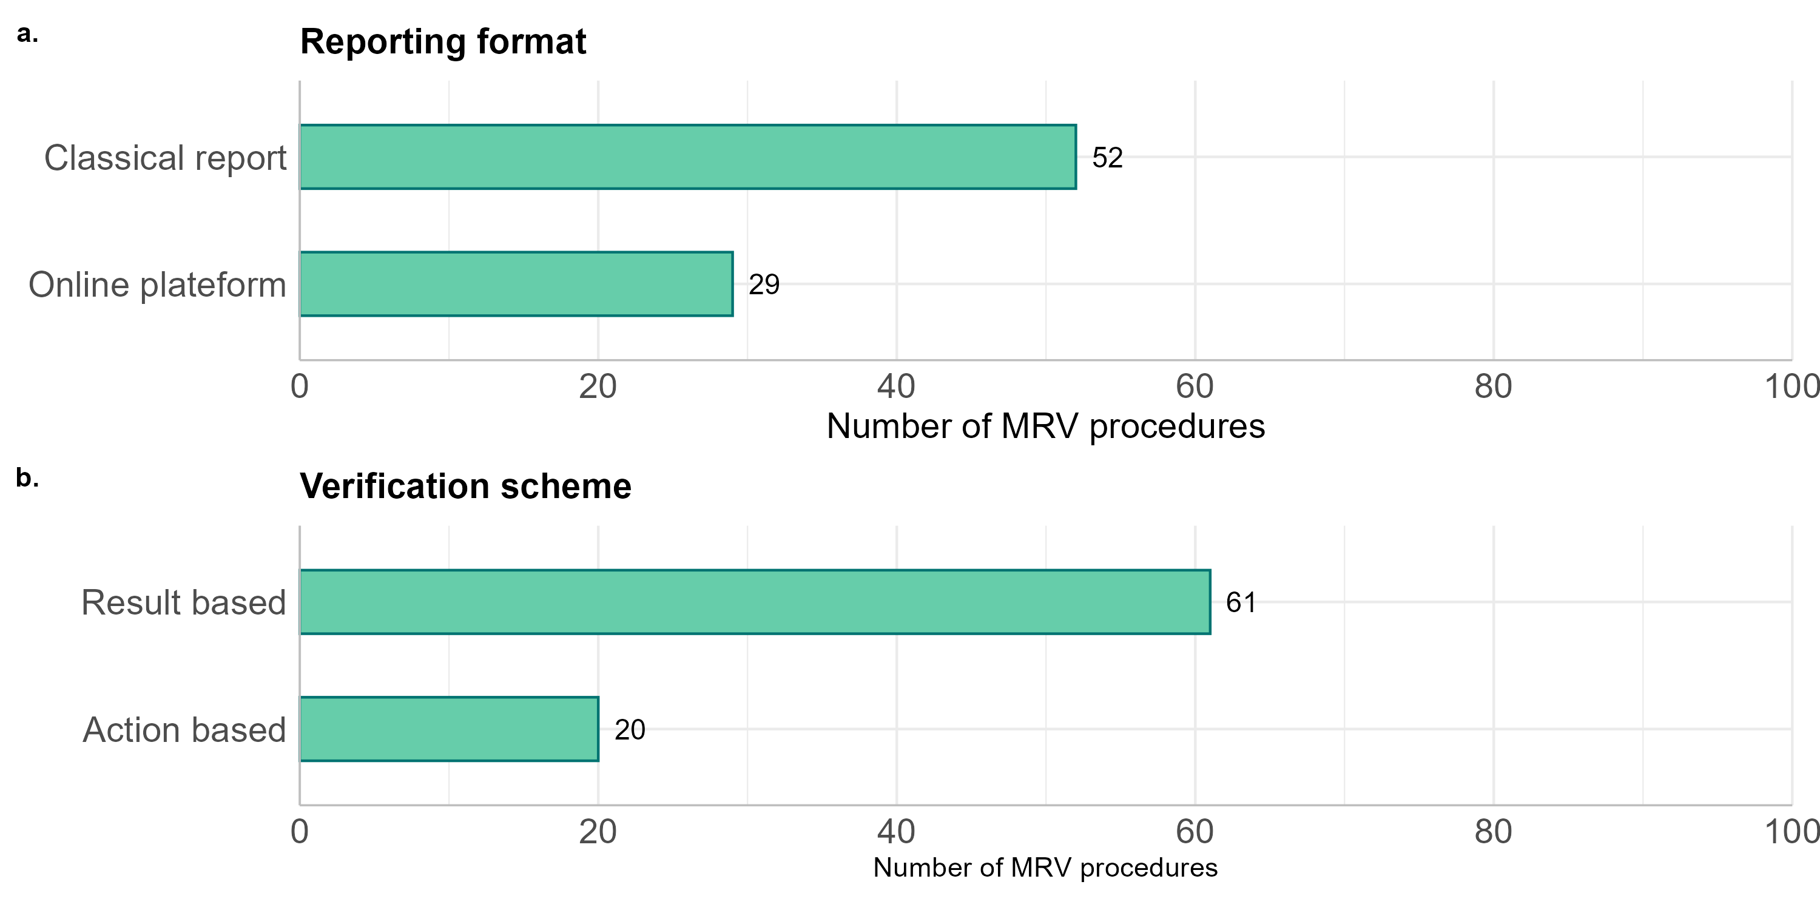

3.2. Co-occurrence between stakeholders’ and MRVs’ characteristics
We looked more precisely at the link between the characteristics of the stakeholders and the MRV procedures, by focusing on the main co-occurrences between stakeholders’ and MRV procedures’ characteristics (i.e. more than 25 MRV procedures, Fig. 5). In agricultural areas, organic matter and carbon was the only soil parameter included in more than 25 MRV procedures. All monitoring methodologies were very frequent, except on-site images. Both ways of result reporting were used in more than 25 MRV procedures. Verification was result-based for more than 25 MRV procedures. At both local and regional scale, we noticed the same pattern for the monitoring par i.e. focused on soil organic matter and carbon, using a diversity of methodologies. Results were gathered in a classical report, and the verification was result-based. For more than 25 MRV procedure, consultants monitored soil organic matter and carbon with modelling, using result-based verification. Concerning farmers, they also focused on soil organic matter and carbon, without any preference for the methodology (except site images). Results were gathered in a classical report and the verification was result-based. As expected, regarding voluntary carbon market, more than 25 MRV procedures include soil organic matter and carbon. More than 50 were based on soil sampling and modelling and more than 25 on land management information or spatial images. Logically, when the implemented action was the change in agricultural practices, MRV procedures’ characteristics were the same as for farmers.
At a larger picture, a lot of combination stakeholders x MRV procedures did not exist or were not communicated yet.

Figure 5. Co-occurrence between the characteristics of stakeholders and MRV procedures
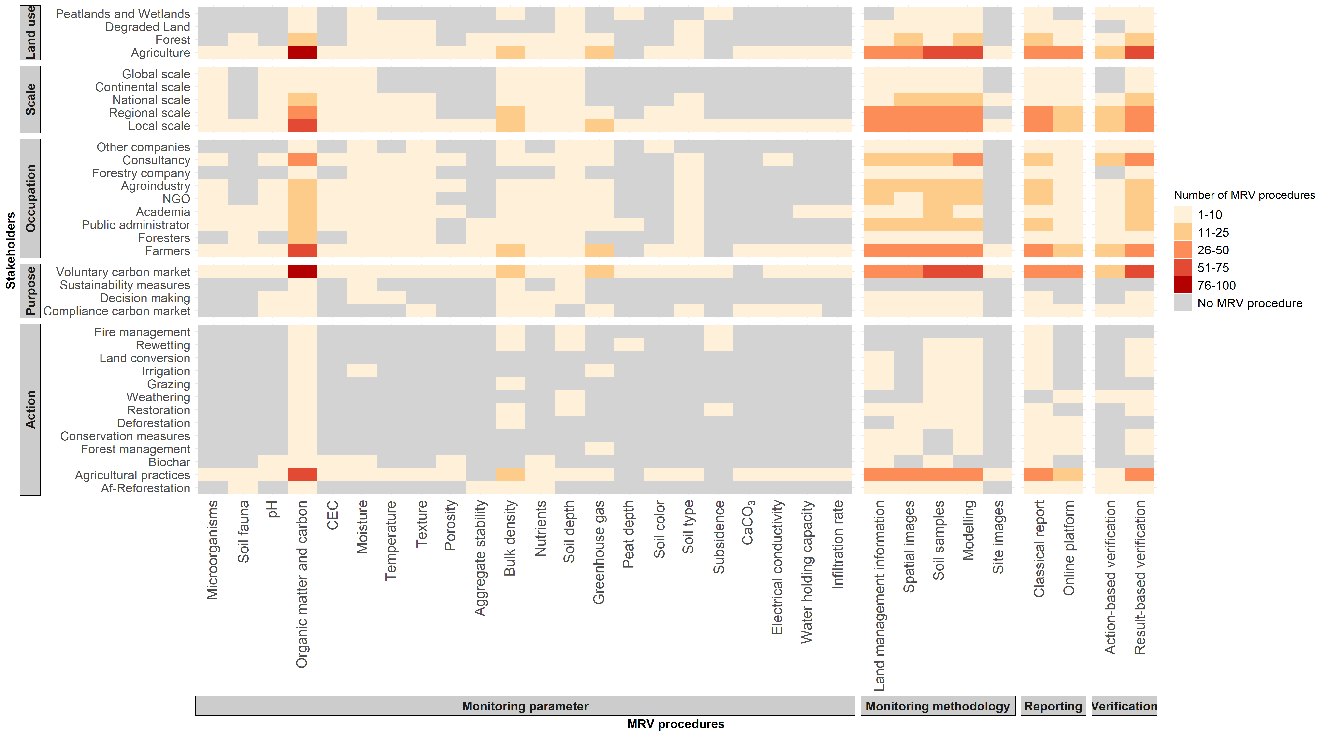

3.3. Typology of stakeholders and MRV procedures
We classified the MRV procedures into six groups, and we highlighted their particular characteristics (Fig. 6). However, group 1 including two MRV procedures, was only characterized by missing information for stakeholder occupation (Fig. 6 a.). Group 2 includes ten MRV procedures. It stood out from the other groups by covering local (all the MRV procedures), national (7), continental (2) and global (2) scales and five occupation types that are public administrators (7), academia (7), NGOs (7), agroindustry (7) and consultancy (8, Fig.6 a.). This group is focused on the change in agricultural practices (9 MRV procedures, Fig. 6 a.). Another particularity was that, for a part of the MRV procedures, pH (8 MRV procedures), cationic exchange capacity (CEC, 3) soil moisture (6), water holding capacity (2), soil type (2), soil depth (4), nutrients (7), porosity (2), texture (3) and temperature (2) were monitored (Fig. 6 b.). Group 3 was also very small with three MRV procedures (Fig.6). Its particularity is the absence of information regarding the geographical scale the MRV procedures took place and the presence of a MRV procedure assessing the impact of the change in grazing rate (Fig. 6 a.). The largest group was the fourth with 56 MRV procedures (Fig. 6). It is characterized by a high specificity: the particularities were the implementation at local scale (for 42 MRV procedures) and not at national, continental nor Global scale (almost all the MRV procedures are not implemented at those scales, Fig. 6 a.). Another particularity was that these MRV procedures did not take place in peatlands or wetlands (55 MRV procedures). This group stand out by targeting farmers (45 MRV procedures) and not consultancy (42). Regarding implemented actions it was also focused on the change in agricultural practices (44). The absence of rarer actions was also group 4’s particularities. Regarding monitoring, a particularity was that almost all the MRV procedures did not include pH (56), moisture (54), soil depth (53) nor nutrient (55, Fig. 6 b.). Different methodologies appeared as group 4’s particularities: soil sampling, spatial images and land management information (Fig. 6 b.). The use of online platform (for 22 MRV procedures) and not a classical report (22) to display the results was also a particularity of the group (Fig. 6 c.). The last one was that the verification was result-based (43) and not action-based (37, Fig. 6 c.). Group 5 included only six MRV procedures (Fig. 6). Most of them focused on peatlands and wetlands (5 MRV procedures) and excluded agricultural areas (4), targeting project developers (4) for land restoration (3) and not change in agricultural practices (4, Fig. 6 a.). Another particularity was the monitoring of rare soil parameters that are subsidence (2) and soil depth (4, Fig. 6 b.). This group was also defined by missing information regarding monitoring methodology (Fig. 6 b.) and verification scheme (Fig. 6 c.). The sixth group, with 19 MRV procedure was the second largest group. One of its particularities is to include 13 MRV procedures not taking place at local scale (Fig. 6 a.). It is also targeting consultancy (for all the MRV procedures) and not farmers (17), academia (all), NGOs (all) nor the agroindustry (18, Fig 6 a.). The implemented actions are not known for all of them (Fig. 6 a.). Regarding monitoring, bulk density was never assessed and the methodology was always modelling (Fig. 6 b.). The absence of soil sampling nor land management information was also a particularity of the group (Fig. 6 b.). It was also characterized by the absence of information regarding reporting format for 18 MRV procedures (Fig. 6 c.). Regarding verification, it was action-based (9) and not result-based (10).

Figure 6. Number of MRV procedures per category in each group and of MRV procedures per category in each group and groups’ particularities
- Stakeholder’characteristics 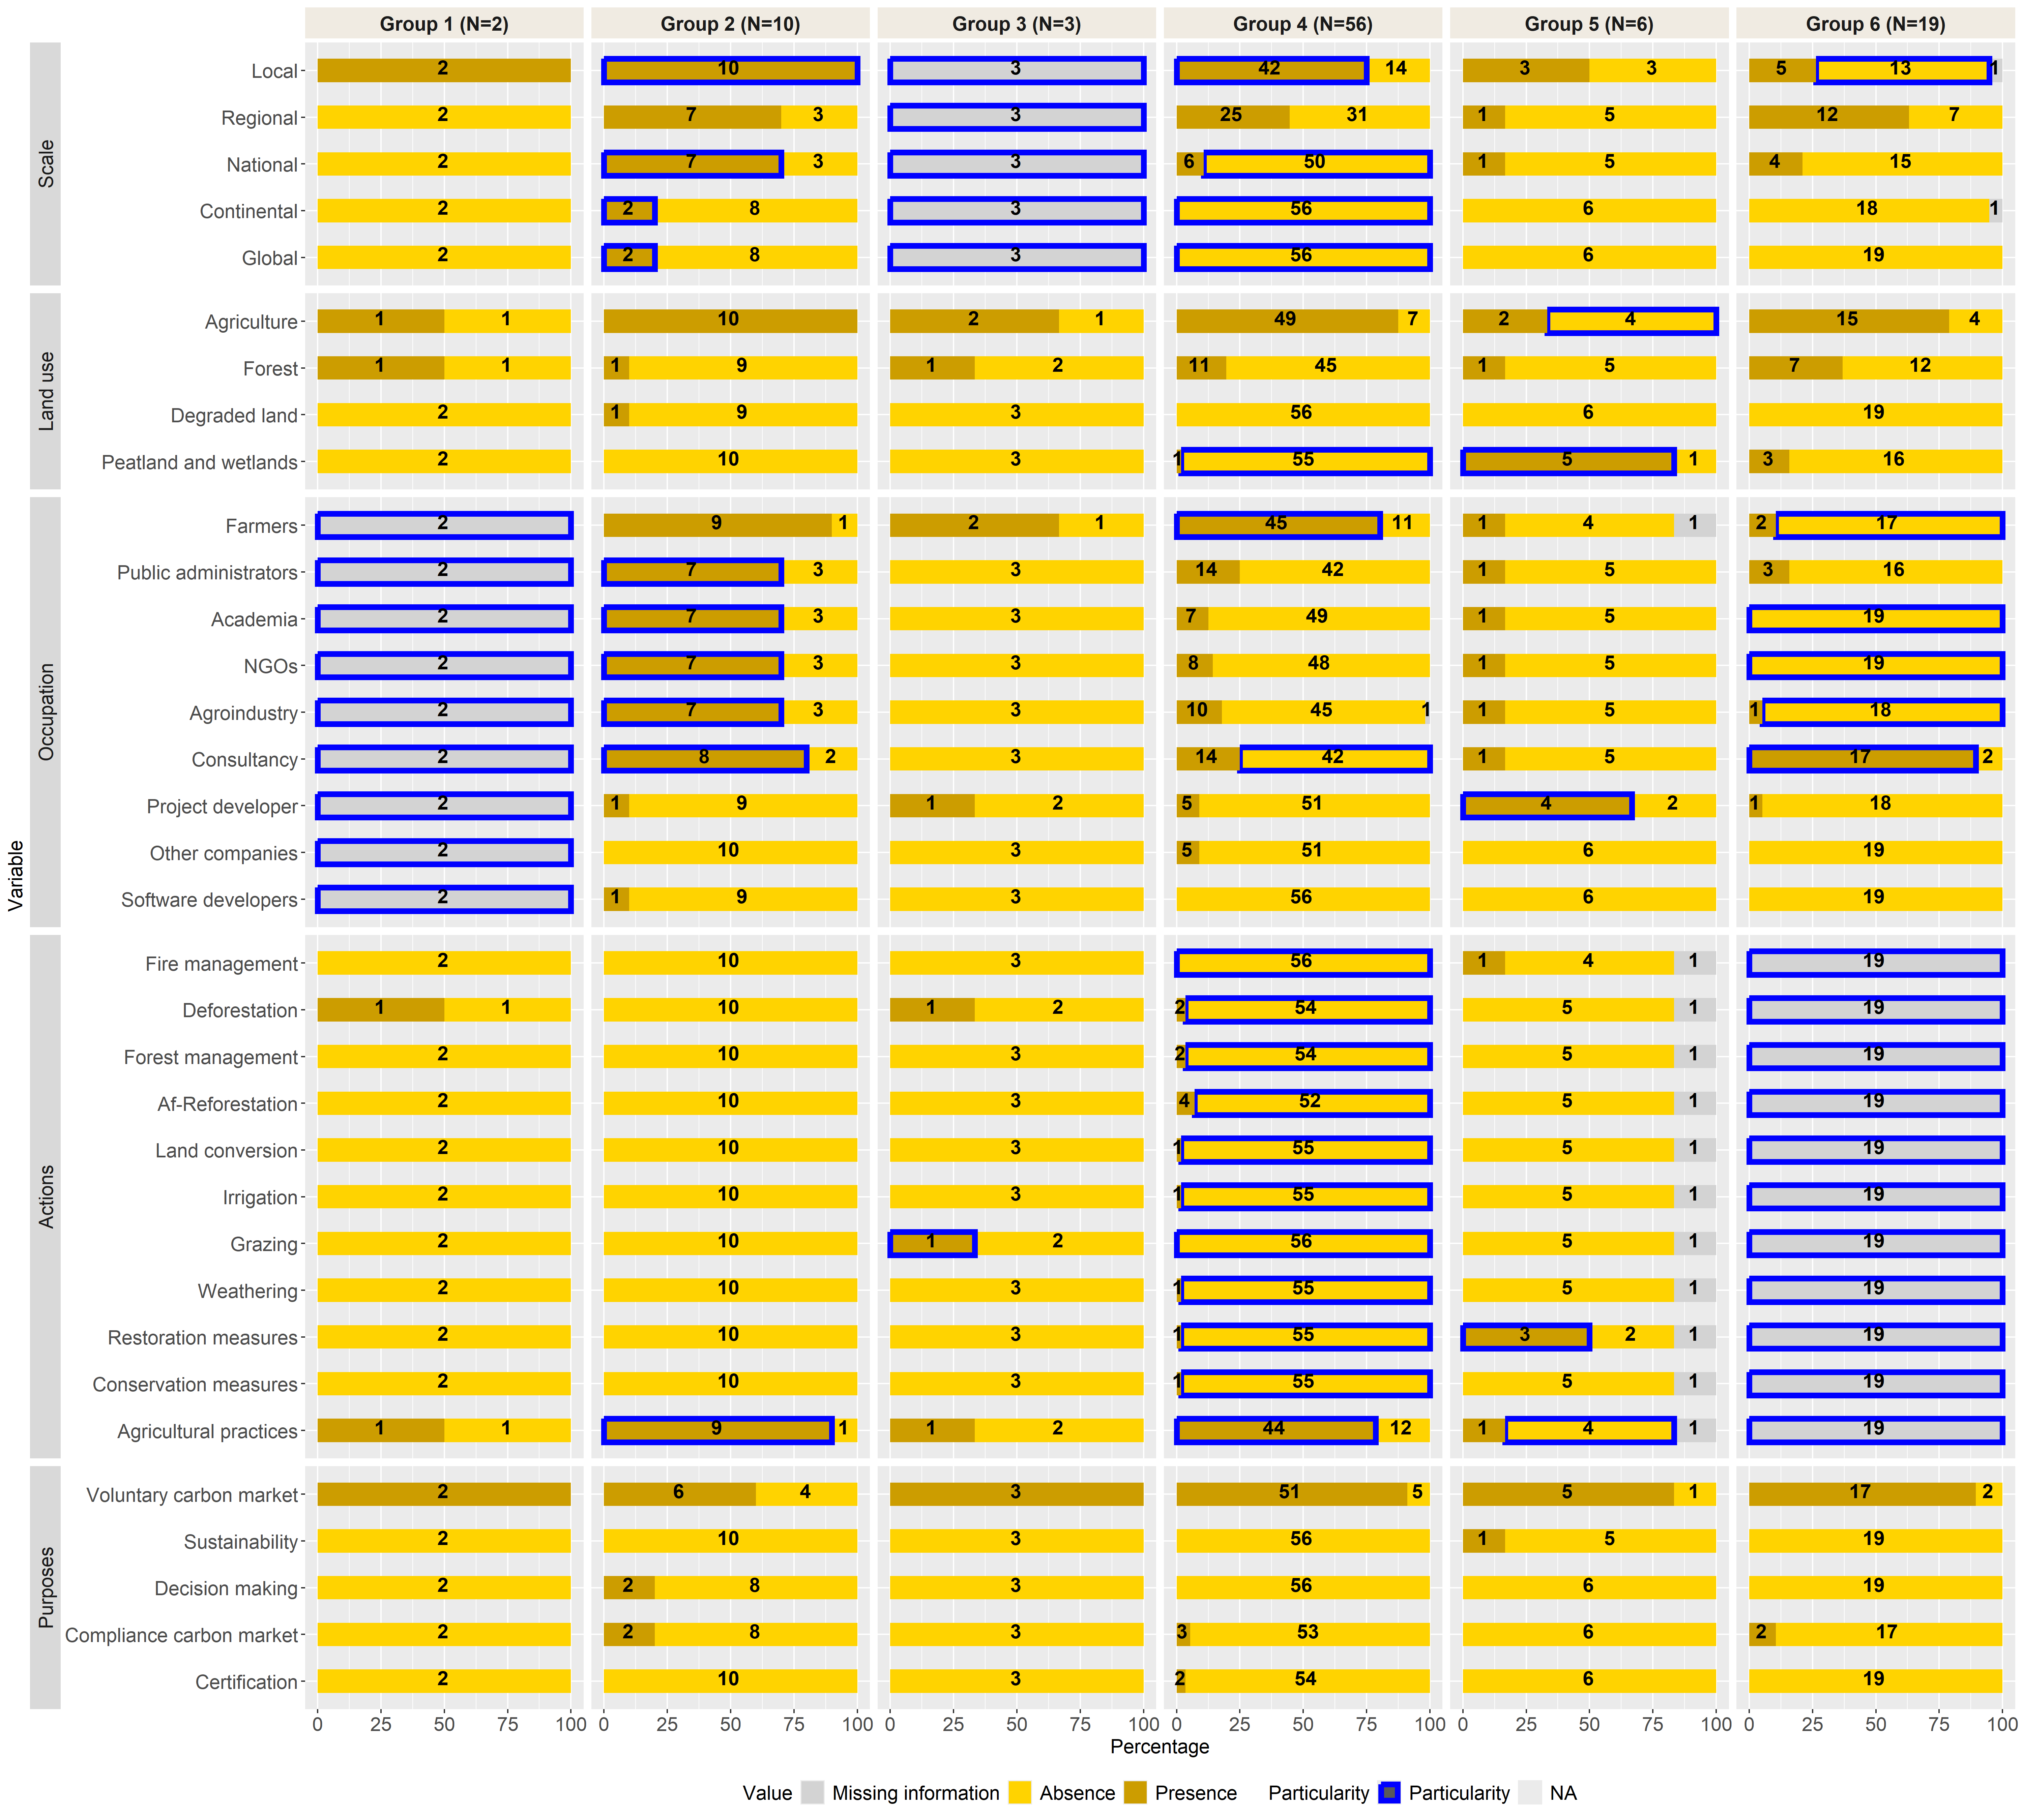
- Monitoring characteristics 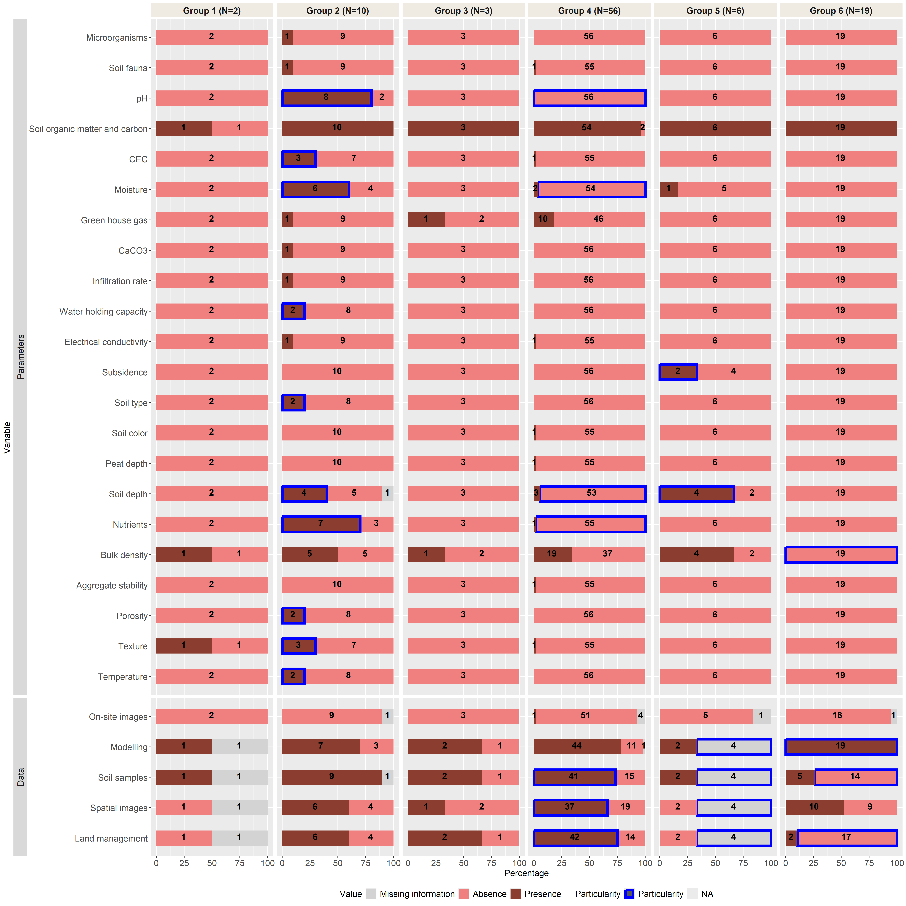
- Reporting and Verification characteristics
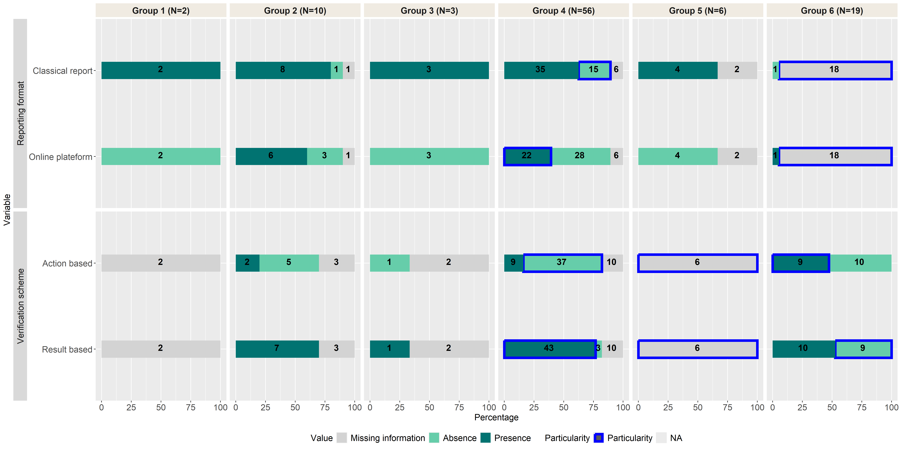

3.5. Decision tool
To encourage knowledge transfer between scientists and non-scientists, we developed a decision tool to help users in the choice of an adapted MRV procedure for soil health. It is available online: https://scraping-soil-monitoring-dzgswmvktuuc6ee2habdjo.streamlit.app/. We used the card format to summarize the collected information. The welcome page explains the purpose of the tool and the information presented on each MRV card. Then, the user selects its context`s characteristics and the tool provide the MRV procedures with a level of similarity higher than 80%. The MRV procedures are presented with the format of cards. The first page of the decision tool corresponds to the user (i.e. the stakeholder)’s characteristics : 1) On which land use do you want to apply the MRV procedure ?, 2) At which geographical scale do you want to apply the MRV procedure ?, 3) What is the purpose of the MRV procedure ?, 4) Which type of actions do you want to implement? and 5) What is your occupation? After answering the previous questions, the MRV cards corresponding to these criteria are suggested. A second filtering, based on the choices of the user could be applied. The user can select the modalities that have to be included in the MRV procedure. The tool presents all the MRV cards with a percentage of similarity S = number of items fitted with user’ wishes/total number of items.

4. Discussion
With only nine scientific articles included in our literature review, the term MRV seems to be rarely used by soil scientists. A large part of scientific articles when mentioning MRV only focus on the monitoring part. The term MRV is more common in the private sector as shown by the higher number of MRV procedures coming from company websites, collected with web scraping. Our study illustrates the difference in terminology between academia and the private sector. These differences could lead to communication difficulties (Weninger et al., 2024). However, scientists implement MRV procedures without calling them like this: they monitor soils, verify their data and report the results in the form of scientific articles. National soil monitoring networks are good examples of these “hidden” MRV procedures (Imbert et al., 2024). Major characteristics of MRV procedures were discarded from the analysis due to lack of information. We are missing knowledge on: sampling designs (plot area, sampling frequency), costs, uncertainty reporting, verification provider and data sharing or availability. Again, we encourage the providers of MRV procedures to clearly communicate about those later points to avoid suspicion of green washing. In our study, very few MRV procedures found took place in Africa or Asia. This result was surprising because compensation using carbon credits by reforestation mainly takes place in the countries of the Global South so in Africa, Asia, Oceania (Australia and New Zealand excluded) and Latin America (Cheong, 2025). Possible explanations would be that the term MRV is not used by all the actors of the private sector or that these MRV procedures do not include soil parameters. Thus, this might be a limitation of our study. The majority of the MRV procedures involved farmers willing to get involved in the voluntary carbon market, by changing their agricultural practices. In this way, our study illustrates the hegemony of the voluntary carbon market in the MRV context. In parallel to carbon markets, certain MRV procedures were designed to help stakeholders in decision making (MRV WE019 and MRV WE040). The aim of these MRV procedures is to give indications to farmers to improve farm management. The farmer chooses to spend money on soil monitoring and compensate this investment with better management (more efficient use of intrants mainly). Among the implemented actions, we found four MRV procedures assessing the effect of deforestation on soils i.e. the disturbance caused on soils. In the French framework “avoid, reduce, compensate” (corresponding to the European no net loss, https://environment.ec.europa.eu/topics/nature-and-biodiversity/nature-restoration-regulation_en), this MRV procedure corresponds to a “compensation” whereas MRV procedures assessing the effect of other actions (e.g. change in agricultural practices, reforestation, implementation of conservation measures) correspond to “reduction” procedures. Regarding monitoring methodology, there is a trade-off between costs and accuracy (Ihasusta et al., 2026). In general, soil sampling is more accurate than modelling (Batjes et al., 2024). However, modelling is more frequently used because it is faster and cheaper to implement. It could be associated with soil sampling that is called “measure-remeasure” to validate the model. It could also be used alone and based on values from other locations. Surprisingly, verification was more often result-based than action-based. We could think that action-based would be the most frequent, as it requires only a field visit, it is more rapid and so cheaper to implement than result based, requiring a new soil assessment. As based on a second monitoring session, result-based verification is more accurate than action-based. We classified the MRV procedures into six groups and identified their particularities (Fig. 6). They were well distinct: the largest group (Group 4) focused on agriculture with farmers and consultants, adopted a large variety of monitoring methodologies, reported the results on an online platform and the verification was result-based. The second largest group (Group 6) targeted consultants and was based on modelling. The verification was action-based. The other groups were very small and specific: group 3 was focused on the effect of grazing rate and group 5 on peatland and wetland restoration. Group 1 was characterized by the absence of information regarding stakeholder occupation.

5. Conclusion and perspectives
This study sheds light upon an overview of MRV procedures including soils. It bridges the scientific gap, previously completed by studies focused on the most common ones, i.e. carbon market in the agricultural context (Batjes et al., 2024). In soil science community, MRV is an emergent framework, and we strongly encourage soil scientists to employ the term MRV in their publications to engage in communication with the private sector. We also encourage the providers of MRV procedures to clearly communicate to avoid suspicion of green washing. Indeed, major information as sampling design or costs were often inaccessible or scarce. Regarding costs, Vanderheyden et al., 2026 assessed them for carbon farming between 4000 and 6000 euros per farm. In the present study, we succeeded in building a typology of MRV procedures and to develop a decision tool to make our work easily accessible to as many people as possible. The next step is to understand how to pass from a (mainly) carbon-focused MRV procedure to a broader one, assessing soil health. Several strategies are used to assess soil health, but they can give contradictory results (Zwaan et al., 2026). A recent study, based on expert knowledge, advised the monitoring listed around thirty parameters, related to soil, topography and climate to properly assess soil health (Vazquez, et al., 2025). To narrow down, the second step was to rank by importance, these parameters according to the pedo-climatic context (Vazquez et al., in progress). Thus, with a maximum of nine parameters assessed, existing MRV procedures do not currently cover soil health. They could be completed with new soil parameters, but the major problem stays the cost.

6. References
Altieri, M.A., Nicholls, C.I., Henao, A., Lana, M.A., 2015. Agroecology and the design of climate change-resilient farming systems. Agron. Sustain. Dev. 35, 869–890. https://doi.org/10.1007/s13593-015-0285-2
Andries, A., Morse, S., Murphy, R.J., Lynch, J., Mota, B., Woolliams, E.R., 2021. Can Current Earth Observation Technologies Provide Useful Information on Soil Organic Carbon Stocks for Environmental Land Management Policy? Sustainability 13, 12074. https://doi.org/10.3390/su132112074
Bárcena, T.G., Kiær, L.P., Vesterdal, L., Stefánsdóttir, H.M., Gundersen, P., Sigurdsson, B.D., 2014. Soil carbon stock change following afforestation in Northern Europe: a meta‐analysis. Global Change Biology 20, 2393–2405. https://doi.org/10.1111/gcb.12576
Batjes, N.H., Ceschia, E., Heuvelink, G.B.M., Demenois, J., Le Maire, G., Cardinael, R., Arias-Navarro, C., Van Egmond, F., 2024. Towards a modular, multi-ecosystem monitoring, reporting and verification (MRV) framework for soil organic carbon stock change assessment. Carbon Management 15, 2410812. https://doi.org/10.1080/17583004.2024.2410812
Ceschia, E., Ihasusta, A., Al Bitar, A., Batjes, N., van Egmond, F., Heuvelink, G., Paul-Victor, C., Nogues, M., Pontes, L., Reynders, S., Wijmer, T., Karunaratne, S., Macdonald, B., Lanckriet, E., Ruau, C., Juber, R., Vira, J., Kulmala, L., 2025. Monitoring, reporting and verification of soil organic carbon stock changes at arable land: Cookbook for assessment in different MRV contexts and proposition of a harmonised approach - ORCASA Deliverable 4.2.
Cheong, B.C., 2025. The Paradox and Fallacy of Global Carbon Credits: A Theoretical Framework for Strengthening Climate Change Mitigation Strategies. Anthr. Sci. 4, 72–83. https://doi.org/10.1007/s44177-025-00084-0
Chowdhury, S., Kain, J.-H., Adelfio, M., Volchko, Y., Norrman, J., 2023. Transforming brownfields into urban greenspaces: A working process for stakeholder analysis. PLoS ONE 18, e0278747. https://doi.org/10.1371/journal.pone.0278747
Directorate-General for Environment, 2025. Directive (EU) 2025/2360 of the European Parliament and of the Council of 12 November 2025 on soil monitoring and resilience (Soil Monitoring Law).
Eggers, J., Räty, M., Öhman, K., Snäll, T., 2020. How Well Do Stakeholder-Defined Forest Management Scenarios Balance Economic and Ecological Forest Values? Forests 11, 86. https://doi.org/10.3390/f11010086
European parliament and the council of the European Union, 2024. Regulation (EU) 2024/3012 of the European Parliament and of the Council of 27 November 2024 establishing a Union certification framework for permanent carbon removals, carbon farming and carbon storage in products (No. PE/92/2024/REV/1 OJ L).
Husson, F., Lê, S., Pagès, J., 2017. Exploratory multivariate analysis by example using R, Second edition. ed. CRC Press, Boca Raton.
Ihasusta, A., Al Bitar, A., Batjes, N.H., Van Egmond, F., Cardinael, R., Karunaratne, S., Barré, P., Arnaud, L., Heuvelink, G., Macdonald, B., Wijmer, T., Demenois, J., Paul-Victor, C., Reynders, S., Ceschia, E., 2026. Choosing the appropriate methodology to monitor soil organic carbon (SOC) in croplands: aligning methods with evolving monitoring reporting verification (MRV) frameworks. Carbon Management 17, 2638317. https://doi.org/10.1080/17583004.2026.2638317
Imbert, C., Berlin, A., Brown, C., Critchley, M., Kapos, V., Pulleman, M., Rusch, G., Tokpah, K., Volkmann, F., Paul, C., 2024. Designing Monitoring Reporting Verification for promoting healthy soils.
Lê, S., Josse, J., Husson, F., 2008. FactoMineR : An R Package for Multivariate Analysis. J. Stat. Soft. 25. https://doi.org/10.18637/jss.v025.i01
Matson, A., Fantappiè, M., Campbell, G.A., Miranda-Vélez, J.F., Faber, J.H., Gomes, L.C., Hessel, R., Lana, M., Mocali, S., Smith, P., Robinson, D.A., Bispo, A., Van Egmond, F., Keesstra, S., Saby, N.P.A., Smreczak, B., Froger, C., Suleymanov, A., Chenu, C., 2024. Four approaches to setting soil health targets and thresholds in agricultural soils. Journal of Environmental Management 371, 123141. https://doi.org/10.1016/j.jenvman.2024.123141
Pachón Maldonado, J.C., Leonard, E.C., Field, D.J., McRobert, K., Heath, R., McBratney, A.B., 2024. Quantifying the connectivity dimension of the soil security assessment framework. Soil Security 17, 100175. https://doi.org/10.1016/j.soisec.2024.100175
Probst, B.S., Toetzke, M., Kontoleon, A., Díaz Anadón, L., Minx, J.C., Haya, B.K., Schneider, L., Trotter, P.A., West, T.A.P., Gill-Wiehl, A., Hoffmann, V.H., 2024. Systematic assessment of the achieved emission reductions of carbon crediting projects. Nat Commun 15, 9562. https://doi.org/10.1038/s41467-024-53645-z
Sayles, J.S., Furey, R.P., Ten Brink, M.R., 2022. How deep to dig: effects of web-scraping search depth on hyperlink network analysis of environmental stewardship organizations. Appl Netw Sci 7, 36. https://doi.org/10.1007/s41109-022-00472-0
Schreefel, L., Creamer, R.E., Van Zanten, H.H.E., De Olde, E.M., Pas Schrijver, A., De Boer, I., Schulte, R.P.O., 2023. How to Monitor the ‘Success’ of (Regenerative) Agriculture: A Perspective (preprint). SSRN. https://doi.org/10.2139/ssrn.4525658
Smith, P., Soussana, J., Angers, D., Schipper, L., Chenu, C., Rasse, D.P., Batjes, N.H., Egmond, F., McNeill, S., Kuhnert, M., Arias‐Navarro, C., Olesen, J.E., Chirinda, N., Fornara, D., Wollenberg, E., Álvaro‐Fuentes, J., Sanz‐Cobena, A., Klumpp, K., 2020. How to measure, report and verify soil carbon change to realize the potential of soil carbon sequestration for atmospheric greenhouse gas removal. Global Change Biology 26, 219–241. https://doi.org/10.1111/gcb.14815
Strauss, V., Paul, C., Dönmez, C., Löbmann, M., Helming, K., 2023. Sustainable soil management measures: a synthesis of stakeholder recommendations. Agronomy for Sustainable Development 43. https://doi.org/10.1007/s13593-022-00864-7
Trencher, G., Nick, S., Carlson, J., Johnson, M., 2024. Demand for low-quality offsets by major companies undermines climate integrity of the voluntary carbon market. Nat Commun 15, 6863. https://doi.org/10.1038/s41467-024-51151-w
Trouwloon, D., Streck, C., Chagas, T., Martinus, G., 2023. Understanding the Use of Carbon Credits by Companies: A Review of the Defining Elements of Corporate Climate Claims. Global Challenges 7, 2200158. https://doi.org/10.1002/gch2.202200158
Vanderheyden, L., Gayot, N., Van Den Broeck, G., 2026. What monitoring, reporting & verification (MRV) systems can reduce costs and enhance scalability of carbon farming? Journal of Environmental Management 401, 128885. https://doi.org/10.1016/j.jenvman.2026.128885
Vanino, S., Pirelli, T., Di Bene, C., Bøe, F., Castanheira, N., Chenu, C., Cornu, S., Feiza, V., Fornara, D., Heller, O., Kasparinskis, R., Keesstra, S., Lasorella, M.V., Madenoğlu, S., Meurer, K.H.E., O’Sullivan, L., Peter, N., Piccini, C., Siebielec, G., Smreczak, B., Thorsøe, M.H., Farina, R., 2023. Barriers and opportunities of soil knowledge to address soil challenges: Stakeholders’ perspectives across Europe. Journal of Environmental Management 325. https://doi.org/10.1016/j.jenvman.2022.116581
Vazquez, C., Mulder, T., Chavez Rodriguez, L., Lonardo, F.D.D.P., Garsia, A., Creamer, R.E., Bünemann, E.K., Soinne, H., Cheval, P., Basile, A., Bacq-labreuil, A., Nordén, J., Cunha, L., Imbert, C., Boix-Fayos, C., 2025. Soil biology, soil health and ecosystem services: an overview, in: Burleigh Dodds Series in Agricultural Science. Burleigh Dodds Science Publishing Limited. https://doi.org/10.19103/AS.2025.0159.01
Vieillard, C., Vidal-Beaudet, L., Dagois, R., Lothode, M., Vadepied, F., Gontier, M., Schwartz, C., Ouvrard, S., 2024. Impacts of soil de-sealing practices on urban land-uses, soil functions and ecosystem services in French cities. Geoderma Regional 38, e00854. https://doi.org/10.1016/j.geodrs.2024.e00854
Weninger, T., Ramler, D., Bondi, G., Asins, S., O’Sullivan, L., Assennato, F., Astover, A., Bispo, A., Borůvka, L., Buttafuoco, G., Calzolari, C., Castanheira, N., Cousin, I., Van Den Elsen, E., Foldal, C., Hessel, R., Kadžiulienė, Ž., Kukk, L., Molina, M.J., Montagne, D., Oorts, K., Pindral, S., Ungaro, F., Klimkowicz‐Pawlas, A., 2024. Do we speak one language on the way to sustainable soil management in Europe? A terminology check via an EU ‐wide survey. European J Soil Science 75, e13476. https://doi.org/10.1111/ejss.13476

https://elicit.com/
https://www.offsetguide.org/understanding-carbon-offsets/what-is-a-carbon-offset/
https://www.perplexity.ai/
https://www.project-marvic.eu/
https://www.selenium.dev/documentation/webdriver/
https://soilhealthbenchmarks.eu/

7. Acknowledgments
This research was funded by the European Union’s Horizon Europe research and innovation program, under Grant Agreement: 101091010, Project BENCHMARKS. We thank Laura Zara for helping in developing the web scraping script and improving the figures. We thank Emily Auraujo, Martina Lori and Johanne Vad for running the web scraping script.

8. Author contribution
CI : Conception, Data collection, Data analysis, Tool conception, Paper writing, Paper revision
AB : Paper revision
SG :Data collection, Paper revision
PH :Data collection, Paper revision
TS :Data collection, Paper revision
SS :Data collection, Paper revision
LR :Tool conception, Paper revision
KW :Data collection, Paper revision

9. Appendices

Appendix 1. PRISMA diagrams according the data source: article database (a.), webscraping (b.) and AI browser (c.)
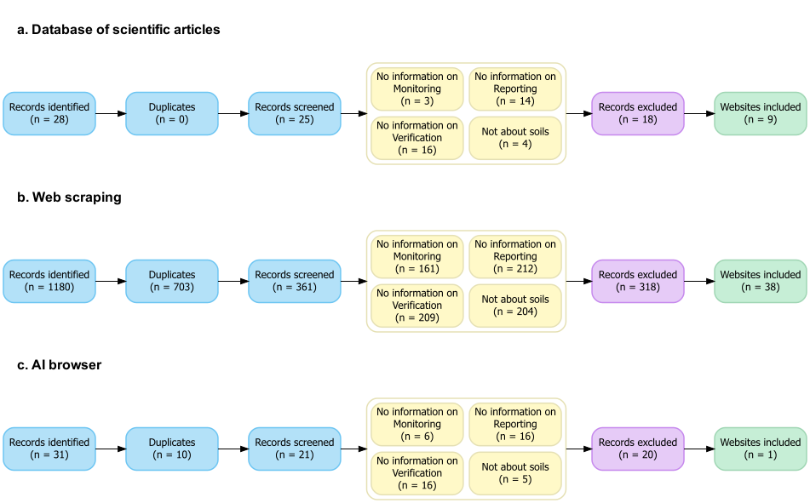

Appendix 2. Web scraping script
GIT URL

Appendix 3.Dataset
DOI to add

Appendix 4. Missing information for each MRV procedure
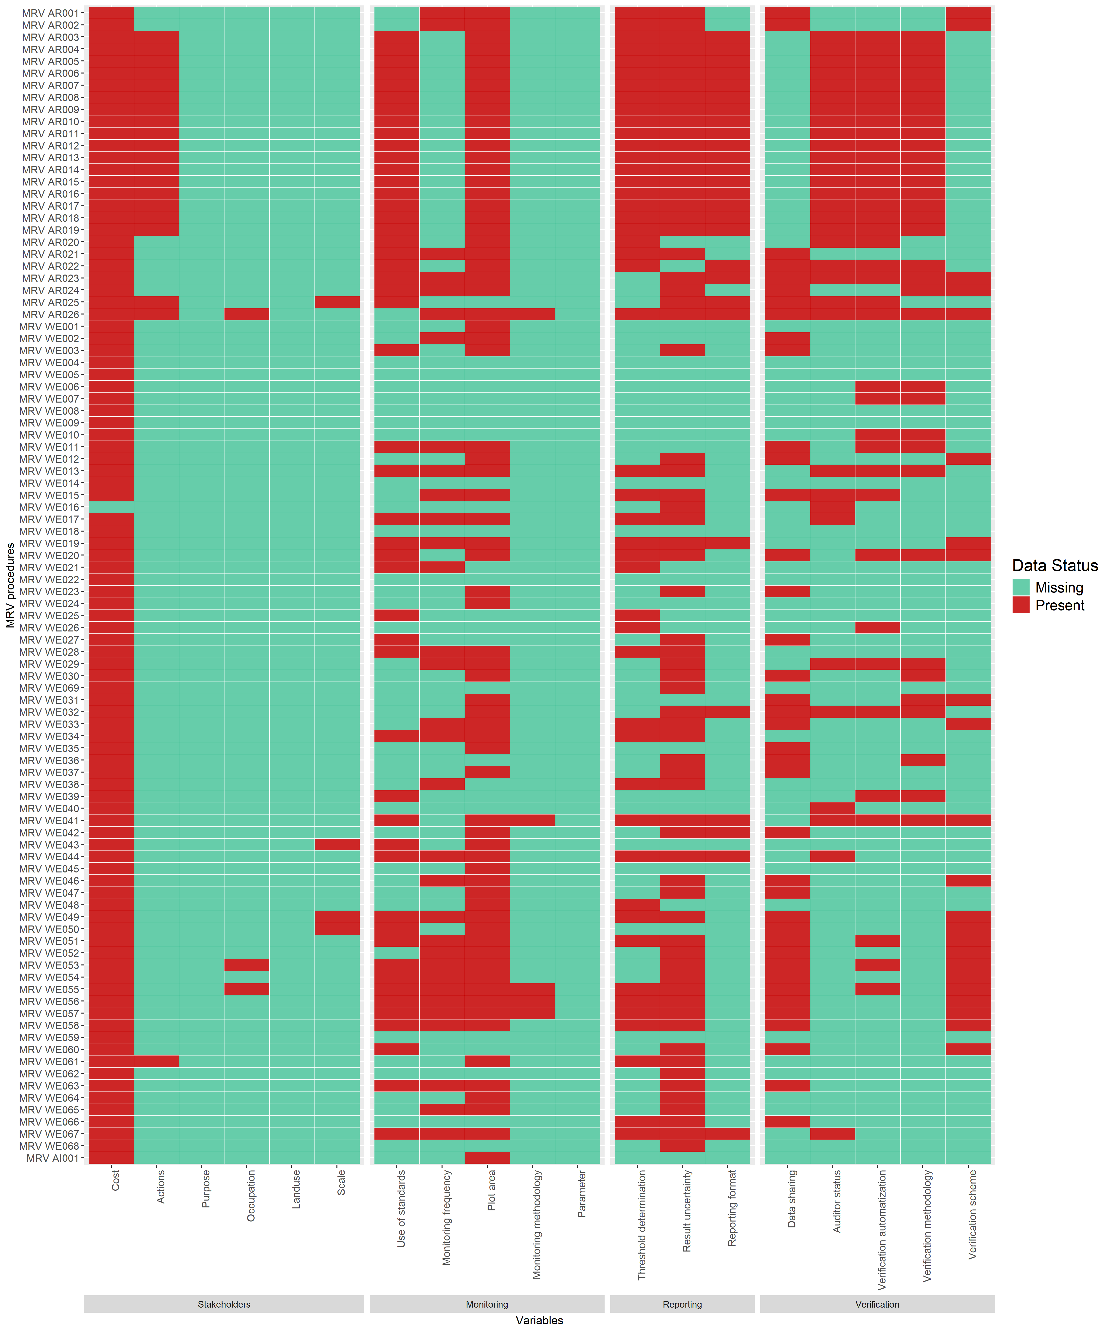

Appendix 5. Percentage of MRV procedures already implemented or under development
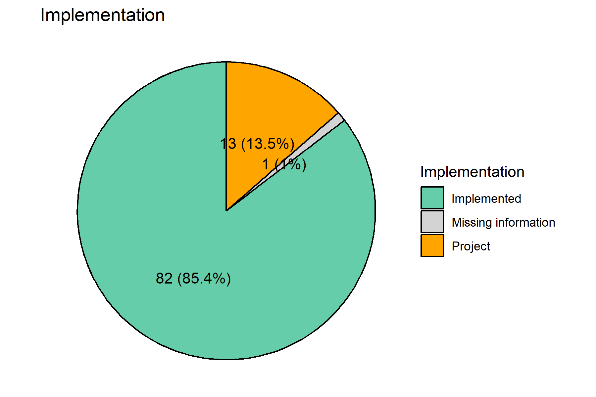

Appendix 6. Contribution of variable modalities computed with MCA, HCPC, v-test and significance test
cluster | category | Cla.Mod | Mod.Cla | Global | p.value | v.test
1 | Occupation_Software_developers=Occupation_Software_developers_Missing_information | 100.00000 | 100.00000 | 2.083333 | 0.0002192982456140349291785 | 3.695681
1 | Occupation_Other_companies=Occupation_Other_companies_Missing_information | 100.00000 | 100.00000 | 2.083333 | 0.0002192982456140349291785 | 3.695681
1 | Occupation_Project_developer=Occupation_Project_developer_Missing_information | 100.00000 | 100.00000 | 2.083333 | 0.0002192982456140349291785 | 3.695681
1 | Occupation_Consultancy=Occupation_Consultancy_Missing_information | 100.00000 | 100.00000 | 2.083333 | 0.0002192982456140349291785 | 3.695681
1 | Occupation_NGOs=Occupation_NGOs_Missing_information | 100.00000 | 100.00000 | 2.083333 | 0.0002192982456140349291785 | 3.695681
1 | Occupation_Educational_Institutions_Research=Occupation_Educational_Institutions_Research_Missing_information | 100.00000 | 100.00000 | 2.083333 | 0.0002192982456140349291785 | 3.695681
1 | Occupation_Public_Administrators=Occupation_Public_Administrators_Missing_information | 100.00000 | 100.00000 | 2.083333 | 0.0002192982456140349291785 | 3.695681
1 | Occupation_Agroindustry=Occupation_Agroindustry_Missing_information | 66.66667 | 100.00000 | 3.125000 | 0.0006578947368421052483214 | 3.406550
1 | Occupation_Farmers=Occupation_Farmers_Missing_information | 66.66667 | 100.00000 | 3.125000 | 0.0006578947368421052483214 | 3.406550
2 | Parameter_Soil_pH=Parameter_Soil_pH_Yes | 100.00000 | 80.00000 | 8.333333 | 0.0000000003393639147125115 | 6.279637
2 | Parameter_Nutrient_availability=Parameter_Nutrient_availability_Yes | 87.50000 | 70.00000 | 8.333333 | 0.0000000785061856034941511 | 5.370529
2 | Parameter_Soil_moisture=Parameter_Soil_moisture_Yes | 66.66667 | 60.00000 | 9.375000 | 0.0000172584752877646469731 | 4.297693
2 | Occupation_Educational_Institutions_Research=Occupation_Educational_Institutions_Research_Yes | 46.66667 | 70.00000 | 15.625000 | 0.0000524427014903932497579 | 4.044465
2 | Occupation_NGOs=Occupation_NGOs_Yes | 43.75000 | 70.00000 | 16.666667 | 0.0000907005218457162252273 | 3.914210
2 | Scale_National=Scale_National_Yes | 38.88889 | 70.00000 | 18.750000 | 0.0002386119642129227579486 | 3.674183
2 | Occupation_Agroindustry=Occupation_Agroindustry_Yes | 36.84211 | 70.00000 | 19.791667 | 0.0003672540816572043994269 | 3.562561
2 | Occupation_Public_Administrators=Occupation_Public_Administrators_Yes | 28.00000 | 70.00000 | 26.041667 | 0.0029385365540606990693295 | 2.974095
2 | Parameter_CEC=Parameter_CEC_Yes | 75.00000 | 30.00000 | 4.166667 | 0.0032330311021204309607224 | 2.944666
2 | Parameter_Particle_size_distribution_Texture=Parameter_Particle_size_distribution_Texture_Yes | 60.00000 | 30.00000 | 5.208333 | 0.0077747448206323477651325 | 2.661699
2 | Scale_Local=Scale_Local_Yes | 16.12903 | 100.00000 | 64.583333 | 0.0095318825121910085579335 | 2.592364
2 | Parameter_Water_holding_capacity=Parameter_Water_holding_capacity_Yes | 100.00000 | 20.00000 | 2.083333 | 0.0098684210526315714606671 | 2.580406
2 | Parameter_Soil_type=Parameter_Soil_type_Yes | 100.00000 | 20.00000 | 2.083333 | 0.0098684210526315714606671 | 2.580406
2 | Parameter_Soil_porosity=Parameter_Soil_porosity_Yes | 100.00000 | 20.00000 | 2.083333 | 0.0098684210526315714606671 | 2.580406
2 | Parameter_Soil_temperature=Parameter_Soil_temperature_Yes | 100.00000 | 20.00000 | 2.083333 | 0.0098684210526315714606671 | 2.580406
2 | Purpose=Decision_making | 100.00000 | 20.00000 | 2.083333 | 0.0098684210526315714606671 | 2.580406
2 | Scale_Global=Scale_Global_Yes | 100.00000 | 20.00000 | 2.083333 | 0.0098684210526315714606671 | 2.580406
2 | Scale_Continental=Scale_Continental_Yes | 100.00000 | 20.00000 | 2.083333 | 0.0098684210526315714606671 | 2.580406
2 | Occupation_Consultancy=Occupation_Consultancy_Yes | 20.00000 | 80.00000 | 41.666667 | 0.0133647760111985404452017 | 2.473898
2 | Parameter_Soil_depth=Parameter_Soil_depth_Yes | 36.36364 | 40.00000 | 11.458333 | 0.0156536972291879683538696 | 2.416891
2 | Driver_Agricultural_practices=Driver_Agricultural_practices_Yes | 16.07143 | 90.00000 | 58.333333 | 0.0331786594884368873925595 | 2.129915
3 | Scale_Global=Scale_Global_Missing_information | 100.00000 | 100.00000 | 3.125000 | 0.0000069988801791713372048 | 4.493723
3 | Scale_National=Scale_National_Missing_information | 100.00000 | 100.00000 | 3.125000 | 0.0000069988801791713372048 | 4.493723
3 | Scale_Regional=Scale_Regional_Missing_information | 100.00000 | 100.00000 | 3.125000 | 0.0000069988801791713372048 | 4.493723
3 | Scale_Continental=Scale_Continental_Missing_information | 75.00000 | 100.00000 | 4.166667 | 0.0000279955207166852946101 | 4.189187
3 | Scale_Local=Scale_Local_Missing_information | 75.00000 | 100.00000 | 4.166667 | 0.0000279955207166852946101 | 4.189187
3 | Driver_Grazing=Driver_Grazing_Yes | 100.00000 | 33.33333 | 1.041667 | 0.0312499999999999965305530 | 2.153875
4 | Driver_Fire_management=Driver_Fire_management_No | 74.66667 | 100.00000 | 78.125000 | 0.0000000001677998316815300 | 6.388245
4 | Driver_Grazing=Driver_Grazing_No | 74.66667 | 100.00000 | 78.125000 | 0.0000000001677998316815300 | 6.388245
4 | Driver_Restoration=Driver_Restoration_No | 76.38889 | 98.21429 | 75.000000 | 0.0000000001951870504147713 | 6.365081
4 | Driver_Deforestation=Driver_Deforestation_No | 75.00000 | 96.42857 | 75.000000 | 0.0000000070749876043666234 | 5.789135
4 | Driver_Land_conversion=Driver_Land_conversion_No | 73.33333 | 98.21429 | 78.125000 | 0.0000000102022297662369455 | 5.727332
4 | Driver_Irrigation=Driver_Irrigation_No | 73.33333 | 98.21429 | 78.125000 | 0.0000000102022297662369455 | 5.727332
4 | Driver_Weathering=Driver_Weathering_No | 73.33333 | 98.21429 | 78.125000 | 0.0000000102022297662369455 | 5.727332
4 | Driver_Conservation=Driver_Conservation_No | 73.33333 | 98.21429 | 78.125000 | 0.0000000102022297662369455 | 5.727332
4 | Driver_Forest_management=Driver_Forest_management_No | 72.97297 | 96.42857 | 77.083333 | 0.0000000851886185480783860 | 5.355779
4 | Data_Land_Management=Data_Land_Management_Yes | 80.76923 | 75.00000 | 54.166667 | 0.0000013071477105676164779 | 4.838664
4 | Driver_Afforestation_Reforestation=Driver_Afforestation_Reforestation_No | 72.22222 | 92.85714 | 75.000000 | 0.0000022323136906437133829 | 4.731168
4 | Driver_Agricultural_practices=Driver_Agricultural_practices_Yes | 78.57143 | 78.57143 | 58.333333 | 0.0000022655254026254713446 | 4.728170
4 | Occupation_Farmers=Occupation_Farmers_Yes | 76.27119 | 80.35714 | 61.458333 | 0.0000084771505227458199255 | 4.452765
4 | Occupation_Consultancy=Occupation_Consultancy_No | 77.77778 | 75.00000 | 56.250000 | 0.0000138026038669852458966 | 4.346978
4 | Parameter_Soil_pH=Parameter_Soil_pH_No | 63.63636 | 100.00000 | 91.666667 | 0.0005799705546962772651290 | 3.440812
4 | Result_based=Result_based_Yes | 70.49180 | 76.78571 | 63.541667 | 0.0017736008488944761569972 | 3.125737
4 | Scale_National=Scale_National_No | 66.66667 | 89.28571 | 78.125000 | 0.0023749578382970737075452 | 3.038834
4 | Land_use_Peatland_Wetland=Land_use_Peatland_Wetland_No | 63.21839 | 98.21429 | 90.625000 | 0.0037434463075850634219965 | 2.899009
4 | Scale_Continental=Scale_Continental_No | 62.22222 | 100.00000 | 93.750000 | 0.0041404315001044465424651 | 2.867260
4 | Format_Document=Format_Document_No | 88.23529 | 26.78571 | 17.708333 | 0.0051999190620953539276883 | 2.794381
4 | Parameter_Nutrient_availability=Parameter_Nutrient_availability_No | 62.50000 | 98.21429 | 91.666667 | 0.0090334807610268769151318 | 2.610784
4 | Scale_Global=Scale_Global_No | 61.53846 | 100.00000 | 94.791667 | 0.0107651219002715368977530 | 2.550232
4 | Data_Soil_samples=Data_Soil_samples_Yes | 68.33333 | 73.21429 | 62.500000 | 0.0120778681169248225391044 | 2.509861
4 | Action_based=Action_based_No | 69.81132 | 66.07143 | 55.208333 | 0.0129007331728683803662161 | 2.486498
4 | Scale_Local=Scale_Local_Yes | 67.74194 | 75.00000 | 64.583333 | 0.0136279461491876346251884 | 2.466924
4 | Parameter_Soil_depth=Parameter_Soil_depth_No | 63.09524 | 94.64286 | 87.500000 | 0.0167458629021905516798263 | 2.392241
4 | Format_Online=Format_Online_Yes | 75.86207 | 39.28571 | 30.208333 | 0.0231373734201498794382790 | 2.271159
4 | Data_Spatial_images=Data_Spatial_images_Yes | 68.51852 | 66.07143 | 56.250000 | 0.0244162675625151544267499 | 2.250515
4 | Parameter_Soil_moisture=Parameter_Soil_moisture_No | 62.06897 | 96.42857 | 90.625000 | 0.0292094261183397999048772 | 2.180648
5 | Land_use_Peatland_Wetland=Land_use_Peatland_Wetland_Yes | 55.55556 | 83.33333 | 9.375000 | 0.0000120058468927418557587 | 4.377482
5 | Data_Spatial_images=Data_Spatial_images_Missing_information | 80.00000 | 66.66667 | 5.208333 | 0.0000222825497990447695231 | 4.240698
5 | Data_Land_Management=Data_Land_Management_Missing_information | 80.00000 | 66.66667 | 5.208333 | 0.0000222825497990447695231 | 4.240698
5 | Data_Modelling=Data_Modelling_Missing_information | 66.66667 | 66.66667 | 6.250000 | 0.0000659695937483749069493 | 3.990373
5 | Data_Soil_samples=Data_Soil_samples_Missing_information | 66.66667 | 66.66667 | 6.250000 | 0.0000659695937483749069493 | 3.990373
5 | Result_based=Result_based_Missing_information | 26.08696 | 100.00000 | 23.958333 | 0.0001088907660630376400502 | 3.869876
5 | Action_based=Action_based_Missing_information | 26.08696 | 100.00000 | 23.958333 | 0.0001088907660630376400502 | 3.869876
5 | Driver_Restoration=Driver_Restoration_Yes | 75.00000 | 50.00000 | 4.166667 | 0.0005508796011992917341510 | 3.454713
5 | Parameter_Soil_depth=Parameter_Soil_depth_Yes | 36.36364 | 66.66667 | 11.458333 | 0.0013565247836319874359667 | 3.203745
5 | Occupation_Project_developer=Occupation_Project_developer_Yes | 33.33333 | 66.66667 | 12.500000 | 0.0020068792445576801378171 | 3.089212
5 | Parameter_Subsidence=Parameter_Subsidence_Yes | 100.00000 | 33.33333 | 2.083333 | 0.0032894736842105274342296 | 2.939307
5 | Land_use_Agriculture=Land_use_Agriculture_No | 23.52941 | 66.66667 | 17.708333 | 0.0089911560854330618147712 | 2.612390
5 | Driver_Agricultural_practices=Driver_Agricultural_practices_No | 20.00000 | 66.66667 | 20.833333 | 0.0175205304080897142360307 | 2.375598
6 | Driver_Fire_management=Driver_Fire_management_Missing_information | 95.00000 | 100.00000 | 20.833333 | 0.0000000000000000003561804 | 8.949783
6 | Driver_Deforestation=Driver_Deforestation_Missing_information | 95.00000 | 100.00000 | 20.833333 | 0.0000000000000000003561804 | 8.949783
6 | Driver_Forest_management=Driver_Forest_management_Missing_information | 95.00000 | 100.00000 | 20.833333 | 0.0000000000000000003561804 | 8.949783
6 | Driver_Afforestation_Reforestation=Driver_Afforestation_Reforestation_Missing_information | 95.00000 | 100.00000 | 20.833333 | 0.0000000000000000003561804 | 8.949783
6 | Driver_Land_conversion=Driver_Land_conversion_Missing_information | 95.00000 | 100.00000 | 20.833333 | 0.0000000000000000003561804 | 8.949783
6 | Driver_Irrigation=Driver_Irrigation_Missing_information | 95.00000 | 100.00000 | 20.833333 | 0.0000000000000000003561804 | 8.949783
6 | Driver_Grazing=Driver_Grazing_Missing_information | 95.00000 | 100.00000 | 20.833333 | 0.0000000000000000003561804 | 8.949783
6 | Driver_Weathering=Driver_Weathering_Missing_information | 95.00000 | 100.00000 | 20.833333 | 0.0000000000000000003561804 | 8.949783
6 | Driver_Restoration=Driver_Restoration_Missing_information | 95.00000 | 100.00000 | 20.833333 | 0.0000000000000000003561804 | 8.949783
6 | Driver_Conservation=Driver_Conservation_Missing_information | 95.00000 | 100.00000 | 20.833333 | 0.0000000000000000003561804 | 8.949783
6 | Driver_Agricultural_practices=Driver_Agricultural_practices_Missing_information | 95.00000 | 100.00000 | 20.833333 | 0.0000000000000000003561804 | 8.949783
6 | Format_Online=Format_Online_Missing_information | 66.66667 | 94.73684 | 28.125000 | 0.0000000000058383500495663 | 6.883539
6 | Format_Document=Format_Document_Missing_information | 66.66667 | 94.73684 | 28.125000 | 0.0000000000058383500495663 | 6.883539
6 | Occupation_Farmers=Occupation_Farmers_No | 50.00000 | 89.47368 | 35.416667 | 0.0000000835216754842071096 | 5.359351
6 | Data_Land_Management=Data_Land_Management_No | 43.58974 | 89.47368 | 40.625000 | 0.0000015792414038774458826 | 4.800938
6 | Occupation_Consultancy=Occupation_Consultancy_Yes | 42.50000 | 89.47368 | 41.666667 | 0.0000026643899291140632083 | 4.695129
6 | Result_based=Result_based_No | 75.00000 | 47.36842 | 12.500000 | 0.0000117018632309677236630 | 4.383070
6 | Data_Soil_samples=Data_Soil_samples_No | 46.66667 | 73.68421 | 31.250000 | 0.0000273735130716101307817 | 4.194284
6 | Scale_Local=Scale_Local_No | 43.33333 | 68.42105 | 31.250000 | 0.0002443027663172734785177 | 3.668160
6 | Parameter_Soil_compaction_Bulk_density=Parameter_Soil_compaction_Bulk_density_No | 28.78788 | 100.00000 | 68.750000 | 0.0003081428039770273325827 | 3.608357
6 | Action_based=Action_based_Yes | 45.00000 | 47.36842 | 20.833333 | 0.0039159483904249569458100 | 2.884854
6 | Data_Modelling=Data_Modelling_Yes | 25.33333 | 100.00000 | 78.125000 | 0.0051084409465387671869796 | 2.800115
6 | Occupation_NGOs=Occupation_NGOs_No | 24.35897 | 100.00000 | 81.250000 | 0.0119545280829580369968967 | 2.513484
6 | Occupation_Educational_Institutions_Research=Occupation_Educational_Institutions_Research_No | 24.05063 | 100.00000 | 82.291667 | 0.0157401286425613920472166 | 2.414886
6 | Occupation_Agroindustry=Occupation_Agroindustry_No | 24.32432 | 94.73684 | 77.083333 | 0.0360996493555405875697240 | 2.095803

Appendix 7. Decision tool script
GIT URL

