Parte A

A. El nombre de la clase que define las excepciones es: “java.lang.Exception”
B. El nombre de la clase que representa las excepciones que se producen al invocar un metodo que pertenece a un objeto nulo es: “java.lang.NullPointerException”
C. printStackTrace imprime la routa de error en el Stack.

Ejercicio
Se puede usar getMessage de java.lang.throwable.

```Java
try {
int resultado = 1 / 0;
} catch (ArithmeticException e) {
String mensajeError = e.getMessage();
System.out.println("Error: " + mensajeError);
}
```

Ejercicio
Tira un error “java.lang.NumberFormatException”
```Java
public class testing {
public static void main(String[] args) {
String aux = "hola";
try {
int aux2 = Integer.parseInt(aux);
} catch (Exception e) {
System.out.println("Error");
}
}
}
```

Ejercicio
```Java
import java.io.*;

public class testing {
public static void main(String[] args) {
FileReader archivo = new FileReader("Testing_File.txt"); //no existe
System.out.println(archivo.read());
}
}
```
Para manejar el error:
```Java
import java.io.*;

public class testing {
public static void main(String[] args) {
try {
FileReader archivo = new FileReader("Testing_File.txt"); //no existe
System.out.println(archivo.read());
} catch (FileNotFoundException e) {
System.out.println("No encontramos el archivo");
} catch (IOException e) {
System.out.println("Error de IO");
}
}
}
```

Ejercicio
```Java
import java.io.*;

public class testing {
public static void main(String[] args) {
try {
FileReader archivo = new FileReader("Testing_File.txt"); //no existe
System.out.println(archivo.read());
int nono = Integer.parseInt("hello")
} catch (FileNotFoundException e) {
System.out.println("No encontramos el archivo");
} catch (IOException e) {
System.out.println("Error de IO");
} catch (NumberFormatException e) {
System.out.println("Error de IO");
}
}
}
```

```Java
import java.io.*;

public class testing {
public static void error_thrower(String filepath) throws FileNotFoundException, IOException, NumberFormatException {
FileReader archivo = new FileReader(filepath); //no existe
System.out.println(archivo.read());
int nono = Integer.parseInt(filepath);
}

public static void catch_errors() {
try {
error_thrower("nono.txt");
} catch (FileNotFoundException e) {
System.out.println("No encontramos el archivo");
} catch (IOException e) {
System.out.println("Error de IO");
} catch (NumberFormatException e) {
System.out.println("Error de IO");
}
}

public static void main(String[] args) {
catch_errors();
}

}
```

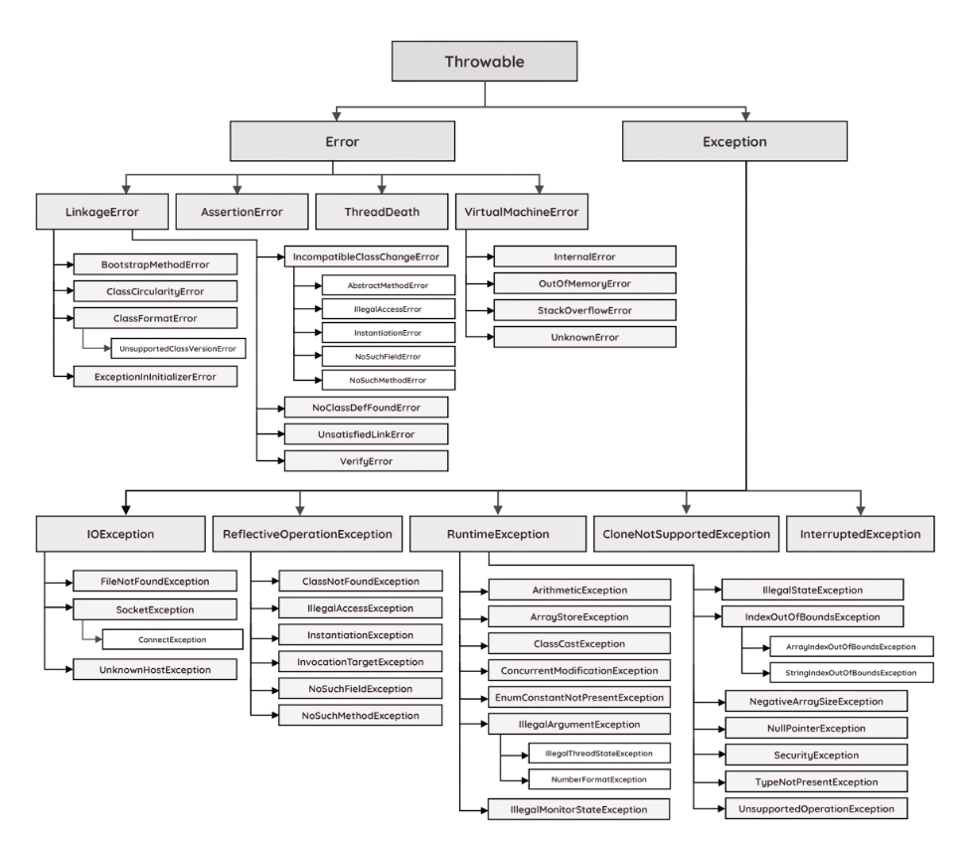
Ejercicio
```Java
public class IOException extends Exception
```
Signals that an I/O exception of some sort has occurred. This class is the general class of exceptions produced by failed or interrupted I/O operations.
```Java
public class RuntimeException extends Exception
```
RuntimeException is the superclass of those exceptions that can be thrown during the normal operation of the Java Virtual Machine.
RuntimeException and its subclasses are unchecked exceptions. Unchecked exceptions do not need to be declared in a method or constructor's throws clause if they can be thrown by the execution of the method or constructor and propagate outside the method or constructor boundary.
```Java
public class InvalidTypeException extends Exception
```
Thrown to indicate a type mismatch in setting the value of a field or variable, or in specifying the return value of a method.
```Java
public class NotBoundException extends Exception
```
A NotBoundException is thrown if an attempt is made to lookup or unbind in the registry a name that has no associated binding.

Ejercicio
FALTA LA DE JERARQUIA

Ejercicio
Devuelve 3. EL finally siempre corre.

