Test Style

Xiaochi

09/01/2020

## Heading 2

### Heading 3

#### Heading 4

This is an R Markdown document. Markdown is a simple formatting syntax for authoring HTML, PDF, and MS Word documents. For more details on using R Markdown see <http://rmarkdown.rstudio.com>.

When you click the **Knit** button a document will be generated that includes both content as well as the output of any embedded R code chunks within the document. You can embed an R code chunk like this:

summary(cars)

## speed dist   
## Min. : 4.0 Min. : 2.00   
## 1st Qu.:12.0 1st Qu.: 26.00   
## Median :15.0 Median : 36.00   
## Mean :15.4 Mean : 42.98   
## 3rd Qu.:19.0 3rd Qu.: 56.00   
## Max. :25.0 Max. :120.00

## Including Plots

You can also embed plots, for example:

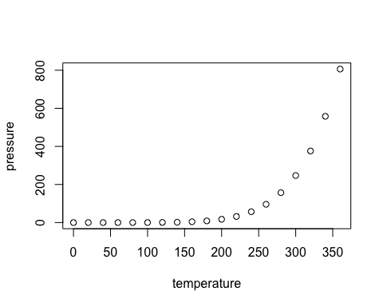

Note that the echo = FALSE parameter was added to the code chunk to prevent printing of the R code that generated the plot.

# Make a table

Create a subset of the mtcars data (Kristensen & Taylor, 2016).

Kristensen et al. (2015) says blah (2015).

|  |  |  |
| --- | --- | --- |
| make_model | mpg | wt |
| Datsun 710 | 22.8 | 2320 |
| Fiat 128 | 32.4 | 2200 |
| Fiat X1-9 | 27.3 | 1935 |
| Honda Civic | 30.4 | 1615 |
| Lotus Europa | 30.4 | 1513 |
| Merc 230 | 22.8 | 3150 |
| Merc 240D | 24.4 | 3190 |
| Porsche 914-2 | 26.0 | 2140 |
| Toyota Corolla | 33.9 | 1835 |
| Toyota Corona | 21.5 | 2465 |
| Volvo 142E | 21.4 | 2780 |

pander(df)

|  |  |  |
| --- | --- | --- |
| make_model | mpg | wt |
| Datsun 710 | 22.8 | 2,320 |
| Fiat 128 | 32.4 | 2,200 |
| Fiat X1-9 | 27.3 | 1,935 |
| Honda Civic | 30.4 | 1,615 |
| Lotus Europa | 30.4 | 1,513 |
| Merc 230 | 22.8 | 3,150 |
| Merc 240D | 24.4 | 3,190 |
| Porsche 914-2 | 26.0 | 2,140 |
| Toyota Corolla | 33.9 | 1,835 |
| Toyota Corona | 21.5 | 2,465 |
| Volvo 142E | 21.4 | 2,780 |

citation("ggplot2")

##   
## To cite ggplot2 in publications, please use:  
##   
## H. Wickham. ggplot2: Elegant Graphics for Data Analysis.  
## Springer-Verlag New York, 2016.  
##   
## A BibTeX entry for LaTeX users is  
##   
## @Book{,  
## author = {Hadley Wickham},  
## title = {ggplot2: Elegant Graphics for Data Analysis},  
## publisher = {Springer-Verlag New York},  
## year = {2016},  
## isbn = {978-3-319-24277-4},  
## url = {https://ggplot2.tidyverse.org},  
## }

## References

Kristensen, L. J., & Taylor, M. P. (2016). Unravelling a ‘miner’s myth’ that environmental contamination in mining towns is naturally occurring. *Environmental Geochemistry and Health*, *38*(4), 1015–1027. <https://doi.org/10.1007/s10653-016-9804-6>

Kristensen, L. J., Taylor, M. P., & Morrison, A. L. (2015). Lead and zinc dust depositions from ore trains characterised using lead isotopic compositions. *Environmental Sciences: Processes and Impacts*, *17*(3), 631–637. <https://doi.org/10.1039/c4em00572d>