**实验三 Windows 应用程序开发**

**一、实验目的**1. 掌握窗口控件的使用方法；  
2. 掌握 Windows 的编程基础。

**二、实验要求**根据要求，编写 C#程序，并将程序代码和运行结果写入实验报告。

**三、实验内容**1. 编写一个计算器， 练习在窗体上添加控件、 调整控件的布局， 设置或修改控件属性，编写事件处理程序的方法。

**Form.cs**

using System;

using System.Collections.Generic;

using System.ComponentModel;

using System.Data;

using System.Drawing;

using System.Linq;

using System.Text;

using System.Threading.Tasks;

using System.Windows.Forms;

namespace 实训3计算器

{

public partial class Form1 : Form

{

double a = 0;

double b = 0;

bool c = false;

string d;

public Form1()

{

InitializeComponent();

}

private void Form1_Load(object sender, EventArgs e)

{

textBox1.Text = "";

}

private void button2_Click(object sender, EventArgs e)

{

if (c == true)

{

textBox1.Text = "";

c = false;

}

textBox1.Text += "1";

}

private void button3_Click(object sender, EventArgs e)

{

if (c == true)

{

textBox1.Text = "";

c = false;

}

textBox1.Text += "2";

}

private void button4_Click(object sender, EventArgs e)

{

if (c == true)

{

textBox1.Text = "";

c = false;

}

textBox1.Text += "3";

}

private void button5_Click(object sender, EventArgs e)

{

if (c == true)

{

textBox1.Text = "";

c = false;

}

textBox1.Text += "4";

}

private void button6_Click(object sender, EventArgs e)

{

if (c == true)

{

textBox1.Text = "";

c = false;

}

textBox1.Text += "5";

}

private void button8_Click(object sender, EventArgs e)

{

if (c == true)

{

textBox1.Text = "";

c = false;

}

textBox1.Text += "6";

}

private void button7_Click(object sender, EventArgs e)

{

if (c == true)

{

textBox1.Text = "";

c = false;

}

textBox1.Text += "7";

}

private void button9_Click(object sender, EventArgs e)

{

if (c == true)

{

textBox1.Text = "";

c = false;

}

textBox1.Text += "8";

}

private void button10_Click(object sender, EventArgs e)

{

if (c == true)

{

textBox1.Text = "";

c = false;

}

textBox1.Text += "9";

}

private void button11_Click(object sender, EventArgs e)

{

if (c == true)

{

textBox1.Text = "";

c = false;

}

textBox1.Text += "0";

if (d == "/")

{

textBox1.Clear();

MessageBox.Show("除数不能为零",

"错误提示", MessageBoxButtons.OK,MessageBoxIcon.Warning);

}

}

private void button1_Click(object sender, EventArgs e)

{

if (textBox1.Text != "")

{

textBox1.Text += ".";

}

}

private void button13_Click(object sender, EventArgs e)

{

c = true;

b = double.Parse(textBox1.Text);

d = "+";

}

private void button14_Click(object sender, EventArgs e)

{

c = true;

b = double.Parse(textBox1.Text);

d = "-";

}

private void button15_Click(object sender, EventArgs e)

{

c = true;

b = double.Parse(textBox1.Text);

d = "*";

}

private void button16_Click(object sender, EventArgs e)

{

c = true;

b = double.Parse(textBox1.Text);

d = "/";

}

private void button12_Click(object sender, EventArgs e)

{

switch (d)

{

case "+": a = b + double.Parse(textBox1.Text); break;

case "-": a = b - double.Parse(textBox1.Text); break;

case "*": a = b * double.Parse(textBox1.Text); break;

case "/": a = b / double.Parse(textBox1.Text); break;

}

textBox1.Text = a + "";

c = true;

}

private void button21_Click(object sender, EventArgs e)

{

textBox1.Text = "";

}

private void button22_Click(object sender, EventArgs e)

{

if (textBox1.Text != "")

{

textBox1.Text = textBox1.Text.Remove(textBox1.Text.Length - 1);

}

}

private void button23_Click(object sender, EventArgs e)

{

Application.Exit();

}

private void button17_Click(object sender, EventArgs e)

{

textBox1.Text = Math.Pow(double.Parse(textBox1.Text),2) + "";

}

private void button18_Click(object sender, EventArgs e)

{

textBox1.Text = Math.Sqrt(double.Parse(textBox1.Text)) + "";

}

private void button19_Click(object sender, EventArgs e)

{

textBox1.Text = Math.Log10(double.Parse(textBox1.Text)) + "";

}

private void button20_Click(object sender, EventArgs e)

{

textBox1.Text = Math.Log(double.Parse(textBox1.Text)) + "";

}

}

}

**截图：**

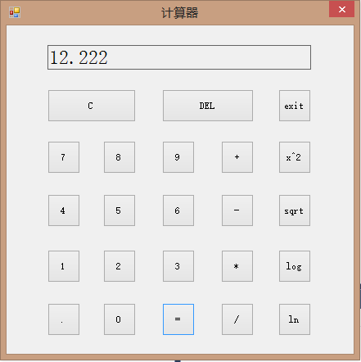

2．自己设计并编写一个 Windows 应用程序，要求至少用到 TextBox、 GroupBox、RadioButton、 CheckBox、 ComboBox、 ListBox 控件。将程序功能、界面布局和运行结果的截图与事件代码写在实验报告中。

**Form.cs**

using System;

using System.Collections.Generic;

using System.ComponentModel;

using System.Data;

using System.Drawing;

using System.Linq;

using System.Text;

using System.Threading.Tasks;

using System.Windows.Forms;

namespace 实训3实验2

{

public partial class Form1 : Form

{

public Form1()

{

InitializeComponent();

}

private void btnAdd_Click(object sender, EventArgs e)

{

string name = this.tbName.Text;

string classname = this.cbClass.Text;

string sex = "";

string like = "";

if (this.rbMan.Checked)

{

sex = this.rbMan.Text;

}

if (this.rbWoman.Checked)

{

sex = this.rbWoman.Text;

}

if (this.cbLookBook.Checked)

{

like += this.cbLookBook.Text;

}

if (this.cbPlayBall.Checked)

{

like += this.cbPlayBall.Text;

}

if (this.cbWalk.Checked)

{

like += this.cbWalk.Text;

}

this.lbView.Items.Add("姓名：" + name + " 班级：" + classname + " 性别：" + sex + " 爱好：" + like);

}

}

}

**截图：**

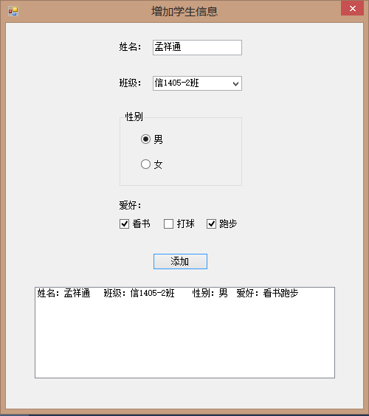

**四、实验总结**

C#针对于窗体应用程序来说，有各式各样的控件，而每个控件又有很多的属性，要想掌握这些控件，只能通过不断的使用才能熟能生巧；并且大多数控件的使用方法都有一定的规律，比如说一些控件显示文本的方式，就是通过设置它的text属性。