**课堂作业**

1. **实验内容：**

**设计一个Person类，并能编写应用该类的c#控制台应用程序。在该类的基础上定义一个派生类Teacher，并能编写应用该类的c#控制台应用程序。**

1. **源程序：**

**主函数：**

using System;

using System.Collections.Generic;

using System.Linq;

using System.Text;

using System.Threading.Tasks;

namespace renwu3

{

class Program

{

static void Main(string[] args)

{

Teacher t = new Teacher("李丽", "女", "1985", "20142478", "2003");

t.Print();

Console.ReadLine();

}

}

}

**Person.cs**

using System;

using System.Collections.Generic;

using System.Linq;

using System.Text;

using System.Threading.Tasks;

namespace renwu3

{

public class Person

{

protected string MyName;

protected string MyGender;

protected string MyYearOfBirth;

protected int Age;

public Person(string name,string gender,string yearOfBirth)

{

this.MyName = name;

this.MyGender = gender;

this.MyYearOfBirth = yearOfBirth;

this.Age = 2016 - int.Parse(yearOfBirth) + 1;

}

public void Print()

{

if (MyGender == "男")

{

Console.WriteLine("姓名：{0}, 先生, 生日：{1}, 年纪：{2}", MyName, MyYearOfBirth, Age);

}

if (MyGender == "女")

{

Console.WriteLine("姓名：{0}, 女士, 生日：{1}, 年纪：{2}", MyName, MyYearOfBirth, Age);

}

}

}

}

**Teacher.cs**

using System;

using System.Collections.Generic;

using System.Linq;

using System.Text;

using System.Threading.Tasks;

namespace renwu3

{

class Teacher:Person

{

protected int tAge;

protected string tId;

protected string tstarYear;

public Teacher(string name,string gender,string yearOfBirth,string MyTId,string MyTstarYear):base(name,gender,yearOfBirth)

{

this.tId = MyTId;

this.tstarYear = MyTstarYear;

this.tAge = 2016 - int.Parse(tstarYear) + 1;

}

public new void Print()

{

base.Print();

Console.WriteLine("工号：{0}, 教龄：{1}", tId, tAge);

}

}

}

1. **实验结果截图：**

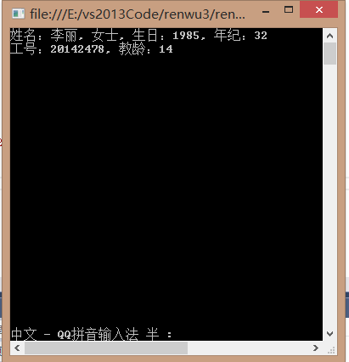

1. **实验总结：**

**通过此次实验，对c#的继承和多态有了一定的了解，知道了如何利用：base调用基类构造函数，如何在派生类中调用基类的方法，例如本例中的base.Print()。**