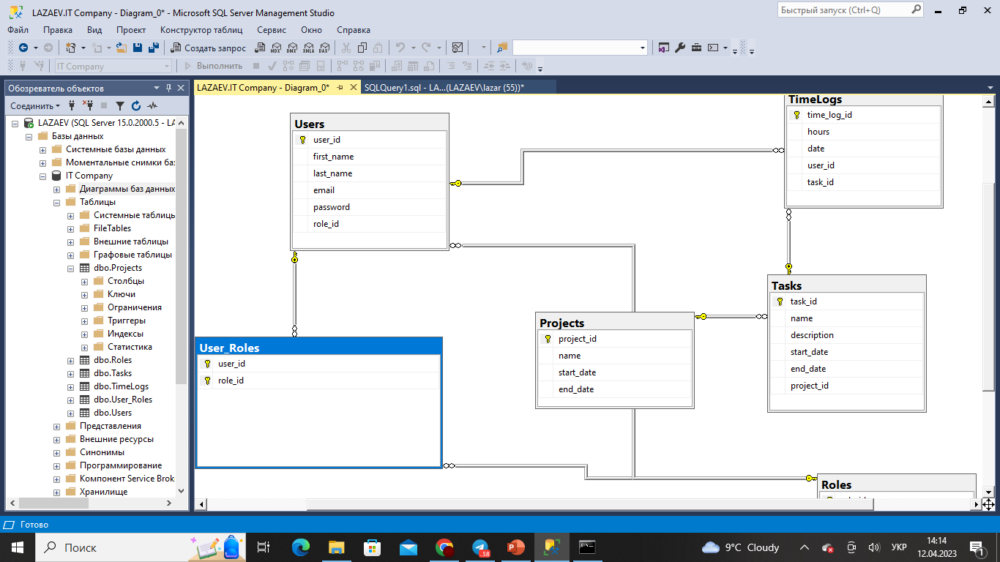

CREATE TABLE Roles (

role_id INT PRIMARY KEY,

name VARCHAR(50)

);

CREATE TABLE Users (

user_id INT PRIMARY KEY,

first_name VARCHAR(50),

last_name VARCHAR(50),

email VARCHAR(100),

password VARCHAR(100),

role_id INT,

FOREIGN KEY (role_id) REFERENCES Roles(role_id)

);

CREATE TABLE Projects (

project_id INT PRIMARY KEY,

name VARCHAR(50),

start_date DATE,

end_date DATE

);

CREATE TABLE Tasks (

task_id INT PRIMARY KEY,

name VARCHAR(50),

description VARCHAR(100),

start_date DATE,

end_date DATE,

project_id INT,

FOREIGN KEY (project_id) REFERENCES Projects(project_id)

);

CREATE TABLE TimeLogs (

time_log_id INT PRIMARY KEY,

hours FLOAT,

date DATE,

user_id INT,

task_id INT,

FOREIGN KEY (user_id) REFERENCES Users(user_id),

FOREIGN KEY (task_id) REFERENCES Tasks(task_id)

);

CREATE TABLE User_Roles (

user_id INT,

role_id INT,

PRIMARY KEY (user_id, role_id),

FOREIGN KEY (user_id) REFERENCES Users(user_id),

FOREIGN KEY (role_id) REFERENCES Roles(role_id)

);