Frontend Specification
Purpose
This document describes the frontend changes for the Soko.market mobile-first PWA so Codex can implement the updated UX.

1. Home Screen Philosophy
The application is no longer dashboard-first. It is chat-first.
After login, the user lands directly in a conversation with their AI business attendant.
The chat becomes the operating system for the business while business cards are generated dynamically by the agent.

2. Fixed Header
The top header remains fixed and contains:
• Soko.market logo/title.
• Store/agent name (e.g. Kwa Jane).
• Online and Synced status badges.
• Notification and overflow menu.
Remove the 'MOBILE PWA SHELL' label completely.

3. Chat Workspace
Everything below the store header is replaced by a full-height chat window.
The first conversation is generated automatically after login.
Example:
'Karibu back, Kwa Jane! I'm your AI attendant and I'm here to help you run your business smoothly. Everything looks good. What would you like to do today?'

4. Dynamic Business Cards
Remove permanent dashboards, navigation grids, business summary cards and bottom navigation.
Instead, the AI generates contextual cards inside the conversation such as:
• Products
• Make a Sale
• Customers
• Invoices
• Payments
• Business Summary
Cards appear only when relevant.

5. Chat Input
Keep a persistent chat input at the bottom with:
• Text input
• Voice button
• Attachment button
• Send button

6. Agent Profile
Clicking the agent avatar or header opens the Agent Profile & Settings page.
The page includes:
• Agent avatar
• Agent name
• Agent description
• AI model selector
• Agent role
• Global Agent ID (public URL)
• Language
• Personality
• Instructions
• Knowledge
• Tools
• Integrations

7. Global Agent Identity
Every agent has a globally unique public ID and storefront URL.
Example:
https://soko.market/agent/<agent-id>
The same agent serves two purposes:
• Business assistant for the owner after login.
• Public storefront assistant for customers from any browser.
Customers interact with the same configured agent using the owner's chosen model, knowledge and personality.

8. UX Principles
• AI-first.
• Mobile-first.
• Minimal navigation.
• Conversation over menus.
• Progressive disclosure.
• Cards generated on demand.
• One agent, one identity, multiple interfaces (owner + storefront).

UI Reference Images

Agent Profile & Settings
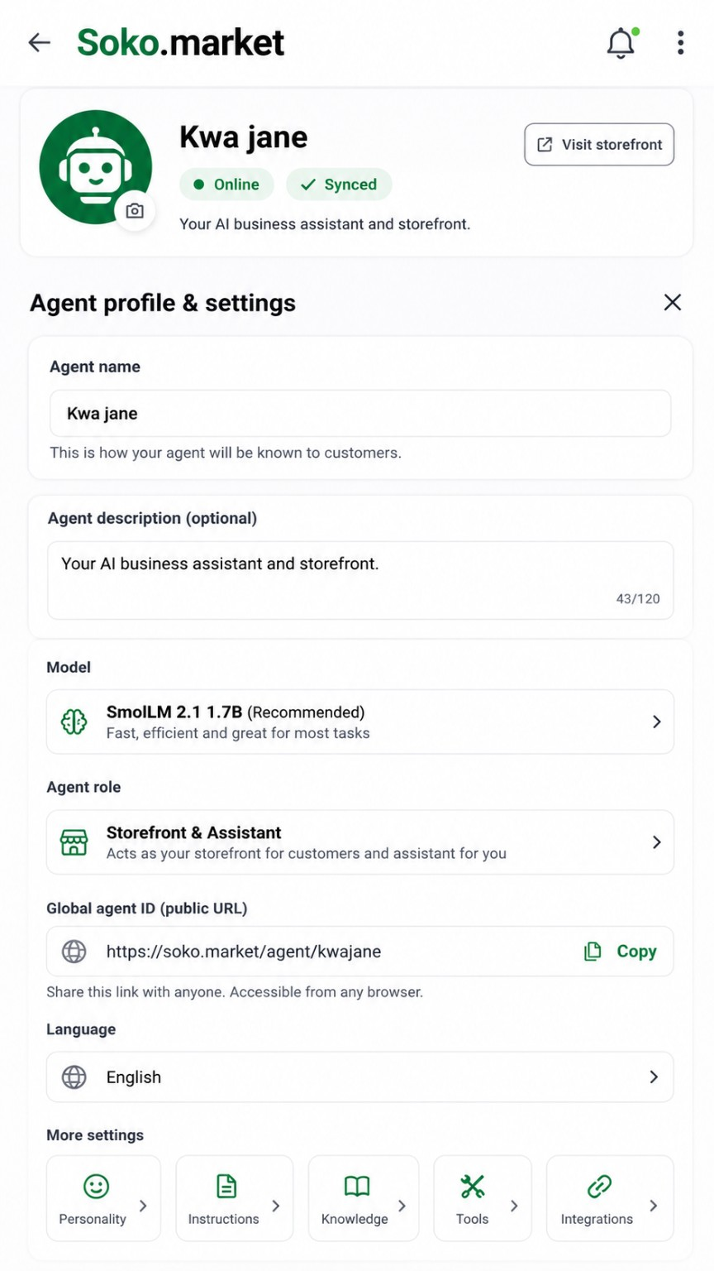

Chat-first Home Screen
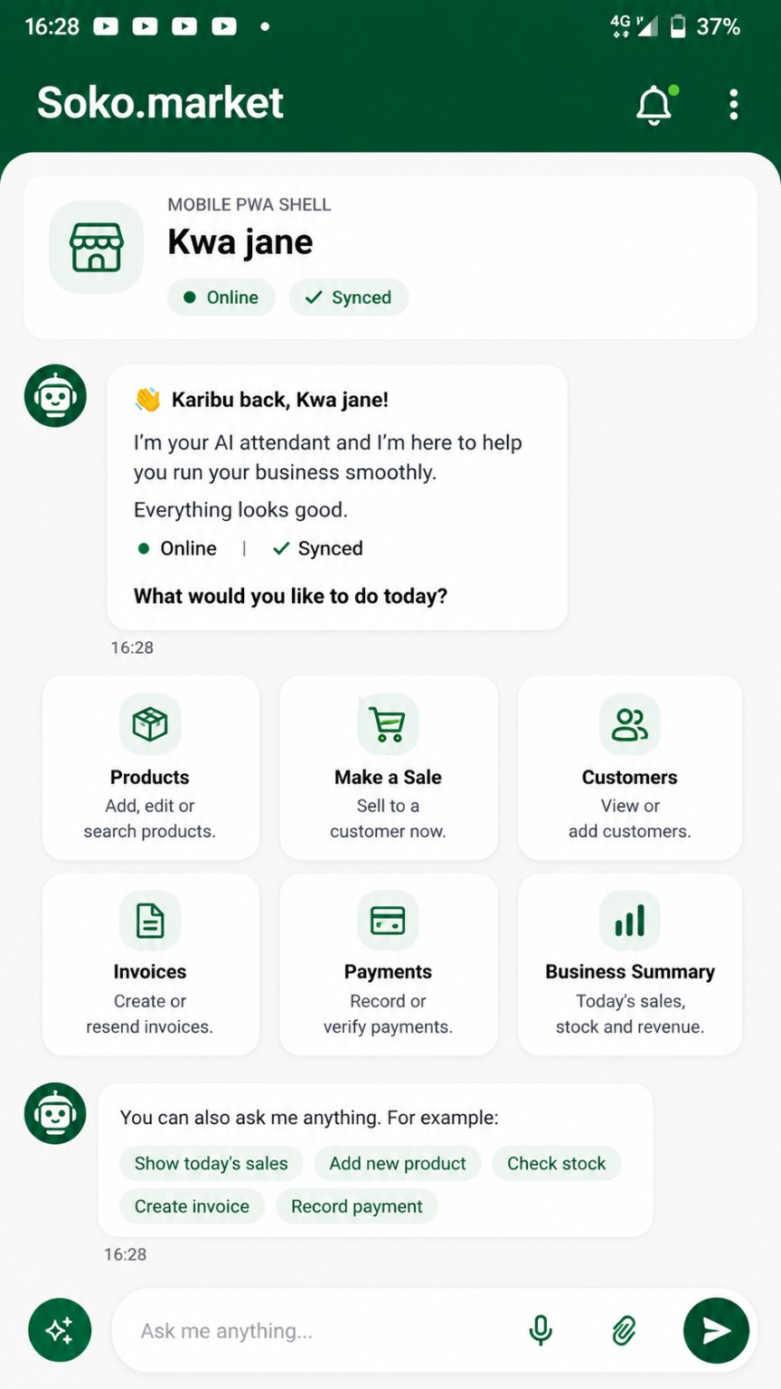

Owner Setup Screen Update
This update applies to the initial owner setup flow. The setup page should be minimal and should end immediately after Step 2.

Required frontend changes
- Remove the text label 'MOBILE PWA SHELL' from the owner setup card.
- Keep the owner setup header with only: Owner setup, Online, and Waiting for setup.
- Make Email authentication functional alongside Phone authentication.
- When Email is selected, the Contact field becomes an email input with email-format validation.
- Request OTP and Verify OTP must send the selected authentication method: phone or email.
- Keep Step 2 with only the Business name field and Language selector.
- Remove everything below Step 2. No additional setup fields, extra sections, or buttons should appear below the Language selector.
- After successful setup, create the business/store, create the default agent, then redirect the owner to the chat-first home screen.

Implementation payloads
Request OTP payload:
{
"method": selectedAuthMethod,
"contact": contactValue
}
Verify OTP payload:
{
"method": selectedAuthMethod,
"contact": contactValue,
"otp": otpValue
}

Owner Setup Reference Image
Reference for the simplified owner setup screen with functional Phone/Email OTP tabs and Step 2 ending after the Language selector.
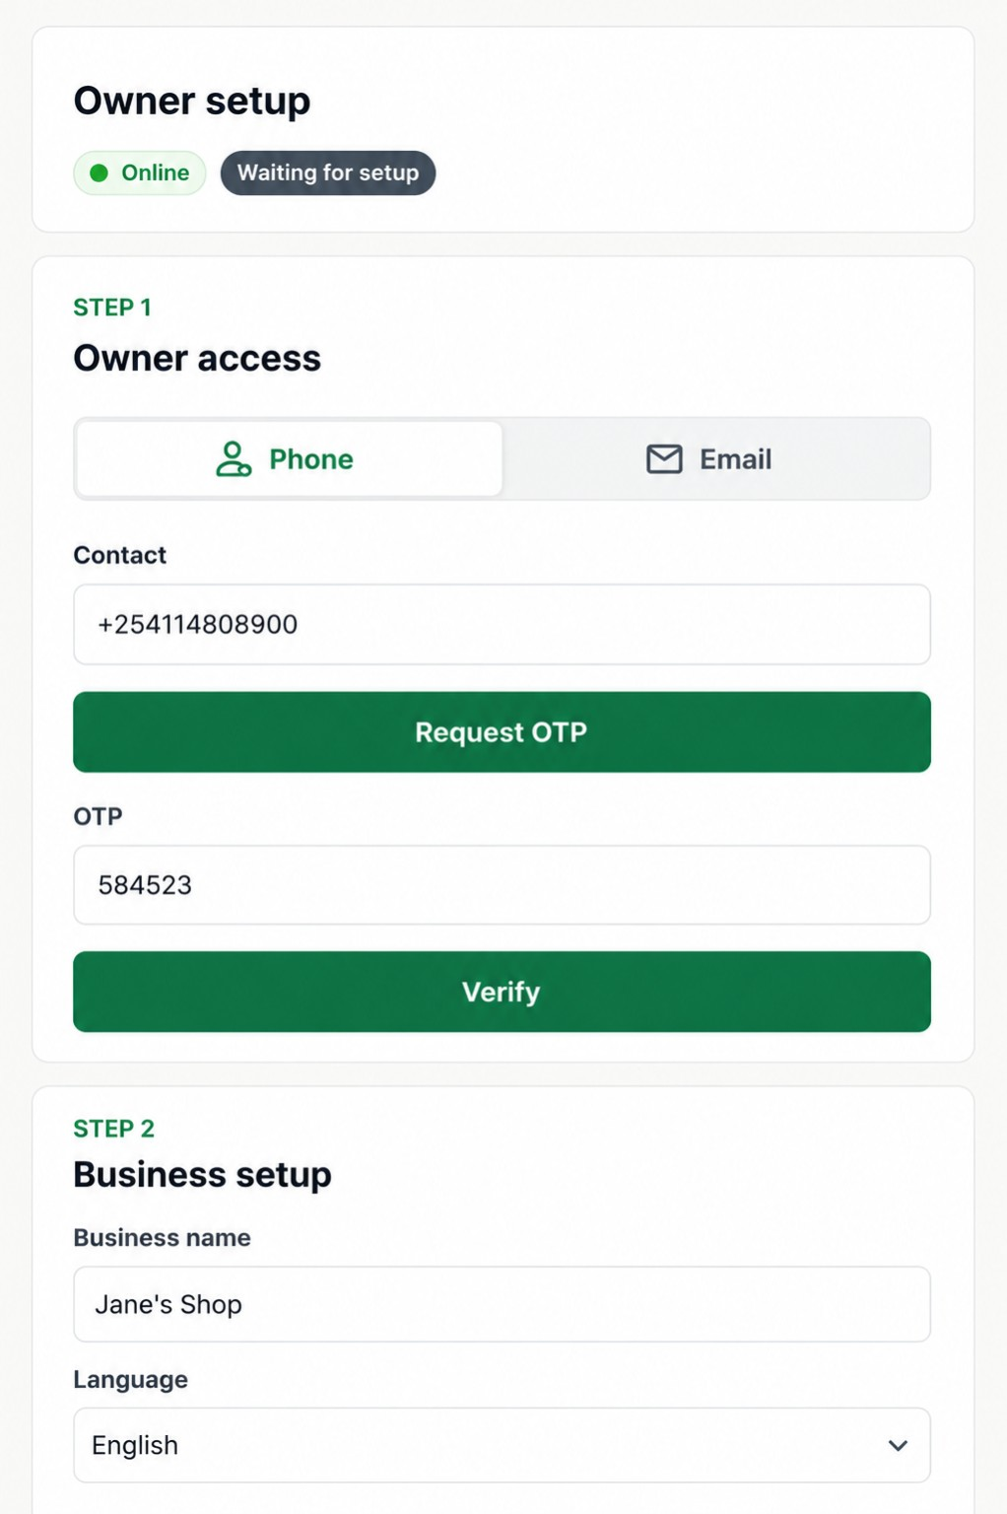

9. Existing User Detection and Saved State
The app must detect whether the current owner already exists before showing the setup flow.
Required behavior:
- On app load, check for an existing authenticated owner session and saved business profile.
- If an existing user is found, do not show Owner setup again.
- Load the previously saved business name, language, agent name, agent model, agent role, status, global agent ID, storefront URL, knowledge, tools, integrations and other saved settings.
- Only show the Owner setup screen when no valid owner profile or business setup exists.
- If setup was started but not completed, resume from the last completed step using saved draft values.
- After successful setup, persist the owner, business and default agent details so future launches load directly into the chat-first home screen.
- Never overwrite saved owner/business/agent details with default demo values such as Jane's Shop or Kwa Jane unless this is the first setup or the user explicitly edits them.
Suggested frontend state flow:
loading -> checkSession -> existingUser ? loadSavedWorkspace : showOwnerSetup

