Soko Global Shop ID
Concept
Every Soko shop is represented by a globally unique Business Agent ID rather than a telephone number. The printed identifier is platform-native and remains stable regardless of SIM card or telecom provider.

Illustration
The BigFish
soko:
+254-A12567835
Where:
• +254 = Country namespace
• A = Business Agent identifier prefix
• 12567835 = Unique global shop identifier
Customers search, chat with, or transact using this Soko ID instead of a phone number.

Design Rationale
• Prevents confusion with telephone numbers by inserting a letter after the country code.
• Gives every shop a permanent, globally addressable identity.
• The same ID can be printed on packaging, receipts, storefronts, QR codes and used throughout the Soko ecosystem.
• The Business Agent behind the shop becomes the storefront's permanent digital identity.

Illustrative Mock-up
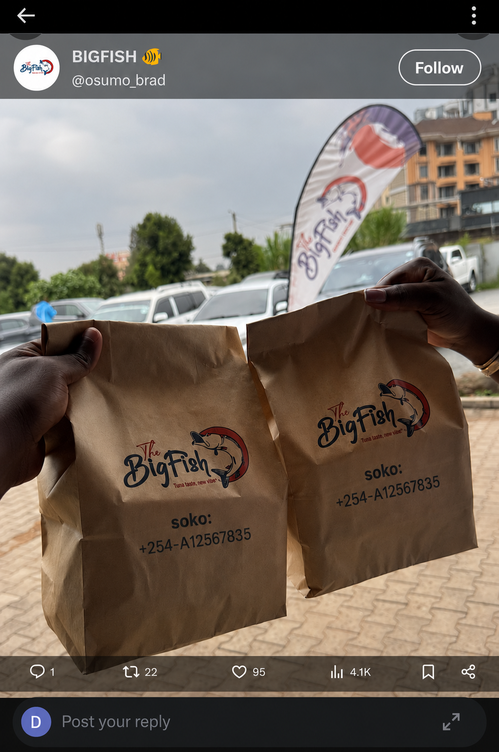
Figure 1. Example packaging showing the Soko global shop identifier replacing a telephone number.

