Probability

Statistical Inference

Brian Caffo, Jeff Leek, Roger Peng

## Notation

* The **sample space**, $Ω$, is the collection of possible outcomes of an experiment
* Example: die roll $Ω=\{1,2,3,4,5,6\}$
* An **event**, say $E$, is a subset of $Ω$
* Example: die roll is even $E=\{2,4,6\}$
* An **elementary** or **simple** event is a particular result of an experiment
* Example: die roll is a four, $ω=4$
* $∅$ is called the **null event** or the **empty set**

## Interpretation of set operations

Normal set operations have particular interpretations in this setting

1. $ω∈E$ implies that $E$ occurs when $ω$ occurs
2. $ω∉E$ implies that $E$ does not occur when $ω$ occurs
3. $E⊂F$ implies that the occurrence of $E$ implies the occurrence of $F$
4. $E∩F$ implies the event that both $E$ and $F$ occur
5. $E∪F$ implies the event that at least one of $E$ or $F$ occur
6. $E∩F=∅$ means that $E$ and $F$ are **mutually exclusive**, or cannot both occur
7. $E^{c}$ or $\overline{E}$ is the event that $E$ does not occur

## Probability

A **probability measure**, $P$, is a function from the collection of possible events so that the following hold

1. For an event $E⊂Ω$, $0≤P(E)≤1$
$P(Ω)=1$

2. If $E_{1}$ and $E_{2}$ are mutually exclusive events $P(E_{1}∪E_{2})=P(E_{1})+P(E_{2})$.

Part 3 of the definition implies **finite additivity**

$$P(\underset{\overset{n}{i=1}}{∪}A_{i})=\sum_{i=1}^{n}{P}(A_{i})$$

where the $\{A_{i}\}$ are mutually exclusive. (Note a more general version of additivity is used in advanced classes.)

## Example consequences

$P(∅)=0$

$P(E)=1−P(E^{c})$

$P(A∪B)=P(A)+P(B)−P(A∩B)$

* if $A⊂B$ then $P(A)≤P(B)$

$P\left(A∪B\right)=1−P(A^{c}∩B^{c})$

$P(A∩B^{c})=P(A)−P(A∩B)$

$P(∪_{i=1}^{n}E_{i})≤\sum_{i=1}^{n}{P}(E_{i})$

$P(∪_{i=1}^{n}E_{i})≥\max_{i}P(E_{i})$

## Example

The National Sleep Foundation ([www.sleepfoundation.org](http://www.sleepfoundation.org/)) reports that around 3% of the American population has sleep apnea. They also report that around 10% of the North American and European population has restless leg syndrome. Does this imply that 13% of people will have at least one sleep problems of these sorts?

## Example continued

Answer: No, the events are not mutually exclusive. To elaborate let:

$$\begin{matrix}A_{1} & = & \{Personhassleepapnea\} \\ A_{2} & = & \{PersonhasRLS\}\end{matrix}$$

Then

$$\begin{matrix}P(A_{1}∪A_{2}) & = & P(A_{1})+P(A_{2})−P(A_{1}∩A_{2}) \\ & = & 0.13−Probabilityofhavingboth\end{matrix}$$

Likely, some fraction of the population has both.

## Random variables

* A **random variable** is a numerical outcome of an experiment.
* The random variables that we study will come in two varieties, **discrete** or **continuous**.
* Discrete random variable are random variables that take on only a countable number of possibilities.
$P(X=k)$

* Continuous random variable can take any value on the real line or some subset of the real line.

$P(X∈A)$

## Examples of variables that can be thought of as random variables

* The $(0−1)$ outcome of the flip of a coin
* The outcome from the roll of a die
* The BMI of a subject four years after a baseline measurement
* The hypertension status of a subject randomly drawn from a population

## PMF

A probability mass function evaluated at a value corresponds to the probability that a random variable takes that value. To be a valid pmf a function, $p$, must satisfy

1. $p(x)≥0$ for all $x$



The sum is taken over all of the possible values for $x$.

## Example

Let $X$ be the result of a coin flip where $X=0$ represents tails and $X=1$ represents heads.

$$p(x)=(1/2)^{x}(1/2)^{1−x} for x=0,1$$

Suppose that we do not know whether or not the coin is fair; Let $θ$ be the probability of a head expressed as a proportion (between 0 and 1).

$$p(x)=θ^{x}(1−θ)^{1−x} for x=0,1$$

## PDF

A probability density function (pdf), is a function associated with a continuous random variable

*Areas under pdfs correspond to probabilities for that random variable*

To be a valid pdf, a function $f$ must satisfy

1. $f(x)≥0$ for all $x$
2. The area under $f(x)$ is one.

x <- c(-0.5, 0, 1, 1, 1.5); y <- c( 0, 0, 2, 0, 0)  
plot(x, y, lwd = 3, frame = FALSE, type = "l")

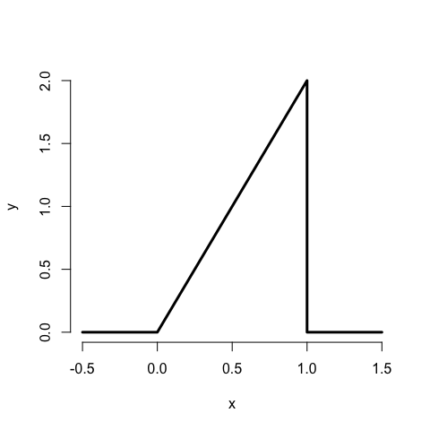

## Example continued

What is the probability that 75% or fewer of calls get addressed?

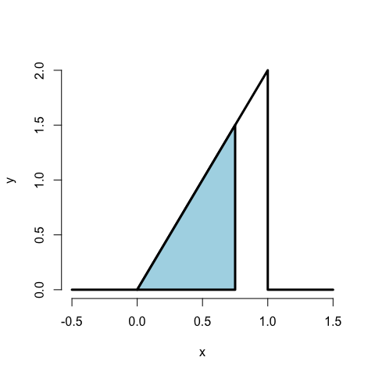

1.5 * .75 / 2

## [1] 0.5625

pbeta(.75, 2, 1)

## [1] 0.5625

## CDF and survival function

* The **cumulative distribution function** (CDF) of a random variable $X$ is defined as the function
$$F(x)=P(X≤x)$$

* This definition applies regardless of whether $X$ is discrete or continuous.
* The **survival function** of a random variable $X$ is defined as
$$S(x)=P(X>x)$$

* Notice that $S(x)=1−F(x)$
* For continuous random variables, the PDF is the derivative of the CDF

## Example

What are the survival function and CDF from the density considered before?

For $1≥x≥0$

$$F(x)=P(X≤x)=\frac{1}{2}Base×Height=\frac{1}{2}(x)×(2x)=x^{2}$$

$$S(x)=1−x^{2}$$

pbeta(c(0.4, 0.5, 0.6), 2, 1)

## [1] 0.16 0.25 0.36

## Quantiles

* The $α^{th}$**quantile** of a distribution with distribution function $F$ is the point $x_{α}$ so that
$$F(x_{α})=α$$

* A **percentile** is simply a quantile with $α$ expressed as a percent
* The **median** is the ${50}^{th}$ percentile

## Summary

* You might be wondering at this point "I've heard of a median before, it didn't require integration. Where's the data?"
* We're referring to are **population quantities**. Therefore, the median being discussed is the **population median**.
* A probability model connects the data to the population using assumptions.
* Therefore the median we're discussing is the **estimand**, the sample median will be the **estimator**