Expected values

Statistical Inference

Brian Caffo, Jeff Leek, Roger Peng

## Expected values

* The **expected value** or **mean** of a random variable is the center of its distribution
* For discrete random variable $X$ with PMF $p(x)$, it is defined as follows


* where the sum is taken over the possible values of $x$
* $E[X]$ represents the center of mass of a collection of locations and weights, $\{x,p(x)\}$

## Example

### Find the center of mass of the bars

## Loading required package: MASS

## Loading required package: HistData

## Loading required package: Hmisc

## Loading required package: lattice

## Loading required package: survival

## Loading required package: Formula

## Loading required package: ggplot2

##   
## Attaching package: 'Hmisc'

## The following objects are masked from 'package:base':  
##   
## format.pval, round.POSIXt, trunc.POSIXt, units

##   
## Attaching package: 'UsingR'

## The following object is masked from 'package:survival':  
##   
## cancer

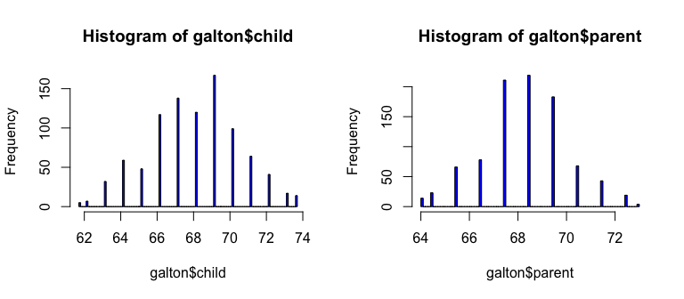

## The center of mass is the empirical mean

hist(galton$child,col="blue",breaks=100)  
 meanChild <- mean(galton$child)  
 lines(rep(meanChild,100),seq(0,150,length=100),col="red",lwd=5)

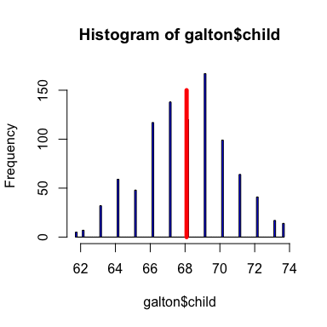

## Example

* Suppose that a die is rolled and $X$ is the number face up
* What is the expected value of $X$?
$$E[X]=1×\frac{1}{6}+2×\frac{1}{6}+3×\frac{1}{6}+4×\frac{1}{6}+5×\frac{1}{6}+6×\frac{1}{6}=3.5$$

* Again, the geometric argument makes this answer obvious without calculation.

## Continuous random variables

* For a continuous random variable, $X$, with density, $f$, the expected value is defined as follows
$$E[X]=theareaunderthefunction tf(t)$$

* This definition borrows from the definition of center of mass for a continuous body

## Example

* Consider a density where $f(x)=1$ for $x$ between zero and one
* (Is this a valid density?)
* Suppose that $X$ follows this density; what is its expected value?  
  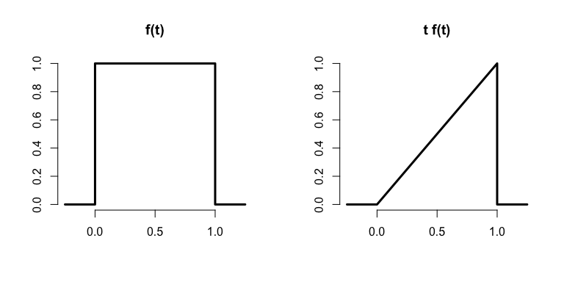

## Rules about expected values

* The expected value is a linear operator
* If $a$ and $b$ are not random and $X$ and $Y$ are two random variables then

$E[aX+b]=aE[X]+b$

$E[X+Y]=E[X]+E[Y]$

## Example

* You flip a coin, $X$ and simulate a uniform random number $Y$, what is the expected value of their sum?
$$E[X+Y]=E[X]+E[Y]=.5+.5=1$$

* Another example, you roll a die twice. What is the expected value of the average?
* Let $X_{1}$ and $X_{2}$ be the results of the two rolls

$$E[(X_{1}+X_{2})/2]=\frac{1}{2}(E[X_{1}]+E[X_{2}])=\frac{1}{2}(3.5+3.5)=3.5$$

## Example

1. Let $X_{i}$ for $i=1,…,n$ be a collection of random variables, each from a distribution with mean $μ$
2. Calculate the expected value of the sample average of the $X_{i}$

$$\begin{matrix}E\left[\frac{1}{n}\underset{\overset{n}{i=1}}{∑}X_{i}\right] & = & \frac{1}{n}E\left[\underset{\overset{n}{i=1}}{∑}X_{i}\right] \\ & = & \frac{1}{n}\sum_{i=1}^{n}{E}\left[X_{i}\right] \\ & = & \frac{1}{n}\sum_{i=1}^{n}{μ}=μ.\end{matrix}$$

## Remark

* Therefore, the expected value of the **sample mean** is the population mean that it's trying to estimate
* When the expected value of an estimator is what its trying to estimate, we say that the estimator is **unbiased**

## The variance

* The variance of a random variable is a measure of *spread*
* If $X$ is a random variable with mean $μ$, the variance of $X$ is defined as

$$Var(X)=E[(X−μ)^{2}]$$

the expected (squared) distance from the mean - Densities with a higher variance are more spread out than densities with a lower variance

* Convenient computational form
$$Var(X)=E[X^{2}]−E[X]^{2}$$

* If $a$ is constant then $Var(aX)=a^{2}Var(X)$
* The square root of the variance is called the **standard deviation**
* The standard deviation has the same units as $X$

## Example

* What's the sample variance from the result of a toss of a die?

$E[X]=3.5$

$E[X^{2}]=1^{2}×\frac{1}{6}+2^{2}×\frac{1}{6}+3^{2}×\frac{1}{6}+4^{2}×\frac{1}{6}+5^{2}×\frac{1}{6}+6^{2}×\frac{1}{6}=15.17$

$Var(X)=E[X^{2}]−E[X]^{2}≈2.92$

## Example

* What's the sample variance from the result of the toss of a coin with probability of heads (1) of $p$?

$E[X]=0×(1−p)+1×p=p$

$E[X^{2}]=E[X]=p$

$Var(X)=E[X^{2}]−E[X]^{2}=p−p^{2}=p(1−p)$

## Interpreting variances

* Chebyshev's inequality is useful for interpreting variances
* This inequality states that
$$P(|X−μ|≥kσ)≤\frac{1}{k^{2}}$$

* For example, the probability that a random variable lies beyond $k$ standard deviations from its mean is less than $1/k^{2}$
$$\begin{matrix}2σ & → & 25\% \\ 3σ & → & 11\% \\ 4σ & → & 6\%\end{matrix}$$

* Note this is only a bound; the actual probability might be quite a bit smaller

## Example

* IQs are often said to be distributed with a mean of $100$ and a sd of $15$
* What is the probability of a randomly drawn person having an IQ higher than $160$ or below $40$?
* Thus we want to know the probability of a person being more than $4$ standard deviations from the mean
* Thus Chebyshev's inequality suggests that this will be no larger than 6%
* IQs distributions are often cited as being bell shaped, in which case this bound is very conservative
* The probability of a random draw from a bell curve being $4$ standard deviations from the mean is on the order of ${10}^{−5}$ (one thousandth of one percent)

## Example

* A former buzz phrase in industrial quality control is Motorola's "Six Sigma" whereby businesses are suggested to control extreme events or rare defective parts
* Chebyshev's inequality states that the probability of a "Six Sigma" event is less than $1/6^{2}≈3\%$
* If a bell curve is assumed, the probability of a "six sigma" event is on the order of ${10}^{−9}$ (one ten millionth of a percent)