**MM803 Assignment2 Report**

**Xinyao(Alvin) Sun**

**1251167**

**Part 1: Image fusion by wavelet domain processing**

My output:

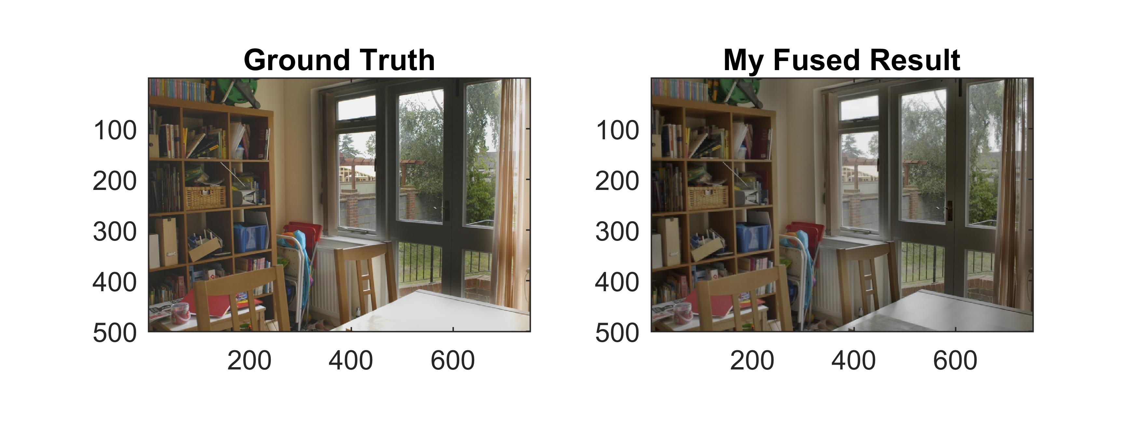

**Highlight progress:**

We are given four images with different exposure level (A, B, C, D).

I fused them as AB, BC, CD. Then I fused AB with BC and BC with CD to get ABC and BCD as shown below.

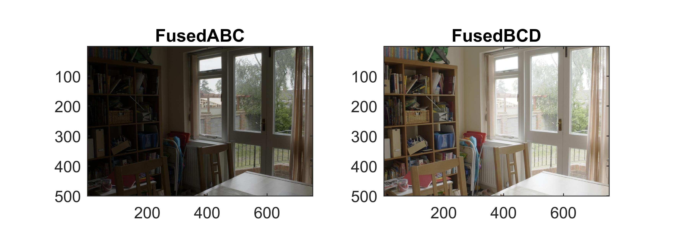

I create my AFUSMETH for ‘wfusimg’ function in Matlab for fusing the ABC and BCD images.

Because based on the given output image that the window area should darker than the indoor area. Even though I found an article that author’s proposed methods get better results [1], in this paper, the author used the same picture here, but his sample output still not close the given result as shown below.

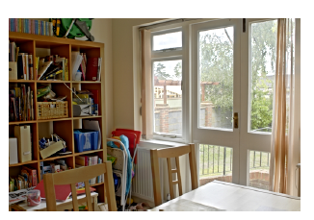

However, if just using “min, max, mean” or simple linear function cannot obtain the close results from FusedABC and FusedBCD. So I decide to have a linear combination of A and B’s wavelet decompositions like with non-constant x.

In ‘myApFun’ function, I created a weight matrix to store the correspond x coefficients.

I first restore the decomposition of two original images and translate to HSV ( I used harr at level 2), then using ‘graytrash’ function to get a threshold of Brightness channel for both of images and get binary segmentation results then do the ‘and’ operation to two logical matrices. The I get a mask matrix as shown below. This aim to segment the two areas with higher brightness and lower brightness.

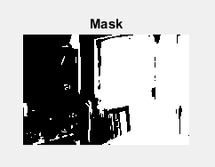

Because it is a binary mask I need a weight matrix, then I used a Gaussian filter with a standard deviation of 2 to the double(Mask) to get a weight matrix.

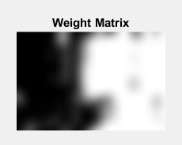

Each entry of the weight matrix corresponds to the x value of the linear combination function of A and B to get a final C.

**Part 2: Removal of periodic noise**

My output:

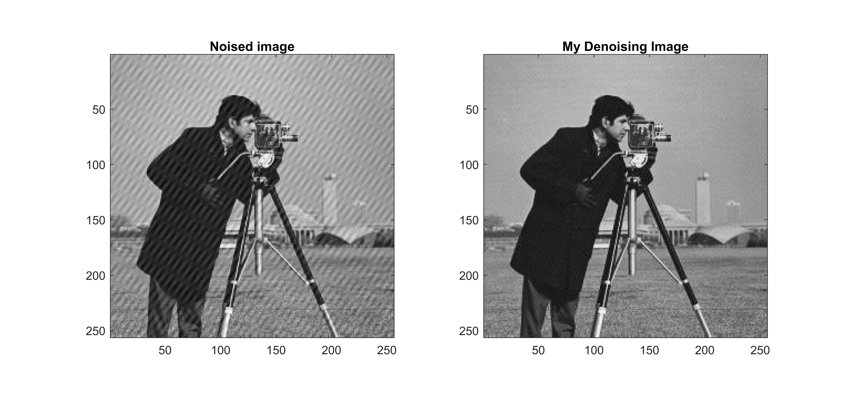

**Highlight process:**

We can access the original image that without any noise.

Apply the fast Fourier transform for both of them we can obtain the Fourier spectrum of both of original and noisy images as shown below.

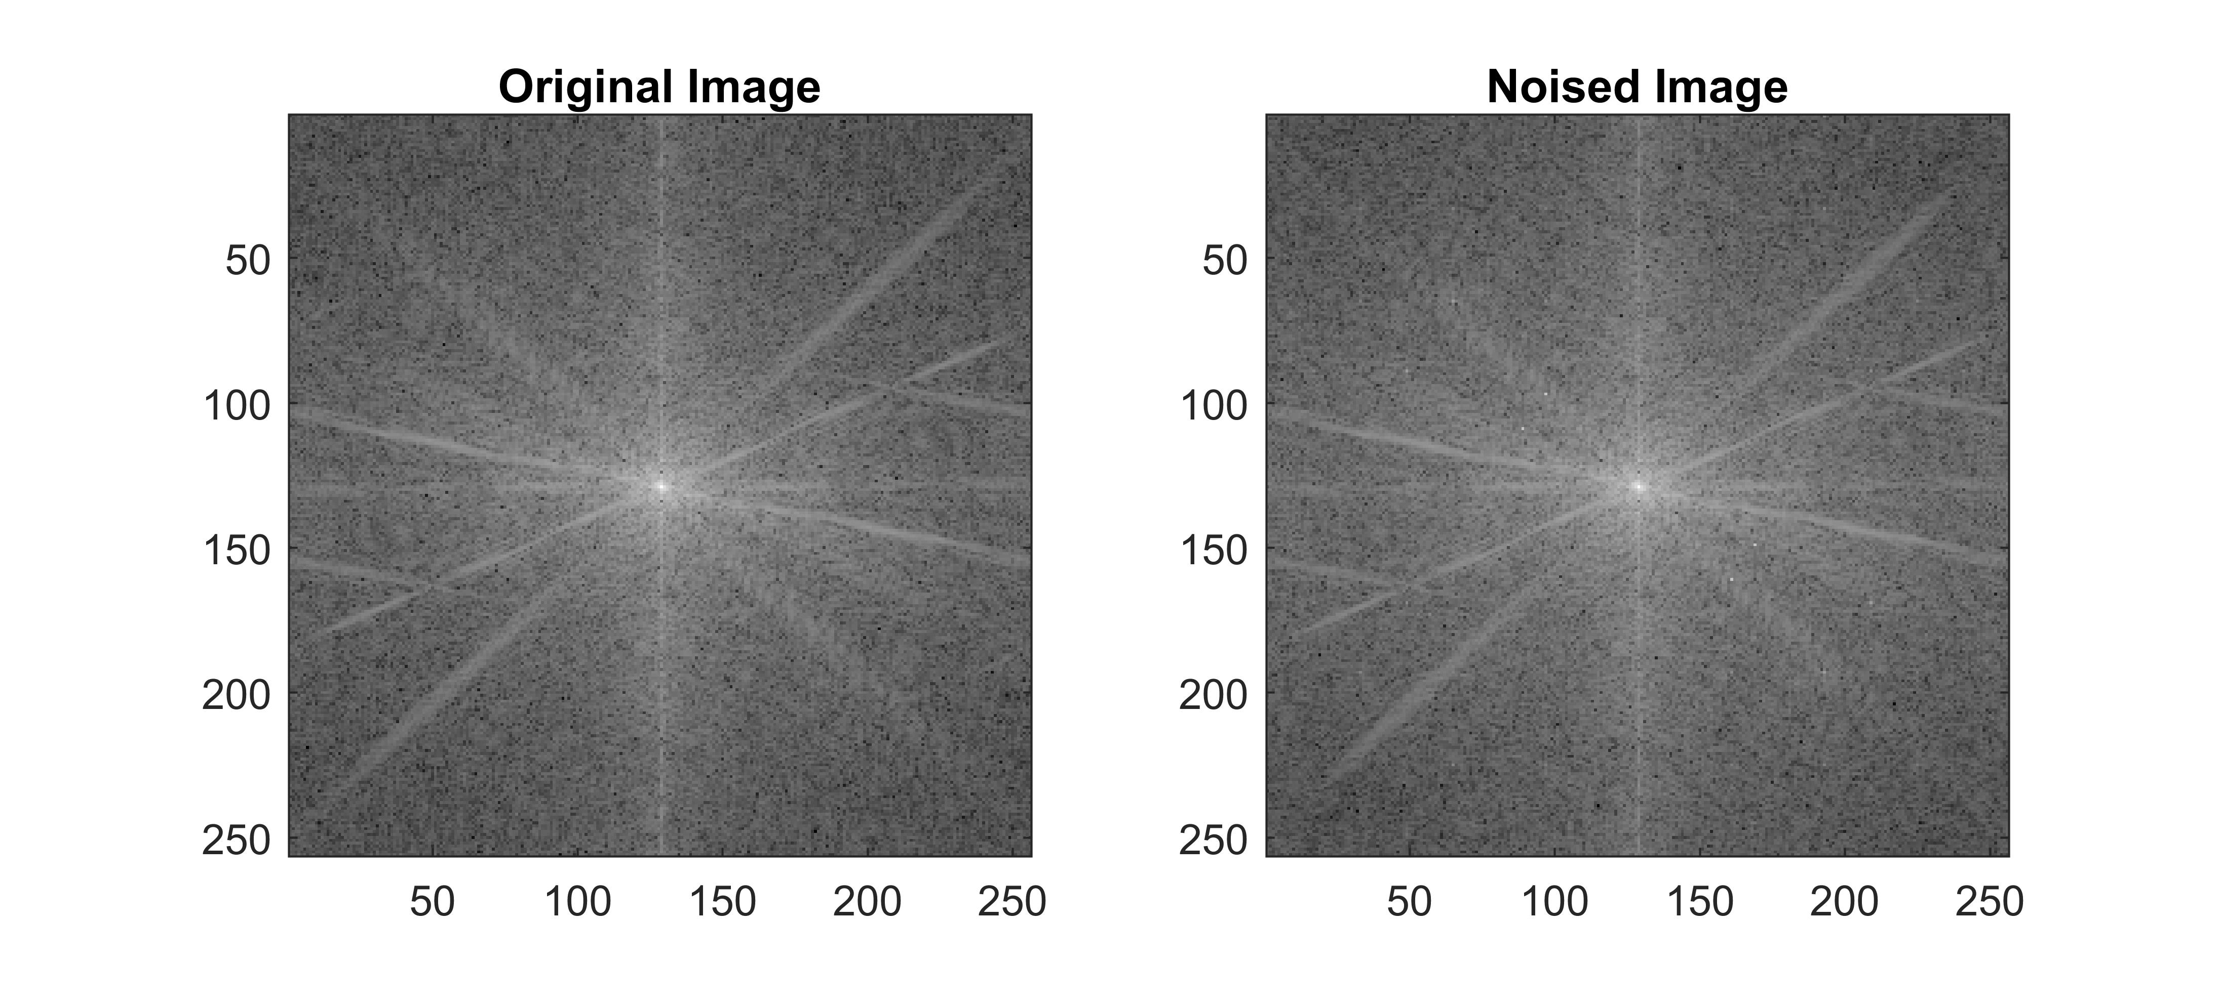

After an observation of this two Fourier spectrum figure, we can find that there are some points with high value on noisy image than the original image such as shown below.

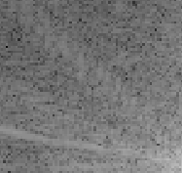 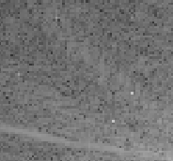

Left is one part of original image Fourier spectrum and the right side is the same part of noise one. The red rectangle indicates some significant difference.

Then I think if I can find the exact noise frequency from the noise FS and eliminate it(them) then I should able to remove the noise.

Then I first tried to get the diff matrix by using FS(Noisy) – FS(Original).

And then collect the entry with the value greater than 0.65 of a maximum of the all the diff values.

Then I have a 32 length of entries that could be the frequency of the noise. Then create a Mask and set these entries to 0 others to 1 as shown below, then apply the mask to the noised FS I can get a good result without noise.



However, I was thinking about whether this mask gets rid of some information of the image; then I think I can manually find the exact entry that correspond the exact frequency of the noise. Then I tried to set the 32 entries from index 1 to 32 from 0 to 1 one by one and see whether the noise appeared or the image have significant changes.

After experiments for 32 entries, I located four exact points on the noise image's Fourier spectrum as shown below.



Then using this final mask to eliminate their’s corresponding frequency from the Noisy Image, I can remove the noise.