Using the Image Tracer
Nathaniel Rossol

Step 1: Opening a new image:
To open up a new image to trace on, first press the open button: Open
Next an open file dialog box should appear asking you to choose which image you would like to open. The new image thumbnail feature allows you to preview your image before you open it to see if it’s the one you want. By default, you will start in Image Tracer’s directory.

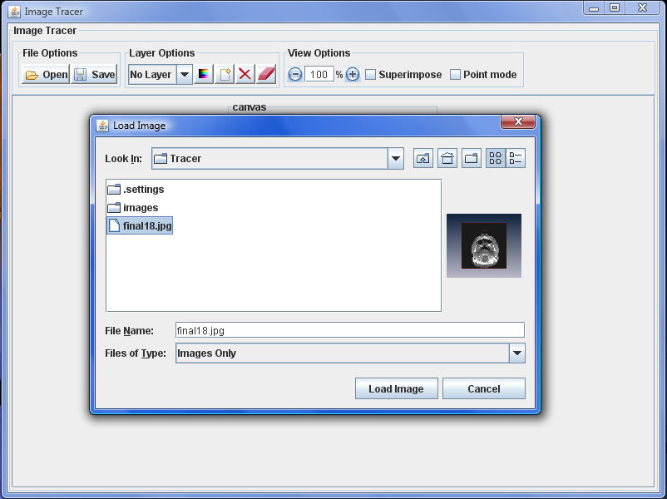
Step 2: Tracing on the image:
Once the image is loaded, tracing is enabled. To trace on the image, simply click and drag the mouse on it.
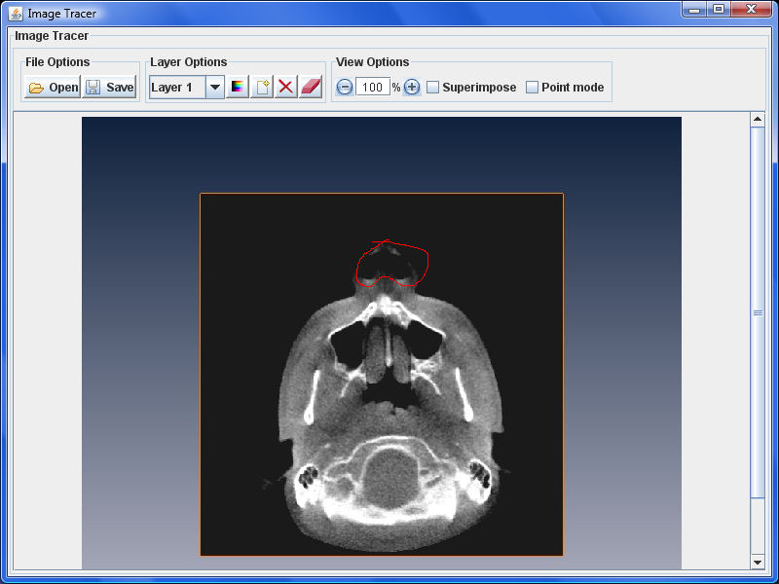

Using the Layer Options:
By default, when you start the application, you will be drawing on Layer 1. To switch to a different layer, use the drop-down combo box in the Layer Options panel to switch to a different tracing layer.
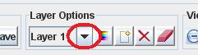
Note: if you switch this to No Layer then the program will hide all tracings, allowing you to view the original background image (make sure superimpose is off).

Adding a new layer
By default, the application only starts with one tracing layer. If you want to add a new layer, simply press the New Layer button to create a new one. You can add as many layers as your system has memory for.

Deleting a layer
To delete a layer, simply press the delete layer button. All layers below it will be renamed accordingly. For example, if you delete Layer 3, then Layer 4 becomes the new Layer 3, Layer 5 is now Layer 4, etc.

Clearing a layer
Unlike, deleting, clearing a layer simply erases all of the tracings off of it.

Eraser Mode
When in eraser mode, you can delete points from existing tracings (this also splits contours in two if you erase the middle of a contour).

Color chooser
The color chooser button allows you to change the color of your tracings for the current layer.

Note that each button also has a tooltip that will pop up if you place your mouse cursor on it to remind you of what each button does.

Using the View Options:
Zooming in and out
Use the + button to zoom in and the - button to zoom out. Alternatively you can enter in a custom zoom value and press enter to change the zoom yourself.

Superimpose
To toggle viewing all tracings on all layers at once, click the superimpose checkbox.
Point Mode
To toggle between viewing points and viewing lines, click the Point mode checkbox.

Step 3: Saving the tracings:
Once you’re finished tracing and wish to save what you’ve done, press the Save button to save your data. You will be prompted with a dialog box asking for the name of your data file. By default, your file is saved to the application’s local directory.
Later, you can reopen your tracings by using the Open button and selecting your save file. Note that you need to load an image before reopening any tracings file.
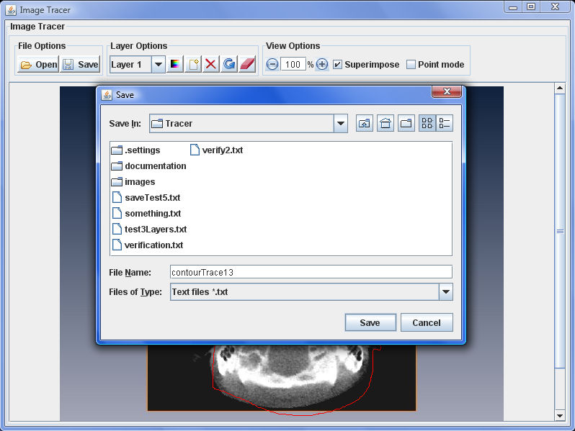
Saved tracings file format:
An example of a saved tracings file is shown below:
New Layer
Start
164 126 26
165 126 32
168 123 28
172 122 27
Stop
Start
143 306 26
138 305 26
135 304 26
131 302 26
126 299 25
123 297 25
123 297 25
119 293 117
116 290 119
113 285 118
113 285 117
Stop
New Layer
Start
452 286 26
455 286 26
460 285 26
480 279 27
483 278 26
484 278 26
486 277 25
Stop

As might be expected, “New Layer” refers to a layer in the Tracer. In the above example, we can see that the user’s tracings are on 2 layers because the line “New Layer” appears twice.
Each layer potentially contains several paths which are delineated by a “Start” and a “Stop” where “Start” indicates when the use pressed down the mouse button and “Stop” indicates when the user released the mouse button We can see that, in the above example, the first Layer has two paths whereas the second has only one.
All the points the user dragged over whilst holding down the mouse button are recorded in between the Start and the Stop. As you can see, each point is represented by 3 integers. The first 2 numbers represent the point’s x and y coordinates respectively, where the image pixel in the top-left corner of the image has the coordinate (0,0). X values increase as you move right across the image and Y values increase as you move down the image.
The final number is a greyscale representation of the color of the pixel the point lies on where 0 means solid black and 255 means solid white.

