**Q**. What are conditional statements? Explain conditional statements with syntax and examples.

**Answers**: One of the key features of JavaScript is the ability to use conditional statements to control the flow of a program.

Conditions work on boolean values, true or false. It is true if it meets the requirement, false otherwise. That is expressions (conditions) are evaluated to be either true or false.

**Conditional statements in JavaScript:**

**1. if statement:**

The most basic form of a conditional statement is the if statement.

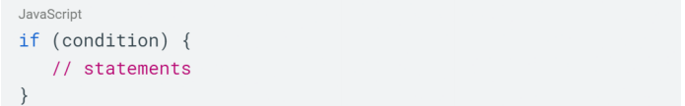The syntax for an if statement is as follows:

**Ex:**

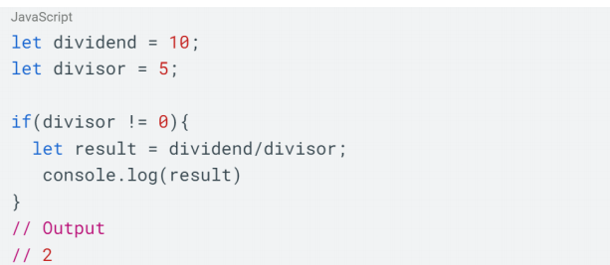Divide only, when the divisor is ! = 0

2. if-else statement:

An if statement can also include an optional else statement, which will execute if the condition is false.

The syntax for an if-else statement is as follows:

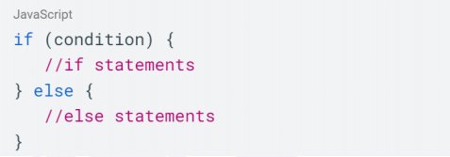

**Ex:**

Only age above 18 are eligible for registration.

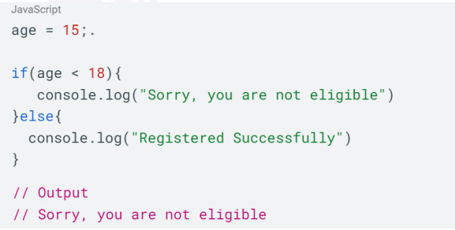

3. **Nested if statement:**

We can nest if else statements inside another if else statements.

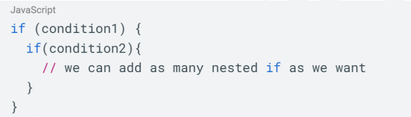The syntax for a nested if statement is as follows:

**Ex:**

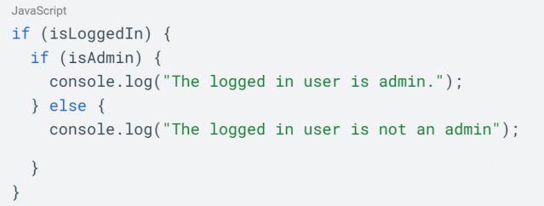Check if the user is logged in and if the logged in user is admin or not.

4. **if else if ladder:**

JavaScript also supports the use of else if statement, which allows you to chain multiple conditions together also called if else ladder.

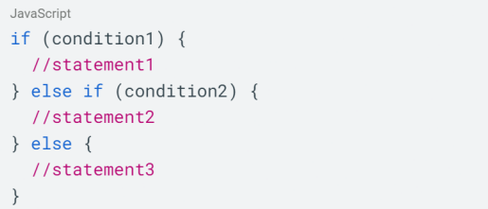The syntax for an if else if ladder is as follows:

**Note 1:** You can chain as many else-if statements as you want.

**Note 2:** Just like the if statement in the if-else ladder also we can omit the last else block, it is not mandatory to put.

**Ex:**

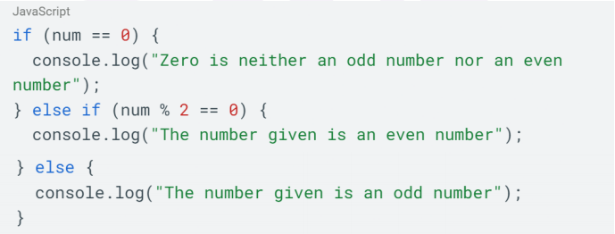Let’s write a program to check if the given number is odd or even