Q. What are loops, and what do we need them? Explain different types of loops with their syntax and examples.

**Answer:**

Loops: Loops are used in programming to repeatedly run a block of code.

1. **For Loop:**

We use for loop to run a piece of code until the set condition turns false.

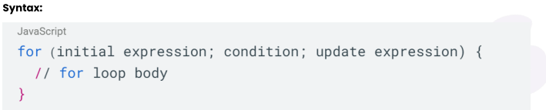

* **Initial Expression** only ever executes once while initializing and d.
* The **Condition** is assessed.
* If the condition is false, the for loop will end.
* If the condition is true,
* The for loop's code block will be executed.
* **Update expression** changes the **initial expression's** value
* The condition is once more assessed and the loop continues until the condition becomes false.

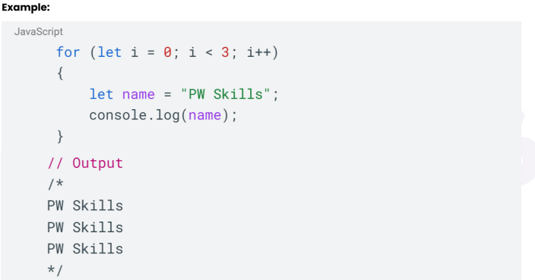

1. **While Loop:** This loop keeps on running as long as the condition is true.

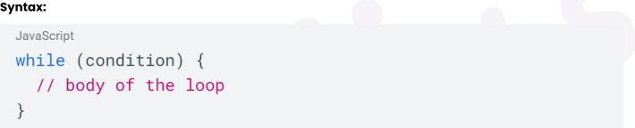

* Loop starts.
* Condition is evaluated.

1. If the condition is false, the while loop will terminate.
2. If the condition is true, the while loop's statements run, and continue until the condition evaluates to false.

* 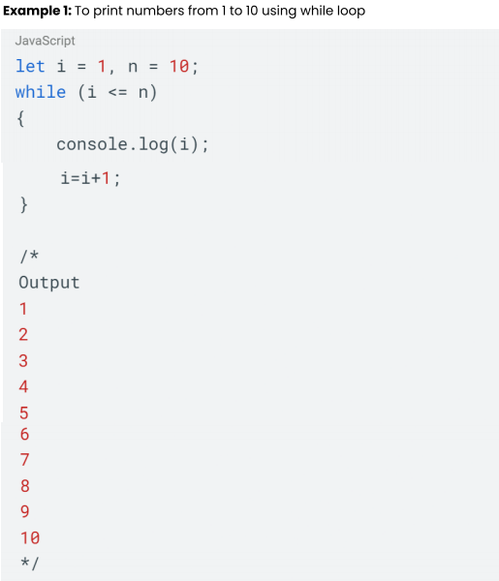Loop Ends.

1. **Do While Loop:** Do while is similar to while loop with one difference that the 1st iteration runs always, and later iterations run after the condition evaluates to true.

* Loop Start.
* Loop Body is executed first.
* Condition is accessed.
* If Condition is false.
* If the condition is true, the while loop's statements run, and continue until the condition evaluates to false.
* 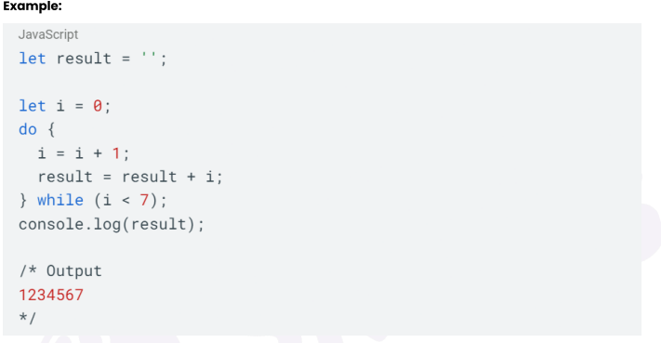Loop Ends