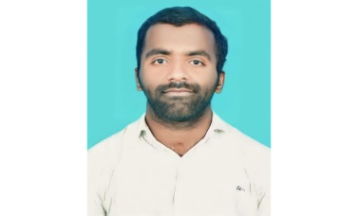 **KARNAM LAXMAN**

karnamlaxman04@gmail.com| (+91) 9502657244

**EXPERIENCE**

* **Full Stack Web Development Intern | EY Global Services Limited** *(Feb ’28 - Apr ‘25)* Created and developed a bus reservation system project using Django for the backend, and HTML, CSS, and Python for the frontend
* **Cloud Computing Intern| UPSKILL CAMPUS** *(Feb ’10 -Mar’10)* Developed a Hospital Management System to streamline hospital operations, using Django for the backend and HTML, CSS, and Python for the frontend.
* **Cyber Security And Digital Forensics Intern | Cyber Secure India** *(Dec ‘5 – Mar ‘5)* Completed a 3-month virtual internship in Cyber Security and Digital Forensics with Cyber Secured India, acquiring practical skills in safeguarding digital assets and analyzing cyber incidents.
* **Pratical Blue Team Intern | Virtual cyber Labs**

**EDUCATION**

* Computer Engineering | Teegala Krishna Reddy Engineering College,Hyderabad *CGPA:7.68* | *(2022-2025)*
* Mechanical Engineering | Government Ploytechnic Navipet College  *CGPA: 8.33*  (2019-2022)
* Completed Class X | Zphs Nagepur *CGPA: 8.8 (2019)*

**ACADEMIC PROJECTS**

* **Random Password Generator**

Developed a program that generates secure, random passwords using Python

* **Rock-Paper-Scissors Game**

Created an interactive game where users can play Rock-Paper-Scissors against the computer using Python

* **ATM Machine Simulation**

Simulated an ATM machine with functionalities like account balance checking, cash withdrawal, and deposit,using Python

**POSITION OF RESPONSIBILITY**

* **Class Representative | Government Polytechnic College, Navipet** *(2019-2022)*

Represented students, organized events, and facilitated communication between students and faculty.

**ACHIVEMENTS**

* **Core Java Training | Aavanto Technology** *(Jan ’23 – Apr 23)*

Earned a certificate, enhancing my knowledge and confidence in Java programming.

* **Certified in Cybersecurity (CC),|(ISC)²** *(Apr ’17 – 2023)*

Completed self-paced training covering fundamental cybersecurity concepts.

**SKILLS**

* **Programming Languages**: Python, Java
* **Web Development**: HTML, CSS, Django
* **Cybersecurity**: Cyber Security Fundamentals, Digital Forensics
* **Tools and Technologies**: SQL