Apache NetBeans 12.0 Features

* Apache NetBeans 12.0 adds support for the latest Java language features, integrates new code donations from Oracle for Java Web development, enhances its best of breed Apache Maven tooling, brings multiple enhancements for users of Gradle, includes built-in features for Payara and WildFly for the first time, introduces new out of the box templates for JavaFX, upgrades and extends its PHP editor and includes a wide range of fixes.
* To use the latest Java language features in the Java Editor, run Apache NetBeans on the JDK that provides those features, enabling Apache NetBeans to use the Java compiler from the JDK it runs on for its Java Editor support for those features.
* JEP 359: Records (Preview Feature) — syntax coloring for the new "record" keyword; Navigator shows equals, hashCode, toString, etc. and formatting support for records.

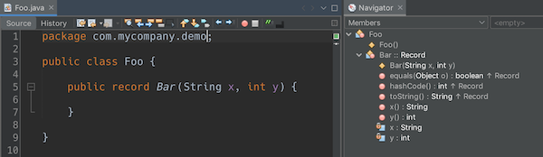

* JEP 359: Records (Preview Feature) — syntax coloring for the new "record" keyword; Navigator shows equals, hashCode, toString, etc; and formatting support for records.

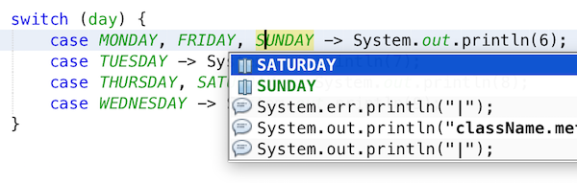

* JEP 359: Records (Preview Feature) — syntax coloring for the new "record" keyword; Navigator shows equals, hashCode, toString, etc. and formatting support for records.

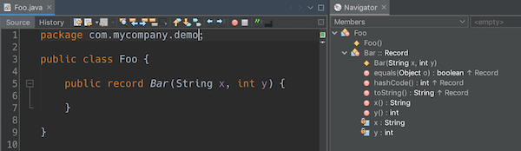

* JEP 355: Text Blocks (Preview) — Java editor hint has been introduced for converting to/from text blocks.



* JEP 305: Pattern Matching for instance of (Preview Feature)



* JEP 330: Launch Single-File Source-Code Programs — single Java source files can be created, outside of projects, in the Favorites window, and they can be run and debugged, if NetBeans is running on JDK 11 or later.
* Two OpenJFX Gluon Maven artifacts are now registered in the New Project dialog, named "FXML JavaFX Maven Archetype (Gluon)" and "Simple JavaFX Maven Archetype (Gluon)", with their nbactions.xml files customized so that running and debugging can be done out of the box without any tweaking needed by the user.

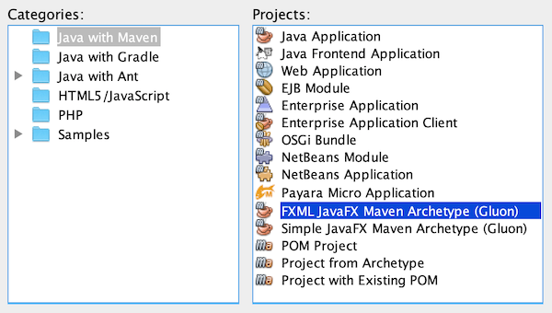

* Java EE 8 support, for the first time in 11.1, for Maven-based and Gradle-based Web applications. The Java EE 8 support provides the ability to create Java EE 8 applications and deploy to a Java EE 8 container, with new "webapp-javaee8" Maven archetype created for use with Apache NetBeans.

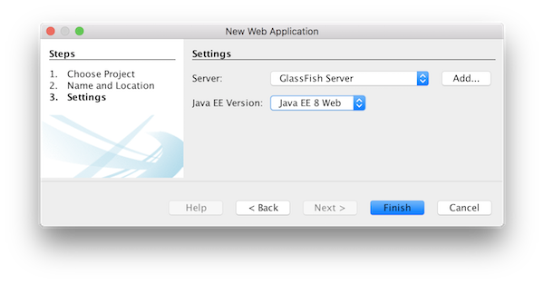

* Support for JSF 2.3: CDI Changes for JSF Artifact Injection ,"f:websocket" is now supported.

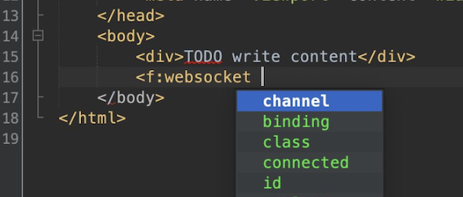

* GlassFish support to 5.0.1.
* Payara integration out of the box for the first time, from 11.1, including Payara Platform 5.194/5.201 support and Payara Server Hot Deploy support.
* Tomcat
* WildFly integration out of the box for the first time, from 12.0.
* The key new feature for Gradle users in Apache NetBeans 12.0 is its support for Java EE.

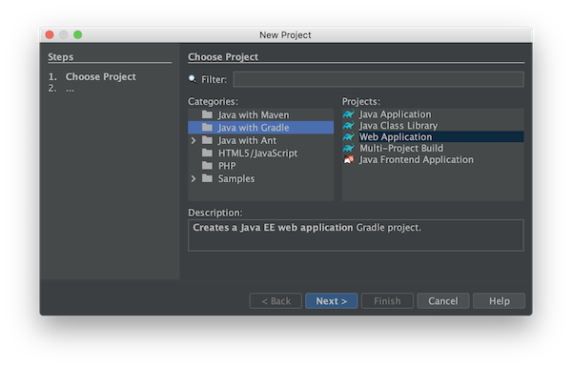

* Feature for PHP users in Apache NetBeans 12.0 is its support for PHP 7.4.

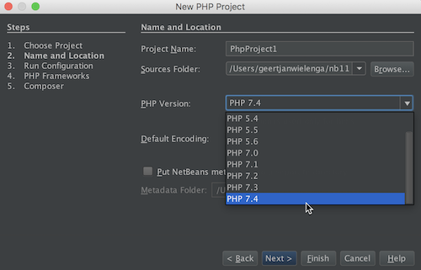

Further details on new support for PHP 7.4 features are provided here and see all fixes in the PHP area in 12.0.

In addition, Apache NetBeans 12.0 integrates out of the box a TypeScript editor, introduced in 11.3.

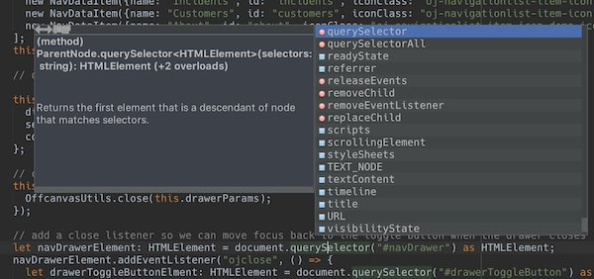

* NetBeans C and C++ features from Oracle to Apache has been completed in the 11.3 timeframe, though the code has not yet been integrated into Apache NetBeans. This is anticipated to be a large task and may take some time, involving not only license changes and IP clearance in Apache, though also potentially code changes since not everything that was part of these features in Oracle was able to be donated by Oracle to Apache. Until the code integration is complete, go to the Plugin Manager, enable the NetBeans IDE 8.2 Update Center, which lets you install the NetBeans IDE 8.2 modules providing C and C++ features.
* key focus of the 12.0 release is around appearance, since the NetBeans dark look and feels support (Dark Metal and Dark Nimbus) has been donated by Oracle to Apache, while FlatLaf, a completely new look and feel by Karl Tauber from FormDev Software GmbH, has been integrated. Also, enhancements for HiDPI on Windows have been introduced.

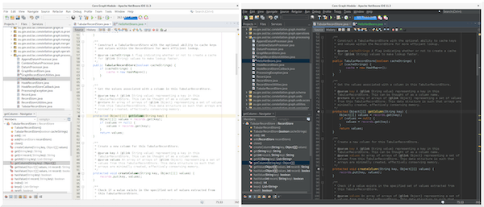

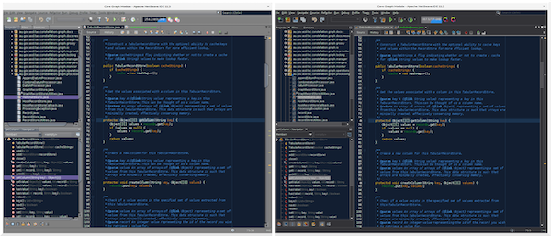

* Windows LAF: Fixed tiny or huge GUI font size on various HiDPI configurations, fixed incorrectly sized component icons (radio buttons, checkboxes, project tree expansion handles etc.) on various HiDPI configurations, fixed uneven borders on text components on non-integral HiDPI scaling factors, e.g., 150%, fixed broken tab dragging (window rearrangements) on HiDPI displays.
* Toolbar browser icon take advantage of improved HiDPI scaling.
* Implemented simplified HeapView widget.
* Fixed incorrectly positioned line-width marker (i.e., shown at 82 characters instead of 80 characters), and inaccurate tab alignments. This bug existed at certain editor zoom levels on Windows, Linux, and MacOS, including on non-HiDPI screens.
* Fixed clipped file names in Projects window and Files window on Windows on HiDPI screens

NetBeans 12.0 Connect to the Apache server.

* Before you can connect to a MySQL Database Server, you must first ensure that the MySQL Database Server is running on your machine. If the database server is not connected you will see (disconnected) next to the user name in the MySQL Server node in the Service window and you will not be able to expand the node
* To connect to the database server, confirm that the MySQL Database Server is running on your machine, right-click the Databases > MySQL Server node in the Services window and choose Connect. You might be prompted to supply a password to connect to the server

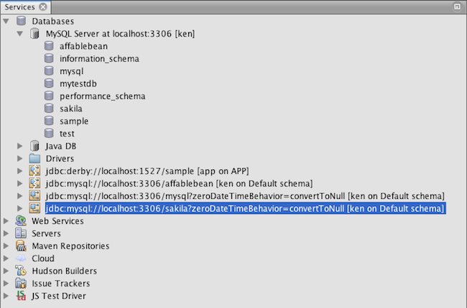

When the server is connected you will be able to expand the MySQL Server node and view the all available MySQL databases

* A common way of interacting with databases is through an SQL editor. NetBeans IDE has a built-in SQL Editor for this purpose. The SQL Editor is generally accessible via the Execute Command option from the right-click menu of the connection node (or of the connection node’s child nodes). Now that you are connected to the MySQL server, you can create a new database instance using the SQL Editor. For purposes of this tutorial, create an instance called MyNewDatabase :

1. In the IDE’s Services window, right-click the MySQL Server node and choose Create Database.
   * The Create MySQL Database dialog box opens.
2. In the Create MySQL Database dialog box, type the name of the new database. We will use MyNewDatabase for this tutorial. Leave the checkbox unselected at this time.

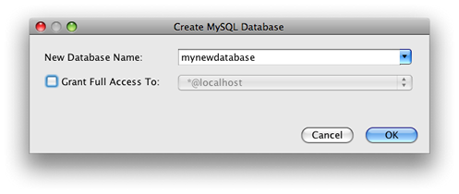

1. Click OK.
   * The new database appears under the MySQL Server node in the Services window.
2. Right-click the new database node and choose Connect in the popup menu to open the connection to the database.
   * Database connections that are open are represented by a complete connection node ( ) in the Services window.