Assignment-3(Group-25)
Ex-Post ML Techniques for Portfolio Optimization

Heatmap of Sample Covariance and Shrunk Covariance
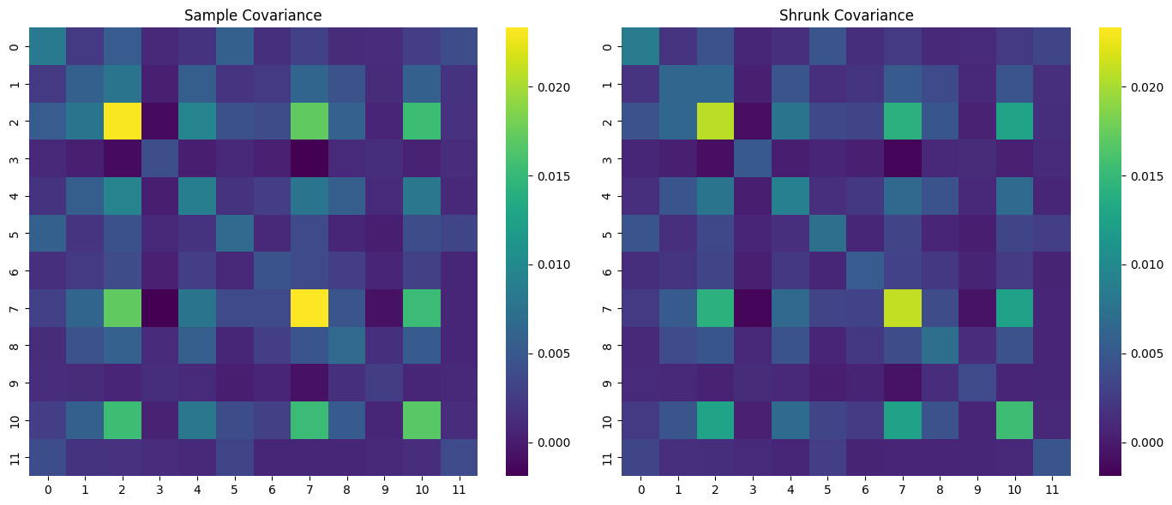

HRP Dendrogram of Stocks
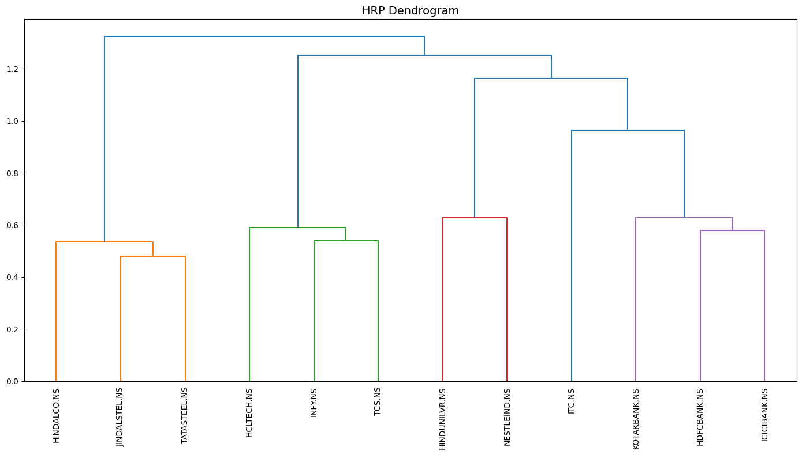

During Banking Crisis Plot
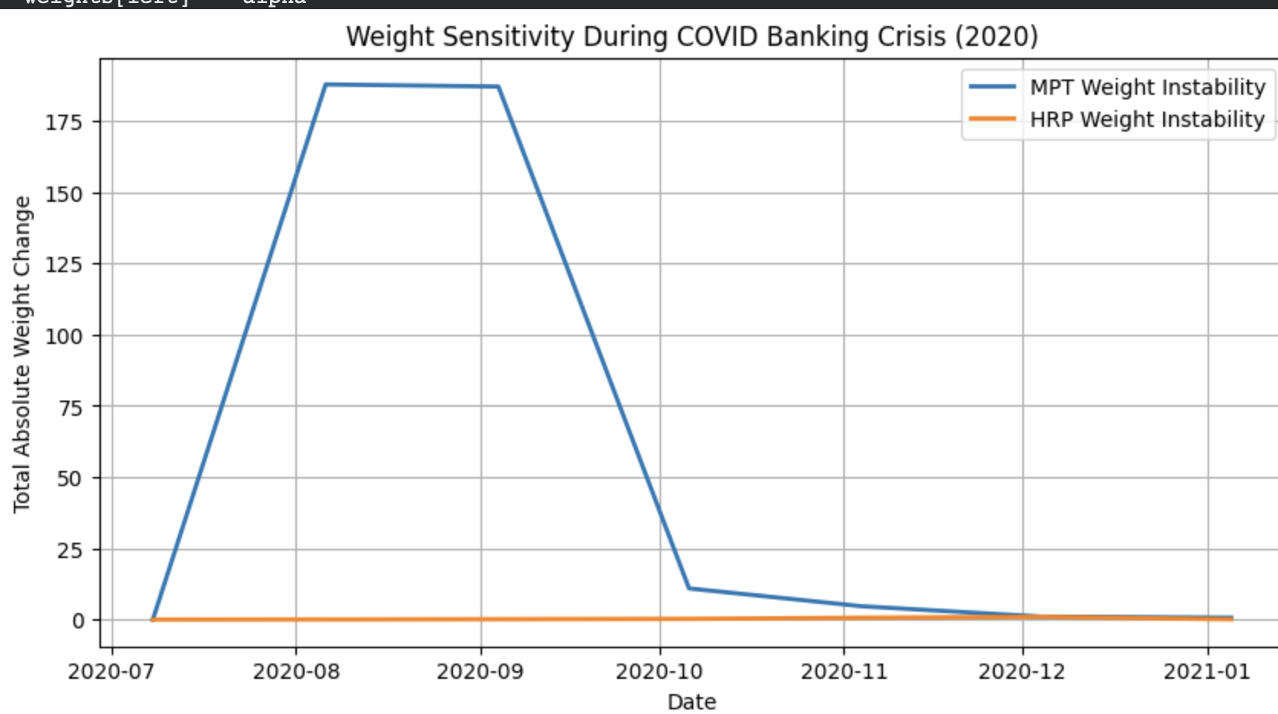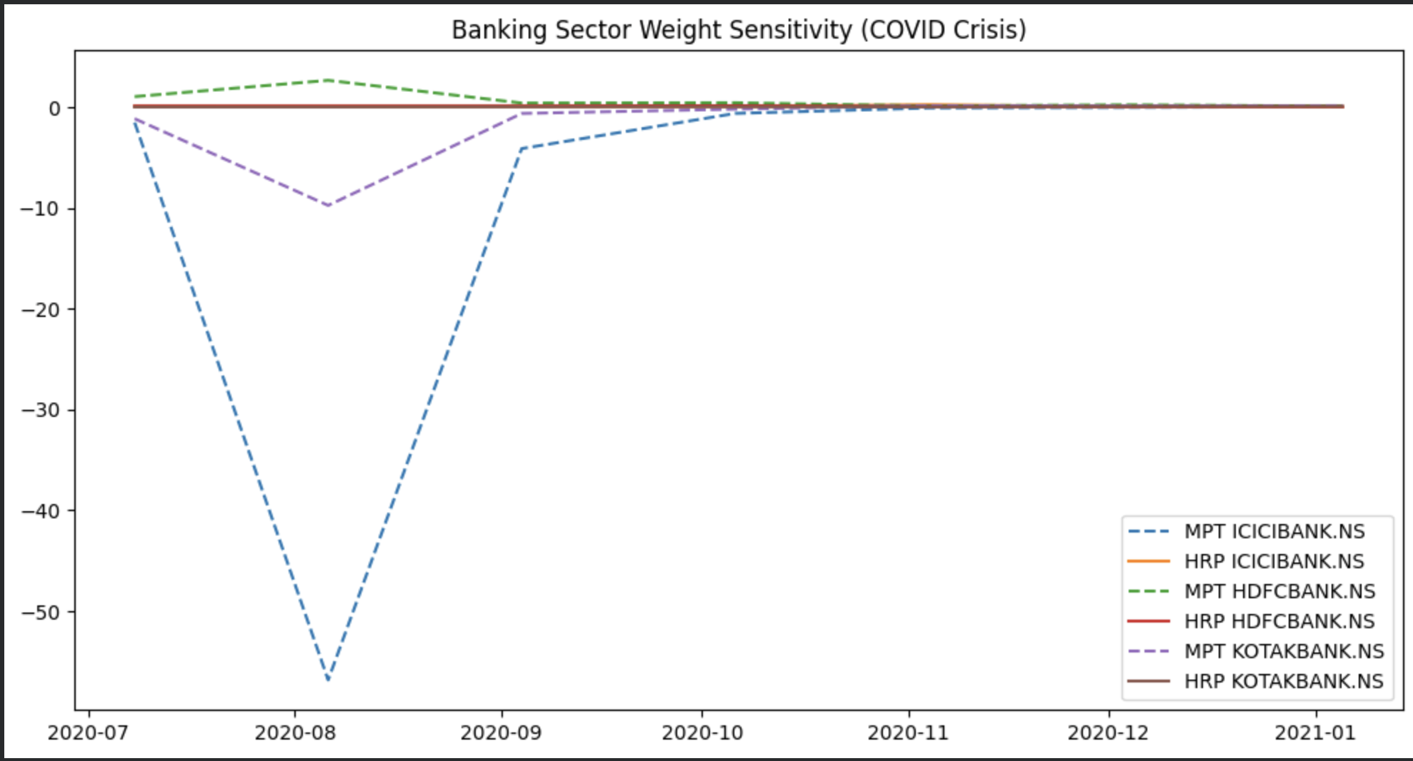

A summary on why regularization is a prerequisite for real-world quantitative trading
In theory Markowitz provides an optimal allocation based on expected returns and the covariance matrix. However in our case the inputs are estimated from finite and noisy data. In our study we got a high condition number(k=93) from the sample covariance matrix during the crisis period, which leads to instability translated into extreme portfolio weights(as provided in the plot) and large turnover=45, especially during periods of market stress.
Statistical regularization through Ledoit-Wolf shrinkage estimator, mitigates this instability by shrinking the noisy sample covariance towards a structured target. This reduces eigenvalue dispersion, lowers the condition number(k), and produces a more stable portfolio allocation.
Structural regularization is implemented via Hierarchical Risk Parity(HRP) which reallocates capital based on topology of correlation rather than relying on matrix inversion. Here we cluster the assets together and by applying recursive bisection HRP avoids amplifying noise. In which we got a lower portfolio turnover of 6 and significantly smoother weight dynamics during the COVID crisis.
In real-world quantitative trading, transaction costs, liquidity constraints, and regime shifts make unstable portfolios economically infeasible. Regularization is therefore not optional but essential. It transforms theoretical portfolio optimization into a practical and deployable strategy by improving robustness, reducing turnover, and enhancing out-of-sample reliability.

Result:
Shrinkage Intensity: 0.17
 | MPT | Regularized
Condition Number | 93.39 | 25.43
Turnover | 45.54 | 6.79

