Multi Dimensional Return Forecasting and Portfolio Management
GROUP-25

1)Data & Feature Engineering

Technical Data

Log returns(1d,5d) | Average True Range(ATR)
RSI | Bollinger Bands
12 month momentum | Volume Average
Simple Moving Average(SMA) Ratio | On-Balance Volume(OBV)
200 Day MA | MACD Histogram

Source: Yahoo Finance
Fundamental Data

Operating Profit Margin | Net Profit YoY
Net Profit Margin | EBITDA YoY
Return on Equity(ROE) | Debt to Equity Ratio
Return on Assets(ROA) | Interest Coverage Ratio
Revenue YoY | Net Debt to EBITDA Ratio
Source: MoneyControl

Macroeconomic Data

Repo Rate | US 10y treasury yield
Consumer Price Index(CPI) YoY | Crude oil log returns
10-Year Government Security Yield(gsec) | Volatility Index (vix) log changes
Nifty log returns | USD/INR log returns
s&p500 log returns
Source: OECD via Federal Reserve Economic Data (FRED) Database, Yahoo finance

Sentiment Data
Source: Google News API, FinBERT

2)Model Architecture & Validation

We used XGBoost Regressor for this assignment because it is much easier to handle messy financial data for it than a simple linear regression. XGBoost having a tree structure so it managed well.
I took first 70% of the data for training and last 30% for testing as mentioned earlier for the last 3 months we have to predict the price of the stock. To make sure the model is tradable, I used followed T-1 Lagging rule.
All the features like RSI are from yesterday also i have started one year after the data as most of the macroeconomic data and 200d moving average were starting after one year so it is better to start after 1 year.

3)Feature Importance
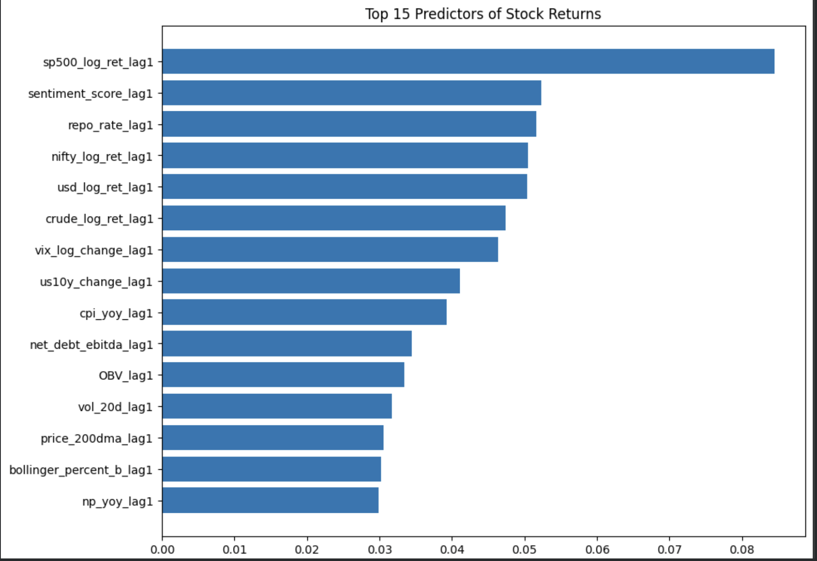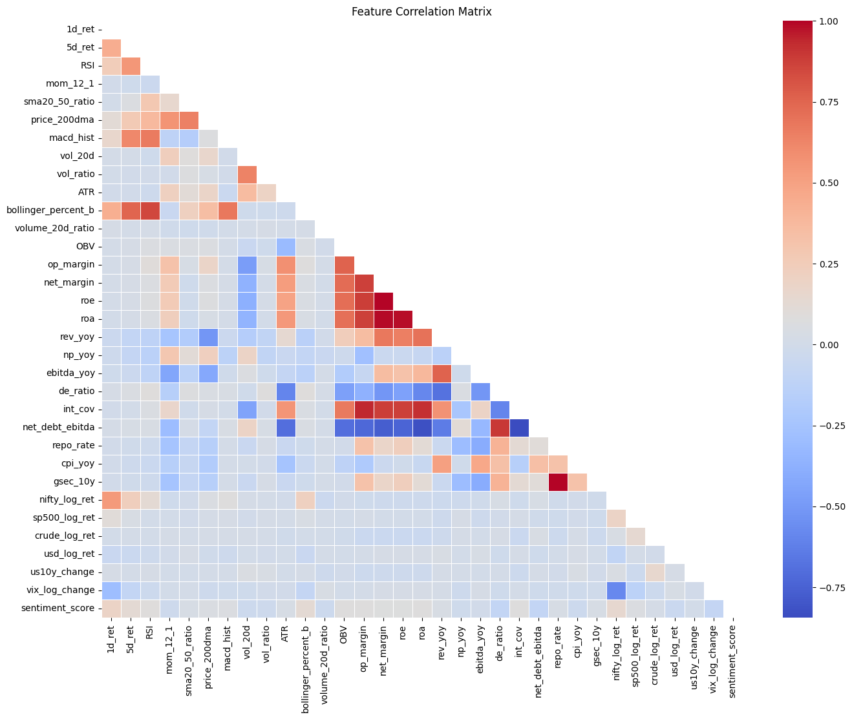

After training the model I analyzed the feature Importance and also the correlation matrix to get to know about the correlation between the features and after identifying the most important and having highly correlated one I selected the top 12 features from the total 33 features.

S&P500 log returns | Vix log changes
Sentiment Scores | US 10y treasury yield
Repo Rate | CPI YoY
Nifty log returns | Net Debt to EBITDA Ratio
UDS/INR log returns | OBV
Crude oil log returns | 20d rolling volatility

4)Model Results
Mean Absolute Error(MAE) : 0.0785
Root Mean Square Error(RMSE) : 0.01048
R-Squared : 0.02245

5)Performance Metrics
Annualized Sharpe: 6.37
Maximum Drawdown: -2.18%
Hit Ratio/Directional Accuracy: 73.77%
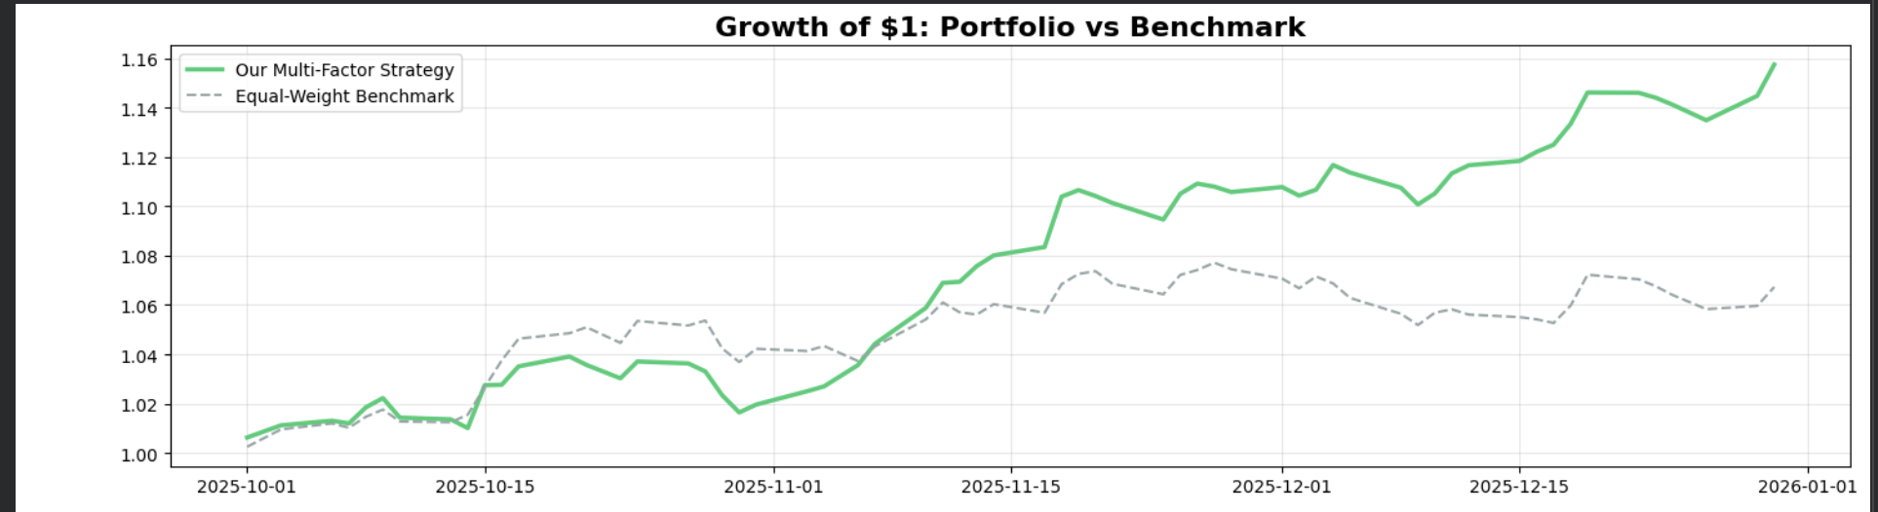

Other metrics
Classifier Accuracy: 56%
High- Confidence: 58.1%
Correlation with scrambled data: -0.0745
Sortino Ratio:15.38
Information Ratio: 5.12
Tracking Error: 6.58%

