**Introduction**

Lorem ipsum dolor sit amet, consectetur adipiscing elit, sed do eiusmod tempor incididunt ut labore et dolore magna aliqua. Ut enim ad minim veniam, quis nostrud exercitation ullamco laboris nisi ut aliquip ex ea commodo consequat. Duis aute irure dolor in reprehenderit in voluptate velit esse cillum dolore eu fugiat nulla pariatur. Excepteur sint occaecat cupidatat non proident, sunt in culpa qui officia deserunt mollit anim id est laborum.

**Objectives**

* Aim : To create a product capable of detecting movement within a set trajectory using light detection.
* Limitation : Keeping the laser module on might get expensive over time, object has to go through the laser trajectory to trigger the circuit.

**Literature Studies**

* Existing products in the market:
* How they work: Using laser to point a light at a light detector, then detecting if there are any changes on the light detector. e.g: The amount of light would noticeably decrease when the laser is blocked and can’t get to the detector
* Component used: Laser and light dependent resistor.
* Basic theory:
  + Light dependent resistor: Light dependent resistor, or photoresistor, are resistors which its resistance is dependent on the amount of light is received on its face. The brighter it is, the less resistance.

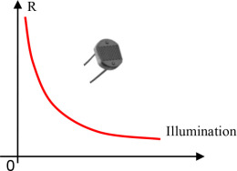

* + Laser: A laser is a device that emits light through a process of optical amplification based on the stimulated emission of electromagnetic radiation. Unlike a normal light source, a laser device is able to be focused to a tight spot. With this, the light can be focused to the photoresistor.
  + Voltage divider: A voltage divider is a simple circuit which produces an output voltage that is a fraction of the input voltage.

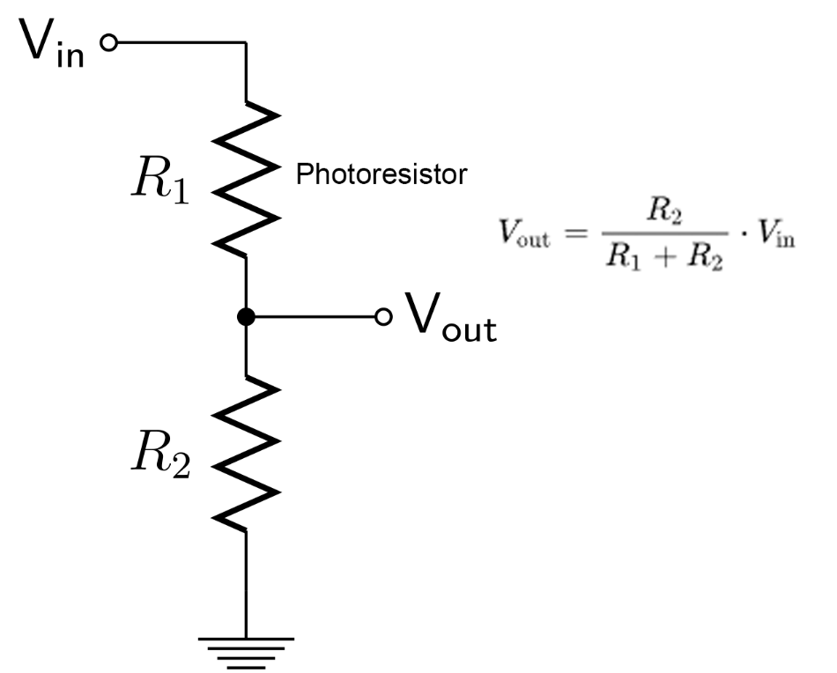

In a normal situation, the laser will point at the photoresistor, which causes the resistance to be low. When the laser is blocked, the photoresistor will no longer be illuminated, therefore raising the resistance. Using the formula above, when the resistance is raised, the output voltage will drop.

* Arduino boards have analog pins, which are able to map operating voltages (5V or 3.3V) into integer values of 1024. The output voltage from the voltage divider is then connected to this pin. With this pin, the Arduino board can detect when the voltage drops.

**Methodology**

Lorem ipsum dolor sit amet, consectetur adipiscing elit, sed do eiusmod tempor incididunt ut labore et dolore magna aliqua.

ideas:

* Light condition changes, might affect photoresistor, need to be able to dynamically change light threshold for the trigger on the fly. Also, to reset the circuit when it is trigerred → Set/reset button
* Light condition might be so bright that the effect of the laser to the photoresistor is negligible → Cover the photoresistor from unwanted light
* Might need to readjust the laser aim → Off button
* Need indication of the state of the circuit → RGB LED: green is ready, yellow is idle/waiting to be set, red is triggered.
* Need some sort of notification system → Buzzer/speaker
* Should determining resistors resistance be included here?

**Design**

* Hardware design

The schematic for the circuit is as follows:

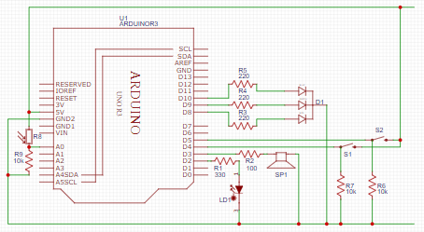

The components needed are:

* + 1x Arduino Uno
  + 1x 5V 650nm Laser diode
  + 1x Photoresistor
  + 1x RGB LED Common Cathode
  + 1x Active piezoelectric speaker/buzzer
  + 2x Momentary switch/push button
  + 1x 100Ω Resistor
  + 3x 220Ω Resistor
  + 1x 330Ω Resistor
  + 3x 10kΩ Resistor
* Software design

Input components:

* + Set button
  + Off button
  + Photoresistor

Output components:

* + RGB LED
  + Buzzer

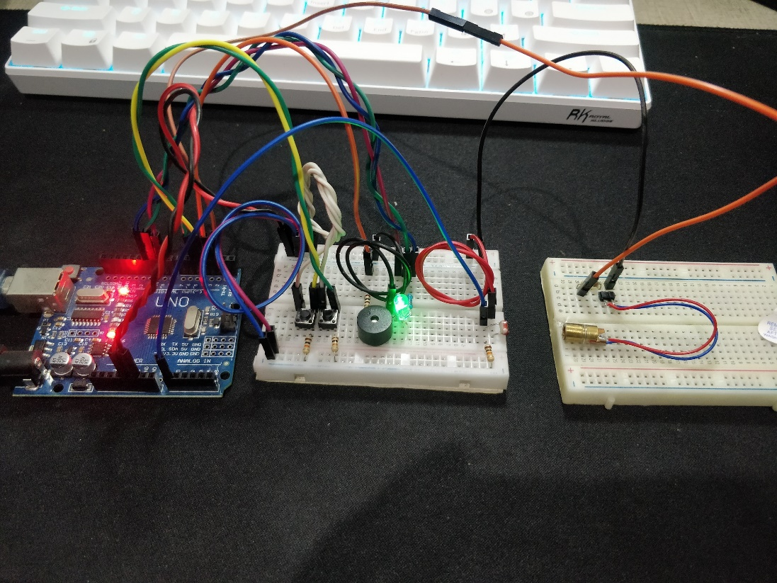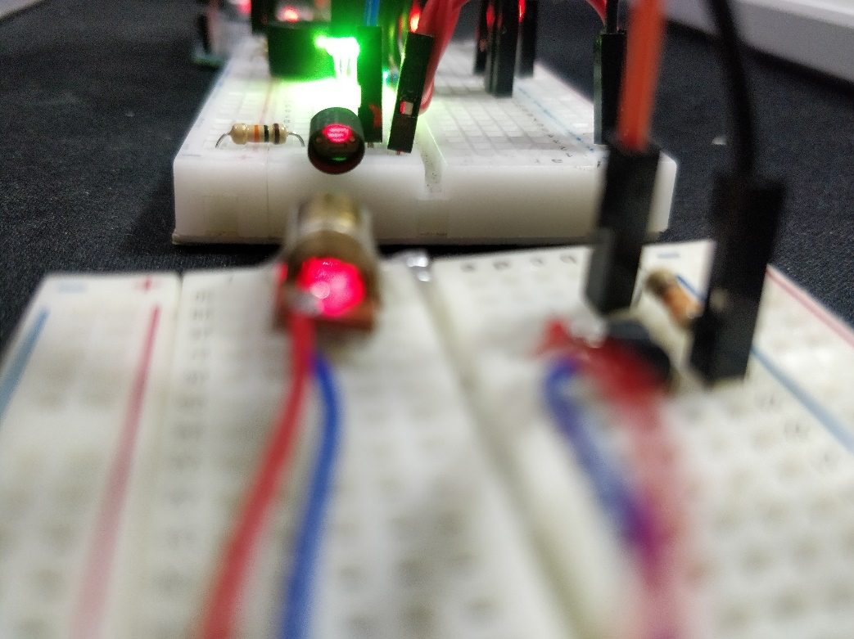

repo: https://github.com/Lucky2307/tripwire-alarm