**DATAGUARD ARCHITECTURE**

**===========================**

**Oracle Dataguard Architecture: how data flows when standby is configured**

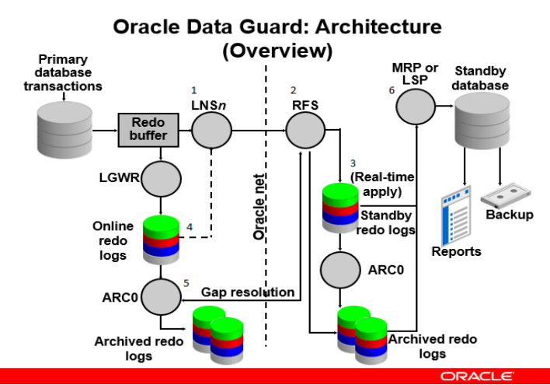

1. LNS process of primary database captures redo from redo log buffer.
2. Send it to RFS process of standby database through oracle net.
3. RFS process then writes that redo information to standby redo log files.
4. If LNS process is not fast enough to capture redo information before it goes to online redo log files or if redo data are going online redo log files very quickly then LNS process will read from Online redo log files and send redo to RFS process through Oracle net.
5. If some network outage occur and online redo log gets log switch and data goes to archived redo log files , before its been written to standby redo log files then RFS process will directly communicate to ARCn process and works for Archive log gap resolution.
6. Once with any possible way redo are written to standby redo log files then , **MRP**[in case of physical dataguard] or **LSP**[in case of logical dataguard] process apply that redo or sql to standby database.
7. The fetch archive log (FAL) client is the MRP process. The fetch archive log (FAL) server is a foreground process that runs on the primary database and services the fetch archive log requests coming from the FAL client. A separate FAL server is created for each incoming FAL client. FAL_SERVER specifies the FAL (fetch archive log) server for a standby database. **The value is an Oracle Net service name**, which is assumed to be configured properly on the standby database system to point to the desired FAL server.

FAL_CLIENT and FAL_SERVER parameters are useful as the managed-recovery process in the physical database will   automatically check and resolve gaps at the time redo is applied. This helps in the sense that you don’t need to perform the transfer of those gaps by yourself.

FAL_CLIENT and FAL_SERVER only need to be defined in the initialization parameter file for the standby database(s). It is possible; however, to define these two parameters in the initialization parameter for the primary database server to ease the amount of work that would need to be performed if the primary database were required to transition its role.

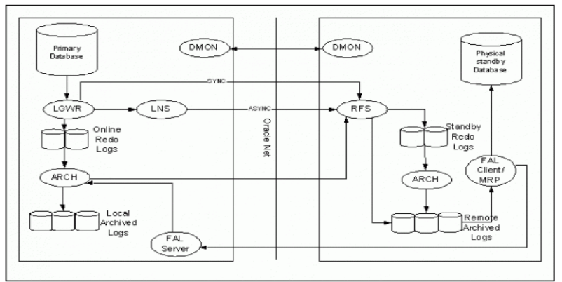

**PRIMARY DATABASE PROCESSES AND STANDBY DATABASE PROCESSES**

**PRIMARY DATABASE PROCESSES**

**1. LGWR**: LGWR collects transaction redo information and updates online redo log files.

**2. How redo data is send**

REDO data is send either through ARCn process or LGWR process.

**Using ARCn process**

This is default and supports only maximum performance. log_archive_max_processes init parameter specifies the max number of ARC process to be invoked when primary db is started. Default value is 4 and it is dynamic parameter can be adjusted with ALTER SYSTEM

On primary database, after **ARC0** successfully archives online redo logfile to local destination, the **ARC1** process transmits redo from local destination to the remote standby destination. On standby database, RFS process will write redo data to archived redo logfiles.

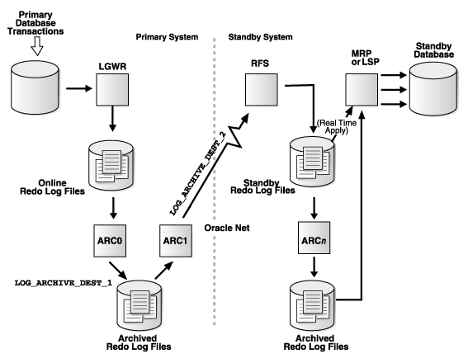

**Using LNS process [Log writer network server]**: LNS process works in two ways.

**SYNC mode** : When you have configured your data guard environment in sync Redo transport Service , LGWR passes redo to LNS process , which transfers data directly to RFS process on the standby database. LGWR waits for confirmation from the LNS process and LNS process waits confirmation from RFS process that redo data are applied to standby database before acknowledging commit.

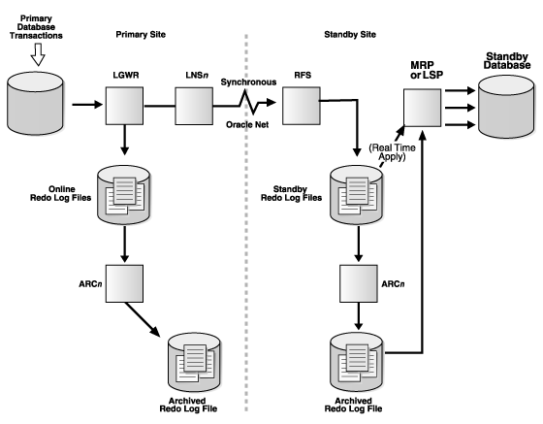

**ASYNC**:  When you have configured async redo transport service, it is independent of LNS process , whether LNS process have read from redo log buffer or from online redo log files .  Data guard just starts asynchronous LNS process , other than that LGWR has no interaction with  any asynchronous standby destinations. In simple terms, data guard will not wait for any acknowledgement from standby database that redo are applied or not and keeps on doing its work. So it is way faster than sync mode.

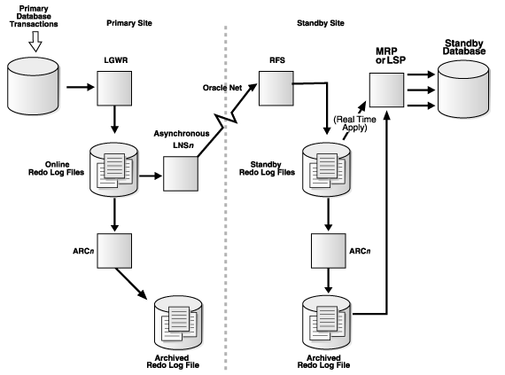

1. **ARCn Process**: As we know ARCn process creates a copy of the online redo log files . ARCn is also responsible for shipping redo data to an RFS process at a standby database and for pro-actively detecting and resolving gaps on all standby database.

**STANDBY DATABASE PROCESSES**

1. **RFS [Remote File Server]**: As we have seen above RFS process can get redo data either from LNS process or from ARCn process of primary and RFS process can writes redo information to standby redo logs files.Each LNS and ARCn process that communicates with Standby database has its own RFS process.
2. **ARCn [Archiver]**: The ARCn process archives standby redo logs.
3. **MRP [Managed Recovery Process]**: In case of physical dataguard MRP process comes into play.MRP process applies archived redo log information to the physical standby database.You can start managed recovery using “ALTER DATABASE RECOVER MANAGED STANDBY DATABASE” this foreground session performs recovery. And if you want to perform recovery on background then you can optionally use DISCONNECT FROM SESSION. clause where MRP background process will start .
4. **LSP [Logical Standby ]:**It comes into play for logical dataguard only. It controls the application of archived redo log information to the logical standby database. LSP process will transform redo data into sql statements and then these sql statements will be applied to logical standby database.

**1. What is the use of standby redolog?**

The Advantage of having Standby Redo Logs is that every records written into the Online RedoLogs of the Primary Database is transferred to the Standby database and written into the Standby Redo Logs at the same time.  
therefore, you it minimizes the probability of Data Loss on the Standby Database.

For real time apply, it is mandatory to have standby redo log on standby database.

Without Standby Redo Logs, an Archived Redo Log is created by the RFS process and when it has completed,  
this Archived Redo Log is applied to the Standby Database by the MRP process . An incomplete Archive Log file cannot be applied on the Standby Database and will not be used in a Failover situation. This causes a certain data loss.

If you have Standby Redo Logs whenever a record is inserted into oracle redolog , the RFS process will write into the Standby Redo Log  of standby redolog and it gets applied by MRP , which ensures real time sync. When a log switch occurs, the Archiver Process of the Standby Database will archive this Standby Redo Log to an Archived Redo Log, while the MRP process applies the information to the Standby Database. In a Failover situation, you will also have access to the information already written in the Standby Redo Logs, so the information will not be lost.

**2. How many standby logs need to be created? What should be the size?**

It is recommended to create one additional standby log group per thread. And its size should be same as that of primary redo log.

Suppose, we have 4 number of redo log groups of 200M on primary, then we need to create 5 standby redo logs of 200M.

Why extra:

During heavy dml activity on primary, this extra standby log will help as a buffer in coping with the sync up.

**5. Support my data guard setups is having one primary and standby and it is in maximum protection mode. Can i convert the standby to snapshot standby database?**

No, we cannot covert the standby database to snapshot in maximum protection, when this is the only standby db.  Because in maximum protection mode, transaction data must be written to standby redo , before proceeding further.

**6. What is the difference between switchover and failover:**

*A switchover means just switching roles between the primary database and standby db.  
switchover, the primary database changed to a standby role, and the standby database changed to the primary role.  
This is typically done for planned maintenance of the primary db. server.*

A failover is when the primary database fails and one of the standby databases is transitioned to take over the primary role. Failover is performed only in the event of a catastrophic failure of the primary database, and there is no possibility of recovering the primary database in a timely manner. Failover may or may not result in data loss depending on the protection mode in effect at the time of the failover.

**8. What is fal_client and fal_server parameter:**

FAL Means – Fetch Archive log. FAL_CLIENT and FAL_SERVER parameters are used on standby database for archive gap resolution. FAL_SERVER and FAL_CLIENT parameters are required on standby database only .

**FAL_SERVER**: Specify an Oracle Net Service Name (TNS-Alias or Connect Descriptor) that points to the Database from where the missing ArchiveLog(s) should be requested i.e the tns alias of the primary db.

**FAL_CLIENT**: Specify an Oracle Net Service Name (TNS-Alias or Connect Descriptor) that points  from FAL_SERVER TO standby db. i.e the tns alias of the standby db. This parameter has been deprecated.

fal_server = ‘primdb’  
fal_client = ‘stdbydb’

**10. What is standby_file_management parameter oracle.**

Standby_file_management parameter can be have two values. MANUAL or AUTO(Recommended).

**AUTO** – > Datafiles created on primary will be create automatically on standby .

**MANUAL** – > Datafiles created on primary , will not be replicated to standby. The datafile need to be created manually on Standby

**11.  With standby_file_management set to AUTO, If I rename a datafile in primary, will the changes be propagated to standby** .

No, for renaming  a data file, the rename command need to be run on standby database as well .

**12. What is active dataguard. Does it needs additional licensing??**

Active dataguard means, the standby database is open with read only mode, when redo logs are getting applied in real time.

Below are the benefit of using active dataguard.

* Reporting queries can be offloaded to standby database.
* Physical block corruptions are repaired automatically either at primary or physical standby database.
* RMAN backups can be initiated from standby , instead  of primary which will reduce cpu load from primary.

NOTE – To use active dataguard, you need additional license from oracle

**14.The support DBA , added a tempfile on primary database, but the tempfile is not reflecting on standby database despite, the standby_file_management is set to AUTO**.

Adding tempfiles to TEMP tablespaces in primary database, will not automatically create on standby database. Because no redo is generated, while adding tempfile. So DBA have to add the temp file manually.

**15. What are the different types of redo transport services in dataguard.**

**1 . ARCH transportation mode:**

In this mode, logs are sent by ARCH process. LNS process is not active here. Also standby redologs are not mandatory. i.e Real time APPLY will not happen here. In this mode.  Archive logs will be copied to standby server and will be applied there.

**2. SYNC and ASYNC transportation mode:( real time apply)**

In below cases, standby redologs will be required.  Redo is read and sent from redo log buffer to standby by LNS process.

If redo logs buffer is flushed to online redolog , before redo being sent to standby, then LNS will read the online redo log files and sent to standby.

**SYNC(SYNCHRONOUS):**

This mode is used for maximum protection and maximum availability protection mode. The synchronous redo transport mode transmits redo data synchronously with respect to transaction commitment. A transaction cannot commit until all redo generated by that transaction has been successfully sent to every standby destinations.

**ASYNC(ASYNCHRONOUS):**

This mode is used for maximum performance mode. A transaction can commit without waiting for the redo generated by that transaction to be successfully sent to any redo transport destination that uses the asynchronous redo transport mode.

**16. Which parameter defines the attributes of redo log transport service.**

log_archive_dest_2(n) – > This parameter defines the service name of the standby database and whether this is SYNC or ASYNC mode and the attributes like AFFIRM/NOAFFIRM.

Apart From that , there are additional attributes like ,

**17. What are the different types of Apply services in dataguard.**

**REDO APPLY:**

With redo apply, apply services waits for a standby redo log file to be archived before applying the redo to standby.

**REAL TIME APPLY:**

If the real-time apply feature is enabled, then apply services can apply redo data ( either from redo log buffer or redo log file)as it is received, without waiting for the current standby redo log file to be archived.

**18. What is fast start fail over (FSFO)?**

Fast-Start Failover is a feature that allows the Oracle Data Guard broker to failover a failed primary database automatically to a predetermined standby database.

Observer process which runs on different server than that of primary and standby, continuously checks the availability of primary database. If both observer and standby database both are unable to connect with primary database for a pre-defined time, Then failover will be initiated automatically. The **FastStartFailoverThreshold**paramter defines the time limit for failover.

And post failover, If observer is able to establish the connection with old primary, then it will reinstate the database using flashback.

**Prerequisites for FSFO:**

* Flashback should be enabled on both primary and standby database.
* Observer need to present on a server different from primary and standby.

NOTE – We can run observer on either primary or standby. But it is always recommended to run observer on a different server.

Because, Let’s say, you are running observer on primary and if primary server goes does, then observer cannot take any action , it is also not available.

19. Let’s say, Fast start failover is configured in the dataguard setup. And the DBA shutdown the primary database using Shutdown immediate, then will failover happen?

No. failover will not initiate if shutdown immediate or shutdown normal issued on primary by user action.

But if shutdown abort is issued, then automatic failover will be initiated.

20. What will be the impact on standby setup, when observer is down?

If the observer is down, then there will be no impact on the dataguard setup. But FSFO i.e automatic failover will not happen if primary becomes inaccessible.

21. What is a far sync instance in data guard?

T Far sync instance is an proxy/dummy instance, which receives redos from primary in sync mode and ships them to one or multiple standby databases (upto 30 members) in async mode.

It has only standby control file. It doesn’t have any user data file. And the instance will be always in mount state. This feature need s active data guard license.

Far sync instance is usually useful, when primary and standby databases are far away.Far sync instances stay close to primary database and manages the near real time apply data.

22. What are the new features of oracle 19c /20c/21c dataguard?

**Automatic flashback of standby db( in. 19c)** – If you flashback the primary database, then standby database will also be flashed back automatically.

**Restore Point Replication( in. 19c) –** If we create a restore on primary , then same restore point will be created on the standby database.

**Active Dataguard DML Redirection(ADR)** – If you run a DML statement on standby , then it will be redirected to primary and the requested data will be send to standby again.

**Database Buffer cache status maintained(18c)**–  Database buffer cache status will be maintained after role transition  on standby also. Users on the standby will be able to continue exactly where they left off after a role change (switchover of failover) with the same performance .

23. What is dataguard broker and how it is useful?

Dg broker is used for easy management and administration of one or multiple standby databases.  It helps in simple switchover, failover, FSFO, role transitions etc.

DMON process run when data guard broker is enabled.

dgmgrl utility is used for administration of dg broker.

Whenever we issue any command from dgmgrl prompt, dmon process will process the request on primary and coordinate the same all standby databases. And it will update the configurations if required.

24. How the apply process in ORACLE RAC dataguard works?

Prior to 12.2, The MRP ( recovery process) can be  started only on one node . However from 12.2 onwards, MRP can started on multiple or all nodes.

Below is the command:

-- Start MRP from all the instances available:

ALTER DATABASE RECOVER MANAGED STANDBY DATABASE DISCONNECT FROM SESSION INSTANCES ALL;

— Start MRP on 2 Instances:

ALTER DATABASE RECOVER MANAGED STANDBY DATABASE DISCONNECT FROM SESSION INSTANCES 2;

25. Why we need to enable force logging on primary database, before setting up standby.

If somone does nologging operations on primary, then these data will be missed on standby, which will make the standby inconsistent with primary. So to ensure all the transaction on primary should generate redolog , force logging is enabled.

26. Which additional parameters we add in primary for configuring standby database.

log_archive_config: –

db_unique_name

standby_file_management=auto

log_archive_dest_2  – tns details of standby database, to which logs will be shipped

log_archive_dest_state_2

db_file_name_convert – for mapping the database files of primary and standby db ( when directory structures are different on primary and standby)

log_file_name_convert – For mapping redologs of primary and standby

fal_server – > This defines from where the standby database should request the missing archive logs. i.e on standby database its values will be the tns service_name of primary .

 27. Will the db_name and db_unique_name will same for primary and standby databases?

DB_NAME will be same for primary and its standby databases. But everyone will have a different db_unique_name.

28. Except snapshot standby method, is there any way we can open the standby database in read write  mode for testing and revert it back once testing is done.

Flashback method can be used.

29. For security reason, you are not allowed to use sys user for redo transport service. Is there any alternative way or we need use sys user only.

If we want to use an user other than SYS, then we can create a user with sysoper privilege and set the parameter REDO_TRANSPORT_USER to that username.

30. Explain the standby database /dataguard related background process.

MRP – > Managed recovery process, which is responsible for read and redo and apply , through multiple parallel process like Pr(n) process.

RFS – > Remote file service.

LNS – > Log network service ( From 12c LNS is replaced with NSS( FOR SYNC) and NSA( For ASYNC).

DMON – > DG BROKER monitor

FSFP – > Fast start failover process.

31. How oracle detects gaps and resolves it?

Two methods are there.

**Automatic gap resolution:**

This is done by log transport service. When there is a mismatch between currently transfered redo with that of last received log in standby, then RFS will request the missing log sequences from primary via arch-rfs hearbeat ping.

No special setting is required.

**Fetch archive log( FAL Method):**

FAL_SERVER – specifies the tns service database from where the missing archive logs need to be fetched.

When a archive is shipped to standby , it gets registered in the standby controlfile. When log apply service detects a gap , it sends a request to fal server to resend the missing logs.

32.  We did failover, and the standby became the new primary. Now we need to make the old primary as new standby. But the database is very high , So rebuilding it will take time. Is there any way to fix it?

There is a way, But only if flashback is enabled. If flashback is enabled , then we can get the current scn from the new primary database and flashback the old primary(new standby) upto that scn.

34.  Can we enable tracing in dataguard .

Yes we can set LOG_ARCHIVE_TRACE parameter to trace redo transport and apply services on primary and standby.

possible values are 0(default means no tracing) , 1,2,4,8,16,32,64 …. 8192

35.  Some one configured the dataguard setup, without enabling force_logging on primary. And in primary  few nologging operations happened . So getting error like data block was loading using NOLOGGINE option. How can We fix it?

In that case, we can get **FIRST_NONLOGGED_SCN** value from v$datafile on standby database.  Then we can take an incremental backup using the SCN  from Primary. and apply the same on standby.

 38. What are the common issues you face in dataguard environments?

1. Replication issues due to network issues
2. Archive  log Missing errors
3. If a datafile is renamed on primary, then also error will come in standby.
4. Issue may occur if someone mistakenly changes the dataguard related parameters like log_archive_config, log_archive_dest parameters.

39. What is FastSync?

Fast Sync provides an easy way of improving performance in synchronous zero data loss configurations. Fast Sync allows a standby to acknowledge the primary database as soon as it receives redo in memory, without waiting for disk I/O to a standby redo log file (SYNC NOAFFIRM). This reduces the impact of synchronous transport on primary database performance by shortening the total round-trip time between primary and standby.

40. What is Multi instance Redo Apply? How can we enable this?

Prior to 12.2 , If your dataguard is RAC, then MRP process can be run only on one node. However From 12.2 Onward, We can enable MIRA( Multi instance Redo apply), i.e MRP can be run on multiple instances or all the nodes.

**Below are the syntax:**

-- Start MRP from all the instances available:

ALTER DATABASE RECOVER MANAGED STANDBY DATABASE DISCONNECT FROM SESSION INSTANCES ALL;

-- Start MRP on 2 Instances:

ALTER DATABASE RECOVER MANAGED STANDBY DATABASE DISCONNECT FROM SESSION INSTANCES 2;

43. Can i run sql tuning advisor in standby database?

Yes we can do that , using the concept of db_link.

in dbms_sqltune module, there is a parameter database_link_to which we can se to a database_link(db_link with connect SYS$UMF , pointing to primary). and then we can run the task on standby.

Reference     –<https://fatdba.com/2022/01/15/part-1-running-sql-tuning-advisor-for-a-slow-sql-in-a-read-only-standby-database/#:~:text=You%20can%20issue%20SQL%20Tuning,write%20the%20SQL%20tuning%20data.>

44. We are having dataguard setup in maximum protection mode , and we created one datafile in a new diskgroup on primary, But that diskgroup was not present in standby? What will be the outcome?

the primary will shutdown .

47. Can i run expdp command on standby?

Yes we can run expdp on standby database by createing  db_link and using  network_link parameter in expdp.

[How to run expdp on physical standby database](https://dbaclass.com/article/use-expdp-export-data-physical-standby-database/)

48. Can I take full backup on standby and incremental backup on primary?

Yes we can do that.

50. Some one mistakenly truncated a table on primary database. We already have a dataguard setup. Is there any way we can recover that table?

Below are the steps.

**primary:**  
create table veridata.flashback_test (id number, tarih date default sysdate);  
insert into veridata.flashback_test(id) values(1);  
insert into veridata.flashback_test(id) values(2);  
commit;

**primary-standby:**  
select * from veridata.flashback_test;

**primary:**  
truncate table veridata.flashback_test;

**standby:**  
select * from veridata.flashback_test;

After an hour, you find actual truncate time on primary:  
select * from VERIDATA.DDL_HISTORY_LOG where action_date >sysdate 10/1440

**standby:**  
alter database recover managed standby database cancel;  
shutdown immediate;  
startup mount;  
flashback database to timestamp TO_TIMESTAMP(‘17.10.2017 09:05:04′,’DD.MM.YYYY HH24:MI:SS’);  
alter database open read only;

**primary:**  
create database link DG connect to veridata identified by “*****” using ‘ALFADG’  
alter session set global_names=false;  
create table flashback_test_recovered as select * from flashback_test@DG;  
select * from flashback_test_recovered;

Now, your table is ready on production.

If you have a dataguard, consider enabling flashback database before disaster 🙂

51. If observor is unable to connect with primary , but it can connect with standby, then what will happen?

If the observor is unable to connect to primary, then it will check the status of primary, through standby.