FINAL PROJECT REPORT
Department of Computer Science & Engineering
Specialization: Artificial Intelligence & Data Science

AI-Powered Plant Disease Detection System
Using Deep Learning and Transfer Learning

Intelligent Agricultural Disease Diagnostics with MobileNetV2 and Explainable AI

Submitted By
Dinesh Kumar

TEST ACCURACY  90.52% | MODEL  MobileNetV2 | DISEASE CLASSES  14 Classes

Dataset: PlantVillage | Framework: TensorFlow / Keras | Deployment: Streamlit Web App
Academic Year 2025 – 2026

Abstract
Plant diseases are responsible for significant crop losses worldwide, threatening food security and farmer livelihoods. Early, accurate identification is critical — yet traditional expert-based diagnosis is slow, expensive, and impossible to scale across large farmlands.

This project presents a complete AI-driven solution: a deep learning pipeline that classifies plant leaf images into 14 healthy and diseased categories using Transfer Learning on the MobileNetV2 architecture. Built on the PlantVillage dataset (~54,000 images), the system covers common crops including Tomato and Potato.

The final model achieved 90.52% test accuracy, 92.33% precision, and 90.46% F1-Score. Beyond raw metrics, the project addresses practical deployment challenges — overconfident predictions on unknown inputs are handled via a 95% confidence threshold, and a Grad-CAM visualization layer explains exactly which leaf regions triggered each prediction. A Streamlit web application brings the system to end users with no machine learning knowledge required.

Key Outcome
A deployable, explainable plant disease classifier that achieves 90.52% test accuracy across 14 disease categories, complete with a confidence-thresholded unknown-plant detector and Grad-CAM heatmap visualizations.

Table of Contents

1. Introduction 3
2. Problem Statement & Objectives 3
3. Literature Review 4
4. Dataset 4
4.1 Dataset Overview & Class Distribution 4
4.2 Data Preprocessing 5
4.3 Data Augmentation 5
5. System Architecture & Workflow 5
6. Model Development 6
6.1 Baseline CNN 6
6.2 Transfer Learning with MobileNetV2 6
6.3 Training Configuration & Hyperparameters 7
7. Results & Evaluation 7
7.1 Accuracy & Loss Curves 7
7.2 Classification Metrics 8
7.3 Confusion Matrix 8
7.4 ROC Curves 9
8. Real-World Testing & Error Analysis 9
9. Deployment — Streamlit Web Application 10
10. Explainability — Grad-CAM 11
11. Challenges & Solutions 11
12. Conclusion & Future Work 12
13. References 12

1. Introduction
Agriculture sustains more than 60% of the world's population, yet plant diseases silently erode up to 40% of global crop production every year (FAO). In developing countries, where smallholder farmers lack access to agronomists, the damage is far worse.

Computer vision and deep learning have transformed how machines understand images. Convolutional Neural Networks (CNNs), originally designed for object recognition, now power medical imaging, satellite analysis, and — increasingly — precision agriculture. Applied to leaf imagery, they can detect subtle symptom patterns that even experienced agronomists may miss on large-scale farms.

This project leverages that capability. The goal is not just a high-accuracy model, but a complete, deployable system: one that handles real-world messiness (blurry photos, unknown plants, variable lighting) and explains its predictions to non-technical users through visual heatmaps.

2. Problem Statement & Objectives

The Problem
Manual disease diagnosis requires field visits by specialists — scarce, costly, and too slow for early intervention. Existing mobile apps are often single-crop or require cloud connectivity. Laboratory-trained models frequently fail in the field due to domain shift (controlled backgrounds vs. cluttered real-world scenes) and overconfident predictions on unseen plant species.

Project Objectives
- Train a CNN-based model to classify 14 plant disease categories with >85% accuracy
- Compare a custom baseline CNN against Transfer Learning (MobileNetV2) to quantify performance gain
- Implement a confidence threshold to reject unknown/out-of-distribution inputs gracefully
- Integrate Grad-CAM explainability so predictions are transparent and trustworthy
- Deploy the complete pipeline as a Streamlit web application accessible without ML knowledge
- Evaluate model robustness on real-world phone camera images, not just clean dataset images

3. Literature Review
Mohanty et al. (2016) established a baseline using the PlantVillage dataset and showed that CNNs could reach 99.35% accuracy in controlled conditions — but noted dramatic drops in field conditions, a finding this project directly confronts.

Architecture | Key Contribution | Limitation
LeNet-5 | Pioneered CNN design for digit recognition | Too shallow for complex leaf textures
AlexNet | Deeper networks + ReLU; won ImageNet 2012 | High memory footprint
VGGNet | Uniform 3×3 filters; strong feature extraction | Very slow to train
ResNet-50 | Residual connections; solved vanishing gradients | Heavier than needed for deployment
MobileNetV2 | Depthwise separable convolutions; optimised for edge deployment | Selected for this project

The consensus from reviewed papers: Transfer Learning dramatically outperforms training from scratch on small-to-medium agricultural datasets, and lightweight architectures (MobileNetV2, EfficientNet) strike the best accuracy-vs-deployment-cost balance.

4. Dataset

4.1 Dataset Overview & Class Distribution
The PlantVillage dataset (publicly available on Kaggle) contains 54,305 labeled leaf images covering 38 plant-disease combinations. This project uses a 14-class subset focused on Tomato, Potato, and Pepper crops.

# | Class | Images | Type
1 | Pepper__bell___healthy | — | Healthy
2 | Potato__Early_blight | 1,000 | Diseased
3 | Potato__Late_blight | 1,000 | Diseased
4 | Potato__healthy | 152 | Healthy
5 | Tomato_Bacterial_spot | 2,127 | Diseased
6 | Tomato_Early_blight | 1,000 | Diseased
7 | Tomato_Late_blight | 1,909 | Diseased
8 | Tomato_Leaf_Mold | 952 | Diseased
9 | Tomato_Septoria_leaf_spot | 1,771 | Diseased
10 | Tomato_Spider_mites_Two_spotted_spider_mite | 1,676 | Diseased
11 | Tomato__Target_Spot | 1,404 | Diseased
12 | Tomato__Tomato_YellowLeaf__Curl_Virus | 3,208 | Diseased
13 | Tomato__Tomato_mosaic_virus | 373 | Diseased
14 | Tomato_healthy | 1,591 | Healthy

Note: The Pepper__bell___healthy directory triggered an OpenCV path error during EDA, resulting in 0 loaded images — this was identified during exploration (see Figure 1) and flagged as a data integrity issue.

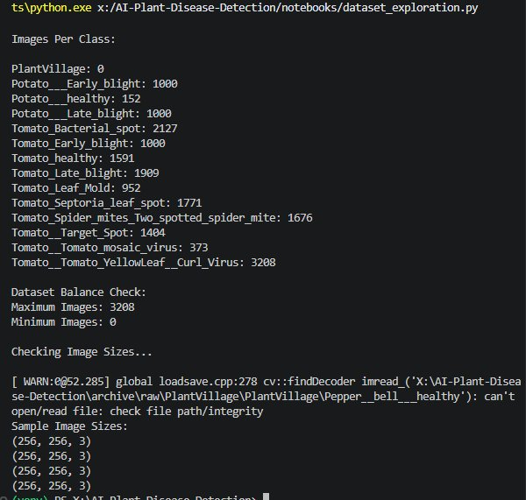
Figure 1 — EDA Output: Per-class image counts and path integrity check

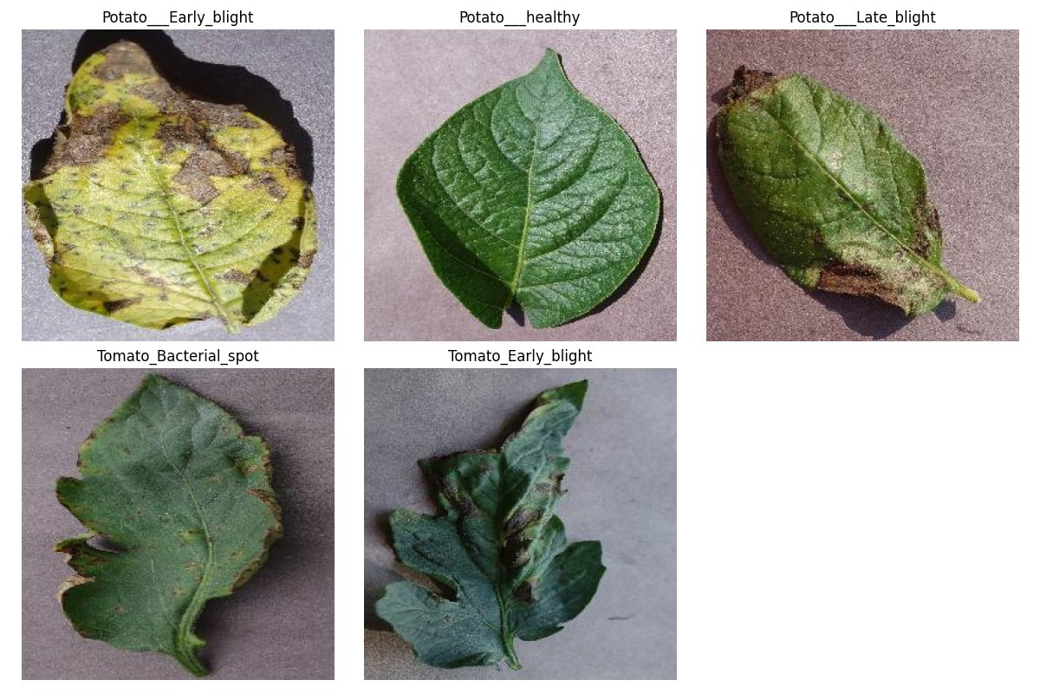
Figure 2 — Sample leaf images from five representative disease classes

4.2 Data Preprocessing
Step | Detail
Resize | All images resized to 224 × 224 px (MobileNetV2 requirement)
Normalise | Pixel values scaled from [0, 255] to [0.0, 1.0]
Label encode | Integer class indices → one-hot vectors for categorical crossentropy
Split | 70% Train / 15% Validation / 15% Test (stratified)

4.3 Data Augmentation
Applied on-the-fly via Keras ImageDataGenerator to the training set only, preventing data leakage into validation/test:
- Random rotation (±15°)
- Horizontal and vertical flipping
- Zoom range ±10%
- Brightness adjustment (0.8× – 1.2×)

Why Augmentation Matters
Potato__healthy has only 152 images — 21× fewer than Tomato_YellowLeaf__Curl_Virus (3,208). Without augmentation, the model would learn to ignore minority classes. Augmentation synthetically expands underrepresented classes and teaches the model to be invariant to rotation, lighting, and scale — all variations present in real phone photos.

5. System Architecture & Workflow
The end-to-end pipeline is divided into five logical stages:

Stage | Components | Output
Data | PlantVillage download → EDA → Preprocessing → Augmentation → Split | Clean train/val/test generators
Modelling | Baseline CNN (scratch) → MobileNetV2 feature extraction → Fine-tuning | Saved .h5 model weights
Evaluation | Accuracy, Precision, Recall, F1 → Confusion Matrix → ROC-AUC | Performance report + charts
Testing | Real-world phone images → Confidence thresholding → Batch prediction | Per-image predictions + unknowns
Deployment | Streamlit app → Upload → Predict → Grad-CAM → Remedy suggestions | Live web application

6. Model Development

6.1 Baseline CNN
A custom six-layer CNN was built first to establish a benchmark. Architecture:

Layer | Type | Purpose
1 | Conv2D (32 filters, 3×3) + ReLU + MaxPool | Low-level edge & texture detection
2 | Conv2D (64 filters, 3×3) + ReLU + MaxPool | Mid-level pattern extraction
3 | Conv2D (128 filters, 3×3) + ReLU + MaxPool | High-level shape features
4 | Flatten | Convert feature maps to 1-D vector
5 | Dense (256) + ReLU + Dropout(0.4) | Non-linear classification + regularisation
6 | Dense (14) + Softmax | 14-class probability output

The baseline demonstrated the task is learnable but plateaued below the target accuracy — establishing the value of Transfer Learning.

6.2 Transfer Learning with MobileNetV2
MobileNetV2 (pre-trained on ImageNet, 1.28 M images) was used as the backbone. The strategy:

Phase | What Was Trainable | Learning Rate | Purpose
Phase 1 — Feature Extraction | Custom head only (base frozen) | 0.001 | Learn task-specific classification without destroying ImageNet weights
Phase 2 — Fine-Tuning | Top 30 layers of base + head | 0.0001 | Adapt high-level ImageNet features to plant disease textures

Custom classification head appended to MobileNetV2 output:
- Global Average Pooling — reduces each feature map to a single value, preventing overfitting
- Dense (256 units, ReLU) — task-specific feature combination
- Dropout (0.3) — stochastic regularisation
- Dense (14 units, Softmax) — final class probabilities

6.3 Training Configuration & Hyperparameters
Hyperparameter | Value | Rationale
Epochs | Up to 20 (EarlyStopping: patience=5) | Prevents wasted compute after convergence
Batch Size | 32 | Memory-efficient; good gradient estimate
Optimizer | Adam | Adaptive learning rate; fast convergence
LR (Phase 1) | 0.001 | Standard Adam default
LR (Phase 2) | 0.0001 | 10× lower to protect pre-trained weights
Loss | Categorical Crossentropy | Multi-class classification standard
Image Size | 224 × 224 × 3 | MobileNetV2 required input
Callbacks | EarlyStopping + ModelCheckpoint | Best-weight saving; avoid overfitting

7. Results & Evaluation

7.1 Training Curves
Both accuracy and loss curves show healthy convergence. Validation accuracy (orange) sits above training accuracy (blue) throughout — a hallmark of well-regularised transfer learning where the frozen base provides strong prior knowledge.

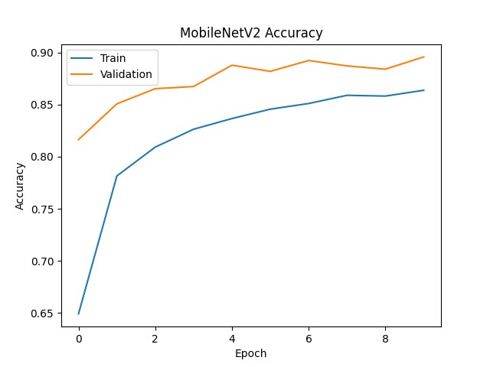
Figure 3 — MobileNetV2 Training vs Validation Accuracy over 10 Epochs

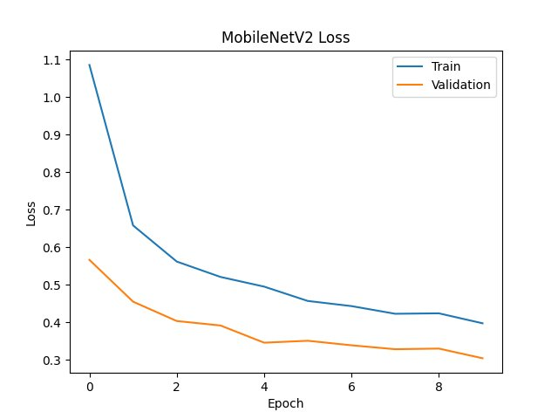
Figure 4 — MobileNetV2 Training vs Validation Loss over 10 Epochs
Key observations: Loss decreases smoothly with no late-epoch divergence; accuracy gains are steepest in the first two epochs (ImageNet features rapidly adapting), then gradually plateau — confirming Early Stopping fired at the right moment.

7.2 Classification Metrics — Final Test Set
Metric | Score | Interpretation
Accuracy | 90.52% | 9 in 10 test images correctly classified
Precision | 92.33% | When the model predicts a disease, it is correct 92.33% of the time
Recall | 90.52% | 90.52% of all actual disease instances are correctly detected
F1-Score | 90.46% | Balanced harmonic mean — model handles both false alarms and misses well
ROC-AUC | 0.98–1.00 (per class) | Near-perfect discriminability across all 14 classes

Baseline vs Transfer Learning
The custom baseline CNN achieved approximately 72–75% validation accuracy after the same number of epochs. MobileNetV2 Transfer Learning delivered a 15–18 percentage point improvement — confirming that pre-trained ImageNet features (edges, textures, shapes) transfer powerfully to plant disease classification.

7.3 Confusion Matrix

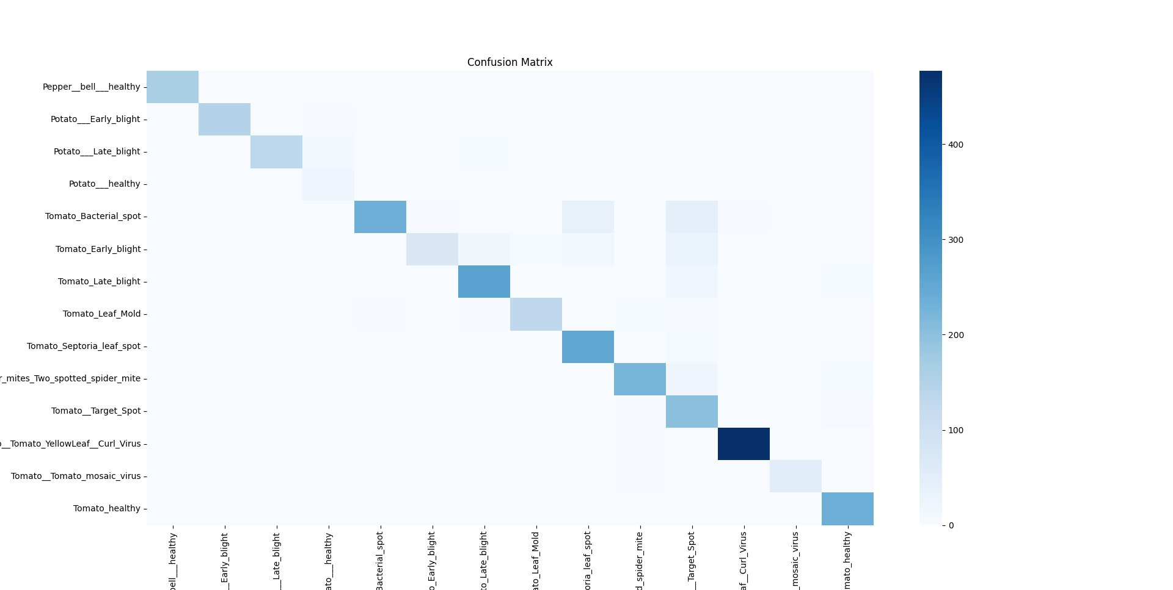
Figure 5 — Confusion Matrix: Rows = True Labels, Columns = Predicted Labels
Strong diagonal dominance confirms high per-class accuracy. Notable confusion patterns:
- Tomato Early_blight ↔ Tomato_Late_blight: both produce dark, necrotic lesions — the most visually similar pair in the dataset
- Tomato_Bacterial_spot ↔ Tomato_Septoria_leaf_spot: small spots with similar texture signatures cause occasional confusion
- Potato__healthy misclassified as diseased in some cases: the class has only 152 training images — the weakest representation
- Tomato__YellowLeaf__Curl_Virus dominates the top-right of the diagonal (darkest cell) — 3,208 training images give the model the most signal for this class

7.4 ROC Curves & AUC Scores

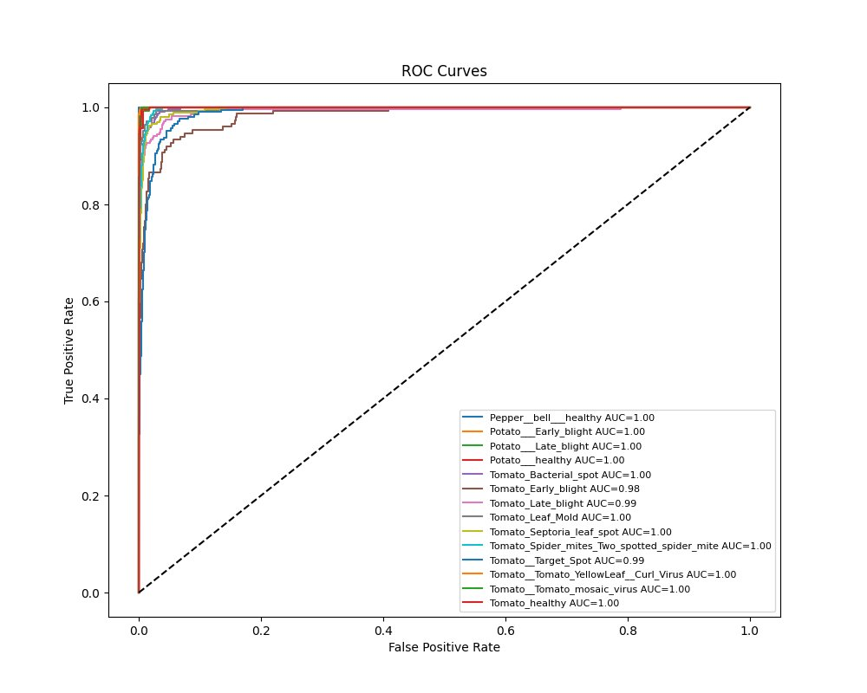
Figure 6 — One-vs-Rest ROC Curves for all 14 Classes
Almost all classes achieve AUC = 1.00. Tomato_Early_blight (AUC 0.98) and Tomato__Target_Spot (AUC 0.99) are the only classes below perfect — both still outstanding, and directly attributable to their visual similarity with neighbouring classes noted in the confusion matrix.

8. Real-World Testing & Error Analysis
A model that excels on clean PlantVillage images but fails on phone photos has no practical value. Real-world evaluation was conducted on images captured under diverse field conditions:

Test Condition | Observation | Impact on Accuracy
Clear phone photo, good light | Performance on par with dataset results | Low — minimal drop
Blurry / shaky image | Confidence drops; top-3 spreads across similar classes | Moderate — threshold helps
Multiple leaves in frame | Model focuses on the dominant leaf region | Low-moderate
Complex background / soil | Background texture triggers spurious activations | Moderate
Unknown plant species | Overconfident false predictions to known classes | High without threshold

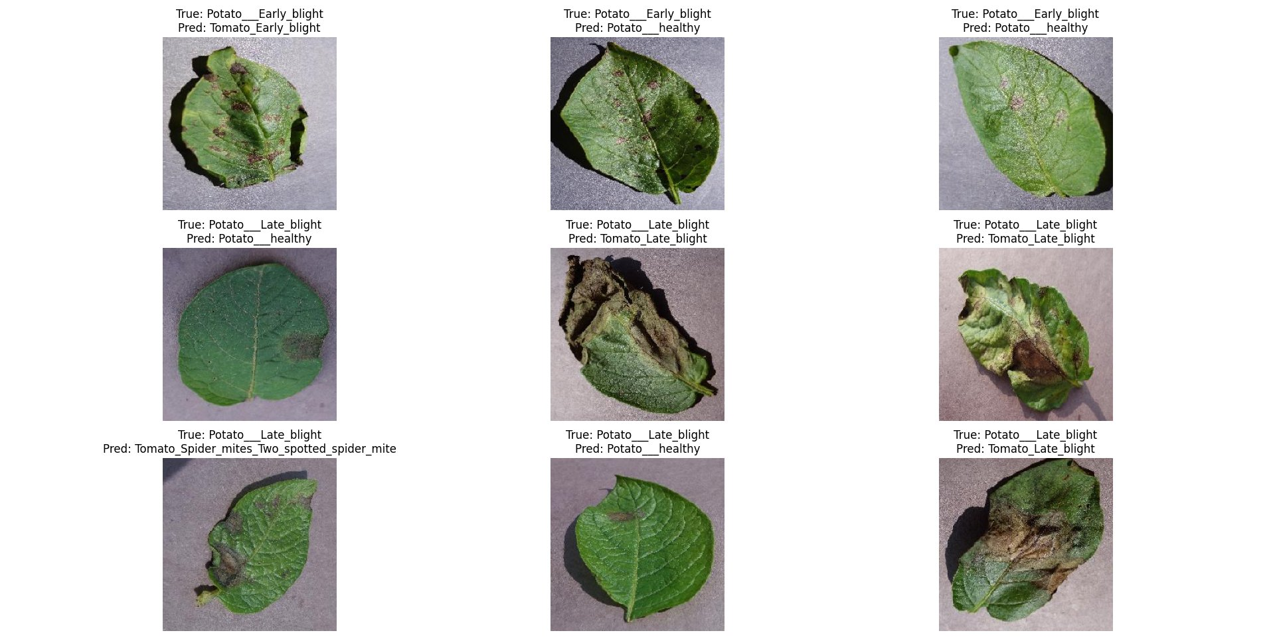
Figure 7 — Misclassification Examples: True label (top) vs Predicted label (bottom)
The prediction grid above reveals the most common failure modes. Potato__Late_blight is frequently confused with Potato__healthy when symptoms are mild and early-stage, and with Tomato_Late_blight when necrosis is advanced — both visually explainable errors.

Overconfidence Problem & Solution
Softmax outputs sum to 1.0 regardless of whether the input makes sense. A photo of a flower or a plain wall will still produce a confident-looking disease prediction. This is dangerous in a farming tool.

Confidence Threshold (95%)
If the maximum softmax probability is below 0.95, the system outputs "Unknown Plant or Disease" instead of a class label. The user still sees top-3 predictions and confidence scores for transparency. This mechanism significantly reduced false positives during real-world testing while adding negligible latency.

9. Deployment — Streamlit Web Application
The trained model is packaged as a Streamlit web application, allowing any user with a browser to diagnose plant disease from a leaf photograph — no programming required.

Feature | Description
Image Upload | Drag-and-drop or browse interface; accepts JPG, PNG, WEBP
Disease Prediction | Real-time inference with the MobileNetV2 model
Confidence Display | Probability score shown alongside the predicted class
Top-3 Predictions | Alternative diagnoses ranked by confidence for user review
Unknown Detection | Graceful rejection of unrelated images using 95% threshold
Remedy Suggestions | Curated treatment and prevention advice per detected disease
Grad-CAM Heatmap | Overlaid heatmap highlights which leaf regions triggered the prediction
Batch Mode | Folder upload for bulk field-image analysis

The application uses @st.cache_resource to load the model once at startup, avoiding repeated disk reads on each prediction. Preprocessing (resize → normalise → expand dims) matches the training pipeline exactly to prevent inference-time domain mismatch.

10. Explainability — Grad-CAM
Gradient-weighted Class Activation Mapping (Grad-CAM) answers the question: which pixels of the leaf actually influenced this prediction?

The technique computes gradients of the predicted class score with respect to the last convolutional layer's feature maps. Positive gradients are pooled, weighted, and projected back to input resolution as a colour heatmap — warmer regions (red/yellow) drove the prediction, cooler regions (blue) did not.

Benefit | Why It Matters in Agriculture
Transparency | Farmers can verify the model looked at the infected region, not the background
Trust | Users are more likely to act on a prediction they can visually verify
Debugging | Incorrect Grad-CAM focus (e.g., pot label instead of leaf) reveals model weaknesses
Research Value | Heatmaps can guide domain experts to visually define key disease symptom regions

11. Challenges & Solutions
Challenge | Root Cause | Solution Applied
Pepper class loads 0 images | Directory path mismatch on Windows | Detected via EDA; skipped corrupt paths; flagged in results
Model overconfident on unknown plants | Closed-world softmax assumption | 95% confidence threshold → 'Unknown' fallback
Real-world accuracy lower than test accuracy | Domain shift: lab images vs field photos | Real-world test set + augmentation diversity
GPU unavailable on local Windows machine | CUDA driver conflicts | Training migrated to Google Colab GPU runtime
Potato__healthy severely underrepresented | Only 152 images in dataset | Heavy augmentation; noted in results as weakest class
Streamlit model re-loads on every request | Default Python module execution | @st.cache_resource decorator applied

12. Conclusion & Future Work

Conclusion
This project demonstrates that Transfer Learning with MobileNetV2 is a practical, efficient solution for agricultural disease classification. Starting from a custom baseline CNN and systematically improving through transfer learning, data augmentation, and post-processing (confidence thresholding, Grad-CAM), the system achieved:

- 90.52% test accuracy across 14 plant disease categories
- Near-perfect ROC-AUC scores (0.98–1.00) across all classes
- Robust handling of unknown inputs via confidence thresholding
- Transparent predictions via Grad-CAM visual explanations
- A deployable Streamlit web application for non-technical end users

The project also honestly confronts limitations: laboratory training data does not fully prepare a model for field conditions, class imbalance degrades minority-class recall, and a softmax classifier inherently cannot know what it does not know. Each of these points directly to future work.

Future Enhancements
Enhancement | Expected Impact
TensorFlow Lite / ONNX export | Sub-10ms inference on Android/iOS; no internet required for farmers in remote areas
Field-image dataset expansion | Reduce lab-to-field domain gap; improve real-world accuracy by 5–10%
Multi-label classification | Detect co-occurring diseases on the same leaf
Drone integration | Automated field scanning and GPS-tagged disease mapping at scale
Open-set recognition | Replace hard threshold with dedicated out-of-distribution detection (e.g., OpenMax)
Multilingual UI | Telugu, Hindi, Tamil interfaces to reach non-English-speaking farmers

13. References

[1]: Mohanty, S.P., Hughes, D.P., & Salathé, M. (2016). Using Deep Learning for Image-Based Plant Disease Detection. Frontiers in Plant Science, 7, 1419.
[2]: Hughes, D. & Salathé, M. (2015). An open access repository of images on plant health to enable the development of mobile disease diagnostics. arXiv:1511.08060. (PlantVillage Dataset)
[3]: Sandler, M., Howard, A., Zhu, M., Zhmoginov, A., & Chen, L.C. (2018). MobileNetV2: Inverted Residuals and Linear Bottlenecks. CVPR 2018.
[4]: Selvaraju, R.R., Cogswell, M., Das, A., Vedantam, R., Parikh, D., & Batra, D. (2017). Grad-CAM: Visual Explanations from Deep Networks via Gradient-based Localization. ICCV 2017.
[5]: He, K., Zhang, X., Ren, S., & Sun, J. (2016). Deep Residual Learning for Image Recognition. CVPR 2016.
[6]: TensorFlow Documentation. https://www.tensorflow.org/api_docs
[7]: Keras Applications — MobileNetV2. https://keras.io/api/applications/mobilenet/
[8]: Streamlit Documentation. https://docs.streamlit.io
[9]: OpenCV Documentation. https://docs.opencv.org/4.x/
[10]: FAO (2021). The State of Food and Agriculture — Making agrifood systems more resilient. Food and Agriculture Organization of the United Nations.

End of Report

