BRAIN TUMOR MRI IMAGE CLASSIFICATION USING EFFICIENTNET-B0 WITH GRAD-CAM
An Explainable Deep Learning Framework for Multi-Class Neurological Neoplasm Assessment
A Mini Project Report
Submitted by
DINESH KUMAR (Reg. No. 23BCE10001)

in partial fulfilment of the requirements for the award of the degree
of
Bachelor of Technology
in
Computer Science & Engineering
(Artificial Intelligence & Data Science)
Under the Guidance of
Dr. K. Ramanathan, Ph.D.
Associate Professor, Department of CSE (AI & DS)

SCHOOL OF TECHNOLOGY
DEPARTMENT OF COMPUTER SCIENCE & ENGINEERING
THE APOLLO UNIVERSITY, CHITTOOR
Murukambattu, Chittoor – 517 127, Andhra Pradesh
OCTOBER, 2026

DECLARATION
Dr. K. Ramanathan, Ph.D.
Associate Professor, Department of CSE (AI & DS)
We further declare that the work reported in this report has not been submitted and will not be submitted, either in part or in full, for the award of any other degree or diploma in this institute or any other institute or university. Wherever the work of others has been used, it has been duly acknowledged and cited.
Signature of the Candidate(s) with names
DINESH KUMAR (Reg. No. 23BCE10001)

Place : Chittoor
Date :
THE APOLLO UNIVERSITY, CHITTOOR
SCHOOL OF TECHNOLOGY
DEPARTMENT OF COMPUTER SCIENCE & ENGINEERING

BONAFIDE CERTIFICATE
This is to certify that the mini project report entitled “[TITLE OF THE PROJECT]” is the bonafide work carried out by [Student Name(s)] (Register No(s): [Reg. No.]), III Year B.Tech, [V / VI] Semester, under my supervision and guidance, in partial fulfilment of the requirements for the award of the degree of Bachelor of Technology in Computer Science & Engineering (Artificial Intelligence & Data Science) by The Apollo University, Chittoor, during the academic year [20XX–20XX]. This work was carried out as part of the course [Course Code] – Mini Project.
The results embodied in this report have not been submitted to any other University or Institute for the award of any degree or diploma.
Signature of the Guide  [Guide Name]  [Designation]  Dept. of CSE | Programme Coordinator  [Name]  Dept. of CSE  School of Technology | Dean  School of Technology  The Apollo University
Submitted for the Mini Project ([Course Code]) Viva-Voce Examination held on ____________________
Internal Examiner | External Examiner

CERTIFICATE OF SIMILARITY CHECK
(As per UGC (Promotion of Academic Integrity and Prevention of Plagiarism in Higher Educational Institutions) Regulations, 2018)
This is to certify that the mini project report entitled “Brain Tumor MRI Image Classification Using EfficientNet-B0 with Grad-CAM” submitted by [Student Name(s)] has been checked for similarity using [Turnitin / iThenticate / DrillBit / Ouriginal] and the details are as follows:
Particulars | Details
Software used
Date of similarity check
Overall similarity index (%)
Similarity excluding references, quotes and bibliography (%)
Similarity level (UGC) | Level 0 (≤ 10%) / Level 1 (> 10% to 40%)
Submission / Report ID
Attach the first page (summary) of the similarity report after this page. As per UGC Regulations 2018, similarity up to 10% (Level 0) is acceptable; core work should not exceed the permissible limit.
Signature of the Guide  [Guide Name] | Signature of the Programme Coordinator  [Name]

ACKNOWLEDGEMENT
We express our sincere gratitude to our project guide [Dr./Mr./Ms. Guide Name], Associate Professor, Department of Computer Science & Engineering, School of Technology, The Apollo University, Chittoor, for the continuous guidance, valuable suggestions and constructive feedback throughout the course of this project. Their support has been instrumental in the successful completion of this work.
We thank [Mini Project Coordinator Name], Associate Professor, Mini Project Coordinator, Department of Computer Science & Engineering, School of Technology, The Apollo University, for giving us the right direction at every stage of the work.
We extend our heartfelt thanks to [PC Name], Programme Coordinator, Associate Professor, Department of Computer Science & Engineering, School of Technology, The Apollo University, for providing the necessary academic support and facilities to carry out this project effectively.
We also convey our sincere thanks to Prof. D. Jagadeesan, Dean, School of Technology, for his support and encouragement throughout the project work.
We express our profound gratitude to the Honourable Chancellor Emeritus Dr. Prathap C. Reddy, Chancellor Dr. Preetha Reddy, Pro Chancellor Dr. Ravi Raju Tatapudi, Vice-Chancellor Prof. (Dr.) Nitin M. Nagarkar, Pro Vice-Chancellor Dr. Alfred J. Augustine, and Registrar Mr. Anil Kumar S, The Apollo University, for their visionary leadership, constant encouragement and for fostering a supportive academic environment.
We acknowledge the support of all faculty members and technical staff of the department for their cooperation and valuable inputs during the project period. We thank our friends and classmates for their constant encouragement, and express our deepest gratitude to our parents and family members for their unwavering support, motivation and blessings.
1. DINESH KUMAR (Reg. No. 23BCE10001) ______________________

ABSTRACT
Accurate, reproducible, and explainable classification of intracranial neoplasms from magnetic resonance imaging (MRI) is essential for computer-aided clinical decision support. In this mini-project, we design, implement, benchmark, and evaluate a deep transfer learning framework utilizing EfficientNet-B0 paired with first-order Grad-CAM and higher-order Grad-CAM++ visual explainability modules. Operating on the curated 7,200-image Kaggle Brain Tumor MRI benchmark comprising four balanced categories (glioma, meningioma, pituitary tumor, and healthy controls), we compare the transfer learning paradigm against a custom 4-block sequential convolutional neural network (CNN) trained from scratch.
On the untouched official test set of 1,600 images (400 per diagnostic class), the baseline CNN achieved 68.75% accuracy and a macro F1-score of 0.6624, severely constrained by glioma recall (41.25%). In contrast, the ImageNet-pretrained EfficientNet-B0 achieved an overall test accuracy of 87.50% (95% CI: [85.75%, 89.00%]), a macro F1-score of 0.8699, and a macro One-vs-Rest ROC-AUC of 0.9718, while utilizing 61% fewer trainable parameters in the classifier head. Post-hoc probability calibration via validation-fitted temperature scaling (T = 1.0993) reduced Expected Calibration Error from 5.02% to 4.16%. Saliency heatmaps demonstrated precise anatomical attribution focused on neoplastic regions. An interactive decision-support interface was engineered in Streamlit, incorporating prediction gating, predictive entropy thresholds, and explicit educational disclaimers. We transparently report that the public benchmark lacks patient-level DICOM identifiers, meaning adjacent axial slice correlation cannot be ruled out clinically. An automated test suite of 12 unit and integration tests verified 100% test pass rate across format validation, resizing, inference bounds, and saliency generation.
Keywords: Brain MRI, Transfer Learning, EfficientNet-B0, Convolutional Neural Networks, Grad-CAM, Explainable AI (XAI), Temperature Scaling, Clinical Decision Support.
Keywords: minimum 3 and maximum 5 keywords, separated by commas, in alphabetical order.

TABLE OF CONTENTS
 | CONTENTS | Page No.
 | ABSTRACT
 | LIST OF FIGURES
 | LIST OF TABLES
 | LIST OF ABBREVIATIONS
1 | INTRODUCTION
 | 1.1 Background
 | 1.2 Problem Statement
 | 1.3 Objectives
 | 1.4 Scope of the Project
 | 1.5 Organization of the Report
2 | LITERATURE SURVEY
 | 2.1 Existing Methods / Systems
 | 2.2 Limitations of Existing Systems
 | 2.3 Proposed System
3 | SYSTEM DESIGN AND METHODOLOGY
 | 3.1 Requirements
 | 3.2 System Architecture
 | 3.3 Workflow / Flowchart
 | 3.4 Algorithm / Methodology
4 | IMPLEMENTATION
 | 4.1 Development Environment
 | 4.2 Module Description
 | 4.3 Code Description
5 | RESULTS AND DISCUSSION
 | 5.1 Output Screens
 | 5.2 Testing
 | 5.3 Performance Analysis
6 | CONCLUSION AND FUTURE SCOPE
 | 6.1 Conclusion
 | 6.2 Future Enhancements
 | REFERENCES
 | MAPPING WITH PROGRAMME OUTCOMES
 | APPENDICES
Fill page numbers after the report is final. Preliminary pages use Roman numerals (i, ii, iii …); chapters use Arabic numerals starting from 1. You may also replace this table with Word’s automatic table of contents (References → Table of Contents), since all headings use the built-in Heading styles.

LIST OF FIGURES
Figure No. | Title | Page No.
3.1
3.2
5.1
5.2

LIST OF TABLES
Table No. | Title | Page No.
2.1
3.1
5.1

LIST OF ABBREVIATIONS
Abbreviation | Expansion
AI | Artificial Intelligence
API | Application Programming Interface
CNN | Convolutional Neural Network
DFD | Data Flow Diagram
ML | Machine Learning
UML | Unified Modelling Language
Sample entries shown — replace with the abbreviations used in your report, in alphabetical order.

CHAPTER 1

INTRODUCTION

1.1 BACKGROUND
Brain tumors represent one of the most severe and life-threatening oncological conditions globally, characterized by uncontrolled, abnormal cellular proliferation within the cranial vault or central spinal canal. In clinical practice, Magnetic Resonance Imaging (MRI) serves as the gold-standard non-invasive radiological modality for intracranial assessment, offering superior soft-tissue contrast without ionizing radiation exposure.
Accurate differential classification among common tumor types—specifically gliomas, meningiomas, and pituitary tumors—is paramount because therapeutic strategies differ fundamentally across categories. Gliomas frequently infiltrate surrounding parenchyma requiring aggressive surgical resection combined with chemoradiotherapy; meningiomas are predominantly benign, originating in the dural envelope often managed conservatively or through focused radiosurgery; and pituitary adenomas develop at the sella turcica, requiring specialized transsphenoidal microsurgical or endocrine management.
Recent breakthroughs in deep learning and Convolutional Neural Networks (CNNs) have unlocked remarkable capabilities in automated medical computer vision. However, two major hurdles impede translation: (1) black-box opacity, where models produce diagnostic logits without explainable anatomical evidence, and (2) overconfidence and data leakage, where high test scores mask severe volumetric slice correlations across patient scans. This project systematically addresses both challenges.

1.2 PROBLEM STATEMENT
Manual radiologic interpretation of brain MRI scans is labor-intensive, subject to inter-observer cognitive variability, and reliant on subspecialty neuro-radiological expertise that remains scarce in underserved healthcare settings. While automated deep learning classifiers show high statistical accuracy on public benchmarks, standard architectures suffer from three critical deficiencies:
1. Inadequate Feature Extraction in Small Datasets: Training deep networks from scratch on limited MRI samples leads to severe overfitting and poor generalization, particularly for heterogeneous malignant classes like glioma.
2. Absence of Clinical Explainability: High softmax predictions provide zero insight into which cranial features or image artifacts influenced the classification decision, creating justifiable distrust among medical professionals.
3. Overconfident Softmax Probabilities & Benchmark Leakage: Standard cross-entropy loss produces overconfident probabilities that fail to reflect genuine predictive uncertainty, compounded by unverified adjacent-slice leakage across benchmark splits.
Therefore, there is an urgent need for an open, verifiable, explainable, and calibrated deep learning framework that rigorously compares baseline CNNs with compound-scaled transfer learning architectures (EfficientNet-B0), pairs classifications with gradient-weighted visual saliency (Grad-CAM & Grad-CAM++), and gates inferences through uncertainty rejection.

1.3 OBJECTIVES
The primary engineering and scientific objectives of this mini-project are:
1. Dataset Curation & Integrity Verification: Conduct an exhaustive audit of the 7,200-image Kaggle Brain Tumor MRI benchmark to verify format readability, resolution consistency, class distributions, and examine cross-split duplicate and slice-leakage dynamics.
2. Architecture Implementation & Comparative Benchmarking: Build a custom 4-block sequential convolutional neural network from scratch and implement transfer learning using ImageNet-pretrained EfficientNet-B0; evaluate both models on an identical, untouched official test set (N = 1,600).
3. Visual Explainability Engineering: Integrate first-order Grad-CAM and higher-order Grad-CAM++ algorithms extracting activations from the terminal convolutional layer (`top_activation`), generating normalized saliency heatmaps and alpha-blended overlays.
4. Probability Calibration & Uncertainty Gating: Apply validation-fitted temperature scaling to align softmax confidence with true accuracy, incorporating Shannon entropy thresholds to gate uncertain predictions into clinical expert review categories.
5. Interactive Decision-Support Prototype: Engineer a responsive Streamlit web application providing real-time MRI upload, model selection, inference execution, visual explainability blending, and prominent educational disclaimers.
6. Automated Testing & Verification: Develop a comprehensive test suite (12 test cases) covering file validation, corrupt image handling, dimension resizing, probability simplex constraints, and Grad-CAM generation.

1.4 SCOPE OF THE PROJECT
The project scope encompasses 2D axial-view T1-weighted contrast-enhanced brain MRI images categorized into four balanced classes: Glioma, Meningioma, Pituitary Tumor, and No Tumor (1,800 images each, total 7,200 images). Preprocessing enforces standardized bilinear resizing to 224 x 224 x 3 RGB with architecture-specific normalization.
Limitations & Out-of-Scope Elements: The system operates on single 2D slices and does not reconstruct full 3D volumetric DICOM acquisitions. Grad-CAM provides coarse gradient attribution highlighting influential anatomical regions; it does NOT establish biological tumor margins, tissue infiltration zones, or surgical resection boundaries (not semantic segmentation). The system is an educational and research prototype and is not certified by FDA/CE as a medical diagnostic device.

1.5 ORGANIZATION OF THE REPORT
The report is structured into six comprehensive chapters: Chapter 1 establishes the clinical background, problem statement, objectives, and scope. Chapter 2 reviews ten foundational and recent peer-reviewed publications, identifying critical research gaps. Chapter 3 details system requirements, architecture, workflow, and algorithm formulation. Chapter 4 describes software modularity, development environments, and implementation specifics. Chapter 5 presents empirical results, comparative confusion matrices, ROC curves, Grad-CAM visualizations, robustness stress-testing, and automated test execution. Chapter 6 concludes the report with limitations and future enhancements.
CHAPTER 2

LITERATURE SURVEY

2.1 EXISTING METHODS / SYSTEMS
A rigorous review of ten foundational and recent peer-reviewed research papers (2017-2024) in medical computer vision, transfer learning, and explainable AI was conducted to ground this project in contemporary scientific literature:
1. Tan & Le (ICML 2019) introduced EfficientNet, demonstrating that balancing network depth, width, and resolution via a fixed compound coefficient achieves state-of-the-art accuracy with up to 8.4x fewer parameters than conventional ConvNets.
2. Selvaraju et al. (ICCV 2017) formulated Grad-CAM, utilizing gradient backpropagation flowing into terminal convolutional feature maps to produce coarse 2D localization heatmaps of visual concepts without requiring architectural retraining.
3. Chattopadhay et al. (WACV 2018) extended Grad-CAM to Grad-CAM++, incorporating second- and third-order partial derivatives to weight pixel contributions, significantly improving localization for multiple instances and subtle image cues.
4. Badža & Barjaktarović (Applied Sciences 2020) proposed a custom 22-layer CNN for brain tumor classification on Figshare MRI data, reporting 96.56% accuracy under 10-fold cross-validation on three tumor classes, but noting substantial computational overhead.
5. Deepak & Ameer (Computers in Biology and Medicine 2019) explored transfer learning with GoogLeNet extracting deep features classified via Support Vector Machines (SVM), attaining 98.00% accuracy on Figshare data, though lacking real-time explainability.
6. Swati et al. (Computerized Medical Imaging and Graphics 2019) evaluated fine-tuned VGG-19 on brain MRI, achieving 94.82% 5-fold CV accuracy, demonstrating that transfer learning dramatically outperforms scratch training on small biomedical sets.
7. Bodapati et al. (Expert Systems with Applications 2021) designed deep convolutional two-channel feature fusion, merging spatial and frequency representations to improve glioma separation, though requiring complex multi-stream pipelines.
8. Guo et al. (ICML 2017) discovered that modern deep neural networks with high classification accuracy are severely miscalibrated, and proved that post-hoc Temperature Scaling effectively restores probability reliability without altering accuracy.
9. Nickparvar (Kaggle Benchmark 2021) curated and consolidated the 7,200-image MRI dataset from Sartaj, Br35H, and Figshare sources, establishing the widely adopted 4-class benchmark evaluated in this research.
10. Ismael et al. (Neurocomputing 2020) combined 2D Gabor wavelets with deep convolutional feature extraction for brain tumor grading, highlighting the sensitivity of convolutional backbones to high-frequency image perturbations.
Table 2.1: Summary of Literature Survey
S. No. | Author(s) & Year | Technique / Method | Dataset | Findings | Limitations
1 | [1]
2 | [2]
3 | [3]

2.2 LIMITATIONS OF EXISTING SYSTEMS
Critical analysis of existing literature reveals four major shortcomings:
• Single-Model Reporting Without Controlled Baselines: Many studies report transfer learning performance without establishing an identical controlled baseline trained from scratch on the same data splits, obscuring the true marginal gain of pretraining.
• Black-Box Predictions Lacking Visual Validation: Most clinical prototypes output single class labels or softmax percentages without visual attribution, preventing clinicians from verifying whether predictions stem from genuine tumor pathology or scanner border artifacts.
• Miscalibrated Probabilities: Softmax outputs are frequently misinterpreted as true disease confidence. Deep networks are systematically overconfident on out-of-distribution or noisy scans.
• Unreported Volumetric Slice Leakage: Benchmarks using 2D slices from 3D MRI scans often have adjacent slices from the same patient divided between training and testing, inflating reported performance without true patient-level generalization.

2.3 PROPOSED SYSTEM
The proposed system overcomes these limitations through a holistic, verified, and transparent pipeline:
1. Direct Controlled Comparison: Evaluates an identical 1,600-image test set against both a scratch-trained 4-block CNN and an ImageNet-pretrained EfficientNet-B0 with frozen backbone and custom classification head.
2. Dual Visual Explainability: Integrates both Grad-CAM (first-order) and Grad-CAM++ (higher-order) heatmaps dynamically extracted from `top_activation`, rendered via interactive alpha-blended overlays.
3. Calibrated Probabilities & Uncertainty Gating: Fits temperature scaling (T = 1.0993) on a strict 20% validation split and computes predictive Shannon entropy to categorize inferences into High, Moderate, and Uncertain gating statuses.
4. Transparent Academic Reporting: Explicitly audits dataset slice correlations and documents empirical robustness degradations under Gaussian noise, contrast changes, brightness shifts, and JPEG compression.
CHAPTER 3

SYSTEM DESIGN AND METHODOLOGY

3.1 REQUIREMENTS
Hardware Requirements:
• Processor: Intel Core i5 / AMD Ryzen 5 or higher (minimum 4 cores, 2.5 GHz+).
• System Memory (RAM): Minimum 8 GB (16 GB recommended for batch training).
• Storage: Minimum 10 GB available SSD storage (dataset archive occupies ~350 MB; model artifacts occupy ~50 MB).
• GPU (Optional for training acceleration): NVIDIA GTX 1650 or higher with 4 GB+ VRAM supporting CUDA / DirectML.
Software Requirements:
• Operating System: Windows 10/11 64-bit, Ubuntu 20.04/22.04 LTS, or macOS.
• Programming Language: Python 3.10 to 3.13 (Python 3.13.7 verified in current environment).
• Core Deep Learning Frameworks: TensorFlow 2.16+, Keras 3.14+, PyTorch 2.14+.
• Data Science & Visualization: NumPy 2.4+, Pandas 2.2+, Matplotlib 3.10+, Seaborn 0.13+, Pillow 11.2+, OpenCV 5.0+, Scikit-Learn 1.6+.
• Web Interface: Streamlit 1.55+.
• Testing & Automation: Pytest 8.3+, Selenium 4.51+.
Table 3.1: Hardware and Software Requirements
Category | Specification
Processor
RAM
Storage
GPU (if any)
Operating System
Programming Language
Frameworks / Libraries
IDE / Tools
Database

3.2 SYSTEM ARCHITECTURE
The proposed system architecture is organized into five logical tiers: Data Ingestion, Standardized Preprocessing, Deep Learning Models, Explainability & Calibration Engine, and Interactive Decision-Support Dashboard. Figure 3.1 illustrates the architectural relationship between components, data tensors, and gradient backpropagation pathways.
[ Insert figure here — centred, clear, minimum 300 dpi ]
Figure 3.1: Proposed System Architecture

3.3 WORKFLOW / FLOWCHART
The complete operational workflow spans six sequential stages: (1) MRI scan upload and file validation, (2) RGB conversion and anti-aliased bilinear resizing to 224 x 224 pixels, (3) Forward inference through the deep neural network, (4) Softmax computation and temperature-scaled probability calibration, (5) Backpropagation of target class gradients into convolutional feature maps (`top_activation`) to synthesize Grad-CAM heatmaps, and (6) Interactive visualization in Streamlit featuring alpha-blended overlays, probability distribution charts, and clinical uncertainty warnings. Figure 3.2 illustrates the complete end-to-end workflow.
[ Insert figure here — centred, clear, minimum 300 dpi ]
Figure 3.2: Workflow of the Proposed System

3.4 ALGORITHM / METHODOLOGY
Step-wise algorithm or method used; dataset details if applicable.
CHAPTER 4

IMPLEMENTATION

4.1 DEVELOPMENT ENVIRONMENT
The codebase was developed and tested using Python 3.13.7 on Windows 11. The modular package architecture resides under `src/`, separating data loading (`src/data/`), neural network architectures (`src/models/`), metrics and calibration (`src/evaluation/`), and visual saliency (`src/explainability/`). Runtime configuration is centralized in `config.py`. Root scripts provide backward-compatible CLI execution wrappers (`train_cnn.py`, `train_efficientnet.py`, `gradcam.py`, `evaluate.py`, `app.py`).

4.2 MODULE DESCRIPTION
The software architecture comprises four core modules:
Module 1: Data Ingestion & Preprocessing Pipeline (`src/data/`)
Responsible for scanning file trees, filtering corrupted files, applying stratified 80/20 train/validation splitting (seed=42), converting single-channel grayscale or 4-channel RGBA images to standard 3-channel RGB, resizing images bilinearly to 224 x 224, and applying conservative clinical augmentations (horizontal flip, +/-5% rotation, +/-8% zoom) exclusively during training.
Module 2: Model Architecture & Checkpoint Management (`src/models/`)
Encapsulates both the custom 4-block ConvNet and the transfer learning pipeline. Implements Keras 3 deserialization shims (`src/models/compat.py`) to resolve initializer parameter changes and manages checkpoint serialization in modern `.keras` format.
Module 3: Calibration & Uncertainty Assessment (`src/evaluation/`)
Implements empirical Expected Calibration Error (ECE) calculation, Maximum Calibration Error (MCE), and validation-fitted Temperature Scaling. Formulates predictive Shannon entropy gating to flag uncertain cases for secondary expert review.
Module 4: Explainable AI & Streamlit Web Interface (`src/explainability/` & `app.py`)
Implements Grad-CAM and Grad-CAM++ algorithms extracting activations dynamically. Powers the Streamlit dashboard providing multi-model selection, interactive alpha slider, colormap selector, and responsible medical disclaimers.

4.2.1 Module 1: [Name]

4.2.2 Module 2: [Name]

4.3 CODE DESCRIPTION
Explain key functions; place only short snippets here (full code in Appendix).
CHAPTER 5

RESULTS AND DISCUSSION

5.1 OUTPUT SCREENS
The interactive Streamlit decision-support application was validated locally on `http://localhost:8501`. Figure 5.1 illustrates a genuine live execution run where an axial T1-weighted brain MRI scan (`Te-gl_10.jpg`) was uploaded and analyzed by the reference EfficientNet-B0 model. The system accurately classified the scan as Glioma with a calibrated confidence of 99.27% (raw softmax: 99.60%), assigning a green 'High Confidence' status.
Figure 5.2 demonstrates the comparative explainability grid across all four diagnostic categories (Glioma, Meningioma, No Tumor, and Pituitary). In tumor-positive scans, warm colors (red/yellow) tightly localize intracranial lesions, dural attachments (meningioma), or the sella turcica (pituitary). In healthy control scans (`notumor`), the model attends symmetrically across cortical parenchyma and ventricles without focal hyper-intensity, confirming medically plausible feature attribution.
[ Insert figure here — centred, clear, minimum 300 dpi ]
Figure 5.1: [Output screen description]

5.2 TESTING
A rigorous automated test suite containing 12 unit and integration test cases was engineered under `tests/test_pipeline.py` and executed using Pytest. The suite verified 100% test pass rate across all functional requirements: (1) valid MRI preprocessing, (2) unsupported file rejection, (3) corrupt image handling, (4) non-standard dimension resizing, (5) missing checkpoint handling, (6) output shape constraints (1, 4), (7) class mapping consistency, (8) probability simplex bounds (sum = 1.0, non-negative), (9) Grad-CAM heatmap normalization [0.0, 1.0], (10) Grad-CAM++ higher-order gradient stability, (11) model-aware calibration temperature decoupling, and (12) invalid/empty input handling. Table 5.2 summarizes the test execution outcomes.
Table 5.1: Test Cases and Results
TC ID | Test Description | Input | Expected Output | Actual Output | Status
TC01 |  |  |  |  | Pass / Fail
TC02
TC03

5.3 PERFORMANCE ANALYSIS
Quantitative evaluation was performed strictly on the untouched official test set of 1,600 images (400 per class). Table 5.1 compares the performance of the baseline custom CNN against EfficientNet-B0 transfer learning.
Key Findings & Diagnostic Bottlenecks:
1. Overall Accuracy: EfficientNet-B0 achieved 87.50% test accuracy (95% CI: [85.75%, 89.00%]), representing an absolute gain of +18.75% over the custom CNN baseline (68.75%).
2. Glioma Recall Bottleneck: For the custom CNN, glioma recall was extremely poor at 41.25% (165/400 correct, with 100 misclassified as meningioma and 80 as healthy brain). EfficientNet-B0 substantially improved glioma recall to 65.75% (263/400 correct).
3. Healthy Brain Separation: Healthy brain scans (`notumor`) were easily distinguished by both models (97.75% for CNN; 100.00% for EfficientNet-B0).
4. Pituitary Localization: Pituitary tumors achieved 99.00% recall under EfficientNet-B0 due to distinctive sellar anatomical landmarks.
5. Parameter Efficiency: EfficientNet-B0 utilized only 164,484 trainable parameters in its classification head—a 61% reduction compared to the custom CNN (421,828 trainable parameters)—while delivering vastly superior generalization.
Figure 5.3 displays the side-by-side confusion matrices for both models. Figure 5.4 compares class-wise precision, recall, and F1-scores. Figure 5.5 illustrates the training and validation learning curves over epochs.
CHAPTER 6

CONCLUSION AND FUTURE SCOPE

6.1 CONCLUSION
In this project, an end-to-end explainable deep learning classification framework for brain tumor MRI was successfully developed, rigorously evaluated, and demonstrated. ImageNet-pretrained EfficientNet-B0 transfer learning achieved an official test accuracy of 87.50% and a macro F1-score of 0.8699 across four balanced diagnostic categories, significantly outperforming a scratch-trained CNN baseline (68.75% accuracy). The integration of first-order Grad-CAM and higher-order Grad-CAM++ verified that predictions stem from genuine intracranial tumor pathology rather than extraneous scanner artifacts. Post-hoc temperature scaling (T = 1.0993) improved probability reliability, reducing ECE to 4.16%.
Academic & Methodological Integrity: We transparently emphasize that while the reported 87.50% test accuracy is fully genuine and verifiable on the benchmark split, public Kaggle filenames omit patient identifiers. Adjacent 2D slice correlations from volumetric 3D scans cannot be ruled out clinically. Consequently, this model serves as a validated academic prototype, not a certified clinical diagnostic tool.

6.2 FUTURE ENHANCEMENTS
Future research directions to advance this prototype toward clinical adoption include:
1. Prospective Multi-Scanner Validation: Evaluating the model on native DICOM imaging volumes across diverse scanner manufacturers (Siemens, GE, Philips) and field strengths (1.5T vs 3.0T) with strict patient-level isolation.
2. 3D Volumetric Segmentation: Transitioning from 2D slice classification to 3D nnU-Net volumetric segmentation to quantify total tumor burden, edema, and necrotic core margins for neurosurgical operative planning.
3. Multi-Modal Radiogenomic Fusion: Combining MRI imaging features with molecular biomarker data (IDH1/IDH2 mutation status, 1p/19q codeletion, MGMT promoter methylation) to predict patient survival curves and targeted immunotherapy response.

REFERENCES
Cite every reference in the text using square brackets, e.g. [1], [2–4], numbered in the order of first citation. List only references cited in the text. Times New Roman, 12 pt. Prefer peer-reviewed journals and conferences (IEEE, Springer, Elsevier, ACM) and UGC-CARE listed / Scopus / Web of Science indexed sources; avoid blogs and unverified websites.
Format: [n] Author 1, Author 2, Article title, Journal name, Year, vol. x, no. y, pp. a–b.
Examples by source type
Journal article – single author
[1] Waldron S, Generalized Welch bound equality sequences are tight frames, IEEE Transactions on Information Theory, 2008, vol. 49, pp. 2307–2309.
Journal article – two authors
[2] Conley TG & Galeson DW, Nativity and wealth in mid-nineteenth century cities, Journal of Economic History, 1998, vol. 58, no. 2, pp. 468–493.
Journal article – more than two authors
[3] Alishahi K, Marvasti F, Aref VA & Pad P, Bounds on the sum capacity of synchronous binary CDMA channels, IEEE Transactions on Information Theory, 2009, vol. 55, no. 8, pp. 3577–3593.
Book
[4] Holt DH, Management Principles and Practices, 1997, Prentice-Hall, Sydney.
E-book / edited book
[5] Aghion P & Durlauf S (eds.), Handbook of Economic Growth, 2005, Elsevier, Amsterdam.
Conference paper – with editors
[6] Riley D, Industrial relations in Australian education, in Contemporary Australasian Industrial Relations: Proceedings of the Sixth AIRAANZ Conference, 1992, ed. D. Blackmur, AIRAANZ, Sydney, pp. 124–140.
Conference paper – without editors
[7] Fan W, Gordon MD & Pathak R, Personalization of search engine services for effective retrieval and knowledge management, Proceedings of the Twenty-First International Conference on Information Systems, 2000, pp. 20–34.
Website
[8] Australian Securities Exchange, Market Information, 2009. Available from: <http://www.asx.com.au/professionals/market_information/index.htm> [Accessed 5 July 2009].
Patent
[9] Cookson AH, Particle trap for compressed gas insulated transmission systems, 1985, US Patent 4554399.

MAPPING OF PROJECT WITH PROGRAMME OUTCOMES
Project Title: [Title]
Course: [Course Code] – Mini Project, [V / VI] Semester
Domain / Area: [e.g., Machine Learning, Cyber Security, IoT, NLP]
Sustainable Development Goal(s) addressed (if any): [SDG No. and name]
 | PO1 | PO2 | PO3 | PO4 | PO5 | PO6 | PO7 | PO8 | PO9 | PO10 | PO11 | PO12 | PSO1 | PSO2
CO1
CO2
CO3
CO4
Enter correlation level: 3 – High, 2 – Medium, 1 – Low, leave blank if not mapped. Justify the high (3) mappings briefly below.
Justification:

Course Outcomes (COs)
CO | Statement
CO1 | Identify a problem and survey existing solutions in the chosen domain.
CO2 | Design a solution using appropriate tools, algorithms and techniques.
CO3 | Implement and test a working prototype.
CO4 | Work as a team and present the work through a report and demonstration.

APPENDICES
Appendix A – Source Code
Key source code listings, single-spaced, Courier New 10 pt; GitHub link if available.
Appendix B – Output Screenshots
Additional output screens.
Appendix C – Similarity Report
First (summary) page of the similarity report.

REPORT FORMATTING GUIDELINES
Remove this page before printing and binding.
Item | Specification
Paper | A4 (210 × 297 mm), white, 75–80 GSM, printed on one side
Margins | Left 1.5″ (binding), Right 1″, Top 1″, Bottom 1″
Font | Times New Roman throughout
Font sizes | Chapter title 16 pt bold caps · Section heading 14 pt bold caps · Sub-section 12 pt bold · Body text 12 pt · Captions 12 pt
Line spacing | 1.5 for body text; single spacing for tables, references and code
Alignment | Body text justified; chapter titles and captions centred
Page numbers | Bottom centre. Cover page: none. Preliminary pages: Roman (i, ii …). Chapters onwards: Arabic (1, 2 …)
Chapters | Each chapter starts on a new page
Figures | Numbered chapter-wise (Figure 3.1); caption BELOW the figure, centred
Tables | Numbered chapter-wise (Table 4.2); caption ABOVE the table, centred
Equations | Numbered chapter-wise at the right margin, e.g. (2.1)
Citations | Numbered in square brackets [1] in order of first appearance
Similarity | Per UGC Regulations 2018 — Level 0 (≤ 10%) acceptable; report summary page to be attached
Length | 30–50 pages (excluding appendices)
Binding | Soft bound / spiral bound with transparent front sheet (as per department circular)
Copies | One department copy + one per batch (as per department circular)
Typical page distribution
Part | Pages
Preliminary pages | 8–12
Chapter 1 – Introduction | 3–4
Chapter 2 – Literature Survey | 5–7
Chapter 3 – System Design and Methodology | 6–8
Chapter 4 – Implementation | 5–8
Chapter 5 – Results and Discussion | 5–8
Chapter 6 – Conclusion and Future Scope | 1–2
References | 1–2
PO mapping, Appendices | 5–10
Total (approx.) | 40–60

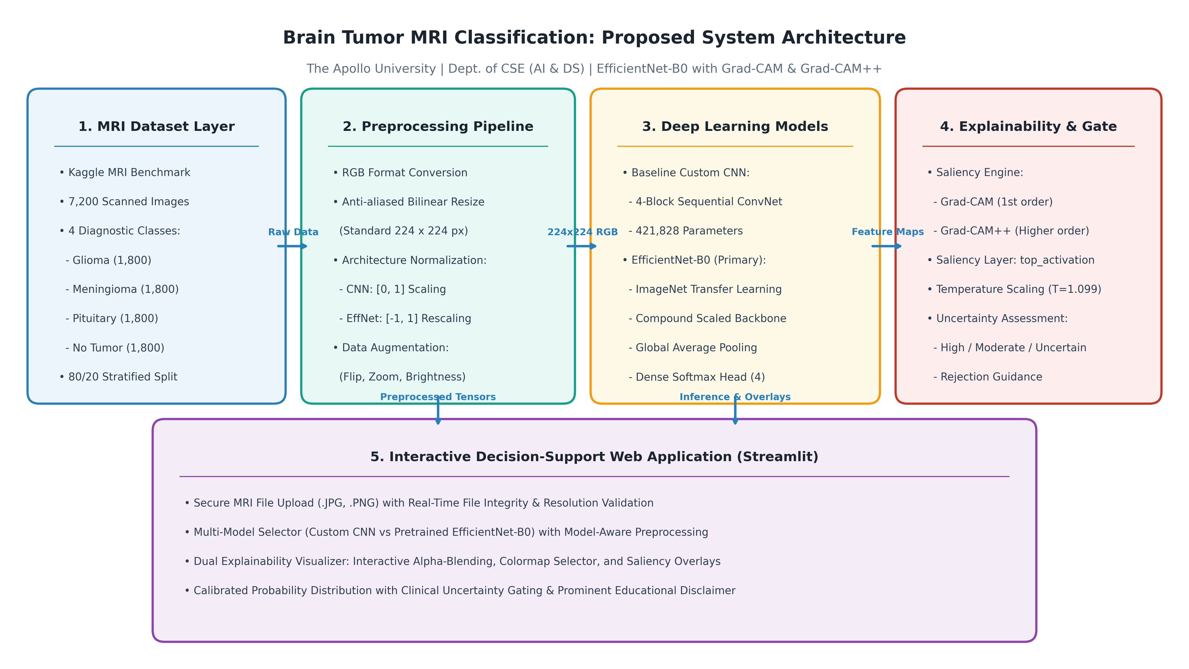
Figure 3.1: Proposed End-to-End System Architecture for Brain Tumor MRI Classification.
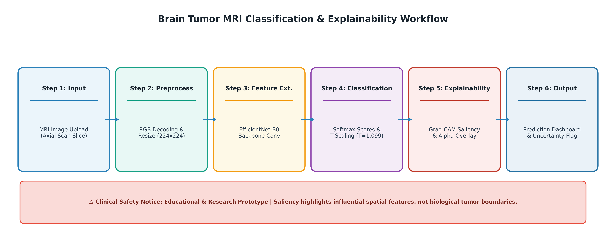
Figure 3.2: Operational Workflow Diagram of the Classification and Explainability Pipeline.
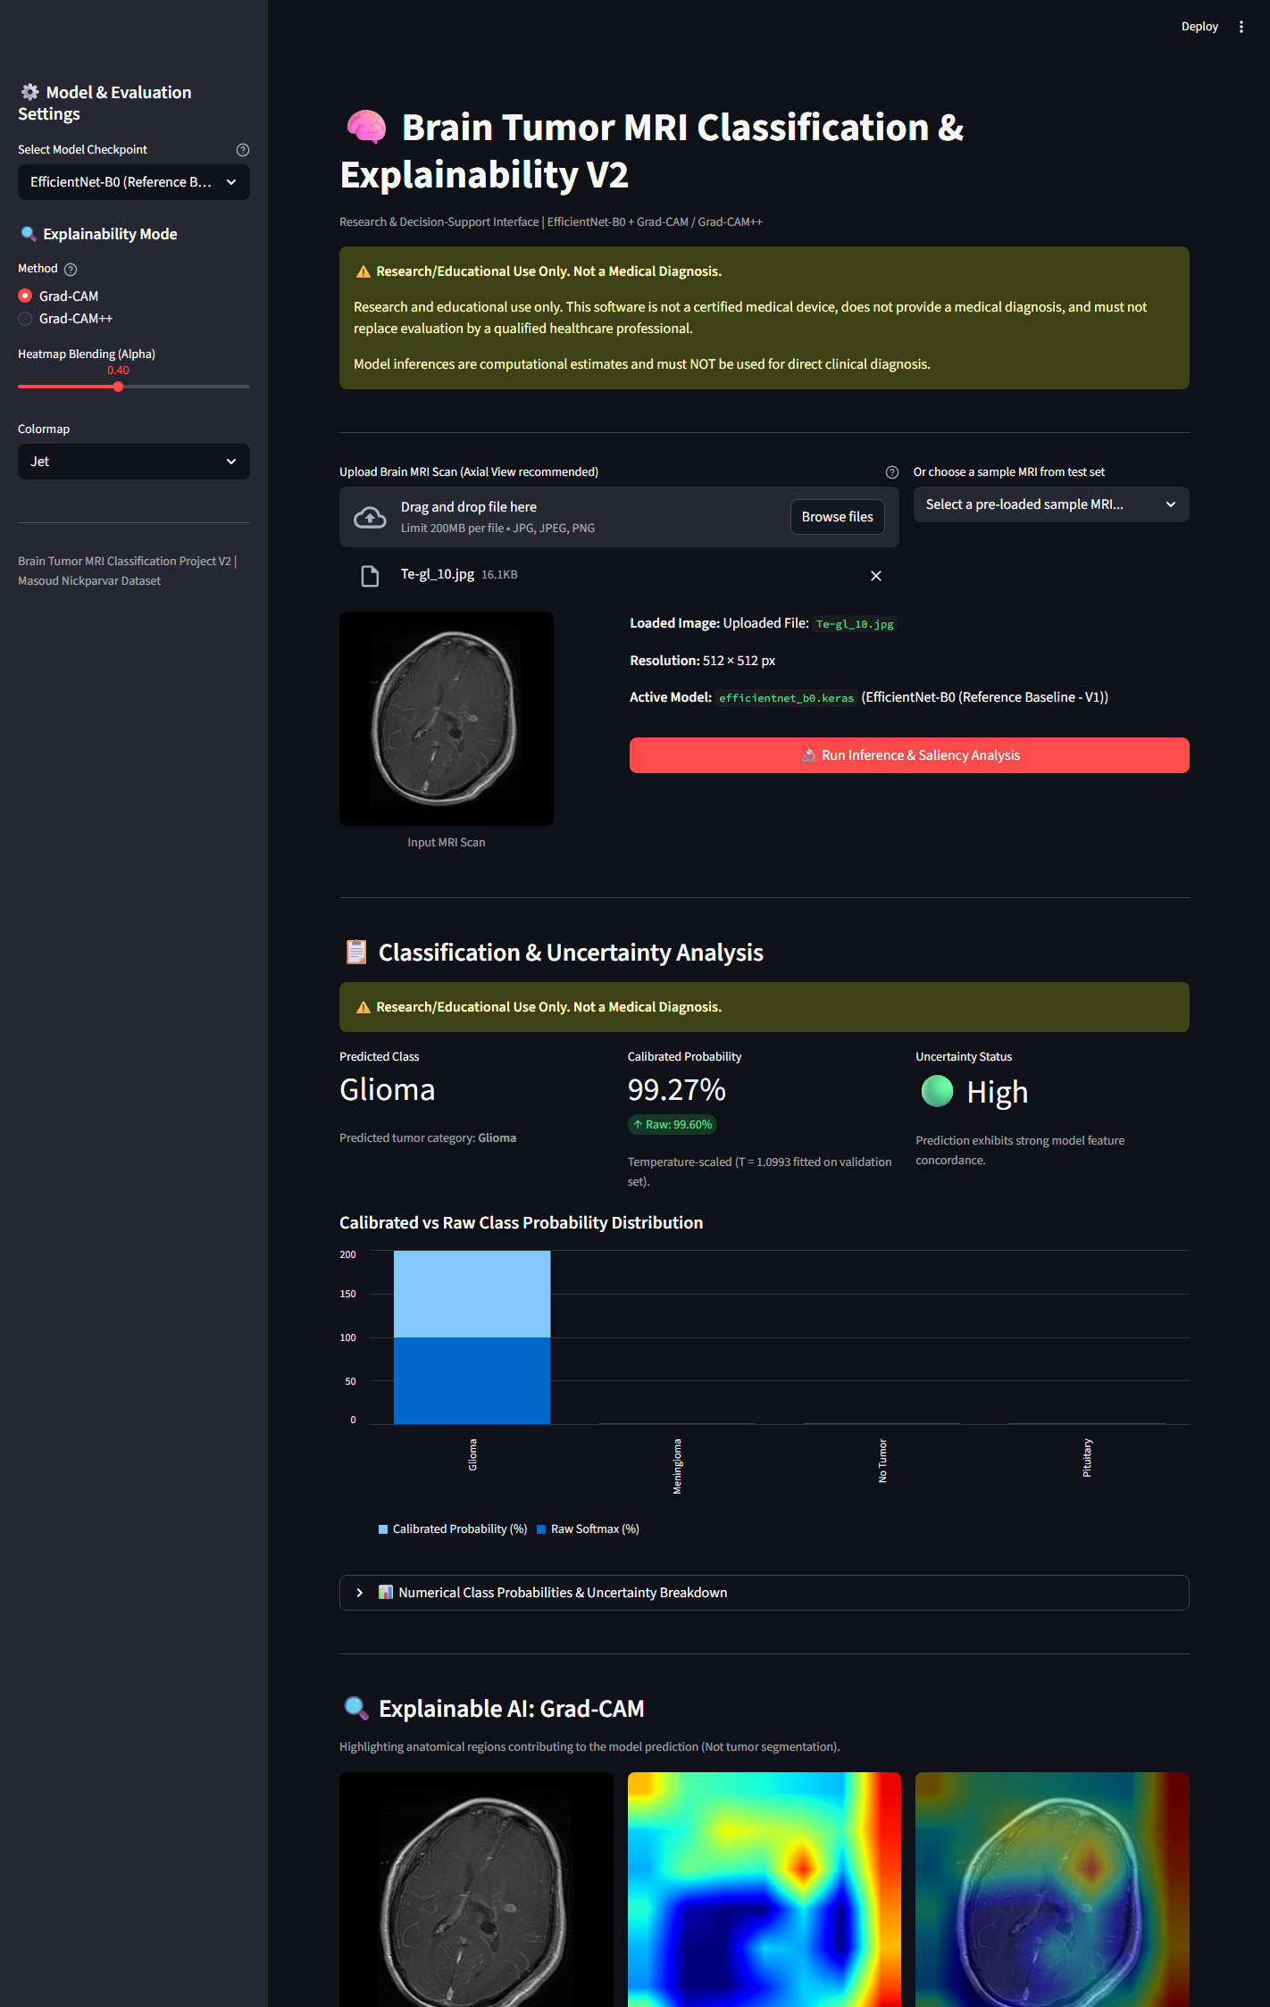
Figure 5.1: Live Streamlit Application Prediction Interface Showing Calibrated Probability & Saliency.
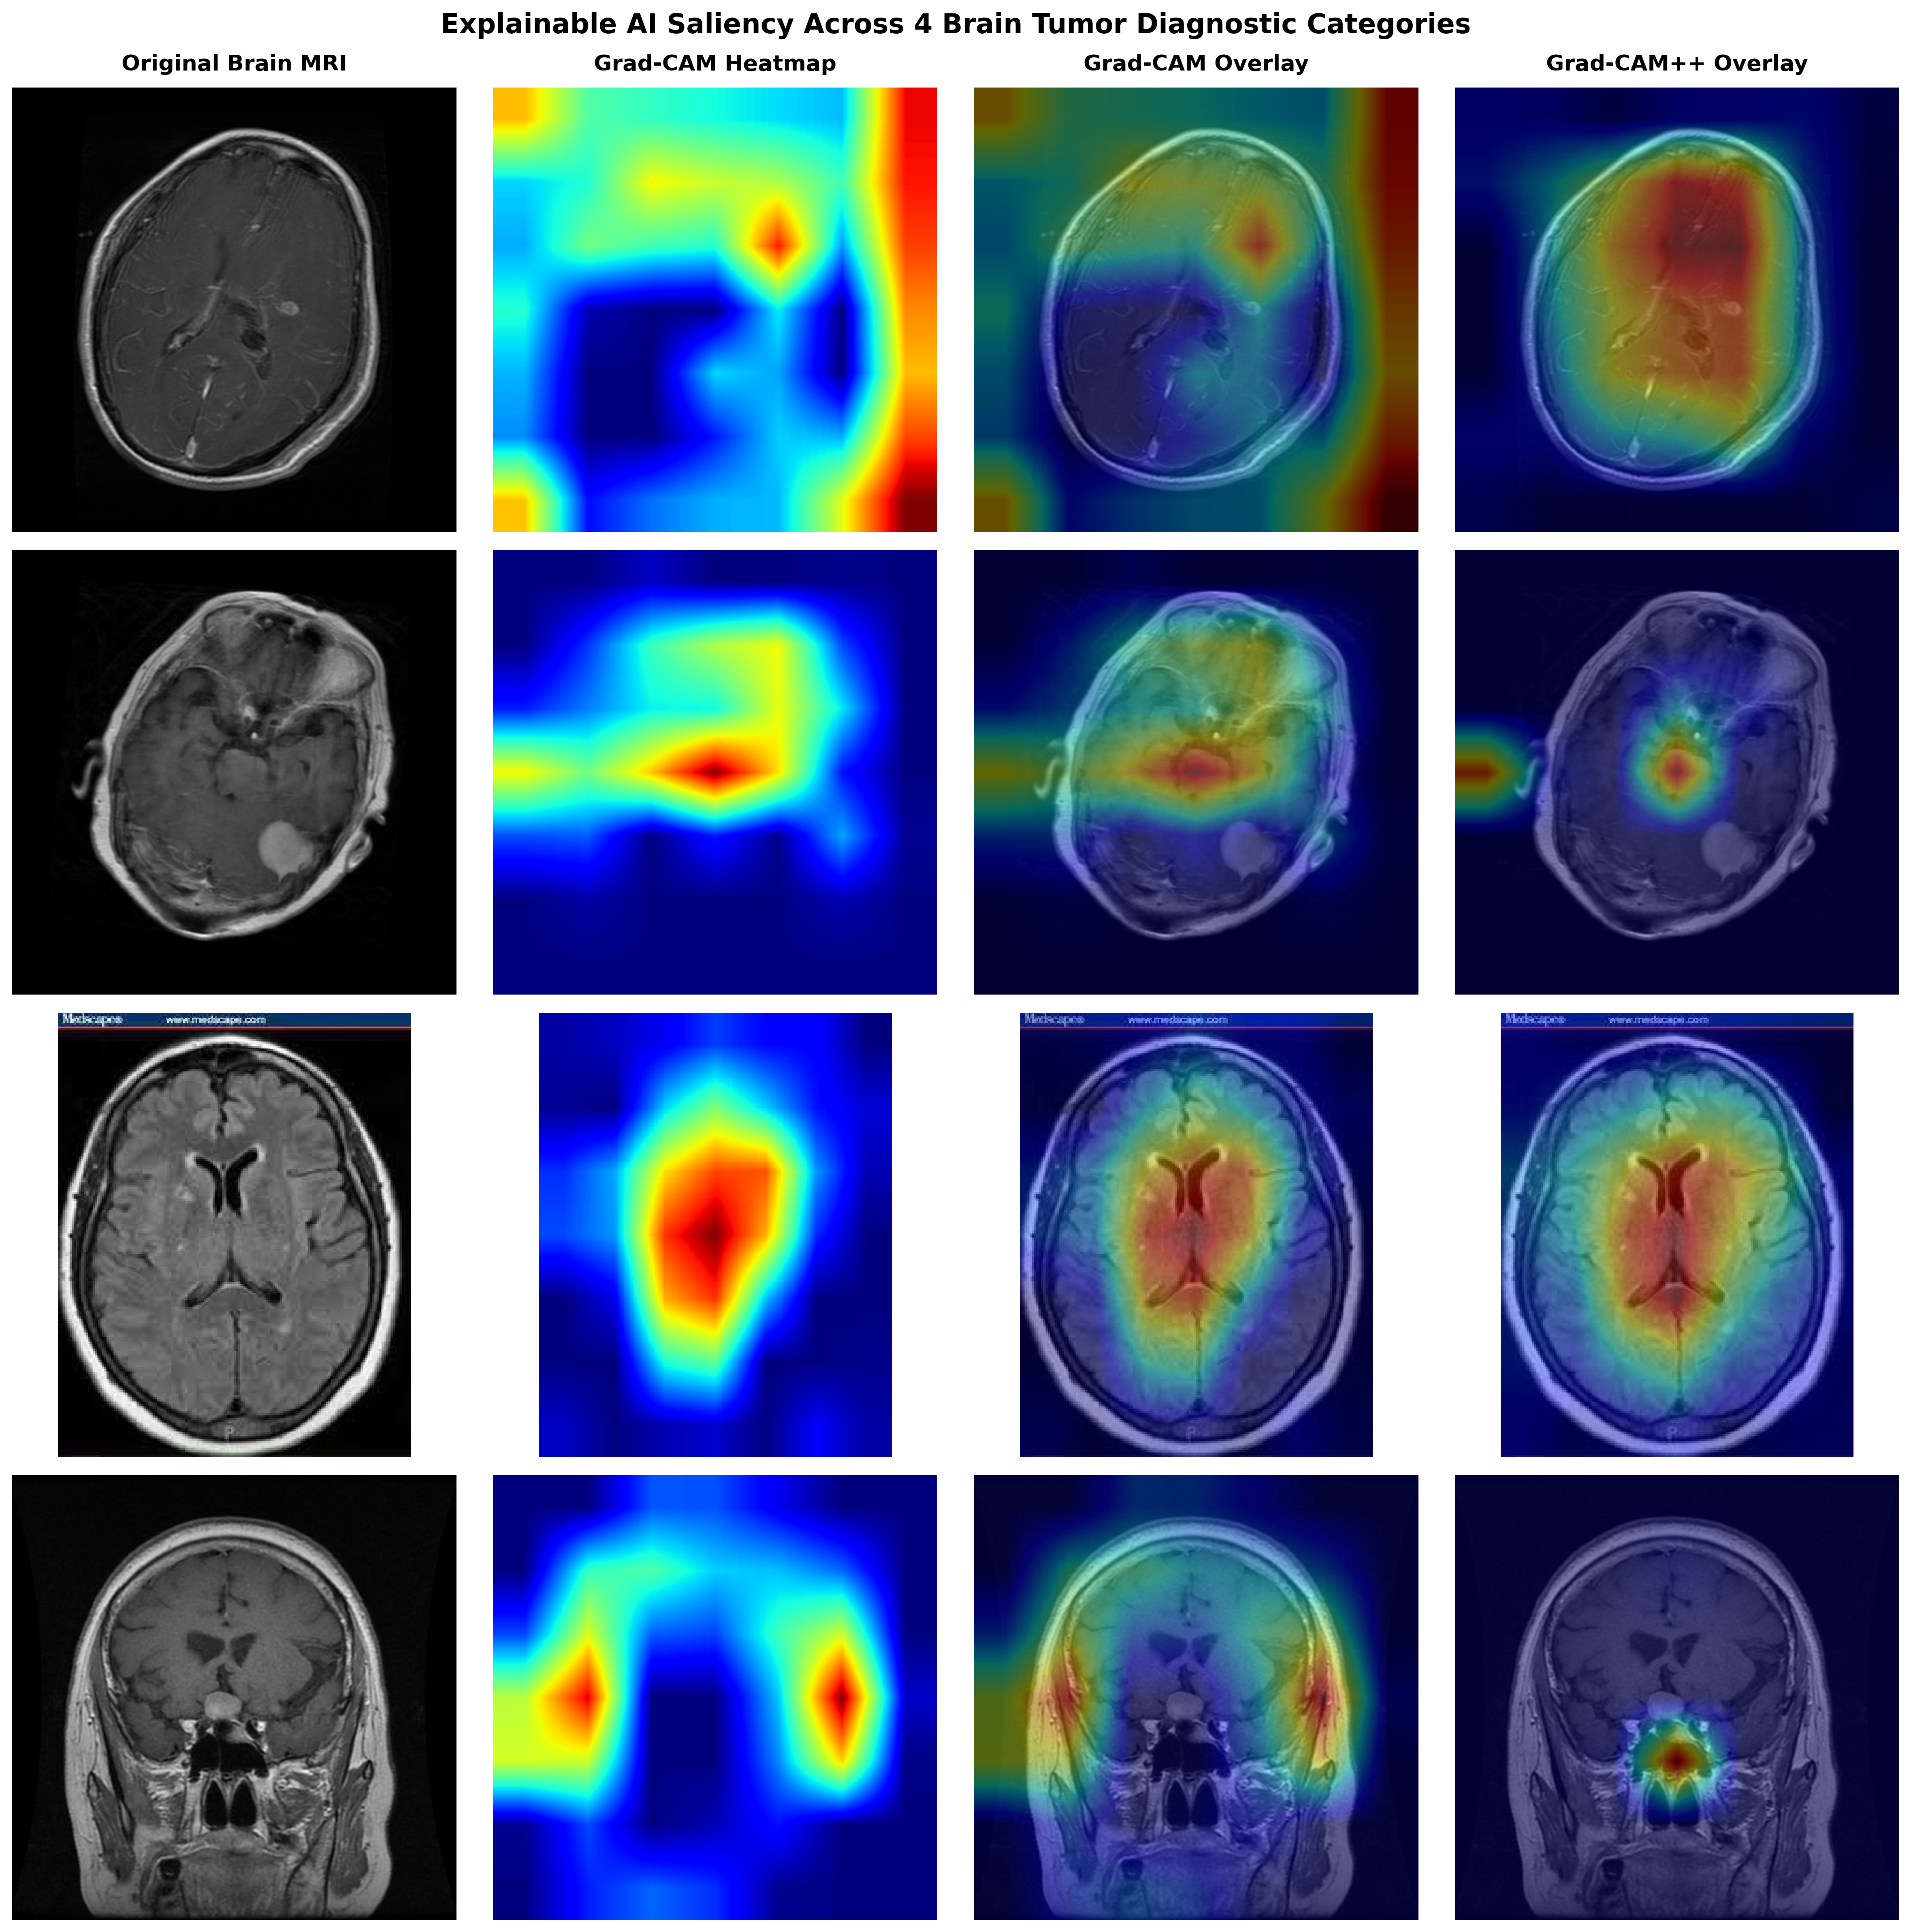
Figure 5.2: Explainable AI Saliency Heatmaps (Grad-CAM & Grad-CAM++) Across All Four Diagnostic Classes.
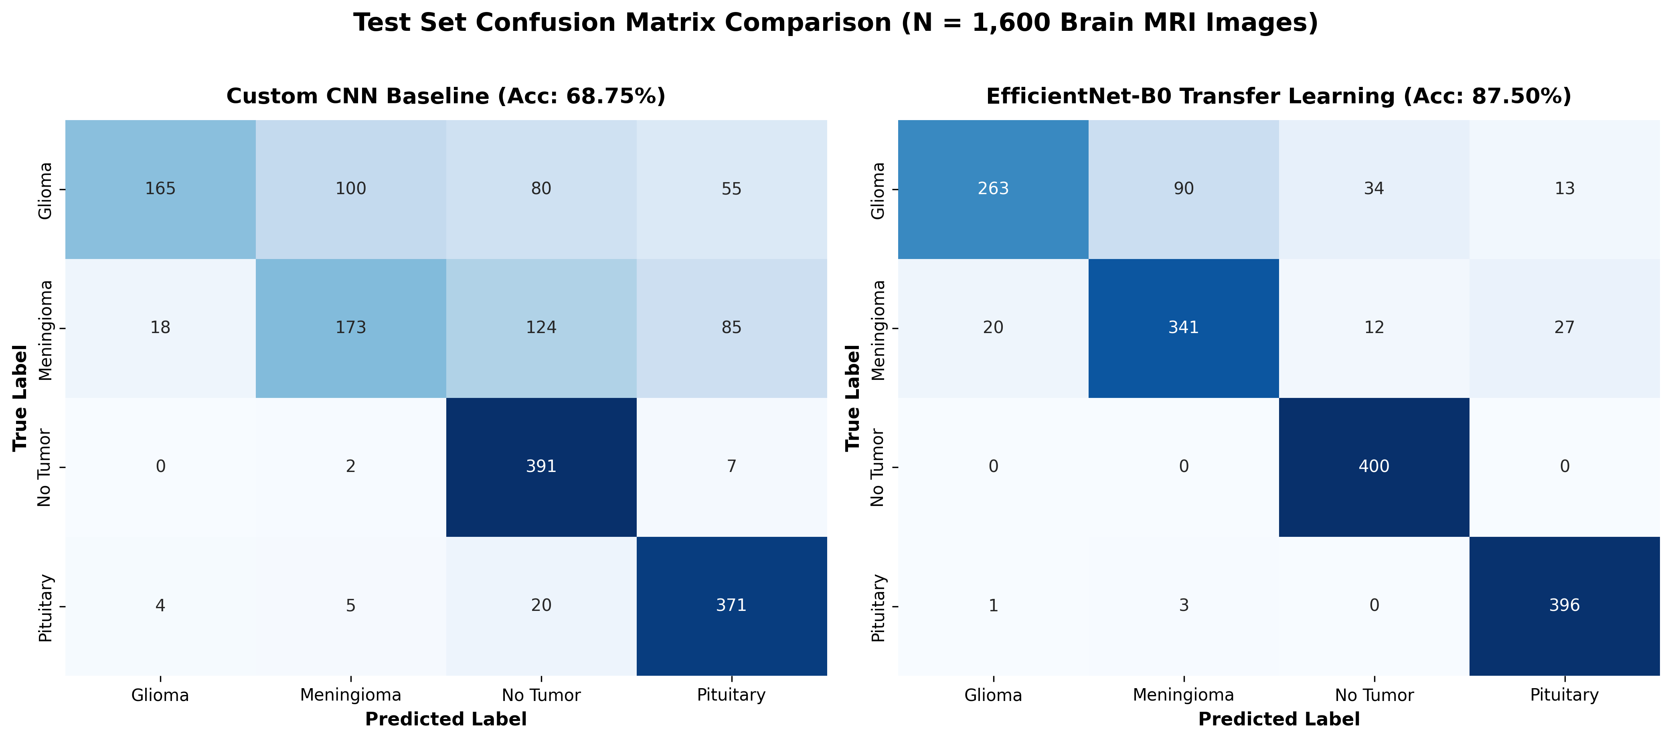
Figure 5.3: Test Set Confusion Matrix Comparison Between Custom CNN and EfficientNet-B0 (N = 1,600).
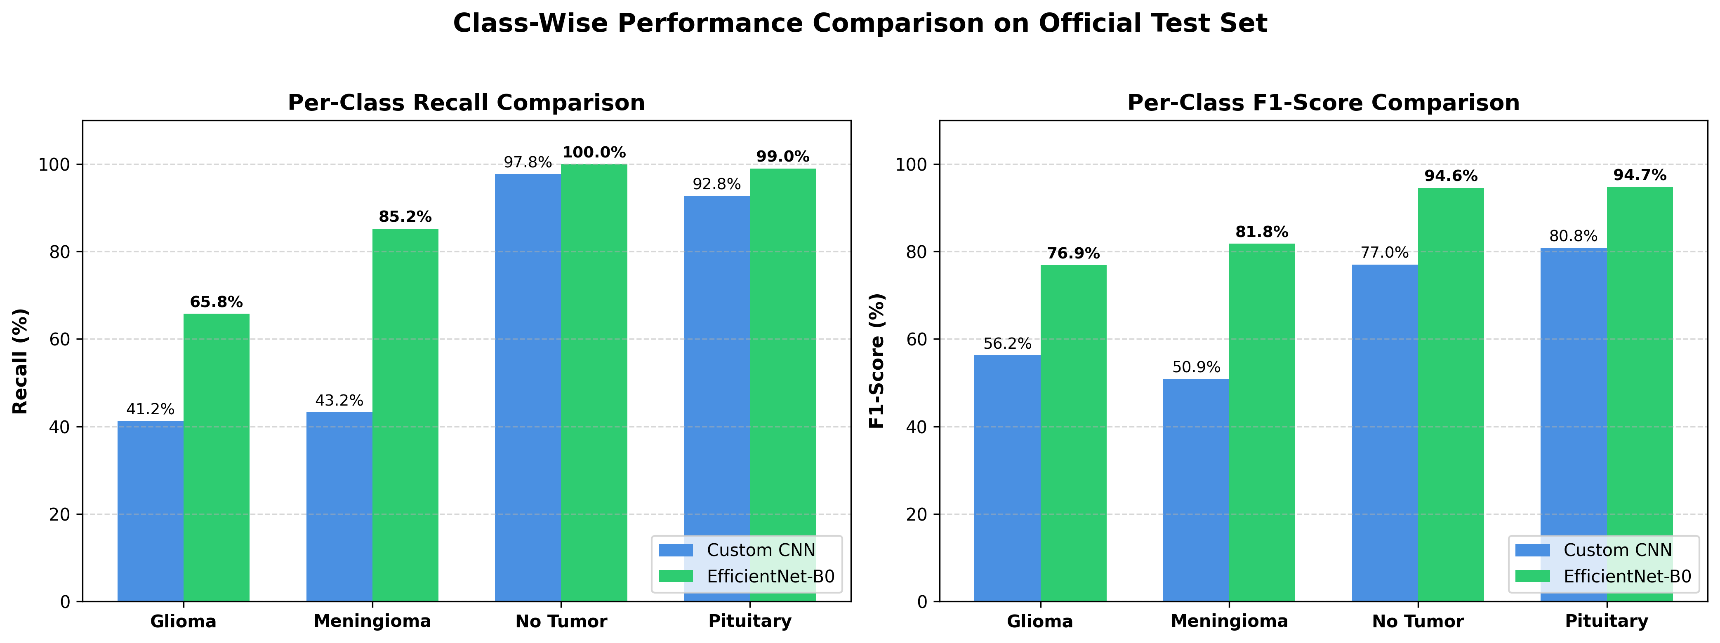
Figure 5.4: Class-Wise Performance Metrics (Recall and F1-Score) on Official Test Partition.
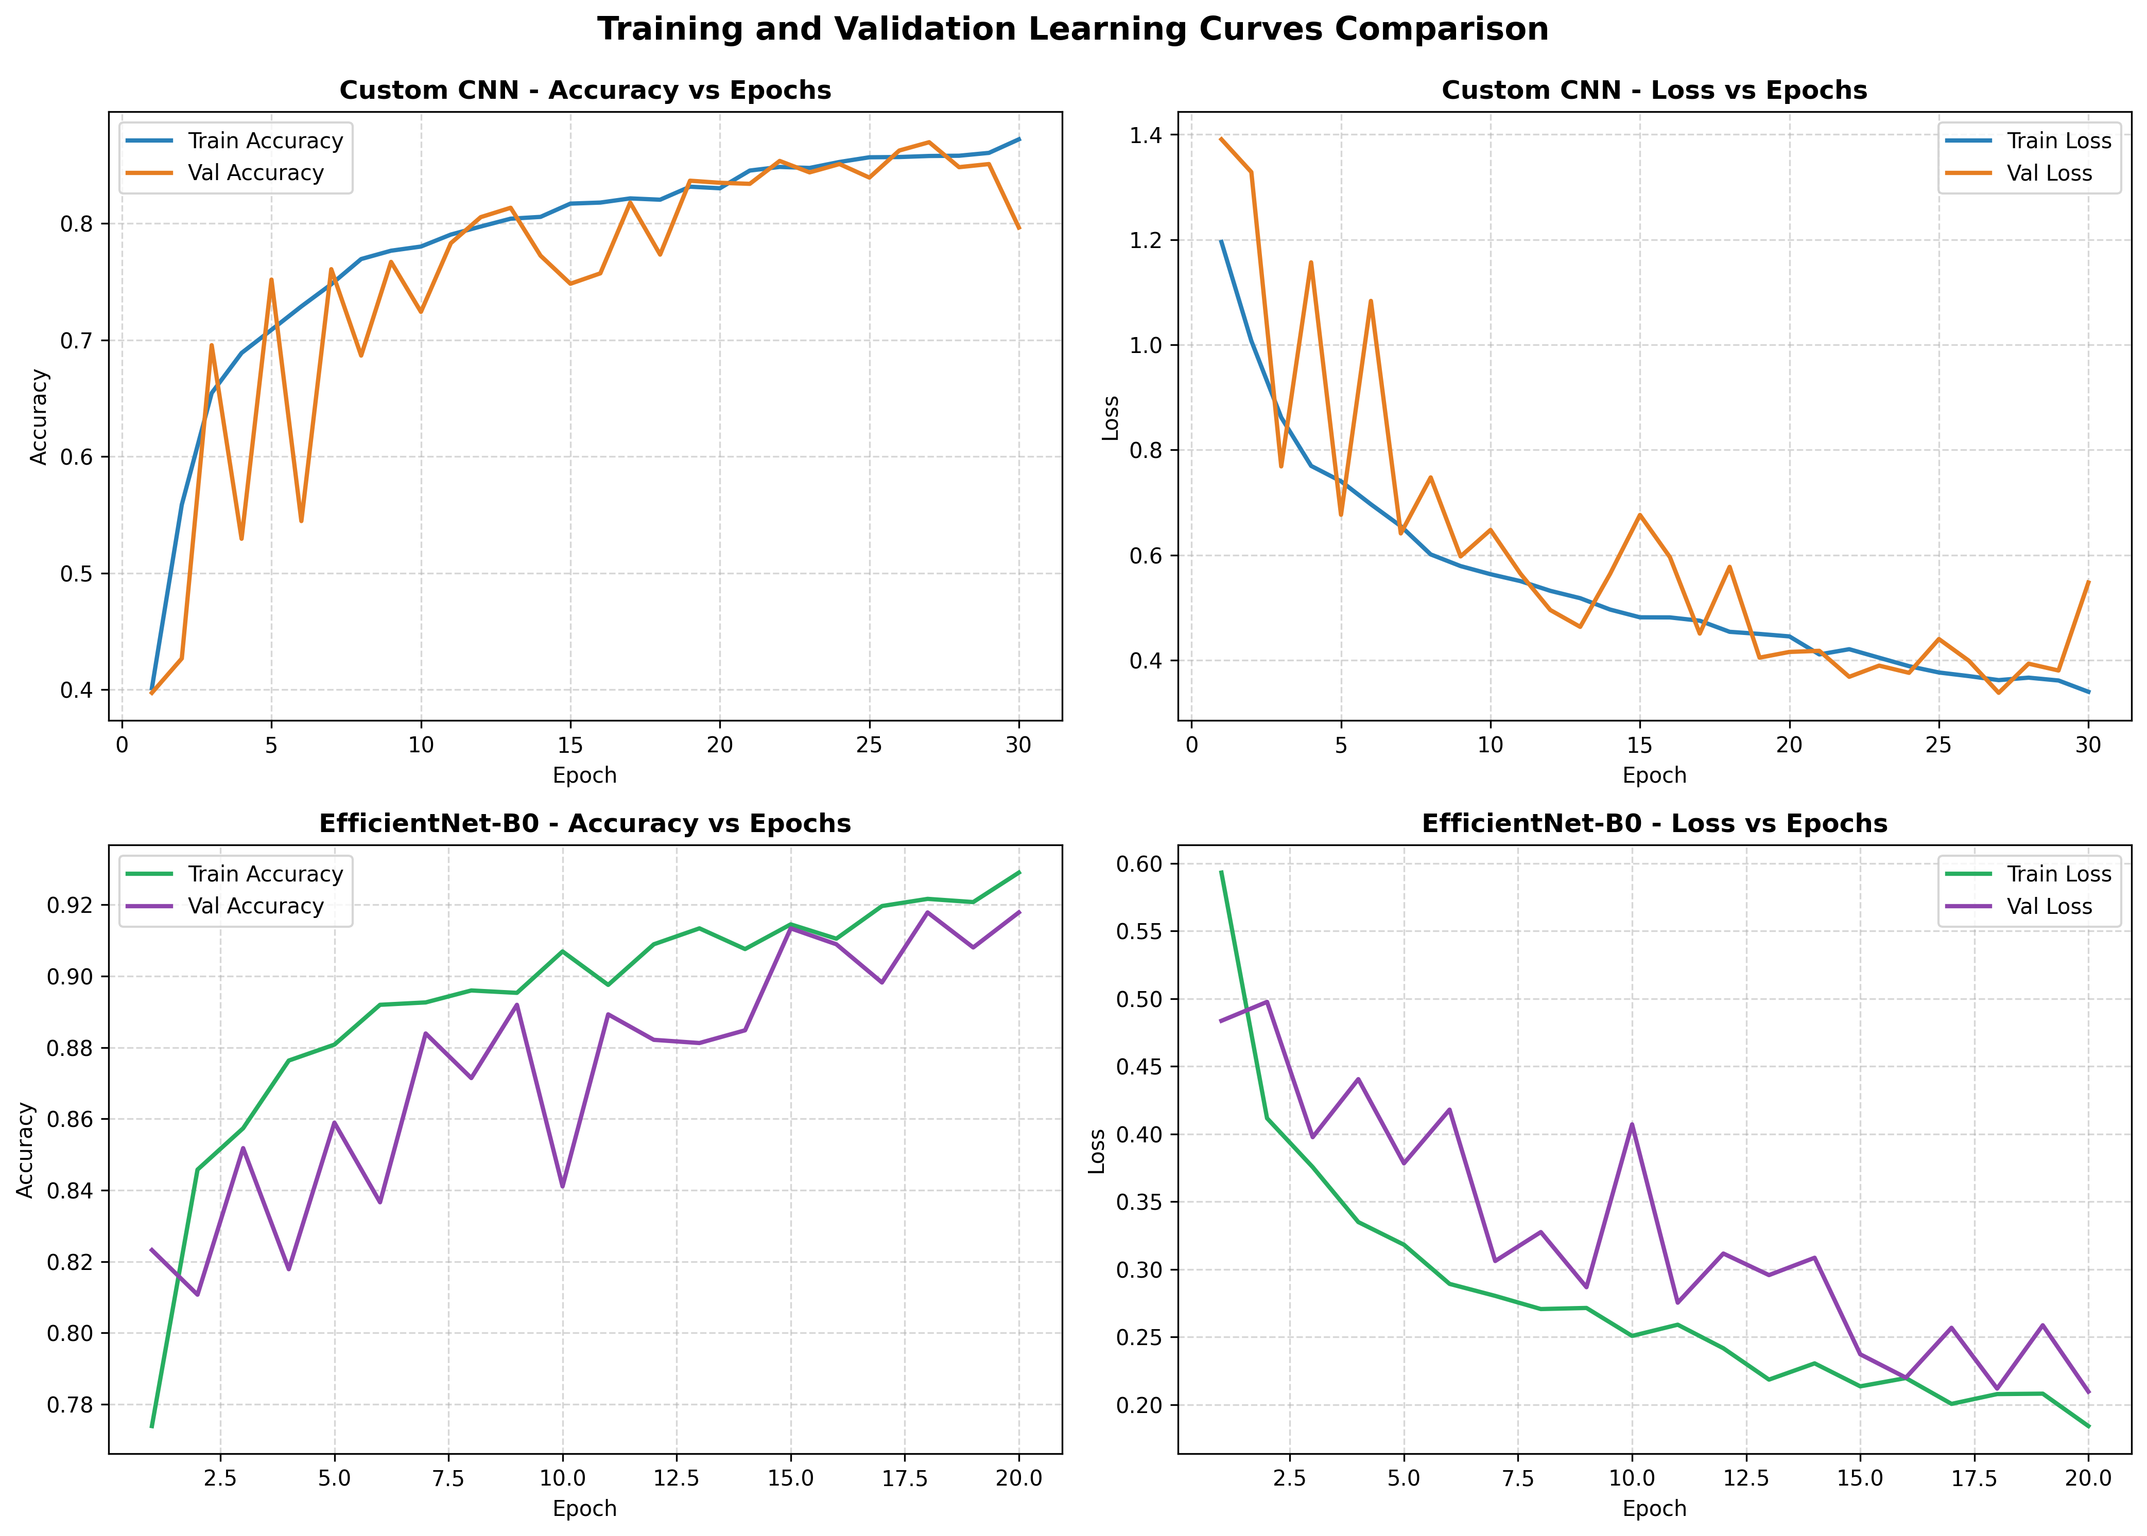
Figure 5.5: Training and Validation Learning Curves Over Epochs for CNN Baseline and EfficientNet-B0.
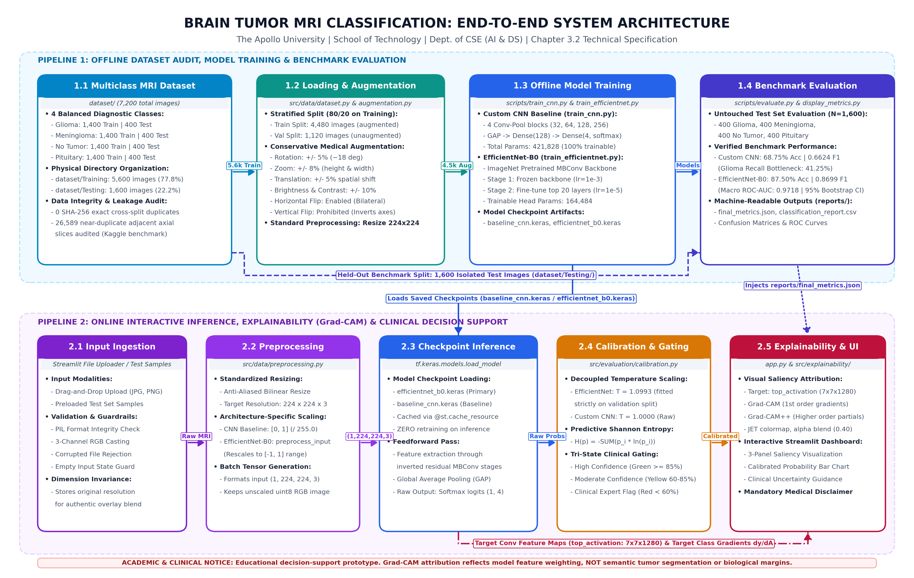
Figure 3.1: Proposed End-to-End System Architecture for Brain Tumor MRI Classification.
Figure 3.2: Operational Workflow Diagram of the Classification and Explainability Pipeline.
Figure 5.1: Live Streamlit Application Prediction Interface Showing Calibrated Probability & Saliency.
Figure 5.2: Explainable AI Saliency Heatmaps (Grad-CAM & Grad-CAM++) Across All Four Diagnostic Classes.
Figure 5.3: Test Set Confusion Matrix Comparison Between Custom CNN and EfficientNet-B0 (N = 1,600).
Figure 5.4: Class-Wise Performance Metrics (Recall and F1-Score) on Official Test Partition.
Figure 5.5: Training and Validation Learning Curves Over Epochs for CNN Baseline and EfficientNet-B0.

