VIRTUAL DATA SCIENCE WITH PYTHON TRAINEE
WEEK 2 – EXPLORATORY DATA ANALYSIS AND VISUALIZATION
UCI Adult / Census Income Dataset

Item | Details
Candidate Name | Lakshman Rao Mude
Internship | Virtual Data Science with Python Trainee
Task | WEEK 2 – Exploratory data analysis and visualization
Dataset Source | UCI Machine Learning Repository
Dataset | Adult (Census Income)
Tools | Python, Pandas, NumPy, Matplotlib, Seaborn, Jupyter Notebook
Deliverable | Submission-ready Word report

1. Executive Summary
This report presents the Exploratory Data Analysis (EDA) and visualization work completed during Week 2 of the Virtual Data Science with Python internship. The primary objective of this task was to analyze a real-world public dataset, understand its structure and characteristics, identify important patterns, examine relationships between variables, detect potential outliers, and communicate findings through effective visualizations.
The UCI Adult Income dataset was selected for this analysis. The dataset contains demographic, educational, occupational, and employment-related information along with an income classification target. The analysis used Python libraries including Pandas for data manipulation, NumPy for numerical processing, Matplotlib and Seaborn for visualization.
Before performing EDA, the raw feature and target datasets were prepared and aligned. Missing categorical values were handled, income labels were normalized, and duplicate complete records were removed. The resulting EDA-ready dataset contained 48,789 records and 15 columns. The final validation confirmed zero missing values and zero duplicate rows.
The exploratory analysis examined income distribution, age, education, work class, working hours, gender, marital status, occupations, capital gains, and relationships between numerical variables. Fifteen visualizations were created to communicate these patterns.
The analysis showed that approximately 76.06% of individuals belong to the <=50K income group, while 23.94% belong to the >50K group. Education demonstrated a strong relationship with income, with higher-income proportions being particularly high among individuals with Doctorate, Prof-school, and Master's education. Gender and marital status also showed noticeable differences in income distribution.
Overall, this project demonstrates how EDA can transform a raw dataset into meaningful insights that can support later statistical analysis and machine learning tasks.

2. Introduction
Exploratory Data Analysis is one of the most important stages of a data science project. Before developing predictive models, analysts need to understand the data, identify its structure, examine distributions, discover relationships, and detect unusual observations.
The purpose of EDA is not simply to create charts. It is a systematic process of asking questions about the dataset and using statistical summaries and visualizations to answer those questions.
For this project, the UCI Adult Income dataset was selected because it contains a combination of numerical and categorical variables. This makes it suitable for demonstrating several important EDA techniques.
The analysis focuses on understanding how demographic and employment characteristics vary across income groups.

3. Task Objective
The objectives of Week 2 were:
- Select a suitable public dataset.
- Prepare an analysis-ready dataset.
- Perform exploratory data analysis using Python.
- Calculate descriptive statistics.
- Analyze numerical and categorical variables.
- Examine income distribution.
- Study relationships between education and income.
- Study relationships between age and income.
- Study working hours and income.
- Analyze gender and income differences.
- Analyze marital status and income.
- Examine correlations between numerical variables.
- Identify potential outliers.
- Analyze occupation frequencies.
- Create meaningful and properly labelled visualizations.
- Interpret the findings.
- Document the complete analytical process.

4. Dataset Description
The dataset used in this project is the UCI Adult Income Dataset, commonly known as the Census Income dataset.
The dataset contains information about individuals including:
- Age
- Workclass
- Final weight (fnlwgt)
- Education
- Education number
- Marital status
- Occupation
- Relationship
- Race
- Sex
- Capital gain
- Capital loss
- Hours worked per week
- Native country
- Income
The target variable is income, which contains two main categories:
- <=50K
- >50K
The dataset is useful for studying relationships between demographic and employment characteristics and income classification.

5. Data Preparation for EDA
The Week 1 preprocessing process produced a cleaned feature dataset. However, the Week 2 analysis required careful alignment between the feature data and target variable.
The initial cleaned feature dataset contained:
48,784 rows × 14 columns
while the original target dataset contained:
48,842 rows × 1 column
The difference occurred because duplicate feature records had previously been removed during the Week 1 cleaning process.
Therefore, for Week 2, the original raw features were reloaded so that the feature and target rows could be aligned correctly.
The Week 2 preparation process then performed the following operations:
- Reloaded the original feature data.
- Loaded the target variable.
- Converted missing-value indicators into missing values.
- Handled missing categorical values.
- Normalized income labels.
- Combined the feature and target datasets.
- Removed complete duplicate records.
- Validated the final dataset.

6. Data Preparation Results
The preparation process produced the following results:
Metric | Result
Initial raw feature records | 48,842
Initial target records | 48,842
Missing values before treatment | 6,465
Missing values after treatment | 0
Duplicate complete records removed | 53
Final records | 48,789
Final columns | 15
Final missing values | 0
Final duplicate rows | 0
The final dataset was saved as:
Week-2/data/adult_eda_ready.csv

7. Final Dataset Structure
The final EDA-ready dataset contains 48,789 records and 15 columns.
Numerical Variables
The numerical variables are:
- age
- fnlwgt
- education-num
- capital-gain
- capital-loss
- hours-per-week
Categorical Variables
The categorical variables are:
- workclass
- education
- marital-status
- occupation
- relationship
- race
- sex
- native-country
- income

8. Dataset Validation
The final validation produced:
Shape: (48789, 15)
Missing values: 0
Duplicate rows: 0
This confirms that the dataset was successfully prepared for exploratory analysis.
The target distribution was also checked.
<=50K 37108
>50K 11681
The data preparation stage therefore produced a consistent and analysis-ready dataset.

9. Descriptive Statistics
The major numerical variables were analyzed using descriptive statistics.
Variable | Mean | Minimum | Maximum
Age | 38.65 | 17 | 90
fnlwgt | 189,669.66 | 12,285 | 1,490,400
Education Number | 10.08 | 1 | 16
Capital Gain | 1,080.24 | 0 | 99,999
Capital Loss | 87.60 | 0 | 4,356
Hours per Week | 40.43 | 1 | 99
The average age is approximately 38.65 years, while the average number of working hours is approximately 40.43 hours per week.

10. Income Distribution
The income variable is the primary target variable.
The distribution is:
Income Group | Count | Percentage
<=50K | 37,108 | 76.06%
>50K | 11,681 | 23.94%
Total | 48,789 | 100%
Interpretation
The dataset is clearly imbalanced toward the <=50K category.
Approximately three-fourths of the observations belong to the lower-income category, while approximately one-fourth belong to the higher-income category.
This imbalance is important if the dataset is later used for classification modelling because model evaluation should consider metrics beyond simple accuracy.
Visualization

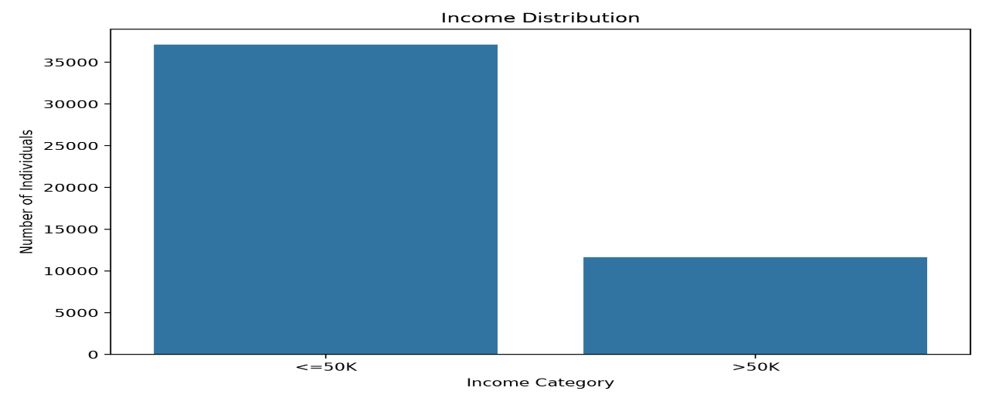
11. Age Distribution
The age variable was analyzed to understand the demographic distribution of the dataset.
Key statistics:
- Mean age: 38.65 years
- Median age: 37 years
- Minimum age: 17 years
- Maximum age: 90 years
- Standard deviation: 13.71 years
Interpretation
Most observations are concentrated around working-age adults. The distribution extends from young adults to individuals aged 90.
The difference between the mean and median is relatively small, indicating that the central distribution is reasonably balanced, although older observations create a longer upper tail.
Visualization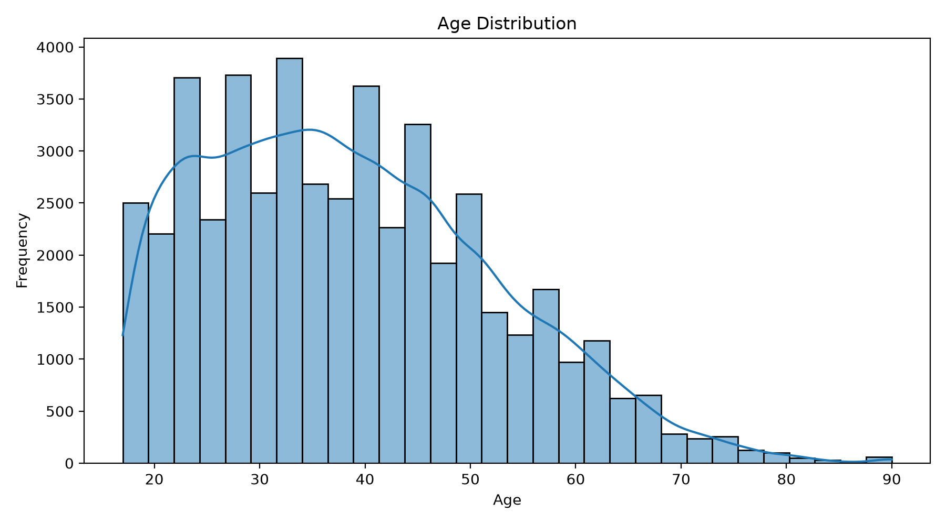
12. Education Distribution
Education is an important categorical variable in the dataset.
The most common education categories were:
Education | Count
HS-grad | 15,770
Some-college | 10,862
Bachelors | 8,013
Masters | 2,656
Assoc-voc | 2,060
11th | 1,812
Assoc-acdm | 1,601
Interpretation
HS-grad is the most common educational category, followed by Some-college and Bachelors.
The dataset contains education levels ranging from Preschool to Doctorate.
Visualization

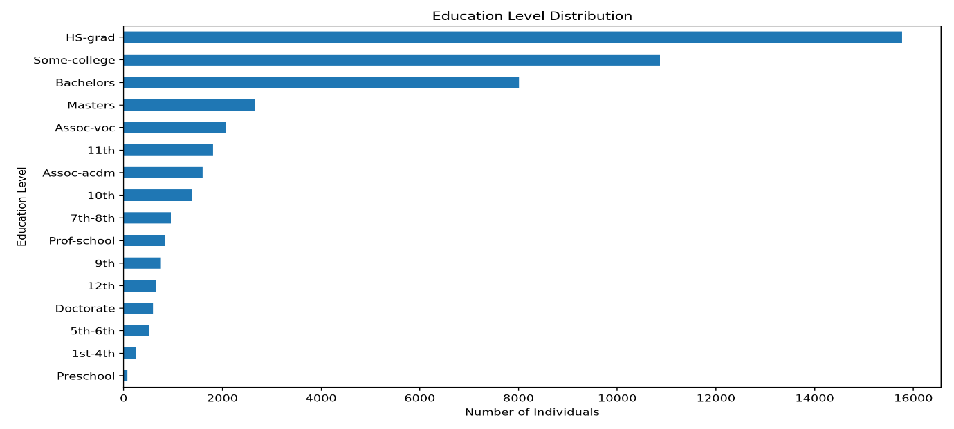
13. Work class Distribution
The workclass variable describes the employment sector.
The largest categories were:
Workclass | Count
Private | 36,654
Self-emp-not-inc | 3,861
Local-gov | 3,136
State-gov | 1,981
Self-emp-inc | 1,694
Federal-gov | 1,432
Interpretation
The Private sector represents the majority of observations.
Government employment and self-employment represent smaller portions of the dataset.
Visualization
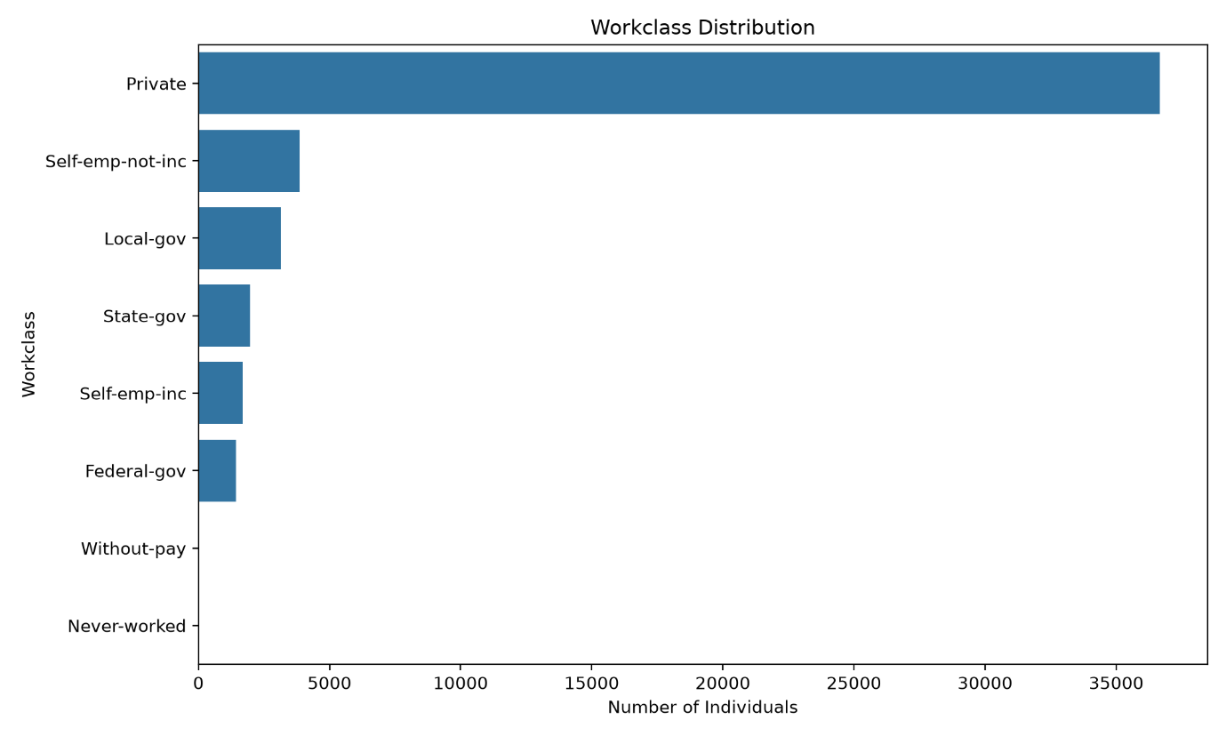

14. Hours Worked Per Week
The hours-per-week variable was examined to understand working patterns.
Statistics:
- Mean: 40.43 hours
- Median: 40 hours
- Minimum: 1 hour
- Maximum: 99 hours
- Standard deviation: 12.39 hours
Interpretation
The median working time is exactly 40 hours per week, indicating that the standard full-time work schedule is highly represented.
However, the range from 1 to 99 hours indicates substantial variation among individuals.
Visualization

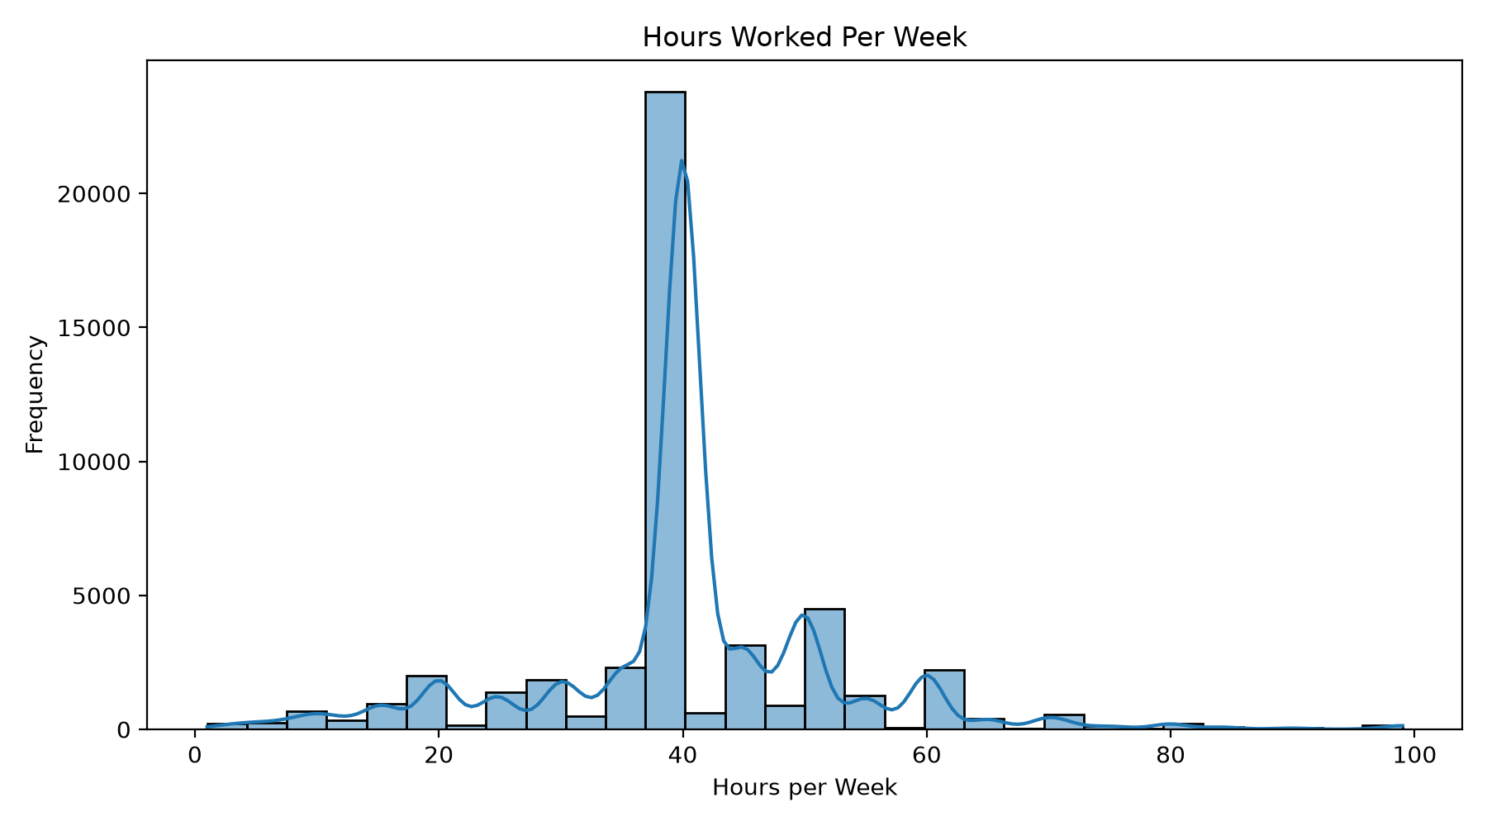
15. Age vs Income
The relationship between age and income was investigated.
Interpretation
Income groups show differences across age ranges. Higher-income observations become more prominent among many middle-aged individuals compared with younger workers.
Age alone does not determine income, but the analysis indicates that age may contain useful information for income classification.
Visualization
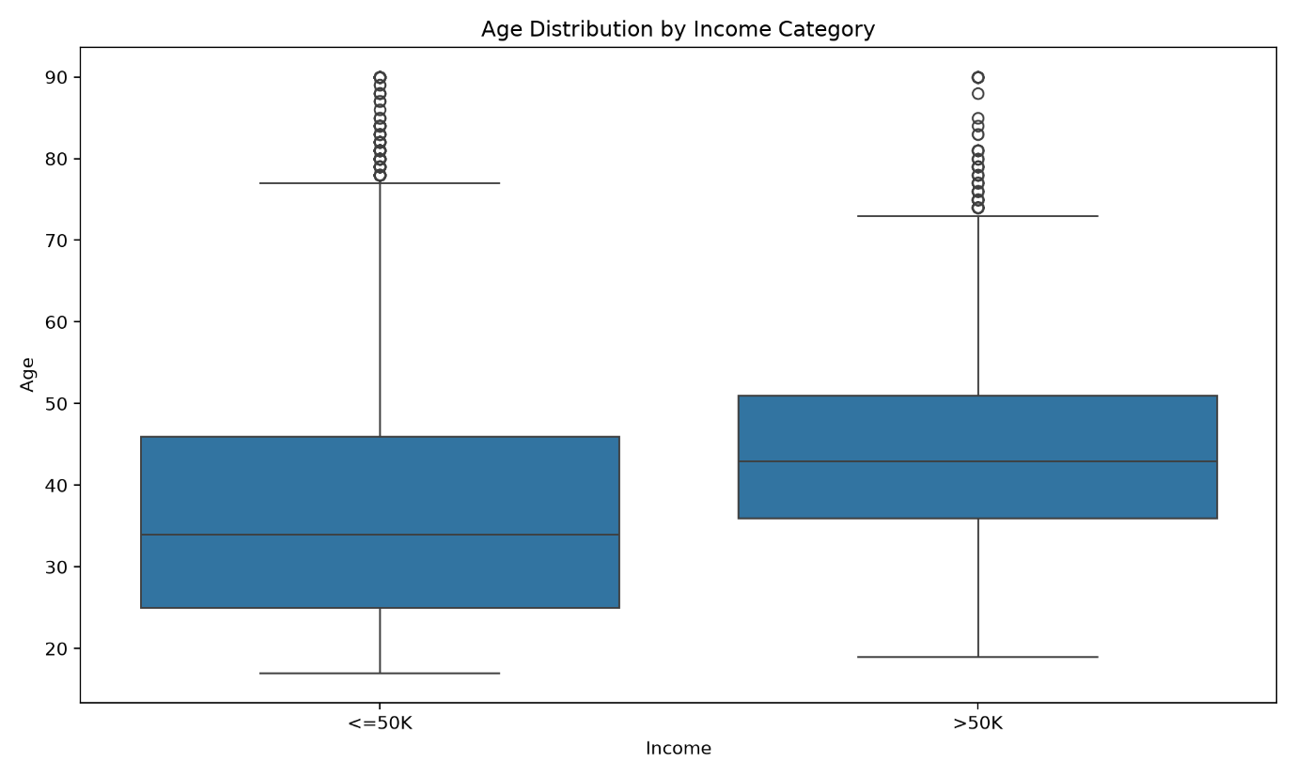

16. Education vs Income
Education showed one of the strongest relationships with income.
The percentage distribution was:
Education | <=50K | >50K
10th | 93.74% | 6.26%
11th | 94.92% | 5.08%
12th | 92.67% | 7.33%
1st-4th | 96.73% | 3.27%
5th-6th | 94.67% | 5.33%
7th-8th | 93.50% | 6.50%
9th | 94.58% | 5.42%
Assoc-acdm | 74.20% | 25.80%
Assoc-voc | 74.66% | 25.34%
Bachelors | 58.68% | 41.32%
Doctorate | 27.44% | 72.56%
HS-grad | 84.14% | 15.86%
Masters | 45.07% | 54.93%
Prof-school | 26.02% | 73.98%
Some-college | 81.03% | 18.97%
Interpretation
A strong pattern can be observed between educational attainment and income.
Individuals with higher educational qualifications have considerably larger proportions of observations in the >50K income category.
For example:
- Doctorate: 72.56% >50K
- Prof-school: 73.98% >50K
- Masters: 54.93% >50K
- Bachelors: 41.32% >50K
In comparison, most lower educational categories have much smaller proportions of individuals earning above $50K.
This suggests that education is an important explanatory variable for income classification.

Visualization

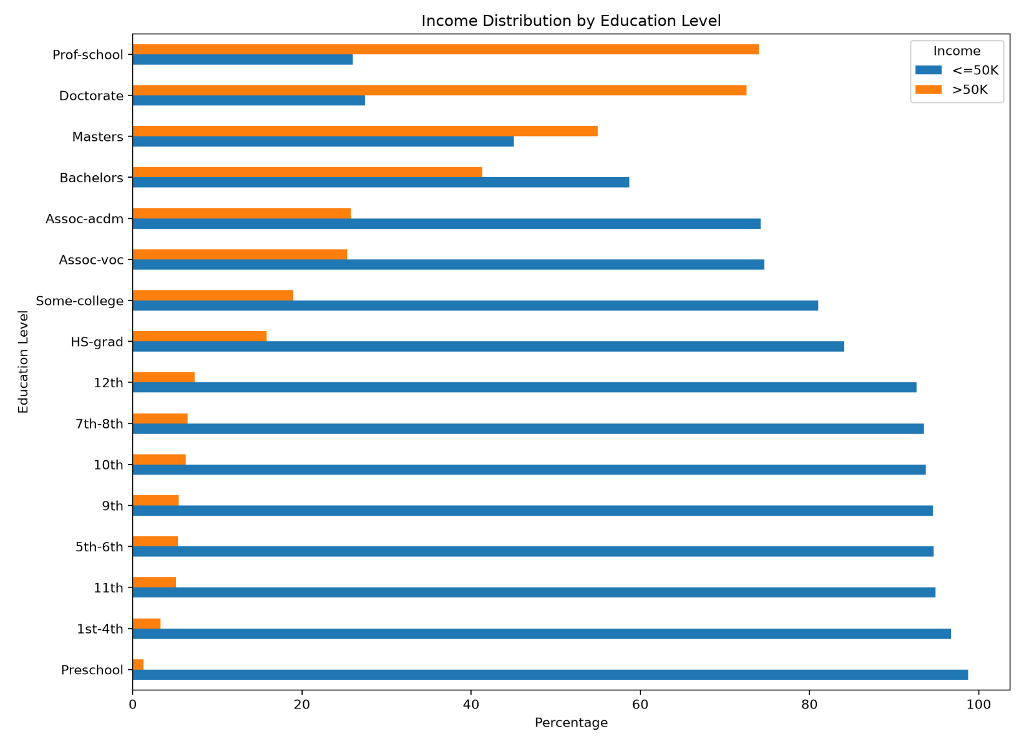
17. Hours Worked vs Income
Working hours were compared with income groups.
Interpretation
Working hours show some differences between income categories, although the relationship is not as strong as education.
Working longer hours may be associated with higher income for some individuals, but hours worked alone are insufficient to explain income.
Other variables such as occupation, education, age, and workclass must also be considered.
Visualization
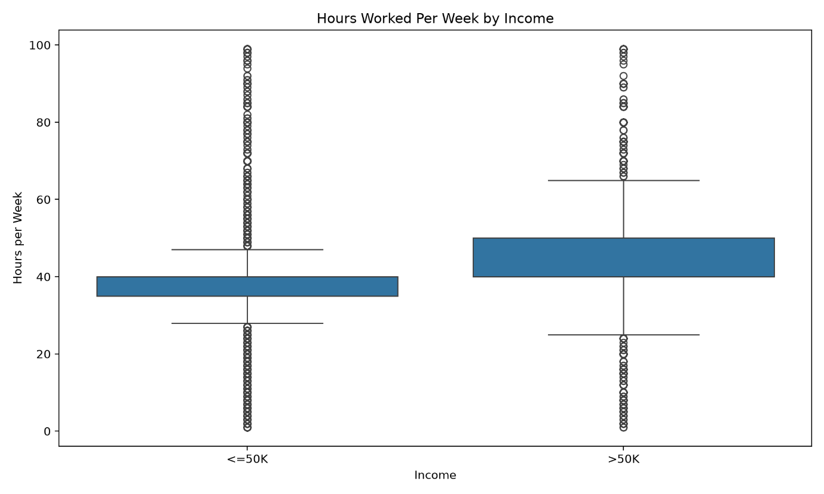
18. Sex vs Income
Income distribution was compared across gender categories.
Sex | <=50K | >50K
Female | 89.06% | 10.94%
Male | 69.61% | 30.39%
Interpretation
The analysis shows a noticeable difference in income distribution between the two groups represented in the dataset.
The proportion of >50K observations is considerably higher among males than females in this dataset.
This is an observed statistical association in the dataset and should not be interpreted as a causal relationship.
Visualization
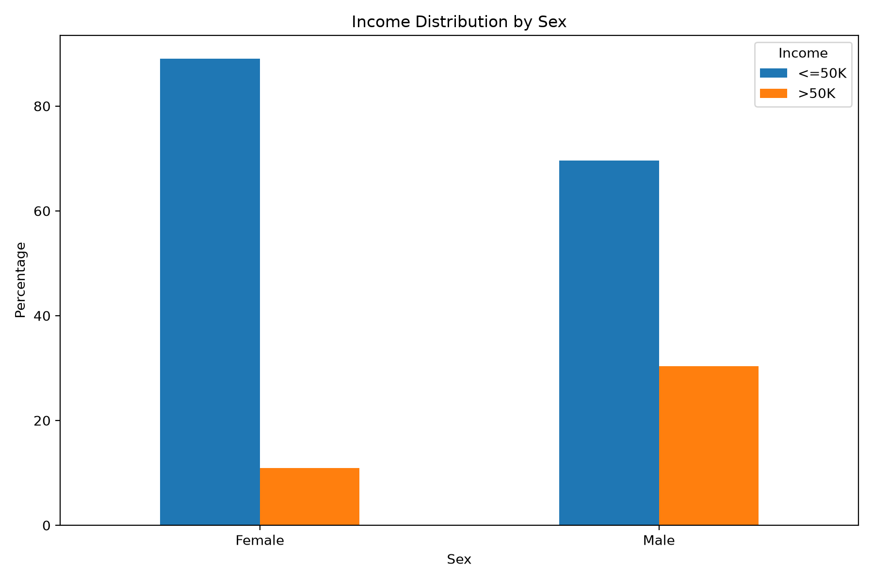
19. Marital Status vs Income
Marital status also showed differences in income distribution.
Marital Status | <=50K | >50K
Divorced | 89.88% | 10.12%
Married-AF-spouse | 62.16% | 37.84%
Married-civ-spouse | 55.39% | 44.61%
Married-spouse-absent | 90.75% | 9.25%
Never-married | 95.44% | 4.56%
Separated | 93.53% | 6.47%
Widowed | 91.57% | 8.43%
Interpretation
The Married-civ-spouse group has the highest proportion of observations above $50K among the listed categories at 44.61%.
The Never-married group has a much lower proportion of observations above $50K at 4.56%.
Again, these are associations in the dataset rather than evidence of causation.
Visualization
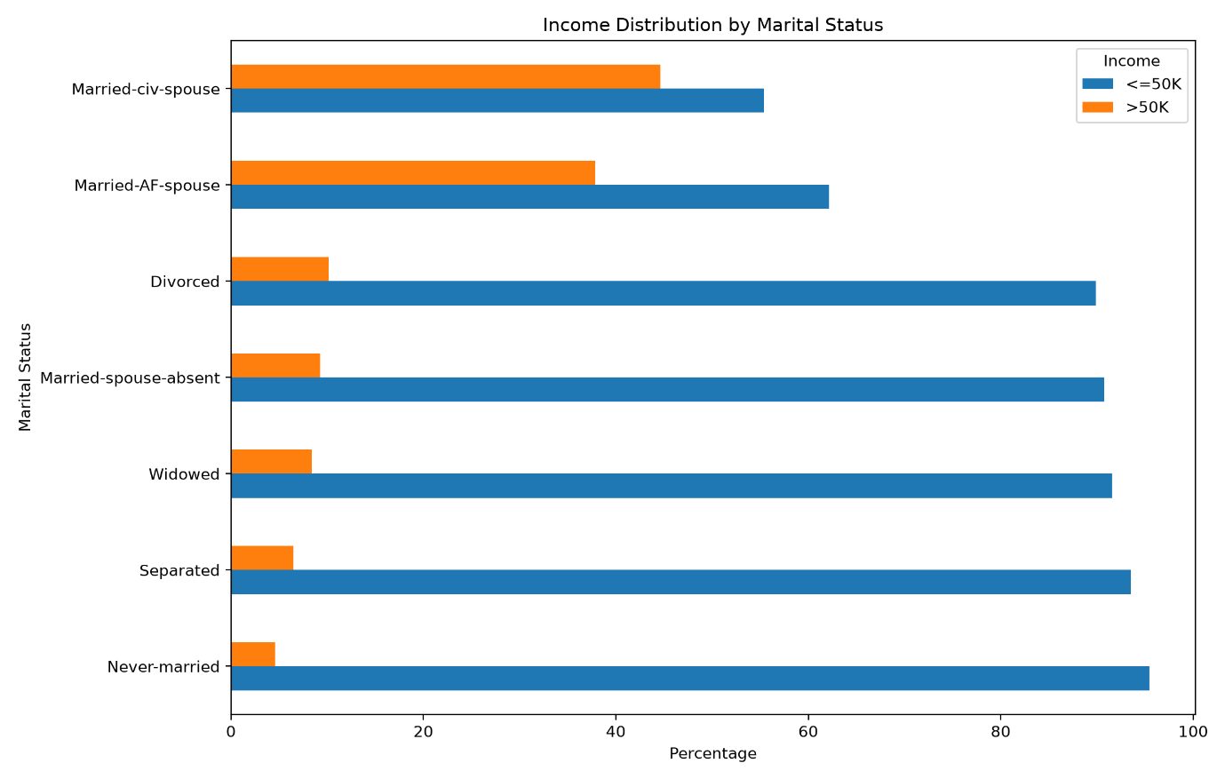

20. Correlation Analysis
A correlation matrix was generated for the numerical variables.
Important correlations included:
Variable Pair | Correlation
Education-num & Hours-per-week | 0.144
Education-num & Capital-gain | 0.125
Age & Capital-gain | 0.077
Capital-gain & Hours-per-week | 0.082
Capital-loss & Education-num | 0.081
Interpretation
Most numerical variables have relatively weak linear correlations with one another.
The highest observed correlation was between education-num and hours-per-week, at approximately 0.144, which is still relatively weak.
This indicates that income-related patterns cannot be understood solely through simple pairwise numerical correlations. Categorical variables and nonlinear relationships are also important.
Visualization
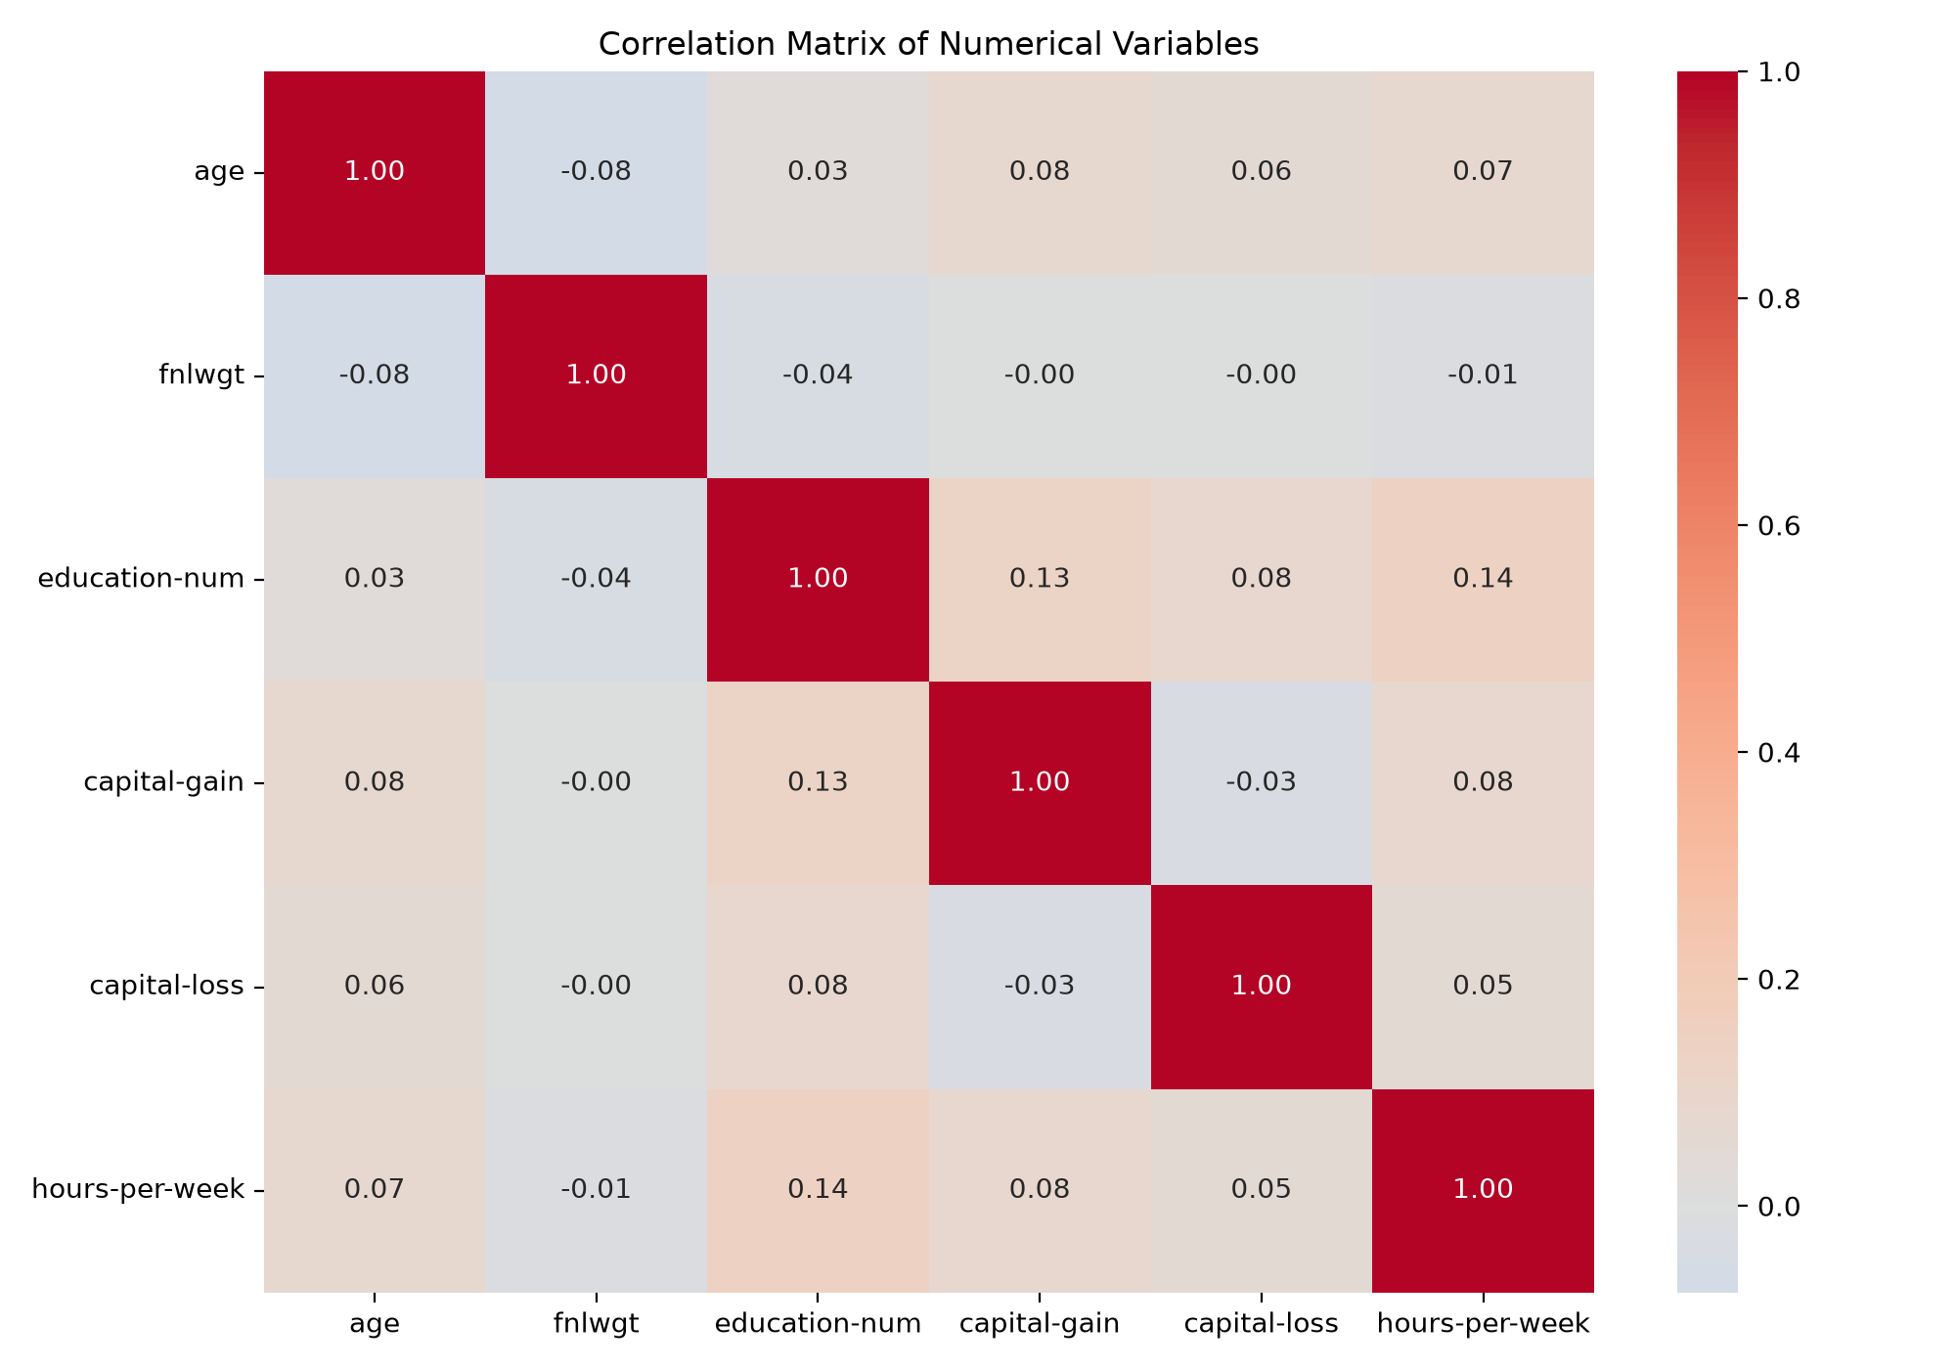
21. Capital Gain Distribution
Capital gain was analyzed separately because the variable contains many zero values and a small number of very large values.
Statistics:
- Mean: 1,080.24
- Median: 0
- Maximum: 99,999
Interpretation
The large difference between the mean and median indicates a highly skewed distribution.
Most observations have zero capital gain, while a relatively small number of observations have substantial capital gains.
This type of distribution should be considered carefully during statistical modelling.
Visualization
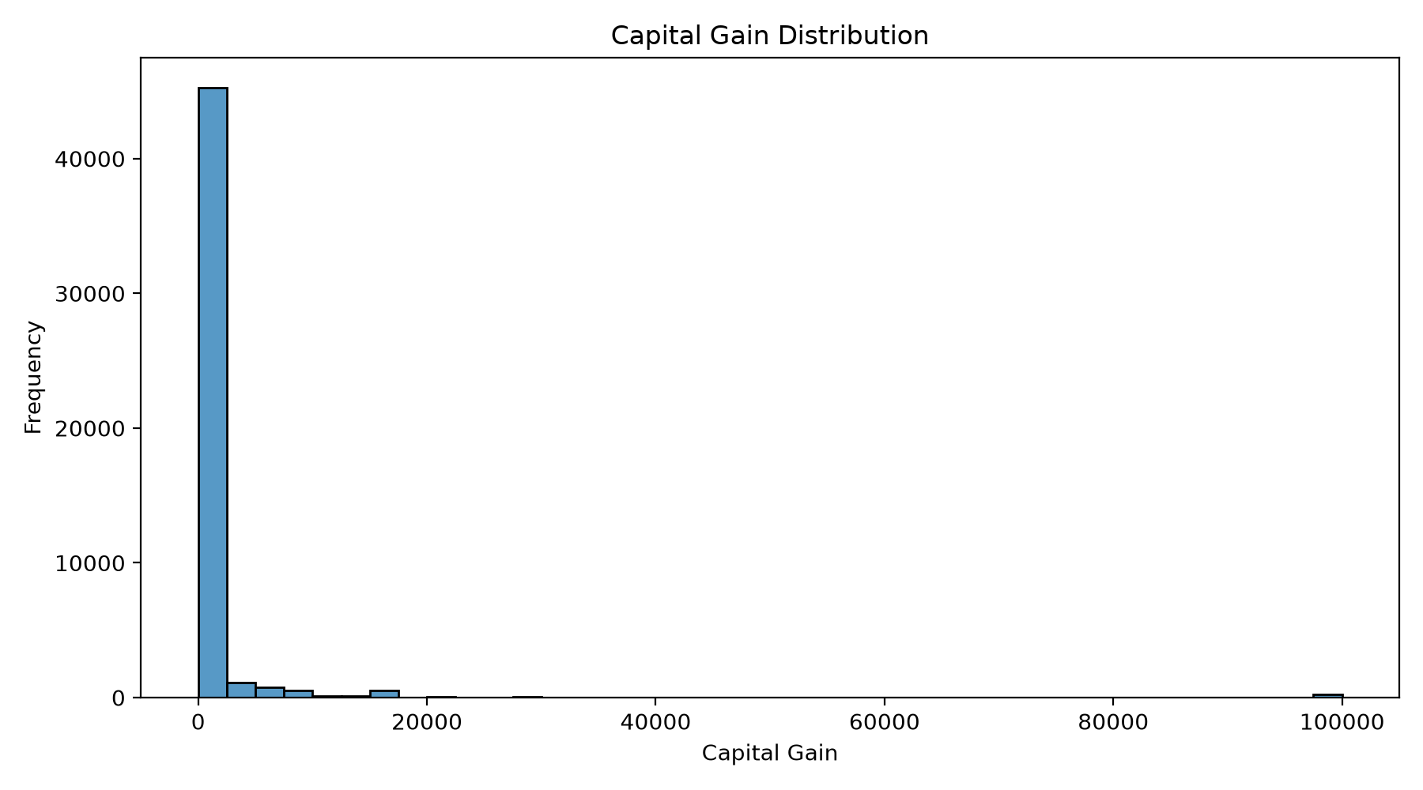
22. Outlier Analysis – Age
The Interquartile Range (IQR) approach was used to identify potential outliers.
For age:
- Lower boundary: approximately -2
- Upper boundary: approximately 78
- Potential outliers: 215
Since a negative age is not meaningful, the lower boundary does not represent realistic observations.
The potential upper outliers are observations above approximately 78 years.
Interpretation
These observations should not automatically be deleted because they may represent valid individuals in the dataset.
Outlier detection should therefore be used as an investigation tool rather than an automatic deletion mechanism.
Visualization
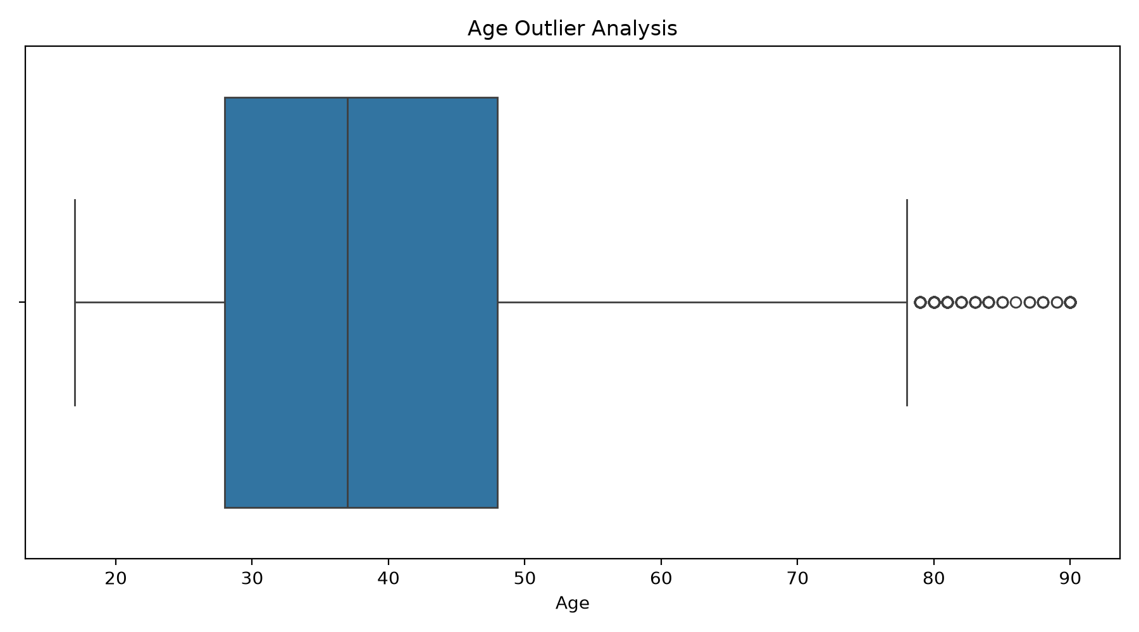
23. Outlier Analysis – Hours per Week
For hours worked per week:
- Lower IQR boundary: 32.5
- Upper IQR boundary: 52.5
- Potential outliers: 13,486
Interpretation
A large number of observations fall outside the traditional IQR boundaries.
However, values outside the IQR range are not necessarily errors. Individuals can legitimately work fewer than 32.5 hours or more than 52.5 hours per week.
Therefore, the analysis treats these as potential statistical outliers rather than invalid records.
Visualization
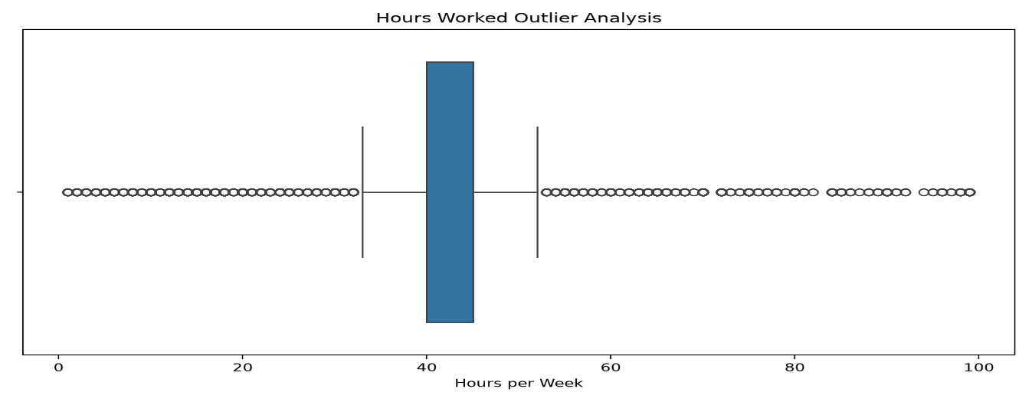
24. Top Occupations
The ten most common occupations were identified.
Rank | Occupation | Count
1 | Prof-specialty | 8,969
2 | Craft-repair | 6,102
3 | Exec-managerial | 6,082
4 | Adm-clerical | 5,606
5 | Sales | 5,501
6 | Other-service | 4,919
7 | Machine-op-inspct | 3,017
8 | Transport-moving | 2,355
9 | Handlers-cleaners | 2,071
10 | Farming-fishing | 1,485
Interpretation
Prof-specialty is the most frequently represented occupation with 8,969 observations.
The occupation distribution provides useful information about the workforce represented in the dataset and may be an important feature for future income prediction.
Visualization
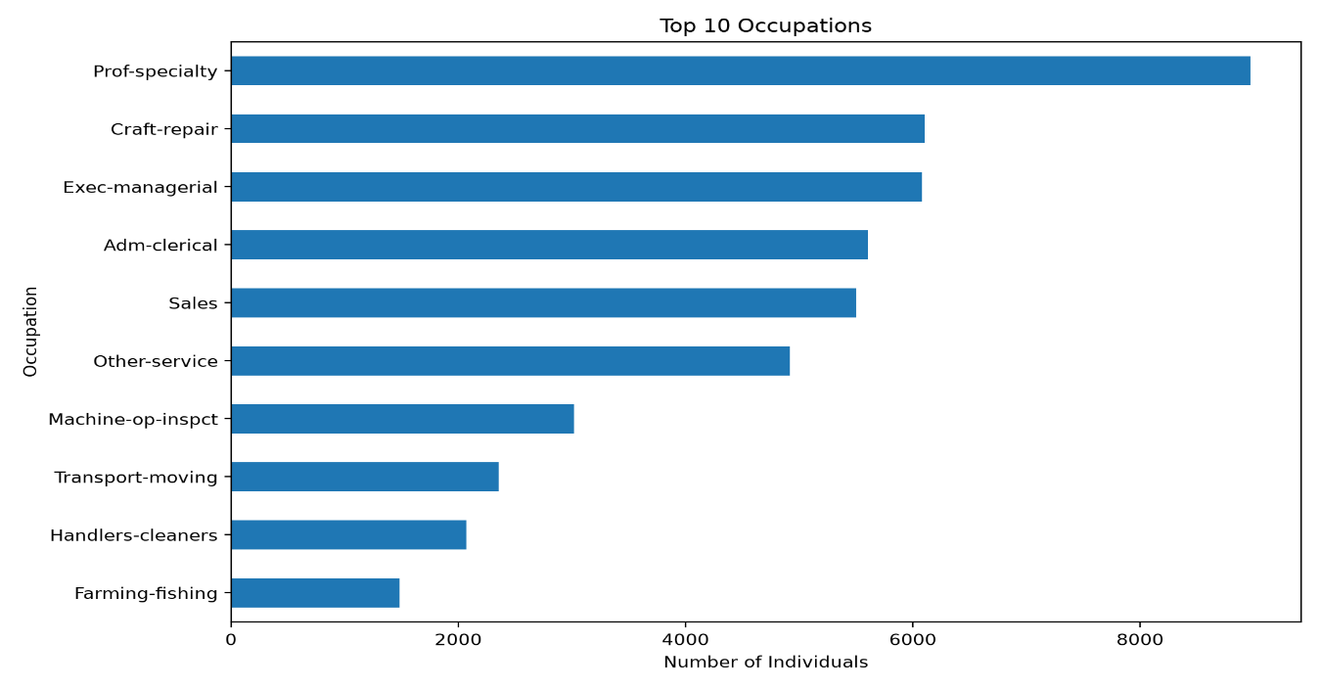
25. Key EDA Findings
The major findings from the analysis are summarized below.
Finding 1 – Income Imbalance
The dataset contains considerably more observations in the <=50K category.
- <=50K: 76.06%
- 50K: 23.94%
Finding 2 – Education is Strongly Associated with Income
Higher educational qualifications show substantially larger proportions of individuals earning above $50K.
Doctorate and professional-school categories have particularly high >50K proportions.
Finding 3 – Private Sector Dominates
The Private workclass contains 36,654 observations, making it by far the largest employment category.
Finding 4 – Typical Working Week
The median working time is 40 hours per week, with an average of 40.43 hours.
Finding 5 – Age
The average age is 38.65 years, with observations ranging from 17 to 90 years.
Finding 6 – Gender Differences
The income distribution differs considerably between male and female observations.
Finding 7 – Marital Status
Marital status also demonstrates noticeable differences in income distribution.
Finding 8 – Numerical Correlations are Mostly Weak
The numerical correlation matrix shows generally weak linear relationships.
Finding 9 – Capital Gain is Highly Skewed
Most observations have zero capital gains, while a small number have very high values.
Finding 10 – Potential Outliers Require Context
Statistical outliers were identified in age, hours, capital gain, capital loss, and other numerical variables. These observations should not automatically be removed without understanding their meaning.

26. Python Libraries Used
The project used the following Python libraries:
Pandas
Used for:
- Reading datasets
- Data cleaning
- Grouping
- Aggregation
- Statistical summaries
- Data transformation
NumPy
Used for:
- Numerical operations
- Missing-value handling
- Array operations
Matplotlib
Used for:
- Histograms
- Bar charts
- Distribution plots
- Comparison plots
Seaborn
Used for:
- Statistical visualization
- Categorical comparisons
- Correlation heatmaps

27. Python Code – Loading the Dataset
import pandas as pd
import numpy as np
import matplotlib.pyplot as plt
import seaborn as sns

df = pd.read_csv(
"Week-2/data/adult_eda_ready.csv"
)

print(df.shape)
print(df.head())
This code loads the prepared EDA dataset and displays its dimensions and first few records.

28. Python Code – Dataset Validation
print("Shape:", df.shape)

print("Missing values:")
print(df.isnull().sum().sum())

print("Duplicate rows:")
print(df.duplicated().sum())

print("Data types:")
print(df.dtypes)
This validation confirms whether the dataset is suitable for further analysis.

29. Python Code – Descriptive Statistics
numeric_columns = [
"age",
"fnlwgt",
"education-num",
"capital-gain",
"capital-loss",
"hours-per-week"
]

print(df[numeric_columns].describe())
The describe() function generates statistics including count, mean, standard deviation, minimum, quartiles, and maximum.

30. Python Code – Income Distribution
income_counts = df["income"].value_counts()

print(income_counts)

income_percentage = (
df["income"]
.value_counts(normalize=True)
.mul(100)
.round(2)
)

print(income_percentage)
This code calculates both the number and percentage of observations in each income category.

31. Python Code – Education vs Income
education_income = pd.crosstab(
df["education"],
df["income"],
normalize="index"
) * 100

print(education_income.round(2))
This creates a percentage-based cross-tabulation showing income distribution within each education category.

32. Python Code – Correlation Analysis
numeric_df = df.select_dtypes(
include=["int64", "float64"]
)

correlation = numeric_df.corr()

print(correlation)
The correlation matrix is useful for identifying linear relationships between numerical variables.

33. Python Code – Outlier Detection
The Interquartile Range method can be used to identify potential outliers.
Q1 = df["age"].quantile(0.25)
Q3 = df["age"].quantile(0.75)

IQR = Q3 - Q1

lower = Q1 - 1.5 * IQR
upper = Q3 + 1.5 * IQR

outliers = df[
(df["age"] < lower) |
(df["age"] > upper)
]

print("Number of outliers:", len(outliers))
The same technique can be applied to other numerical variables.

34. Python Code – Visualization
Example of an income distribution chart:
plt.figure(figsize=(8, 5))

sns.countplot(
data=df,
x="income"
)

plt.title("Income Distribution")
plt.xlabel("Income Group")
plt.ylabel("Number of Individuals")

plt.tight_layout()
plt.show()
Visualization makes statistical patterns easier to communicate and interpret.

35. EDA Methodology
The overall EDA process followed this sequence:
Dataset Acquisition
↓
Data Preparation
↓
Data Validation
↓
Descriptive Statistics
↓
Univariate Analysis
↓
Bivariate Analysis
↓
Correlation Analysis
↓
Outlier Analysis
↓
Visualization
↓
Interpretation
↓
Key Findings
This structured approach ensures that the analysis progresses from basic understanding to deeper investigation.

36. Importance of Data Visualization
Visualization is an important part of exploratory analysis because numerical summaries alone may not reveal important patterns.
The visualizations created during this project helped identify:
- Income imbalance
- Age distribution
- Education concentration
- Workclass distribution
- Working-hour patterns
- Education-income relationships
- Age-income patterns
- Gender-income differences
- Marital-status differences
- Numerical correlations
- Capital-gain skewness
- Potential outliers
- Occupation concentration
Charts also make the analysis easier for non-technical stakeholders to understand.

37. Limitations of the Analysis
Although the EDA provides useful insights, several limitations should be considered.
- The analysis identifies associations rather than causation.
- The income distribution is imbalanced.
- Some variables contain highly skewed values.
- Statistical outliers may represent legitimate observations.
- Historical census data may not represent current economic conditions.
- Demographic variables require careful interpretation to avoid biased conclusions.
- Correlation does not imply causation.
- Further statistical testing would be required to establish the significance of observed relationships.

38. Future Scope
The analysis can be extended into a machine learning project.
Potential future steps include:
- Feature engineering
- Encoding categorical variables
- Feature scaling
- Train-test splitting
- Logistic Regression
- Decision Trees
- Random Forest
- Gradient Boosting
- Model comparison
- Hyperparameter tuning
- Cross-validation
- Precision, recall, and F1-score analysis
- ROC-AUC analysis
- Feature importance analysis
A future model could predict whether an individual belongs to the <=50K or >50K income category.

39. Conclusion
The Week 2 Exploratory Data Analysis project successfully demonstrated the practical application of Python-based data analysis techniques on the UCI Adult Income dataset.
The final EDA-ready dataset contained 48,789 records and 15 variables, with zero missing values and zero duplicate rows.
The analysis revealed several important patterns. The majority of observations belong to the <=50K income category. Education showed a particularly strong association with income, while age, occupation, workclass, gender, marital status, and working hours also provided useful analytical perspectives.
The correlation analysis showed that most numerical variables have relatively weak linear relationships, demonstrating why EDA should include both numerical and categorical analysis.Outlier analysis identified potentially unusual observations, but the results also demonstrated that statistical outliers are not necessarily data errors. Context is important when deciding whether observations should be removed or retained.
The fifteen visualizations created during the project effectively communicated the major patterns and supported the interpretation of the dataset.
Overall, this project strengthened practical skills in Pandas, NumPy, Matplotlib, Seaborn, descriptive statistics, categorical analysis, correlation analysis, outlier detection, and data visualization. The completed EDA provides a strong foundation for future predictive modelling and machine learning work.

