VIRTUAL DATA SCIENCE WITH PYTHON TRAINEE
WEEK 3 – UNSUPERVISED LEARNING AND CLUSTERING ANALYSIS
UCI Adult / Census Income Dataset

Item | Details
Candidate Name | Lakshman Rao Mude
Internship | Virtual Data Science with Python Trainee
Task | Week-3 Unsupervised Learning and Clustering Analysis
Dataset Source | UCI Machine Learning Repository
Dataset | UCI Adult Dataset
Tools | Pandas, NumPy, Scikit-learn, Matplotlib, Seaborn
Deliverable | Submission-ready Word report

1.Objective
The objective of this Week 3 task is to apply unsupervised learning techniques to a publicly available dataset and identify meaningful groups of observations without using a predefined target during cluster formation. The analysis focuses on clustering numerical characteristics of the UCI Adult dataset using K-Means and Hierarchical Clustering.
The project includes data preparation, feature selection, standardization, selection of an appropriate number of clusters, clustering model implementation, cluster visualization, cluster profiling, and interpretation of the resulting groups. Silhouette scores are used to evaluate cluster quality and compare different cluster configurations.
The analysis also examines the characteristics of the identified clusters using age, education, working hours, financial attributes, employment characteristics, gender, marital status, occupation, and income distribution
2.Dataset Description
The dataset used for this analysis is the UCI Adult dataset, which contains demographic, education, employment, and income-related information. The Week 2 EDA-ready dataset was used as the starting point for Week 3.
The EDA-ready dataset contains 48,789 records and 15 columns. It contains 14 explanatory attributes and the income attribute. Before clustering, six numerical variables were selected because K-Means and hierarchical clustering operate naturally on numerical feature representations.
The selected clustering variables were:
- Age
- fnlwgt
- Education-num
- Capital-gain
- Capital-loss
- Hours-per-week
The income variable was retained for post-clustering profiling and interpretation, rather than being used as an input feature for forming the clusters.

3. Tools and Technologies
The analysis was implemented using Python in Visual Studio Code. The following libraries and technologies were used:
- Python – programming language
- Pandas – data loading, transformation, aggregation, and analysis
- NumPy – numerical operations
- Scikit-learn – feature standardization, K-Means, hierarchical clustering, silhouette evaluation, and PCA
- Matplotlib – visualization
- Seaborn – statistical visualization
- Microsoft Word – final documentation
- GitHub – project version control and submission

4.Data Preparation
Data Preparation and Preprocessing
The clustering-ready dataset was prepared from the Week 2 EDA-ready dataset. The dataset was checked for missing values and duplicate records before clustering.
The resulting dataset contained 48,789 rows and six selected numerical features. No missing values were present. During clustering preparation, 428 duplicate feature records were identified. Duplicate handling was performed before the hierarchical clustering analysis.
Because the selected variables have very different numerical scales, standardization was applied using Scikit-learn's StandardScaler. After standardization, the feature means were approximately zero and the standard deviations were approximately one.
Standardization was important because distance-based algorithms such as K-Means can otherwise give excessive influence to variables with larger numerical scales.
from sklearn.preprocessing import StandardScaler

features = [
"age",
"fnlwgt",
"education-num",
"capital-gain",
"capital-loss",
"hours-per-week"
]

scaler = StandardScaler()
X_scaled = scaler.fit_transform(df[features])

K-Means Methodology
5. K-Means Clustering
K-Means clustering was selected as the primary clustering technique because it is a widely used unsupervised learning algorithm for partitioning numerical observations into groups based on similarity. The algorithm assigns each observation to the nearest cluster centroid and iteratively updates the centroids.
Candidate values from K=2 to K=10 were evaluated. Two important measures were considered:
Inertia: measures the within-cluster sum of squared distances. Lower inertia indicates more compact clusters, although inertia normally decreases as the number of clusters increases.
Silhouette score: measures how well observations fit within their assigned cluster compared with other clusters. Higher values generally indicate better separation and cohesion.
from sklearn.cluster import KMeans
from sklearn.metrics import silhouette_score

for k in range(2, 11):
model = KMeans(
n_clusters=k,
random_state=42,
n_init=10
)

labels = model.fit_predict(X_scaled)
score = silhouette_score(X_scaled, labels)

print(k, model.inertia_, score)

5.1 Elbow Method
The elbow method was used to examine the reduction in inertia as the number of clusters increased. The analysis evaluated K values from 2 through 10. Although inertia continuously decreased, the elbow visualization helped assess the point at which additional clusters provided diminishing improvement.
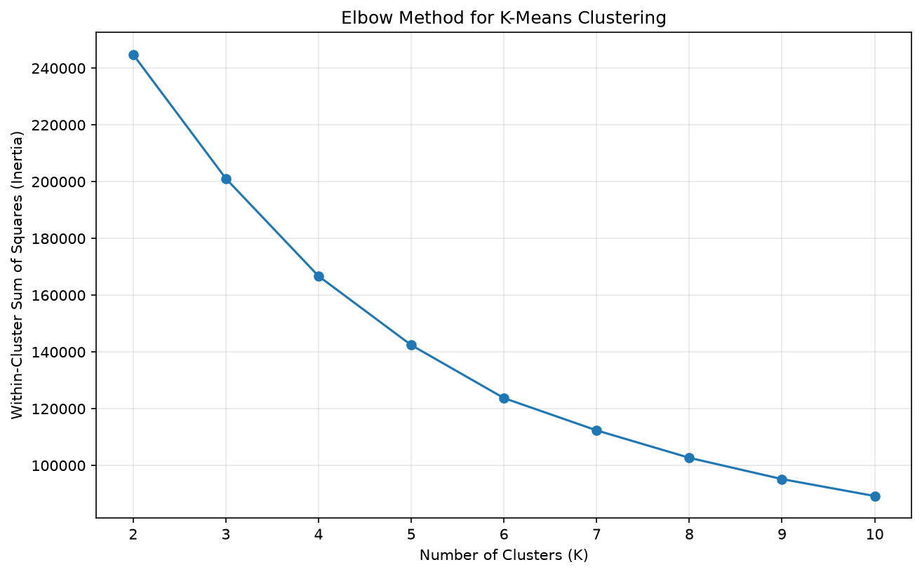Figure 1. Elbow method for K-Means cluster selection

5.2 Silhouette Analysis
Silhouette scores were calculated for each candidate value of K. The highest silhouette score was obtained at K=3, with a score of 0.5247.
Therefore, K=3 was selected as the main K-Means clustering configuration.
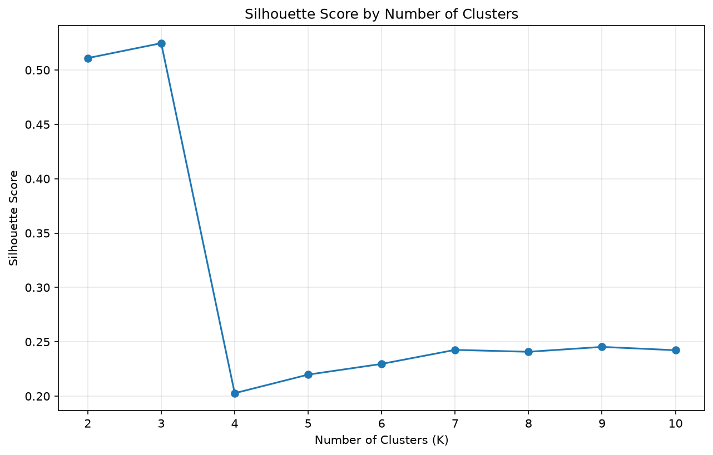 Figure 2. Silhouette scores for K=2 through K=10

6. K-Means Results
The K-Means evaluation produced the following results:
- K=2 → Silhouette: 0.5110
- K=3 → Silhouette: 0.5247
- K=4 → Silhouette: 0.2027
- K=5 → Silhouette: 0.2198
- K=6 → Silhouette: 0.2296
- K=7 → Silhouette: 0.2425
- K=8 → Silhouette: 0.2408
- K=9 → Silhouette: 0.2453
- K=10 → Silhouette: 0.2422
Based on the highest silhouette score, three clusters were selected.

6.1 Cluster Distribution
The selected K-Means model produced three clusters:
Cluster | Records | Percentage
Cluster 0 | 46,307 | 94.91%
Cluster 1 | 2,238 | 4.59%
Cluster 2 | 244 | 0.50%
Cluster 0 represents the overwhelming majority of observations, while Clusters 1 and 2 represent smaller and more distinctive groups.
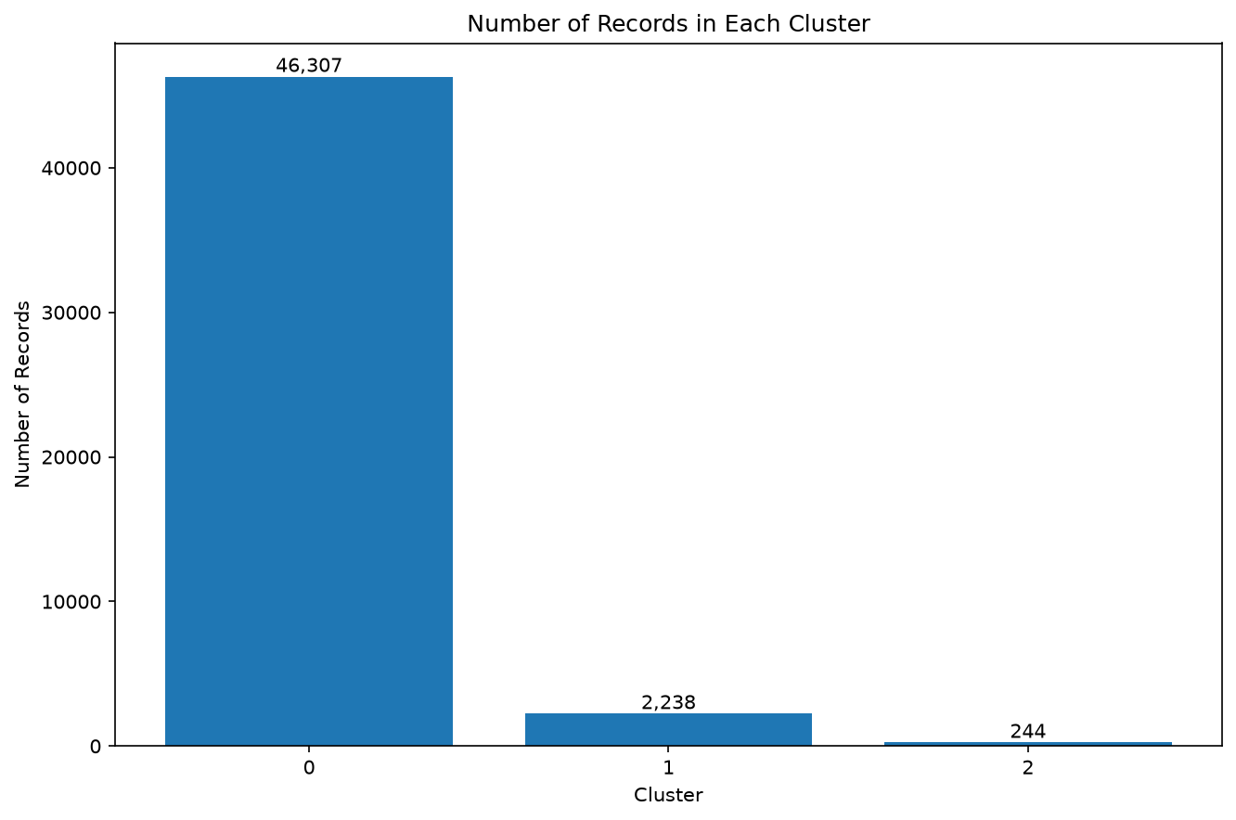Figure 3. K-Means cluster sizes
7. Cluster Profiling and Interpretation
After clustering, the resulting cluster labels were attached to the original dataset to understand the characteristics of each group. Profiling was performed using numerical averages and categorical distributions.
The numerical profiles were:
Cluster | Average Age | Education-num | Capital Gain | Capital Loss | Hours/Week
0 | 38.46 | 10.02 | 611.23 | 0.54 | 40.23
1 | 41.78 | 11.00 | 0.00 | 1898.38 | 43.34
2 | 46.61 | 13.02 | 99999.00 | 0.00 | 50.48

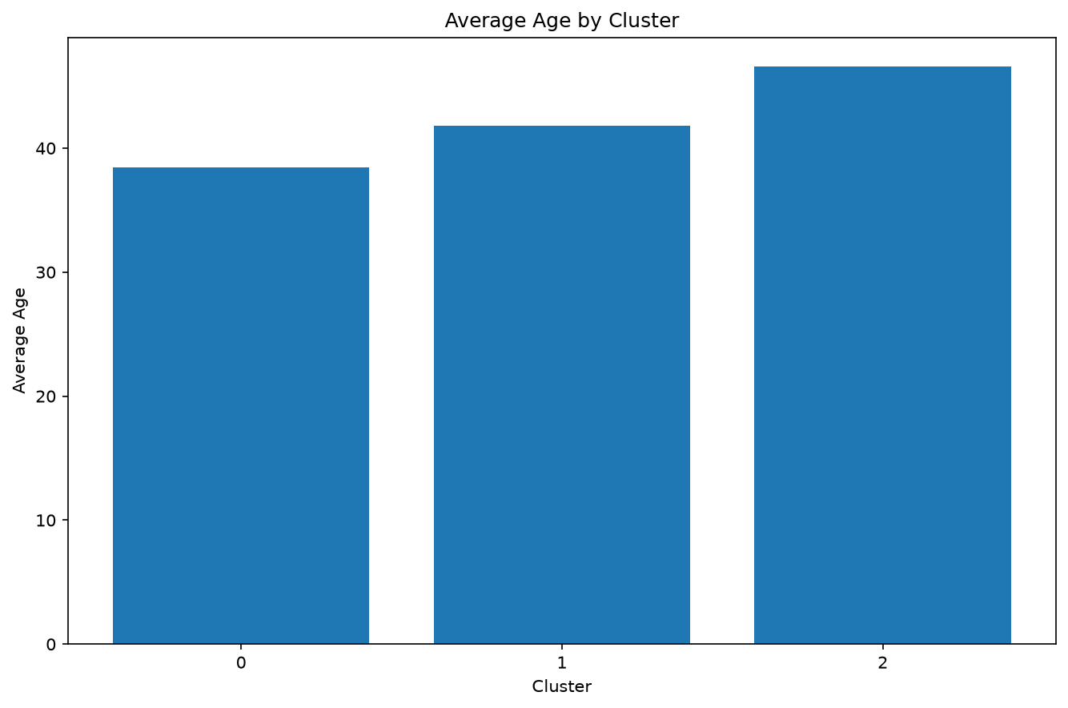Figure 4. Average age across K-Means clusters

Figure 5
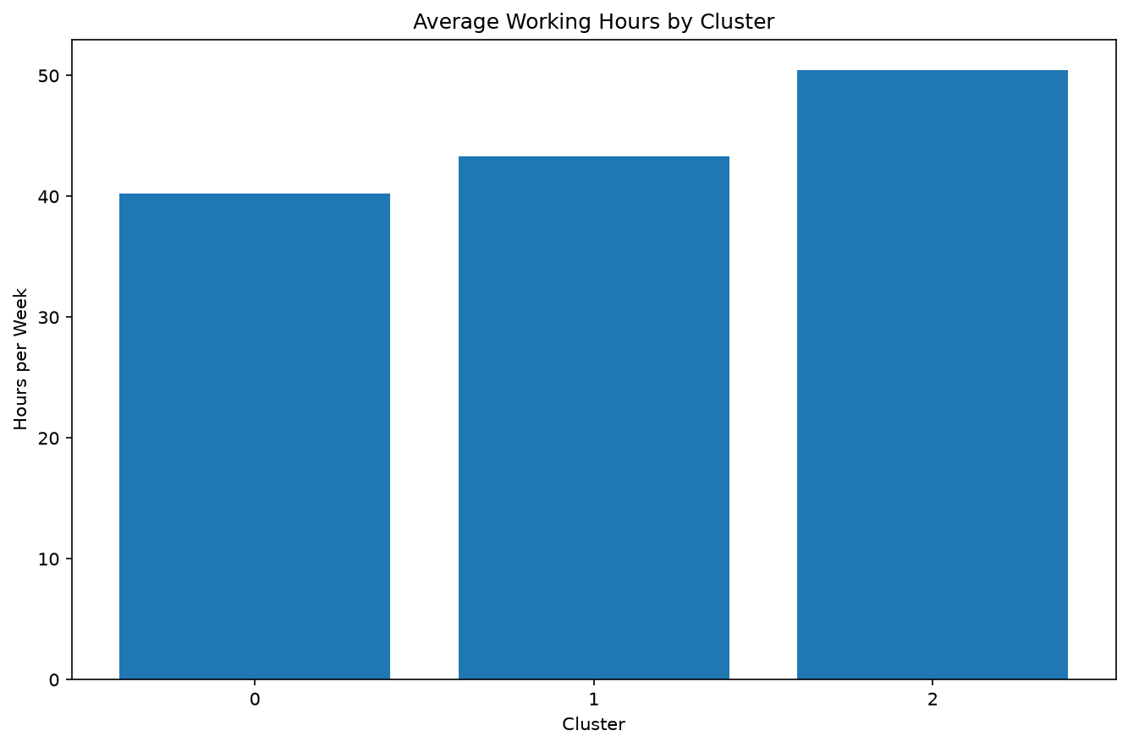Figure 5. Average working hours per week across clusters
Figure 6
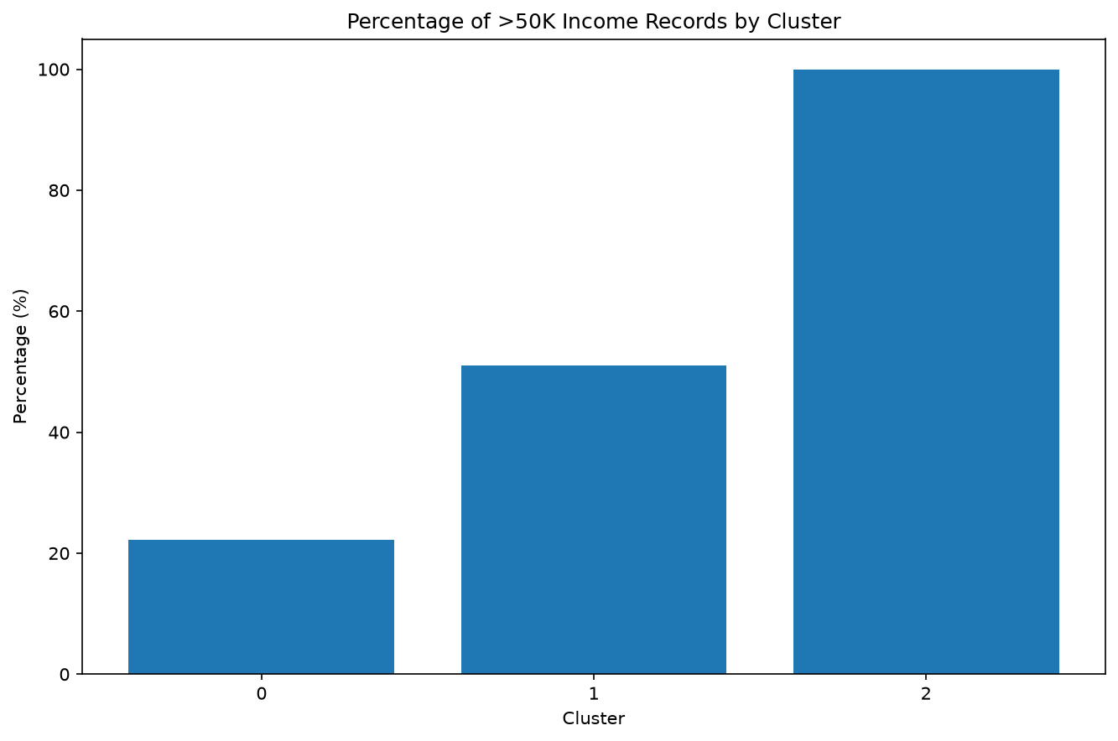Figure 6. High-income percentage by cluster
Interpret the Clusters
7.1 Cluster 0 – General Population Segment
Cluster 0 is the dominant segment, containing 46,307 records (94.91%). Its average age is 38.46 years, while average working hours are 40.23 hours per week. The cluster has an income distribution of 77.77% at or below $50K and 22.23% above $50K.
The most common education categories include HS-grad, Some-college, and Bachelors. Private employment is the dominant workclass, and Prof-specialty, Craft-repair, Exec-managerial, Adm-clerical, and Sales are among the leading occupations.
This cluster can therefore be interpreted as the broad mainstream population segment within the selected numerical feature space.
Cluster 1
Cluster 1 contains 2,238 records (4.59%). Its average age is 41.78 years, and average working hours are 43.34 hours per week. The cluster has a substantially higher proportion of high-income observations, with 51.03% earning above $50K.
The cluster also shows a much higher average capital-loss value than Cluster 0. Professional, managerial, sales, and craft-related occupations are prominent.
This group represents a smaller population with relatively higher working hours and a stronger association with the higher-income category.
Cluster 2
Cluster 2 is the smallest group, containing only 244 records (0.50%). It has the highest average age at 46.61 years, the highest education-num at approximately 13.02, and the highest average working hours at 50.48 hours per week.
The reported average capital-gain value is 99,999, while capital loss is zero. Importantly, 100% of observations in this cluster are above $50K.
Prof-school and Bachelors are among the leading education categories, while professional and managerial occupations are prominent. This makes Cluster 2 a particularly distinctive high-income segment.

Hierarchical Clustering
8. Hierarchical Clustering
Hierarchical clustering was implemented as a second unsupervised learning approach to provide a comparison with K-Means. Because hierarchical clustering is computationally more expensive on a large dataset, the analysis used a sample of 5,000 observations after removing the 428 duplicate feature rows.
Candidate values from K=2 through K=6 were evaluated using silhouette scores.
The results were:
- K=2 → 0.7914
- K=3 → 0.5258
- K=4 → 0.1715
- K=5 → 0.1613
- K=6 → 0.1732
The best result was obtained at K=2, with a silhouette score of 0.7914.

Hierarchical Screenshot 23
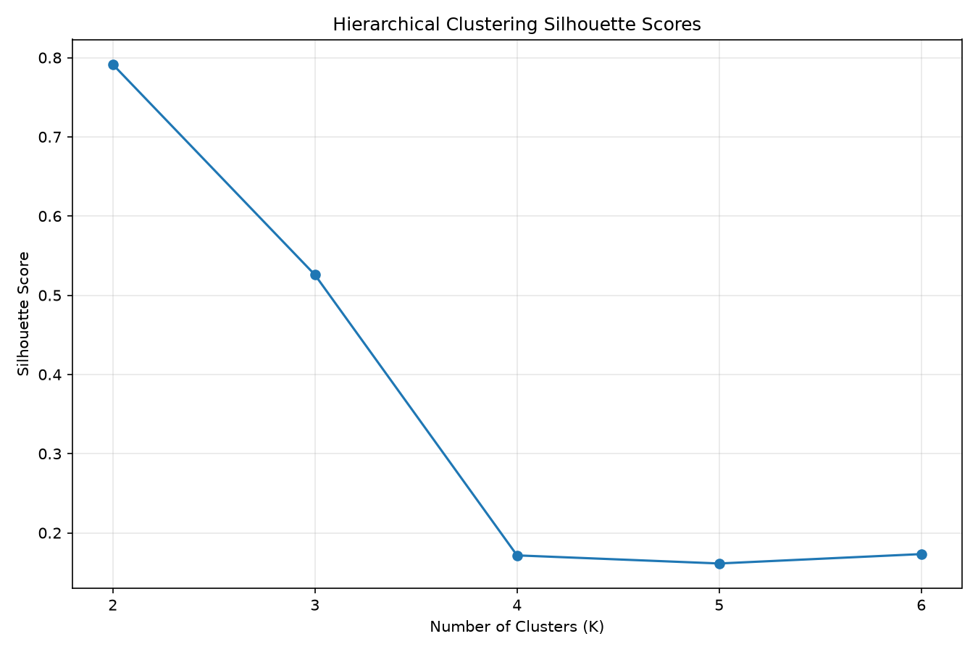Figure 7. Hierarchical clustering silhouette scores
The silhouette evaluation indicates that K=2 provided the strongest separation among the tested hierarchical clustering configurations.

Hierarchical PCA Screenshot
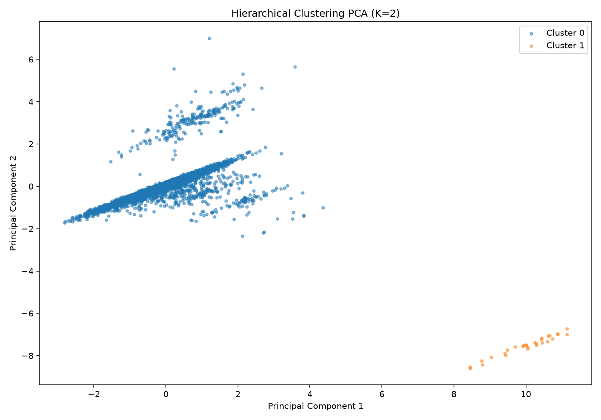Figure 8. PCA visualization of hierarchical clustering sample
PCA was used to project the standardized six-dimensional feature space into two dimensions for visualization. The visualization provides a two-dimensional representation of the cluster structure and helps communicate the separation produced by the hierarchical clustering model.

Hierarchical Results
8.1 Hierarchical Cluster Results
The final hierarchical model produced two clusters:
Cluster | Records | Percentage
Cluster 0 | 4,971 | 99.42%
Cluster 1 | 29 | 0.58%
Although the silhouette score of 0.7914 is considerably higher than the K-Means score, the resulting clusters are extremely imbalanced. Almost the entire sample belongs to Cluster 0, while only 29 observations belong to Cluster 1.
Therefore, the high silhouette score should be interpreted together with cluster size. The hierarchical result demonstrates strong separation of a very small distinctive group, but it is less useful for balanced multi-segment profiling.
Comparison
9. Comparison of K-Means and Hierarchical Clustering
K-Means and hierarchical clustering produced different segmentation structures.
K-Means selected K=3 with a silhouette score of 0.5247. It produced three groups of different sizes and provided a useful basis for detailed cluster profiling.
Hierarchical clustering selected K=2 with a silhouette score of 0.7914. However, the resulting segmentation was highly imbalanced, with 99.42% of the sample in one cluster and only 0.58% in the other.
For this project, K-Means provides the more useful primary segmentation because it produces three interpretable groups rather than separating almost all observations into a single cluster.

10. Business and Research Implications
The clustering analysis demonstrates how unsupervised learning can identify groups within a population without using the income label during model training.
The resulting segments can potentially support:
- Population segmentation
- Customer profiling
- Workforce analysis
- Targeted communication strategies
- Identification of distinctive high-income segments
- Further predictive modelling
- Exploratory socioeconomic research The clusters reveal differences in age, education, working hours, and financial characteristics. These patterns can help analysts investigate why particular groups differ and can provide a foundation for subsequent supervised learning or statistical analysis.
However, clustering identifies patterns of similarity and should not be interpreted as evidence of causation.
11. Limitations
The analysis has several limitations:
- Only six numerical variables were used to create the clusters.
- Categorical variables such as occupation, workclass, race, sex, and marital status were not directly used as clustering inputs.
- Capital-gain and capital-loss contain highly skewed values that can have a strong influence on distance-based clustering.
- The hierarchical clustering model was applied to a 5,000-record sample because of computational considerations.
- The hierarchical solution produced a highly imbalanced two-cluster result.
- Cluster labels such as Cluster 0, Cluster 1, and Cluster 2 are identifiers only and do not represent rankings.
- The income variable was used for cluster profiling and interpretation, not as a clustering feature.

12. Conclusion
Week 3 successfully applied unsupervised learning techniques to the UCI Adult dataset. The project included data preparation, numerical feature selection, standardization, K-Means clustering, hierarchical clustering, silhouette evaluation, PCA visualization, and cluster profiling.
K-Means was evaluated across K=2 to K=10 and selected K=3, achieving a silhouette score of 0.5247. The resulting clusters showed meaningful differences in age, education, working hours, financial characteristics, and income distribution.
Hierarchical clustering was evaluated using a 5,000-record sample and selected K=2, achieving a higher silhouette score of 0.7914. However, its 99.42% versus 0.58% cluster distribution demonstrated a highly imbalanced segmentation.
Overall, the project demonstrates the practical application of unsupervised learning for discovering hidden patterns in unlabeled data. The analysis also highlights the importance of considering both quantitative evaluation metrics and practical interpretability when selecting a clustering solution.

