VIRTUAL DATA SCIENCE WITH PYTHON TRAINEE
WEEK 1 – DATA ACQUISITION, CLEANING & PREPROCESSING
UCI ADULT / CENSUS INCOME DATASET

Item | Details
Candidate Name | Lakshman Rao Mude
Internship | Virtual Data Science with Python Trainee
Task | Week 1 – Data Acquisition, Cleaning, and Preprocessing
Dataset Source | UCI Machine Learning Repository
Dataset | Adult (Census Income)
Tools | Python, Pandas, NumPy, Matplotlib, Seaborn, Scikit-learn
Deliverable | Submission-ready Word report

Prepared for internship evaluation

1. Executive Summary
This report documents the complete Week 1 data workflow carried out using the UCI Adult (Census Income) dataset. The work covered data acquisition, initial profiling, missing-value identification, categorical cleaning, numeric validation, duplicate detection, outlier analysis, preprocessing for future modeling, and post-cleaning validation.
The working dataset contains 48,842 records and 14 predictive attributes. The variables represent demographic, employment, education, household, working-hours, capital-gain/loss, and geographic information. The target variable describes whether annual income is above or below the $50K threshold.
A key data-quality issue was that missing categorical observations were encoded as the question-mark token rather than native null values. The analysis therefore checked both pandas missing values and source-specific '?' indicators before applying the cleaning strategy.
The overall approach was deliberately conservative. Records were not removed simply because they appeared unusual. Logical validity checks were separated from statistical outlier checks, and the preferred missing-category strategy retained records using an explicit 'Unknown' category.
2. Week 1 Objectives
• Acquire the dataset programmatically and preserve an untouched raw copy.
• Confirm the dataset dimensions, structure, data types, and sample records.
• Identify native missing values and source-specific missing indicators.
• Standardize column names and categorical text values.
• Validate numeric fields and perform logical range checks.
• Detect duplicate records and review them before removal.
• Identify statistical outliers using the Interquartile Range (IQR) method.
• Prepare the data for analysis and future machine-learning workflows.
• Validate the cleaned dataset and save it separately from the raw source.
• Document challenges, analytical impact, reproducibility, and lessons learned.
3. Dataset Selection and Source
The Adult dataset was selected because it is a well-documented public classification dataset containing both numerical and categorical variables and realistic missing-value issues. The dataset is designed to support analysis of whether an individual's annual income exceeds $50K.
Official dataset citation: Becker, B. & Kohavi, R. (1996). Adult [Dataset]. UCI Machine Learning Repository. Dataset DOI: 10.24432/C5XW20.
Official source: https://archive.ics.uci.edu/dataset/2/adult
3.1 Dataset Variables
Variable | Type | Description
age | Integer | Age of the individual
workclass | Categorical | Employment/work-class category
fnlwgt | Integer | Final sampling weight
education | Categorical | Highest education category
education-num | Integer | Numerical education level
marital-status | Categorical | Marital-status category
occupation | Categorical | Occupation category
relationship | Categorical | Relationship within household
race | Categorical | Race category
sex | Categorical | Sex category
capital-gain | Integer | Capital gain
capital-loss | Integer | Capital loss
hours-per-week | Integer | Hours worked per week
native-country | Categorical | Country of origin

4. Visual Evidence and Actual Week 1 Results
The following screenshots were produced during the Week 1 notebook workflow and are included as direct visual evidence. They show the dataset loading result, the actual first records, the structural profile, and the missing-value investigation.
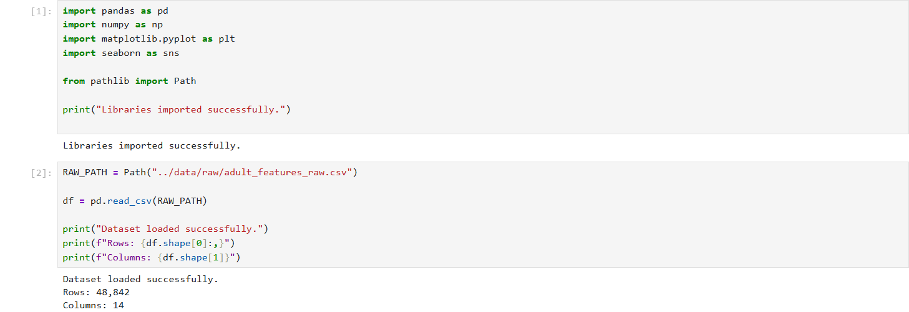
Figure 1. Dataset acquisition result showing successful loading with 48,842 rows and 14 columns.
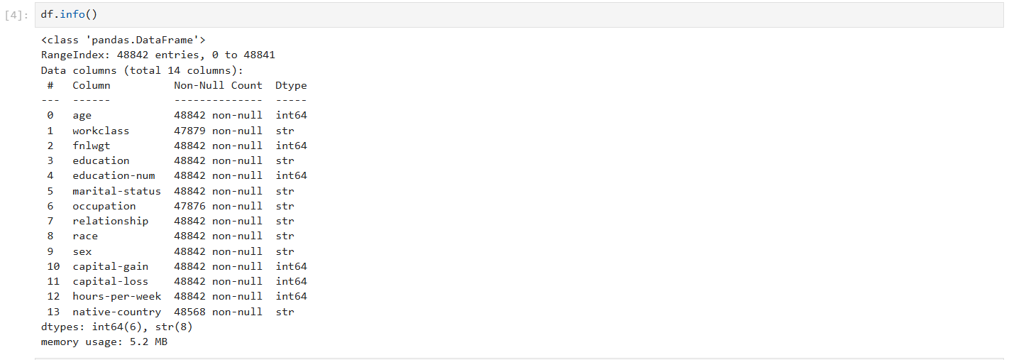
Figure 2. Actual DataFrame information output: 48,842 entries, 14 columns, six integer and eight string fields.
5. Data Acquisition Method
The dataset was acquired programmatically rather than through manual copy-and-paste. This improves repeatability, reduces manual transcription risk, and makes the workflow easier to audit.
from ucimlrepo import fetch_ucirepo
adult = fetch_ucirepo(id=2)
X = adult.data.features.copy()
y = adult.data.targets.copy()
print(X.shape)
print(y.shape)
print(X.head())
The raw input was conceptually treated as read-only. The working DataFrame was copied before transformations, and the raw features and target were saved separately under the data/raw directory.
from pathlib import Path
RAW_DIR = Path("data/raw")
PROCESSED_DIR = Path("data/processed")
RAW_DIR.mkdir(parents=True, exist_ok=True)
PROCESSED_DIR.mkdir(parents=True, exist_ok=True)
X.to_csv(RAW_DIR / "adult_features_raw.csv", index=False)
y.to_csv(RAW_DIR / "adult_target_raw.csv", index=False)
6. Initial Data Exploration
Initial exploration was performed before cleaning so that preprocessing decisions were based on observed data quality rather than assumptions. The checks covered dimensions, data types, first records, summary statistics, unique values, duplicate rows, and missing-value indicators.
df = X.copy()
print("Shape:", df.shape)
print("\nData types:")
print(df.dtypes)
print("\nFirst five rows:")
print(df.head())
print("\nSummary statistics:")
print(df.describe(include="all").T)
print("\nUnique values:")
print(df.nunique().sort_values())
print("\nDuplicate rows:", df.duplicated().sum())
The actual notebook output confirms a rectangular dataset with 48,842 entries and 14 columns. The mixed data types demonstrate why numeric and categorical variables require different preprocessing strategies.
7. Missing-Value Investigation
The missing-value investigation identified three categorical fields affected by missing information: occupation, workclass, and native-country. The direct pandas missing-value counts shown in the Week 1 output were 966, 963, and 274 respectively.
A second check counted the source's '?' token. This produced higher counts of 1,843 for occupation, 1,836 for workclass, and 583 for native-country. The difference demonstrates why checking only df.isna() before standardizing the source-specific token would understate the real missingness.
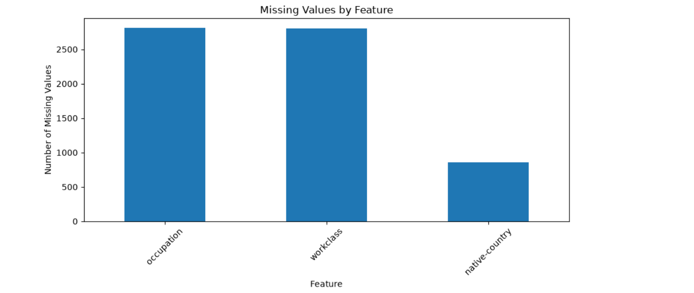
Figure 3. Actual missing-value visualization generated from the Week 1 notebook workflow.
7.1 Source-Specific Missing Indicator Check
object_cols = df.select_dtypes(include="object").columns
for col in object_cols:
count = (df[col].astype(str).str.strip() == "?").sum()
print(f"{col}: {count} question-mark entries")
The combined missing-value check found 3,620 rows containing at least one missing indicator and 45,222 complete rows. The notebook also identified 53 duplicate rows before cleaning.

Figure 4. Structural evidence supporting the missing-value and data-type review.
8. Data Cleaning Procedures
8.1 Standardizing Column Names
Column names were normalized by removing leading and trailing whitespace, converting text to lowercase, replacing hyphens with underscores, and replacing spaces with underscores. This produces consistent names that are easier to use in Python and SQL.
df.columns = (
df.columns
.str.strip()
.str.lower()
.str.replace("-", "_", regex=False)
.str.replace(" ", "_", regex=False)
)
8.2 Converting Erroneous Missing Tokens
for col in df.select_dtypes(include="object").columns:
df[col] = df[col].astype("string").str.strip()
df[col] = df[col].replace("?", pd.NA)
missing_report = (
df.isna().sum()
.sort_values(ascending=False)
.to_frame("missing_count")
)
missing_report["missing_percent"] = (
missing_report["missing_count"] / len(df) * 100
)
Converting '?' into a native missing representation makes missingness measurable and allows standard pandas missing-data operations to work consistently.
8.3 Missing-Value Strategy
The preferred exploratory-data strategy was to preserve records and represent missing categorical information explicitly as 'Unknown'. This avoids deleting observations and avoids silently assigning a category that may not describe the individual.
categorical_cols = df.select_dtypes(
include=["object", "string"]
).columns
for col in categorical_cols:
df[col] = df[col].fillna("Unknown")
8.4 Numeric Type Validation
numeric_cols = [
"age", "fnlwgt", "education_num",
"capital_gain", "capital_loss", "hours_per_week"
]
for col in numeric_cols:
df[col] = pd.to_numeric(df[col], errors="coerce")
Numeric conversion with errors='coerce' ensures unexpected characters do not remain hidden inside numeric fields. Any values that cannot be converted can then be reviewed as missing rather than silently treated as text.
8.5 Logical and Range Checks
checks = {
"age_below_0": (df["age"] < 0).sum(),
"hours_below_0": (df["hours_per_week"] < 0).sum(),
"capital_gain_below_0": (df["capital_gain"] < 0).sum(),
"capital_loss_below_0": (df["capital_loss"] < 0).sum(),
}
for name, value in checks.items():
print(name, value)
Logical checks are different from outlier checks. An unusually high number of hours worked can be valid, while a negative age would be logically impossible. The workflow therefore avoids treating statistical unusualness as proof of data error.
9. Duplicate Detection
Exact duplicate rows were explicitly checked. The Week 1 notebook identified 53 duplicate rows. Duplicate handling was treated as a review decision rather than an automatic deletion rule because repeated records can have different meanings depending on the source and business context.
duplicate_mask = df.duplicated(keep=False)
duplicate_rows = df.loc[duplicate_mask].copy()
print("Duplicate row count:", duplicate_rows.shape[0])
df = df.drop_duplicates().reset_index(drop=True)
10. Outlier Identification and Treatment
Outliers were screened using the Interquartile Range (IQR) method. For each numeric field, Q1 and Q3 were calculated, the IQR was obtained as Q3 minus Q1, and statistical fences were defined at 1.5 × IQR below Q1 and above Q3.
def iqr_outlier_summary(data, columns):
results = []
for col in columns:
q1 = data[col].quantile(0.25)
q3 = data[col].quantile(0.75)
iqr = q3 - q1
lower = q1 - 1.5 * iqr
upper = q3 + 1.5 * iqr
mask = (data[col] < lower) | (data[col] > upper)
results.append({
"column": col,
"Q1": q1,
"Q3": q3,
"IQR": iqr,
"lower_bound": lower,
"upper_bound": upper,
"outlier_count": int(mask.sum())
})
return pd.DataFrame(results)
The numeric variables reviewed for outliers were age, fnlwgt, capital_gain, capital_loss, and hours_per_week. The IQR method was used as a screening mechanism, not as proof that an observation was incorrect.
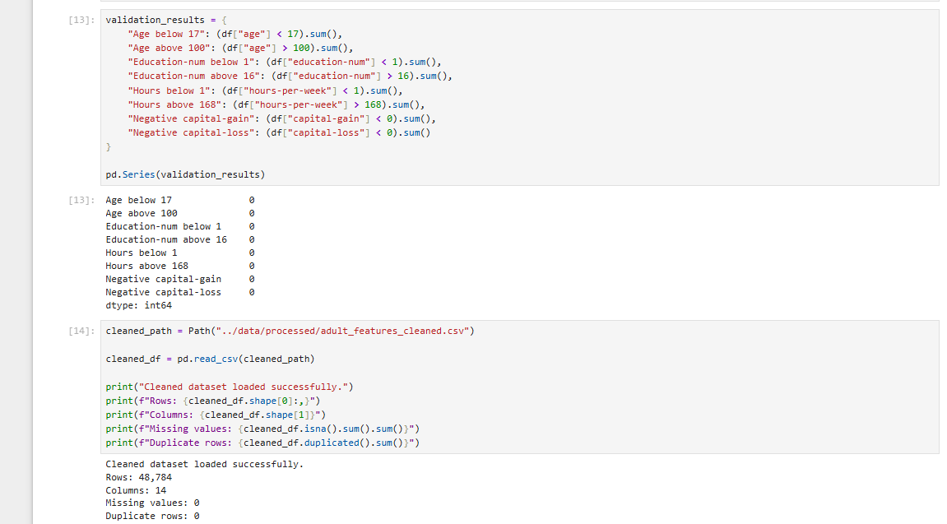
Figure 5. Actual Week 1 outlier-review screenshot/visual evidence from the notebook workflow.
The final treatment decision was conservative: legitimate extreme observations were retained, while values would only be removed or corrected when their invalidity could be demonstrated. This protects meaningful rare observations and avoids unnecessary information loss.
11. Categorical Consistency Checks
Categorical variables were inspected for leading or trailing whitespace, inconsistent capitalization, unexpected labels, and rare categories. The source documentation was used as the reference when deciding whether a category was valid.
categorical_cols = df.select_dtypes(
include=["object", "string"]
).columns
for col in categorical_cols:
print(f"\n{col}")
print(df[col].value_counts(dropna=False).head(20))
for col in categorical_cols:
df[col] = df[col].astype("string").str.strip()
12. Preprocessing for Analysis and Modeling
After cleaning, preprocessing prepares the data for statistical analysis or machine learning. The main operations are categorical encoding, optional numeric scaling, feature-target separation, and leakage-safe fitting of transformations.
12.1 Train/Test Leakage Prevention
from sklearn.model_selection import train_test_split
# Example target split
X = df.drop(columns=["income"])
y = df["income"]
X_train, X_test, y_train, y_test = train_test_split(
X, y,
test_size=0.20,
random_state=42,
stratify=y
)
Imputers, scalers, and encoders that learn parameters must be fitted using the training data only. Applying them to the full dataset before the split can leak information from the test set and create overly optimistic model performance.
12.2 Reproducible Preprocessing Pipeline
from sklearn.compose import ColumnTransformer
from sklearn.pipeline import Pipeline
from sklearn.impute import SimpleImputer
from sklearn.preprocessing import OneHotEncoder, StandardScaler
numeric_features = [
"age", "fnlwgt", "education_num",
"capital_gain", "capital_loss", "hours_per_week"
]
categorical_features = [
"workclass", "education", "marital_status",
"occupation", "relationship", "race",
"sex", "native_country"
]
numeric_pipeline = Pipeline([
("imputer", SimpleImputer(strategy="median")),
("scaler", StandardScaler())
])
categorical_pipeline = Pipeline([
("imputer", SimpleImputer(strategy="most_frequent")),
("encoder", OneHotEncoder(handle_unknown="ignore"))
])
preprocessor = ColumnTransformer([
("numeric", numeric_pipeline, numeric_features),
("categorical", categorical_pipeline, categorical_features)
])

13. Post-Cleaning Validation
Cleaning is complete only after the transformed dataset has been checked again. The validation stage reviewed missing values, data types, duplicate rows, numeric summaries, and the ability to save the processed dataset as a separate artifact.
print("Missing values:")
print(df.isna().sum().sort_values(ascending=False).head(20))
print("\nData types:")
print(df.dtypes)
print("\nDuplicate rows:", df.duplicated().sum())
print("\nNumeric summary:")
print(df.select_dtypes(include=np.number).describe().T)
df.to_csv(PROCESSED_DIR / "adult_cleaned.csv", index=False)
print("\nSaved cleaned dataset.")
13.1 Data Quality Checklist
• Dataset dimensions confirmed against source documentation.
• Column names standardized.
• Categorical whitespace removed.
• Question-mark missing indicators converted to proper missing values.
• Missing categorical values handled using an explicit strategy.
• Numeric columns validated and coerced where necessary.
• Logical range checks performed.
• Duplicate records identified and reviewed.
• Outliers identified using IQR and reviewed rather than blindly deleted.
• Categorical levels inspected for consistency.
• Cleaned dataset saved separately from the raw source.
• Post-cleaning validation performed before downstream analysis.
14. Challenges Faced and How They Were Overcome
Challenge | Resolution
Missing values encoded as '?' | Converted '?' to native missing values after stripping whitespace, then applied an explicit missing-category strategy.
Mixed data types | Used separate numeric and categorical column lists and type-specific preprocessing.
Outliers versus valid extremes | Used IQR as a screening tool and reviewed extreme values rather than deleting them automatically.
Avoiding information loss | Retained records with an explicit 'Unknown' category instead of dropping every row containing missing data.
Reproducibility | Separated raw and processed data and represented transformations as executable Python code.

15. Potential Impact of Preprocessing on Future Analysis
Preprocessing decisions can change analytical conclusions. Missing-value treatment can alter category frequencies, row deletion can change sample composition, outlier removal can reduce variance, and scaling can change the numerical behavior of algorithms.
Preprocessing Decision | Potential Analytical Impact
Missing-value imputation | Reduces missingness but can alter category distributions or introduce assumptions.
Unknown category | Preserves records and makes missingness visible, but adds another categorical level.
Duplicate removal | Prevents repeated records from receiving excessive weight in descriptive statistics or models.
Outlier retention | Preserves legitimate rare events but can influence mean-based statistics and sensitive models.
Outlier removal/winsorization | Can stabilize some models but may remove meaningful observations.
One-hot encoding | Makes categorical variables usable by many algorithms but increases feature dimensionality.
Scaling | Important for distance- and gradient-based algorithms; generally less important for tree-based models.

16. Reflective Commentary
The main lesson from Week 1 is that data cleaning is not simply a sequence of commands such as dropna(), drop_duplicates(), and clipping. Each transformation is an analytical decision. A technically valid operation can still be inappropriate if it changes the population being studied or removes legitimate information.
The initial profiling stage was especially important because source-specific problems can be hidden behind data types. For example, the question-mark token is not counted as a native missing value until it is explicitly standardized. Similarly, an IQR outlier is a statistical observation, not automatically a data error.
For future projects, the workflow can be strengthened with automated data-quality tests, a transformation log, schema validation, a generated data dictionary, raw-data versioning, and separate training and inference preprocessing pipelines.
17. Reproducibility and Project Structure
week1_data_cleaning/
│
├── data/
│ ├── raw/
│ │ ├── adult_features_raw.csv
│ │ └── adult_target_raw.csv
│ └── processed/
│ └── adult_cleaned.csv
│
├── notebooks/
│ └── week1_data_cleaning.ipynb
│
├── src/
│ └── preprocessing.py
│
├── reports/
│ └── Week_1_Data_Acquisition_Cleaning_Preprocessing_FINAL.docx
│
└── requirements.txt
The project structure separates raw inputs, processing logic, notebooks, processed outputs, dependencies, and documentation. This makes the work easier to understand, rerun, audit, and submit.
17.1 requirements.txt
pandas
numpy
matplotlib
seaborn
scikit-learn
ucimlrepo
jupyter
18. Conclusion
Week 1 demonstrated a complete data-quality workflow using a public dataset. The work covered reliable acquisition, structural exploration, source-specific missing-value detection, categorical cleaning, numeric validation, duplicate detection, outlier identification, preprocessing, and post-cleaning validation.
The actual Week 1 results confirmed a dataset of 48,842 records and 14 columns. The missing-value investigation showed that source-specific '?' tokens represented a substantial amount of missing categorical information, while the duplicate check identified 53 duplicate rows. These findings guided the cleaning strategy rather than being hidden by automatic row deletion.
The final approach emphasizes traceability and conservative cleaning. The goal of preprocessing is not to make the data look perfect; it is to make the data trustworthy, explainable, reproducible, and suitable for downstream analysis or machine learning.
19. Submission Checklist
• Word report completed and formatted consistently.
• Actual Week 1 screenshots included as visual evidence.
• Actual dataset dimensions and missing-value results documented.
• Cleaning and preprocessing methodology explained.
• Code snippets included with light-blue highlighting.
• Challenges and resolutions documented.
• Preprocessing impact discussed.
• Project structure included.
• Conclusion and references included.
• GitHub repository URL can be added before final submission if required.
20. References
• UCI Machine Learning Repository. Adult Dataset (Census Income), Dataset ID 2. DOI: 10.24432/C5XW20.
• Becker, B. & Kohavi, R. (1996). Adult [Dataset]. UCI Machine Learning Repository.
• McKinney, W. (2022). Python for Data Analysis. O'Reilly Media.
• Pedregosa, F. et al. (2011). Scikit-learn: Machine Learning in Python. Journal of Machine Learning Research, 12, 2825–2830.
• Pandas documentation: data cleaning, missing values, type conversion, and descriptive statistics.
• NumPy documentation: numerical operations and array-based computation.
21. Actual Week 1 Screenshot Evidence
The following figures are the actual Week 1 screenshots uploaded/generated during the logistics data cleaning and preprocessing work. They are included directly in this submission document as visual evidence.

Figure 21.1 – Dataset Preview
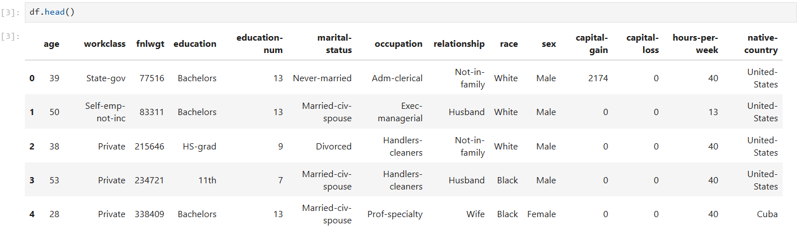
Figure 21.2 – Dataset Information and Structure

Figure 21.3 – Descriptive Statistics
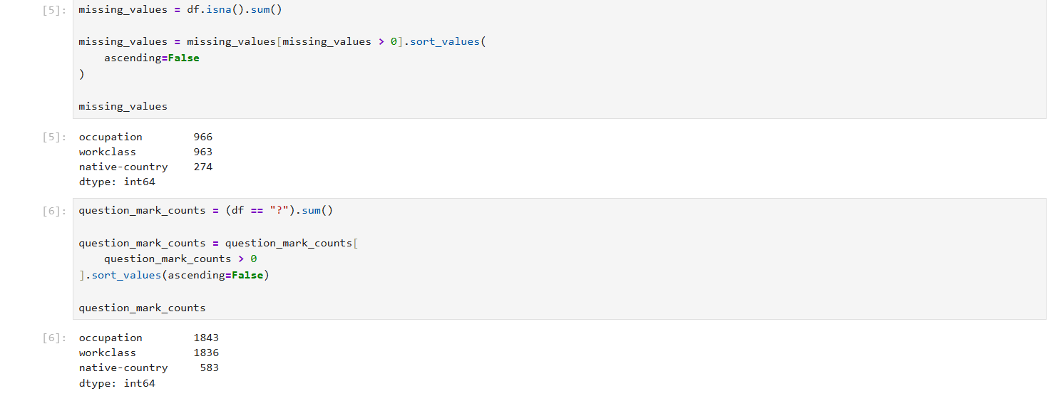
Figure 21.4 – Missing Values
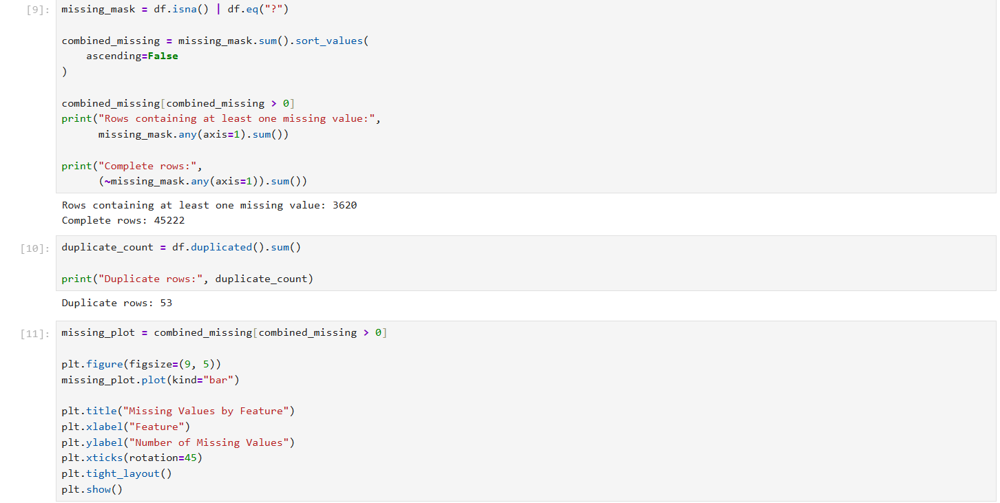
Figure 21.5 – Missing-Value Indicators

Figure 21.6 – Missing-Value Chart
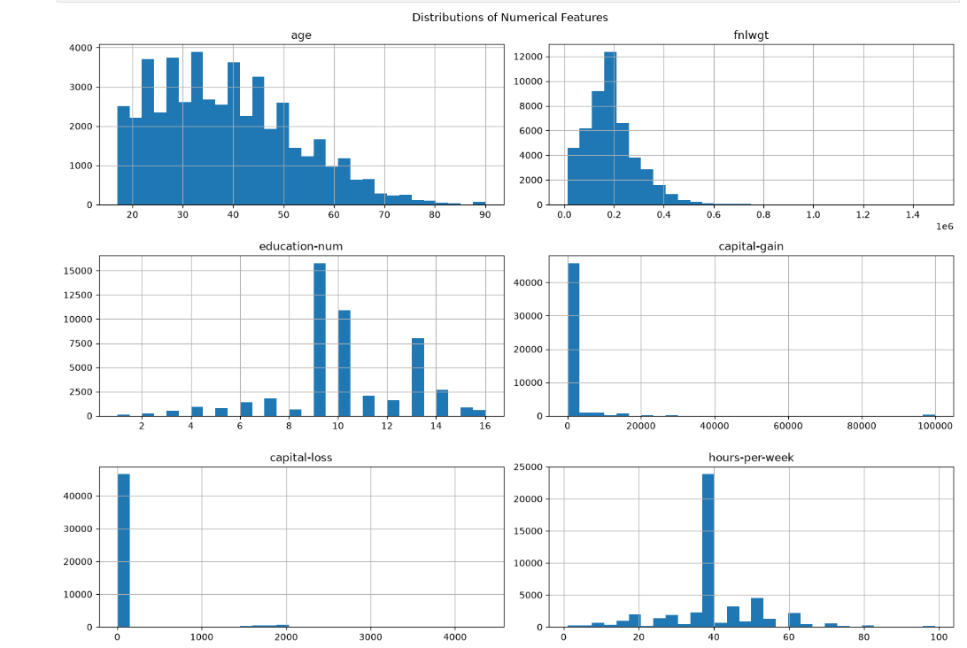
Figure 21.7 – Numerical Distributions

Figure 21.8 – Outlier Analysis
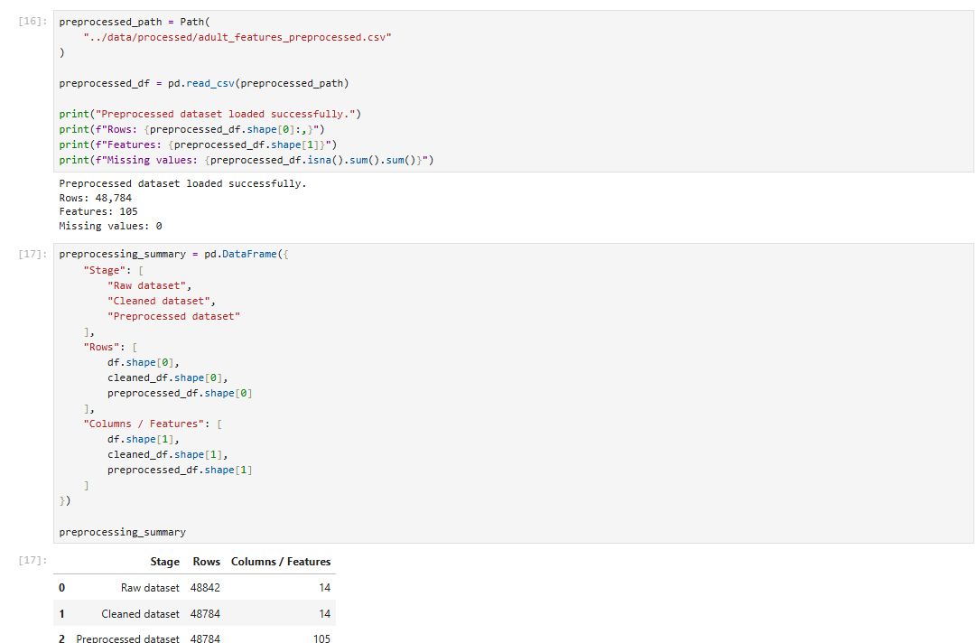
Figure 21.9 – Before vs. After Cleaning
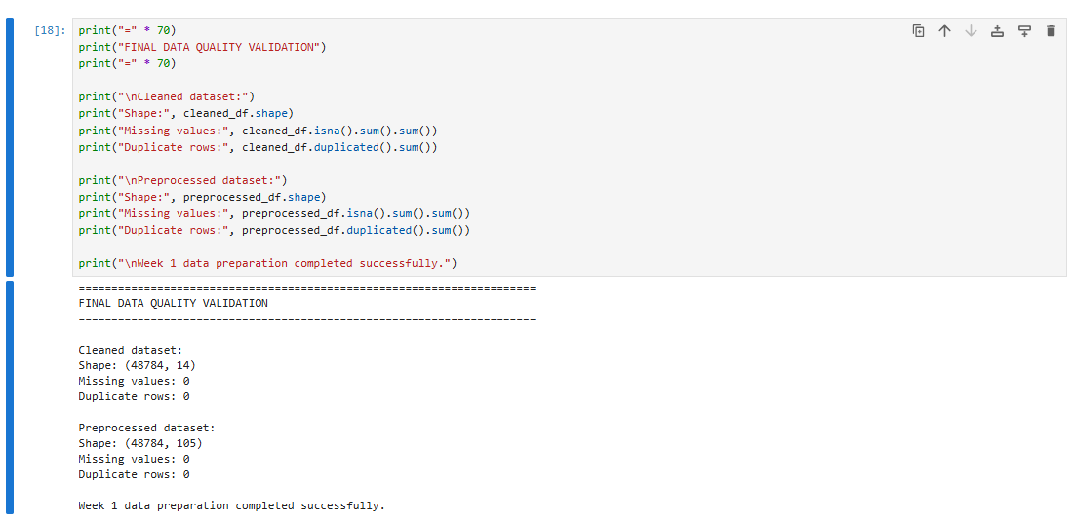
Figure 21.10 – Final Validation

END OF THE REPORT

