**Enhancing Education Menteeship:   
Improving On-Line Career Selection for STEM Personnel**

*Dan M. Davis & Kenneth Shaw*

University of Southern California

12015 E Waterfront Drive

Los Angeles CA 90094

310 909-3487

dmdavis@acm.org & kshaw@ict.usc.edu

*Karen B. Predovich*

High School Counselor

Cañon City CO

predovichk@gmail.com

*Frederica J. Stassi*

Science Educator

Lompoc, California

frjstassi@gmail.com

*Howard Spaulding*

Training Consultant

Arlington, Texas

pirate612@cablelynx.com

Keywords:

STEM, Mentoring, Virtual Human Conversations

Abstract: The nation suffers from a personnel shortfall in the Science, Technology, Engineering and Mathematics (STEM) fields and this paper addresses improving guidance for pre-college youth. As on-line educational systems become more prevalent, one aspect that may be impacted is educational and career counseling. This may well have a deleterious impact on the nation. The authors are experienced educational mentors who have identified major impediments in this area, e.g. the lack of profession-awareness among U.S. students. This lack of awareness is characterized and quantified in this paper and the negative impacts are described and analyzed. Both anecdotal and statistical data are adduced to show the need of significant reformation of the approaches currently implemented. Using statistics that enumerate the extent of untapped human resources in this country’s public, private and schools, the paper outlines the societal and personal pressures that constrain the output of STEM personnel at all levels. Further, they present on-line approaches to ameliorating these problems. The authors discuss their activities in creating an on-line series of technical mentors for prospective technical professionals and they discuss their findings of a distinct lack of what they term “menteeship.” They outline their experience with the students’ inability to formulate good questions for the mentor, the preponderance of images based on fictional characters in the media, and the reliance on adults to make decision for them. They close by describing their early attempts and successes with using Virtual Humans as both trainers and as counselors to overcome these obstacles.

1. Introduction

The impending increase in the dearth of technically trained personnel in the nation is approaching crisis proportions [1]. The authors' contention is that many students, who are fully capable of technical work, finally eschew Science, Technology, Engineering, and Mathematics (STEM) careers for a variety of reasons. Some of these reasons are both ill-founded and exacerbated by societal factors [2]. Current efforts designed to assist students with making appropriate career choices are constrained by many factors, some of which are organizational and financial, leaving counseling personnel insufficient time to work personally with each student over the entire high school experience. Other factors are occasioned by the students' individual situations, such as geographical remoteness, Socio-Economic Status (SES), and family occupational background. Yet others are more societal: media representation of STEM personnel, adolescent peer images of "nerds," and cultural gender norms in certain ethnic groups [3].

This paper addresses some of the issues surrounding the situations described above, but will focus mainly on current research and nascent technologies that can effectively address those situations. These solutions are centered on reacting to three of the major issues: providing wide-spread accessibility, identifying knowledgeable and engaging mentors, and inculcating critical thinking about career choices. First, the generally impressions of the target population, late adolescent, precollege youth are laid out. Special attention is given to common misconception, corrupting influences and unfocussed analytic processes. Then a brief review of advisory sources of career parameters and choice parameters that are available to the target population are set forth. This is followed by a brief review of the manifest efficacy of the current implementation of these assets.

After that, the focus turns to current analyses of the problems and attempts to ameliorate the seemingly immutable constraints to improvement. Both passive informational and interactive conversational computer programs are outlined and discussed. The collected data for an interactive conversational program, MentorPal, are presented and analyzed. The use of this approach is contrasted with the face-to-face advising as experienced in an on-campus career fair.

The paper concludes with a discussion of future implementation needs and plans, potential extensions of these technologies into other areas and required additional research which has been envisioned. Some of this analysis considers risks and hurdles to achieving better education and career selection outcomes.

Pre-College and Pre-Career Populations and Environments

Today's pre-college or pre-career late adolescent has a better than 85% likelihood of graduating from high school [4] and all of the high schools with which the authors are familiar have some kind of counseling available to their students. While one might assume that sufficiently addresses the issues raised above, it is the authors' observation and contention that the available counseling holds little sway against the countervailing pressures from peers, expectations of parents and misimpressions conveyed by stereotypes in the media.

There are vast discrepancies between high school career programs in the United States which are often dictated by the socio-economic-educational status of the school and community. Students from minority-urban areas, economically devastated areas and remote rural areas may not have much exposure to jobs or careers except through media experiences which may not give them a realistic picture of a specific job. Even with a career program that brings awareness of possible jobs, the real challenge for a counselor is to convince the students that they can achieve and succeed out of their immediate environment. In the authors’ experience, this population of students can, and often do, ‘turn off” information presented to them by manifesting their underlying attitudes of despair and low confidence. Students on the opposite end of the SES spectrum many times are influenced by parent and peer expectations and limit their explorations. They are often coerced into going to a certain university or career and have not been inclined or induced to investigate an alternate vocational field that may be more rewarding to them. High school students in general may be presented with career information, but tune out as they have been observed to be so focused on social media, the dynamics of the high school environment, and the many unrealistic views of sports and the entertainment business. Unfortunately, the authors note that this generation of students shows a desire for immediate gratification in many cases, so it is difficult for them to rationally evaluate long-term opportunities and hurdles. They often fail to actually listen to career information.

The authors have all seen many potential sources of student misconceptions of STEM careers, which are then made manifest by students appearing to eschew pursuit of those careers as reported in the literature. [5]. The hypotheses advanced by this paper are that much of this misimpression is caused by a combination of false impressions of STEM professionals that are pervasive in the media and the lack of knowledge of real STEM professionals. As near as an assiduous search of the literature can discern, there is not a very large body of research on the magnitude and causes of the misconceptions. One of the authors (Davis), conducted an informal survey by asking all of the high school students in his children's carpools and sports trips: "What is a typical workday like for your parents?". After a couple of dozen questions of that nature, he reports that the typical response indicated a clear lack of knowledge of what their parents' goals, objectives and activities were. Many were unable to even give a parents job title: "Oh, he works in an office.". These students were from a very high SES secondary school, serving professionals and scientist from the entertainment industry and Caltech's Jet Propulsion Laboratory. The high school's SAT Score average established it as being in the top 2% of California High Schools, earning an average of 1811 out of 2400 [6], so the authors posit that knowledge of lower SES students would not be more illuminating of STEM careers.

Characterizing the Students Career Choice Approaches

Because of the rapid advancement of technology and communication, this paper accepts the premise that the culture of the American adolescent has changed. They have been exposed to information, images and values that were non –existent or rarely communicated in earlier generations [7]. They are products of different styles of parenting and exposed to many environmental changes and dangers. They are bombarded with peer influences both good and bad. Adolescents today are bombarded with stress and this is when we come in with career and college information to add to their self-concerns. Career programs can present information, but to really connect with a high school student, this paper holds that it has to be on a personal level to be effective. A career mentor or a counselor who has the time to dedicate to individual meetings may be ideal, but student loads, bureaucratic duties, and disciplinary duties militate against spending adequate time to accomplish this [8]. An online mentor program can be effective as most adolescents are used to this type of communication and are sometimes more comfortable in this setting. The authors' experience is that adolescents need to hear the human side of a job and what are the personal requirements of a job not just the job description and salary. A preferred career program would incorporate career information throughout K-12 grades with a emphasis during the last classes before the end of high school. Career information can be tied to high school subjects as a preparation for high school and mentorship can play a big part in individual career maturity. Most science standards reviewed did not contain requirements to emphasize STEM career details.

Typical Counseling Services

Most counselors have a large student counselor ratio which prohibits them from seeing individual students just for career development. The American School Counselor Association recommends a ratio of 250 students per counselor, but the national average is 483 students, with only three states satisfying that bench mark and the highest state ratio was reported at nearly four times that amount, 983 students per counselor [9]. They may have many extra duties and are also required to react to crisis situations. Some counselors have limited knowledge of career counseling or the district will not provide funding for program such as aptitude assessments, *etc.* Some teachers do not want to give up “class time” for counseling programs when in reality all teachers should incorporate careers into their subject matter. Many rural counselors are required to have k-12 programs or teach classes which really spreads them thin for individual work with students. Within the authors' experience, counselors are regularly accused by some parents that of trying to usurp parental control of and input into college or career choice.

Some of the manifold duties which are typically imposed upon counselors are: career/college programs, financial aid and scholarship assistance, crisis counseling, group counseling, parent -teacher -counselor -student conferences, securing independent studies for students, coordinating high school-college dual credit classes, attending Individualized Education Plan (IEP) meetings, coordinating with school psychologist, principal, teachers, parents to develop individual discipline or graduation plan, workshops for parents on financial aid and college applications, letters of recommendation, coordinating student award programs or opportunities, e.g. Boys/Girls State for example, class observations for case studies, class scheduling and creating master schedule, state programs like Anti-Bullying, called in to cover teacher’s classes, scheduling college and vocational recruiters , setting up job, career or college fairs, *etc*.!

Post-Secondary School Counseling and Career Mentoring

One form of career counseling and professional mentoring that has been documented for some time is the process of accession into, assignments within and advancement in skill and position in the military. Mentoring in the Navy has probably been going on since Oct 14th 1775 when the 2nd man joined the newly formed United States Navy. Much of this would have been based on the more common civilian seafarers' experience and on the organization of the British Navy. The military experience provides yet another set of insights, as the assignment to one of a vast array of fields has traditionally been done by the service, historically with virtually no choice left to the enlistee. Lest the reader be misled, it should be noted that the modern military establishment is not monolithically comprised of infantry in the Army and boatswain mates in the Navy, the respective portions of their services being ~15% and ~7%. The Navy lists 58 different rates running from Air Traffic Controller to Yeoman [10].

Not only is the mentor imparting their wisdom, usually learned from a mentor, they are investing in the future of the mentee. When one enlists in the military, there is never an end date set in stone. One may re-enlist or may even get out for some reason before their scheduled release date. I always said that the purpose of the mentor is to Train your replacement. This paper asserts that the mentor must be willing to impart their knowledge of the career paths and stages on to the next generation if the Navy is to function. Some examples of mentoring in a Navy setting may be as simple as describing duty stations, the various duties performed at each stage of a career and what the future may hold for different ratings. Specialty training may include what to expect in different situations such as airborne or sub service operations.

Mostly in the military, the mentor will be senior in rank to the mentee. Occasionally, a senior E-5 or E-6 may be retrained (cross rated) from another specialty. Times like this, the senior person must be willing to be mentored by someone his junior. One thing that all mentors must have in common is to exhibit the attributes it takes to be successful in the task at hand.

A good mentor guides the mentee when it comes to career decisions. Just because a person has an interest in surfing, make sure they understand what the work environment and job satisfaction will be like before they sign up for a tour in Hawaii or Guam. Likewise, an isolated tour may often be one of the most fulfilling in terms of contributing to the overall mission of the Navy. Sometimes there might be a young Sailor who obtained his college degree before enlisting. They may have all the tools to be an excellent officer but for reasons known sometimes only to them, they prefer to stay enlisted instead of accepting a commission. A case in point during a tour at the recruiting office in Southern California, one of the authors (Spaulding), had a young man who scored extremely high on every aptitude test he was given. He qualified for anything he would choose to do in the Navy. He wanted to be a Boatswain's Mate, but he was informed that was open to him. He informed the staff that when he went through classification testing, they told him he had qualified to sign up for the Nuclear Power program. However, he said that he didn't want to take that path because his Father and Grandfather had both been Boatswain Mates and that's all he wanted.

Throughout the Navy, the importance of the mentor cannot be emphasized enough. Whether it's offering career advice or imparting job skills they have learned to help in professional development, the actions of good mentors will always be one of the most valuable assets a command may have. In the civilian world, a lot of people are drawn to certain occupations because of high earning potential or familial ties to that profession. Often, they find themselves deep in debt over student loans and working in a field that is not at all what they thought it would be.

Poor Career Selection Ramifications

When working for a major U.S. trucking company, it was common to observe professional people who were making career changes to driving a truck. One example was an attorney who decided one day that he had never enjoyed practicing law and wanted out of the that high pressure and unfulfilling profession [11]. Many people who had never considered driving for a living until they learned how high the earning potential can be. Others, often females, had stayed away from trucking because they didn't know whether they would be accepted or not. A personal example from one of the authors was a man who graduated from Law School but was never happy in the corporate world. He wound up as the D.A. in one of the smaller counties in Nevada and loved it.

Several sailors and officers in the Navy should have never been in the jobs they held or even in the Navy in some cases, but the two authors who are veterans were both surprised at the number of people who were placed by the Navy in fields that they did not request and yet found a life-long love of the work they did. The authors regret that they could find no data as to the career satisfaction achieved by the military as opposed to the career selections made by high school seniors who stay in the civilian sector.

One observation from the trucking industry was that a significant number of people were there when their financial circumstances forced the issue or when they were seduced into entering the field by having listened to one of the many truck driving songs. Anecdotally, both groups seemed to exhibit higher rates of truncated truck driving careers as they found out it wasn't what they thought. A lot of the most successful drivers ended up moving into management or training billets and thrived there as much as they did as drivers. One driver was asked by the owner of a trucking company what made him seem so enthusiastic and motivated every time he saw him. The driver told him, "Don't you understand, driving a truck is just about the most fun a guy can have with his clothes on".

1. Virtual Humans in the MentorPal Project

The MentorPal project is funded by the U.S. Office of Naval Research to improve the selection of STEM careers. They funded a program based on earlier USC technology that delivered as conversation-like exchange. Initially, a group of 500 to 1,500 short (~1.5 minute) video clips responding to carefully crafted questions about STEM careers, *e.g.* "What does your work area look like?" These clips are then used to create an on-line mentor for pre-college students and it presents a conversational exchange of data.

To those who have not had to face the challenges of its hurdles, creating a virtual human may seem as simple as remodeling a human using Computer Generated Imagery (CGI.) It turns out that it takes significant study and effort to implement a Virtual Conversation and the process can consume considerable computing power. The range of skills and the application of technologies that go into the creation of a virtual conversation with lifelike abilities include Natural Language Processing (NLP), machine learning, Virtual Reality (VR), CGI (if animation is involved.), and social stimulation of humans by computer-generated interactions. NLP will be the main focus of this discussion, though the same argument concerning the limits of virtual humans can be made with several of the other components. Natural Language Processing is comprised of the decomposition of language to allow the computer to do useful communications [12]. Recent developments in NLP have made significant advances, including breaking down sentences into: parts-of-speech tags, chunks, entity tags, semantic roles, similar words, and the grammatical and semantic elements of a sentence that generate meaning [13].

The MentorPal project draws from earlier approaches using some of the same underlying natural language dialog technology; ICT’s contribution is known as NPCEditor [14], which specializes in question-answering agents. NPCEditor is one of the two methods used by MentorPal in selecting the best video clip to respond to the users' questions. One of the first implementations of the NPCEditor technology was an exhibit at the Boston Museum of Science called The Twins, where visitors interacted with dialog-based virtual agents who could answer questions about computer science and about how they worked [15]. Later research examined the use of the underlying dialog technology to reproduce the experiences of Holocaust survivors, by producing recorded video clips of the living Holocaust victims to be used as responses, in an attempt to make the conversations more personal than using animated avatars [16]. These programs relied on a range of interactions and social dynamics. Often they included a live guide who would direct a group of visitors in taking turns asking questions to which the program would respond. In the project here, MentorPal has been designed to focus on lower cost, enhanced program design control, more manageable question sets and improved mentor-like dialog. This “faster-cheaper” approach was intended to enhance adoption of this method by others.

This work was all based on the previous and extensive literature on mentoring relying on Artificial Intelligence (AI). The focus of MentorPal is on emulating the experience of an informational interview, such as the kind a student would have with a mentor in a counseling office or at a career fair. This can be contrasted with counseling via systems that are designed to help participants working on a specific project, an example of which would be AutoMentor [17]. MentorPal can also be compared to intelligent mentor agents which gave support to metacognition as part of an open learner model [18]. On the other hand, MentorPal is not intended to build skills. Among mentoring agents which also handle question-asking and familiarization, *e.g.* the SimCoach system [19], MentorPal is dis­tinct due to its focus on subjective experiences instead of data. Rather than a general description of STEM careers or fields, it is intended to help learners select a virtual mentor whose experiences resonate with them and then enables them to explore a more realistic vision of a career.

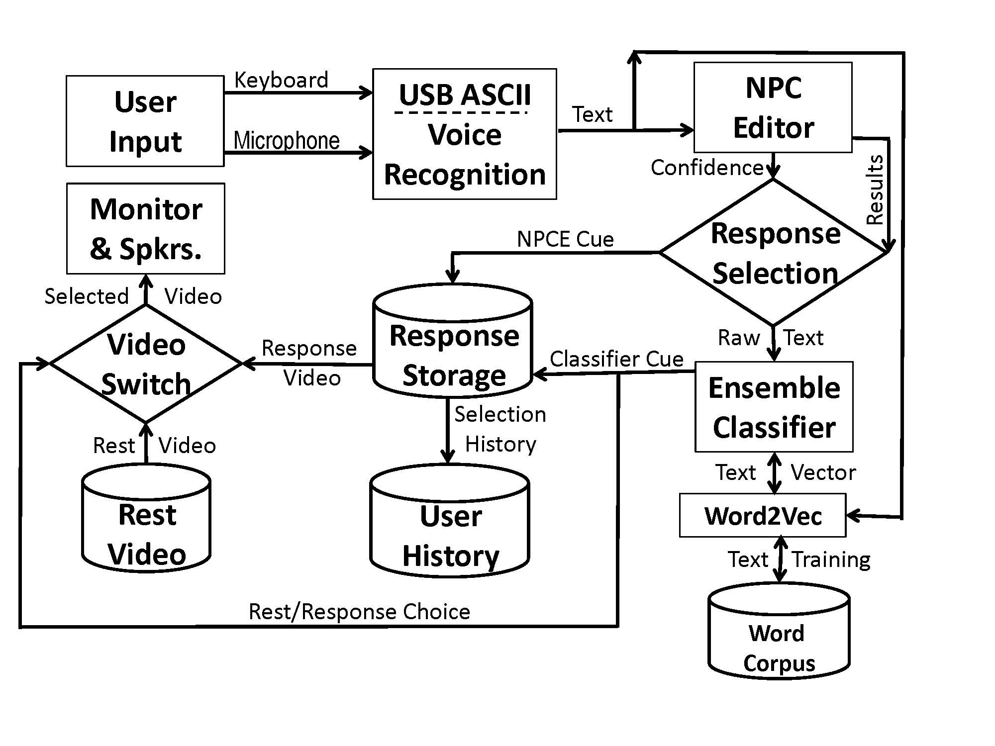

Figure 1.MentorPal Conceptual Flowchart

One of the issues of consequence is that many users, especially the target teen-age demographic for this research, have now become familiar with on-line conversational agents. Most of these other agents are simple question/answer operations, a kind of an articulate FAQ. However, earlier work with NPCEditor and similar systems do not speak to some of the critical MentorPal project issues, especially that many of the users really do not know what to ask when evaluating a career or have already made simplistic uninformed choices. They must be "primed" before using the system or prompted later when they cannot formulate germane questions on their own. As this is an emerging technology, careful monitoring of user reaction is indicated. Therefore, this STEM fair exhibit offers a different perspective on interactions with this kind of system. In particular, for the STEM fair it was not certain if students would find the system novel, due to their greater familiarity with engaging virtual assistants. Prior testing with MentorPal was conducted with one-on-one use *i.e.*, a sole student sitting at a computer, so it was uncertain how differently students would interact with the system as part of a social group or of family cluster.

1. Producing a Virtual Conversation

This section lays out ICT MentorPal's current operations data flow. The user inputs text or voice and the rest of the flow, as shown in Figure 1, is a succession of parsers and filters to select and cue up the most appropriate answer. The creating a large data base of short clip files is a somewhat daunting task, described in earlier papers [20]. This includes methods for asking questions, turning questions into transcripts, cleaning transcripts, feeding these into dialog models, and improving these models by classifying new paraphrases/aliases for questions. Assembling an interactive virtual mentor from previously recorded videos takes up to approximately 20 hours of video taping to provide a broad enough coverage of useable responses, with approximately 60 hours of additional time for video production completion. That is made up of: about 40 hours for generating the transcripts and 20 hours for post-processing of the dialog videos. Because a long-term goal of this project is to enable the easy recording of any person as a mentor, without researcher or video-producer intervention, enhancements in the current procedures are underway for all elements of the process. System engineering principles are being rigorously applied.

Creating the Mentor Database of Video Clips

Each mentor was recorded across at least five sessions, each about three hours long, to cover the entire question set. All of these sessions had a mix of all of these topics in order to avoid fatigue and tedium. After each of the sessions, re-recording sessions were held as required. These were devoted to recording new answers to bad video clips or to recording answers to common questions that were not recorded. Each follow-up session typically lasted for about 45 minutes to an hour. These follow-ups were important because they assist with creating a more natural conversational ﬂow, by enabling the mentor to answer questions that were likely to be asked after a mentee had heard the initial response.

Recording involved careful review and control, with monitoring from ICT staff in order to ensure that the recordings were consistent and the responses were appropriate to "chunk" into useful response clips. Standardization included ensuring that the mentor returned to a resting position for approximately three seconds before and after the question was answered. The required rest position was necessary to ensure the mentor was going to be in the same screen location throughout the recordings, to avoid “jumping” during the transition from clip to clip. This disruption could occur if a mentor’s next statement was delivered from a totally different head or body position on the screen.

The career counselor was coached to react with enthusiasm and was monitored by members of the production staff. The video-taping process included making sure that the recording had been standardized by using the same production equipment: videotaping cameras, professional microphones, and cloth backdrops. These had been shipped to any mentors who were located remotely. Following the videotaping, the video clips were uploaded to centrally located storage for further processing. The quality of audio signals, the video images and the rest-answer-rest transitions were all better than anticipated. Later, users reported that they found the quality and transitions did not disrupt the impression of a conversation.

Further Production Activities to Produce Conversations

The MentorPal NLP program selects the best answer from the two different classifiers, as is shown in Figure 1 above. Currently, it sends it to both the NPCEditor and a Python classifier based on a neural network to get two alternate answers. Of these, the NPCEditor answer is used if it has high confidence (since it is faster) while neural network classifier is used otherwise. Further description of these processes is contained in [20]. This section describes how the data for these models is created.

As noted above, the questions, with the resulting live mentor answers, are used to produce classifier data, NPCEditor data and metadata [14 & 20]. The collected and characterized sets are generated manually based on based on alternative ways that the production groups assume that other people would ask the questions. Each question is also manually tagged with topics from a bank of 40 predefined topics that cover all broad categories of questions. An ordering of questions resulted in generating topics, which are used to create random questions associated with those topics. These are also added to the MentorPal classifier data, where it is represented as a vector for each question, using many dimensions. It then stores this data into files for use by the classifier.

The procedure for creating such a conversational Virtual Human (VH) mentor involves a number of steps, in addition to the development and tuning of the software code that makes the program function. Literally volumes have been written about how to system engineer large code programs, running all the way from general, almost philosophical approaches, *e.g*. Professor Fred Brook's book [21] to more detailed and didactic tomes (Pressman & Maxim, 2005). Project personnel, basing their approach on lessons learned from previous ICT efforts, knew they needed to optimize a process for the production of the videos.

Further testing and research is ongoing in a continuous effort to characterize and to improve these processes, both at ICT and across the NLP community. A particular issue with the classifier was the desire to enable oﬄine mode on tablet devices. Unfortunately, the word vector models otherwise employed are typically too large to work on device in memory: the Google News Word2Vec model is 3.5 GB, for example [22]. To address this, the MentorPal ensemble makes use of a systematically pruned version of Google's Word2Vec model which is described more fully in a workshop paper [23].

1. Comparing Live and Virtual Mentors: EngX STEM Fair

The present version of the MentorPal system was tested with a two mentor panel at a STEM Fair called EngX 2018 (Figure 2.) The fair is part of a series of STEM events conducted over the last four years, led by the Armani Lab at the University of Southern California (USC). This year’s fair attracted a broad range of students aged from eleven to eighteen years old. More than 800 students indicated they would come and the turn-out was estimated at about that number by the ICT staff. As the event is in an open campus setting, it is difficult to establish precise attendance figures. It was a full-day fair, running from 8 AM until 4 PM and was held on a Saturday in March on an open quadrangle on the USC campus and attracted local students, parents and teachers. EngX fielded about 20 booths; the majority of exhibits were not computer-based, but were instead featured the physical sciences: water-powered rocket cars, pipe mazes with miniature robots, mirror-based holograms, and similar demonstrations. Some booths used posters from conference poster session, which seemed to be less enticing than other approaches.



Figure 2 EngX on the USC Campus

Students arrived in varying-sized of groups, visiting the various booths. Some came alone, but most were in small groups, and many were closely attended by one or more adults/parents. They were observed to be of varying socio-economic status and ethnicities. Like many pre-college students, they seemed more attracted to interesting new experiences than they were focused on a sober contemplation on the career choices they were about to make. As an indication of such interest, in addition to using the MentorPal system, many visitors were curious about the goals of ICT's work and how it related to the students’ or parents' own interests in research or technical work. Many of the parents reported participation in the computer or entertainment industries or in the various levels of education.

The EngX venue seemed to be well-suited to communicating about STEM, both in person and via MentorPal. Both students and parents evidenced and articulated the need for the information being proffered. One negative was the lack of convenient free public parking at USC. While twelve dollars may not seem daunting to upper SES families, it is not trivial to those with far less disposable income. Even though Southern California has uniformly good weather, even in March, this year the day of the fair was hampered by cool temperatures (low 60s) and a significant gusting wind. The MentorPal booth was not impacted by the wind, as the only paper used were the two informal surveys administered: mentees/users and booth crews. It is mentioned here for the benefit of those who do not enjoy Southern California weather and may need to plan an indoor setting or alternative.

There was no known attempt to formally characterize all of the fair attendees, but the ICT booth crew observed a number of characteristics that seemed to bear on the issues at hand. Parents were particularly active in pursuing issues of concern to them, even to the detriment of the time their students had with the ICT professionals. The crew found it advantageous to have one crew member take the parents' questions, while another crew member took the students in hand and both talked to them and assisted them in their use of the MentorPal program. Both parents and students reacted well to this procedure. That allowed each to get the full attention of a crew member, without the need of engaging in a way that they otherwise would have thought would "sit well" with their family members.

Three distinct types of attendee/booth interaction emerged when exhibiting MentorPal in this context. The first was group briefings on MentorPal with large screen display, made up of collections of family groups. A second type was comprised of individual trials of MentorPal on individual tablet computers in which the users were almost always students. The third set of interactions turned out to be individual discussions about the work and technical careers, more often initiated by parents than by the students.

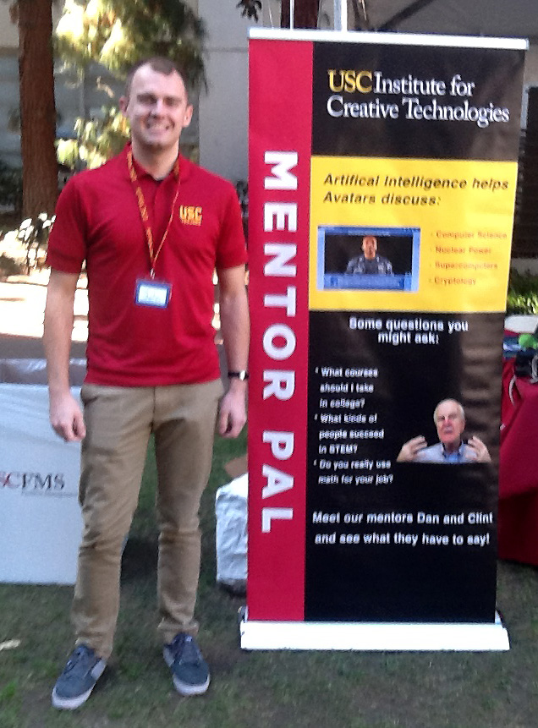

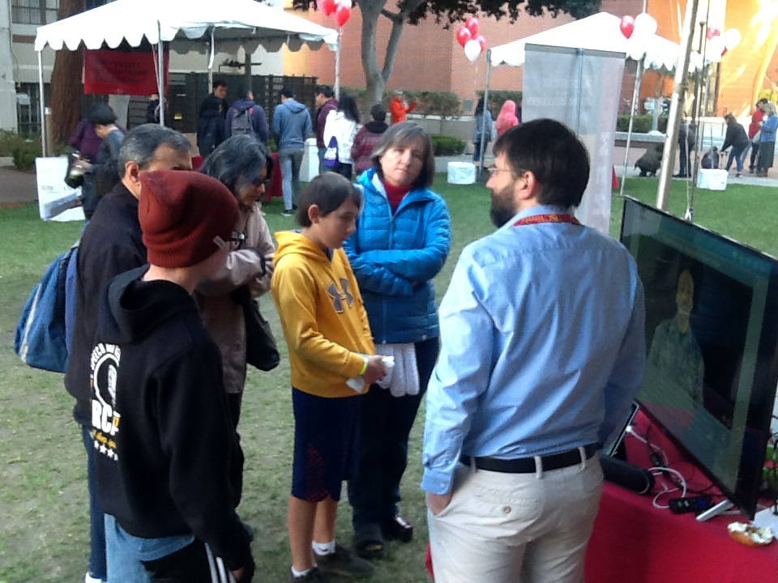

Figure 3. EngX Fair MentorPal Setup

The "traffic" through the MentorPal booth was high, with approximately 50% of passing groups stopping for a significant span of time. This amounted to several hundred "window shoppers" of whom the booth crew estimates that around 100 to 150, stopped long enough for a full demonstration and briefing. This good response was likely partly due to MentorPal's being the Fair exhibit that was the most clearly AI-relevant, as well as due to the use of a large banner (see images of the EngX fair in Figure 3). That was MIDN 1/ now C (ENS) Lazzeroni standing in to show the scale of the banner.

The EngX fair further reinforced earlier observations that students often were unable to think of many useful questions for MentorPal, *e.g*., the students said they didn’t know what to ask or asked questions unrelated to careers. This mirrors the experience of the MentorPal staff when they visited with high-school classes in earlier efforts to amass relevant questions. This behavior was particularly prevalent in students monitored by parents. However, students were more productive when they used the MentorPal menu that allowed generating questions from the topic categories that the team thought the students should be asking. In this fallback mode, rather than entering free-text questions, the users clicked on the topics to see suggested questions that they could ask. The menu-based experience resulted in a more traditional "question and answer" session than in a conversational dialogue. There are advantages to this mode: students may gain insight from reading the suggested questions and it does sidestep classification errors. By comparison, MentorPal appeared to respond to free text questions with reasonable answers about two-thirds of the time, while in the other cases, it answered inaccurately or had no answer. This is apparent accuracy is higher than the actual accuracy: leave-one-out testing found only about 50% for hold-out paraphrases matched their equivalent question [20].

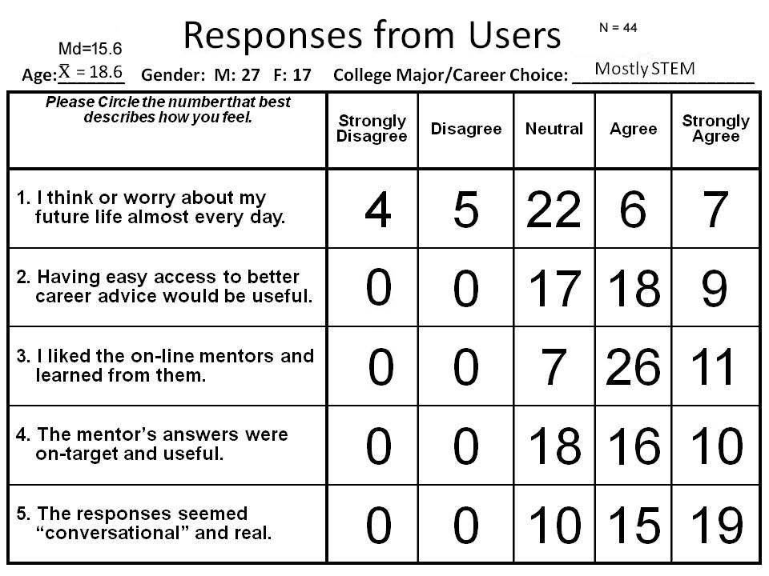

Table 1 Straw Poll Results

Students were content to ask questions from MentorPal for fairly long periods of time, approaching fifteen minutes. As the intent of the project was to create a conversational easiness with the student that would encourage the mentor-mentee relationship, one of the areas in which the team was most interested was the students’ view of their dialogue with the mentor.

Since this instance of use was as an exhibit, rather than as a research study, no formal survey was done of their views. However, to help gather feedback about how to improve the system and memorialize visitor reactions, a straw poll (Table 1) was offered to students and adults who spent substantial time interacting with the MentorPal mentors, either individually or as part of a group. Forty-four of the mentees completed it.

The responses were all "firewalled" to the right (Neutral, Agree, Strongly Agree), with virtually none receiving any "Strongly Disagree" or "Disagree Marks." Our hope of correlating some of the demographic data with the Likert responses has, so far, been frustrated by the low response rate of the already fairly limited number of all of the booth crew participants. Nonetheless, the responses do convey data from which the reader may draw some insights. Of particular note was the nearly universal commitment to participate in next years' EngX and the high marks given to MentorPal by users and by the parents. Reactions were positive overall for those who completed the poll, with 77% agreeing that the answers were conversational and 84% enjoying the experience. With that said, this sample is inherently biased, as this sample likely represents more motivated users than those who may be exposed to it on-line.

Among the new insights emerging from the MentorPal participation in EngX was in terms of its potential impact on the prospective users in the target audience. That was the interaction between the parents and the students. On the one hand, the booth crew reported that the parents were much more focused on the career choice facing their students. This seemed to drive productive questions to and answers from MentorPal on career selection and planning. However, this also caused the students to become more withdrawn and incommunicative; often the parents talked and the students just stood. While this is not hard evidence of the relevance of such behavior, all of the booth crew reported the same impression. By comparison, one-on-one interactions between a student and the virtual mentor tended to separate the students from the parent who otherwise interposed themselves as intermediaries. The tradeoff in this case was that students varied significantly in how focused their questions were, *e.g.*, some were more off-topic or asked about biographical details such as family members of the mentor, rather than being career focused.

Since students likely benefit more from the one-on-one interactions, *e.g*., they can ask their own questions, research is now looking into dialog techniques that help steer them toward more productive questions. Different strategies are being considered, which include the importance-weighting and answering non-germane questions with useful responses. Importance weighting would consider the research team’s assessment of the quality of the answer during the selection process, *e.g.*, rather than answer the “best match” from the classifier, instead use a weighted mixture that considers the content value. This should be particularly useful for vague questions, which are common for free text questions, *e.g*., “What do you like?”.

1. Simulation Potential and Research Directions

Having reviewed the results from testing with students so far, a number of possible approaches have been identified to improve the experience and information shared during a brief virtual mentoring session using this technology.

Expanding the Mentor Experience to Multiple Mentors

A variety of mentors is desirable to be able to find the most engaging and informative mentor for each mentee student. Then, on issue that arises is how to choose which virtual mentors to present. The mentees may not want to be constrained in talking to only one mentor, particularly if they feel they did not find that mentor interesting, relevant, or engaging. A series of one-on-one chats also makes it hard to see contrasting experiences. One approach to solve these issues is to consolidate mentors into a panel, where students can hear answers from several agents (see Figure 4). The agents may be chosen from a drop-down menu located in the dark blue round-ended box at the top right of the screen. Each agent responds to the question and the most relevant and accurate answer is displayed. Students can then listen to the other mentors’ responses to get a wider variety of experiences and opinions. Students may also choose a mentor to engage in an extended one-on-one dialog with just that one agent.

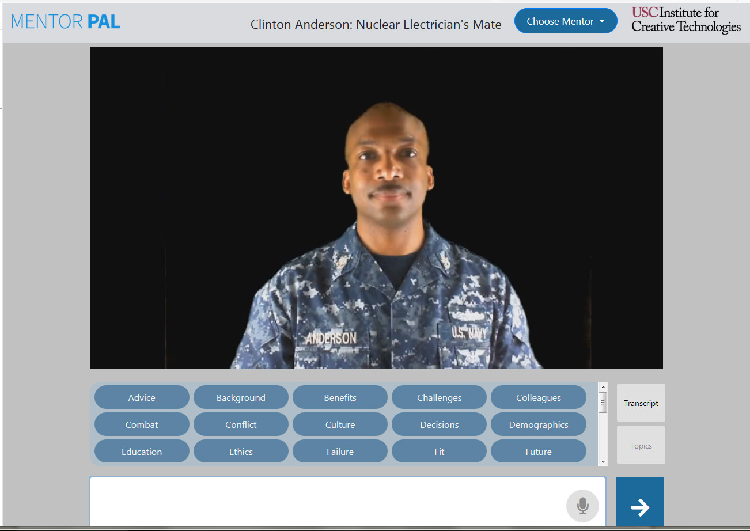

Figure 4. MentorPanel Prototype on 1680 x 1050 pixel screen

The main benefit of this approach is that students could hear from professionals spanning multiple STEM careers, of different ages, and of both genders. This allows them to see how those mentors' advice differ from or augment each other. Students who lack exposure to STEM careers may not know which fields they can explore, and this approach will give them an overview of several different career paths. They can then dive into a specific career or pick a mentor with whom they resonate.

Assisting the User with Salient Issues

The current group of taped mentors addressed STEM careers with answers that fairly were cogent and compelling, but the users’ ability to ask good questions was a primary limiting factor. This issue is not unique to MentorPal users [24]. This suggests that there is a pedagogical issue which must be addressed. For example, when piloting this research with the Next Generation Leaders mentoring program, their instructors preceded the interaction with a brief exercise where students discussed their most significant role models and the kinds of questions that they would want to ask them. After that interaction, they then reinforced lessons-learned by having a discussion about what were most interesting insights and about which parts of career choice the virtual mentor helped them come to appreciate. This was a very beneficial teacher-student interaction, and the research team is interested in seeing how different teachers might integrate this kind of integration of this genre of technology into larger lesson plans for their students.

This strategy might also be possible for virtual mentors to implement. This would require the virtual mentor to pose significant questions and respond meaningfully to those responses. This situation brings out a whole new area of computerized conceptualization and communication. At least for small question progressions, this might be accomplished even with video-based mentors. Perhaps this could be done within limited recording time with a small set of standardized questions like “Who are mentors in your life?”, “What are you worried about for your career?”, or “What parts of a career do you think are most important?” While processing these would require careful attention to the scope, asking germane but general questions has might be productive if well-founded and carefully bounded.

Porting the MentorPal Program to Use on the Web.

To meet several of the critical objectives of this initiative, accessibility via the internet is important, if not vital. Early in the spring of 2018, this task was passed to some of the programmers at ICT, including one of the visiting Research Assistants. This additional accessibility addresses the issues with geographical remoteness, SES isolation, and lack of family or neighborhood career focus that does not include the STEM professions.

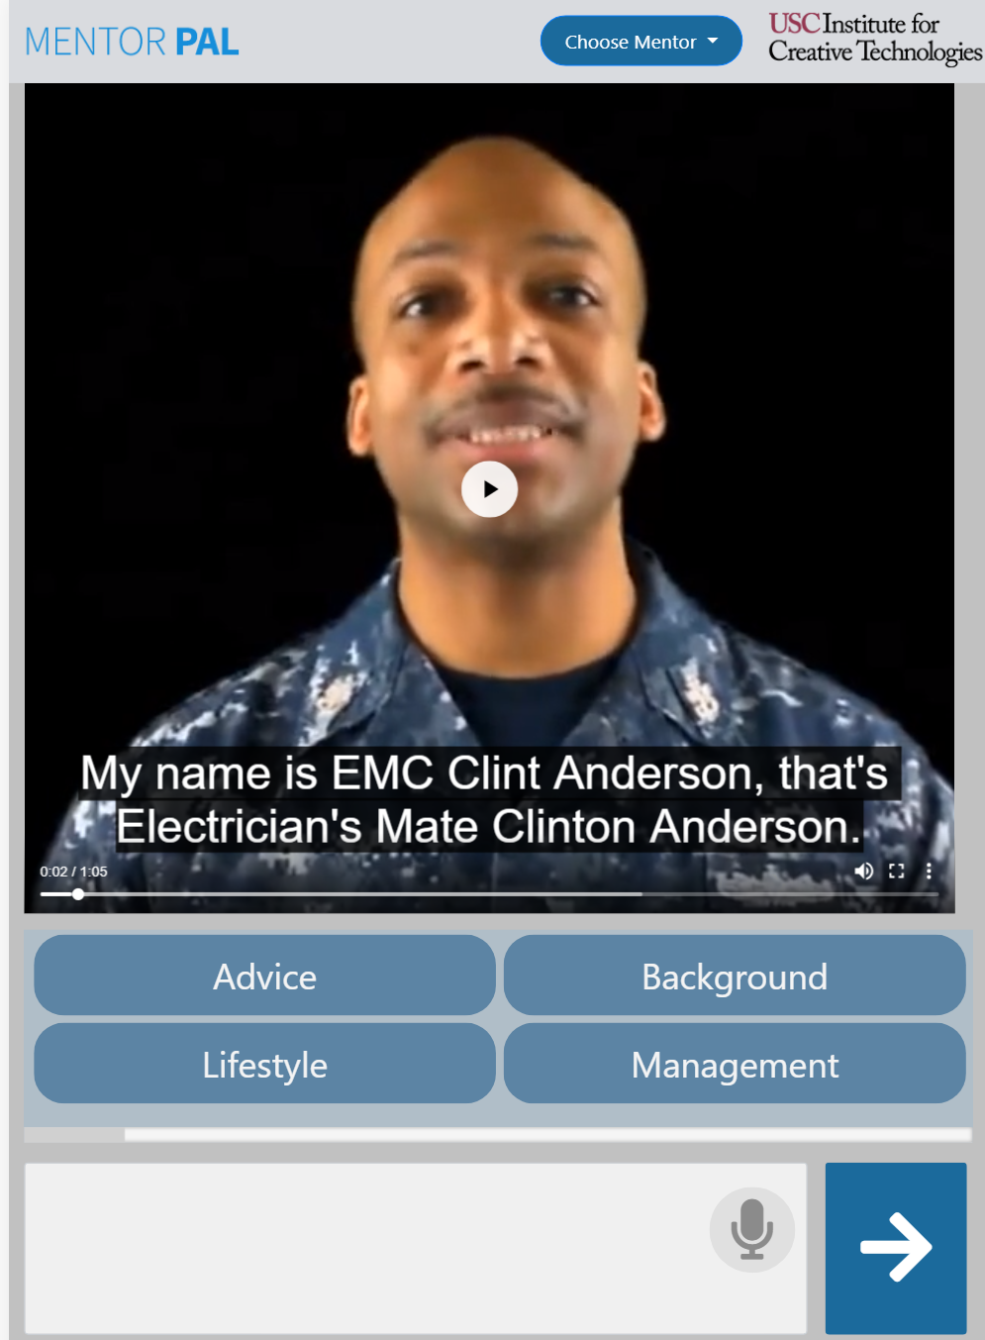To gain internet accessibility, the software required a sizeable redesign around the existing underlying natural language dialog technology. In the past, each MentorPal instance was deployed on custom installation Windows machines and launched with a Unity3D-powered interface instance as well as their own copy of a question-answering agent. However, to meet the demands of a web interface version, the natural language dialog agent was instead held centrally and modified to handle clients being connected using unique identification numbers from various locations. A separate backend Node.js server was then created to handle the interactive portions of the HTML5 interface to clients including routing and calling the dialog information from the Python model to clients using websockets. To optimize bandwidth usage, an additional video hosting platform handled various versions of the videos for different web browsers, including a cropped square version for the vertical mobile user interface, as shown in Figure 5.

Figure 5. MentorPal Mobile on iPhone

Deploying the modified dialogue technology with an existing web framework proved to not be an insurmountable issue, with much credit due to hardware independent Python code. However, it was found that the Virtual Private Server had stability issues handling multiple clients with multiple dialog models running simultaneously. In the past, each user’s devices required a substantial amount of software installed on them, but consequently the dialog model processing was distributed on onto comparatively powerful devices. To mitigate the server load after the unstable first deployment, it was thought that separating the dialog model from the web backend into two separate servers would provide a coarse distribution of load cycles.

However, after investigation to the server usage, it was found that loading the dialog models and Node backend was very RAM size dependent but not very CPU dependent; Unity3D required many of the CPU cycles on the laptops. Therefore, for the prototype, Solid State Drive (SSD) space was virtualized into RAM using a Swap file to stabilize the system. In theory, it was expected that this would cause erratic response times to clients. However, the swap file was swiftly able to optimize itself for efficiency and worked effectively for this usage. In addition, as a fallback, the server was wrapped into a very large Docker file. This allows for automated parallel deployment of multiple servers with identical configurations behind load balancers if required. This scalability would prove to be successful had more users needed to query MentorPal. With this, it was found that resources can be intelligently managed to still provide quality interactive experiences to many users inexpensively.

The inherent ability of the web enabled interface to be available anywhere instantly proved to be beneficial. When demonstrating the product, mentors could be instantaneously viewed and interacted with on the user’s own devices anywhere. However, the variation in clients that users could possibly have also proved to be a challenge, especially since the requirements of an interactive tutoring system is quite demanding on devices. Users could be using various input devices such as mouse, touchpad, or touch-screen so interfaces were reduced from proprietary advanced interfaces to universal simple scrollbars to support all users. In addition, portrait mobile browsers required a new interface entirely. Importantly, the videos had to be cropped to fill a larger part of the screen and the closed captioning system had to be edited to become useful on mobile versions while still being economical to recreate from the existing IBM Watson dialogs. Through this adaptation, MentorPal’s interface could adapt to any internet connected device.

In addition, to minimize potential issues on various browsers and operating systems, plug-ins such as Java or Flash were completely avoided and instead HTML5, native JavaScript and jQuery were implemented. However, some compatibility errors still did surface, especially from the Edge browser and iPhones. To find many of these errors, prototype frontends were released at weekly meetings where other researchers could visit the website and provide feedback on usability. This proved to be a very effective technique to aid in finding various client-side errors that would surface from range of interfaces. In the end, it was found that engaging mentoring experiences could be created for a variety of different clients using the lowest common denominator: HTML5.

Previous use-cases for the local network MentorPal also included other researchers in proximity with the user to assist them in using the product, but the web-oriented MentorPal.org approach has no such guarantee. This required an interactive tutorial and help page to allow users to orient themselves in MentorPal when they first visit the website. This addition also compelled users to interact with the web page before being greeted with the mentor, allowing proper loading time as well as the auto-enabling of HTML5 video playback by many web browsers. Future experiments around the product will be able to integrate around a web-based survey which will integrate MentorPal within it and orient users through the various features of MentorPal. This will provide a new user engagement metrics with the possibility of many more users possibly from all over the globe instead of from one targeted area.

1. Conclusions

The United States has a critical need for a continuing supply of STEM personnel. There are many students who are capable of this work who do not pursue that career choice of any number of reasons. One common set of these reasons centers on the lack of attractive and engaging role models of STEM professionals which leads to many misconceptions in the students' image of STEM careers. High School and adult counselors are hard pressed to make up for this information deficit. Both technical career events like EngX and on-line resources demonstrate a good potential for overcoming this serious national issue: the declining availability of competent technical personnel. The career fair approach is personal, engaging, and illuminating, but there is still the issue of getting under-represented groups to attend. The on-line method is available to low SES students and those who are geographically remote who otherwise have been, and will continue to be, left out. It is clear that there are many improvements on the horizon, but programs like the MentorPal system already shows promise as a mentoring conduit: allowing the most engaging set of mentors to communicate with a broader population of students.

The ICT MentorPal experience at the STEM fair indicated that students do engage effectively with this sort of virtual human conversation system in a one-on-one environment, but with they do need a suitable introduction to the appropriate goals and the focus of interactions with the system. While the amount of time for such interactions is only moderate, say up to 15 minutes, even for a small booth with five tablet computers, students spent many cumulative hours speaking with the virtual mentors, which is many more than the booth staff would have been able to accomplish alone. Given the limited availability of mentors and the desirability of instant access to a mentor on-demand, this particularly indicates that a network-wide, on-line delivery system for mentors would be ideal, as the current version runs only on-device.

There is a putative benefit of the MentorPal model, which is the opportunity to capture particularly engaging and compelling human mentors, even those who might become unavailable in the near future. For example, there is the case of Jaime Escalante, the renowned high school teacher of calculus. There are those who argue his skills were literally unique ones based on charisma and personal characteristics which cannot be readily taught or transferred to other teachers or role models [25]. Mr. Escalante has now passed away; so much of his personality is lost to us. Such mentors could communicate concepts for classroom instructor who would not have the same skill set.

A final concern is the adoption and support of this technical advancement by the educational establishment and counseling community. The authors are aware of many programs like Project Seed [26] which showed promise but were not adopted by the education leadership. It could be argued that the most effective implementation of this approach can only be realized with the support of the teaching community and existing networks for STEM mentors [27]. Such institutions are vital as a source for recruiting and recording mentors and as venues for encouraging interaction with virtual mentors. They would be the best suited to know who represent effective mentors for their student groups, where an ideal case might be to capture a highly-impactful real-life local mentor who is expected to become unavailable, e.g., move away. Toward that end, there is a strong interest in identifying how to help teachers and similar leaders record and refine mentors.

To sum up, the need for attracting the best candidates into technical work is a critical national trend. The authors and others continue to recognize huge gaps between the assumed and actual familiarity of students with technical careers and personnel, which can lead to unsustainable career choices. Both technical career fairs and virtual conversational mentors have a place in attacking these issues. The ones who are most in need are the lower SES students and those located far from major centers of technical and academic activity. However, even in STEM professional's homes, the authors often find little understanding among the children about what a technical person's workday looks like.

These observations lead to many open and desirable future research paths. Work in enhancing web based systems, creative conversational initiatives, and body-language/facial expression monitoring are offered as major priorities. Also on the docket of desired work is the easy design and fielding of mentor creation by computer users with little or no knowledge of programming or video production.

1. ACKNOWLEDGEMENTS

More than anyone else, the authors wish to express their appreciation for the MentorPal Principal Investigator, Dr. Benjamin Nye. His support and guidance is the foundation on which all this work was accomplished. MentorPal is supported by grants from the Office of Naval Research from the ONR STEM Program: Mentor PAL: Growing STEM Pipelines with Personalized Dialogs with Virtual STEM Professionals, N00014-16-1-2820. The statements and views expressed in this paper are the views of the authors alone and do not represent the views of the Office of Naval Research or the US Government. Additionally, we would like to acknowledge the leadership of Dr. Andrea Armani and the hospitality of the Armani Lab at the University of Southern California who organized the EngX STEM fair a test site for MentorPal.

1. References
2. *BLS,* *STEM 101: Intro to Tomorrow’s Jobs,* U.S. Bureau of Labor Statistics, Washington D.C., retrieved on 25 June 2018 from: https://www.bls.gov/careeroutlook/2014/spring/art01.pdf., 2014.

1. Strasburger, V. C., Hogan, M. J., Mulligan, D. A., Ameenuddin, N., Christakis, D. A., Cross, C.,... & Moreno, M. A., Children, Adolescents, and the Media, *Pediatrics,* 132(5), 958-961, 2013.

1. O'Brien, L. T., Blodorn, A., Adams, G., Garcia, D. M., & Hammer, E., Ethnic Variation in Gender-STEM Stereotypes and STEM Participation: An Intersectional Approach. *Cultural Diversity and Ethnic Minority Psychology*, 21(2), 169, 2015.

Greene, J. P., & Forster, G., Public High School Graduation and College Readiness Rates in the United States. Education Working Paper No. 3. *Center for Civic Innovation*, 2003.

1. Hossain, Md., Mokter; G. Robinson, & MichaelHow to motivate US students to pursue STEM (science, technology, engineering and mathematics) careers.  *US-China Education Review A 4* pp442-451 2012.
2. LA Times. *Top SAT Scores,* Los Angeles Times, retrieved from the internet on 01 July 2018, from: http://schools.latimes.com/sat-scores/ranking/page/1/

1. Larson, R. W., Richards, M. H., Moneta, G., Holmbeck, G., & Duckett, E. Changes in Adolescents' Daily Interactions with their Families from Ages 10 to 18: Disengagement and transformation. *Developmental Psychology,* 32(4), 744. 1996.
2. McCarthy, C., Van Horn Kerne, V., Calfa, N. A., Lambert, R. G., & Guzmán, M. An Exploration of School Counselors’ Demands and Resources: Relationship to Stress, Biographic, and Caseload Characteristics. Professional School Counseling, 13(3). 2010.
3. ASCA. *The NACAC and ASCA State-by-State Student-to-Counselor Ratio Report: Ten Year Trends*. American School Counselor Association. Retrieved from the Internet on 15 June 2018 from:  
   https://www.schoolcounselor.org/asca/media/asca/Publications/ratioreport.pdf 2018
4. U.S. Navy. *U.S, Navy Enlisted Ratings and Programs*, Retrieved from the Internet on 02 July 2018, from: https://www.navycs.com/navy-jobs/ 2018
5. Schiltz, P. J. (1999). On being a Happy, Healthy, and Ethical Member of an Unhappy, Unhealthy, and Unethical Profession. *Vanderbilt Law Review*, 52, 871.

1. Chowdhury, G. Natural Language Processing. *Annual Review of Information Science and Technology*, 37(1), 51-89. 2003.

1. Collobert, R., & Weston, J. (,). A Unified Architecture for Natural Language Processing: Deep Neural Networks with Multitask Learning.” In Proceedings of the *25th International Conference on Machine Learning* (pp. 160-167). July 2008.

1. Leuski, A., and Traum, D. : NPCEditor: Creating Virtual Human Dialogue using Information Retrieval Techniques. *AI Magazine* 32(2), 42–56. 2011.

1. Swartout, W., Traum, D., Artstein, R., Noren, D., Debevec, P., Bronnenkant, K., Williams, J., Leuski, A., Narayanan, S., *et al* ,Piepol, D.,. : Ada and grace: Toward Realistic and Engaging Virtual Museum Guides. In: *International Conference on Intelligent Virtual Agents*. pp. 286–300. Springer. 2010.

1. Traum, D., Jones, A., Hays, K., Maio, H., Alexander, O., Artstein, R., Debevec, P., Gainer, A., Georgila, K., *et al.* Haase, K., : New Dimensions in Testimony: Digitally Preserving a Holocaust Survivors Interactive Storytelling. In: *International Conference on Interactive Digital Storytelling*. pp. 269–281. Springer. 2015

1. Wang, J., Li, H., Cai, Z., Keshtkar, F., Graesser, A., Shaﬀer, D.W. : Automentor: Artificial Intelligent Mentor in Educational Game. In: *International Conference on Artificial Intelligence in Education*. pp. 940–941. Springer. 2013.

1. Dimitrova, V., and Brna, P. : From Interactive Open Learner Modeling to Intelligent Mentoring: Style-OLM and Beyond. *International Journal of Artificial Intelligence in Education* 26(1), 332–349. 2016.

1. Rizzo, A., Lange, B., Buckwalter, J.G., Forbell, E., Kim, J., Sagae, K., Williams, J., Difede, J., Rothbaum, B.O., Reger, G., et al. : Simcoach: an Intelligent Virtual Human System for Providing Healthcare Information and Support. *International Journal on Disability and Human Development* 10(4), 277–281. 2011.

1. Nye, B., Swartout, W., Campbell, J., Krishnamachari, M., Kaimakis, N., Davis, D. : MentorPal: Interactive Virtual Mentors Based on Real-life STEM Professionals. In: *Proceedings of the Interservice/Industry Simulation, Training and Education Conference* (I/ITSEC). 2017.

1. Brooks, F. , *The Mythical Man - Month. Anniversary Edition*, Boston, MA: Addison-Wesley Professional. 1995.

1. Mikolov, T., Sutskever, I., Chen, K., Corrado, G.S., Dean, J. : Distributed representations of Words and Phrases and their Compositionality. In: *Advances in Neural Information Processing System*s. pp. 3111–3119 2013.

1. Kaimakis, N., Davis, D., Breck, S., Nye, B. : Domain-specific Reduction of Language Model Databases: Overcoming Chatbot Implementation Obstacles. In: *Proceedings of the ModSim World Conference*. 2018.
2. Beck, S., Carr, K., Davis, D. M., Nordhagen, J. N., and Nye, B. D. Virtual Mentors in a Real STEM Fair: Experiences, Challenges, and Opportunities ".In *Third International Workshop on Intelligent Mentoring Systems (IMS 2018) Proceedings*. 2018.

1. Jesness, J. : Stand and Deliver Revisited. *Reason* 34(3), 34–39. 2002.

1. Phillips, S., & Ebrahimi, H. *Equation for success: Project SEED*. Reaching all students with mathematics, 244. 1993.

1. Smith, A., Anderson, J. : *AI, Robotics, and the Future of Jobs*. Pew Research Center 6. 2014.

Authors’ Biographies

**Dan M. Davis** is now a consultant for the University of Southern California, focusing on large-scale distributed DoD training, education and avatar mentors. Pre-retirement, he was the Director of USC’s JESPP project for JFCOM for a decade. As the Assistant Director of the Center for Advanced Computing Research at Caltech, he managed Synthetic Forces Express, bringing HPC to DoD simulations. Prior experience includes serving as a Director at the Maui High Performance Computing Center and as a Software Engineer at the Jet Propulsion Laboratory and Martin Marietta. He has served as the Chairman of the Coalition of Academic Supercomputing Centers and has taught at the undergraduate and graduate levels. As early as 1971, Dan was writing programs in FORTRAN on one of Seymour Cray’s CDC 6500’s. He saw duty in Vietnam as a USMC Cryptologist and retired as a Commander, Cryptologic Specialty, U.S.N.R. He received B.A. and J.D. degrees from the University of Colorado in Boulder.

**Karen B. Predovich** continues to consult in educational matters after retiring as a long-time high school counselor for pre-college students in a modestly sized Colorado city. She was active in her professional life in finding assets for students outside of major metropolitan areas, where professional role models and mentors are very difficult to locate. Her observations have resulted in a professional stance of articulating the need for and the parameters of a new approach to guidance counseling on a national basis. Karen has focused decades of her counseling in characterizing the difficulties of finding technically oriented mentors in geographically remote or socially isolated areas. She received a BA and an MA in Guidance and Counseling from Western State Colorado University (formerly Western State College of Colorado.)

**Frederica J. Stassi. Ed.D**. is a Science Education Analyst working in the Central Coast of California. Her background includes research for the National Science Foundation in which she was funded to study pedagogies and efficacy in U.S. Science museums. This research involved museums from the East Coast to O‛ahu in Hawai‛i. Her doctoral research was conducted under the guidance of Professor William McComas and focused on the development of science standards for the State of California. In the past, she has been on the research staff at both the California Institute of Technology (Caltech) and the Information Sciences Institute of the University of Southern California. She received a BA degree from Tabor college, as well as an M.A. Degree in music performance and an Ed.D., both from the University of Southern California.

**Howard Spaulding** is a retired Cryptologic Technician (Interpretive) Senior Chief Petty Officer and recently retired from Schneider National where his duties focused on training. His military service spanned three decades including 28 months in Viet Nam as a Marine Cryptologic Linguist. His Naval service included tours in the Philippines, Thailand and Japan. He also served as the Assistant Officer in Charge during the development of a highly technical project under the supervision of CNSG and SPAWAR and was instrumental in the interior design of the ES-3A Aircraft. He made two deployments aboard an Allied Naval vessel as the lone area/target expert. He has been at the forefront of career path decisions of other personnel in both the military and civilian sectors. He received a BA from California State University, Long Beach in 1983 while still on active duty.

**Kenneth Shaw** is a visiting Research Assistant at the Institute for Creative Technologies of the University of Southern California. He was selected to participate in the National Science Foundation’s Research Experiences for Undergraduates in 2018. His major interests in research include creating life-like interactive experiences using artificial intelligence and motion-planning or decision making for robots. In addition, he is designing and producing new weather balloon electronics and software to better monitor lightning storms at his home institution, as well as consumer-facing utilities on the Blockchain. He is currently studying Computer Engineering and Computer Science in Intelligence at the Georgia Institute of Technology.