In [1]:
%%bash
if [ -d "./blood_cells_data/dataset2-master" ]; then
echo "Dataset already exists, skipping download."
else
echo "Dataset not found, downloading..."
kaggle datasets download -d paultimothymooney/blood-cells --force unzip -q blood-cells.zip -d ./blood_cells_data
fi

Dataset not found, downloading...
Warning: Looks like you're using an outdated `kaggle` version (installed: 2.0.2), please consider upgrading to the latest version (2.2.2)
Dataset URL: https://www.kaggle.com/datasets/paultimothymooney/blood-cells License(s): other
Downloading blood-cells.zip to /content
100%|██████████| 108M/108M [00:00<00:00, 246MB/s]

In [2]:
import os
import glob
import numpy as np
import matplotlib.pyplot as plt
import tensorflow as tf

In [3]:
train_dir = './blood_cells_data/dataset2-master/dataset2-master/images/TRAIN'

train_ds = tf.keras.utils.image_dataset_from_directory( train_dir,
validation_split=0.2, subset="training",
seed=123,
image_size=(128, 128), batch_size=32,
label_mode="categorical"
)

val_ds = tf.keras.utils.image_dataset_from_directory( train_dir,
validation_split=0.2, subset="validation", seed=123,
image_size=(128, 128), batch_size=32,
label_mode="categorical"
)

class_names = train_ds.class_names

normalization_layer = tf.keras.layers.Rescaling(1./255)
train_ds = train_ds.map(lambda x, y: (normalization_layer(x), y)) val_ds = val_ds.map(lambda x, y: (normalization_layer(x), y))

train_ds = train_ds.cache().prefetch(buffer_size=tf.data.AUTOTUNE) val_ds = val_ds.cache().prefetch(buffer_size=tf.data.AUTOTUNE)

Found 9957 files belonging to 4 classes. Using 7966 files for training.
Found 9957 files belonging to 4 classes. Using 1991 files for validation.

In [4]:
model = tf.keras.models.Sequential([
tf.keras.layers.Input(shape=(128, 128, 3)),
tf.keras.layers.Conv2D(32, (3, 3), activation='relu'),
tf.keras.layers.MaxPooling2D((2, 2)),
tf.keras.layers.Conv2D(64, (3, 3), activation='relu'),
tf.keras.layers.MaxPooling2D((2, 2)), tf.keras.layers.Flatten(),
tf.keras.layers.Dense(128, activation='relu'), tf.keras.layers.Dense(4, activation='softmax')
])

model.compile(
optimizer='adam',
loss='categorical_crossentropy', metrics=['accuracy']
)

model.summary()

Model: "sequential"
┏━━━━━━━━━━━━━━━━━━━━━━━━━━━━━━━━━┳━━━━━━━━━━━━━━━━━━━━━━━━┳━━━━━━━━━━━━━━
┃ Layer (type) ┃ Output Shape ┃ Param #
┡━━━━━━━━━━━━━━━━━━━━━━━━━━━━━━━━━╇━━━━━━━━━━━━━━━━━━━━━━━━╇━━━━━━━━━━━━━━
│ conv2d (Conv2D) │ (None, 126, 126, 32) │ 896
├─────────────────────────────────┼────────────────────────┼──────────────
│ max_pooling2d (MaxPooling2D) │ (None, 63, 63, 32) │ 0
├─────────────────────────────────┼────────────────────────┼──────────────
│ conv2d_1 (Conv2D) │ (None, 61, 61, 64) │ 18,496
├─────────────────────────────────┼────────────────────────┼──────────────
│ max_pooling2d_1 (MaxPooling2D) │ (None, 30, 30, 64) │ 0
├─────────────────────────────────┼────────────────────────┼──────────────
│ flatten (Flatten) │ (None, 57600) │ 0
├─────────────────────────────────┼────────────────────────┼──────────────
│ dense (Dense) │ (None, 128) │ 7,372,928
├─────────────────────────────────┼────────────────────────┼──────────────
│ dense_1 (Dense) │ (None, 4) │ 516
└─────────────────────────────────┴────────────────────────┴──────────────
C C
Total params: 7,392,836 (28.20 MB)
Trainable params: 7,392,836 (28.20 MB)
Non-trainable params: 0 (0.00 B)
In [5]:
history = model.fit( train_ds,
validation_data=val_ds, epochs=10
)

Epoch 1/10
249/249 ━━━━━━━━━━━━━━━━━━━━ 16s 45ms/step - accuracy: 0.3082 - loss: 1.4210 - va l_accuracy: 0.2431 - val_loss: 1.3880
Epoch 2/10
249/249 ━━━━━━━━━━━━━━━━━━━━ 4s 15ms/step - accuracy: 0.3286 - loss: 1.3303 - val
_accuracy: 0.3923 - val_loss: 1.2625 Epoch 3/10
249/249 ━━━━━━━━━━━━━━━━━━━━ 4s 15ms/step - accuracy: 0.4276 - loss: 1.2147 - val
_accuracy: 0.4309 - val_loss: 1.1994 Epoch 4/10
249/249 ━━━━━━━━━━━━━━━━━━━━ 4s 15ms/step - accuracy: 0.5222 - loss: 1.0502 - val
_accuracy: 0.5103 - val_loss: 1.0588 Epoch 5/10
249/249 ━━━━━━━━━━━━━━━━━━━━ 4s 15ms/step - accuracy: 0.6215 - loss: 0.8891 - val
_accuracy: 0.5008 - val_loss: 1.1275 Epoch 6/10
249/249 ━━━━━━━━━━━━━━━━━━━━ 4s 15ms/step - accuracy: 0.7179 - loss: 0.6969 - val
_accuracy: 0.5123 - val_loss: 1.2245 Epoch 7/10
249/249 ━━━━━━━━━━━━━━━━━━━━ 4s 15ms/step - accuracy: 0.8030 - loss: 0.5256 - val
_accuracy: 0.5324 - val_loss: 1.3523 Epoch 8/10
249/249 ━━━━━━━━━━━━━━━━━━━━ 4s 15ms/step - accuracy: 0.8522 - loss: 0.4111 - val
_accuracy: 0.4882 - val_loss: 1.8827 Epoch 9/10
249/249 ━━━━━━━━━━━━━━━━━━━━ 4s 15ms/step - accuracy: 0.8947 - loss: 0.2991 - val
_accuracy: 0.5073 - val_loss: 1.8016 Epoch 10/10
249/249 ━━━━━━━━━━━━━━━━━━━━ 4s 15ms/step - accuracy: 0.9352 - loss: 0.1982 - val
_accuracy: 0.5048 - val_loss: 1.9906

In [6]:
plt.figure(figsize=(10, 5))
plt.plot(history.history['accuracy'], label='Training Accuracy')
plt.plot(history.history['val_accuracy'], label='Validation Accuracy') plt.xlabel('Epoch')
plt.ylabel('Accuracy') plt.legend()
plt.title('Training and Validation Accuracy') plt.show()

final_val_acc = history.history['val_accuracy'][-1]
print(f"Final Validation Accuracy: {final_val_acc:.4f}")

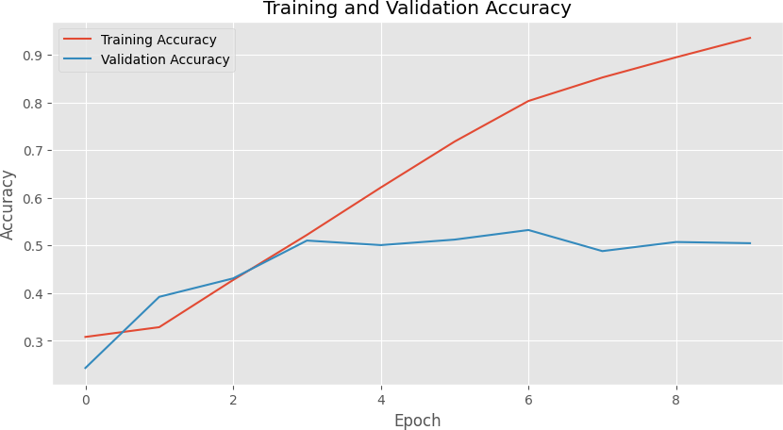
Final Validation Accuracy: 0.5048

In [7]:
test_images = glob.glob('./blood_cells_data/dataset2-master/dataset2-master/imag if test_images:
test_img_path = test_images[0]
img = tf.keras.utils.load_img(test_img_path, target_size=(128, 128)) img_array = tf.keras.utils.img_to_array(img)
img_array = normalization_layer(img_array) img_array = tf.expand_dims(img_array, 0)

predictions = model.predict(img_array)
predicted_class = class_names[np.argmax(predictions[0])]

print(f"Test Image Path: {test_img_path}")
print(f"Predicted Class Label: {predicted_class}")

else:
print("No test images found.")
1/1 ━━━━━━━━━━━━━━━━━━━━ 1s 581ms/step
Test Image Path: ./blood_cells_data/dataset2-master/dataset2-master/images/TEST/M ONOCYTE/_2_966.jpeg
Predicted Class Label: MONOCYTE

