In [11]:
%%bash
if [ -d "./blood_cells_data/dataset2-master" ]; then
echo "Dataset already exists, skipping download."
else
echo "Dataset not found, downloading..."
kaggle datasets download -d paultimothymooney/blood-cells --force unzip -q blood-cells.zip -d ./blood_cells_data
fi

Dataset already exists, skipping download.

In [12]:
import os
import matplotlib.pyplot as plt
import tensorflow as tf
from tensorflow.keras.preprocessing.image import ImageDataGenerator
from tensorflow.keras import mixed_precision

policy = mixed_precision.Policy('mixed_float16') mixed_precision.set_global_policy(policy)

In [13]:
train_dir = './blood_cells_data/dataset2-master/dataset2-master/images/TRAIN'

train_datagen = ImageDataGenerator( rescale=1./255,
rotation_range=20,
horizontal_flip=True, zoom_range=0.2,
validation_split=0.2
)

train_generator = train_datagen.flow_from_directory( train_dir,
target_size=(128, 128), batch_size=32,
class_mode='categorical', subset='training',
seed=123
)

val_generator = train_datagen.flow_from_directory( train_dir,
target_size=(128, 128), batch_size=32,
class_mode='categorical', subset='validation',
seed=123
)

Found 7968 images belonging to 4 classes. Found 1989 images belonging to 4 classes.

In [14]:
model = tf.keras.models.Sequential([
tf.keras.layers.Input(shape=(128, 128, 3)),
tf.keras.layers.Conv2D(32, (3, 3), activation='relu'),
tf.keras.layers.MaxPooling2D((2, 2)),
tf.keras.layers.Conv2D(64, (3, 3), activation='relu'),
tf.keras.layers.MaxPooling2D((2, 2)), tf.keras.layers.Flatten(),
tf.keras.layers.Dense(128, activation='relu'),

tf.keras.layers.Dense(4, activation='softmax', dtype='float32')
])

model.compile(
optimizer='adam',
loss='categorical_crossentropy', metrics=['accuracy']
)

model.summary()
Model: "sequential_2"
┏━━━━━━━━━━━━━━━━━━━━━━━━━━━━━━━━━┳━━━━━━━━━━━━━━━━━━━━━━━━┳━━━━━━━━━━━━━━
┃ Layer (type) ┃ Output Shape ┃ Param #
┡━━━━━━━━━━━━━━━━━━━━━━━━━━━━━━━━━╇━━━━━━━━━━━━━━━━━━━━━━━━╇━━━━━━━━━━━━━━
│ conv2d_4 (Conv2D) │ (None, 126, 126, 32) │ 896
├─────────────────────────────────┼────────────────────────┼──────────────
│ max_pooling2d_4 (MaxPooling2D) │ (None, 63, 63, 32) │ 0
├─────────────────────────────────┼────────────────────────┼──────────────
│ conv2d_5 (Conv2D) │ (None, 61, 61, 64) │ 18,496
├─────────────────────────────────┼────────────────────────┼──────────────
│ max_pooling2d_5 (MaxPooling2D) │ (None, 30, 30, 64) │ 0
├─────────────────────────────────┼────────────────────────┼──────────────
│ flatten_2 (Flatten) │ (None, 57600) │ 0
├─────────────────────────────────┼────────────────────────┼──────────────
│ dense_4 (Dense) │ (None, 128) │ 7,372,928
├─────────────────────────────────┼────────────────────────┼──────────────
│ dense_5 (Dense) │ (None, 4) │ 516
└─────────────────────────────────┴────────────────────────┴──────────────
C C
Total params: 7,392,836 (28.20 MB)
Trainable params: 7,392,836 (28.20 MB)
Non-trainable params: 0 (0.00 B)
In [15]:
history = model.fit( train_generator,
validation_data=val_generator, epochs=7,
)

Epoch 1/7
249/249 ━━━━━━━━━━━━━━━━━━━━ 56s 196ms/step | - accuracy: | 0.2460 | - loss: | 1.4987 | - v
al_accuracy: 0.2489 - val_loss: 1.3863
Epoch 2/7
249/249 ━━━━━━━━━━━━━━━━━━━━ 46s 183ms/step | - accuracy: | 0.2427 | - loss: | 1.3865 | - v
al_accuracy: 0.2484 - val_loss: 1.3863
Epoch 3/7
249/249 ━━━━━━━━━━━━━━━━━━━━ 47s 188ms/step | - accuracy: | 0.2456 | - loss: | 1.3864 | - v
al_accuracy: 0.2494 - val_loss: 1.3863
Epoch 4/7
249/249 ━━━━━━━━━━━━━━━━━━━━ 46s 184ms/step | - accuracy: | 0.2486 | - loss: | 1.3865 | - v
al_accuracy: 0.2383 - val_loss: 1.3865
Epoch 5/7
249/249 ━━━━━━━━━━━━━━━━━━━━ 45s 180ms/step | - accuracy: | 0.2515 | - loss: | 1.3877 | - v
al_accuracy: 0.2629 - val_loss: 1.3853
Epoch 6/7
249/249 ━━━━━━━━━━━━━━━━━━━━ 47s 187ms/step | - accuracy: | 0.2422 | - loss: | 1.3868 | - v
al_accuracy: 0.2484 - val_loss: 1.3864
Epoch 7/7
249/249 ━━━━━━━━━━━━━━━━━━━━ 45s 182ms/step | - accuracy: | 0.2436 | - loss: | 1.3866 | - v
al_accuracy: 0.2509 - val_loss: 1.3867

In [16]:
plt.figure(figsize=(12, 5))

plt.subplot(1, 2, 1)
plt.plot(history.history['loss'], label='Training Loss')
plt.plot(history.history['val_loss'], label='Validation Loss') plt.xlabel('Epoch')
plt.ylabel('Loss') plt.legend()
plt.title('Training and Validation Loss')

plt.subplot(1, 2, 2)
plt.plot(history.history['accuracy'], label='Training Accuracy')
plt.plot(history.history['val_accuracy'], label='Validation Accuracy') plt.xlabel('Epoch')
plt.ylabel('Accuracy') plt.legend()
plt.title('Training and Validation Accuracy')

plt.tight_layout() plt.show()

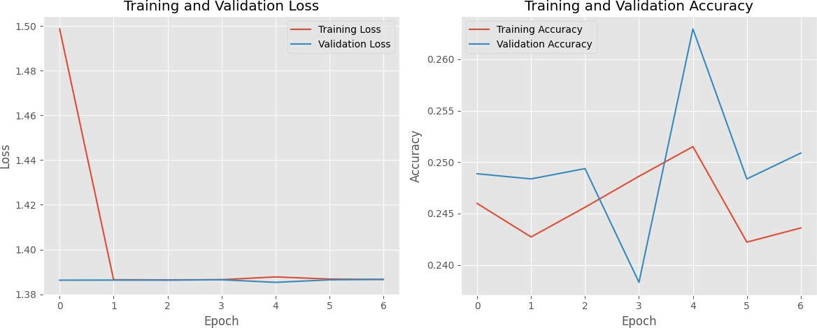

Task 3: Performance Analysis Comments

- Overfitting: If the training loss decreases while the validation loss increases (or
stalls), or if there is a wide, increasing gap between training accuracy and validation accuracy, the model is overfitting.
- Underfitting: If both training and validation accuracies remain low or fail to improve
significantly over epochs, the model is underfitting.
- Well-fitted: If training and validation losses decrease steadily together and reach a similar low value, and the validation accuracy tracks the training accuracy closely, the model is well-fitted.

