Software Requirements Specification

for

InvestiFull Version 1.0

Prepared by Brian Peters, Dylan Whitehead, Austin Oakes, Ryan Driver, and Anthony Criscione

2/21/20

Table of Contents

Table of Contents ii

Revision History iii

1. Introduction: 1

1.1 Purpose 1

1.2 Document Conventions 1

1.3 Intended Audience and Reading Suggestions 1

1.4 Product Scope 1

1.5 References 1

2. Overall Description 2

2.1 Product Perspective 2

2.2 Product Functions 2

2.3 User Classes and Characteristics 3

2.4 Operating Environment 3

2.5 Design and Implementation Constraints 3

2.6 User Documentation 3

2.7 Assumptions and Dependencies 3

3. External Interface Requirements 3

3.1 User Interfaces 3

3.2 Hardware Interfaces 3

3.3 Software Interfaces 4

3.4 Communications Interfaces 4

4. System Features 4

4.1 Populate New Database - High Priority 4

4.2 Delete Database - Medium Priority 5

4.3 Append Database – Medium Priority 6

4.4 Search- High Priority 8

5. Other Nonfunctional Requirements 9

5.1 Performance Requirements 9

5.2 Safety Requirements 9

5.3 Security Requirements 9

5.4 Software Quality Attributes 10

5.5 Business Rules 10

6. Other Requirements 11

Appendix A: Glossary 11

Appendix B: Analysis Models 12

Appendix C: To Be Determined List: 12

Revision History

|  |  |  |  |
| --- | --- | --- | --- |
| **Name** | **Date** | **Reason for Changes** | **Version** |
| Dylan Whitehead, Brian Peters | 2/17/20 | Document creation | 1.0 |
|  |  |  |  |

# Introduction:

## Purpose

This document outlines the requirements involved in the development of InvestiFull. InvestiFull is a piece of software that provides topological information on fullerenes that exist within a given range of carbon atoms, up to two hundred. InvestiFull is a python program that interfaces with an SQLite database, and the Fortran program ‘Spiral.f’ to produce an adjacency matrix, chart, and Schlegell diagram for each desired fullerene.

## Document Conventions

IEEE standards for document formatting and references to outside sources are followed throughout documentation for the InvestiFull project.

## Intended Audience and Reading Suggestions

This document is intended for Professor Patricia Hillman, the instructor of CSCI 408: Software Engineering at Edinboro University, as well as our client Dr. Douglas Puharic. Furthermore, InvestiFull is designed for use by graph theorists looking to use the topology of fullerenes for various research purposes.

The remaining sections of the project document hold information concerning the requirements imposed on the interface and visual imagery methods, as well as an outline on external resources utilized to accomplish these methods. If you need information about fullerenes and the various input needed to create Schlegell diagrams, please refer to the section **1.5: References**. For more information about fullerenes view the glossary at the end of the document.

## Product Scope

InvestiFull produces an adjacency matrix, chart, and Schlegell diagram to represent the topology of fullerenes based on a range of carbon atoms input by the user. The goal of the project is to dynamically populate a database of ready to use adjacency matrices that aid graph theorists in their research.

## References

[1] Csgorham, “csgorham/kinked_chain,” GitHub, 05-Aug-2015. [Online]. Available: https://github.com/csgorham/kinked_chain. [Accessed: 17-Feb-2020].

[2] D.R. Walton and H. W. Kroto, “Encyclopædia Britannica,” Encyclopædia Britannica, inc, 13 03 2019. [Online]. Available: https://www.britannica.com/science/fullerene. [Accessed 18 02 2020]

[3] E. M. Lazar, “Schlegel Diagrams,” Bar-llan University, [Online]. Available:

http://u.math.biu.ac.il/~mlazar/schlegels.html. [Accessed 20 2 2020].

[4] M. Jones, “Encyclopædia Britannica,” Encyclopædia Britannica, inc, 18 10 2016. [Online]. Available: https://www.britannica.com/science/isomerism. [Accessed 26 02 2020]

# Overall Description

## Product Perspective

InvestiFull is a program that utilizes the existing Spiral.f program [1] that produces information on the topology of fullerene molecules that can be created with a range of carbon atoms given by the user. InvestiFull uses Spiral.f to populate a database with fullerene topological information and allow for users to search and display that information.

See Figure 3 for Use-case diagram.

## Product Functions

* Add New
  + Add a new database to be populated with the topology of the desired fullerenes based on a given range of carbon atoms.
* Delete
  + Delete an existing database.
* Append
  + Add fullerene topological information to an existing database.
* Search
  + Search for a specific fullerene based on isomer to have the topological information displayed.

## User Classes and Characteristics

The primary intended user class for InvestiFull is graph theorists. They are expected to utilize all functionalities provided by the software and are expected to understand fullerenes and their topology.

## Operating Environment

InvestiFull is intended for a Linux machines of any distribution. InvestiFull has no dependencies as it comes packaged with all required software.

## Design and Implementation Constraints

InvestiFull must properly interface with both the provided Spiral.f program [1], and SQLite for databasing. InvestiFull was written using the Python programming language, version 3.7.4.

## User Documentation

For user information, refer to both the README file attached to the InvestiFull program, as well as the README included for the Spiral.f [1] program.

## Assumptions and Dependencies

The spiral algorithm implemented by the Fortran program, Spiral.f, is only reliable in calculating the topology of fullerenes produced with up to two hundred carbon molecules. Consequently, this limitation is currently present in InvestiFull.

# External Interface Requirements

## User Interfaces

* Buttons performing these actions which are specified in detail in section 4
  + Populate New Database
  + Delete Database
  + Append Database
  + Search

## Hardware Interfaces

* No special hardware interface requirements or restrictions apply.

## Software Interfaces

* InvestiFull is developed in the programing language Python version 3.7.4. It is portable across different operating systems and tested in a Linux Fedora 32 environment.
* The Fortran program Spiral.f [1] is utilized to obtain topological information on each fullerene.
  + This program takes in a range of carbon atoms, produce an adjacency matrix, and topological chart associated with each fullerene.
* The library SQLite3 is utilized to create SQL databases.
  + The databases store thee adjacency matrix, topological chart, and Schlegell diagram associated with each fullerene.

## Communications Interfaces

None currently apply.

# System Features

## Populate New Database - High Priority

4.1.1 InvestiFull populates a new database, created by SQLite with all fullerene topologies within a specified range of carbon atoms.

4.1.2 The sequence of actions is as follows:

* + The user provides either a range of carbon atoms or a specific carbon atom count to InvestiFull as well as a 0 or a 1. A 0 will indicate that the user wants to include fullerenes with a topology containing touching pentagons, whereas a 1 will indicate the user wants to exclude those fullerenes.
  + Spiral.f produces the adjacency matrix and topological chart related to each specific fullerene.
  + For each fullerene, InvestiFull creates a Schlegell diagram based off its adjacency matrix that was generated by Spiral.f.
  + InvestiFull creates a new database with the SQLite API.
  + The new database is populated with the adjacency matrices and chart information pertaining to the fullerene topologies, along with the Schlegell diagrams by InvestiFull.

4.1.3 Functional Requirements:

**REQ-1:** InvestiFull validates that the users input carbon count is within the supported range of 0 – 200 carbon atoms before calling Spiral.f and feeding it the carbon atom count and desired pentagon rule.

**REQ-2:** InvestiFull creates a new database using SQLite which is populated with the topological information by InvestiFull. The database produced by InvestiFull will conform to Boyce-Codd normal form.

**REQ-3:** In the case that the user attempts to populate a new database without enough disc space, SQLite throws an error which InvestiFull handles and notifies the user via an error message displayed on screen. The new database is not created.

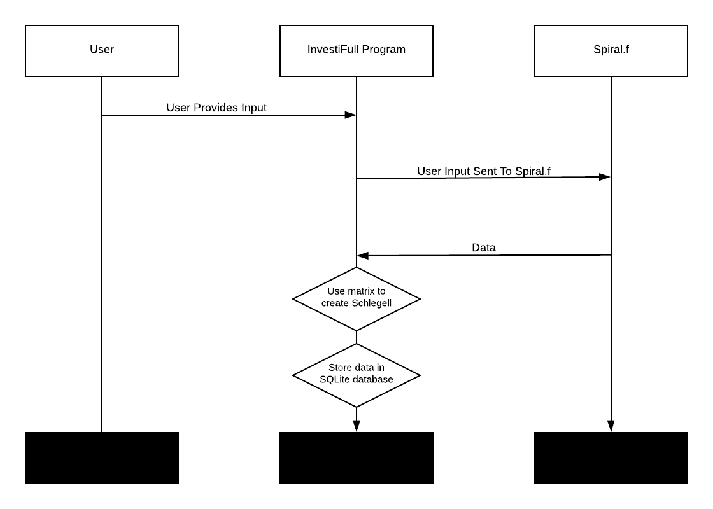

## Delete Database - Medium Priority

4.2.1 InvestiFull deletes the database chosen by the user.

4.2.2 The sequence of actions is as follows:

* User selects the intended database.
* SQLite’s API is utilized by InvestiFull to delete the database.
* InvestiFull triggers a display letting the user know when the deletion process has been completed by SQLite.

4.2.3 Functional Requirements:

**REQ-1:**InvestiFull validates that the database selected by the user exists.

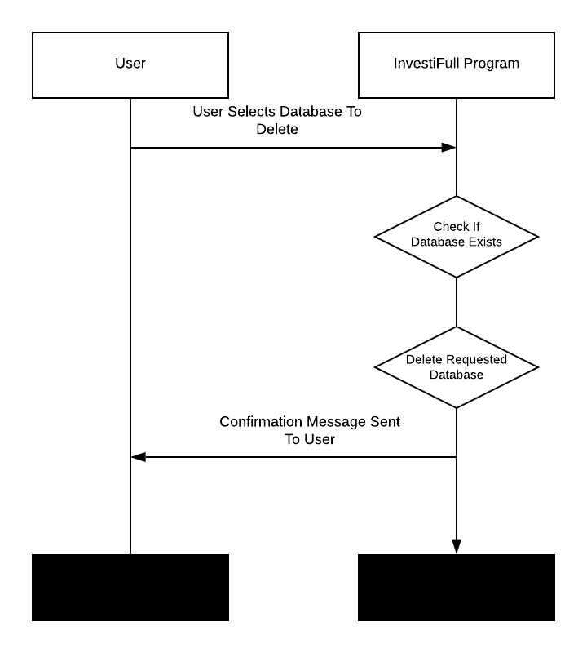**REQ-2:** InvestiFull deletes the database using SQLite.

## Append Database – Medium Priority

4.3.1 InvestiFull adds new records to an existing database.

4.3.2 The sequence of actions is as follows:

* The user selects the intended database
* The user provides either a range of carbon atoms or a specific carbon atom count to InvestiFull as well as a 0 or a 1. A 0 will indicate that the user wants to include fullerenes with a topology containing touching pentagons, whereas a 1 will indicate the user wants to exclude those fullerenes.
* Spiral.f produces the adjacency matrix and topological chart related to each specific fullerene.
* For each fullerene, InvestiFull creates a Schlegell diagram based off its adjacency matrix that was generated by Spiral.f.
* The selected database is populated with the adjacency matrices and chart information pertaining to the fullerene topologies, along with the Schlegell diagrams by InvestiFull.

4.3.3 Functional Requirements:

**REQ-1:** InvestiFull validates that the users input carbon count is within the supported range of 0 – 200 carbon atoms before calling Spiral.f and feeding it the carbon atom count and desired pentagon rule.

**REQ-2:** InvestiFull checks to see if the selection is a valid database.

**REQ-3:** InvestiFull adds to the intended database.

**REQ-4:** In the case that the user attempts to populate a new database without enough disc space, SQLite throws an error which InvestiFull handles and notifies the user via an error message displayed on screen. The new database is not created.

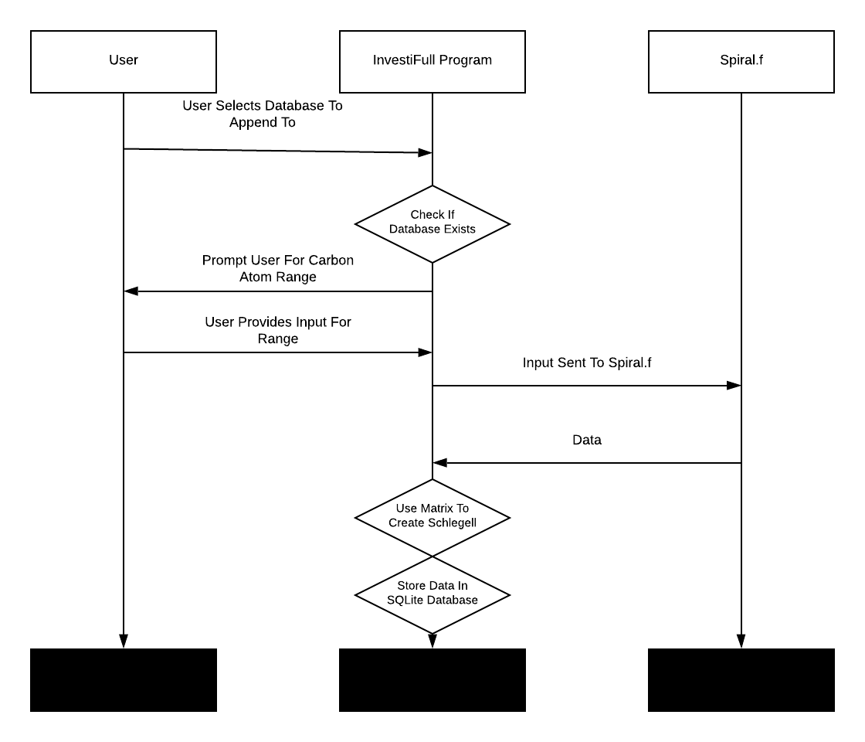

## Search- High Priority

4.4.1 InvestiFull displays records from a chosen database pertaining to a specific isomer.

4.4.2 The sequence of actions is as follows:

* The user selects the intended database
* InvestiFull searches the database based on number of carbon atoms the user provided.
* The user selects the specific fullerene they wish to view within InvestiFull.
* An adjacency matrix and topological chart information is displayed to the screen by InvestiFull.
* InvestiFull displays a two-dimensional Schlegell diagram in a separate window.

4.4.3 Functional Requirements:

**REQ-1:** InvestiFull checks to see if the selection is a valid database.

**REQ-2:** InvestiFull uses the SQLite API to display all records pertaining to the chosen isomer.

**REQ-3:** If no records for the chosen isomer exist InvestiFull displays an error message to the user.

**REQ-4:** InvestiFull displays the adjacency matrix and topological information for the specific fullerene.

**REQ-5:**InvestiFull **c**reates a window displaying the fullerene’s topology via a Schlegell diagram.

# Other Nonfunctional Requirements

## Performance Requirements

In the instance the user attempts to create a database, they must have enough memory to store the database before it is created.

## Safety Requirements

None apply.

## Security Requirements

None apply.

## Software Quality Attributes

* + InvestiFull accurately produces diagrams and charts for fullerenes at or below a range of two hundred carbon atoms. Additionally, it stores and maintains entered ranges within a database for later searching and visualization.
  + InvestiFull is written in python to make the software both portable and easy to expand. The future addition of desired features is also taken into consideration.

## Business Rules

Any users can use any of the functionality at any point during the runtime of the program. No account authorization or user requirements are necessary.

# Other Requirements

Appendix A: Glossary

* Fullerene

Any series of hollow carbon molecules that form either a closed cage or a cylinder. [2]

* Isomer  
    
  Molecules that have the same numbers of the same kinds of atoms (and hence the same formula) but differ in chemical and physical properties. [4]
* Spiral Algorithm

This is in reference to a spiral algorithm that produces topological information on fullerenes. A Fortran implementation retrieved from GitHub user 'csgorham' utilizes in InvestiFull. [1]

* Schlegel Diagram

A Schlegel diagram is the projection of a polytope from n-dimensional space into n-1 dimensions. [3]

* Topological Chart

A chart displaying the geometric properties and spatial relations of a Fullerene.

Appendix B: Analysis Models

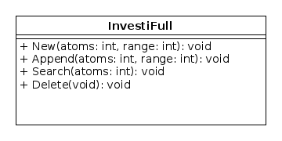

Figure : Class Diagram

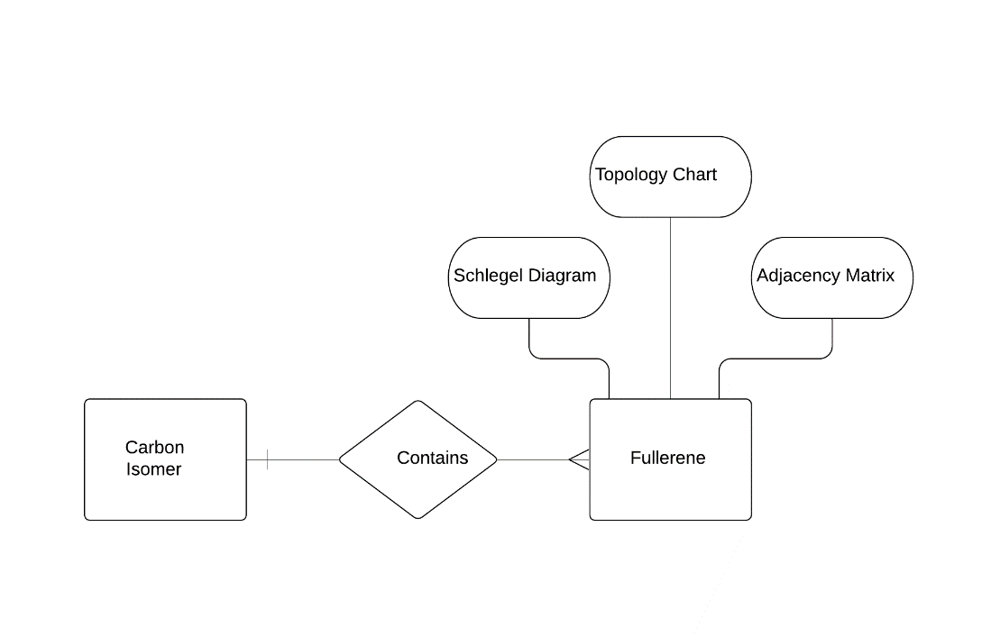

Figure 2: ER Database Diagram

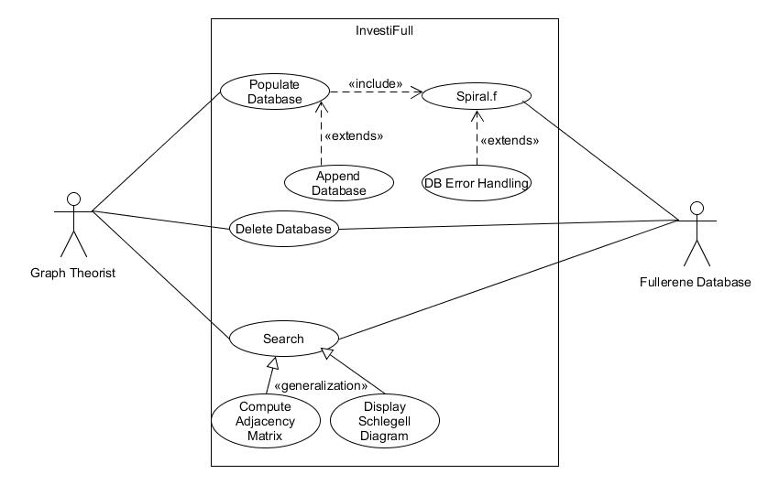

Figure 3: Use-case Diagram

**Name:** InvestiFull Use Case Diagram

**Actors:**

* Graph Theorist
* Fullerene Database

**Preconditions:** Machine has enough space to store fullerene information in database

**Scenario:**

1. User inputs a range of carbon atoms that they desire fullerene topological information on.
2. Range of atoms is given to Spiral.f to have the information computed.
3. InvestiFull takes the Adjacency Matrix computed by Spiral.f and creates a Schlegell diagram.
4. All computed information is stored in a database using the SQLite API.
5. User searches for fullerenes based on the isomer they were derived from.
6. User selects specific fullerene they desire.
7. InvestiFull displays all the topological information to the user.

Appendix C: To Be Determined List:

README: A README file that explains how to utilize InvestiFull