Cisco Packet Tracer Practical 3 – Connecting Two PC’s

Step 1: Open Packet Tracer:-
• Open Cisco Packet Tracer software.
• Wait until the workspace loads.

Step 2: Add Devices:-
• from the bottom left, click End Devices.
• Drag and drop (PCs) into the workspace.
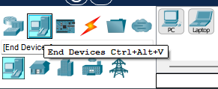

Step 3: Connect Devices:-
• Click on Connections (Lightning icon).
• Choose Copper Straight Through Cable (THE DOTTED ONE).
• Connect:
- PC to FastEthernet0
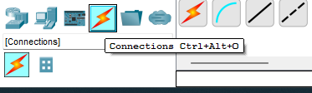
Step 3: Configure IP Address:-
• Click on PC.
• Go to Desktop → IP Configuration.
• Enter:
- IP Address:- 192.168.1.1 (for PC1) and 192.168.1.2 (for PC2)
- Subnet Mask:- 225.225.225.1 (Must same for both PCs)
• Repeat for other PC.
