**FAQ**

1. **How do I Run the game on a Local server?(can play multiple users at the same time)**

You need JDK version 8.0 and Glassfish version 4.1 or tomcat server (we added tomcat to the game folder) installed to run the Game Server.

After installed tomcat (If havent) , First Open **GloryServer** in Game folder in your IDE and run the project. Then Open **GloryClient**. Then follow the given steps:

* **Go to the:**

GloryClient -> glory_schema -> VariableElement.java. Make changes to the following

Lines.

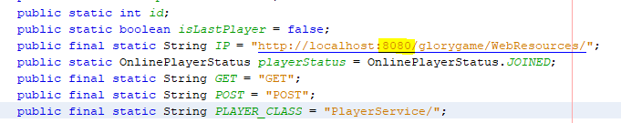 Change the port(**your port** instead of 8080)

(public final static String IP = "http://localhost:**8080**/ glorygame /WebResources/";)

Then run the Game Client.

* **Go to the:**

GloryServer -> Restful Web Services -> PlayerService

Find registerPlayer() and addPlayer() Methods, Change port to your **local** like above And change the partition if you **haven’t D drive.**

Finally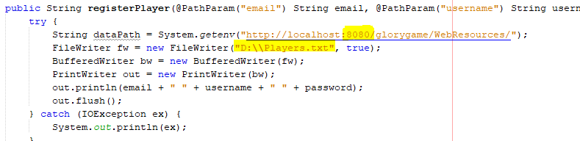 copy paste the **dictionary text file** into your above partition.

