This document will walk you through how to use the script tool Download Photos from a single Feature Layer and Rename



When you open the script tool you will see the following window

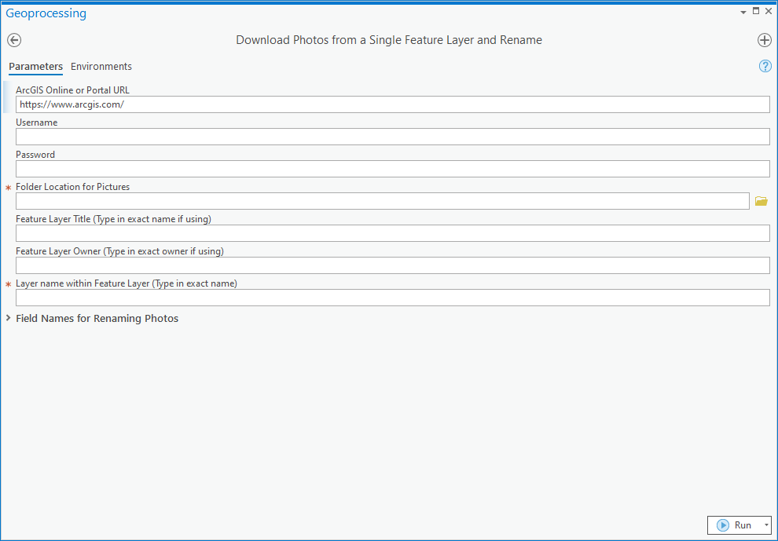

The parameters with a red star next to them are mandatory parameters that you must fill in to run the tool.

Below is explanation of all the parameters to help you fill them in.

1. ArcGIS Online or Portal URL: This is set as a default to <https://www.arcgis.com/>
   1. If you are searching for a feature layer stored in your ArcGIS Online account you will leave the default and you will need to fill in the Username and Password to log into your ArcGIS Online account.
   2. If the feature layer is stored in your organizations Portal you will need to use your organizations Portal URL and fill in the Username and Password.
   3. If you are searching for publically available feature layers by logging into ArcGIS Online anonymously you must delete this and leave it blank.
2. Username: This is an optional parameter as **you do not need to log into search for publically available data**.
   1. If your data is not shared publically then you need to fill this in to log into your organization in order to access your feature layer.
   2. If you are searching for publically available data you need to leave this blank
3. Password: This is an optional parameter as **you do not need to log into search for publically available data**.
   1. If your data is not shared publically and you have filled in the Username parameter you will need to fill in the Password parameter. **The script tool will fail and throw an error if only the Username is filled in and the Password is left blank**
   2. If you are searching for publically available data you need to leave this blank
4. Folder Location for Pictures: This is a mandatory parameter and is the location on your local machine where you want to download the photos to. This folder must exists as the script will be looking for it and the script will not run if the location entered does not exist.
5. Feature Layer Title (Type in exact name if using): This is the layer name of the feature layer you will be downloading the photos from. The layer name must be typed in exactly as it would look in ArcGIS Online. See below for how to find this information on the overview panel of the feature layer.
6. Feature Layer Owner (Type in exact owner if using): This is the username of the owner of the feature layer you will be downloading the photos from. The username must be typed in exactly as it would look in ArcGIS Online. See below for how to find this information on the overview panel of the feature layer.
7. Layer name within the Feature Layer (Type in exact name): This is a mandatory parameter and is the name of the layer within the feature layer that the photos are attached to. See below for how to find this information on the overview panel of the feature layer.

The image below shows where on the overview you will find the feature layer title (5), feature layer owner (6), and layer name (7)

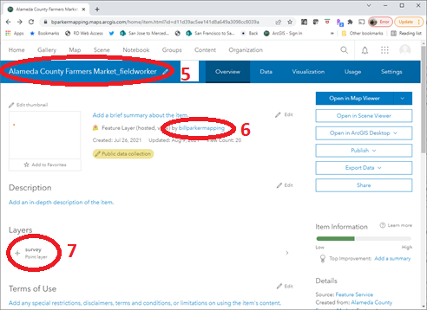

To see the four option field names for renaming the photos with expand the Field Names for Renaming Photos section.

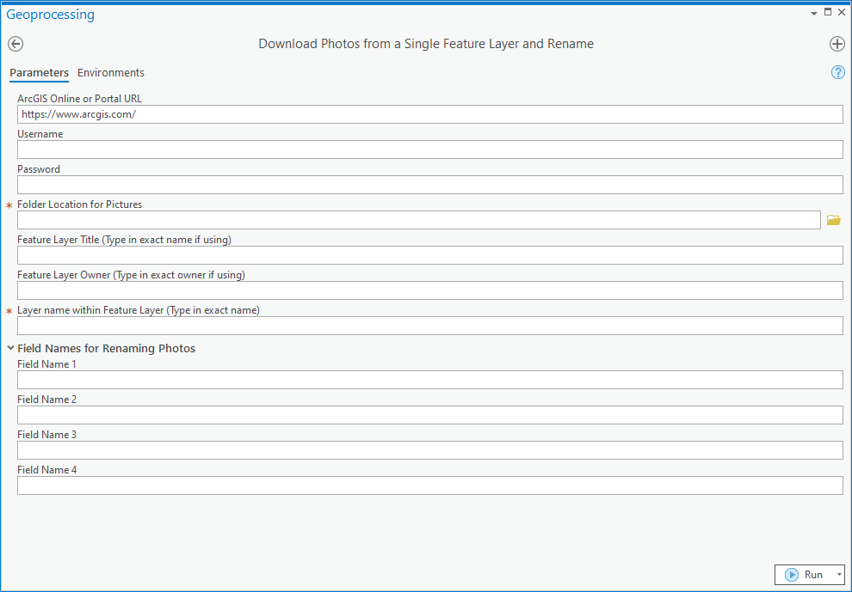

You have 4 field names you can use the attribute values from to rename your photos. You must type in the field names exactly as they are in the feature layer. To see the field names available in your feature layer click on the Data tab and then the Fields toggle. Below you will see a sample of the fields toggle. You can see the Display Name and Field Name for your feature layer. You must type in the name in the Field Name column NOT the Display Name column.

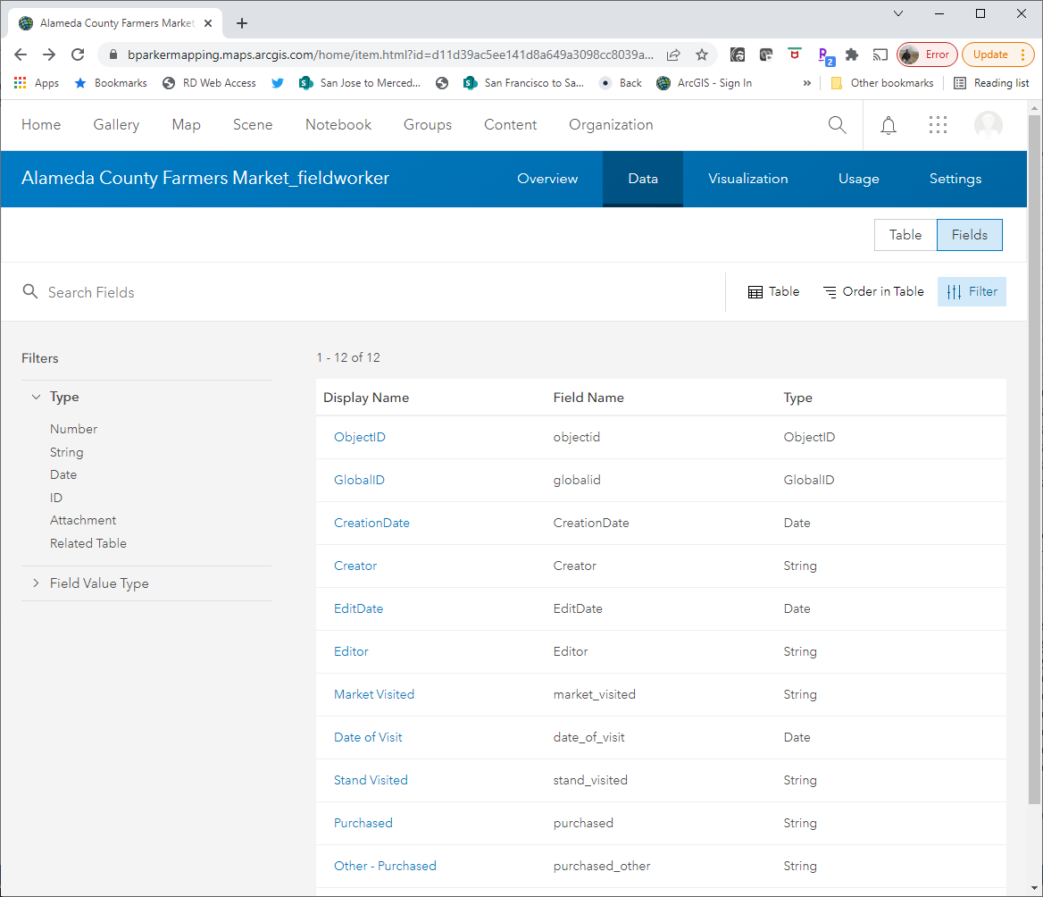

Below is an example of how to use the tool to download the photos from the Alameda County Farmers Market fieldworker feature layer.

1. The feature layer is publically available so you will delete the ArcGIS Online or Portal URL parameter.
2. You will leave the Username parameter blank
3. You will leave the Password parameter blank
4. The location for the photos is a folder on my local drive.
5. The Feature Layer Title parameter is filled in to match the data from the feature overview tab
   1. Alameda County Farmers Market_fieldworker
6. The Owner Name parameter is filled in to match the data from the feature overview tab
   1. billparkermapping
7. The Layer Name parameter is filled in to match the data from the feature overview tab.
   1. survey
8. The fields being used to rename the photos are
   1. market_visited
   2. stand_visited

