Notice:

1. 請儘量看懂程式 writes.c, reads.c, bindump.c, Huffman.c
2. 看程式Huffman.c前,先讀 Huffman Coding 檔案 (word file)

1. writes.c //writes strings typed at keyboard into the file "textfile.txt"

C:\Users\win7\Documents\2013\2013_Course\計概102\Textbook_C_Programming-King\huffman_coding\作業2\writes

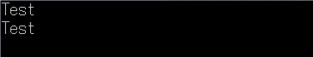

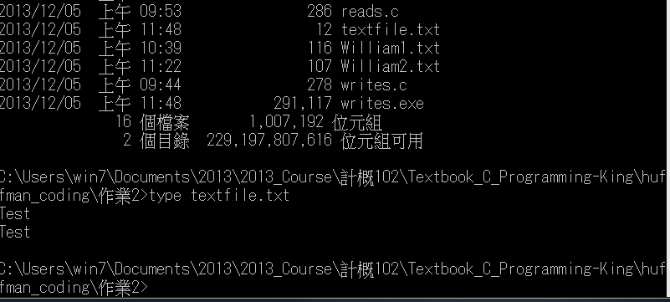

2. reads.c //reads strings from file "textfile.txt", and then display them on screen

C:\Users\win7\Documents\2013\2013_Course\計概102\Textbook_C_Programming-King\huffman_coding\作業2\reads

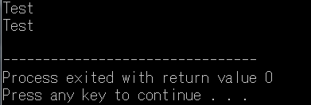

3. bindump.c

/* does binary dump of disk file*/

/* each line is ten ASCII codes followed by ten characters */

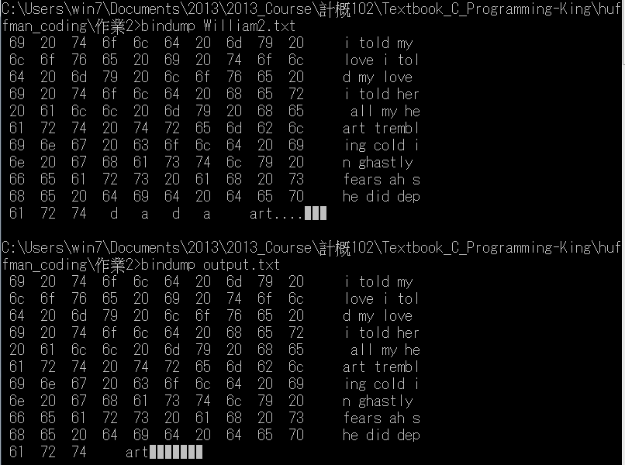

4. huffman.c // 壓縮&解壓縮一文字檔 (文字檔只能由 'a','b',...,'z',及' ' 所構成)

Step1: (壓縮)

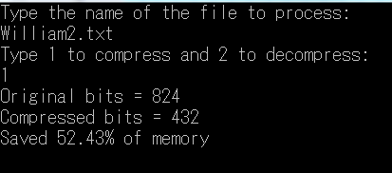

Step2: 將輸出檔檔名 ”output.txt” 改成 ”output1.txt” Note: 此時, output1.txt為壓縮檔

Step3: (解壓縮)

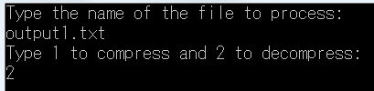

此時, 輸出檔”output.txt” 為解壓縮檔 Note: 比較output.txt與原先檔William2.txt是否相同?