IVF AI Chatbot (RAG-Based Healthcare Assistant)
AI-powered IVF healthcare chatbot using Retrieval-Augmented Generation (RAG), FAISS, LangChain, SentenceTransformers, Ollama, and Streamlit for document-grounded medical question answering.

Project Overview
The IVF AI Chatbot is a healthcare-focused Generative AI application designed to provide accurate, context-aware, and document-grounded responses for IVF-related questions.

Problem Statement
Patients undergoing IVF treatment often struggle with medical terminology, inconsistent information, and lack of instant support. Traditional chatbots may hallucinate or provide unsafe responses.

Solution
This project uses Retrieval-Augmented Generation (RAG) to retrieve relevant medical content from verified IVF documents before generating responses using an LLM.

Core Features
• RAG-based healthcare chatbot
• FAISS vector database
• Semantic search using embeddings
• Local LLM inference using Ollama + Mistral
• Streamlit conversational UI
• Hallucination reduction pipeline
• PDF + DOCX + Web ingestion

Tech Stack
Frontend: Streamlit
Backend: Python
Framework: LangChain
Vector DB: FAISS
Embedding Model: all-MiniLM-L6-v2
LLM: Mistral via Ollama

RAG Workflow
1. Document ingestion
2. Text chunking
3. Embedding generation
4. Vector storage in FAISS
5. Semantic similarity retrieval
6. Prompt augmentation
7. LLM response generation

Healthcare Safety Features
The system implements context-grounded prompting, retrieval-only generation, trusted medical sources, and semantic filtering to reduce hallucinations.

Interview Insights
Why RAG?
- Dynamic knowledge updates
- Reduced hallucinations
- Better explainability
Why FAISS?
- Fast vector similarity search
- Efficient local deployment
Why embeddings?
- Semantic understanding instead of keyword matching.

Future Improvements
• Conversational memory
• Hybrid Search
• Docker deployment
• HuggingFace deployment
• Medical citation generation

Author
Lucky Singh
Aspiring Data Scientist & GenAI Developer

High Level Design
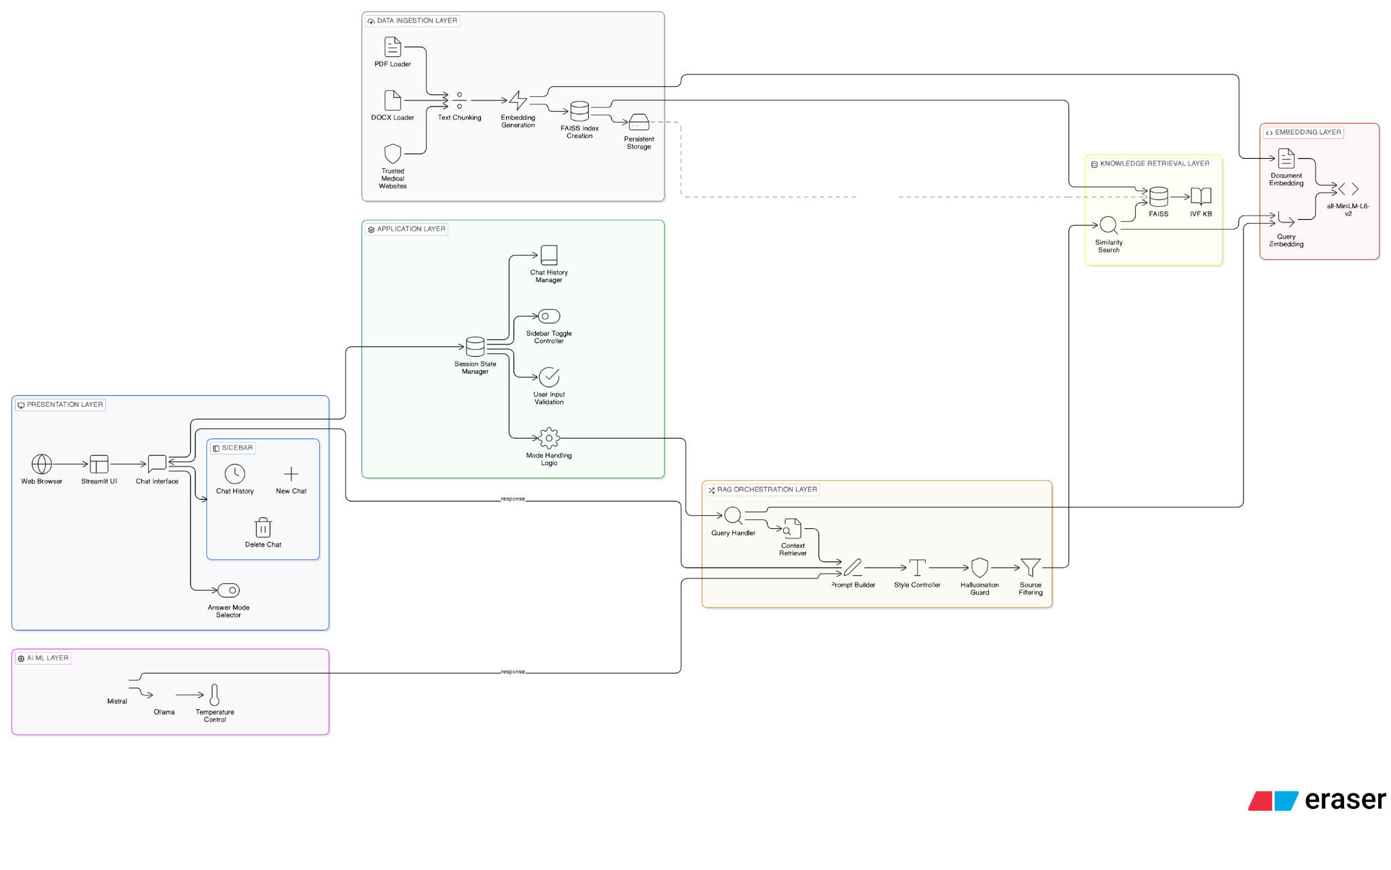
High Level Design

Low Level Design
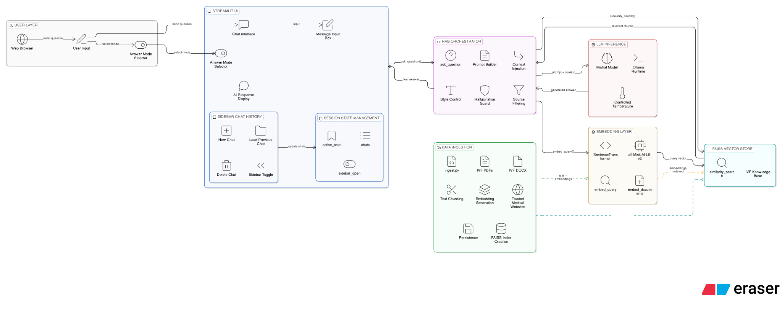
Low Level Design

Application UI
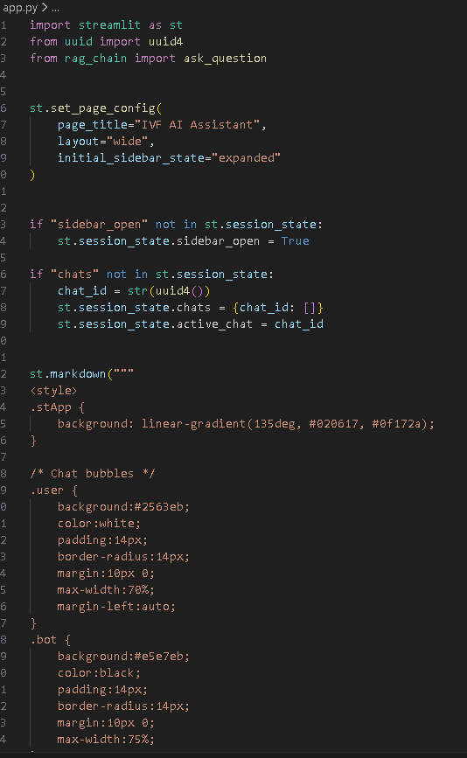
Application UI

Chatbot Logic
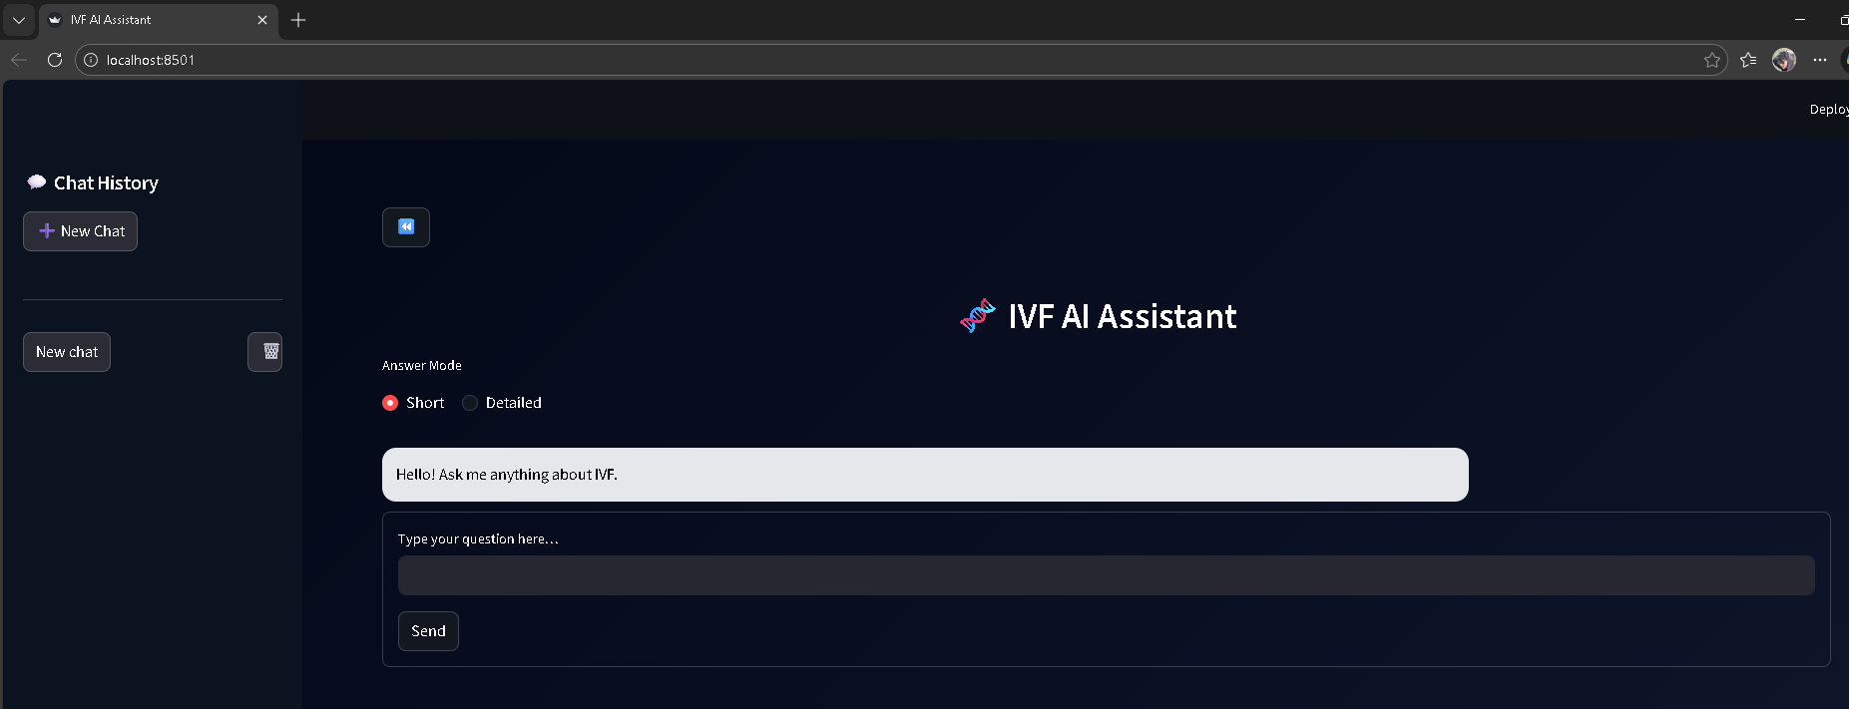
Chatbot Logic

RAG Pipeline
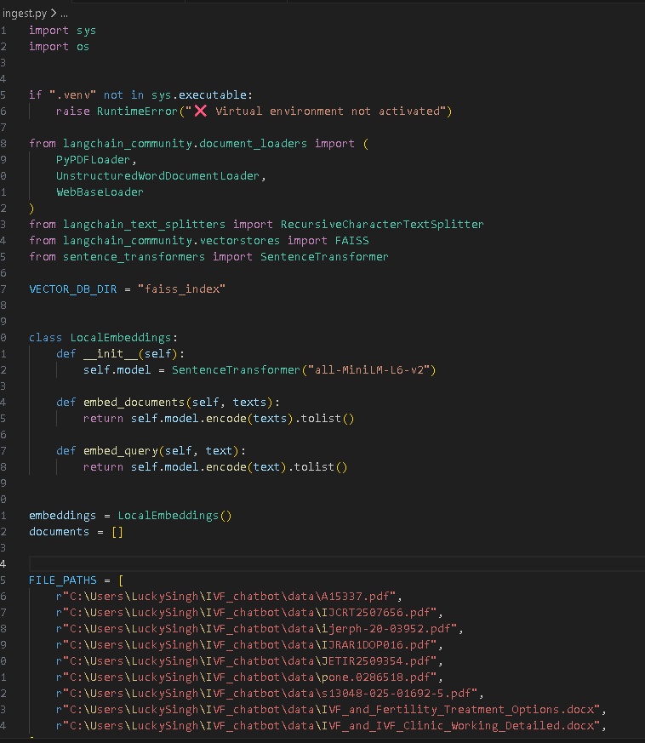
RAG Pipeline

