## mono crystalProcess Document Translation Test

### **1.**Process Introduction

Test Content 1: During the process of drawing Ingot, we generally go through the following steps:

Melt, adjust temperature, neck, crown, shoulder, body, Tail, Pop out, Recharge, adjust temperature, neck……

As described above, after undergoing multiple rounds of drawing, the drawing of the finishing mandrel is carried out according to the Process plan. After the body stage, the Tail operation can be skipped directly and proceed to the shutdown operation. If the drawing is interrupted at Structure Loss (Loss of Structure), proceed directly to Pop out. After completing Pop out, whether to start the re-drawing of adjust temperature directly or to perform Recharge followed by adjust temperature can be decided based on the requirements of Process.

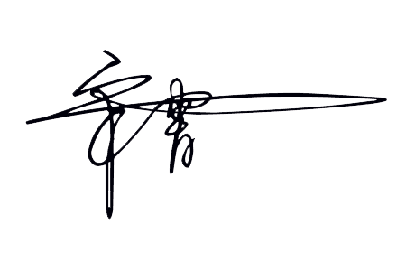

### **2.**Random Translation Test

JSG

ATW

Dislocation

Twin

Hot zone

SL-CL ratio

$${\left(x+a\right)}^{n}=\sum_{k=0}^{n}{\left(\frac{n}{k}\right)x^{k}a^{n−k}}$$ $$f\left(x\right)=a_{0}+\sum_{n=1}^{∞}{\left(a_{n}\cos{\frac{nπx}{L}}+b_{n}\sin{\frac{nπx}{L}}\right)}$$