**INDEX**

|  |  |  |
| --- | --- | --- |
| **SR. NO.** | **CONTENTS** | **PAGE NO.** |
| **1.** | **INTRODUCTION** | **3** |
| **2.** | **THE SITUATION** | **4** |
| **3.** | **FEATURES** | **5** |
| **4.** | **COMPONENTS** | **6** |
| **5.** | **CIRCUIT** | **7** |
| **6.** | **WORKING** | **8** |
| **7.** | **NEED OF WATER LEVEL INDICATOR** | **10** |
| **8.** | **APPLICATIONS** | **11** |

**INTRODUCTION**

**What is Water level indicator?**

The Water Level Indicator employs a simple mechanism to detect and indicate the water level in an overhead tank or any other water container.

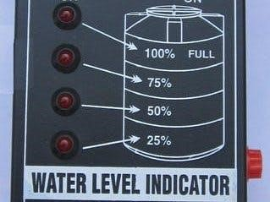

# THE SITUATION

* The house where we live in has an overhead tank which is about 30 feet from the ground level.
* We were getting bored going up the rooftop to check whether the tank has filled or the water level was below to start the pump.
* We had to do this again and again. Then we sought for a solution.

We always used to think of the possibilities of how can this problem be tackled in an electronic way.

After years of research and by trial and error, we found one and wanted to put whatever we have done out here so that it may be helpful to someone who has a overhead water tank at their homes.

So we have tried our best efforts to optimise all the resources and have come up with a bright project that could enlighten the future generations.

# FEATURES

· Easy installation.

· Low maintenance

· Compact elegant design

· Avoid seepage of roofs and walls due to overflowing tanks

· Consume very little energy, ideal for continuous operation

· Shows clear indication of water levels in the overhead tank.

# COMPONENTS

FOLLOWING ARE THE REQUIRED COMPONENTS FOR MAKING WATER LEVEL INDICATOR CIRCUIT:

1. RESISTORS
2. TRANSISTOR
3. BUZZER
4. LED
5. CONNECTING WIRES

6

. 9V DC BATTERY

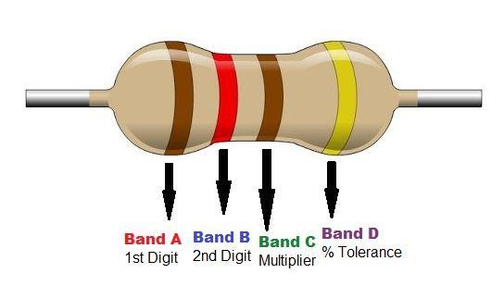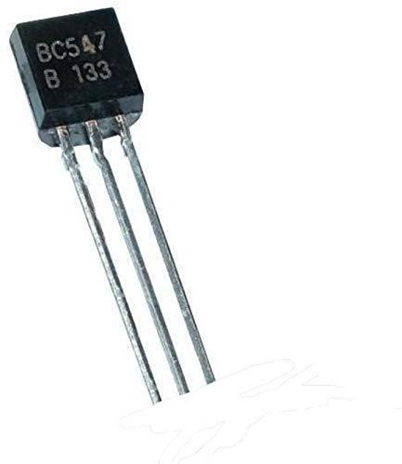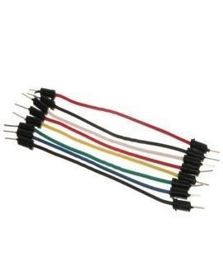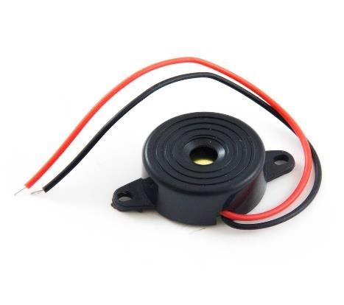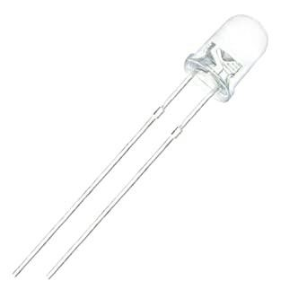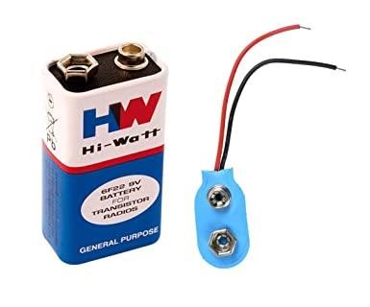

Circuit

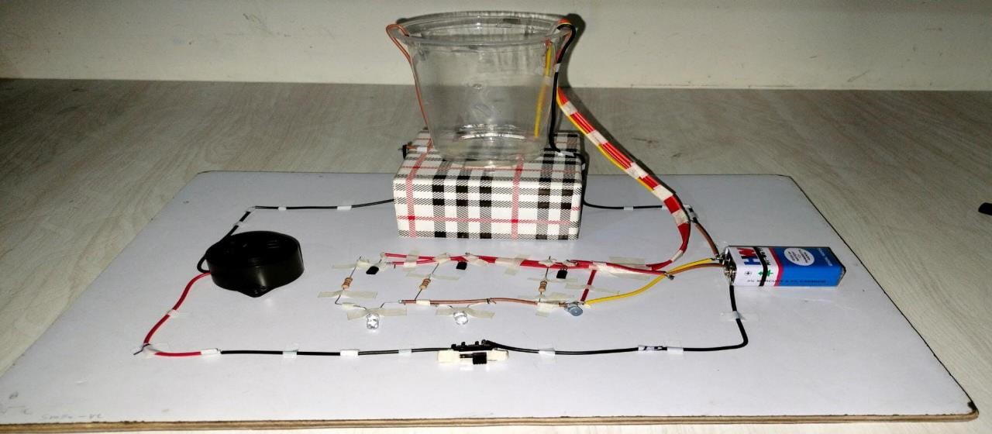 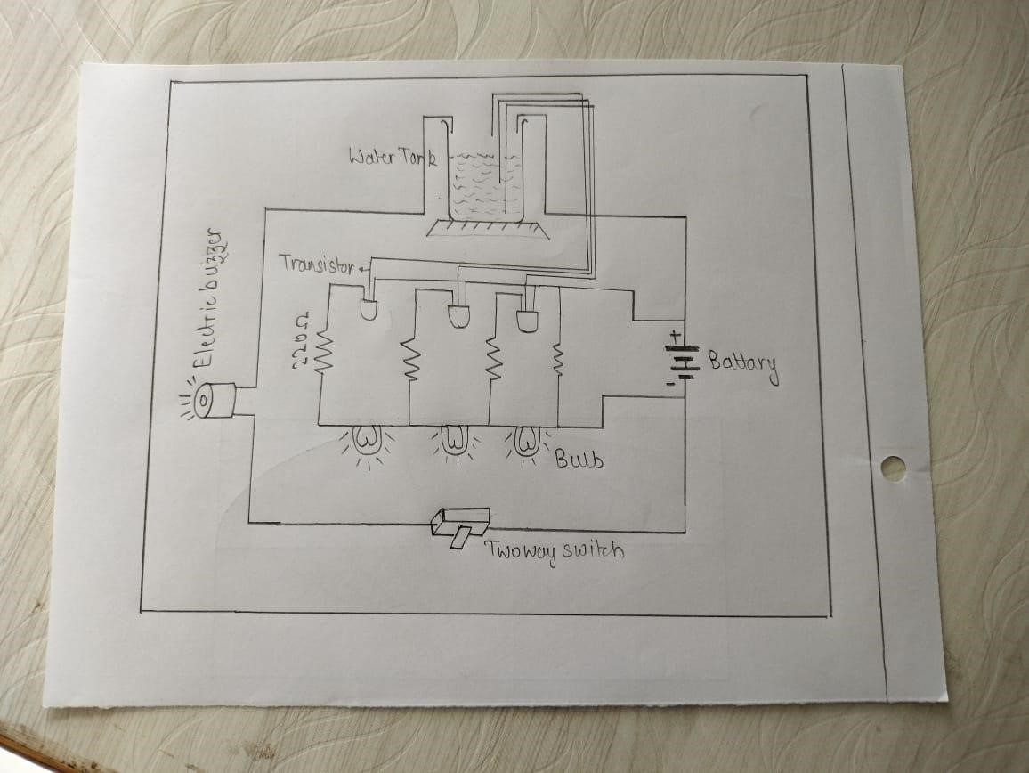

WORKING

1. The water level indicator employs a simple mechanism to detect and indicate the water level in an overhead tank or any other water container.
2. The operation of this project is very simple and can be understood easily. In our project there are 3 main conditions.
   1. when 10% of tank is filled.
   2. when 50% tank id filled.
   3. when tank is full.

## When 10% tank filed

When then tank is empty there

is no conductive part between any of the 3 indicating probes and the common probe . So the transistor emilter region will not have sufficient biasing voltage hence it remain in cut off region and the output across its collector will be Vc approximately max and thus indicate, the tank is empty.

## When 50% tank is filled

Now as the water starts filling in the tank a conductive

Path is established between the sensing probes and the

Common probe and the corresponding transistor get Sufficient biasing at their base.

So, when water reaches 50 %, the transistor get activated And it is indicated by second LED.

## When Tank is full

When, the tank becomes full, the toplevel probe get the conductive path through water and the corresponding transistor gets into conduction not only displays the level through the third LED but also activates the continuous buzzer by which user can understand that tank is full

## **Need of water level indicator**

1. Overflow problems
2. To prevent wastage of energy
3. To prevent wastage of water
4. To Indicate Level of Water Stored in any Container
5. To Monitor the Pressure of Liquid
6. To detect the water level in reservoirs and Underground Tank
7. To give alert about floods, by measuring the water level of river
8. To calculate amount of water used in particular process.

## **Applications** :

1. Now no need to go on the roof to check the water level.
2. Can be used to measure underground storage of water.
3. Water level Indicator works to maintain a constant water level.

(Used in different Plants and Industries).

1. Alarm starts ringing as soon as tank becomes full.
2. It helps to check overflow and wastage of water by warning the person when the tank is about to brim.
3. It can also be used to calculate incoming and outgoing water in large reservoirs.
4. It is used to predict the arrival of floods.

# Conclusion:

So, we can establish the Water level Indicator at home, by implementing simple mechanism using the basic electronic devices available.

**~~Circuit:~~**