PORTFOLIO JOURNAL  Reyniel Polancos  Fresh IT Graduate | Frontend & Mobile App Development  A concise portfolio prepared for journal requirements, highlighting academic background, technical skills, projects, certifications, and career readiness for entry-level developer roles.  Current Status Fresh Graduate  Target Role Junior Developer  Focus Frontend & Mobile App  Location Digos City, Davao del Sur  Email reynren11@gmail.com  GitHub github.com/LuckyYunqi | 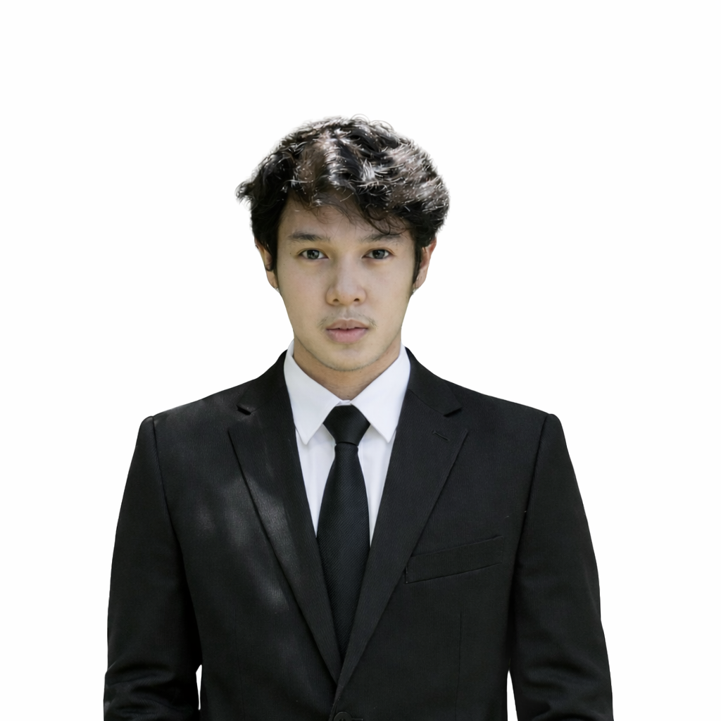  Prepared for Portfolio / Journal Submission

Career Objective
Objective
To contribute as an entry-level frontend or mobile app developer while strengthening real-world development practices, code quality, collaboration, and user-centered problem solving.

About Me
I am Reyniel Polancos, a fresh IT graduate with a foundation in web design, frontend development, and practical React-based project work. I build clean, responsive interfaces and continue improving through hands-on projects using HTML, CSS, React JS, and React Native.
I have beginner-level practical experience in mobile app development, including React Native app structure, screens, navigation concepts, and connecting user-focused features into a usable interface.

Skills Profile
Category | Skills
Frontend | HTML, CSS, React JS
Mobile | React Native
Design / Editing | Photoshop, Premiere Pro, After Effects
Tools | GitHub, VS Code, XAMPP

Education
University of Mindanao - College Graduate | Digos City, Davao del Sur
University of Mindanao - Senior High School | Digos City, Davao del Sur
Holy Cross Academy of Digos - Junior High School | Digos City, Davao del Sur
Ramon Magsaysay Elementary School - Elementary | Digos City, Davao del Sur

Projects

Lawyer Consultation Mobile App
- Type: Mobile App
- Role: Mobile App Developer
- Technology: React Native, mobile app screens, consultation workflows
- Repository: github.com/xxexil/MobileLex
Description: A lawyer consultation app focused on schedules, messages, payments, and client-centered consultation flows.
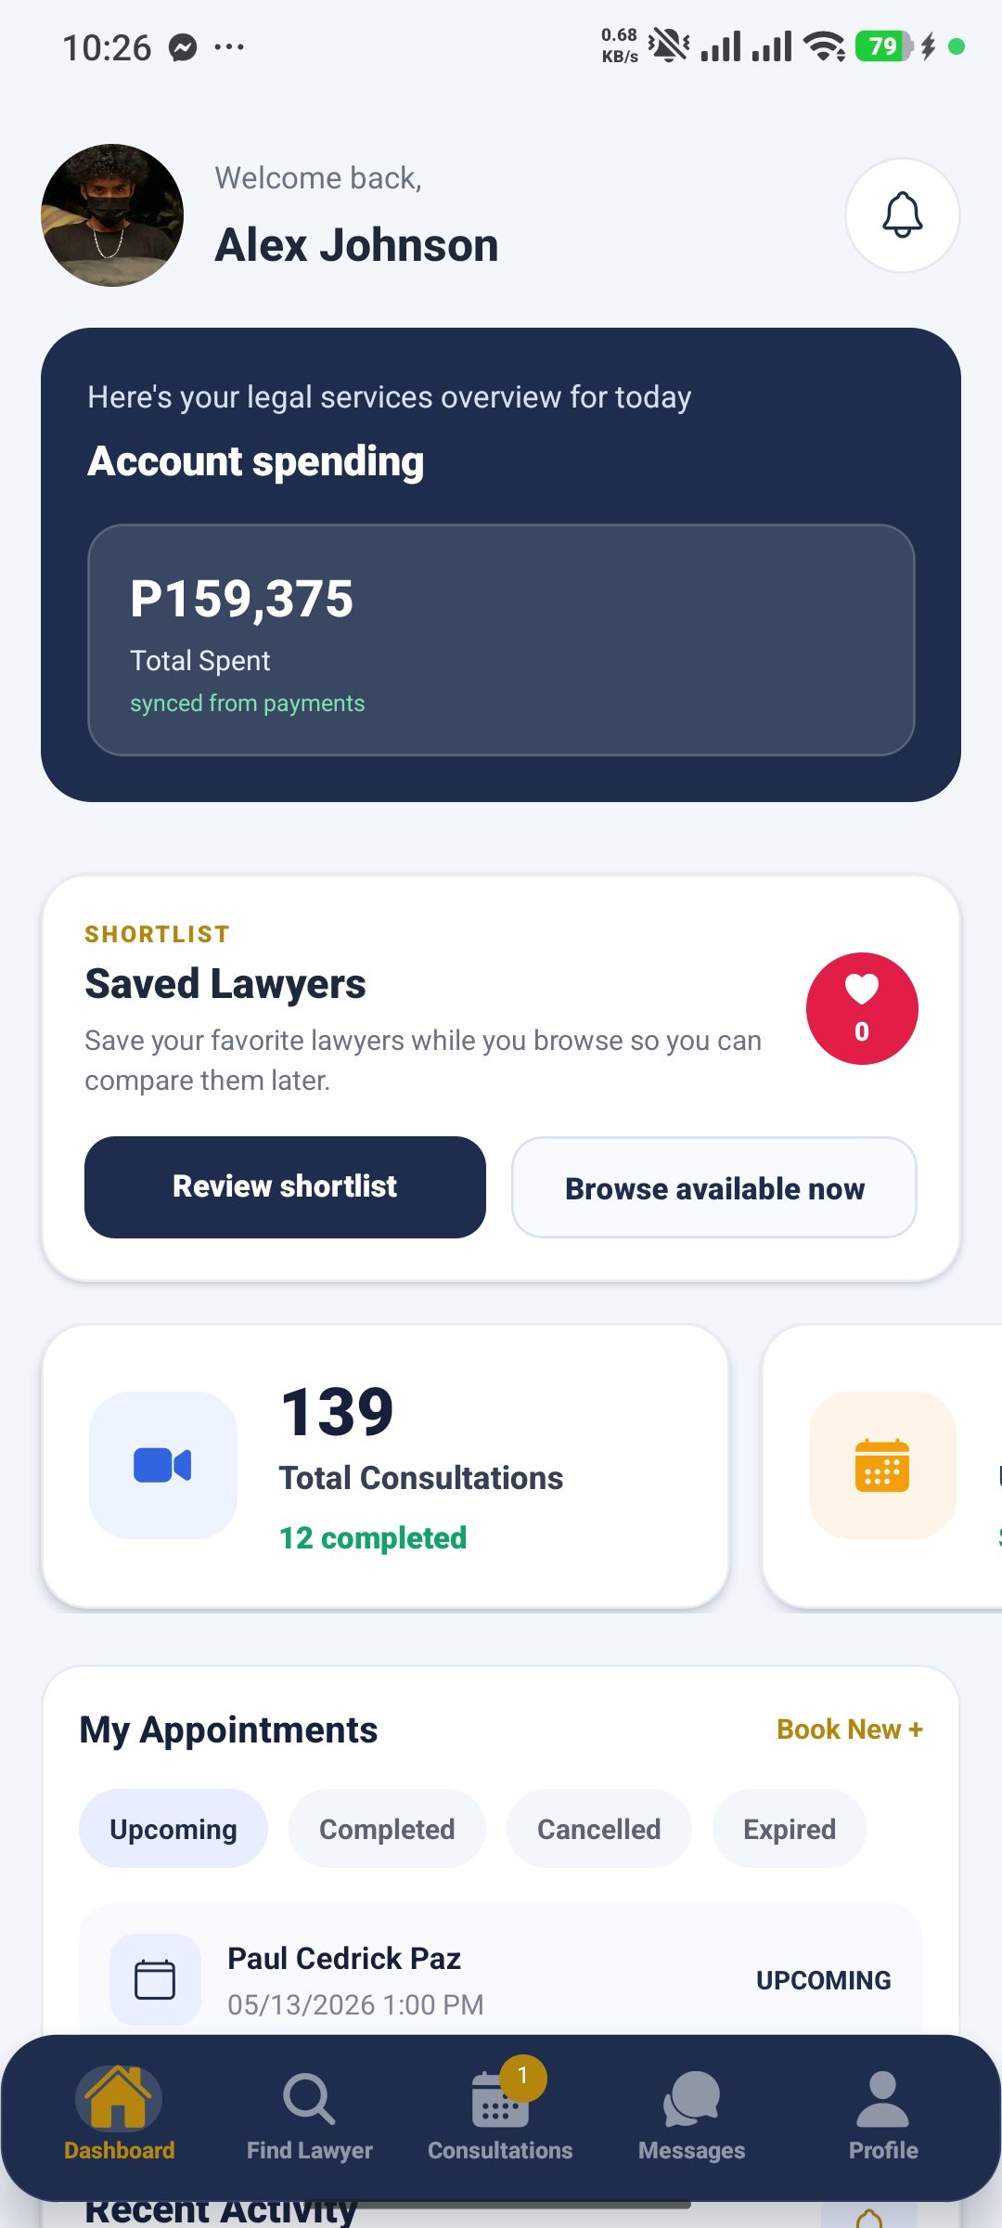
MobileLex dashboard screen

Inventory of Medicines System (IMES)
- Role: Full Stack / System Contributor
- Tech Stack: Web app, inventory management, reports
- A web-based system for managing pharmaceutical inventory, stock movements, and reporting. Screenshot unavailable because the system was turned over to the client.

Personal Portfolio Website
- Role: Web Designer / Frontend Developer
- Tech Stack: HTML, CSS, JavaScript
- A responsive portfolio website presenting profile, education, certificates, projects, skills, and contact information.

Responsive Web Design
- Role: Frontend Practice
- Tech Stack: HTML, CSS, accessibility, responsive layouts
- Coursework and practice projects focused on responsive layouts and mobile-first fundamentals.

Certifications
- Installing and Configuring Computer Systems - TESDA (Completed September 5, 2025)
- Setting Up Computer Networks - TESDA (Completed September 5, 2025)
- Setting Up Computer Servers - TESDA (Completed September 5, 2025)
- Maintaining Computer Systems and Networks - TESDA (Completed September 5, 2025)
- Introduction to CSS - TESDA (Completed September 1, 2025)
- IT Specialist: HTML and CSS - Certiport / Pearson VUE (Completed February 28, 2026)

OJT / Career Preparation
Readiness Statement
I am prepared to enter a real development environment as a fresh graduate who is willing to learn, accept feedback, document tasks, communicate clearly, and improve through daily practice.
- Strengthen React JS and React Native fundamentals through small, complete projects.
- Practice GitHub workflow, code organization, and project documentation.
- Continue improving UI consistency, responsive layouts, and accessibility.
- Prepare for interviews by explaining project role, decisions, challenges, and learning outcomes.

Reflection
This portfolio represents my current growth as a fresh IT graduate. It shows my academic foundation, beginner-level practical experience, and willingness to continue learning in a company related to my expertise.

