*Introduction*

The objective of this assignment is to perform automated variable selection techniques for identifying the “best” regression model for predicting sale price for homes in the Ames, Iowa area. The first phase includes the assessment of which predictor variables, based on common sense and business justification, made sense to include in a predictive model. After conducting some preliminary exploratory data analysis (EDA), it was concluded that the following predictor variable candidates would be considered in the model:

X1-GrLivArea

X2-LotArea

X3-AgeAtSale

X4-TotalBsmtSF

X5-total_baths_calc

X6-TotRmsAbvGrd

X7-highend_ind Neighborhood grouping

X8-midend_ind Neighborhood grouping

X9-good_heating

X10-excl_kitchen kitchen quality

X11-central_air

X12-fireplace_ind

X13-garage_ind

X14-good_basement_ind

X15-concr_foundation

X16-quality_index

X17-brick_exterior

X18-lot_frontage

X19-new_bldg

X20-old_bldg

X21-pos_cond

X22-recent_remodel

*Training data set*

The data set has been split in test/train data set as shown below. We will test the model accuracy by training the model on the 70% of the data set and validating its accuracy on remaining 30%.

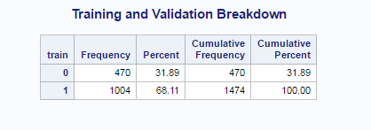

*Adjusted R-Squared Model (Model_AdjR2)*

The results of the adjusted R-squared variable selection method determined that not all predictor variables candidates (X1-X22) should be included in the final model. The adjusted R-squared of the final model was 0.8941. Table 1 below, you can see the summary output of the variable selection process with the final result in the first row.

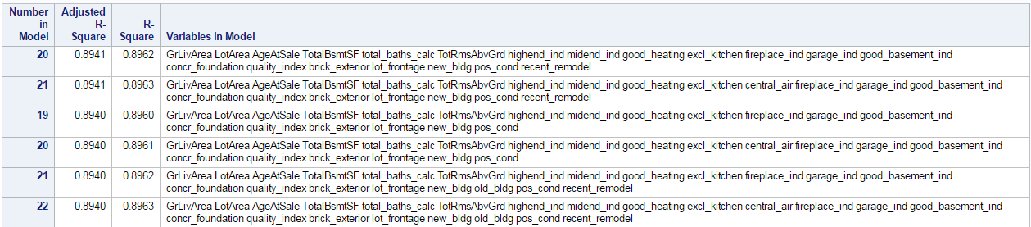

The adjusted R-squared model suggest to exclude variables central_air(X11) and old_bldg(X20).

*Maximum R-Squared Model (Model_MaxR)*

Like the adjusted R-squared variable selection method, the results of the maximum R-squared variable selection method determined that not all predictor variable candidates (X1-X22) should be included in the final model. The R-squared of the final model was 0.8963. In Table below, we can see the ANOVA and parameter estimates for the final suggested model from the maximum R-squared variable selection method. The model suggests excluding variables central_air(X11) and old_bldg(X20) as none of them is statistically significant.

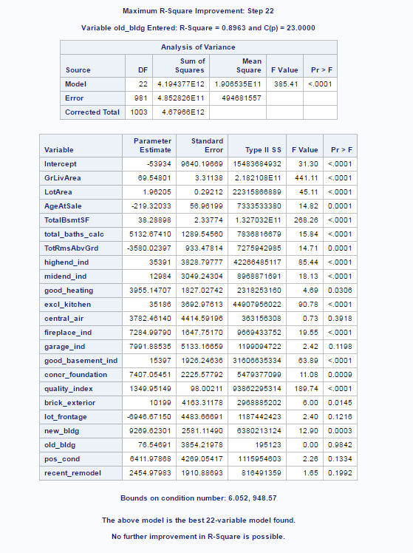

*Mallow’s Cp Model (Model_MCp)*

As with the previous two models, the results of the Mallow’s Cp variable selection method also determined that not all predictor variable candidates (X1-X22) should be included in the final model. The Mallow’s Cp of the final model was 19.3852. In Table 3 below, we can see some of the output from the Mallow’s Cp variable selection process. The best model is shown in the first row of the table. 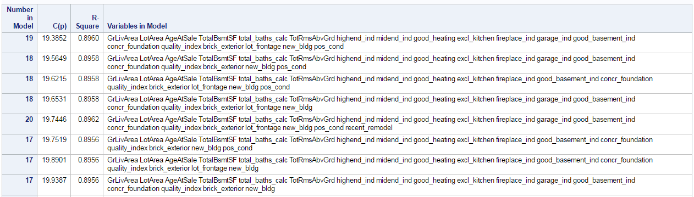

Apart from old_bldg(X20) and central_air(X11) the model suggest to exclude recent_remodel(X22) variable.

*Forward Selection Model (Model_F)*

Like proceeding variable selection methods, the results of the forward variable selection method also determined that not all predictor variable candidates (X1-X22) should be included in the final model. In table below, we can see the summary of the forward selection method and you’ll notice that the p-value from the nested F-tests did not increase until the 10th variable was entered into the model. For this method, we chose a *slentry* value of 0.15 as our threshold for variables to be allowed to enter into the model.

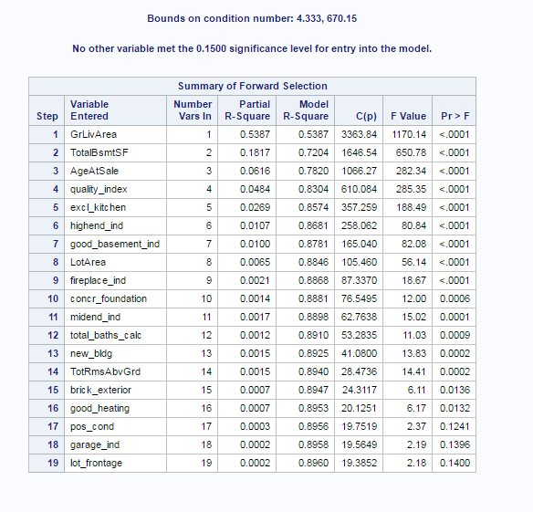

The model suggest exclusion of central_air(X11), old_bldg(X20), recent_remodel(X22) variables

*Backward Model (Model_B)*

Also this time the results of the backward variable selection method determined that not all predictor variable candidates (X1-X22) should be included in the final model. In table below, we can see the summary of the beckward elimination method. For this method, we chose a *slentry* value of 0.15 as our threshold for variables to be allowed to enter into the model.

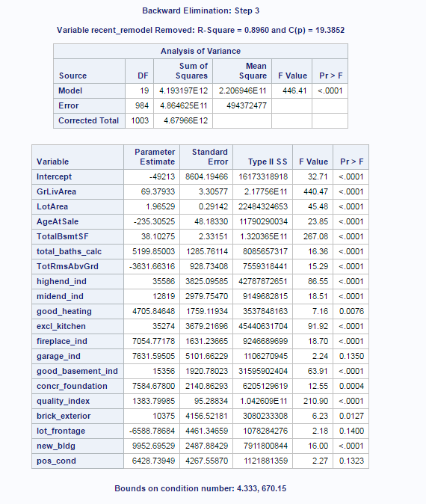

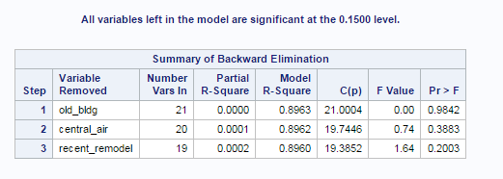

The model suggest exclusion of central_air(X11), old_bldg(X20), recent_remodel(X22) variables

*Stepwise Selection Model (Model_S)*

The stepwise selection method was the final option used for model selection. As with previous methods, the stepwise selection method indicated that not all predictor variable candidates should remain in the model. The stepwise variable selection summary is shown below.

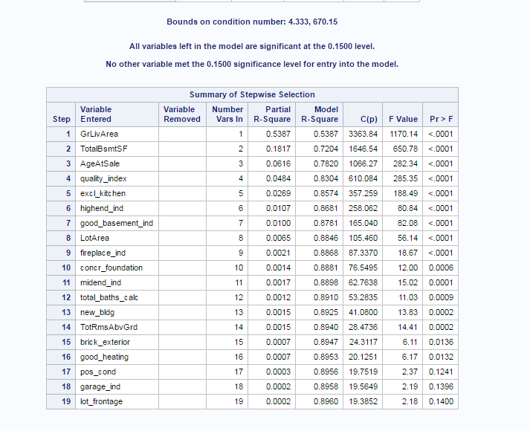

At the 0.1500 level variable X20-X22 were excluded from the model.

*Model Comparison*

|  |  |  |  |  |  |  |  |
| --- | --- | --- | --- | --- | --- | --- | --- |
|  |  | Model_AdjR2 | Model_MaxR | Model_MCp | Model_F | Model_B | Model_S |
| Train | Predictors  excluded | X11,X20 | X11,X20 | X11,X20,X22 | X11,X20,X22 | X11,X20,X22 | X11,X20,X22 |
| Train | Adjusted R2 | 0.8941 | 0.8940 | 0.8940 | 0.8940 | 0.8940 | 0.8940 |
| Train | AIC | 20118.9967 | 20122.23 | 20118.67 | 20118.67 | 20118.67 | 20118.67 |
| Train | BIC | 20121.9478 | 20125.31 | 20121.51 | 20121.51 | 20121.51 | 20121.51 |
| Train | Mallow’s Cp | 19.7446 | 23 | 19.3852 | 19.3852 | 19.3852 | 19.3852 |
| Train | MAE | 15879.15 | 15866.46 | 15907.54 | 15907.54 | 15907.54 | 15907.54 |
| Train | MSE | 483716094 | 483349211 | 484524420 | 484524420 | 484524420 | 484524420 |
| Test | MAE | 15052.86 | 15016.78 | 15107.78 | 15107.78 | 15107.78 | 15107.78 |
| Test | MSE | 426320079 | 424752379 | 430209443 | 430209443 | 430209443 | 430209443 |

There has been slight variation in variable selection between models . Table below shows model fit criteria from the models created using the training sample. Based on the results, we can see that the predictive ability of the final model built from the training sample performed very well with the test sample data.

*Multicollinearity*

Values 10 or above for variance inflation analysis may cause serious problem for data analysis. It seems that there are no immediate risk for multicollinearity even though the value for AgeAtSale is a little bit high.

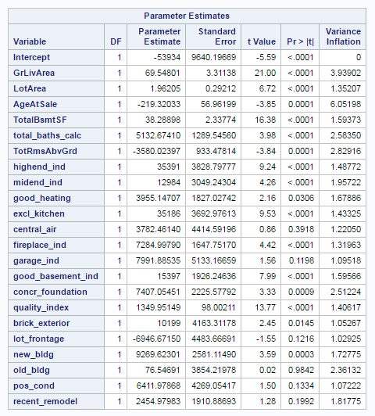

Pearson Correlation analysis reveals that correlation between AgeAtSale and other variables is within -0.7 and 0.7. The highest value of 0.65 is between AgeAtSale and concr_foundation. The table below shows variables with highest Pearson Correlation.

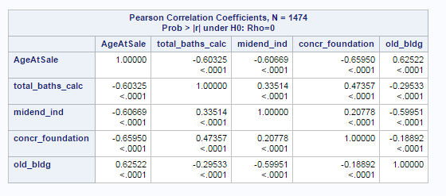

*Operational validation*

To assess the operational accuracy of the final model, we placed the predictive scores, absolute value for each observation’s actual vs predicted value for the response variable SalePrice, into three categories: Grade 1 (within 10% of the observed value), Grade 2 (between 10-15% of the observed value), Grade 3 (everything else). Below the results for each one of the models.

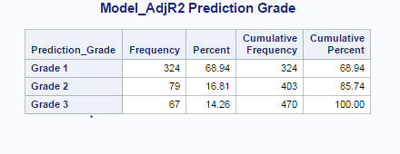

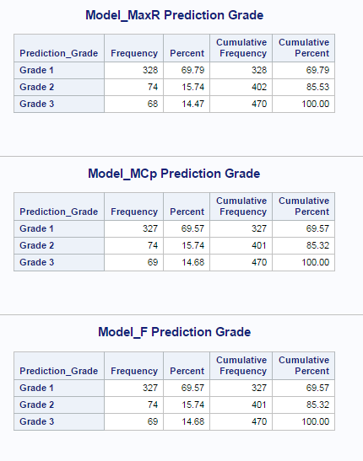

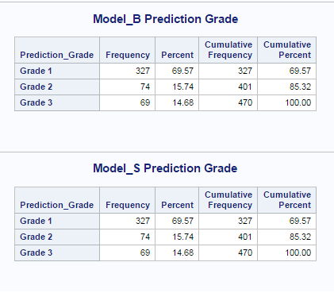

Based on the results of the prediction scores above, we can see that 85% of the predicted values were within 15% of the observed value.

*Conclusion*

In order to see effects of the automated variable selection I had to choose quite a few variables. The model might be hard to interpret for the business users, although it performs quite well. It has been proven that simpler models repeatedly run on larger data sets perform better in the long run.

It is quite clear how automated variable selection can be valuable when designing a predictive model. That should be combined with domain knowledge of stakeholders in order to achieve the best results.

libname mydata '/libname mydata '/scs/crb519/PREDICT_410/SAS_Data/' access=readonly;

ods graphics on;

ods noproctitle;

title 'Assignment 5';

*data set A method b for defining variables without YearBuilt funkar utan yb 10 variabler

* create water drop condition to establish sample;

data building;

set mydata.ames_housing_data;

format drop_condition $40.;

if (BldgType ne '1Fam') then drop_condition='01: Not a Single Family';

else if (Zoning not in ('RH','RL','RM','FV')) then drop_condition='02: Non-Residential Zoning';

else if (GrLivArea > 4000 and SalePrice < 200000) then drop_condition='03: Large Area and Low Sale Price';

else if (FullBath < 1) then drop_condition='04: No Bath';

else if (LotArea > 20000) then drop_condition='05: Lot Area Over 20,000sqf';

else if (SalePrice > 700000) then drop_condition='06: Sale Price Over $700,000';

else if (SalePrice < 15000) then drop_condition='07: Sale Price Below $15,000';

else if (GrLivArea < 1000) then drop_condition='08: Living Area Below 1000sqf';

else if (GrLivArea > 3000) then drop_condition='09: Living Area Above 3000sqf';

else if (AgeAtSale > 100) then drop_condition='10: Age Over 100';

else if (Functional ne 'Typ') then drop_condition='11: Non-Typcial Function';

else if (SaleCondition ne 'Normal') then drop_condition='12: Non-Normal Sale';

else drop_condition='99: Sample Population';

AgeAtSale = YrSold - YearBuilt;

logSalePrice = log(SalePrice);

run;

proc freq data=building;

tables drop_condition;

title 'Sample Waterfall';

run;

data train;

set building

(where = (drop_condition = '99: Sample Population'));

u = uniform(123);

if (u < 0.70) then train = 1; else train = 0;

if (train=1) then train_response=SalePrice; else train_response=.;

* create derived variables;

total_SF = max(GrLivArea,0) + max(TotalBsmtSF,0);

total_baths = max(FullBath,0) + max(BsmtFullBath,0);

total_halfbaths = max(HalfBath,0) + max(BsmtHalfBath,0);

total_baths_calc = total_baths + total_halfbaths;

*Kitchen categorical variables;

if (KitchenQual = 'Ex') then excl_kitchen = 1; else excl_kitchen = 0;

*Fireplace;

if (Fireplaces>0) then fireplace_ind=1; else fireplace_ind=0;

*Exterior;

if (ExterQual in ('Ex', 'Gd')) then good_exterior=1; else good_exterior=0;

*Neighborhood variables;

if (Neighborhood in ('StoneBr','NridgHt','Greens','GrnHill')) then

highend_ind = 1;

else

highend_ind = 0;

if (Neighborhood in ('BrDale','IDOTRR','MeadowV','OldTown','SWISU')) then

midend_ind = 0;

else

midend_ind = 1;

*Foundation;

if (Foundation = 'PConc') then concr_foundation = 1; else concr_foundation = 0;

quality_index = OverallCond*OverallQual;

if(CentralAir='Y') then central_air=1; else central_air=0;

if (GarageCars>0) then garage_ind=1; else garage_ind=0;

if (BsmtQual in ('Ex', 'Gd')) or (BmstCond in ('Ex', 'Gd'))

then good_basement_ind=1;

else good_basement_ind=0;

if (BsmtFinType1 = 'GLQ') then good_basement_ind=1; else good_basement_ind=0;

if (HeatingQC = 'Ex') then good_heating = 1; else good_heating = 0;

if (Exterior1 in ('BrkComm','BrkFace')) or (Exterior2 in ('BrkComm','BrkFace'))

then brick_exterior=1; else brick_exterior=0;

if (LotConfig in ('FR2','FR3')) then lot_frontage=1; else lot_frontage=0;

if (AgeAtSale < 5) then new_bldg = 1; else new_bldg = 0;

if (AgeAtSale > 85) then old_bldg = 1; else old_bldg = 0;

if (Condition1 in ('PosA','PosN') or Condition2 in ('PosA','PosN')) then pos_cond = 1; else pos_cond = 0;

YearsSinceRemodel = YrSold - YearRemodel;

if (YearsSinceRemodel >= 0 and YearsSinceRemodel <= 10) then recent_remodel = 1; else recent_remodel = 0;

run;

* Model_AdjR2: use automatic variable selection with adjusted R squre ;

proc reg data = train plots = diagnostics(unpack) outest = Model_AdjR2_est;

Model_AdjR2: model train_response =

GrLivArea LotArea AgeAtSale TotalBsmtSF total_baths_calc

TotRmsAbvGrd highend_ind midend_ind good_heating excl_kitchen

central_air fireplace_ind garage_ind good_basement_ind concr_foundation

quality_index brick_exterior lot_frontage new_bldg old_bldg pos_cond recent_remodel

/ selection=adjrsq best=1 aic bic cp vif;

output out=Model_AdjR2_out (keep=train SalePrice yhat) predicted=yhat;

title 'Model_AdjR2';

run;

* Model_MaxR: use automatic variable selection with MaxR ;

proc reg data = train plots = diagnostics(unpack) outest = Model_MaxR_est;

Model_MaxR: model train_response =

GrLivArea LotArea AgeAtSale TotalBsmtSF total_baths_calc

TotRmsAbvGrd highend_ind midend_ind good_heating excl_kitchen

central_air fireplace_ind garage_ind good_basement_ind concr_foundation

quality_index brick_exterior lot_frontage new_bldg old_bldg pos_cond recent_remodel

/ best=1 selection=maxr aic bic cp vif;

output out=Model_MaxR_out (keep=train SalePrice yhat) predicted=yhat;

title 'Model_MaxR';

run;

*-------------------------------------------------------------------------------------------

* Modle_MCp

*-------------------------------------------------------------------------------------------;

* Model_MCp: use automatic variable selection with Minimal Mallow's Cp ;

proc reg data = train plots = diagnostics(unpack) outest = Model_MCp_est;

Model_MCp: model train_response =

GrLivArea LotArea AgeAtSale TotalBsmtSF total_baths_calc

TotRmsAbvGrd highend_ind midend_ind good_heating excl_kitchen

central_air fireplace_ind garage_ind good_basement_ind concr_foundation

quality_index brick_exterior lot_frontage new_bldg old_bldg pos_cond recent_remodel

/ best=1 selection=cp best=1 aic bic cp vif;

output out=Model_MCp_out (keep=train SalePrice yhat) predicted=yhat;

title 'Model_MCp';

run;

* Model_F: use automatic variable selection with forward selection ;

proc reg data = train plots = diagnostics(unpack) outest = Model_F_est;

Model_F: model train_response =

GrLivArea LotArea AgeAtSale TotalBsmtSF total_baths_calc

TotRmsAbvGrd highend_ind midend_ind good_heating excl_kitchen

central_air fireplace_ind garage_ind good_basement_ind concr_foundation

quality_index brick_exterior lot_frontage new_bldg old_bldg pos_cond recent_remodel

/ best=1 selection=forward slentry=0.15 aic bic cp vif;

output out=Model_F_out (keep=train SalePrice yhat) predicted=yhat;

title 'Model_F';

run;

* Model_B: use automatic variable selection with backward selection ;

proc reg data = train plots = diagnostics(unpack) outest = Model_B_est;

Model_B: model train_response =

GrLivArea LotArea AgeAtSale TotalBsmtSF total_baths_calc

TotRmsAbvGrd highend_ind midend_ind good_heating excl_kitchen

central_air fireplace_ind garage_ind good_basement_ind concr_foundation

quality_index brick_exterior lot_frontage new_bldg old_bldg pos_cond recent_remodel

/ selection=backward slstay=0.15 best=1 aic bic cp vif;

output out=Model_B_out (keep=train SalePrice yhat) predicted=yhat;

title 'Model_B';

run;

* Model_S: use automatic variable selection with stepwise selection ;

proc reg data = train plots = diagnostics(unpack) outest = Model_S_est;

Model_S: model train_response =

GrLivArea LotArea AgeAtSale TotalBsmtSF total_baths_calc

TotRmsAbvGrd highend_ind midend_ind good_heating excl_kitchen

central_air fireplace_ind garage_ind good_basement_ind concr_foundation

quality_index brick_exterior lot_frontage new_bldg old_bldg pos_cond recent_remodel

/ best=1 selection=stepwise slentry=0.15 slstay=0.15 aic bic cp vif;

output out=Model_S_out (keep=train SalePrice yhat) predicted=yhat;

title 'Model_S';

run;

* create macros for printing the estimators and calculating MSE and MAE;

%macro print_est(indata,mytitle);

proc print data=&indata.;

title &mytitle.;

run; quit;

%mend;

%macro data_validation(indata,outdata);

data &outdata.;

set &indata.;

err = SalePrice - yhat;

abserr = abs(SalePrice - yhat);

sqerr = (SalePrice - yhat) ** 2;

if (abserr <= SalePrice * 0.1) then

Prediction_Grade = 'Grade 1';

else if (abserr <= SalePrice * 0.15) then

Prediction_Grade = 'Grade 2';

else

Prediction_Grade = 'Grade 3';

run; quit;

%mend;

%macro print_grade(indata,mytitle);

proc freq data=&indata.;

tables Prediction_Grade;

where train=0;

title &mytitle.;

run; quit;

%mend;

%macro print_mse_mae(indata,mytitle);

proc means data=&indata. mean min max median sum;

var abserr sqerr;

class train;

title &mytitle;

run; quit;

%mend;

* print model estimates for all six models ;

%print_est(indata=%str(Model_AdjR2_est),mytitle=%str('Model_AdjR2 estimator'));

%print_est(indata=%str(Model_MaxR_est),mytitle=%str('Model_MaxR estimator'));

%print_est(indata=%str(Model_MCp_est),mytitle=%str('Model_MCp estimator'));

%print_est(indata=%str(Model_F_est),mytitle=%str('Model_F estimator'));

%print_est(indata=%str(Model_B_est),mytitle=%str('Model_B estimator'));

%print_est(indata=%str(Model_S_est),mytitle=%str('Model_S estimator'));

* run model in-sample and out-of-sample validation and print results ;

%data_validation(indata=%str(Model_AdjR2_out),outdata=%str(Model_AdjR2_validation));

%print_mse_mae(indata=%str(Model_AdjR2_validation),mytitle=%str('Model_AdjR2 MSE MAE'));

%data_validation(indata=%str(Model_MaxR_out),outdata=%str(Model_MaxR_validation));

%print_mse_mae(indata=%str(Model_MaxR_validation),mytitle=%str('Model_MaxR MSE MAE'));

%data_validation(indata=%str(Model_MCp_out),outdata=%str(Model_MCp_validation));

%print_mse_mae(indata=%str(Model_MCp_validation),mytitle=%str('Model_MCp MSE MAE'));

%data_validation(indata=%str(Model_F_out),outdata=%str(Model_F_validation));

%print_mse_mae(indata=%str(Model_F_validation),mytitle=%str('Model_F MSE MAE'));

%data_validation(indata=%str(Model_B_out),outdata=%str(Model_B_validation));

%print_mse_mae(indata=%str(Model_B_validation),mytitle=%str('Model_B MSE MAE'));

%data_validation(indata=%str(Model_S_out),outdata=%str(Model_S_validation));

%print_mse_mae(indata=%str(Model_S_validation),mytitle=%str('Model_S MSE MAE'));

* print model operational grades ;

%print_grade(indata=%str(Model_AdjR2_validation),mytitle=%str('Model_AdjR2 Prediction Grade'));

%print_grade(indata=%str(Model_MaxR_validation),mytitle=%str('Model_MaxR Prediction Grade'));

%print_grade(indata=%str(Model_MCp_validation),mytitle=%str('Model_MCp Prediction Grade'));

%print_grade(indata=%str(Model_F_validation),mytitle=%str('Model_F Prediction Grade'));

%print_grade(indata=%str(Model_B_validation),mytitle=%str('Model_B Prediction Grade'));

%print_grade(indata=%str(Model_S_validation),mytitle=%str('Model_S Prediction Grade'));

* run a final operationa validation of the model produced by F/S/B;

proc reg data = train plots = diagnostics(unpack) outest = Model_Final_est;

Model_Final: model train_response =

GrLivArea LotArea AgeAtSale TotalBsmtSF total_baths_calc

TotRmsAbvGrd highend_ind midend_ind good_heating excl_kitchen

fireplace_ind good_basement_ind concr_foundation quality_index

brick_exterior new_bldg;

output out=Model_Final_out (keep=train SalePrice YrSold yhat) predicted=yhat;

title 'Model_Final';

run;

%data_validation(indata=%str(Model_Final_out),outdata=%str(Model_Final_validation));

*Multicollinearity;

proc reg data=train;

model train_response =

GrLivArea LotArea AgeAtSale TotalBsmtSF total_baths_calc

TotRmsAbvGrd highend_ind midend_ind good_heating excl_kitchen

central_air fireplace_ind garage_ind good_basement_ind concr_foundation

quality_index brick_exterior lot_frontage new_bldg old_bldg pos_cond recent_remodel / corrb vif collin;

ods graphics on;

title 'Correlation matrix ';

proc corr data=train plots=scatter(alpha=.20 .30);

var GrLivArea LotArea AgeAtSale TotalBsmtSF total_baths_calc

TotRmsAbvGrd highend_ind midend_ind good_heating excl_kitchen

central_air fireplace_ind garage_ind good_basement_ind concr_foundation

quality_index brick_exterior lot_frontage new_bldg old_bldg pos_cond recent_remodel ;

run;

ods graphics off;

ods graphics on;

title 'Correlation matrix ';

proc corr data=train plots=scatter(alpha=.20 .30);

var AgeAtSale total_baths_calc

midend_ind

concr_foundation

old_bldg ;

run;

ods graphics off;scs/crb519/PREDICT_410/SAS_Data/' access=readonly;

ods graphics on;

ods noproctitle;

title 'Assignment 5';

*data set A method b for defining variables without YearBuilt funkar utan yb 10 variabler

* create water drop condition to establish sample;

data building;

set mydata.ames_housing_data;

format drop_condition $40.;

if (BldgType ne '1Fam') then drop_condition='01: Not a Single Family';

else if (Zoning not in ('RH','RL','RM','FV')) then drop_condition='02: Non-Residential Zoning';

else if (GrLivArea > 4000 and SalePrice < 200000) then drop_condition='03: Large Area and Low Sale Price';

else if (FullBath < 1) then drop_condition='04: No Bath';

else if (LotArea > 20000) then drop_condition='05: Lot Area Over 20,000sqf';

else if (SalePrice > 700000) then drop_condition='06: Sale Price Over $700,000';

else if (SalePrice < 15000) then drop_condition='07: Sale Price Below $15,000';

else if (GrLivArea < 1000) then drop_condition='08: Living Area Below 1000sqf';

else if (GrLivArea > 3000) then drop_condition='09: Living Area Above 3000sqf';

else if (AgeAtSale > 100) then drop_condition='10: Age Over 100';

else if (Functional ne 'Typ') then drop_condition='11: Non-Typcial Function';

else if (SaleCondition ne 'Normal') then drop_condition='12: Non-Normal Sale';

else drop_condition='99: Sample Population';

AgeAtSale = YrSold - YearBuilt;

logSalePrice = log(SalePrice);

run;

proc freq data=building;

tables drop_condition;

title 'Sample Waterfall';

run;

data train;

set building

(where = (drop_condition = '99: Sample Population'));

u = uniform(123);

if (u < 0.70) then train = 1; else train = 0;

if (train=1) then train_response=SalePrice; else train_response=.;

* create derived variables;

total_SF = max(GrLivArea,0) + max(TotalBsmtSF,0);

total_baths = max(FullBath,0) + max(BsmtFullBath,0);

total_halfbaths = max(HalfBath,0) + max(BsmtHalfBath,0);

total_baths_calc = total_baths + total_halfbaths;

*Kitchen categorical variables;

if (KitchenQual = 'Ex') then excl_kitchen = 1; else excl_kitchen = 0;

*Fireplace;

if (Fireplaces>0) then fireplace_ind=1; else fireplace_ind=0;

*Exterior;

if (ExterQual in ('Ex', 'Gd')) then good_exterior=1; else good_exterior=0;

*Neighborhood variables;

if (Neighborhood in ('StoneBr','NridgHt','Greens','GrnHill')) then

highend_ind = 1;

else

highend_ind = 0;

if (Neighborhood in ('BrDale','IDOTRR','MeadowV','OldTown','SWISU')) then

midend_ind = 0;

else

midend_ind = 1;

*Foundation;

if (Foundation = 'PConc') then concr_foundation = 1; else concr_foundation = 0;

quality_index = OverallCond*OverallQual;

if(CentralAir='Y') then central_air=1; else central_air=0;

if (GarageCars>0) then garage_ind=1; else garage_ind=0;

if (BsmtQual in ('Ex', 'Gd')) or (BmstCond in ('Ex', 'Gd'))

then good_basement_ind=1;

else good_basement_ind=0;

if (BsmtFinType1 = 'GLQ') then good_basement_ind=1; else good_basement_ind=0;

if (HeatingQC = 'Ex') then good_heating = 1; else good_heating = 0;

if (Exterior1 in ('BrkComm','BrkFace')) or (Exterior2 in ('BrkComm','BrkFace'))

then brick_exterior=1; else brick_exterior=0;

if (LotConfig in ('FR2','FR3')) then lot_frontage=1; else lot_frontage=0;

if (AgeAtSale < 5) then new_bldg = 1; else new_bldg = 0;

if (AgeAtSale > 85) then old_bldg = 1; else old_bldg = 0;

if (Condition1 in ('PosA','PosN') or Condition2 in ('PosA','PosN')) then pos_cond = 1; else pos_cond = 0;

YearsSinceRemodel = YrSold - YearRemodel;

if (YearsSinceRemodel >= 0 and YearsSinceRemodel <= 10) then recent_remodel = 1; else recent_remodel = 0;

run;

* Model_AdjR2: use automatic variable selection with adjusted R squre ;

proc reg data = train plots = diagnostics(unpack) outest = Model_AdjR2_est;

Model_AdjR2: model train_response =

GrLivArea LotArea AgeAtSale TotalBsmtSF total_baths_calc

TotRmsAbvGrd highend_ind midend_ind good_heating excl_kitchen

central_air fireplace_ind garage_ind good_basement_ind concr_foundation

quality_index brick_exterior lot_frontage new_bldg old_bldg pos_cond recent_remodel

/ selection=adjrsq best=1 aic bic cp vif;

output out=Model_AdjR2_out (keep=train SalePrice yhat) predicted=yhat;

title 'Model_AdjR2';

run;

* Model_MaxR: use automatic variable selection with MaxR ;

proc reg data = train plots = diagnostics(unpack) outest = Model_MaxR_est;

Model_MaxR: model train_response =

GrLivArea LotArea AgeAtSale TotalBsmtSF total_baths_calc

TotRmsAbvGrd highend_ind midend_ind good_heating excl_kitchen

central_air fireplace_ind garage_ind good_basement_ind concr_foundation

quality_index brick_exterior lot_frontage new_bldg old_bldg pos_cond recent_remodel

/ best=1 selection=maxr aic bic cp vif;

output out=Model_MaxR_out (keep=train SalePrice yhat) predicted=yhat;

title 'Model_MaxR';

run;

*-------------------------------------------------------------------------------------------

* Modle_MCp

*-------------------------------------------------------------------------------------------;

* Model_MCp: use automatic variable selection with Minimal Mallow's Cp ;

proc reg data = train plots = diagnostics(unpack) outest = Model_MCp_est;

Model_MCp: model train_response =

GrLivArea LotArea AgeAtSale TotalBsmtSF total_baths_calc

TotRmsAbvGrd highend_ind midend_ind good_heating excl_kitchen

central_air fireplace_ind garage_ind good_basement_ind concr_foundation

quality_index brick_exterior lot_frontage new_bldg old_bldg pos_cond recent_remodel

/ best=1 selection=cp best=1 aic bic cp vif;

output out=Model_MCp_out (keep=train SalePrice yhat) predicted=yhat;

title 'Model_MCp';

run;

* Model_F: use automatic variable selection with forward selection ;

proc reg data = train plots = diagnostics(unpack) outest = Model_F_est;

Model_F: model train_response =

GrLivArea LotArea AgeAtSale TotalBsmtSF total_baths_calc

TotRmsAbvGrd highend_ind midend_ind good_heating excl_kitchen

central_air fireplace_ind garage_ind good_basement_ind concr_foundation

quality_index brick_exterior lot_frontage new_bldg old_bldg pos_cond recent_remodel

/ best=1 selection=forward slentry=0.15 aic bic cp vif;

output out=Model_F_out (keep=train SalePrice yhat) predicted=yhat;

title 'Model_F';

run;

* Model_B: use automatic variable selection with backward selection ;

proc reg data = train plots = diagnostics(unpack) outest = Model_B_est;

Model_B: model train_response =

GrLivArea LotArea AgeAtSale TotalBsmtSF total_baths_calc

TotRmsAbvGrd highend_ind midend_ind good_heating excl_kitchen

central_air fireplace_ind garage_ind good_basement_ind concr_foundation

quality_index brick_exterior lot_frontage new_bldg old_bldg pos_cond recent_remodel

/ selection=backward slstay=0.15 best=1 aic bic cp vif;

output out=Model_B_out (keep=train SalePrice yhat) predicted=yhat;

title 'Model_B';

run;

* Model_S: use automatic variable selection with stepwise selection ;

proc reg data = train plots = diagnostics(unpack) outest = Model_S_est;

Model_S: model train_response =

GrLivArea LotArea AgeAtSale TotalBsmtSF total_baths_calc

TotRmsAbvGrd highend_ind midend_ind good_heating excl_kitchen

central_air fireplace_ind garage_ind good_basement_ind concr_foundation

quality_index brick_exterior lot_frontage new_bldg old_bldg pos_cond recent_remodel

/ best=1 selection=stepwise slentry=0.15 slstay=0.15 aic bic cp vif;

output out=Model_S_out (keep=train SalePrice yhat) predicted=yhat;

title 'Model_S';

run;

* create macros for printing the estimators and calculating MSE and MAE;

%macro print_est(indata,mytitle);

proc print data=&indata.;

title &mytitle.;

run; quit;

%mend;

%macro data_validation(indata,outdata);

data &outdata.;

set &indata.;

err = SalePrice - yhat;

abserr = abs(SalePrice - yhat);

sqerr = (SalePrice - yhat) ** 2;

if (abserr <= SalePrice * 0.1) then

Prediction_Grade = 'Grade 1';

else if (abserr <= SalePrice * 0.15) then

Prediction_Grade = 'Grade 2';

else

Prediction_Grade = 'Grade 3';

run; quit;

%mend;

%macro print_grade(indata,mytitle);

proc freq data=&indata.;

tables Prediction_Grade;

where train=0;

title &mytitle.;

run; quit;

%mend;

%macro print_mse_mae(indata,mytitle);

proc means data=&indata. mean min max median sum;

var abserr sqerr;

class train;

title &mytitle;

run; quit;

%mend;

* print model estimates for all six models ;

%print_est(indata=%str(Model_AdjR2_est),mytitle=%str('Model_AdjR2 estimator'));

%print_est(indata=%str(Model_MaxR_est),mytitle=%str('Model_MaxR estimator'));

%print_est(indata=%str(Model_MCp_est),mytitle=%str('Model_MCp estimator'));

%print_est(indata=%str(Model_F_est),mytitle=%str('Model_F estimator'));

%print_est(indata=%str(Model_B_est),mytitle=%str('Model_B estimator'));

%print_est(indata=%str(Model_S_est),mytitle=%str('Model_S estimator'));

* run model in-sample and out-of-sample validation and print results ;

%data_validation(indata=%str(Model_AdjR2_out),outdata=%str(Model_AdjR2_validation));

%print_mse_mae(indata=%str(Model_AdjR2_validation),mytitle=%str('Model_AdjR2 MSE MAE'));

%data_validation(indata=%str(Model_MaxR_out),outdata=%str(Model_MaxR_validation));

%print_mse_mae(indata=%str(Model_MaxR_validation),mytitle=%str('Model_MaxR MSE MAE'));

%data_validation(indata=%str(Model_MCp_out),outdata=%str(Model_MCp_validation));

%print_mse_mae(indata=%str(Model_MCp_validation),mytitle=%str('Model_MCp MSE MAE'));

%data_validation(indata=%str(Model_F_out),outdata=%str(Model_F_validation));

%print_mse_mae(indata=%str(Model_F_validation),mytitle=%str('Model_F MSE MAE'));

%data_validation(indata=%str(Model_B_out),outdata=%str(Model_B_validation));

%print_mse_mae(indata=%str(Model_B_validation),mytitle=%str('Model_B MSE MAE'));

%data_validation(indata=%str(Model_S_out),outdata=%str(Model_S_validation));

%print_mse_mae(indata=%str(Model_S_validation),mytitle=%str('Model_S MSE MAE'));

* print model operational grades ;

%print_grade(indata=%str(Model_AdjR2_validation),mytitle=%str('Model_AdjR2 Prediction Grade'));

%print_grade(indata=%str(Model_MaxR_validation),mytitle=%str('Model_MaxR Prediction Grade'));

%print_grade(indata=%str(Model_MCp_validation),mytitle=%str('Model_MCp Prediction Grade'));

%print_grade(indata=%str(Model_F_validation),mytitle=%str('Model_F Prediction Grade'));

%print_grade(indata=%str(Model_B_validation),mytitle=%str('Model_B Prediction Grade'));

%print_grade(indata=%str(Model_S_validation),mytitle=%str('Model_S Prediction Grade'));

* run a final operationa validation of the model produced by F/S/B;

proc reg data = train plots = diagnostics(unpack) outest = Model_Final_est;

Model_Final: model train_response =

GrLivArea LotArea AgeAtSale TotalBsmtSF total_baths_calc

TotRmsAbvGrd highend_ind midend_ind good_heating excl_kitchen

fireplace_ind good_basement_ind concr_foundation quality_index

brick_exterior new_bldg;

output out=Model_Final_out (keep=train SalePrice YrSold yhat) predicted=yhat;

title 'Model_Final';

run;

%data_validation(indata=%str(Model_Final_out),outdata=%str(Model_Final_validation));

*Multicollinearity;

proc reg data=train;

model train_response =

GrLivArea LotArea AgeAtSale TotalBsmtSF total_baths_calc

TotRmsAbvGrd highend_ind midend_ind good_heating excl_kitchen

central_air fireplace_ind garage_ind good_basement_ind concr_foundation

quality_index brick_exterior lot_frontage new_bldg old_bldg pos_cond recent_remodel / corrb vif collin;

ods graphics on;

title 'Correlation matrix ';

proc corr data=train plots=scatter(alpha=.20 .30);

var GrLivArea LotArea AgeAtSale TotalBsmtSF total_baths_calc

TotRmsAbvGrd highend_ind midend_ind good_heating excl_kitchen

central_air fireplace_ind garage_ind good_basement_ind concr_foundation

quality_index brick_exterior lot_frontage new_bldg old_bldg pos_cond recent_remodel ;

run;

ods graphics off;

ods graphics on;

title 'Correlation matrix ';

proc corr data=train plots=scatter(alpha=.20 .30);

var AgeAtSale total_baths_calc

midend_ind

concr_foundation

old_bldg ;

run;

ods graphics off;